1. 原始图片：
2. 叠加高斯噪声： 均值滤波后：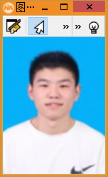

中值滤波后：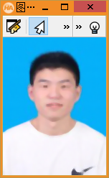

在消除高斯噪声中，均值滤波的效果更好

3.叠加椒盐噪声：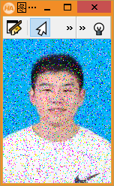 均值滤波后：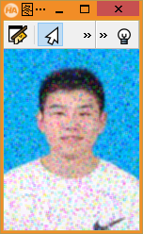

中值滤波后：

在消除椒盐噪声中，中值滤波的效果更好一点，均值滤波中仍存在噪声

dev_close_window()

read_image(Image,'C:/Users/Admin/Desktop/1.jpg')

get_image_size(Image,Width,Height)

dev_open_window(0,0,Width,Height,'black',Windowhandle)

dev_display(Image)

stop()

dev_open_window(0,150,Width,Height,'black',Windowhandle1)

gauss_distribution(2.0,distribution)

add_noise_distribution(Image,gauss_ImageNoise,distribution)

dev_display(gauss_ImageNoise)

stop()

dev_open_window(0,300,Width,Height,'black',Windowhandle2)

mean_image(gauss_ImageNoise,mean_gauss_Image,3,3)

dev_display(mean_gauss_Image)

stop()

dev_open_window(0,450,Width,Height,'black',Windowhandle3)

median_image(gauss_ImageNoise,median_gauss_Image,'square',2,'mirrored')

dev_display(median_gauss_Image)

stop()

dev_open_window(210,0,Width,Height,'black',Windowhandle4)

sp_distribution(5.0,5.0,Distribution)

add_noise_distribution(Image,sp_ImageNoise,Distribution)

dev_display(sp_ImageNoise)

stop()

dev_open_window(210,150,Width,Height,'black',Windowhandle5)

mean_image(sp_ImageNoise,mean_sp_Image,3,3)

dev_display(mean_sp_Image)

stop()

dev_open_window(210,300,Width,Height,'black',Windowhandle6)

median_image(sp_ImageNoise,median_sp_Image,'square',2,'mirrored')

dev_display(median_sp_Image)

stop()