TATEINU COIN v1

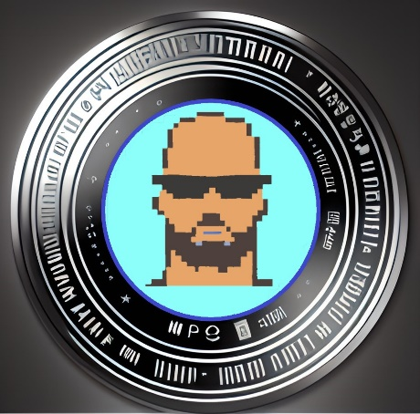**A new type of asset distribution management service that links Defi and NFT market services through blockchain to be closer to mass adoption**

TateInu Coin White Paper V1

Polygon address: 0X0000

About TateInu Coin

is a 100% genuine meme token inspired by the adorable Shiba and Kishu dogs. Shiba Inu and Kishu Inu have been highly successful meme tokens, and TateInu aims to follow in their footsteps. The TateInu-loving community is expected to grow fast, and we strive to become as popular as the Shiba Inu community.

100% about coin memes. Audit and Future KYC.

Automatic token burning mechanism according to volume Attractive reflection mechanism

Why should I own TateInu Coin? TateInu is a new and exciting meme coin that offers fair and equal opportunities to all investors. We highly value our community, and it is at the core of our x1000 at ATH project. Our goal is to create a transparent blockchain meme token that is truly owned by everyone. We have an attractive and profitable betting mechanism for investors holding TateInu.

TateInu is a genuine, brand new meme coin without VCs. We want to turn this small meme coin into your big dream. We plan to be an honest community project that has renounced ownership and undergone audit and KYC procedures to ensure clear safety.

We have big plans for TateInu, which may include creating applications such as payment in-app, games, football bets, Casinos, betting and much more in a future!. There's no limit to what we can achieve together as a community.

Launched in April 2023, Tateinu Coin one of the fastest growing community in crypto memes. Tateinu is on a mission to bring crypto to the average person while also helping save dogs in need. Tateinu is built on POLYGON chain with extremely fast block times and cheaper gas fees than ethereum. Tateinu Coin has learned a few tricks and lessons from older succesfull memes fathers. A new crypto birthed by a fan of the Crypto Doge Memes online communities and projects. Tateinu seeks to impress his father by showing his new improved transaction speeds & adorableness. He is Hyper-deflationary with reflections, so more Tateinu coins are being automatically added to your wallet on each transaction.

The initial launch for the token will happen via a Web App. This decision was made in an attempt to get involved the existing DeFi/Crypto community. The goal is for the existing community members to have enough incentivization to continually participate in the long-term education of those newer to the space. As this part of the platform/service is nothing new to the space we have decided to stick to the most basic features and layout for the Web App.

It was decided to have a centralized team behind the project to better address the project requirements, shape the general project direction and facilitate the development of some DApps for the protocol. Our goal is to reach full decentralization through community governance. However, we are also realists and have conducted a risk/benefit assessment to determine that the protocol and its community should be mature enough to justify implementing on-chain governance from the start of the project. We look forward to implementing a fully decentralized community governance system and managing the protocol with you in the near future.

DISCLAIMER

TateInu, including but not limited to the overall project, token, website, smart contracts and any official apps (“TateInu coin”) as presented in this conceptual paper is not a licensed, unlicensed or exempted financial or payment service of any kind and in any jurisdiction. Any terminology used in this Whitepaper, on the Website or within the app is intended only as a basic reference, without any legal meaning or responsability of the same terms in a regulated and/or financial environment TateInu is a token founder and top 20 biggest holders community-driven project. TateInu smart contracts are open-source, security audited, permanent andnon-modifiable in any way. The TateInu is strictly a meme utility token in all jurisdictions and is not and cannot be considered to be a “security” or otherwise regulated token of any kind. TateInu is not in any way e-money and/or fiat money, or an asset backed stablecoin, whether global or limited in scope. This Whitepaper taken by itself is not a contract or a contractual agreement of any kind, nor is it an invitation, solicitation or o er to invest in TateInu or acquire or use TateInu tokens in any way and with any expectation of profit therefrom. Any user of TateInu represents and warrants that such user has received appropriate technical, administrative, regulatory and legal advice before and a er accessing and/or reading this Whitepaper or the Website, and/or using any portion or element of TateInu (including the TateInu token). The user hereby acknowledges and accepts that there is an inherent high risk in accessing, acquiring or using any kind of blockchain and/or crypto system, token, platform, including TateInu, and further disavows any claim of any kind against any community member directly or indirectly involved with TateInu, for any damage, including total loss. TateInu is built on polygon smart chain with extremely cheaper gas fees than ethereum. TateInu was created as a joke and should not be taken seriously and may result in a 100% total loss.

***Check our Legal, Disclaimer and Privacy policy for the full section and more information***

***(Not afiliated with any other coin, or internet celebrity)***

***Our Values***

**FREEDOM, COMMUNITY, TRUST, LONGEVITY, SECURITY, PRIVACY**

***Our Vision***

**Simple accessibility to our NFTs asset and cryptotoken assets, so anyone can easily access; Decentralized finance with a future focus on privacy transactions to protect our costumers from malicious attacks. Opening a new platform so that customers can make their own asset management rather than large institutions. And with that, to build a stable asset management service in the virtual asset market. That is the vision of TATEINU COIN.Blockchain is an important tool for shaping the future of finance. In particular, smart contract tokens and NFTs are the biggest topics in the new virtual asset market. We want to create services for our customers by continuously upgrading until the day that all digital assets are freely traded in decentralized financial markets.**

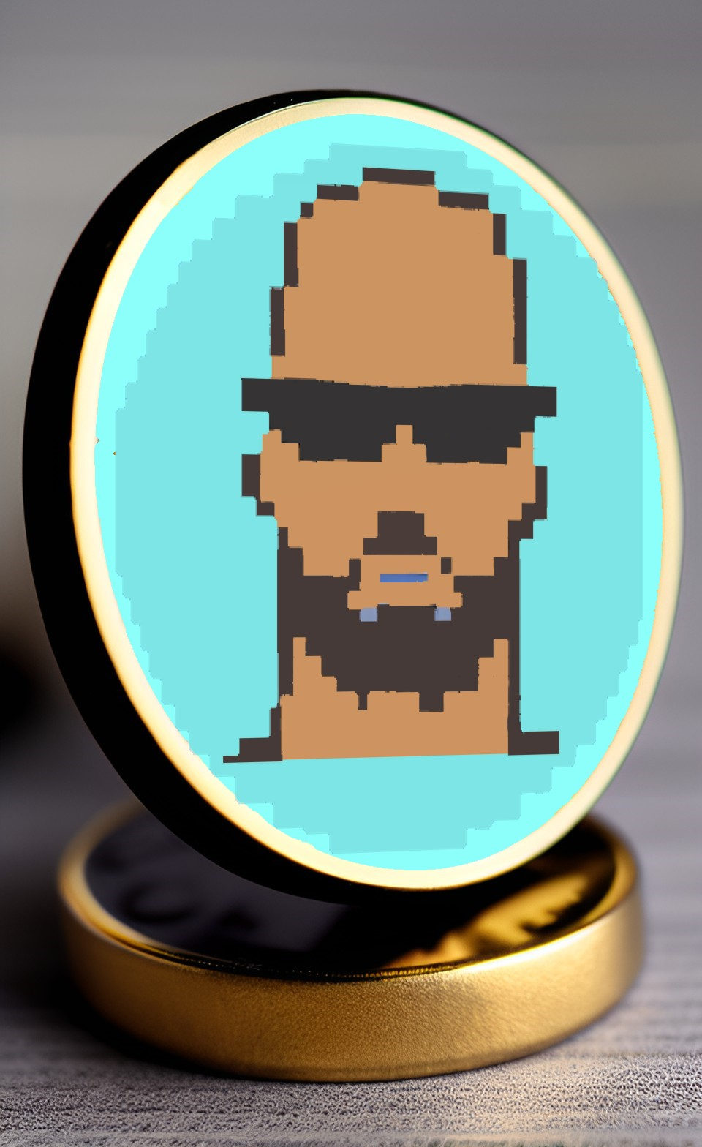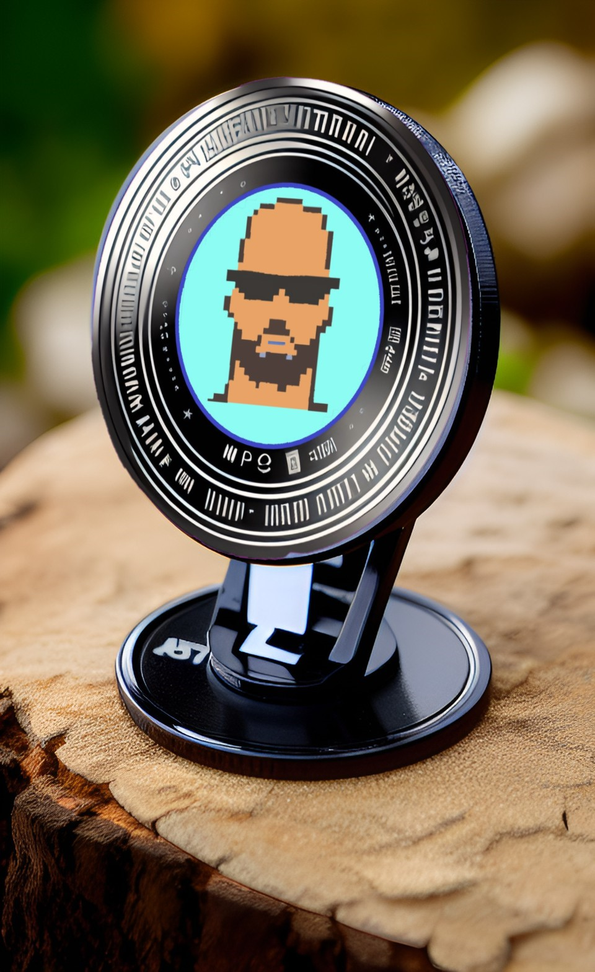

TOKENOMICS

**SUPPLY ALLOCATION**

TOTAL SUPPLY: 100.000.000 Tokens

Initial Presale Distribution: 45%

Team/Founder: 10%

Angel Investors (Friends/Family): 5%

Partnership Reserve: 5%

New Features Reserve: 15%

Centralized Exchange Liquidity Reserve: 15%

Marketing Reserve: 5%

TAX FEE DISTRIBUTIONS

TateInu Coin employs 3 simple functions: Reflection + LP acquisition + Burn and its distributed on this way:

ROADMAP

***Q1 BIRTH***

Website launch,PRESALE, FIRST EXCHANGE LISTINGS, PROMOTE SOCIALS TO GROW OUR COMMUNITY MEMBERS

***Q2 STAND UP***

COINGECKO AND COINMARKET LISTING, KYC, 2nd Audit, contribution’s Management for our big development

***Q3 FIRST STEPS***

Host our first voting mechanism event to decide our first development tool, such as:

**-TateInu Swap and bridges for new chains such as bsc.**

**-Tateinu simple web3 game**

**-TateInu Wallet (with options to implement a *zk-snarks* like protocol to reinforce our community security)**

**-TateInu Debit Crypto Card**

**-TateInu Merchandise**

**-Tateinu Foods/Drinks**

***Q4 WALKING SESSION***

***-When reached 1m$ on our charity wallet donate half into local animal shelters and decide with out voting gobernance mechanism where should it be donated.***

Explore new opportunities and use cases for the platform, such as integrating with new blockchains or supporting new types of digital assets.

***Q5 RUNNING SESSION***

Continuously improve and expand the **TateInu** ecosystem, incorporating the latest technology and market trends to stay ahead of the curve.

Build out a robust ecosystem of partners and integrations to support the **TateInu** project and provide additional value to users.

Establish the **TateInu** as a widely recognized and utilized cryptocurrency, with strong liquidity and market capitalization.

Expand the use cases for the **TateInu** Token and the hole ecosystem, including support for new digital assets, DeFi applications, and other emerging use cases.

Build out a strong community of supporters and advocates for the **TateInu coin** project and the Token, leveraging social media, influencer marketing, and other channels.

Foster a culture of innovation and collaboration within the **TateInu** team, supporting continued growth and development of the project.

Stay vigilant and adaptable in response to changes in the regulatory and market environment, and maintain a strong commitment to security and user privacy. Pursue additional listings on centralized and decentralized exchanges to increase liquidity and accessibility of the **TateInu** Token.

Develop strategic partnerships with other crypto projects and platforms to enhance the value proposition of the **TateInu** platform and increase adoption.

Offer new services and features, such as staking, lending, borrowing, and other DeFi applications.

Develop and launch additional marketing campaigns and initiatives to continue building awareness and engagement with the **TateInu Coin ecosystem project and community**.

TEAM



***Carlos G***

***(Founder and spokesman )***

He brings a unique set of skills to the  
team, with a deep understanding of  
data analysis and programming brings a wealth of experience in the  
cryptocurrency industry, serving as:

Marketer and Social Media Manager, extensive experience in marketing and  
social media management to the  
project, helping to raise awareness  
and build a community around the project.

A Data Scientist and Blockchain developer, and student. With a background in marketing and communications, also skilled in developing and executing successful marketing campaigns. He is dedicated to staying up-to-date with the latest trends in digital marketing and social media, always exploring new ways to reach and engage with the target audience. He is an enthusiast in the field of cryptocurrency security and has attended numerous conferences and several events on the topic. With responsibilities such as overseeing the development of the project, and he is capable of handing the  
complex demands of the cryptocurrency industry. He is also equipped to tackle the challenges of developing a cutting-edge digital asset platform project, always willing to go above and beyond to ensure the success of the project. He also works closely with other team members, such as angel investors or advisers to collaborate on development projects and provide guidance and support as much as needed. The founder/Developer also has a deep understanding of the latest blockchain technologies and is always keeping up to- date with the latest developments in the industry. He is known for his meticulous attention to detail and his ability to develop robust, secure smart contracts that are free from vulnerabilities.

**AT LEAST ONE OF OUR TEAM MEMBERS WILL BE KYC’ed**