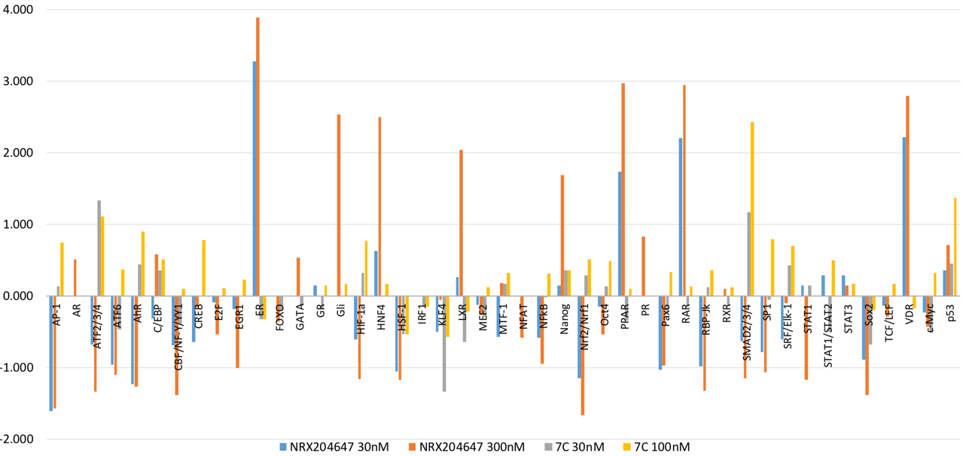

Supplementary Figure 3. Profiling effects of selective RARγ agonist NRX204647 and antagonist 7C. Cignal Finder 45-pathway array was used to profile the action of selective RARγ ligands. Values of drug treated groups are averages of 2 samples. Values of control are averages of samples. Please refer manufacturers handbook for detail information of pathway specific reporters and experimental procedures.

