ANALYSTLAB AFRICA
Experience Lab Internship Programme
Week 1 — FinTrust Digital Bank: Understand & Plan
Track: Data Analytics
Deliverable: FinTrust Business & Data Intelligence Assessment
Field | Detail
Intern Name | Tatenda Farai Mujati
Batch | Batch E
Track | Data Analytics
Project | FinTrust Financial Intelligence & Digital Banking Support Solution
Week | Week 1
Submission Date | 20 September 2026, 11:59 PM WAT

1. Business Understanding

1.1 The FinTrust business problem.
What problem is FinTrust trying to solve?
FinTrust Digital Bank needs to convert its raw customer and transaction records into usable business intelligence. As a digital bank, it currently generates large volumes of customer and transaction data but lacks a structured way to understand customer behaviour, monitor transaction performance and reliability, and identify risk-related patterns — which limits management's ability to make informed, timely decisions.
Why is the problem important?
Without structured intelligence, FinTrust risks losing customers it can't see disengaging, missing operational failures (failed/reversed transactions) that erode trust, under-investing in the channels customers actually use, and being slow to notice risk-related transaction patterns. Turning raw data into monitored KPIs and dashboards directly supports customer retention, operational reliability and risk management — all core to a digital bank's survival.
How can the Data Analytics track contribute to solving it?
The Data Analytics track can profile the available customer and transaction data, define the KPIs that matter to FinTrust's stakeholders, and design (then build, in Weeks 2–4) a dashboard that turns raw records into an at-a-glance view of customer behaviour, transaction performance and risk indicators — giving non-technical stakeholders self-service access to the intelligence they need.
What type of output could the Data Analytics track provide?
A structured data-profiling report, a defined set of analytical questions and KPIs, a dashboard wireframe (Week 1), and ultimately a working Power BI/Excel dashboard with supporting documentation (Weeks 2–4).

1.2 Track-specific business understanding (Part A)
1. What business questions should FinTrust's management be able to answer?
Which customer segments are most valuable and which are most at risk of disengaging? Which channels (Mobile App, USSD, ATM, POS, Web) drive the most transaction volume and value and which underperform? How reliable is the transaction infrastructure — what share of transactions are successful, fail or get reversed and where do failures concentrate? Which transactions or patterns warrant closer risk review? How is the customer base evolving in engagement, tenure and income profile?
2. What decisions could data analysis support?
- Product and channel investment — prioritising digital feature development based on channel usage and success rates.
- Customer relationship management — targeting dormant/low-engagement customers for re-activation and high-value segments for retention.
- Operational reliability decisions — investigating root causes behind failed/reversed transactions by channel or type.
- Risk and compliance prioritisation — directing manual review capacity toward the channels/segments most associated with the Risk-Review-Flag.
- Geographic strategy — deciding which cities merit expanded digital or physical service based on transaction concentration.
3. What stakeholders could benefit from the analytical outputs?
- Executive / Management team — strategic oversight of customer and transaction performance.
- Product & Digital Channels team — improving app, USSD, POS and web experiences.
- Risk & Compliance team — prioritising review of flagged transactions.
- Customer Experience / Retention team — engagement and win-back campaigns.
- Operations team — reducing failed/reversed transaction rates.
- Data Science, ML Engineering and Generative AI tracks — as downstream consumers of the cleaned data and defined KPIs from Week 2 onward.

2. Resource Review
Resource | What It Contains | How I Will Use It | Limitations Identified
FinTrust_Customer_Data.csv | One row per customer: Customer_ID, Customer_Name, Age, Gender, City, Customer_Segment, Account_Type, Tenure_Months, Digital_Engagement_Score, Monthly_Income_Band, Preferred_Channel, Account_Status. | Primary source for customer profiling, segmentation and demographic KPIs; joins to the transaction file via Customer_ID. | Customer_Name is synthetic and flagged in the data dictionary as demo/portfolio use only. Full row count and null-value profile still need confirming from the source CSV.
FinTrust_Transaction_Data.csv | One row per transaction: Transaction_ID, Customer_ID, Transaction_DateTime, Transaction_Type, Amount_NGN, Channel, Device_Type, Location, International_Transaction, Transaction_Status, Risk_Review_Flag. | Primary source for transaction-volume, value, channel, status and risk analysis; the fact table that joins to the customer dimension. | Channel values are inconsistently labelled (e.g. 'POS' vs 'POS Terminal', 'ATM' vs 'ATM Terminal', 'Web' vs 'Web Browser') and will need standardising before aggregation.
FinTrust_Data_Dictionary.xlsx | Field-level definitions across three tabs (Customer_Dictionary, Transaction_Dictionary, Project_Notes): field name, dataset, data type, example value, business definition, and intended use. | Reference throughout Weeks 1–4 to confirm field meaning before building KPIs or visuals. | Confirms several fields are synthetic — real-world financial conclusions should not be drawn from the values.
FinTrust Project Brief / 4-Week Master Roadmap | Overall project goals, track responsibilities and expected milestones across the four weeks. | Used to align the Week 1 plan with what other tracks (Data Science, MLE, GenAI, PM) will eventually need from Data Analytics outputs. | High-level; track-specific detail comes from the Week 1 assignment document itself.

3. Data Understanding / Profiling Report
Number of records
- FinTrust_Customer_Data: at least ~1,500 customers — the highest Customer_ID referenced anywhere in the data is FT-C01394, so the base is at least this size. The exact total should be confirmed by opening the full FinTrust_Customer_Data.csv directly, as this profiling was done from a working sample view of the sheet.
- FinTrust_Transaction_Data: a sample of ~100 transaction records (Transaction_ID FT-T000001 onward) was directly reviewed; the full file likely contains substantially more rows given the customer base size. Exact total to be confirmed from the full CSV.
Number of columns
- FinTrust_Customer_Data: 12 columns.
- FinTrust_Transaction_Data: 11 columns.
Field names, data types, categorical variables, numerical variables, and date/time variables
Customer_Data:
Field | Data Type | Variable Type | Example / Observed Categories
Customer_ID | Text | Identifier (key) | FT-C00001
Customer_Name | Text | Identifier (display only) | Amina Okafor
Age | Integer | Numerical | 46
Gender | Category | Categorical | Female, Male
City | Text | Categorical | Lagos, Kano, Port Harcourt, Kaduna, Enugu, Abuja, Ibadan, Benin City
Customer_Segment | Category | Categorical | Everyday, Premium, SME
Account_Type | Category | Categorical | Savings, Current
Tenure_Months | Integer | Numerical | 79
Digital_Engagement_Score | Decimal | Numerical | 10–100 range
Monthly_Income_Band | Category | Categorical (ordinal) | Below 100k, 100k–249k, 250k–499k, 500k–999k, 1m+
Preferred_Channel | Category | Categorical | Mobile App, USSD (others likely present)
Account_Status | Category | Categorical | Active, Dormant (others possible, e.g. Closed)
Transaction_Data:
Field | Data Type | Variable Type | Example / Observed Categories
Transaction_ID | Text | Identifier (key) | FT-T000001
Customer_ID | Text | Identifier (foreign key) | FT-C01135
Transaction_DateTime | Date/Time | Date/time | m/d/yyyy h:mm — Africa/Lagos locale
Transaction_Type | Category | Categorical | Card Purchase, Cash Withdrawal, Transfer, Deposit, Airtime/Data, Bill Payment
Amount_NGN | Numeric (currency) | Numerical | 739.65
Channel | Category | Categorical | Mobile App, ATM, POS Terminal, POS, Web Browser, Web, USSD, ATM Terminal
Device_Type | Category | Categorical | Android, iOS (others possible)
Location | Text | Categorical | Enugu, Kaduna, Kano, Abuja, Port Harcourt, Lagos, Ibadan, Benin City
International_Transaction | Boolean | Categorical (binary) | Yes, No
Transaction_Status | Category | Categorical | Successful, Reversed, Failed, Pending
Risk_Review_Flag | Category (Boolean-like) | Categorical (binary) | Yes, No
Relationship between the datasets
One-to-many star structure: Customer_Data is the dimension table (one row per customer), Transaction_Data is the fact table (many transactions per customer), joined on Customer_ID. Any transaction-level metric can therefore be sliced by any customer attribute (segment, income band, tenure, engagement score, city).
Missing values
Full null-value counts could not be completed from the sheet sample and are the first task planned for Week 2 (see Initial Analysis Plan). No obviously blank required fields (Customer_ID, Transaction_ID) were observed in the sample reviewed.
Obvious data-quality issues
- Channel labelling is inconsistent — 'POS' and 'POS Terminal' appear to represent the same channel, as do 'ATM'/'ATM Terminal' and 'Web'/'Web Browser'. This will inflate the apparent number of distinct channels unless standardised before analysis.
- Customer_Name is synthetic and explicitly marked in the data dictionary as for display/demo purposes only — not to be used in analysis or modelling.
- City (Customer_Data) and Location (Transaction_Data) should be checked for consistent spelling/casing before being used as a shared join/filter dimension.
- Outlier checks on Age, Amount_NGN, Tenure_Months and Digital_Engagement_Score have not yet been run against the full file and are planned for Week 2.

4. Analytical Questions
Eight questions, spanning customer behaviour, transaction activity, transaction value, transaction channels, transaction status and risk-related patterns as required — each answerable from the fields confirmed to exist in the data.
- What is the overall transaction success rate and how does it vary across Channel and Transaction_Type? (transaction status)
- Which transaction types and channels generate the highest total and average transaction value (Amount_NGN)? (transaction value, channels)
- How does customer digital engagement (Digital_Engagement_Score) differ across Customer_Segment, Account_Type and Preferred_Channel? (customer behaviour)
- What proportion of transactions are flagged for risk review (Risk_Review_Flag), and are flagged transactions concentrated in specific channels, transaction types or international transactions? (risk-related patterns)
- Which cities/locations account for the highest transaction volume and value and how closely does this match the geographic distribution of customers? (transaction activity)
- Is there a relationship between customer tenure (Tenure_Months) and transaction frequency or value? (customer behaviour)
- How do Active vs Dormant accounts differ in transaction volume, value and channel usage? (customer behaviour, transaction activity)
- Does a customer's Monthly_Income_Band correlate with transaction value, transaction type mix or preferred channel? (transaction value, channels)

5. KPI Definition Table
Eight KPIs, each with definition, business rationale and the exact data required.
KPI | Definition | Why It Matters | Required Data
Transaction Success Rate | Successful transactions ÷ total transactions | Core measure of platform/operational reliability across channels | Transaction_Status
Average Transaction Value | Mean of Amount_NGN across transactions (overall and by segment) | Indicates typical customer spend and revenue potential per transaction | Amount_NGN
Risk Review Rate | Transactions flagged Risk_Review_Flag = Yes ÷ total transactions | Early warning indicator of risk exposure by channel/type/segment | Risk_Review_Flag
Active Customer Rate | Customers with Account_Status = Active ÷ total customers | Measures the health and engagement of the overall customer base | Account_Status
Average Digital Engagement Score | Mean Digital_Engagement_Score, sliced by segment/channel | Tracks digital adoption and informs channel investment decisions | Digital_Engagement_Score, Customer_Segment
Channel Utilisation Share | % of total transactions occurring in each Channel | Shows where transaction load and customer preference concentrate | Channel
International Transaction Share | International_Transaction = Yes ÷ total transactions | Flags cross-border activity relevant to risk and compliance monitoring | International_Transaction
Average Customer Tenure | Mean Tenure_Months, by Customer_Segment | Indicator of customer loyalty and lifecycle stage across segments | Tenure_Months, Customer_Segment

6. Dashboard Wireframe
Layout for the Week 2–4 Power BI/Excel dashboard, showing proposed sections, KPI cards, charts, filters and expected insights. This is a design plan only.
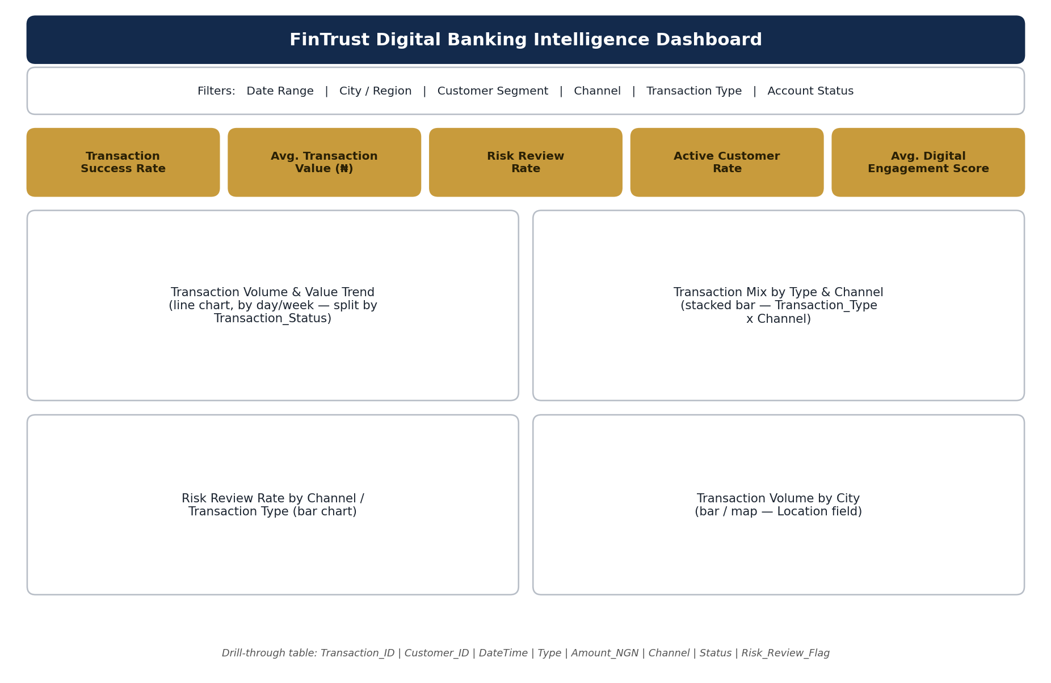
Proposed dashboard sections
- Title/header bar.
- Filter bar: Date Range, City/Region, Customer Segment, Channel, Transaction Type, Account Status.
- KPI summary row (5 cards).
- Two mid-page charts: transaction trend and transaction mix.
- Two lower charts: risk-review breakdown and geographic breakdown.
- Optional drill-through detail table for transaction-level records.
Key KPI cards
- Transaction Success Rate
- Average Transaction Value (₦)
- Risk Review Rate
- Active Customer Rate
- Average Digital Engagement Score
Charts / visuals
- Transaction Volume & Value Trend — line chart over time, split by Transaction_Status.
- Transaction Mix by Type & Channel — stacked bar, Transaction_Type x Channel.
- Risk Review Rate by Channel / Transaction Type — bar chart.
- Transaction Volume by City — bar chart or map, using Location.
Filters
- Date Range (Transaction_DateTime)
- City / Region (Location / City)
- Customer Segment
- Channel
- Transaction Type
- Account Status
Major insights the dashboard is expected to communicate
- Where transaction reliability is weakest (lowest success rate by channel/type).
- Which channels and transaction types drive the most value, to guide product investment.
- Where risk-review activity concentrates, to help prioritise manual review capacity.
- How customer segments differ in engagement, tenure and value, to guide retention strategy.
- Geographic concentration of transaction activity, to guide regional service decisions.

7. Track Objectives
- Produce a complete, accurate profile of both FinTrust datasets (fields, types, categories, relationships, and known data-quality issues) to serve as the foundation for all later analysis.
- Define a focused, answerable set of analytical questions and KPIs that map directly to FinTrust's stated business problem and can be built from the available fields.
- Design a dashboard structure (wireframe) that clearly communicates transaction performance, customer behaviour and risk indicators to non-technical stakeholders.
- Clean, standardise and prepare the datasets in Week 2 (starting with the Channel-label inconsistency and full null/outlier checks) ahead of dashboard build.
- Build and validate a working Power BI/Excel dashboard against the defined KPIs by the end of Week 4, documenting assumptions and limitations throughout.

8. Success Criteria
- Every defined KPI can be calculated correctly and consistently from the cleaned data.
- Every analytical question above can be answered directly by a chart, table or KPI in the final dashboard.
- The dashboard is interactive (filters/slicers work as designed) and loads without error.
- Data-quality issues identified in Week 1 (e.g. Channel label inconsistency) are resolved and documented before final submission.
- A reviewer unfamiliar with the project can understand the dashboard's purpose and read off key insights within a few minutes, supported by clear documentation.

9. Initial Analysis Plan (Weeks 2–4)
Week | Focus | Key Activities | Expected Output
Week 2 | Data preparation & validation | Load full CSVs in Excel/Python; confirm true row counts; check nulls, duplicates and outliers on Age, Amount_NGN, Tenure_Months and Digital_Engagement_Score; standardise Channel labels ('POS'/'POS Terminal' etc.); validate the Customer_ID join between tables. | Cleaned, documented dataset ready for analysis; a data-cleaning log.
Week 3 | Analysis & KPI build | Calculate all 8 KPIs; answer the 8 analytical questions using pivot tables/SQL/Python; begin building visuals in Power BI/Excel aligned to the wireframe. | Draft dashboard with core KPI cards and charts; documented findings.
Week 4 | Finalisation & validation | Complete remaining visuals and filters; validate figures for accuracy; write up insights and recommendations; prepare final documentation and presentation. | Finished, validated Power BI/Excel dashboard plus a written insights summary.

10. Relevant Risks
Risk | Likely Impact | Mitigation
Inconsistent category labels (e.g. Channel) distort aggregated metrics | KPIs and charts misrepresent true channel performance | Standardise categories during Week 2 cleaning before any KPI calculation
Full dataset (row counts, missing values) not yet confirmed | Profiling conclusions in this report may need revising once the full CSV is reviewed | Complete full-file profiling at the very start of Week 2 before building further
Amount_NGN or Age outliers/erroneous values | Averages and totals skewed, misleading KPI values | Outlier detection and documented handling rules in Week 2
Synthetic data limits real-world business relevance | Insights are illustrative rather than actionable for a real bank | Clearly document the synthetic nature of the data in all deliverables
Time constraint across four weeks alongside cleaning, analysis and dashboard build | Risk of an incomplete or rushed final dashboard | Follow the week-by-week plan closely; keep KPI/question scope fixed (8 each) rather than expanding

11. Relevant Future Dependencies (Planning Only)
No formal cross-track collaboration is required in Week 1. The following are anticipated dependencies for Week 2 onward, noted here for planning purposes only:
- The Data Science track may later need the same cleaned transaction/customer dataset and the Data Analytics team's data-quality notes (e.g. the Channel standardisation) to avoid duplicating cleaning work.
- The Data Science track's Risk_Review_Flag target analysis and the Data Analytics track's Risk Review Rate KPI cover related ground — outputs could be cross-checked once both exist.
- The Generative AI track's customer-support assistant may eventually benefit from Data Analytics findings on common transaction issues (e.g. reversed/failed transaction patterns) to inform grounded response scenarios.
- The Project Management track will need the Week 2–4 plan above as an input to the overall project timeline and work breakdown structure.

