DEPARTMENT OF INSTITUTE OF COMPUTING
CHANDIGARH UNIVERSITY

Project: Weather Forecasting
Subject Name: Web Designing
Subject Code:

Submitted to: Professor Harkamal Kaur
Submitted by: Tatenda Chikopfa
UID: 25BCA10438
Class:25BCA-2B

1. Introduction
A Weather Forecasting Website is a web-based application that provides real-time weather information for any location. It helps users understand current weather conditions such as temperature, wind speed, and atmospheric conditions, enabling better planning of daily activities.
This project is developed using HTML, CSS, and JavaScript and uses the Open-Meteo API, which provides free weather data without requiring an API key. The application demonstrates how web technologies can interact with external APIs to fetch and display dynamic data in real time.

2. Objectives
- To design a simple and interactive weather application
- To fetch real-time weather data using a free API
- To implement city-based search using geocoding
- To display weather information clearly and efficiently
- To understand API integration and asynchronous JavaScript
- To enhance frontend development skills

3. Working Principle
The system works in the following steps:
- The user enters a city name or selects the current location
- The application uses the Open-Meteo Geocoding API to convert the city name into latitude and longitude
- These coordinates are sent to the Open-Meteo Weather API
- The API returns real-time weather data in JSON format
- JavaScript processes the data and extracts relevant information
- The results are displayed dynamically on the webpage
This process uses asynchronous programming, allowing data to be fetched without refreshing the page.
Code.
HTML (index.html)
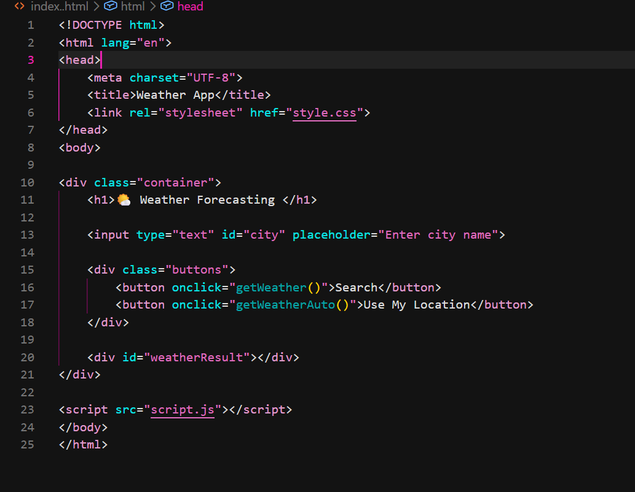

CSS (style.css)
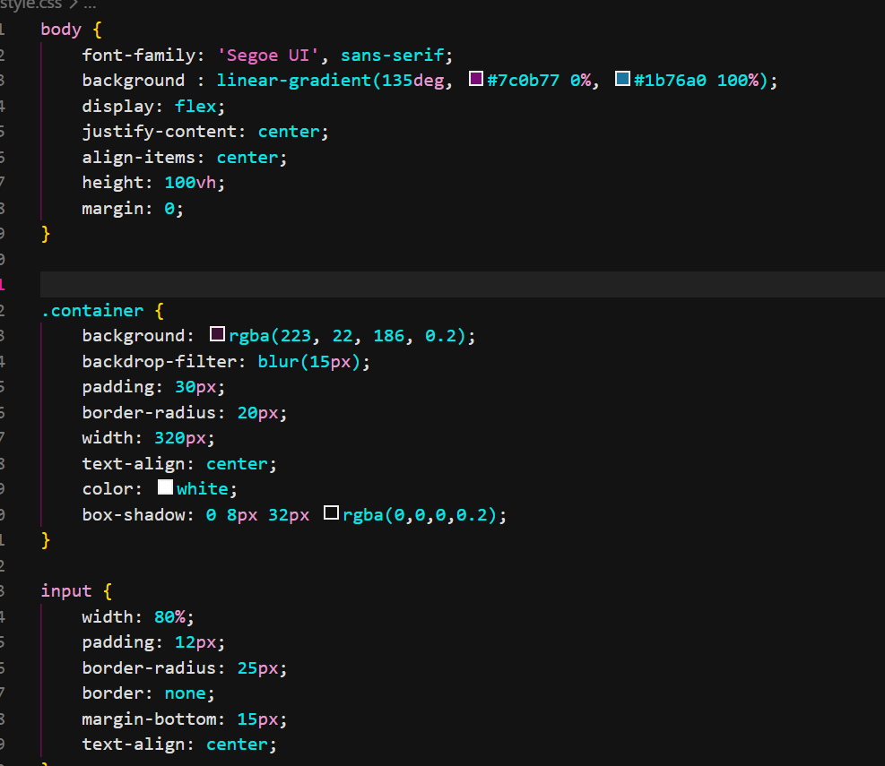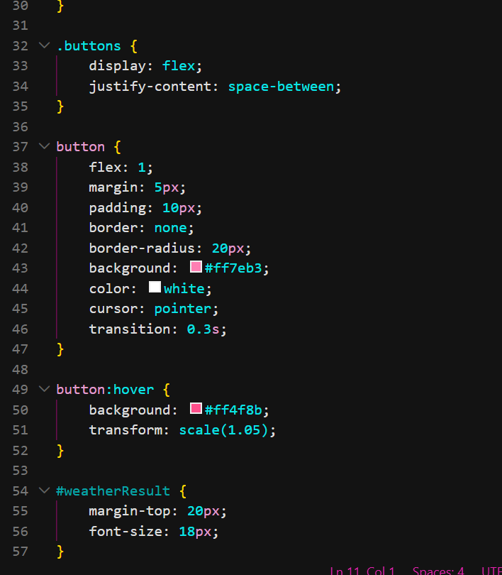
JavaScript (script.js)
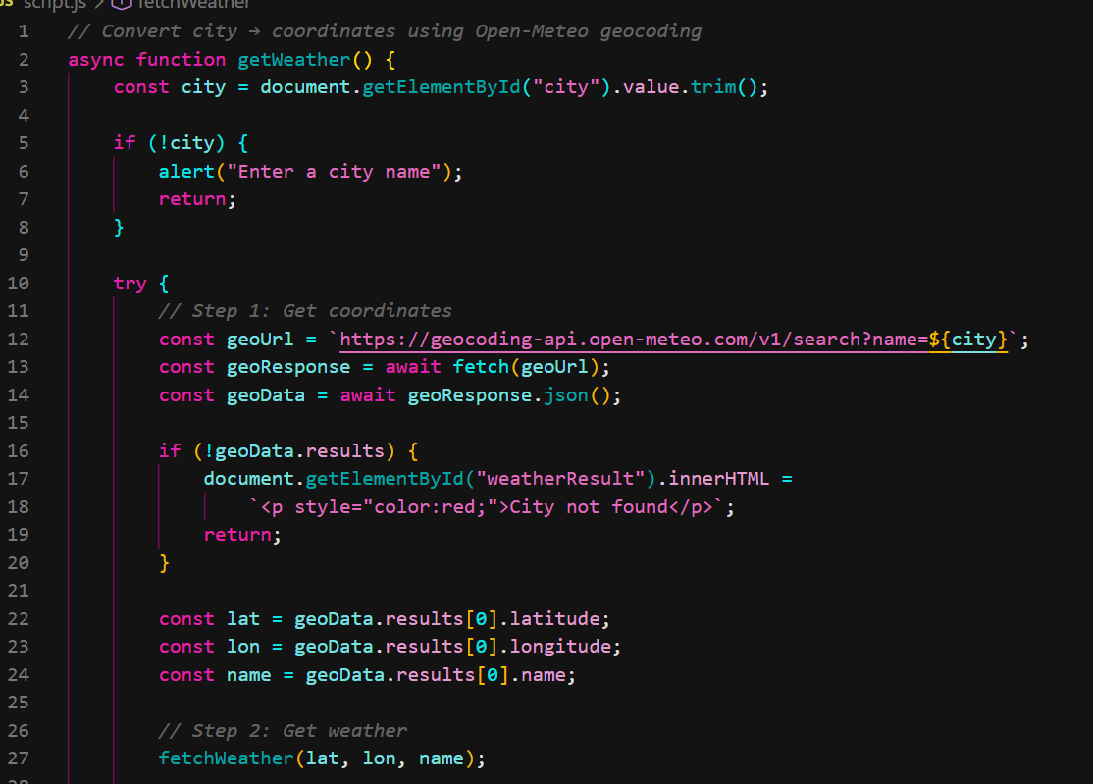
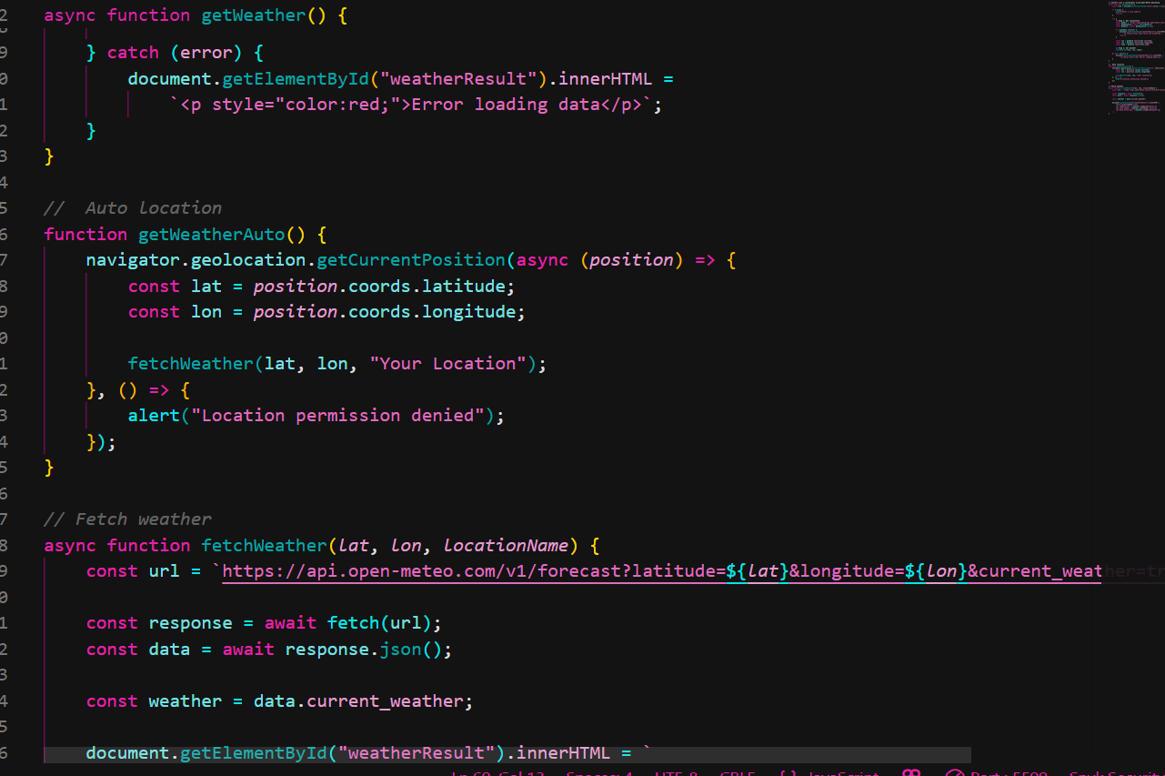
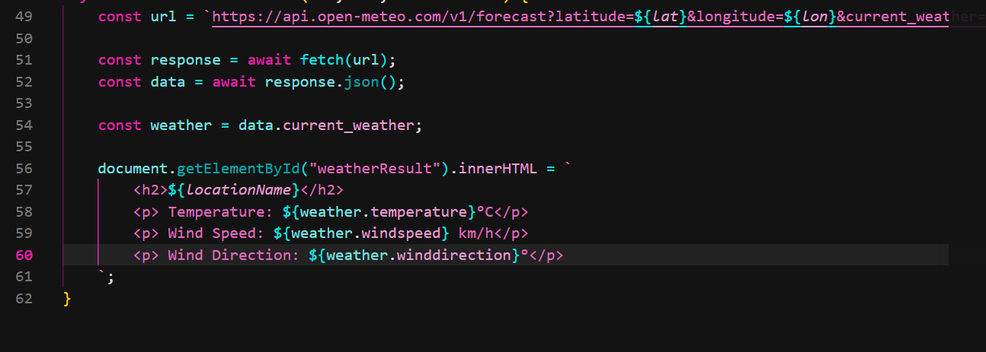
4.Output
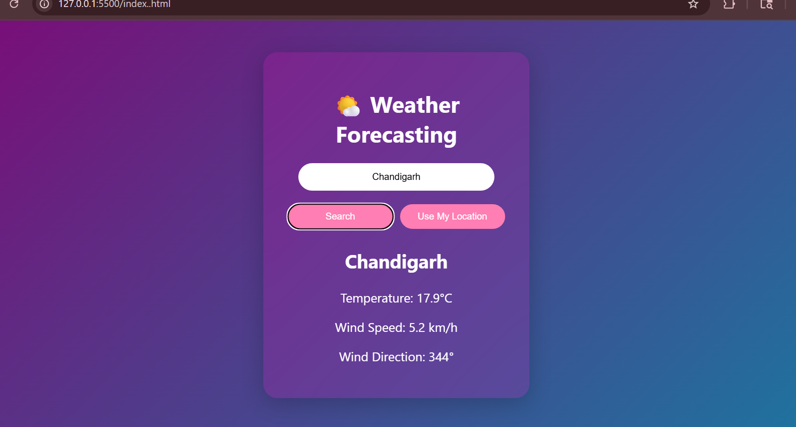

6. Conclusion
The Weather Forecasting Website successfully demonstrates how web technologies can be used to create dynamic and interactive applications. By integrating the Open-Meteo API, the system provides real-time weather information without requiring an API key.
This project helps in understanding key concepts such as:
- API integration
- Asynchronous JavaScript
- User interface design
The application can be further enhanced with additional features such as extended forecasts and responsive design, making it more powerful and user-friendly.

