SuiLoyalty — Database Design
Off-Chain PostgreSQL Schema with System Architecture — Sprint 3 Update (Avatar + BrandNode migration)

1. System Architecture
SuiLoyalty follows a three-layer architecture. The consumer PWA and merchant terminal call the Node.js backend via REST API. The backend reads and writes to PostgreSQL for fast off-chain data access and communicates with the Sui blockchain via JSON-RPC for on-chain operations. Google OAuth handles authentication via zkLogin. Following the Sprint 3 migration, the backend now operates as a privileged orchestrator: it holds an on-chain AdminCap that authorises it to mutate the shared LoyaltyAvatar objects on behalf of customers, enabling a frictionless Web2-style UX over a fully Web3 asset model.
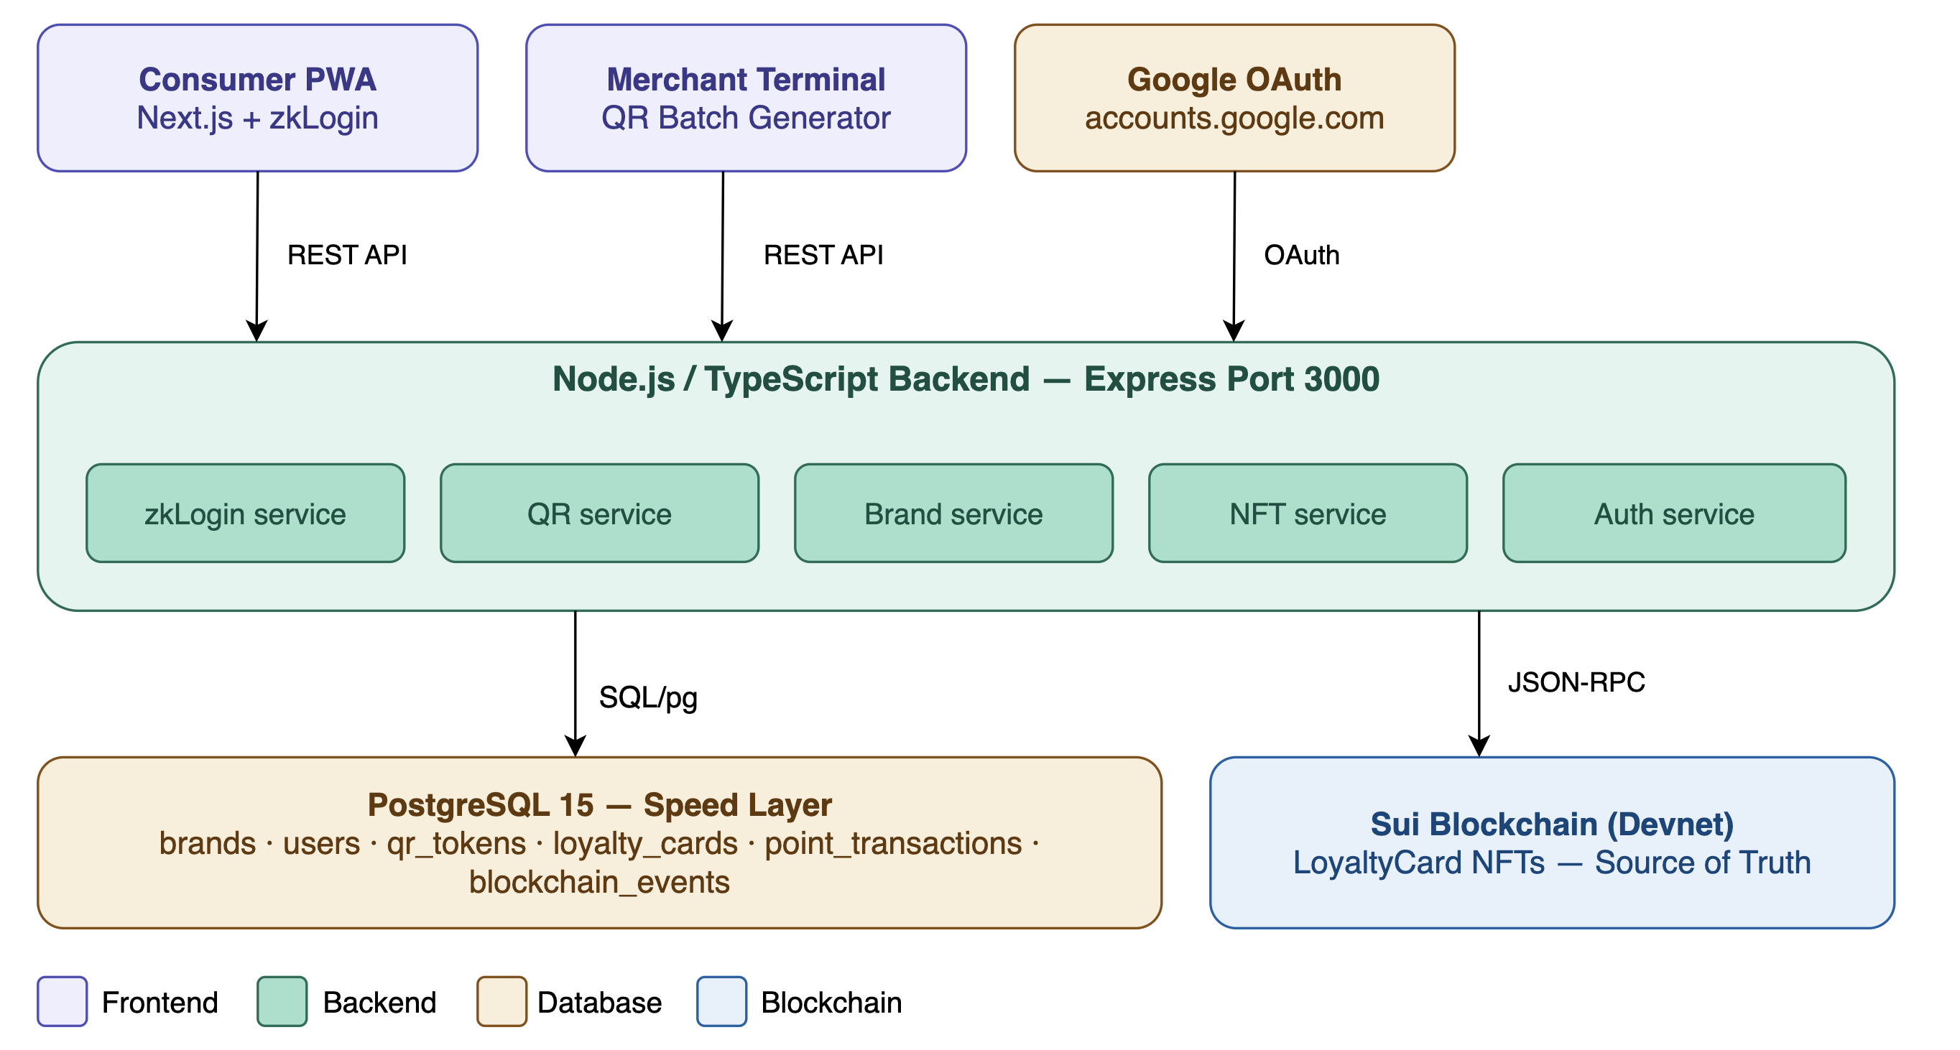
Figure 1 — SuiLoyalty system architecture

2. Multi-Brand Avatar Architecture
The defining change in Sprint 3 is the move from the flat LoyaltyCard model to a hierarchical LoyaltyAvatar + BrandNode model. Each customer owns exactly one LoyaltyAvatar NFT, which is created as a Sui shared object so the backend can mutate it under AdminCap authorisation. Individual brand relationships (Starbucks, Nike, Amazon, Emirates, etc.) are not separate NFTs anymore — they are BrandNode dynamic object fields attached to the parent Avatar. The Avatar also carries global aggregates (level, experience, attributes) that span all brands, while each BrandNode tracks the per-brand points balance, scan count, and tier. The off-chain PostgreSQL schema mirrors this hierarchy exactly: loyalty_avatars (1 row per user) and loyalty_brand_nodes (1 row per user per brand).
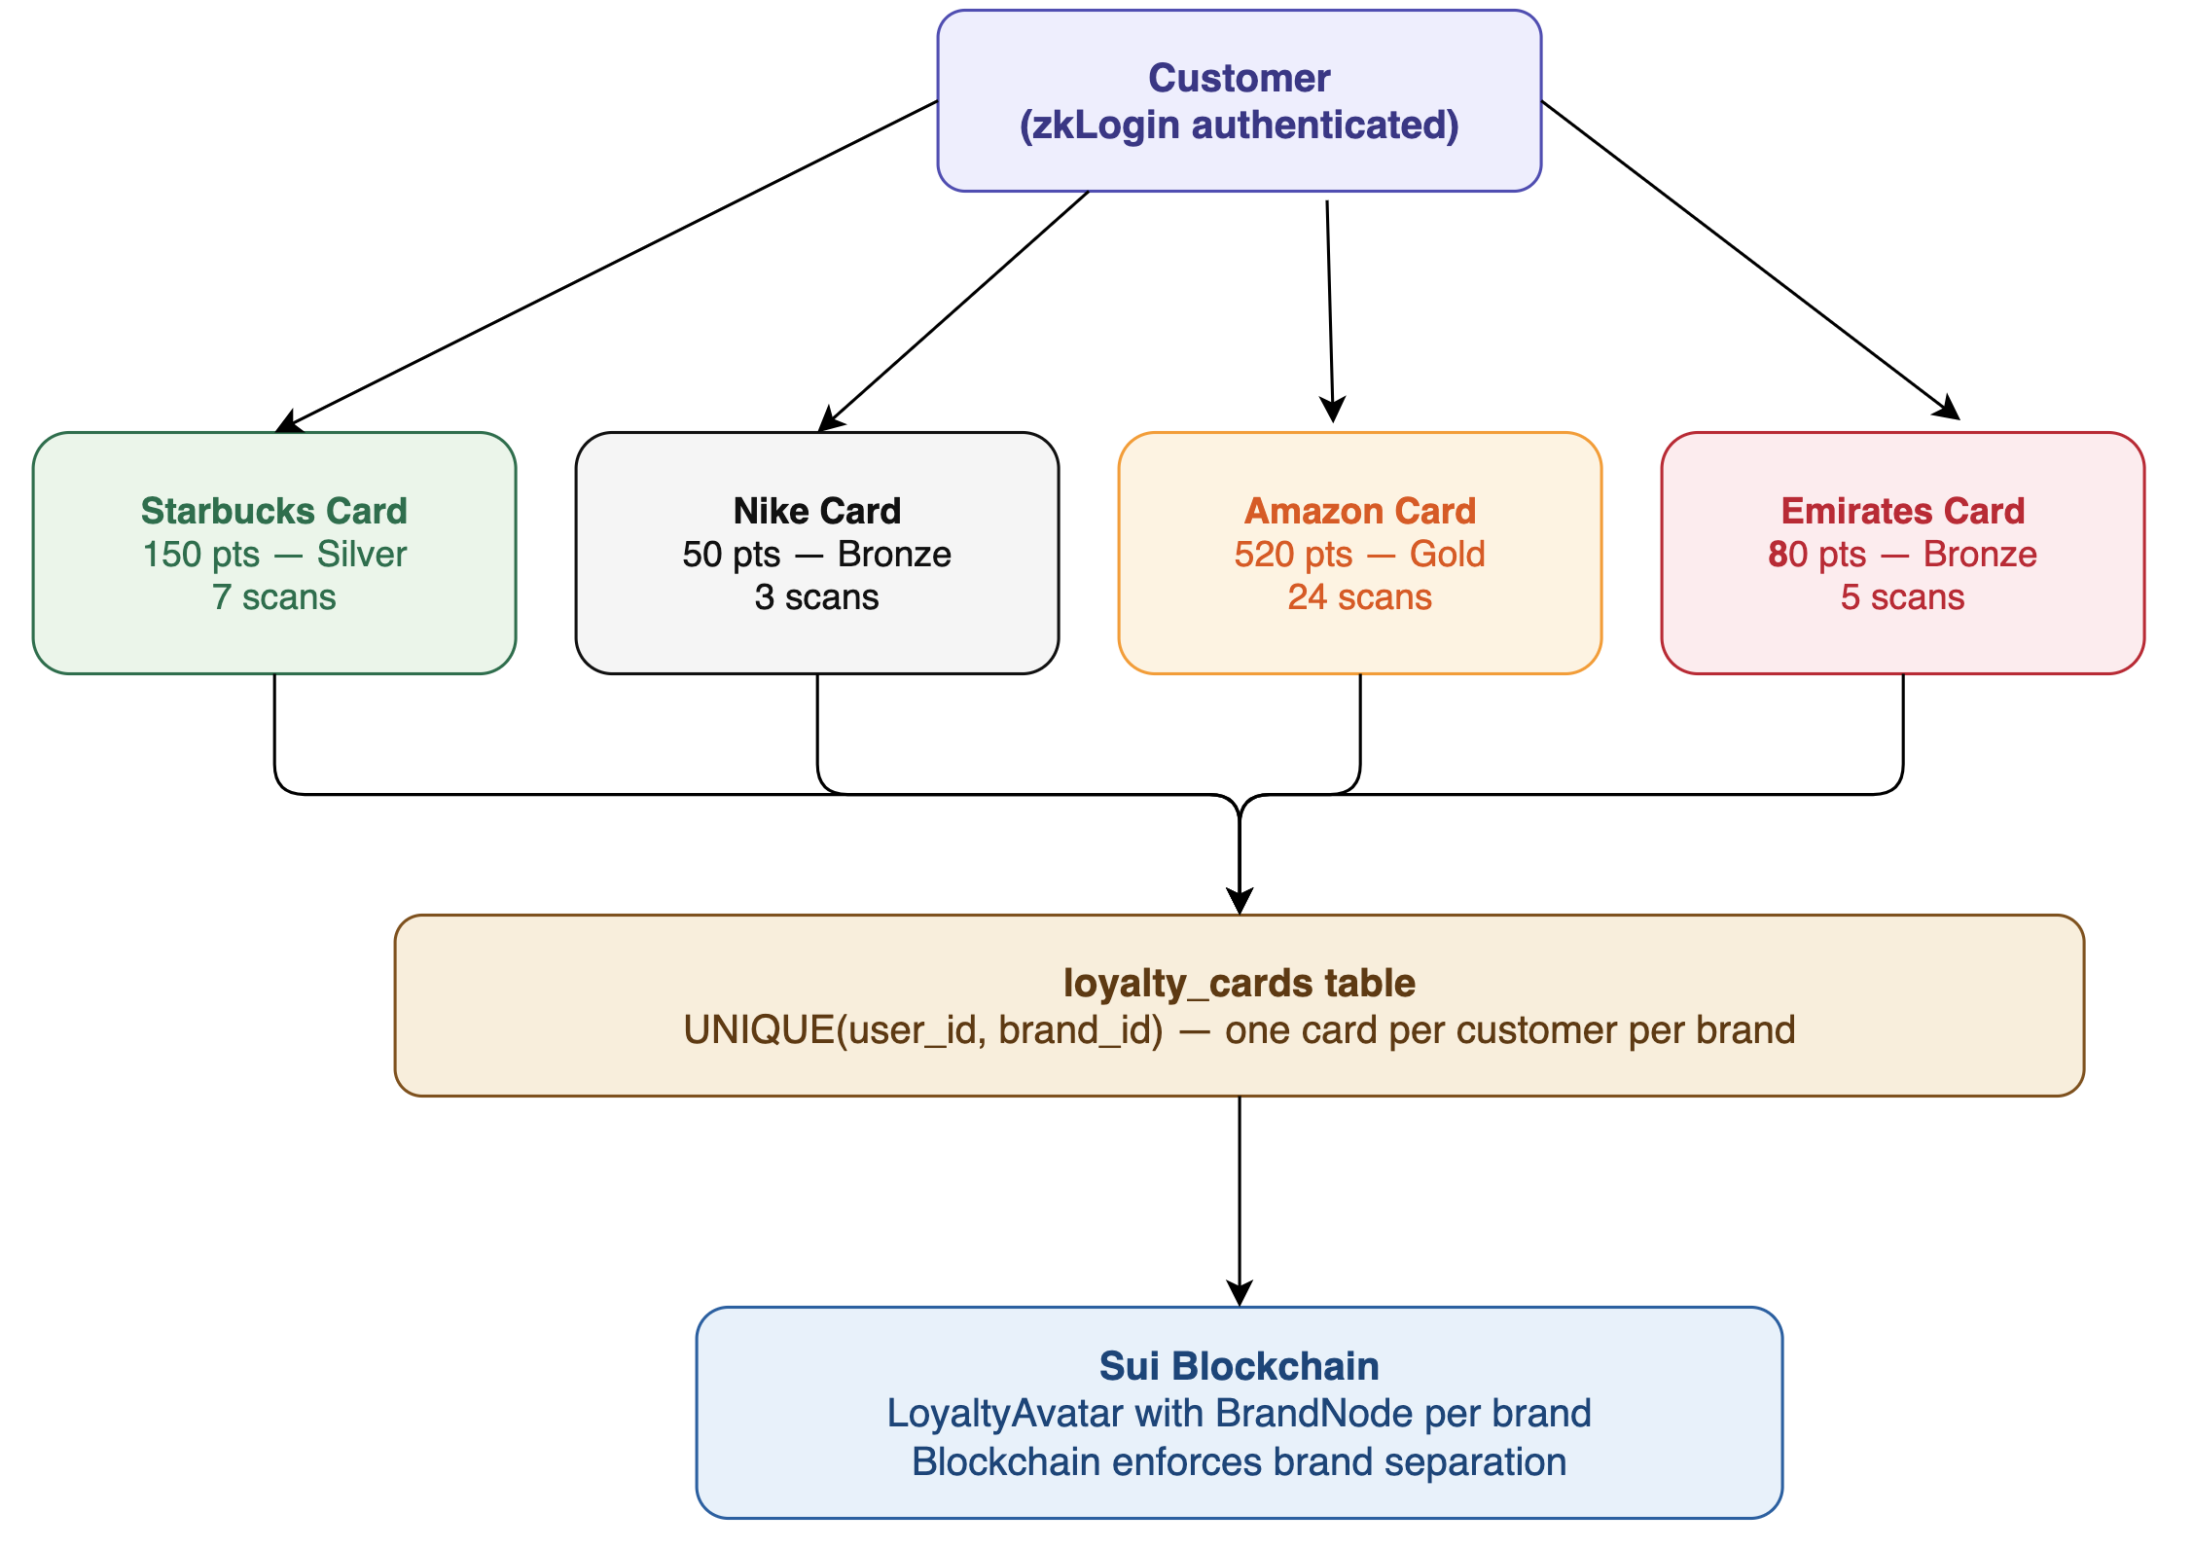
Figure 2 — Multi-brand Avatar + BrandNode architecture

3. Database Schema — 7 Tables
The PostgreSQL database now has 7 tables. The legacy loyalty_cards table was dropped and replaced by two tables that mirror the new on-chain structure: loyalty_avatars (one row per user, tracking the Avatar NFT object ID) and loyalty_brand_nodes (one row per user per brand, tracking points, tier, and scan counts). The users table was extended with avatar_object_id as a convenience lookup, qr_tokens gained a printed flag for the merchant terminal print workflow, and point_transactions was rewired to reference loyalty_brand_nodes rather than the removed loyalty_cards.

brands — one row per participating brand. Pre-seeded with Starbucks, Nike, Amazon, Emirates.
Column | Type | Constraint | Purpose
id | UUID | PRIMARY KEY | Internal unique identifier
name | VARCHAR(100) | NOT NULL | Brand display name
category | VARCHAR(60) | OPTIONAL | Brand category — Coffee, Sports, Retail, Airlines
color | VARCHAR(20) | DEFAULT '#6366f1' | Brand colour used in the consumer PWA UI
created_at | TIMESTAMPTZ | DEFAULT NOW() | When the brand was registered

users — one row per customer. Created when they first sign in via zkLogin.
Column | Type | Constraint | Purpose
id | UUID | PRIMARY KEY | Internal unique identifier
wallet_address | VARCHAR(66) | UNIQUE NOT NULL | Sui address derived from Google login via zkLogin
email | VARCHAR(255) | OPTIONAL | From Google JWT — display only, never stored on-chain
display_name | VARCHAR(100) | OPTIONAL | Customer name from Google profile
avatar_object_id | VARCHAR(66) | UNIQUE | Cached Sui object ID of this user's LoyaltyAvatar NFT
created_at | TIMESTAMPTZ | DEFAULT NOW() | When they first registered

qr_tokens — every QR code generated by the merchant terminal. One-time use only.
Column | Type | Constraint | Purpose
id | UUID | PRIMARY KEY | Internal identifier
token_uuid | UUID | UNIQUE NOT NULL | The UUID encoded in the QR code — what gets scanned
brand_id | UUID | FK → brands.id | Which brand this QR code belongs to
points_value | INTEGER | DEFAULT 10 | How many points this scan awards — set by merchant
used | BOOLEAN | DEFAULT FALSE | Atomically flipped to TRUE on first scan — prevents replay
used_by | UUID | FK → users.id | Which customer scanned it
used_at | TIMESTAMPTZ | NULLABLE | When it was scanned
expires_at | TIMESTAMPTZ | NULLABLE | 24 hours from generation — prevents old photo attacks
printed | BOOLEAN | DEFAULT FALSE | TRUE after the merchant terminal has printed the QR label
created_at | TIMESTAMPTZ | DEFAULT NOW() | When the QR was generated

loyalty_avatars — one row per customer. Mirrors the on-chain LoyaltyAvatar shared object.
Column | Type | Constraint | Purpose
id | UUID | PRIMARY KEY | Internal identifier
on_chain_avatar_id | VARCHAR(66) | UNIQUE NOT NULL | Sui object ID of the LoyaltyAvatar shared NFT
user_id | UUID | FK → users.id, UNIQUE | Owner of the Avatar — one Avatar per user
created_at | TIMESTAMPTZ | DEFAULT NOW() | When the Avatar was minted on-chain

loyalty_brand_nodes — one row per customer per brand. Mirrors the on-chain BrandNode dynamic object field.
Column | Type | Constraint | Purpose
id | UUID | PRIMARY KEY | Internal identifier
user_id | UUID | FK → users.id | The customer this BrandNode belongs to
brand_id | UUID | FK → brands.id | The brand this BrandNode tracks
brand_name | TEXT | NOT NULL | Cached brand name for quick display without a join
points_balance | BIGINT | DEFAULT 0 | Current points for this brand — atomic update on scan
scan_count | BIGINT | DEFAULT 0 | Total QR codes scanned for this brand
tier | SMALLINT | DEFAULT 0 | 0=Bronze, 1=Silver (100pts), 2=Gold (500pts) — auto-calculated
created_at | TIMESTAMPTZ | DEFAULT NOW() | When the BrandNode was created on-chain
UNIQUE | (user_id, brand_id) | CONSTRAINT | One BrandNode per customer per brand — enforced at DB level

point_transactions — audit log of every earn event, linked to the on-chain transaction.
Column | Type | Constraint | Purpose
id | UUID | PRIMARY KEY | Internal identifier
node_id | UUID | FK → loyalty_brand_nodes.id | Which BrandNode earned the points
points_added | BIGINT | NOT NULL | How many points were earned in this transaction
sui_tx_digest | VARCHAR(90) | UNIQUE | Sui blockchain transaction hash — on-chain proof
created_at | TIMESTAMPTZ | DEFAULT NOW() | When the transaction was processed

blockchain_events — raw event log from Sui. Every event is stored first, processed second.
Column | Type | Constraint | Purpose
id | UUID | PRIMARY KEY | Internal identifier
event_type | VARCHAR(120) | NOT NULL | e.g. sui_loyalty::loyalty_nft::PointsEarned
payload | JSONB | NOT NULL | Full raw event data from the Sui blockchain
tx_digest | VARCHAR(90) | NULLABLE | The transaction that triggered this event
processed | BOOLEAN | DEFAULT FALSE | FALSE until backend acts on it — crash recovery mechanism
created_at | TIMESTAMPTZ | DEFAULT NOW() | When the event was received

4. Key Design Decisions

4.1 Shared Object + AdminCap orchestration
In the Sui object model, a server cannot permissionlessly mutate an object that is owned by a customer's wallet. To preserve a frictionless Web2-style UX (instant points on scan) while keeping the assets fully on-chain, mint_avatar calls transfer::share_object(avatar) so the Avatar enters global shared state. Every mutative entry function (add_brand, add_brand_points, gain_experience, add_attribute) now requires &AdminCap as its first parameter, which only the backend holds. The backend injects tx.object(process.env.ADMIN_CAP_ID) into its Programmable Transaction Blocks to prove authority over the shared object.

4.2 Atomic QR validation — race condition prevention
QR validation still uses a single atomic PostgreSQL UPDATE. Row-level locking guarantees that only one concurrent request succeeds even if two customers scan the same QR simultaneously:
UPDATE qr_tokens SET used=TRUE, used_by=$2, used_at=NOW()
WHERE token_uuid=$1 AND used=FALSE AND (expires_at IS NULL OR expires_at > NOW())
RETURNING *;

4.3 Tier auto-calculation in SQL
Tier is computed inside the same atomic UPDATE as the points change on loyalty_brand_nodes, so balance and tier can never disagree:
UPDATE loyalty_brand_nodes
SET points_balance = points_balance + $1,
scan_count = scan_count + 1,
tier = CASE
WHEN points_balance + $1 >= 500 THEN 2 -- Gold
WHEN points_balance + $1 >= 100 THEN 1 -- Silver
ELSE 0 -- Bronze
END
WHERE user_id = $2 AND brand_id = $3;

4.4 Hierarchical enforcement — one Avatar, many BrandNodes
UNIQUE (user_id) on loyalty_avatars ensures exactly one Avatar per customer, matching the on-chain invariant. UNIQUE (user_id, brand_id) on loyalty_brand_nodes ensures exactly one BrandNode per customer per brand. The backend workflow (qr.service.ts) enforces the creation order: it mints an Avatar on first scan if absent, then adds a BrandNode for the merchant if absent, then awards points with AdminCap — each step guarded by an ON CONFLICT DO NOTHING / existence check so concurrent scans cannot produce duplicates.

4.5 ON DELETE CASCADE for referential safety
loyalty_avatars.user_id, loyalty_brand_nodes.user_id, loyalty_brand_nodes.brand_id, and point_transactions.node_id all cascade on delete. Removing a user cleans up their Avatar, BrandNodes, and earn history atomically; removing a brand cleans up every BrandNode referencing it. This keeps the off-chain mirror internally consistent even under admin-side deletions — the on-chain NFTs remain, but the audit trail is never left with dangling references.

5. Entity Relationships
- users → loyalty_avatars: one customer has exactly one Avatar (1:1)
- users → loyalty_brand_nodes: one customer has many BrandNodes (1:N)
- brands → loyalty_brand_nodes: one brand has many customer BrandNodes (1:N)
- brands → qr_tokens: one brand has many QR tokens (1:N)
- users → qr_tokens: used_by links a scanned token to the customer (N:1)
- loyalty_brand_nodes → point_transactions: one BrandNode has many earn events (1:N)
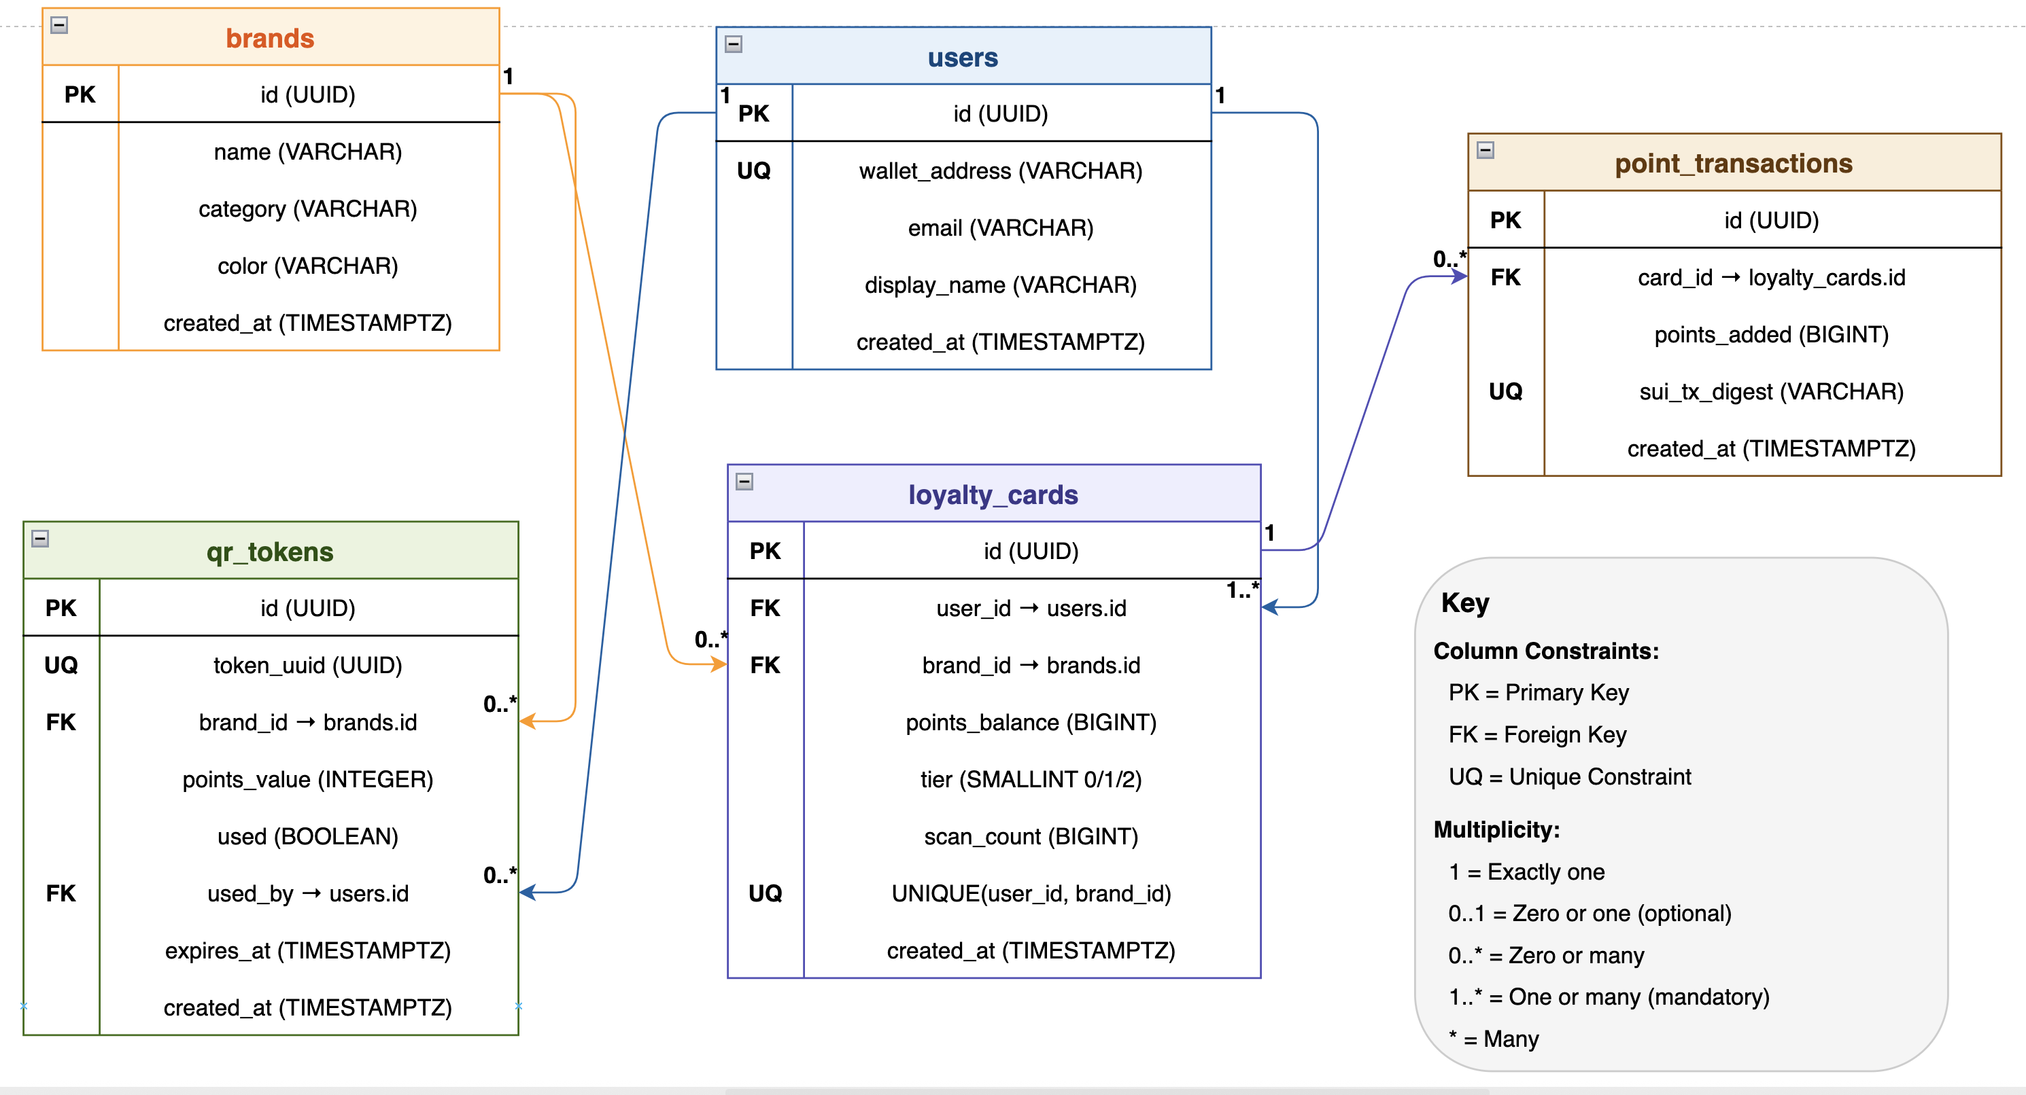
Figure 3 — Entity-relationship diagram (Sprint 3 Avatar + BrandNode schema)

Package ID on Sui Devnet:
0x72449f17b1b8bc401be98023639c4232187ed94d4a6d0f70a01ecd59221acde5
Explorer: https://devnet.suivision.xyz/package/0x72449f17…cde5

