SuiLoyalty — Database Design
Off-Chain PostgreSQL Schema with System Architecture — Sprint 3 Update
1. System Architecture
SuiLoyalty follows a three-layer architecture. The consumer progressive web app (PWA) and merchant terminal call the Node.js backend via REST API. The backend reads and writes to PostgreSQL for fast off-chain data access and communicates with the Sui blockchain via JSON-RPC for on-chain operations. Google OAuth handles authentication via zkLogin. Following the Sprint 3 migration, the backend now operates as a privileged orchestrator: it holds an on-chain AdminCap that authorises it to mutate the shared LoyaltyAvatar objects on behalf of customers.
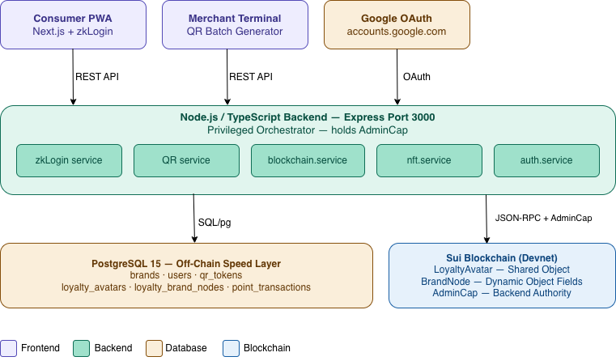
Figure 1 — SuiLoyalty system architecture

2. Multi-Brand Architecture
Each customer owns exactly one LoyaltyAvatar NFT, which is created as a Sui shared object so the backend can mutate it under AdminCap authorisation. Individual brand relationships (Starbucks, Nike, Amazon, Emirates, etc.) are not separate NFTs, they are BrandNode dynamic object fields attached to the parent Avatar. The Avatar also carries global aggregates (level, experience, attributes) that span all brands, while each BrandNode tracks the per-brand points balance, scan count, and tier. The off-chain PostgreSQL schema mirrors this hierarchy exactly: loyalty_avatars (1 row per user) and loyalty_brand_nodes (1 row per user per brand).

Tier Logic: Bronze = 0-499 pts (tier 0) | Silver = 500-999 pts (tier 1) | Gold = 1000+ pts (tier 2)
Each brand tracks points independently. Scanning a Starbucks QR never affects Nike points.

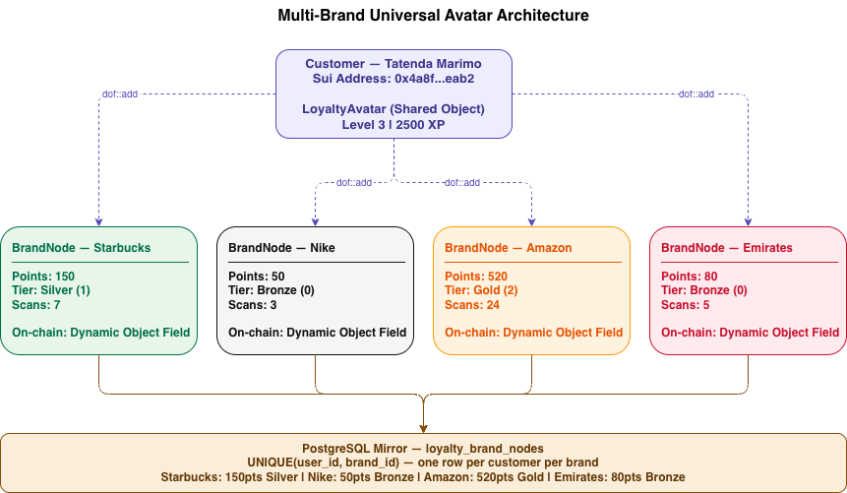
Figure 2 — Multi-brand loyalty card architecture

QR Redemption Flow

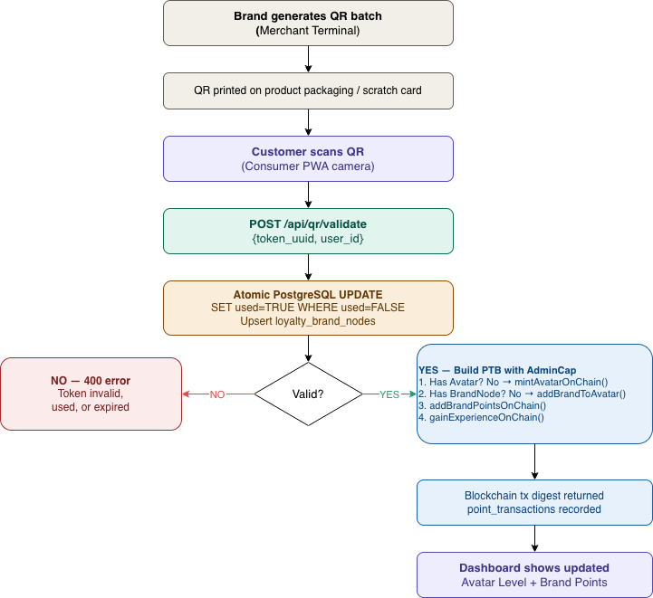
Figure 3

3. Database Schema — 7 Tables
The PostgreSQL database has 7 tables. The brands table was added in Sprint 3 to support multi-brand loyalty.

brands — one row per participating brand. Pre-seeded with Starbucks, Nike, Amazon, Emirates.

Column | Type | Constraint | Purpose
id | UUID | PRIMARY KEY | Internal unique identifier
name | VARCHAR(100) | NOT NULL | Brand display name
category | VARCHAR(60) | OPTIONAL | Brand category — Coffee, Sports, Retail, Airlines
created_at | TIMESTAMPTZ | DEFAULT NOW() | When the brand was registered

users — one row per customer. Created when they first sign in via zkLogin.

Column | Type | Constraint | Purpose
id | UUID | PRIMARY KEY | Internal unique identifier
wallet_address | VARCHAR(66) | UNIQUE NOT NULL | Sui address derived from Google login via zkLogin
email | VARCHAR(255) | OPTIONAL | From Google JWT — display only, never stored on-chain
display_name | VARCHAR(100) | OPTIONAL | Customer name from Google profile
avatar_object_id | VARCHAR(66) | UNIQUE | Cached Sui object ID of this user's LoyaltyAvatar NFT
created_at | TIMESTAMPTZ | DEFAULT NOW() | When they first registered

qr_tokens — every QR code generated by the merchant terminal. One-time use only.

Column | Type | Constraint | Purpose
id | UUID | PRIMARY KEY | Internal identifier
token_uuid | UUID | UNIQUE NOT NULL | The UUID encoded in the QR code — what gets scanned
brand_id | UUID | FK → brands.id | Which brand this QR code belongs to
points_value | INTEGER | DEFAULT 10 | How many points this scan awards — set by merchant
used | BOOLEAN | DEFAULT FALSE | Atomically flipped to TRUE on first scan — prevents replay
used_by | UUID | FK → users.id | Which customer scanned it
used_at | TIMESTAMPTZ | NULLABLE | When it was scanned
expires_at | TIMESTAMPTZ | NULLABLE | 24 hours from generation — prevents old photo attacks
printed | BOOLEAN | DEFAULT FALSE | TRUE after the merchant terminal has printed the QR label
created_at | TIMESTAMPTZ | DEFAULT NOW() | When the QR was generated

loyalty_avatars — one row per customer. Mirrors the on-chain LoyaltyAvatar shared object.

Column | Type | Constraint | Purpose
id | UUID | PRIMARY KEY | Internal identifier
on_chain_avatar_id | VARCHAR(66) | UNIQUE NOT NULL | Sui object ID of the LoyaltyAvatar shared NFT
user_id | UUID | FK → users.id, UNIQUE | Owner of the Avatar — one Avatar per user
created_at | TIMESTAMPTZ | DEFAULT NOW() | When the Avatar was minted on-chain

loyalty_brand_nodes — one row per customer per brand. Mirrors the on-chain BrandNode dynamic object field.

Column | Type | Constraint | Purpose
id | UUID | PRIMARY KEY | Internal identifier
user_id | UUID | FK → users.id | The customer this BrandNode belongs to
brand_id | UUID | FK → brands.id | The brand this BrandNode tracks
brand_name | TEXT | NOT NULL | Cached brand name for quick display without a join
points_balance | BIGINT | DEFAULT 0 | Current points for this brand — atomic update on scan
scan_count | BIGINT | DEFAULT 0 | Total QR codes scanned for this brand
tier | SMALLINT | DEFAULT 0 | 0=Bronze, 1=Silver (100pts), 2=Gold (500pts) — auto-calculated
created_at | TIMESTAMPTZ | DEFAULT NOW() | When the BrandNode was created on-chain
UNIQUE | (user_id, brand_id) | CONSTRAINT | One BrandNode per customer per brand — enforced at DB level

point_transactions — audit log of every earn event, linked to the on-chain transaction.

Column | Type | Constraint | Purpose
id | UUID | PRIMARY KEY | Internal identifier
node_id | UUID | FK → loyalty_brand_nodes.id | Which BrandNode earned the points
points_added | BIGINT | NOT NULL | How many points were earned in this transaction
sui_tx_digest | VARCHAR(90) | UNIQUE | Sui blockchain transaction hash — on-chain proof
created_at | TIMESTAMPTZ | DEFAULT NOW() | When the transaction was processed

blockchain_events — raw event log from Sui. Every event is stored first, processed second.

Column | Type | Constraint | Purpose
id | UUID | PRIMARY KEY | Internal identifier
event_type | VARCHAR(120) | NOT NULL | e.g. sui_loyalty::loyalty_nft::PointsEarned
payload | JSONB | NOT NULL | Full raw event data from the Sui blockchain
tx_digest | VARCHAR(90) | NULLABLE | The transaction that triggered this event
processed | BOOLEAN | DEFAULT FALSE | FALSE until backend acts on it — crash recovery mechanism
created_at | TIMESTAMPTZ | DEFAULT NOW() | When the event was received

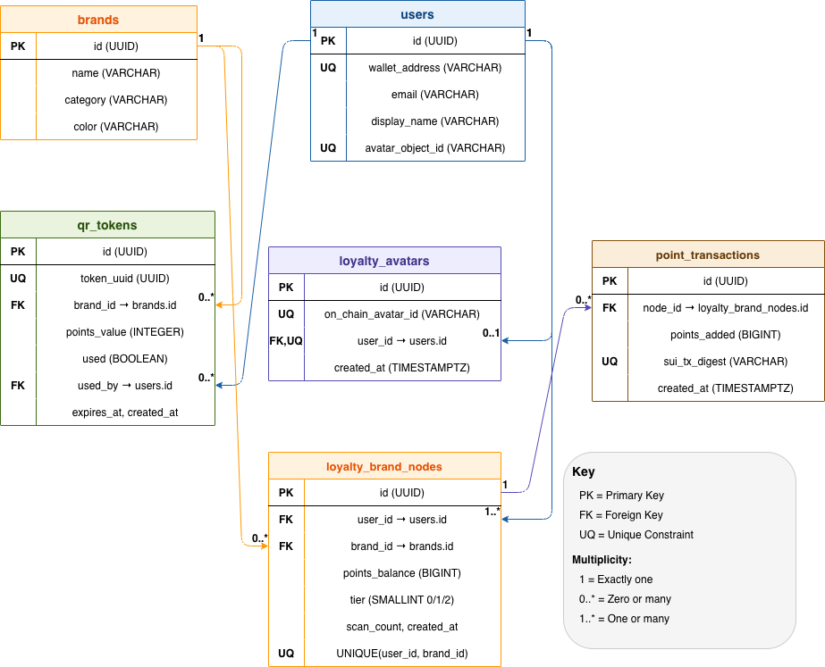
Figure 4

4. Key Design Decisions

Shared Object + AdminCap orchestration

In the Sui object model, a server cannot permissionlessly mutate an object that is owned by a customer's wallet. To preserve a frictionless Web2-style UX (instant points on scan) while keeping the assets fully on-chain, mint_avatar calls transfer::share_object(avatar) so the Avatar enters global shared state. Every mutative entry function (add_brand, add_brand_points, gain_experience, add_attribute) now requires &AdminCap as its first parameter, which only the backend holds. The backend injects tx.object(process.env.ADMIN_CAP_ID) into its Programmable Transaction Blocks to prove authority over the shared object.

Atomic QR validation — race condition prevention

QR validation still uses a single atomic PostgreSQL UPDATE. Row-level locking guarantees that only one concurrent request succeeds even if two customers scan the same QR simultaneously:
UPDATE qr_tokens SET used=TRUE, used_by=$2, used_at=NOW()
WHERE token_uuid=$1 AND used=FALSE AND (expires_at IS NULL OR expires_at > NOW())
RETURNING *;

Tier auto-calculation in SQL

Tier is computed inside the same atomic UPDATE as the points change on loyalty_brand_nodes, so balance and tier can never disagree:

UPDATE loyalty_brand_nodes
SET points_balance = points_balance + $1,
scan_count = scan_count + 1,
tier = CASE
WHEN points_balance + $1 >= 500 THEN 2 -- Gold
WHEN points_balance + $1 >= 100 THEN 1 -- Silver
ELSE 0 -- Bronze
END
WHERE user_id = $2 AND brand_id = $3;

Hierarchical enforcement — one Avatar, many BrandNodes

UNIQUE (user_id) on loyalty_avatars ensures exactly one Avatar per customer, matching the on-chain invariant. UNIQUE (user_id, brand_id) on loyalty_brand_nodes ensures exactly one BrandNode per customer per brand. The backend workflow (qr.service.ts) enforces the creation order: it mints an Avatar on first scan if absent, then adds a BrandNode for the merchant if absent, then awards points with AdminCap — each step guarded by an ON CONFLICT DO NOTHING / existence check so concurrent scans cannot produce duplicates.

ON DELETE CASCADE for referential safety

loyalty_avatars.user_id, loyalty_brand_nodes.user_id, loyalty_brand_nodes.brand_id, and point_transactions.node_id all cascade on delete. Removing a user cleans up their Avatar, BrandNodes, and earn history atomically; removing a brand cleans up every BrandNode referencing it. This keeps the off-chain mirror internally consistent even under admin-side deletions — the on-chain NFTs remain, but the audit trail is never left with dangling references.

Entity Relationships
- users → loyalty_avatars: one customer has exactly one Avatar (1:1)
- users → loyalty_brand_nodes: one customer has many BrandNodes (1:N)
- brands → loyalty_brand_nodes: one brand has many customer BrandNodes (1:N)
- brands → qr_tokens: one brand has many QR tokens (1:N)
- users → qr_tokens: used_by links a scanned token to the customer (N:1)
- loyalty_brand_nodes → point_transactions: one BrandNode has many earn events (1:N)

Package ID on Sui Devnet: 0x72449f17b1b8bc401be98023639c4232187ed94d4a6d0f70a01ecd59221acde5
Explorer: https://devnet.suivision.xyz/package/0x72449f17...cde5

