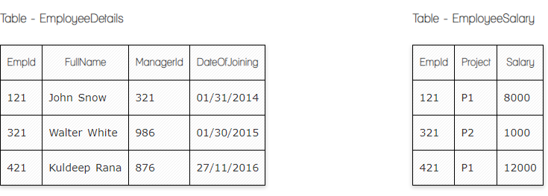

**SQL query to fetch the count of employees working in project 'P1'.**

Select Count(EmpId) as EmployeesWorkingIn_P1

from EmployeeSalary

where Project='P1'

**SQL query to fetch employee names having salary greater than or equal to 5000 and less than or equal 10000.**

Select EmployeeDetails.FullName

from EmployeeDetails

Inner Join EmployeeSalary

on EmployeeDetails.EmpId=EmployeeSalary.EmpId

where salary between 5000 and 10000

**a SQL query to fetch count of employees sorted by project's count in descending order.**

Select count(EmpId) as counter,Project

from EmployeeSalary

group by project

order by counter Desc

**SQL query to fetch employee names and salary records. Return employee details even if the salary record is not present for the employee.**

Select EmployeeDetails.FullName,EmployeeSalary.Salary

from EmployeeDetails

Left Join EmployeeSalary

on EmployeeDetails.empId=EmployeeSalary.EmpId

**SQL query to create an empty table with ‘Test’ name.**

**A table is a collection of data columns and rows. We need at least one data column, so the empty table with no columns can’t be created.**

Create table Test(id int); --at least one column

**SQL query to delete an empty table with ‘Test’ name.**

Drop table Test

**SQL query to fetch all the Employees details from EmployeeDetails table who joined in Year 2016.**

Select * from EmployeeDetails

where DateOfJoining like '%2016%'

**SQL query to insert new record to the EmployeeDetails table with any data.**

Insert into EmployeeDetails(FullName,DateOfJoining)

values('Will Smith','10/25/2022')

**SQL query to update EmployeeSalary table with setting Salary to 2000 for Project P2.**

Update EmployeeSalary

Set Salary=2000

Where Project='P2'

**SQL query to right join both tables and draw the results.**

Select EmployeeDetails.*,EmployeeSalary.*

from EmployeeDetails

Right Join EmployeeSalary

on EmployeeDetails.EmpId=EmployeeSalary.EmpId