MAVEN ELECTRONICS
Global Electronics Retailer
Sales Performance Analysis & Revenue Decline Investigation

Prepared for Company Management
Data Analysis Report | September 2026

Executive Summary
Maven Electronics sells computers, cell phones, TVs, cameras, home appliances, audio equipment, and games/toys across both online and offline (in-store) channels, serving customers across North America, Europe, and Australia. This report profiles the company's 2016–2021 transaction data, answers management's core exploratory questions, and investigates the sharp revenue decline between 2019 and 2020.
The headline finding: total revenue fell from $16.4M in 2019 to $8.4M in 2020, a 49% decline. The drop is a broad-based volume collapse — not a pricing or product problem — concentrated almost entirely in March 2020 onward, consistent with the onset of COVID-19 disruptions. It affected every category, every major market, and both online and offline channels roughly equally.
-49%  Revenue, 2019 → 2020 | -49%  Orders, 2019 → 2020 | -41%  Active Customers, 2019 → 2020

Objective & Approach
Management asked for the underlying CSV data to be profiled, modeled, and enriched into an interactive report that supports self-service exploration of performance. This analysis works from the resulting Power BI data model (Report.pbix), which links six fact/dimension tables — Sales, Sales OrderLine, Products, Stores, Customers, and Categories/Sub-Categories — spanning transactions from January 2016 through February 2021 (2021 is a partial year and is excluded from year-over-year comparisons below).
The analysis addresses four questions management posed, followed by a deep dive into the 2019–2020 revenue decline with recommendations.

1. Product Mix & Customer Geography
The catalog spans 2,517 products across 8 categories. Computers is the largest revenue category by a wide margin, followed by Home Appliances; Games and Toys is the smallest.
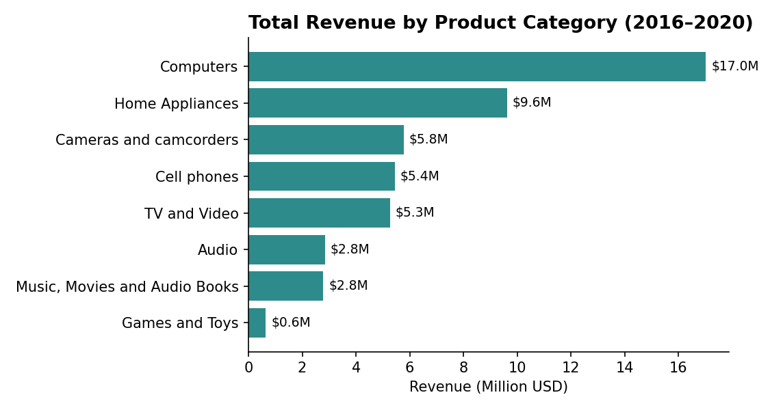
Figure 1. Total revenue by product category, 2016–2020.
Customers are concentrated in three continents, led by North America:
Continent | Customers | Share
North America | 8,381 | 55%
Europe | 5,465 | 36%
Australia | 1,420 | 9%

At the country level, the United States is the largest single market (6,828 customers), followed by the United Kingdom, Canada, and Germany. The company operates 67 physical stores across the United States, Germany, France, the United Kingdom, Australia, Canada, the Netherlands, and Italy, with the U.S. hosting the largest store footprint (24 locations).

2. Seasonal Patterns in Orders & Revenue
A clear and consistent seasonal cycle repeats every year in the data: revenue peaks in December (holiday shopping) and January–February, then drops sharply in March and bottoms out in April, before climbing gradually back up through the second half of the year.
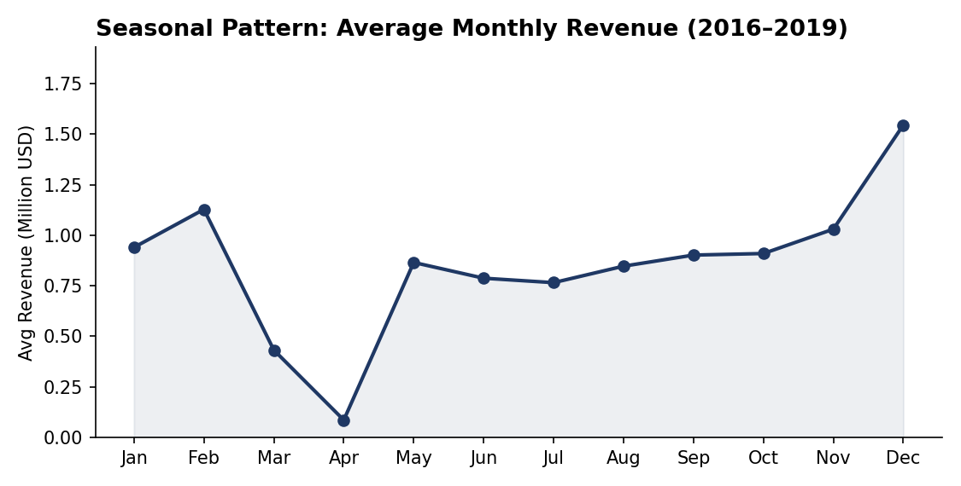
Figure 2. Average monthly revenue, 2016–2019 (pre-decline years), showing the recurring holiday peak and spring trough.
This pattern held across all four years prior to 2020, which matters for the decline analysis below: the March–April dip is a normal seasonal feature of the business, not evidence of a problem in isolation. Order volume follows the same shape as revenue. At the weekly level, Saturday is by far the busiest day for orders, and Sunday the quietest.

3. Delivery Time: Average & Trend
Average delivery time has improved steadily year over year, from 7.3 days in 2016 down to roughly 4.0 days by 2019–2020. Note that a delivery date is only recorded for a subset of orders (about 17–23% depending on year), so this reflects the tracked subset rather than every shipment — but the direction and consistency of the trend across years is a reliable signal of improving fulfillment operations.
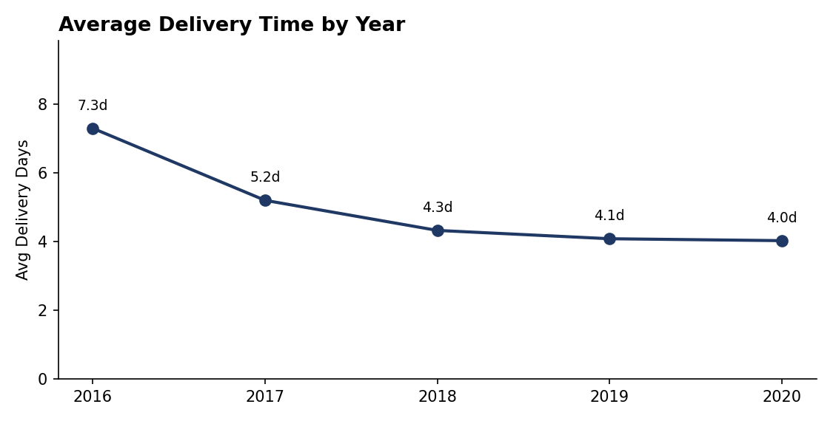
Figure 3. Average delivery time (days) by year.
The steady improvement in delivery time through 2019–2020 also helps rule out fulfillment problems as a driver of the 2020 revenue decline — if anything, delivery performance was at its best when revenue fell.

4. Average Order Value: Online vs. In-Store
Across the full dataset, in-store (offline) orders carry a slightly higher average order value than online orders:
Channel | Total Revenue | Orders | Avg Order Value
Offline (in-store) | $42.2M | 20,647 | $2,043
Online | $10.8M | 5,541 | $1,957

Offline is the dominant channel, generating roughly 4x the revenue of online and accounting for about 79% of all orders. The AOV gap between channels is modest (about $86, or 4%) and stayed essentially flat during the 2019–2020 decline, indicating the two channels serve a similar mix of basket sizes rather than online being reserved for smaller, incidental purchases.

Deep Dive: Why Did Sales Decline from 2019 to 2020?
Total revenue fell from $16.4M in 2019 to $8.4M in 2020 (–49%), with orders falling from 8,896 to 4,534 and active customers from 6,399 to 3,802. Four data points together point to a clear cause.

A. The decline is a hard break in March 2020, not a slow slide
January and February 2020 actually outperformed the same months in 2019. Revenue then fell 60–75% starting in March 2020 and never recovered for the rest of the year — a pattern inconsistent with a gradual 2019 downturn and highly consistent with the timing of COVID-19 lockdowns and reduced store traffic.
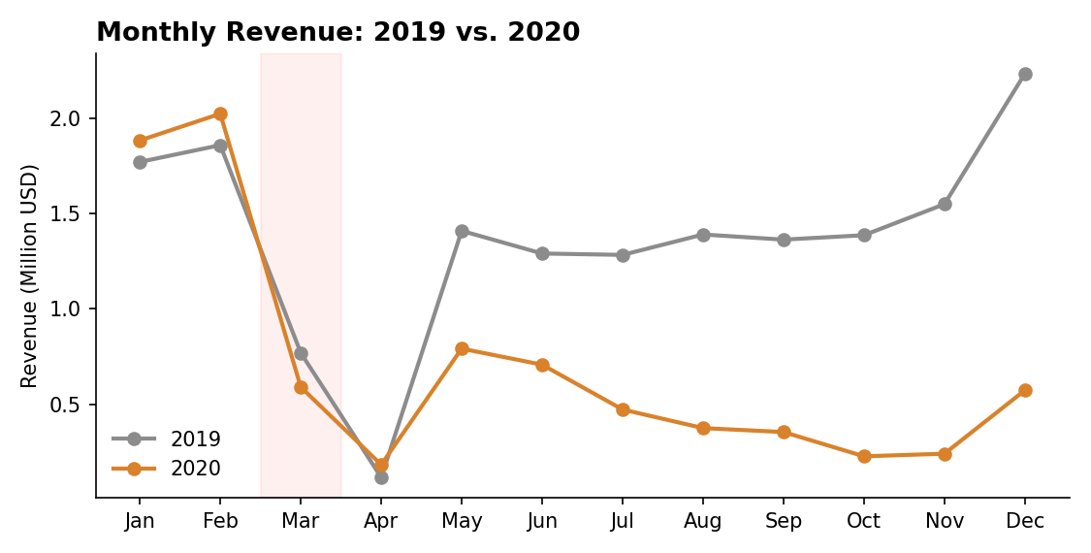
Figure 4. Monthly revenue, 2019 vs. 2020. The shaded band marks March–April, when the divergence begins.

B. It is a volume collapse, not a pricing or basket-size problem
Average order value was essentially unchanged: $1,856 (2019) vs. $1,878 (2020) in-store, and $1,810 vs. $1,792 online. Customers who purchased spent about the same as before. The revenue loss is fully explained by fewer orders from fewer customers, not discounting, smaller baskets, or price cuts.

C. The impact was broad-based across products, geography, and channel
Every product category declined between 44% and 59% — Audio was hit hardest, Cell phones least. Every major market declined between 44% and 62%, except France, which held up notably better at –26%. Store count was nearly unchanged (55 → 53 active stores), ruling out store closures as the cause.
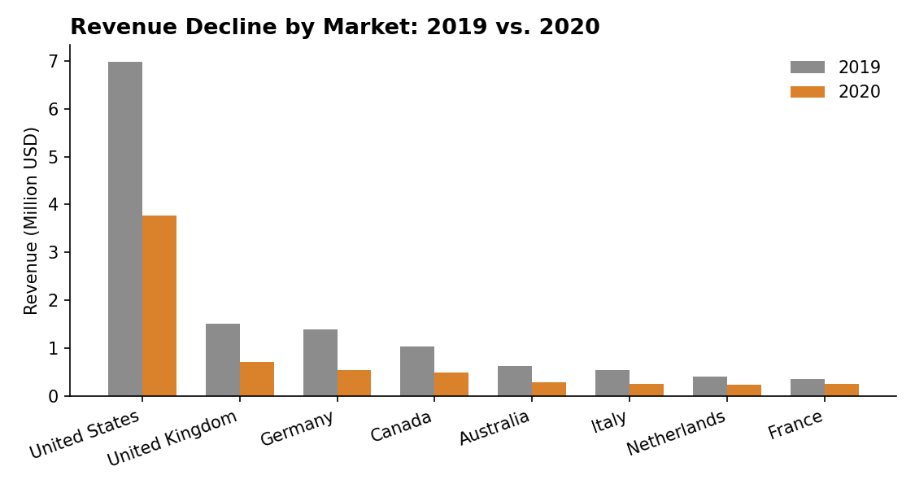
Figure 5. Revenue by top market, 2019 vs. 2020.
Most notably, online revenue fell 47% — almost as much as offline's 49% decline. In a typical pandemic scenario, online sales absorb demand displaced from closed stores; that did not happen here, suggesting the drop reflects overall demand destruction (customers pulling back on discretionary electronics spending) rather than a channel-specific or operational failure.

D. Seasonality alone does not explain it
The March–April trough is normal for this business (see Figure 2), but in 2020 revenue never recovered to seasonal norms afterward — May through December 2020 all ran 40–85% below the equivalent 2019 months, well outside the usual seasonal rebound pattern.

Recommendations
- Strengthen online as a demand shock absorber. Since online declined in lockstep with offline instead of offsetting it, review digital marketing spend, delivery capacity, and online stock availability during the March–April 2020 window to identify why e-commerce did not flex upward when in-store traffic fell.
- Prioritize customer win-back over basket-size tactics. Because AOV was stable and the drop was driven by a 41% fall in active customers, recovery efforts (loyalty campaigns, targeted reactivation offers, email/SMS win-back) are likely to have more impact than price promotions or upsell pushes.
- Use category resilience to guide inventory and promotions. Cell phones and Music/Movies held up best (-44%) while Audio and Home Appliances fell hardest (-56% to -59%), suggesting customers treated some categories as more essential during the downturn; weight future promotional and inventory planning accordingly during demand shocks.
- Study the France exception as a playbook. France's smaller decline (-26% vs. -45% to -62% elsewhere) is worth a focused review of local store operations, promotions, or category mix that may be replicable in other markets.
- Build a monthly early-warning view. Because the 2020 decline was visible in the data within the first month it began (March), an interactive report with month-over-month and year-over-year revenue tracking by channel, category, and market would let management flag similar demand shocks earlier in the future.

Appendix: Annual Revenue Trend, 2016–2020
For context, revenue grew every year from 2016 through 2019 before the 2020 decline, more than doubling over that period. This underscores that 2020 was a reversal of a previously healthy growth trajectory, not a continuation of an existing downward trend.
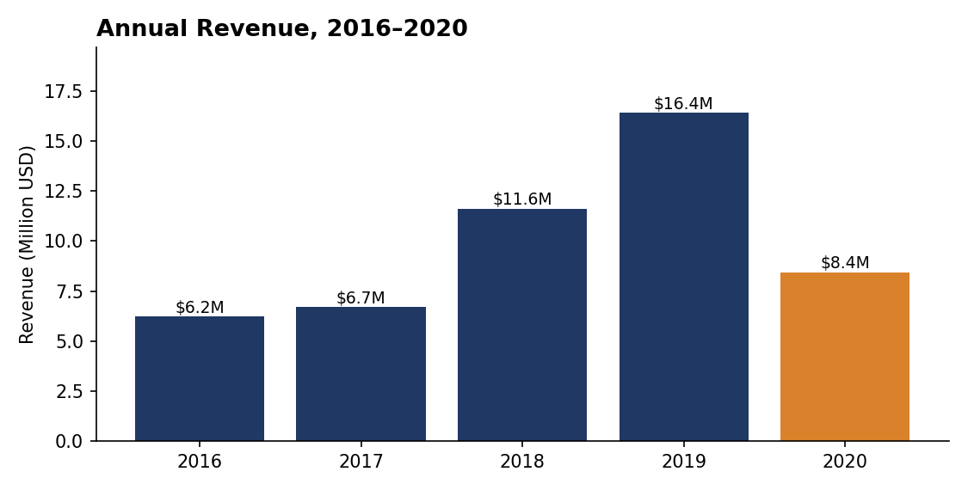
Figure 6. Annual revenue, 2016–2020.

