SentiScope AI
Intelligent Sentiment Analysis Platform:
Traditional Machine Learning vs Transformer-Based NLP

University | Quaid-i-Azam University, Islamabad
Department | Department of Computer Science
Course | Natural Language Processing
Course Instructor | Dr. Nadia Saeed

Group Members
Tatheer Zahra
Sehrish Siddique
Masooma Muhammadi
Haleema Sadia
Naila Habib

2. Abstract
SentiScope AI is a web-based Natural Language Processing system developed to perform sentiment analysis on textual data such as tweets, reviews, comments, and user feedback. Sentiment analysis is an important NLP task because it enables automated understanding of public opinion, customer satisfaction, and emotional tone in large volumes of unstructured text. Many sentiment analysis systems rely on a single model and provide limited transparency, making it difficult to understand how different NLP approaches behave on the same input. SentiScope AI addresses this limitation by integrating both a traditional machine learning pipeline and a modern transformer-based NLP pipeline within a single interactive platform.
The traditional model is implemented using TF-IDF feature extraction and Logistic Regression classification. This approach provides a lightweight and interpretable baseline for sentiment classification. The modern model uses DistilBERT, a transformer-based architecture capable of processing text contextually. The system allows users to analyze single text inputs, visualize preprocessing steps, compare predictions side by side, and process CSV files in batch mode. In addition, the platform includes an Explainable NLP section that highlights positive and negative sentiment keywords, while clearly stating that this is a keyword-level explanation rather than full transformer interpretability.
Version 4 and Version 5 enhancements extend the system into a complete sentiment analytics platform. These include batch CSV analysis, CSV export, KPI cards, model agreement analysis, analytics dashboards, performance metrics, and report-ready screenshots. The Analytics Dashboard uses DistilBERT as the final analytics model because of its contextual language understanding, while TF-IDF + Logistic Regression remains available as the baseline comparison model. Overall, SentiScope AI demonstrates a practical, educational, and submission-ready NLP system suitable for academic analysis and software demonstration.

3. Introduction
Natural Language Processing is a major branch of artificial intelligence that focuses on enabling computers to understand, process, and generate human language. Human language is complex because it contains ambiguity, context, sentiment, subjectivity, and cultural variation. Unlike structured numerical data, textual data often appears in free-form sentences, comments, tweets, product reviews, and social media posts. NLP provides computational methods to transform such unstructured text into meaningful information that can be analyzed by machines.
Sentiment analysis is one of the most widely used applications of NLP. It is also known as opinion mining because it attempts to identify whether a piece of text expresses a positive, negative, or neutral opinion. In modern digital environments, users continuously express opinions on social media platforms, e-commerce websites, mobile applications, and public forums. Manually reading and classifying this large amount of text is not practical. Automated sentiment analysis systems help organizations, researchers, and decision-makers understand user attitudes at scale.
Traditional sentiment analysis approaches usually rely on manually engineered features or statistical text representations. One of the most common traditional methods is TF-IDF, which converts text into numerical features based on the importance of words. These features can then be passed to machine learning classifiers such as Logistic Regression. Modern NLP has been significantly improved by transformer-based models such as BERT and DistilBERT. The motivation behind SentiScope AI is to compare these two approaches within one implemented platform.

4. Problem Statement
Existing sentiment analysis systems often focus on producing a final label without explaining the underlying process. Many systems rely on only one model, which limits the ability to compare classical NLP techniques with modern transformer-based methods. This creates a gap for students and researchers who want to understand how different approaches handle the same sentiment classification task.
Organizations and analysts require systems that can classify sentiment accurately, process large batches of text, visualize sentiment trends, compare model behavior, and generate exportable results for reporting. SentiScope AI is proposed as a solution to this problem by integrating traditional machine learning, transformer-based NLP, batch analytics, and explainable keyword-level interpretation.

5. Objectives
The main objective of SentiScope AI is to develop a complete NLP-based sentiment analysis platform that demonstrates both traditional and modern approaches to text classification. The project aims to provide single text analysis, preprocessing visualization, TF-IDF + Logistic Regression classification, DistilBERT prediction, batch CSV analysis, analytics dashboards, model agreement analysis, and report-ready export support.

6. Scope of Project
SentiScope AI is designed as an academic NLP software engineering project. Its current scope includes sentiment classification for English textual data such as tweets, reviews, comments, and feedback. The system supports three sentiment classes: Positive, Negative, and Neutral. It can be applied in product review analysis, student feedback analysis, social media opinion mining, app review classification, and customer satisfaction monitoring.
The project has some limitations. DistilBERT is not fine-tuned on the local Twitter dataset in the current version. The Explainable NLP module is keyword-based and does not represent full transformer explainability. The current system is primarily designed for local execution and academic demonstration rather than large-scale production deployment.

7. System Architecture
The architecture of SentiScope AI follows a modular pipeline that begins with user input and ends with prediction, comparison, analytics, and exportable results.
- User enters text or uploads a CSV file.
- Text is preprocessed for traditional NLP and visualization.
- TF-IDF + Logistic Regression produces baseline sentiment prediction.
- DistilBERT produces transformer-based sentiment prediction.
- The comparison engine displays both outputs side by side.
- Batch outputs are converted into dashboard analytics.
- Final results are displayed and exported for reports.

8. Dataset Description
The project uses a Twitter Sentiment Dataset stored locally inside the data folder. The expected dataset file is data/Twitter_Data.csv. The clean_text column contains tweet or comment text, while the category column contains the sentiment label. The labels are mapped as -1 for Negative, 0 for Neutral, and 1 for Positive.
The dataset is used for training and evaluating the traditional TF-IDF + Logistic Regression model. The dataset is not pushed to GitHub due to file size and reproducibility concerns.

9. Methodology

9.1 User Input Module
The user input module provides single text input and batch CSV upload. Single text input is used for quick demonstration, while batch upload supports analysis of multiple records.

9.2 Text Preprocessing
The preprocessing pipeline includes lowercasing, punctuation removal, tokenization, and stopword removal. Lemmatization is discussed as a future extension because the current implementation intentionally uses lightweight preprocessing for clarity.

9.3 Traditional NLP Pipeline
The traditional pipeline uses TF-IDF to convert text into numerical vectors and Logistic Regression to classify sentiment.

9.4 DistilBERT Pipeline
The DistilBERT pipeline tokenizes the original sentence and passes it through a transformer model. The output probabilities are converted into a sentiment label and confidence score.

9.5 Prediction Comparison Engine
Both models run on the same text and their outputs are displayed side by side, including sentiment, confidence, and processing time.

9.6 Explainable NLP Module
The explanation module highlights positive and negative words using keyword-level sentiment clues. This is not full BERT explainability, but it improves transparency for demonstration.

9.7 Batch CSV Processing
The batch module reads uploaded CSV files, detects text columns, runs both models for each row, and exports prediction results.

9.8 Analytics Dashboard
The dashboard uses DistilBERT final predictions for KPI cards and sentiment distribution while retaining TF-IDF outputs for baseline comparison and agreement analysis.

9.9 Performance Metrics Dashboard
The metrics dashboard displays accuracy, precision, recall, F1 score, and confusion matrices.

10. Pseudocode-Style Workflows

10.1 Traditional Model Pipeline
- Load the Twitter sentiment dataset.
- Detect or configure text and label columns.
- Clean labels and map them into Positive, Negative, and Neutral.
- Preprocess text using lowercasing, punctuation removal, tokenization, and stopword removal.
- Split the dataset into training and testing sets.
- Fit TF-IDF vectorizer on training text.
- Train Logistic Regression classifier.
- Evaluate using accuracy, precision, recall, F1 score, and confusion matrix.
- Save model, vectorizer, and report assets.

10.2 DistilBERT Pipeline
- Receive raw text.
- Load DistilBERT tokenizer and transformer model.
- Tokenize the input sentence.
- Generate model logits and probabilities.
- Select the sentiment class with the highest probability.
- Return sentiment label, confidence score, and inference time.

10.3 Batch CSV Processing Pipeline
- Upload CSV file.
- Detect likely text columns.
- Allow user to select the correct text column.
- Run traditional and DistilBERT predictions for each row.
- Store predictions, confidence scores, and model agreement.
- Display results and allow CSV download.

10.4 Analytics Dashboard Generation Pipeline
- Load latest batch prediction results.
- Use DistilBERT predictions as final analytics labels.
- Calculate KPI statistics.
- Generate sentiment distribution and agreement charts.
- Provide exportable results for reporting.

11. Implementation Details

Home Page
The Home Page introduces SentiScope AI and presents the project as a final NLP submission platform.

Single Text Analysis
The Single Text Analysis page allows the user to enter a tweet, review, or comment and compare outputs from both models.

Preprocessing Visualization
The preprocessing section displays original text, lowercased text, cleaned text, tokens, stopword removal output, and final processed text.

Traditional Model
The traditional model is trained using TF-IDF and Logistic Regression and saved as a reusable model file.

DistilBERT Model
The DistilBERT model is integrated through Hugging Face Transformers and returns sentiment, confidence, and inference time.

Explainable NLP
The Explainable NLP section highlights positive and negative sentiment clues in the input text.

Batch CSV Analysis
The batch page supports CSV upload, text column detection, dataset preview, prediction generation, and CSV export.

Analytics Dashboard
The dashboard displays KPI cards, sentiment distribution charts, confidence distributions, agreement analysis, and class frequency charts.

Performance Metrics Dashboard
The metrics page displays evaluation metrics and confusion matrices.

CSV Export
Batch results can be downloaded as a CSV file for inclusion in reports and presentations.

12. Evaluation Metrics
The project evaluates models using accuracy, precision, recall, F1 score, and confusion matrix. Accuracy measures the proportion of correct predictions. Precision measures how many predicted instances are correct. Recall measures how many actual instances are found. F1 score balances precision and recall and is used as the primary model selection metric because sentiment datasets may contain class imbalance. A confusion matrix shows which classes are correctly or incorrectly predicted.

13. Traditional vs Modern NLP Comparison
Feature | TF-IDF + Logistic Regression | DistilBERT Transformer
Context Understanding | Limited | Strong
Semantic Understanding | Based mainly on word frequency | Captures word relationships
Accuracy | Strong when trained on local dataset | Depends on pretrained/fine-tuned model
Training Cost | Low | High if fine-tuned
Inference Speed | Very fast | Slower on CPU
Computational Cost | Low | Higher
Explainability | Easier to interpret | More complex
Scalability | Good for lightweight systems | Requires more resources
Best Use | Baseline classification | Context-aware NLP analysis

The traditional model performs strongly because it is trained directly on the Twitter sentiment dataset. DistilBERT provides a modern contextual approach, but its performance depends on how closely the pretrained model matches the target dataset. The comparison demonstrates the practical trade-off between speed, interpretability, and contextual understanding.

14. Innovation and Optimization
SentiScope AI is innovative because it integrates traditional NLP and transformer-based NLP in one platform. It includes explainability, batch analytics, interactive dashboards, model agreement analysis, and exportable report assets. DistilBERT is selected as the final analytics model because it represents contextual transformer-based NLP, while TF-IDF + Logistic Regression remains a strong baseline comparison model.

15. Screenshots and Results
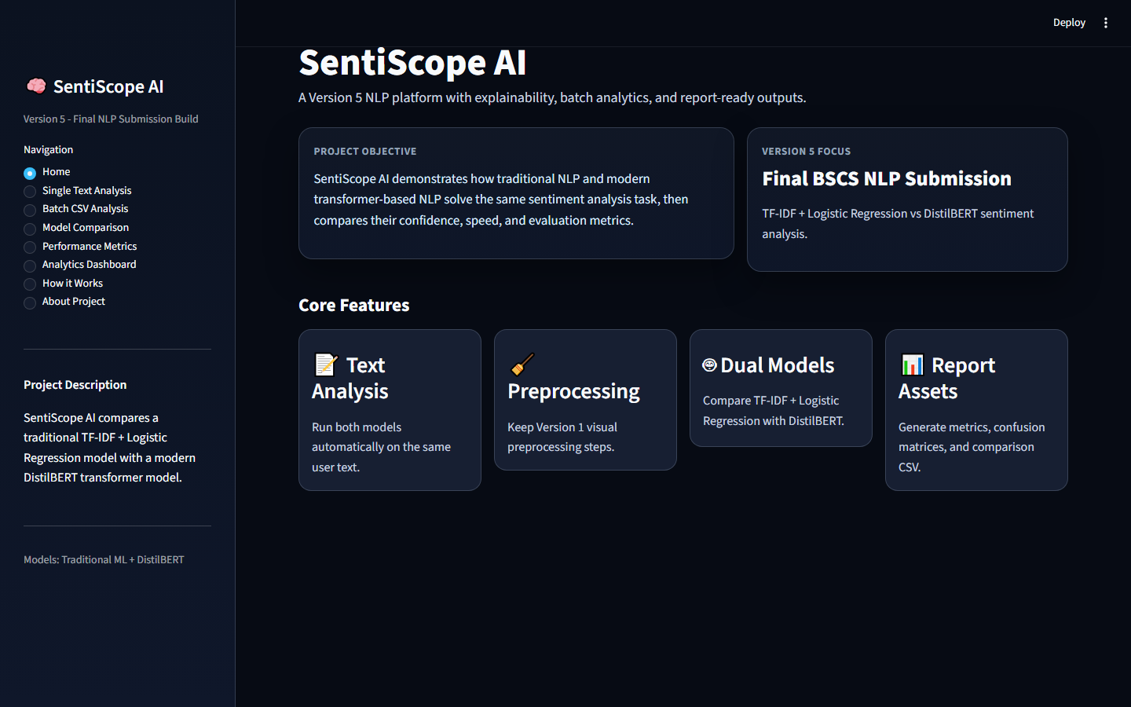
Figure 1: Home Dashboard
The Home Dashboard introduces SentiScope AI and presents the overall project objective and major features.
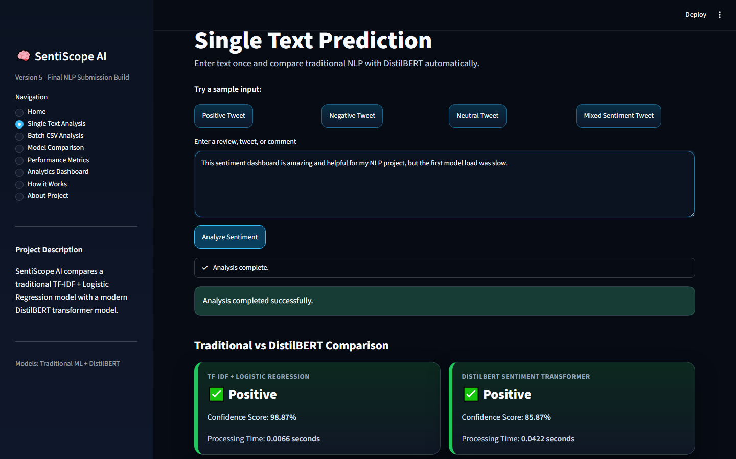
Figure 2: Single Text Analysis
The Single Text Analysis page shows sentiment prediction for a realistic input using both models.
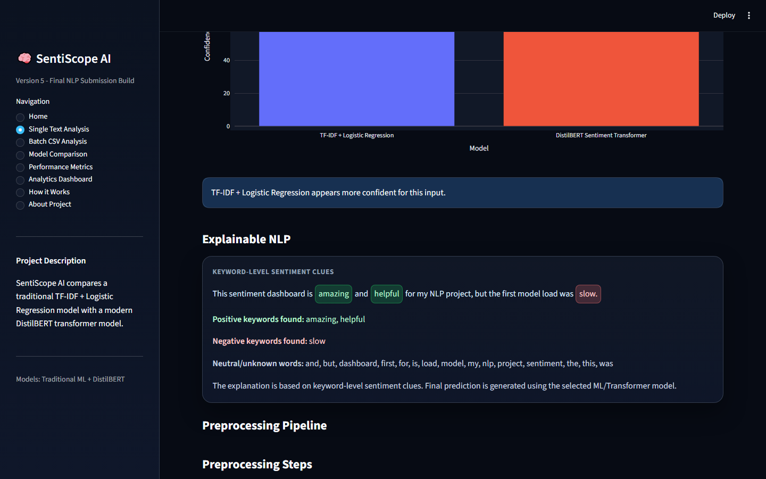
Figure 3: Preprocessing Visualization
The preprocessing screenshot shows original text, lowercasing, cleaning, tokenization, stopword removal, and final processed text.

Figure 4: Traditional vs DistilBERT Comparison
This figure displays side-by-side prediction outputs, confidence scores, and processing time.

Figure 5: Explainable NLP
The Explainable NLP section highlights positive and negative sentiment clues in the input text.
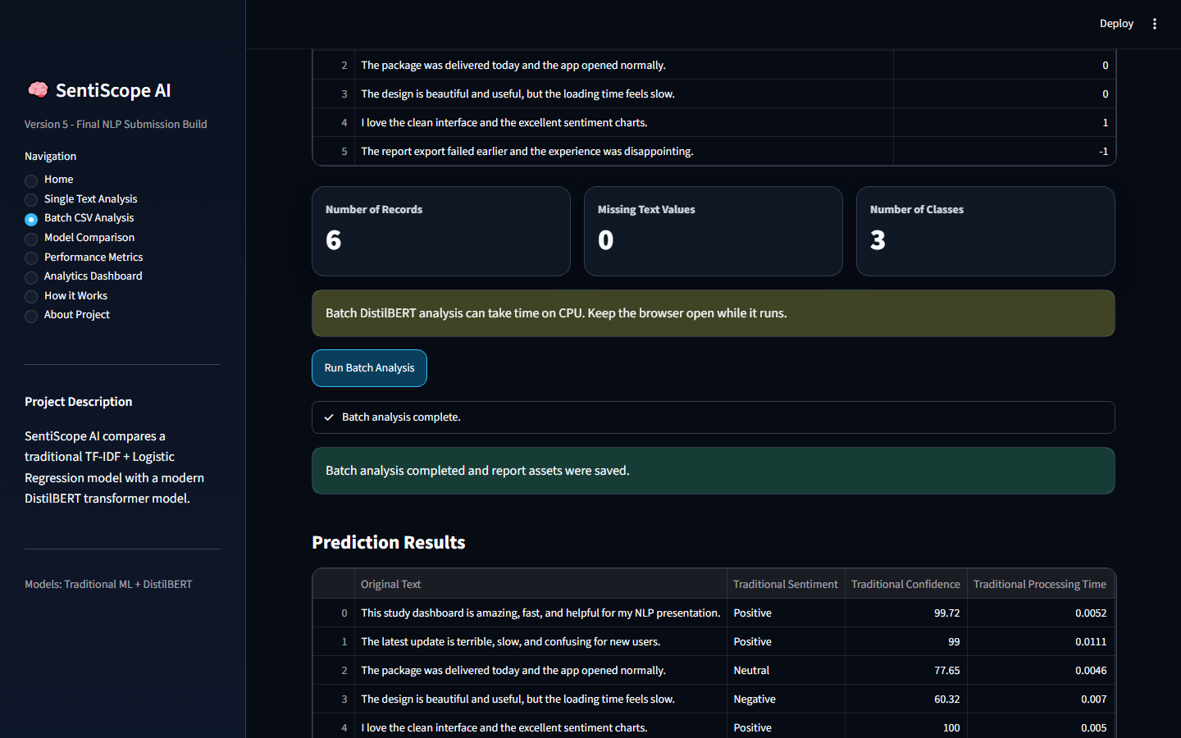
Figure 6: Batch CSV Analysis
The batch analysis page shows CSV upload, text column selection, dataset preview, prediction results, and export support.
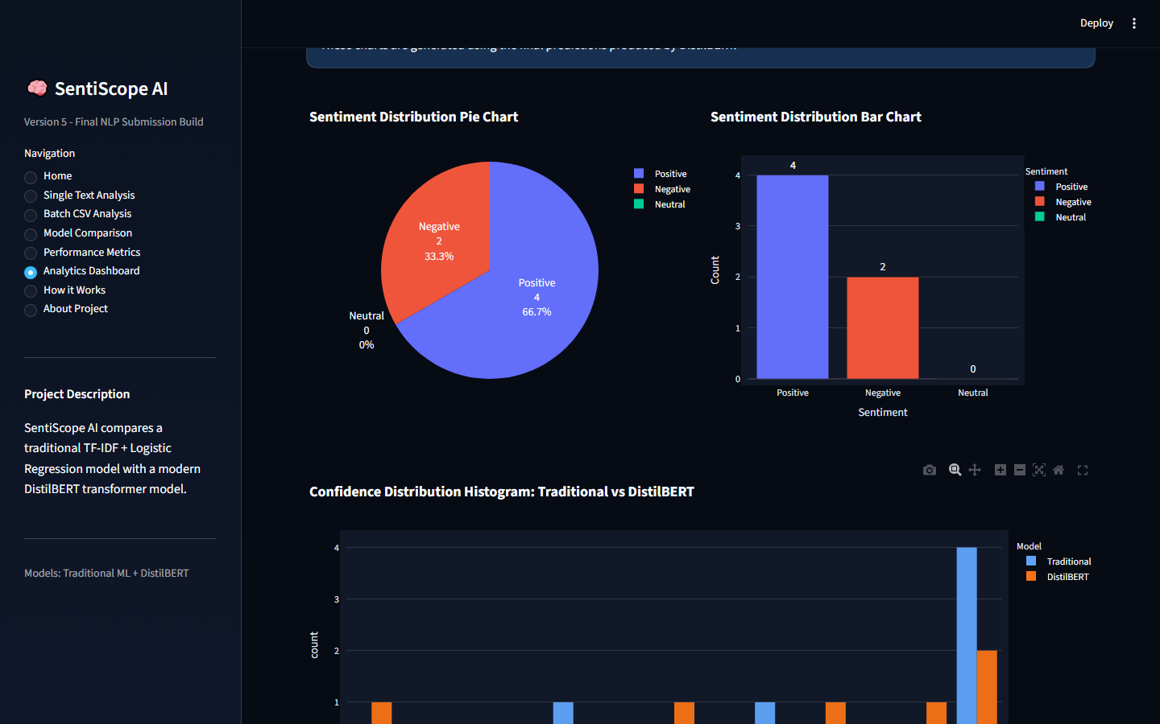
Figure 7: Analytics Dashboard
The analytics dashboard displays KPI cards, sentiment distribution charts, confidence histogram, and agreement analysis.
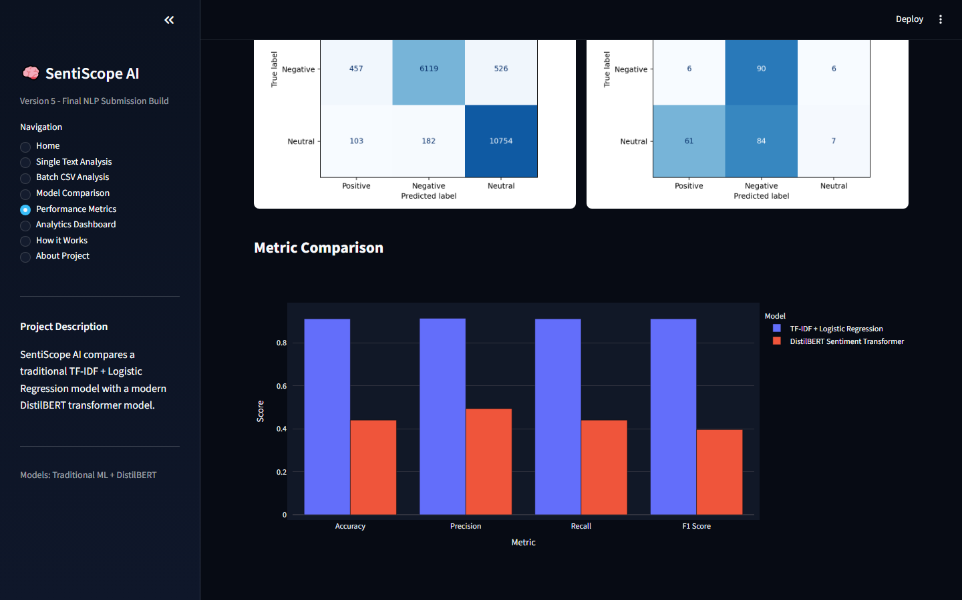
Figure 8: Performance Metrics Dashboard
The performance metrics page presents evaluation metrics and confusion matrices for model assessment.

16. Challenges Faced
Several challenges were faced during development. Social media text required preprocessing because tweets often contain informal words and inconsistent formatting. DistilBERT integration required dependency management and model downloads. Batch prediction introduced performance challenges because transformer inference is slower on CPU. UI readability was also important because the dashboard uses a dark theme. Model comparison required careful explanation because the traditional model is trained directly on the dataset, while DistilBERT provides a contextual modern approach.

17. Future Work
Future improvements include Urdu sentiment analysis, multilingual sentiment analysis, sarcasm detection, fake review detection, emotion detection, aspect-based sentiment analysis, and real-time social media monitoring. Another major improvement would be fine-tuning DistilBERT on the Twitter sentiment dataset to improve transformer performance.

18. Conclusion
SentiScope AI successfully implements a complete sentiment analysis platform for BSCS NLP project submission. The system demonstrates preprocessing, traditional machine learning, transformer-based prediction, batch CSV analysis, explainable NLP, model comparison, analytics visualization, and report-ready screenshots. The project shows that TF-IDF + Logistic Regression remains a strong baseline, while DistilBERT demonstrates the importance of modern contextual NLP. Overall, SentiScope AI provides a strong academic foundation for understanding and demonstrating sentiment analysis using both classical and modern NLP methods.

