*1) Top 20 areas ( BY Branch State) by total transaction value for each transaction type:*

SELECT branch_state, transaction_type, total

FROM (

SELECT branch_state, transaction_type, SUM(transaction_value) as total,

ROW_NUMBER() OVER (PARTITION BY transaction_type

ORDER BY SUM(transaction_value) DESC) AS rn

FROM cdw_sapp_creditcard join cdw_sapp_branch

ON (cdw_sapp_branch.branch_code = cdw_sapp_creditcard.branch_code)

GROUP BY branch_state, transaction_type ORDER BY total) t

WHERE t.rn <= 20

ORDER BY transaction_type, total desc;

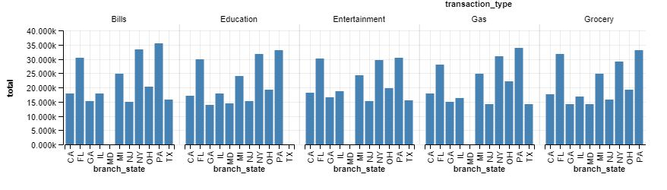

*2) Find total transaction value for each transaction type by the Quarters in 2018*

SELECT transaction_type,

SUM(transaction_value) as total_value, quarter

FROM cdw_sapp_creditcard join cdw_sapp_time

ON (cdw_sapp_time.timeid = cdw_sapp_creditcard.timeid)

WHERE year=2018

GROUP BY transaction_type, quarter;

