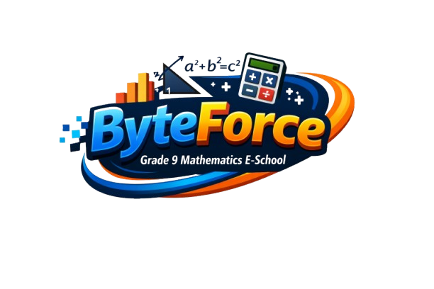

Contents
Assignment 2
Our Team: Byte Force 3
Stages of development 4
Project description 5

Assignment

The project "Electronic School" is part of the project activities for the 2025/2026 school year. The primary objective was to develop a software application that functions as an interactive educational platform for a specific subject, paired with an electronic testing system to assess and grade student knowledge.
The project was developed under the following mandatory requirements:
- Subject Focus: The application represents an electronic school for Grade 9 Mathematics, specifically covering Linear Equations, Algebraic Expressions, Geometry, and Statistics.
- Working Language: The core interface and all elements within the code are implemented in English.
- Educational Content: The software must include attractive didactic tools such as lesson content, practice exercises, and independent homework assignments.
- Testing Engine: A dynamic test generator was required to pull 20 questions from a bank of at least 30 questions, categorized by difficulty and weight.
- Assessment & Analytics: The system must automatically evaluate students using the six-point grading scale and provide detailed statistics, including average scores and per-category performance.
- Technical Standards: The application is built using C++ with a focus on clear code structure, proper variable naming conventions, and modularity.
- Collaboration: Development was managed via GitHub, emphasizing teamwork through regular commits, task planning, and role-based contributions.
The project duration for this specific assignment was from February 25, 2026, to March 23, 2026, concluding with a formal defense and demonstration of the software.

Our Team: Byte Force

№ | Name and class | Role
№1 | Tatiana Kovacheva – 9B | Scrum trainer
№2 | Plamen Rusev – 9G | Front-End  Developer
№3 | Mustafa Mustafa – 9A | Back-End Developer
№4 | Selin Vatansever – 9B | Designer

Stages of development

№ | Stage
1 | Planning  Topic selection and team registration via the Scrum Trainer.
2 | Design  Structuring the math lessons (Linear Equations, Geometry, etc.) and defining grading scales.
3 | Implementation  Writing C++ code across modular files (main, app, test_session, statistics, data).
4 | Collaboration  Continuous integration using Git and GitHub to track progress and roles.
5 | Finalization  Preparing the presentation, and final code debugging for the defense.

Project description

ByteForce is a terminal-based interactive school environment designed to assist 9th-grade students in mastering mathematical concepts.
- Learning Content: Features 4 detailed lessons: Linear Equations, Algebraic Expressions, Geometry, and Statistics Basics.
- Practice & Homework: Includes 2 practice sets with worked problems and 3 independent homework sets.
- Testing System: A 20-question test is dynamically generated from a bank of 32 questions. Questions are split into four categories with varying weights (1 to 3 points each).
- Grading: Students are assessed on a six-point scale based on percentage thresholds (e.g., ≥90% for a Grade 6).
- Statistics: The application tracks the best/worst results, calculates the class average, and provides a per-category performance breakdown.

