|  |  |
| --- | --- |
| **ФИО** | Кривова Татьяна Сергеевна |

**Перечислить все таблицы и первичные ключи в базе данных dvd-rental**

-- Все таблицы:

**SELECT**

table_name

, table_type

, table_schema

, table_catalog

**FROM** information_schema.**tables**

**WHERE** table_schema **NOT** **IN** ('information_schema','pg_catalog')

**ORDER** **BY** table_name **ASC**

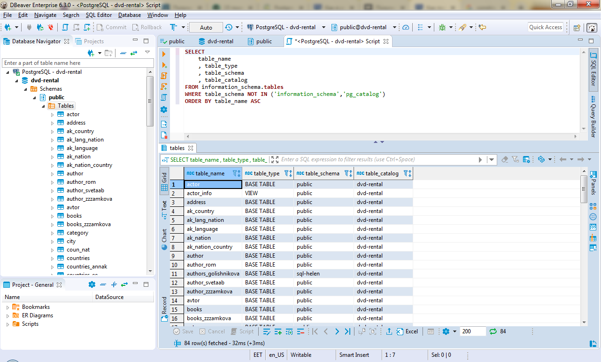

|  |  |  |  |  |
| --- | --- | --- | --- | --- |
| **#** | **table_name** | **table_type** | **table_schema** | **table_catalog** |
| 1 | actor | BASE TABLE | public | dvd-rental |
| 2 | actor_info | VIEW | public | dvd-rental |
| 3 | address | BASE TABLE | public | dvd-rental |
| 4 | ak_country | BASE TABLE | public | dvd-rental |
| 5 | ak_lang_nation | BASE TABLE | public | dvd-rental |
| 6 | ak_language | BASE TABLE | public | dvd-rental |
| 7 | ak_nation | BASE TABLE | public | dvd-rental |
| 8 | ak_nation_country | BASE TABLE | public | dvd-rental |
| 9 | author | BASE TABLE | public | dvd-rental |
| 10 | author_rom | BASE TABLE | public | dvd-rental |
| 11 | authors_golishnikova | BASE TABLE | sql-helen | dvd-rental |
| 12 | author_svetaab | BASE TABLE | public | dvd-rental |
| 13 | author_zzzamkova | BASE TABLE | public | dvd-rental |
| 14 | avtor | BASE TABLE | public | dvd-rental |
| 15 | books | BASE TABLE | public | dvd-rental |
| 16 | books_zzzamkova | BASE TABLE | public | dvd-rental |
| 17 | category | BASE TABLE | public | dvd-rental |
| 18 | city | BASE TABLE | public | dvd-rental |
| 19 | coun_nat | BASE TABLE | public | dvd-rental |
| 20 | coun_nat | BASE TABLE | sql-helen | dvd-rental |
| 21 | countries | BASE TABLE | sql-helen | dvd-rental |
| 22 | countries | BASE TABLE | public | dvd-rental |
| 23 | countries_annak | BASE TABLE | public | dvd-rental |
| 24 | countries_ee | BASE TABLE | public | dvd-rental |
| 25 | countries_ee | BASE TABLE | sql-helen | dvd-rental |
| 26 | countries_romanova | BASE TABLE | public | dvd-rental |
| 27 | countries_z | BASE TABLE | public | dvd-rental |
| 28 | country | BASE TABLE | sql-il.al | dvd-rental |
| 29 | country | BASE TABLE | public | dvd-rental |
| 30 | country_nation | BASE TABLE | public | dvd-rental |
| 31 | country_nation_svetaab | BASE TABLE | public | dvd-rental |
| 32 | country_svetaab | BASE TABLE | public | dvd-rental |
| 33 | creations | BASE TABLE | sql-helen | dvd-rental |
| 34 | creations | BASE TABLE | public | dvd-rental |
| 35 | creations_svetaab | BASE TABLE | public | dvd-rental |
| 36 | customer | BASE TABLE | public | dvd-rental |
| 37 | customer_list | VIEW | public | dvd-rental |
| 38 | film | BASE TABLE | public | dvd-rental |
| 39 | film_actor | BASE TABLE | public | dvd-rental |
| 40 | film_category | BASE TABLE | public | dvd-rental |
| 41 | film_list | VIEW | public | dvd-rental |
| 42 | hw_countries | BASE TABLE | public | dvd-rental |
| 43 | hw_languages | BASE TABLE | public | dvd-rental |
| 44 | hw_nations | BASE TABLE | public | dvd-rental |
| 45 | hw_nations_countries | BASE TABLE | public | dvd-rental |
| 46 | inventory | BASE TABLE | public | dvd-rental |
| 47 | lang_nat | BASE TABLE | public | dvd-rental |
| 48 | lang_nat | BASE TABLE | sql-helen | dvd-rental |
| 49 | language | BASE TABLE | sql-il.al | dvd-rental |
| 50 | language | BASE TABLE | public | dvd-rental |
| 51 | language_annak | BASE TABLE | public | dvd-rental |
| 52 | language_annak1 | BASE TABLE | public | dvd-rental |
| 53 | language_romanova | BASE TABLE | public | dvd-rental |
| 54 | languages | BASE TABLE | sql-helen | dvd-rental |
| 55 | languages_ee | BASE TABLE | public | dvd-rental |
| 56 | languages_ee | BASE TABLE | sql-helen | dvd-rental |
| 57 | language_svetaab | BASE TABLE | public | dvd-rental |
| 58 | languages_z | BASE TABLE | public | dvd-rental |
| 59 | last_customer_film | VIEW | public | dvd-rental |
| 60 | last_rent | VIEW | public | dvd-rental |
| 61 | last_rent_of_customer | VIEW | public | dvd-rental |
| 62 | nationalities | BASE TABLE | sql-helen | dvd-rental |
| 63 | nationalities_annak | BASE TABLE | public | dvd-rental |
| 64 | nationalities_annak1 | BASE TABLE | public | dvd-rental |
| 65 | nationalities_ee | BASE TABLE | sql-helen | dvd-rental |
| 66 | nationalities_ee | BASE TABLE | public | dvd-rental |
| 67 | nationalities_z | BASE TABLE | public | dvd-rental |
| 68 | nationality | BASE TABLE | sql-il.al | dvd-rental |
| 69 | nationality_country | BASE TABLE | public | dvd-rental |
| 70 | nation_romanova | BASE TABLE | public | dvd-rental |
| 71 | nations | BASE TABLE | sql-helen | dvd-rental |
| 72 | nations_svetaab | BASE TABLE | public | dvd-rental |
| 73 | nicer_but_slower_film_list | VIEW | public | dvd-rental |
| 74 | orders | BASE TABLE | public | dvd-rental |
| 75 | orders_anna | BASE TABLE | public | dvd-rental |
| 76 | orders_svetaab | BASE TABLE | public | dvd-rental |
| 77 | payment | BASE TABLE | public | dvd-rental |
| 78 | rental | BASE TABLE | public | dvd-rental |
| 79 | sales_by_film_category | VIEW | public | dvd-rental |
| 80 | sales_by_store | VIEW | public | dvd-rental |
| 81 | staff | BASE TABLE | public | dvd-rental |
| 82 | staff_list | VIEW | public | dvd-rental |
| 83 | store | BASE TABLE | public | dvd-rental |
| 84 | view_v | VIEW | public | dvd-rental |

-- Первичные ключи:

**SELECT**

table_name

, column_name

, constraint_name

, table_schema

, table_catalog

**FROM** INFORMATION_SCHEMA.CONSTRAINT_COLUMN_USAGE

**WHERE** constraint_name **IN**

(**SELECT** constraint_name **FROM** INFORMATION_SCHEMA.TABLE_CONSTRAINTS

**WHERE** constraint_type = 'PRIMARY KEY')

**ORDER** **BY** table_name **ASC**

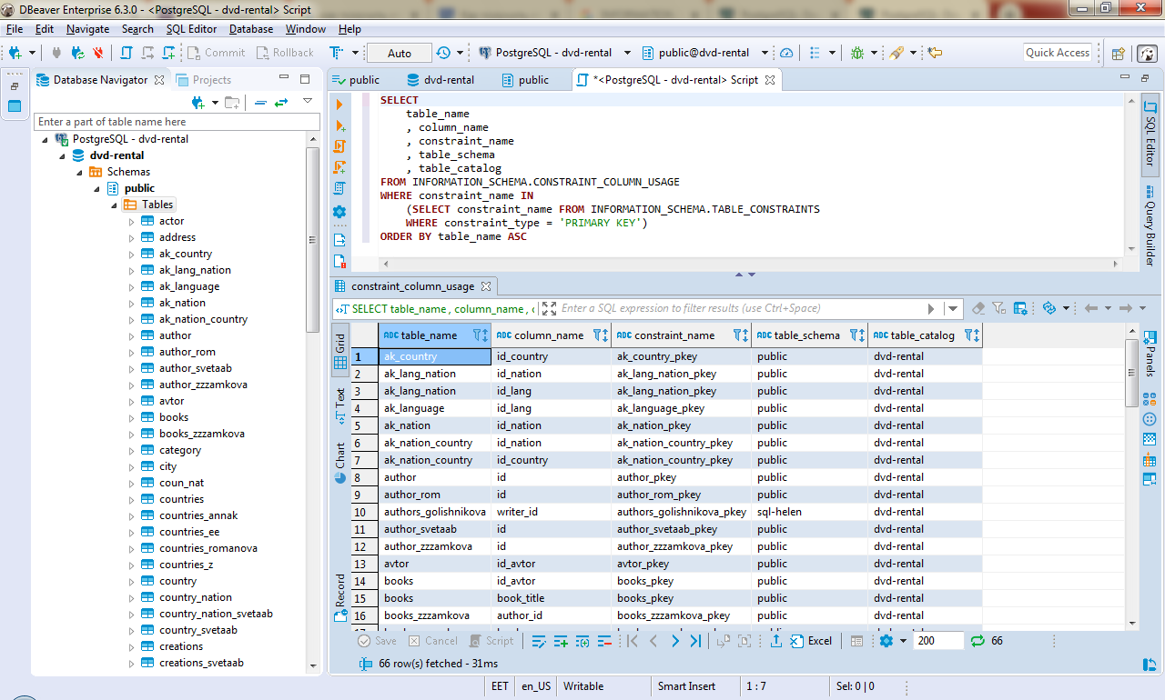

|  |  |  |  |  |  |
| --- | --- | --- | --- | --- | --- |
| **#** | **table_name** | **column_name** | **constraint_name** | **table_schema** | **table_catalog** |
| 1 | ak_country | id_country | ak_country_pkey | public | dvd-rental |
| 2 | ak_lang_nation | id_nation | ak_lang_nation_pkey | public | dvd-rental |
| 3 | ak_lang_nation | id_lang | ak_lang_nation_pkey | public | dvd-rental |
| 4 | ak_language | id_lang | ak_language_pkey | public | dvd-rental |
| 5 | ak_nation | id_nation | ak_nation_pkey | public | dvd-rental |
| 6 | ak_nation_country | id_nation | ak_nation_country_pkey | public | dvd-rental |
| 7 | ak_nation_country | id_country | ak_nation_country_pkey | public | dvd-rental |
| 8 | author | id | author_pkey | public | dvd-rental |
| 9 | author_rom | id | author_rom_pkey | public | dvd-rental |
| 10 | authors_golishnikova | writer_id | authors_golishnikova_pkey | sql-helen | dvd-rental |
| 11 | author_svetaab | id | author_svetaab_pkey | public | dvd-rental |
| 12 | author_zzzamkova | id | author_zzzamkova_pkey | public | dvd-rental |
| 13 | avtor | id_avtor | avtor_pkey | public | dvd-rental |
| 14 | books | id_avtor | books_pkey | public | dvd-rental |
| 15 | books | book_title | books_pkey | public | dvd-rental |
| 16 | books_zzzamkova | author_id | books_zzzamkova_pkey | public | dvd-rental |
| 17 | books_zzzamkova | book_name | books_zzzamkova_pkey | public | dvd-rental |
| 18 | coun_nat | nat_id | coun_nat_pkey | public | dvd-rental |
| 19 | coun_nat | coun_id | coun_nat_pkey | public | dvd-rental |
| 20 | countries | country_id | countries_pkey | public | dvd-rental |
| 21 | countries | coun_id | countries_pkey | sql-helen | dvd-rental |
| 22 | countries_annak | country_id | countries_annak_pkey | public | dvd-rental |
| 23 | countries_ee | coun_id | countries_ee_pkey | public | dvd-rental |
| 24 | countries_ee | coun_id | countries_ee_pkey | sql-helen | dvd-rental |
| 25 | countries_romanova | country_id | countries_romanova_pkey | public | dvd-rental |
| 26 | countries_z | id | countries_z_pkey | public | dvd-rental |
| 27 | country | country_id | country_pkey | sql-il.al | dvd-rental |
| 28 | country_nation | country_id | country_nation_pkey | public | dvd-rental |
| 29 | country_nation | nat_id | country_nation_pkey | public | dvd-rental |
| 30 | country_nation_svetaab | country_id | country_nation_svetaab_pkey | public | dvd-rental |
| 31 | country_nation_svetaab | nation_id | country_nation_svetaab_pkey | public | dvd-rental |
| 32 | country_svetaab | id | country_svetaab_pkey | public | dvd-rental |
| 33 | creations | id | creations_pkey | sql-helen | dvd-rental |
| 34 | creations | id | creations_pkey | public | dvd-rental |
| 35 | creations_svetaab | id | creations_svetaab_pkey | public | dvd-rental |
| 36 | hw_countries | id | hw_countries_pkey | public | dvd-rental |
| 37 | hw_languages | id | hw_languages_pkey | public | dvd-rental |
| 38 | hw_nations | id | hw_nations_pkey | public | dvd-rental |
| 39 | hw_nations_countries | nation_id | hw_nations_countries_pkey | public | dvd-rental |
| 40 | hw_nations_countries | country_id | hw_nations_countries_pkey | public | dvd-rental |
| 41 | lang_nat | lang_id | lang_nat_pkey | public | dvd-rental |
| 42 | lang_nat | nat_id | lang_nat_pkey | public | dvd-rental |
| 43 | language | language_id | language_pkey | sql-il.al | dvd-rental |
| 44 | language_annak | languge_id | language_annak_pkey | public | dvd-rental |
| 45 | language_annak1 | languge_id | language_annak1_pkey | public | dvd-rental |
| 46 | language_romanova | lang_id | language_romanova_pkey | public | dvd-rental |
| 47 | languages | lang_id | languages_pkey | sql-helen | dvd-rental |
| 48 | languages_ee | lang_id | languages_ee_pkey | public | dvd-rental |
| 49 | languages_ee | lang_id | languages_ee_pkey | sql-helen | dvd-rental |
| 50 | language_svetaab | id | language_svetaab_pkey | public | dvd-rental |
| 51 | languages_z | id | languages_z_pkey | public | dvd-rental |
| 52 | nationalities | nat_id | nationalities_pkey | sql-helen | dvd-rental |
| 53 | nationalities_annak | nationality_id | nationalities_annak_pkey | public | dvd-rental |
| 54 | nationalities_annak1 | nationality_id | nationalities_annak1_pkey | public | dvd-rental |
| 55 | nationalities_ee | nat_id | nationalities_ee_pkey | sql-helen | dvd-rental |
| 56 | nationalities_ee | nat_id | nationalities_ee_pkey | public | dvd-rental |
| 57 | nationalities_z | id | nationalities_z_pkey | public | dvd-rental |
| 58 | nationality | national_id | nationality_pkey | sql-il.al | dvd-rental |
| 59 | nationality_country | country_id | nationality_country_pkey | public | dvd-rental |
| 60 | nationality_country | nationality_id | nationality_country_pkey | public | dvd-rental |
| 61 | nation_romanova | nat_id | nation_romanova_pkey | public | dvd-rental |
| 62 | nations | nat_id | nations_pkey | sql-helen | dvd-rental |
| 63 | nations_svetaab | id | nations_svetaab_pkey | public | dvd-rental |
| 64 | orders | id | orders_pkey | public | dvd-rental |
| 65 | orders_anna | id | orders_anna_pkey | public | dvd-rental |
| 66 | orders_svetaab | id | orders_svetaab_pkey | public | dvd-rental |

**Вывести всех неактивных покупателей**

**SELECT** *

**FROM** customer **as** c

**WHERE** c.active != 1

**ORDER** **BY** c.customer_id **ASC**

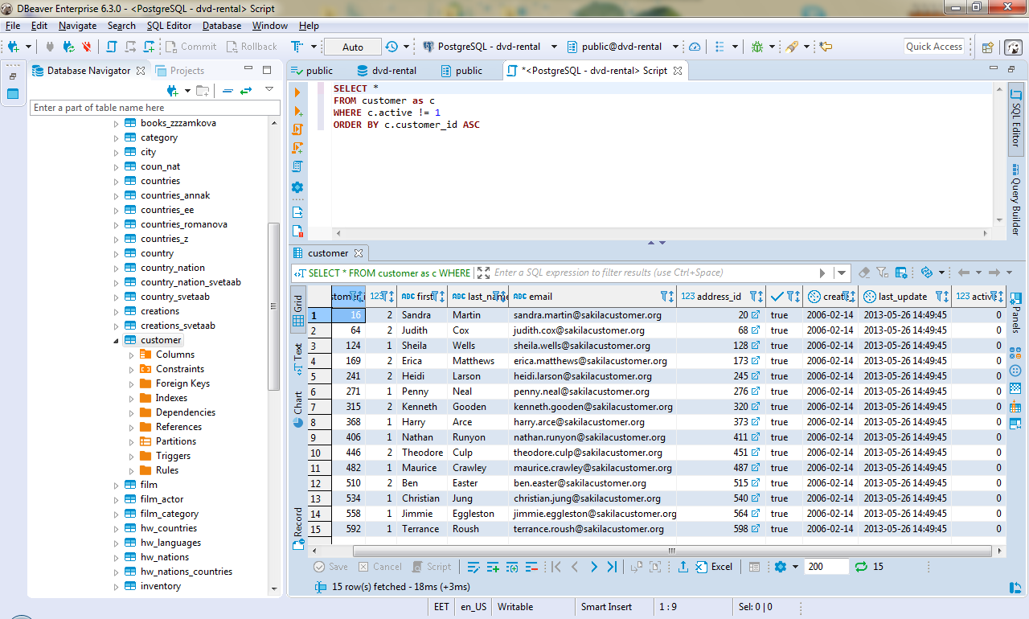

**Вывести 10 последних платежей за прокат фильмов (таблица payment)**

**SELECT** *

**FROM** payment **as** p

**ORDER** **BY** p.payment_date **desc**, p.payment_id **desc**

**limit** 10

