**FB‐to‐SMV**

**IEC 61499 function blocks XML to SVM model converter manual**

**Load FB**

Converter allows to load FB XML definition from *.xml and *.fbt files.

To load FB XML definition, click *File -> Load* and choose input files type in standard windows open file dialog.

If composite FB is chosen, all its components will be leaded automatically, but they supposed to be the same file type (either *.xml or *.fbt) and placed at the same directory.

**SMV data types**

Default SMV data types are shown in the table below

|  |  |
| --- | --- |
| **Type** | **SMV variable type** |
| event | boolean |
| BOOL | boolean |
| INT | 0..99 |
| UINT |
| Other types | Not defined |

For variables with types INT and UINT it is possible to change SMV data type.

To change SMV type, select target FB type in the types tree (Fig. 1), select target variable, specify new SMV type and press *“Change”* button. When variable is selected, all variables, interconnected with selected variable, are shown in the *“Connected variables”* list: *(TYPE)Variable_name->FB_Type*

SMV data types for all connected variables will be changed when one variable type is changed.

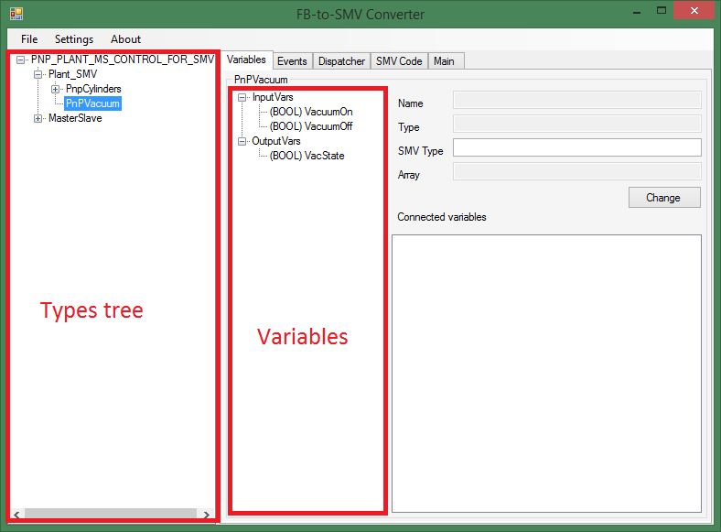

Fig. 1 – FB-to-SMV converter window

**Restrictions**

* Only ST algorithms are supported.
* In ST algorithms, only assignment and branch (IF..THEN..ELSE..END_IF) operators with any depth of nesting are supported
* Only “physical” connections (but not dependencies by algorithms) affect variable connections graph.

**Input events priorities**

If more than one event occur on the basic FB inputs, only one event will be processed and other events will be cleared. The processing event choice is based on simple priorities and converter allows to change priorities in the *“Events”* tab (Fig. 2).

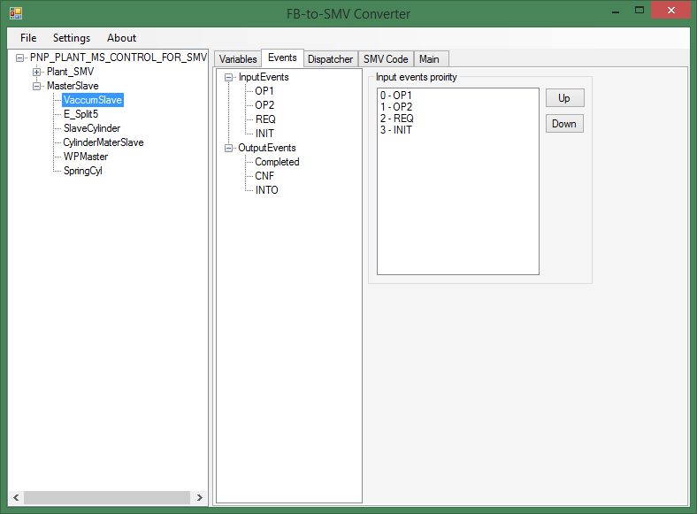

Fig. – “Events” tab

**Composite FB with dispatcher**

In generated SMV model, components execution order in composite FB is controlled regard to cyclic execution discipline and converter allows to change execution order on the *“Dispatcher”* tab (Fig. 3).

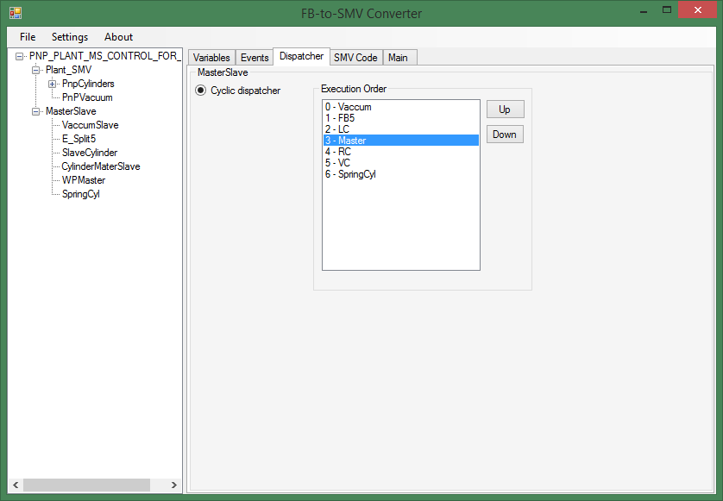

Fig. 3 – “Dispatcher” tab

**SMV model generation**

To generate SMV model choose File->Generate SMV code

After the converter generate SMV model, “SMV Code” tab will be opened.

With SMV modules for all FB types, converter generates ‘main’ SMV module dummy to make sure, all inputs and outputs of top-level FB are connected properly. This module can be changed manually in the *“Main”* tab before SMV model save or in the saved file.

Converter allows to use different options for generated SMV model. Options are available in settings window (Fig. 4). In current converter version (0.9.0.2) there are two options available:

* Modular arithmetic in basic FB algorithms
* Usage of asynchronous SMV module instances (processes)/synchronous SMV module instances

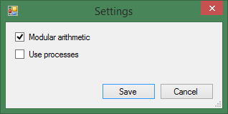

Fig. – settings window