buttRflyfish: reproduction of figure 2b from Nowicki et al. 2020

Gabriel A. Preising1,✉, Tatiana Bellagio1, and Sebastian ToroArana1,✉

10 December, 2021

1 Stanford University Biology Department

✉ Correspondence: [Gabriel A. Preising <[gpreisin@stanford.edu](mailto:gpreisin@stanford.edu)>](mailto:gpreisin@stanford.edu), [Sebastian ToroArana <[sebatoro@stanford.edu](mailto:sebatoro@stanford.edu)>](mailto:sebatoro@stanford.edu)

# 1 Introduction

Here, we reproduce figure 2b from (Nowicki et al., 2020) - “Gene expression correlates of social evolution in coral reef butterfly fishes.” This study analyzed the neural correlates of pair-bonding vs. solitary mating behavior in several species of *Chaetodontidae* fishes. To accomplish this, they compared gene expression of socially-relevant neuropeptides in brain regions pertinent to social function. One of their main findings was that the males of pair-bonding species had elevated oxytocin receptor (OTR) expression in the supracommissural part of the ventral telencephalon (Vs) compared to the males of solitary species.

# 2 Methods

The authors of (Nowicki et al., 2020) used qRT-PCR to quantify relative mRNA expression of OTR in Vs of 5 *Chaetodontidae* species: *C. vagabundus*, *C. lunatus*, *C. baronessa*, *C. trifascialis*, and *C. rainfordi*. They employ a Markov Chain Monte Carlo approach to analyze differential gene expression. Below is a reproduction of figure 2b using our package buttRflyfish.

# 3 Results

library(buttRflyfish)  
  
data = load_data() # load data  
model = run_model(data) # run MCMC model  
p = otr_expression_plot(model,data) # plot differential expression results

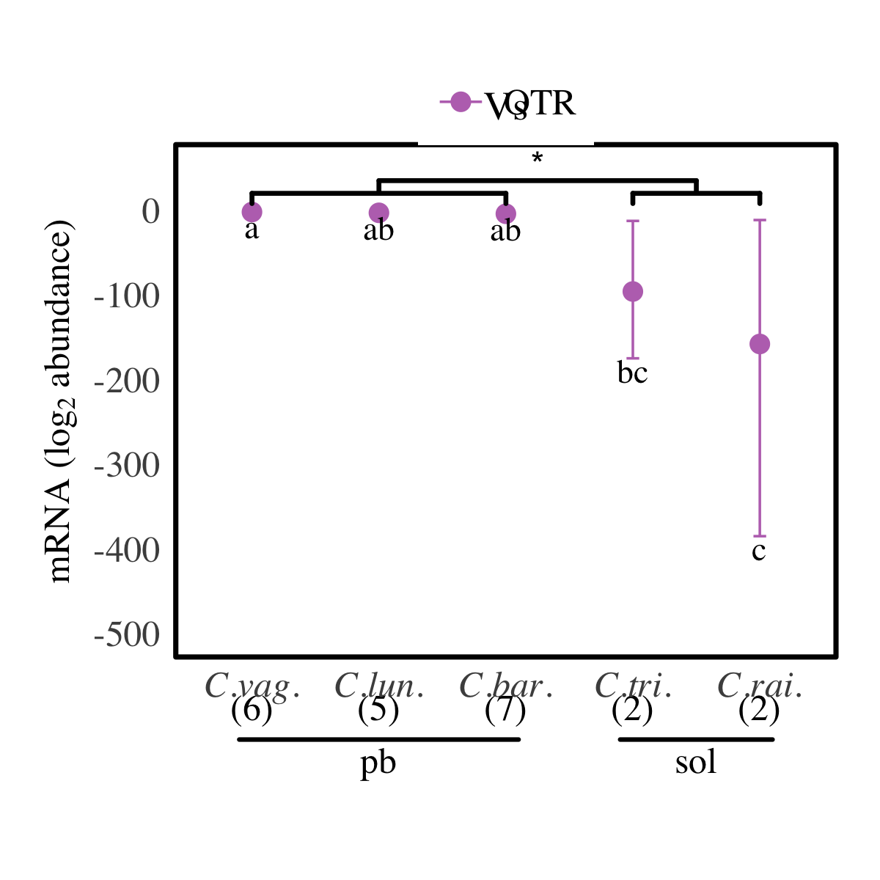

Figure 3.1: Reproduction of figure 2b from Nowicki et al. 2020.

# 4 References

Nowicki, J.P., Pratchett, M.S., Walker, S.P.W., Coker, D.J., O’Connell, L.A., 2020. Gene expression correlates of social evolution in coral reef butterflyfishes. Proceedings of the Royal Society B: Biological Sciences 287, 20200239. <https://doi.org/10.1098/rspb.2020.0239>

### 4.0.1 Colophon

This report was generated on 2021-12-10 15:17:44 using the following computational environment and dependencies:

#> ─ Session info 🎽 👨🏼‍💼 🇸🇽 ─────────────────────────────────────────────────  
#> hash: running shirt, man office worker: medium-light skin tone, flag: Sint Maarten  
#>   
#> setting value  
#> version R version 4.1.1 (2021-08-10)  
#> os macOS Big Sur 10.16  
#> system x86_64, darwin17.0  
#> ui X11  
#> language (EN)  
#> collate en_US.UTF-8  
#> ctype en_US.UTF-8  
#> tz America/Los_Angeles  
#> date 2021-12-10  
#> pandoc 2.11.4 @ /private/var/folders/q1/p49blfh10mb757vn308yc7v00000gn/T/AppTranslocation/B29962B3-0028-409A-AB26-461AEABC02E9/d/RStudio.app/Contents/MacOS/pandoc/ (via rmarkdown)  
#>   
#> ─ Packages ───────────────────────────────────────────────────────────────────  
#> package * version date (UTC) lib source  
#> ape 5.5 2021-04-25 [1] CRAN (R 4.1.0)  
#> assertthat 0.2.1 2019-03-21 [1] CRAN (R 4.1.0)  
#> bookdown 0.24 2021-09-02 [1] CRAN (R 4.1.0)  
#> buttRflyfish * 0.0.0.9000 2021-12-10 [1] local  
#> cachem 1.0.6 2021-08-19 [1] CRAN (R 4.1.0)  
#> callr 3.7.0 2021-04-20 [1] CRAN (R 4.1.0)  
#> cli 3.1.0 2021-10-27 [1] CRAN (R 4.1.0)  
#> coda 0.19-4 2020-09-30 [1] CRAN (R 4.1.0)  
#> colorspace 2.0-2 2021-06-24 [1] CRAN (R 4.1.0)  
#> corpcor 1.6.10 2021-09-16 [1] CRAN (R 4.1.0)  
#> crayon 1.4.2 2021-10-29 [1] CRAN (R 4.1.0)  
#> cubature 2.0.4.2 2021-05-13 [1] CRAN (R 4.1.0)  
#> DBI 1.1.1 2021-01-15 [1] CRAN (R 4.1.0)  
#> desc 1.4.0 2021-09-28 [1] CRAN (R 4.1.0)  
#> devtools 2.4.2 2021-06-07 [1] CRAN (R 4.1.0)  
#> digest 0.6.28 2021-09-23 [1] CRAN (R 4.1.0)  
#> dplyr 1.0.7 2021-06-18 [1] CRAN (R 4.1.0)  
#> ellipsis 0.3.2 2021-04-29 [1] CRAN (R 4.1.0)  
#> evaluate 0.14 2019-05-28 [1] CRAN (R 4.1.0)  
#> fansi 0.5.0 2021-05-25 [1] CRAN (R 4.1.0)  
#> farver 2.1.0 2021-02-28 [1] CRAN (R 4.1.0)  
#> fastmap 1.1.0 2021-01-25 [1] CRAN (R 4.1.0)  
#> fs 1.5.0 2020-07-31 [1] CRAN (R 4.1.0)  
#> generics 0.1.0 2020-10-31 [1] CRAN (R 4.1.0)  
#> ggplot2 3.3.5 2021-06-25 [1] CRAN (R 4.1.0)  
#> ggsignif 0.6.3 2021-09-09 [1] CRAN (R 4.1.0)  
#> glue 1.5.0 2021-11-07 [1] CRAN (R 4.1.0)  
#> gtable 0.3.0 2019-03-25 [1] CRAN (R 4.1.0)  
#> highr 0.9 2021-04-16 [1] CRAN (R 4.1.0)  
#> htmltools 0.5.2 2021-08-25 [1] CRAN (R 4.1.0)  
#> knitr 1.36 2021-09-29 [1] CRAN (R 4.1.0)  
#> labeling 0.4.2 2020-10-20 [1] CRAN (R 4.1.0)  
#> lattice 0.20-45 2021-09-22 [1] CRAN (R 4.1.0)  
#> lifecycle 1.0.1 2021-09-24 [1] CRAN (R 4.1.0)  
#> magrittr 2.0.1 2020-11-17 [1] CRAN (R 4.1.0)  
#> Matrix 1.3-4 2021-06-01 [1] CRAN (R 4.1.1)  
#> MCMC.qpcr 1.2.4 2020-03-29 [1] CRAN (R 4.1.0)  
#> MCMCglmm 2.32 2021-03-12 [1] CRAN (R 4.1.0)  
#> memoise 2.0.1 2021-11-26 [1] CRAN (R 4.1.0)  
#> munsell 0.5.0 2018-06-12 [1] CRAN (R 4.1.0)  
#> nlme 3.1-153 2021-09-07 [1] CRAN (R 4.1.0)  
#> pillar 1.6.4 2021-10-18 [1] CRAN (R 4.1.0)  
#> pkgbuild 1.2.0 2020-12-15 [1] CRAN (R 4.1.0)  
#> pkgconfig 2.0.3 2019-09-22 [1] CRAN (R 4.1.0)  
#> pkgload 1.2.3 2021-10-13 [1] CRAN (R 4.1.0)  
#> prettyunits 1.1.1 2020-01-24 [1] CRAN (R 4.1.0)  
#> processx 3.5.2 2021-04-30 [1] CRAN (R 4.1.0)  
#> ps 1.6.0 2021-02-28 [1] CRAN (R 4.1.0)  
#> purrr 0.3.4 2020-04-17 [1] CRAN (R 4.1.0)  
#> R6 2.5.1 2021-08-19 [1] CRAN (R 4.1.0)  
#> Rcpp 1.0.7 2021-07-07 [1] CRAN (R 4.1.0)  
#> remotes 2.4.1 2021-09-29 [1] CRAN (R 4.1.0)  
#> rlang 0.4.12 2021-10-18 [1] CRAN (R 4.1.0)  
#> rmarkdown 2.11 2021-09-14 [1] CRAN (R 4.1.0)  
#> rprojroot 2.0.2 2020-11-15 [1] CRAN (R 4.1.0)  
#> rstudioapi 0.13 2020-11-12 [1] CRAN (R 4.1.0)  
#> scales 1.1.1 2020-05-11 [1] CRAN (R 4.1.0)  
#> sessioninfo 1.2.1 2021-11-02 [1] CRAN (R 4.1.0)  
#> stringi 1.7.6 2021-11-29 [1] CRAN (R 4.1.1)  
#> stringr 1.4.0 2019-02-10 [1] CRAN (R 4.1.0)  
#> tensorA 0.36.2 2020-11-19 [1] CRAN (R 4.1.0)  
#> testthat 3.1.0 2021-10-04 [1] CRAN (R 4.1.0)  
#> tibble 3.1.6 2021-11-07 [1] CRAN (R 4.1.0)  
#> tidyselect 1.1.1 2021-04-30 [1] CRAN (R 4.1.0)  
#> usethis 2.1.3 2021-10-27 [1] CRAN (R 4.1.0)  
#> utf8 1.2.2 2021-07-24 [1] CRAN (R 4.1.0)  
#> vctrs 0.3.8 2021-04-29 [1] CRAN (R 4.1.0)  
#> withr 2.4.2 2021-04-18 [1] CRAN (R 4.1.0)  
#> xfun 0.28 2021-11-04 [1] CRAN (R 4.1.0)  
#> yaml 2.2.1 2020-02-01 [1] CRAN (R 4.1.0)  
#>   
#> [1] /Library/Frameworks/R.framework/Versions/4.1/Resources/library  
#>   
#> ──────────────────────────────────────────────────────────────────────────────

The current Git commit details are:

#> Local: main /Users/gabep/Desktop/Stanford/bios207/buttRflyfish  
#> Remote: main @ origin (https://github.com/Tatianabellagio/buttRflyfish)  
#> Head: [5c19e39] 2021-12-10: work on the paper