4. Program to count total number of Uppercase and Lowercase letters in a file.

Objective: To learn and understand the use of yyin in File Handling.

Code:

%{

int upper=0, lower=0;

%}

%%

[A-Z] upper++;

[a-z] lower++;

%%

void main()

{

yyin = fopen("f.txt","r");

yylex();

printf("\nUppercase Letters: %d", upper);

printf("\nLowercase Letters: %d", lower);

}

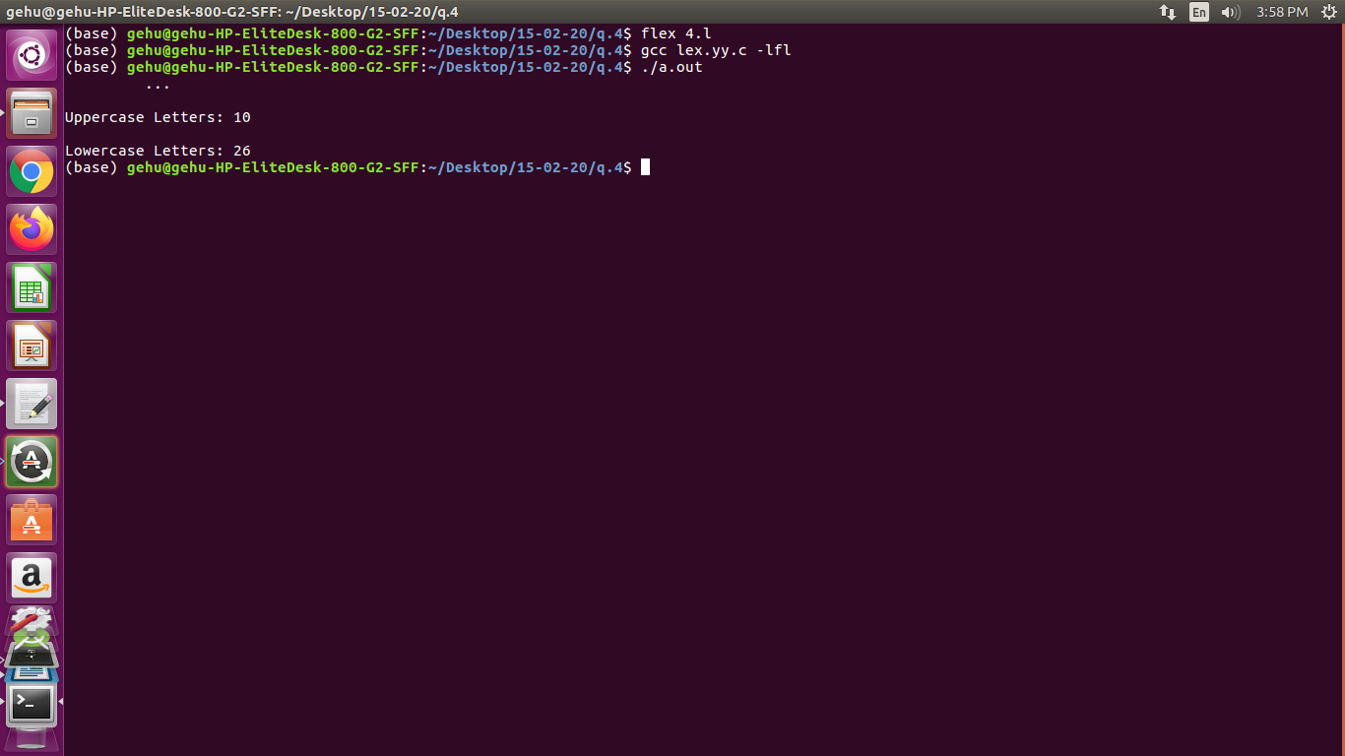

%{

int upper=0, lower=0;

%}

%%

[A-Z] upper++;

[a-z] lower++;

%%

void main()

{

yyin = fopen("gautam.txt","r");

yylex();

printf("\nUppercase Letters: %d\n", upper);

printf("\nLowercase Letters: %d\n", lower);

}

