Auction House

Contents
Business Description 3
1.1 the Benefits of implementing a database. Project Vision 3
2 Model description 3
2.1 Definitions & Acronyms 3
2.2 Logical Scheme 3
2.3 Objects 3

Business Description
the Benefits of implementing a database. Project Vision
An auction house is a fast-moving environment. Sellers bring items, buyers compete for them. Without a proper database, tracking who bid what, which item sold for how much and whether the buyer actually paid would be a nightmare of spreadsheets and manual logs. The whole point of this model is to make that chaos manageable and traceable.
The database solves the main problems of the domain. Every bid is saved the moment it is placed. Every sale outcome is recorded when the lot closes. Nothing gets overwritten. If a buyer disputes a price, the full bid history is there. If a seller wants to know what sold, one query answers it.
Data integrity is enforced through constraints. Foreign keys make sure every bid points to a real item and every payment points to a real result. The UNIQUE constraint on email stops the same person from registering twice. CHECK constraints on price and amount fields make sure no zero or negative values get in.
History is preserved by design. The BID table is append-only every bid is a new row, old ones are never touched. When bidding closes, the result is written into AUCTION_RESULT and stays there permanently. Nothing is ever edited after the fact.
The model scales easily. Adding a new auction, item or category is just inserting a new row. No tables need to change. The self-referential structure in CATEGORY and EMPLOYEE means hierarchies can grow as deep as needed without touching the schema.

Model description
Definitions & Acronyms
USER a registered person in the system. Can be a buyer, a seller or both
EMPLOYEE a staff member who runs auction events. Every employee is also a USER
AUCTION a scheduled sale event at a specific location
LOT a group of items inside an auction, with its own open and close time
ITEM a good submitted by a seller for sale within a lot.
CATEGORY a label that classifies items. Supports a parent-child hierarchy
BID a single offer placed on an item. Recorded with amount and timestamp. Never edited or deleted
AUCTION_RESULT the permanent outcome record after a lot closes. Stores the winning bid and final price. Never overwritten
PAYMENT tracks how and when the buyer paid for a result
PK Primary Key, the unique identifier for each row
FK Foreign Key, a reference to the PK of another table
UUID Universally Unique Identifier, used as the PK type in every table
3NF Third Normal Form. Every non-key field depends only on the primary key, nothing else

Logical Scheme
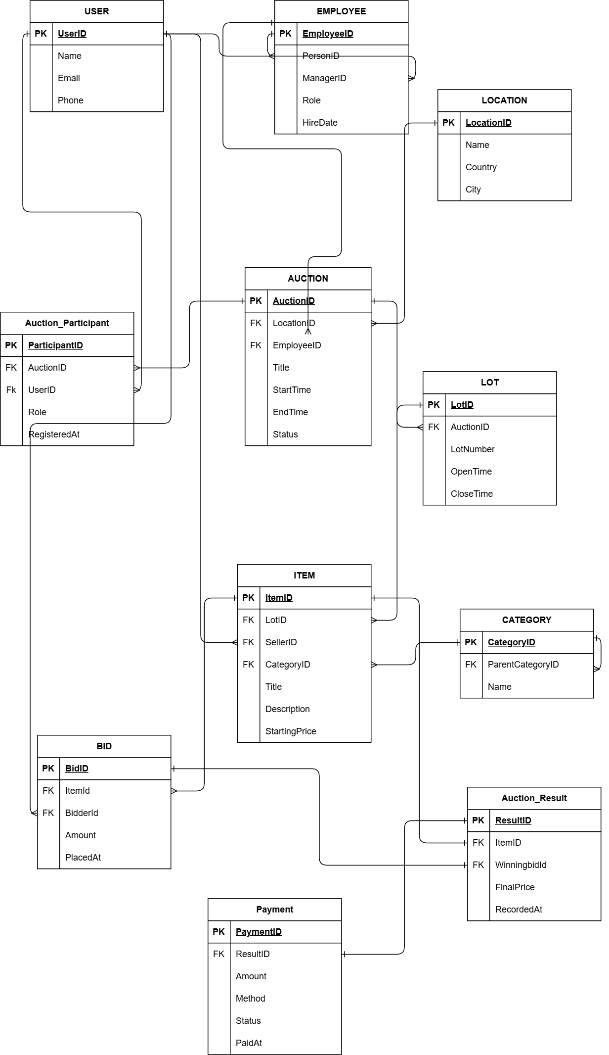

The hardest decision was the self-referential relationships in EMPLOYEE and CATEGORY. In EMPLOYEE, ManagerID is a foreign key pointing back to EmployeeID in the same table because a manager is also an employee. In CATEGORY, ParentCategoryID works the same way. A NULL value just means there is no parent.
Three anomalies the model prevents:
1. update anomaly if buyer and seller were separate tables, changing someone's email would need to be done in two places. One USER table fixes this.
2. insertion anomaly without FK constraints, a bid could be inserted for an item that does not exist. The FK on ItemID blocks this.
3. deletion anomaly if AUCTION_RESULT were inside BID, deleting a bid could remove the sale record. Keeping them separate prevents this.
The model is scalable. New rows can be added to any table without changing the structure. Categories and employee hierarchies can grow indefinitely through the self-referential FKs. No redesign is needed to add new auctions, items or participants.
The part most likely to change is PAYMENT. Right now it handles one payment per result. If the business needed partial payments, refunds or multiple currencies, PAYMENT would need to be split into a header and line-item structure. Everything else would stay the same.

Objects
USER Table
- Stores every registered person in the system buyers, sellers or both.
- One table covers both roles because the same person can sell in one auction and bid in another. Splitting into two tables would create duplicates and update anomalies.
- 3NF. Every field depends only on UserID. No partial or transitive dependencies exist.
- No partial or transitive dependencies. Name, Email, and Phone all describe the user directly nothing depends on another non-key field.
- UUID was chosen as PK because email can change over time. A composite key does not make sense for a person entity. No outward FKs.

Table Name | Field name | Field Description | Data Type
USER | UserID | Unique identifier, PK | UUID
 | Name | Name of the user, not null | Varchar(100)
 | Email | Email address, not null, unique | Varchar(150)
 | Phone | Phone number, optional | Varchar(30)

UserID | Name | Email | Phone
1 | Tatia Ninoshvili | Tnino23@freeuni.edu.ge | 599350153
2 | Nanuka Lashkhi | Nlash23@freeuni.edu.ge | 555122987

EMPLOYEE table
- Stores staff members who manage auction events.
- Employees have extra attributes like Role, HireDate and ManagerID that regular users do not have. Mixing them into USER would add irrelevant fields to most rows.
- 3NF. All fields depend only on EmployeeID. No transitive dependencies.
- No partial or transitive dependencies. ManagerID is a self-referential FK, not a dependency source.
- UUID as PK. A composite key would not make sense here. FKs: PersonID → USER, ManagerID → EMPLOYEE (self-referential).
Table Name | Field name | Field Description | Data Type
EMPLOYEE | EmployeeID | Unique identifier, PK | UUID
 | PersonId | Links to USER, FK | UUID
 | ManagerId | Self referential FK | UUID
 | Role | Job title, not null | Varchar(100)
 | HireDate | Date hired, not null | Date

EmployeeID | PersonID | ManagerID | Role | HireDate
Emp-01 | Bsns2.. | Null | Head auctioner | 2023-09-08
Emp-02 | Anhs3.. | Emp-01 | Event coordinator | 2021-02-03
LOCATION table
- Stores the physical venues where auctions take place.
- The same venue can host many auctions. Storing city and country on every AUCTION row would repeat the same data repeatedly.
- 3NF. Name, City and Country all depend only on LocationID.
- No dependencies of any kind. All fields describe the location directly.
- UUID as PK. No natural key is guaranteed stable. No outward FKs.

Table Name | Field name | Field Description | Data Type
LOCATION | LocationID | Unique identifier, PK | UUID
 | Name | Venue name, not null | Varchar(150)
 | Country | Venue county, not null | Varchar(100)
 | City | Venue city, not null | Varchar(100)

LocationID | Name | Country | City
Loc-01 | Grand auction hall | United Kingdom | London
Loc-02 | Gallerea Tbilisi | Georgia | Tbilisi
AUCTION table
- Stores each scheduled sale event.
- Auctions have its own attributes like Title, StartTime, and Status. Merging it into LOCATION or EMPLOYEE would mix unrelated data.
- 3NF. All fields depend only on AuctionID. Location and employee details live in their own tables.
- No transitive dependencies. LocationID and EmployeeID are FK references, not dependency sources.
- UUID as PK. FKs: LocationID → LOCATION, EmployeeID → EMPLOYEE.

Table Name | Field name | Field Description | Data Type
AUCTION | AuctionID | Unique identifier, PK | UUID
 | LocationID | Location of the auction, FK, Not null | UUID
 | EmployeeID | Staff of the event, FK, not null | UUID
 | Title | Name of the event, not null | Varchar(200)
 | StartTime | Scheduled start, not null | TIMESTAMP
 | EndTime | Scheduled end, not null | TIMESTAMP
 | Status | Upcoming/active/closed, not null | Varchar(20)

AuctionID | LocationID | Title | StartTime | Status
Auc-001 | Loc-01 | Fine art sale | 2024-04-10 10:00 | Closed
Auc-002 | Loc-02 | Antiques | 2024-05-20 09:00 | Upcoming
AUCTION_PARTICIPANT table
- Stores who participate in which auction and in what role.
- A user can join many auctions, and an auction has many users this is a many-to-many relationship. A junction table is the correct way to implement it. Without it, you would need to store a list of users inside AUCTION which violates 1NF.
- 3NF. All fields depend only on ParticipantID.
- No partial or transitive dependencies.
- UUID as PK. A composite key of (AuctionID, UserID) could work but UUID is safer if the same user registers multiple times in different roles. FKs: AuctionID → AUCTION, UserID → USER.

Table Name | Field name | Field Description | Data Type
AUCTION_PARTICIPANT | ParticipantID | Unique identifier, PK | UUID
 | AuctionID | Auction joined, FK | UUID
 | UserID | User joined, FK | UUID
 | Role | Buyer or seller, Not null | Varchar(20)
 | RegisteredAt | When they registered, not null | TIMESTAMP

ParticipantID | AuctionID | UserID | Role | Registered at
Par-001 | Auc-001 | 1 | Seller | 2024-03-01 09:00
Par-002 | Auc-002 | 2 | Buyer | 2024-03-05 14:30
LOT table
- Stores groups of items within an auction, each with their own bidding window.
- One auction has many lots with different open and close times. Merging into AUCTION would repeat auction data on every lot row.
- 3NF. LotNumber, OpenTime, and CloseTime all describe the lot, not the auction.
- No partial or transitive dependencies.
- UUID as PK. FK: AuctionID → AUCTION.

Table Name | Field name | Field Description | Data Type
LOT | LotID | Unique identifier, PK | UUID
 | AuctionID | Lot owner auction, FK | UUID
 | LotNumber | Number in the auction, not null | INT
 | OpenTime | When bidding opens, not null | Timestamp
 | CloseTime | When bidding closes, not null | Timestamp

LotID | AuctionID | LotNumber | OpenTime | CloseTime
Lot-001 | Auc-001 | 11 | 2024-09-02 10:00 | 2024-04-10 11:00
Lot-001 | Auc-002 | 13 | 2024-10-02 4:00 | 2024-04-10 6:00
CATEGORY table
- Stores classification labels for items, with an optional parent category.
- Storing category names directly on ITEM rows would repeat data. A separate table also allows the hierarchy to grow freely.
- 3NF. Name depends only on CategoryID. ParentCategoryID is a FK, not a dependency source.
- No partial or transitive dependencies.
- UUID as PK. ParentCategoryID is nullable NULL means it is a root category. FK: ParentCategoryID → CATEGORY (self-referential).
- Table Name | Field name | Field Description | Data Type
CATEGORY | CategoryID | Unique identifier, PK | UUID
 | ParentCategoryID | Parent category, FK | UUID
 | Name | Category label, unique, not null | Varchar(100)

CategoryID | ParentCategory | Name
Cat-001 | Null | Art
Cat-002 | Cat-001 | Paintings
ITEM table
- Stores each good submitted by a seller for sale within a lot.
- Items have their own attributes like Title, Description, and StartingPrice that do not belong in LOT or USER.
- 3NF. All fields depend only on ItemID. No transitive dependencies.
- No partial or transitive dependencies. LotID, SellerID, and CategoryID are FK references only.
- UUID as PK. StartingPrice has CHECK (> 0). FKs: LotID → LOT, SellerID → USER, CategoryID → CATEGORY.
- Table Name | Field name | Field Description | Data Type
ITEM | ItemID | Unique identifier, PK | UUID
 | LotID | Lot item is from, FK | UUID
 | SellerID | User that submitted it, FK | UUID
 | CategoryID | Item classification, FK | UUID
 | Title | Item name, not null | Varchar(200)
 | Description | Full description, nullable | text
 | StartingPrice | Minimum opening bid, not null | Numeric(12,2)

ItemId | LotID | SellerID | Title | StartingPrice
Ite-001 | Lot-001 | Bsns2.. | 19th Century oil painting | 500.00
Ite-002 | Lot-002 | Anhs3.. | Georgian Silver Vase | 250.00
BID Table
- Stores every offer placed on an item during bidding.
- Bids are events, not properties of an item. They need their own table so the full history is preserved. Rows are never updated or deleted.
- 3NF. Amount and PlacedAt depend only on BidID.
- No partial or transitive dependencies.
- UUID as PK. Amount has CHECK (> 0). FKs: ItemID → ITEM, BidderID → USER.

- Table Name | Field name | Field Description | Data Type
BID | BidID | Unique identifier, PK | UUID
 | ItemID | Item being bid on, FK | UUID
 | BidderID | User placing the bid, FK | UUID
 | Amount | Bid value, not null | Numeric(12,2)
 | PlacedAt | Timestamp of the bid, not null | Timestamp

BidID | ItemId | BidderID | Amount | PlacedAt
Bid-001 | Ite-001 | B1B2 | 500.00 | 2024-04-10 10:15
Bid-002 | Ite-002 | B2B2 | 250.00 | 2024-04-10 10:22
AUCTION_RESULT table
- Stores the final outcome when a lot closes — which bid won and at what price.
- Keeping this separate from BID means the winning bid record stays untouched and the full bid history is preserved. Results are created once and never modified.
- 3NF. FinalPrice and RecordedAt depend only on ResultID.
- No partial or transitive dependencies.
- UUID as PK. ItemID is UNIQUE — one result per item. FKs: ItemID → ITEM, WinningBidID → BID.
- Table Name | Field name | Field Description | Data Type
AUCTION_RESULT | ResultID | Unique identifier, PK | UUID
 | ItemID | Sold item, FK, unique | UUID
 | WinningBidID | Bid that won, FK, not null | UUID
 | FinalPrice | Sale price, not null | Numeric(12,2)
 | RecordedAt | When the result was recorded, not null | timestamp

ResultID | ItemID | winningbidID | FinalPrice | RecordedAt
Res-001 | Ite-001 | Bid-003 | 700.00 | 2024-04-10 18:06
Res-002 | Ite-002 | Bid-007 | 310.00 | 2024-04-10 17:10
PAYMENT table
- Stores how and when the buyer paid after winning an auction.
- Payment is a separate real-world event that happens after the auction closes. Mixing it into AUCTION_RESULT would combine outcome data with financial transaction data.
- 3NF. Amount, Method, Status, and PaidAt all depend only on PaymentID.
- No partial or transitive dependencies.
- UUID as PK. ResultID is UNIQUE — one payment per result. PaidAt is nullable until payment completes. FK: ResultID → AUCTION_RESULT.
- Table Name | Field name | Field Description | Data Type
PAYMENT | PaymentId | Unique identifier, PK | UUID
 | ResultID | Is being paid for, Fk | UUID
 | Amount | Amount paid, not null, check>0 | Numeric(12,2)
 | Method | Card/transfer/cash, not null | Varchar(50)
 | Status | Pending/completed/failed, not null | Varchar(20)
 | Paidat | When it was paid, nullable | Timestamp

PaymentId | ResultID | Amount | Method | Status | PaidAt
Pay-001 | Res-001 | 700.00 | card | Completed | 2024-04-11 09:01
Pay-002 | Res-002 | 310.00 | transfer | Pending

