**Recipe Generator Tech (Design) Documentation**

**Team Buckeye: Asad Iqbal, Tatsumi Suenaga, Qu Chen**

**Prepared By: Qu Chen**

**4/19/15**

1. Project Objective

Develop a web application based on MVC architecture using Ruby on Rails with standard CRUD actions.

Recipe Generator is a web application where you can search for recipes using the API provided by yummly.com, create/edit/delete accounts linked to your profiles to add/show/edit/delete your profile information and your own recipes.

2. Technical Design Diagram

The Recipe Generator developed through Ruby on Rails uses the MVC (Model-Views-Controller) architecture; the specific models, views and controllers to support the application are illustrated in this diagram:

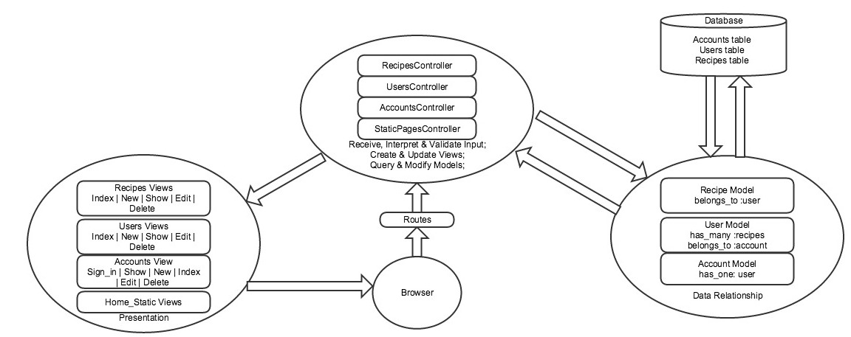

There are three tables in the database: accounts table, users table and recipes table. The class relationships is represented in the following diagram:

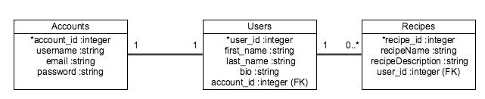

**3. Technical Specifications**

3.1 Operating System

The application is developed using Ubuntu 12.04+ Linux Operating System.

3.2 RubyGems

Here are the gem requirements for this application:

source 'https://rubygems.org'

gem 'rails'**,** '4.2.1'

gem 'bootstrap-sass'**,** '3.2.0.0'

gem 'mysql2'

gem 'sass-rails'**,** '~> 5.0'

gem 'uglifier'**,** '>= 1.3.0'

gem 'coffee-rails'**,** '~> 4.1.0'

gem 'jquery-rails'

gem 'turbolinks'

gem 'jbuilder'**,** '~> 2.0'

gem 'sdoc'**,** '~> 0.4.0'**,** group: **:doc**

group **:development, :test do**

gem 'byebug'

gem 'web-console'**,** '~> 2.0'

gem 'spring'

**end**

**3.3 Database**

This application uses MySQL2 as the database management system and will require MySQL client libraries and Ruby MySQL libraries for database development. Configurations of the development database (config/database.yml) is specified as below:

development:

adapter: mysql2

encoding: utf8

database:

pool: 5

username:

password:

socket: /run/mysqld/mysqld.sock

When using the application, update the configurations to your own database name, MySQL username, and MySQL password.