**Recipe Generator User Documentation**

**Team Buckeye: Asad Iqbal, Tatsumi Suenaga, Qu Chen**

**Prepared By: Qu Chen**

**4/19/15**

1. Ruby on Rails Setup

1.1 Install gem bundler

In your terminal, run

$ bundle install

1.2 Create and Configure your database.yml

In your mysql, create the database named: rails_project_development

mysql> CREATE DATABASE rails_project_development;

In your config/database.yml, change the username and password to your mysql username and password

development:

adapater: mysql2

encoding: utf8

database: rails_project_development

pool: 5

username: #your own username#

password: #your own password#

socket: /var/run/mysqld/mysqld.sock

1.3 Migrate database

In your terminal, run

$ rake db:migrate

Now you should be ready to open up your browser and see the home page

1.4. Run the server

In your terminal, run

$ rails s

Open up the browser and type in the URL

http://localhost:3000

Your should be able to see the home page of recipe generator

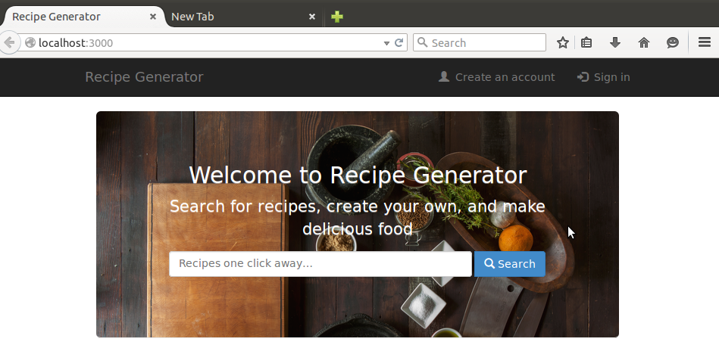

1-1

2. Create Accounts and Sign-in

1. For first time users

Create your account using “Create an account”

:::::Downloads:2.png

2-1-1

Input your username, password and email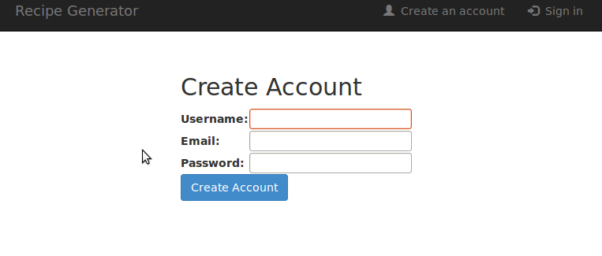

2-1-2

After you create the account, you will be logged in to your profile front page, and from there your could create your profile

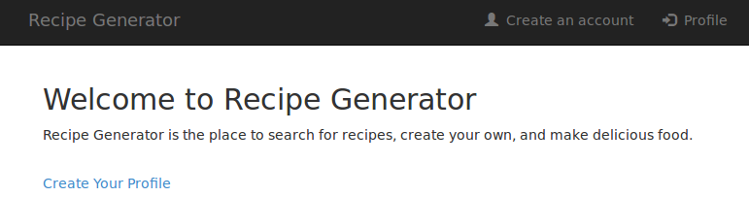

2-1-3

2. For returning users to sign in

To sign in, Click on “Sign in” and type in your username and password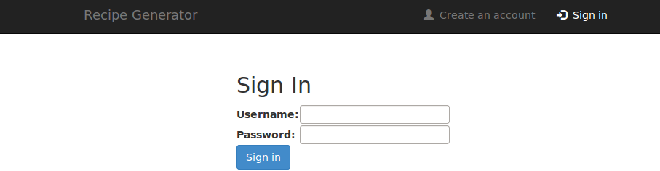

2-2-1

3. Creating duplicate accounts

If you are creating account with a username or an email address that exist in the database, it will not log in to the profile page and will generate a message saying, “That username is already being used” or “ That email is already being used”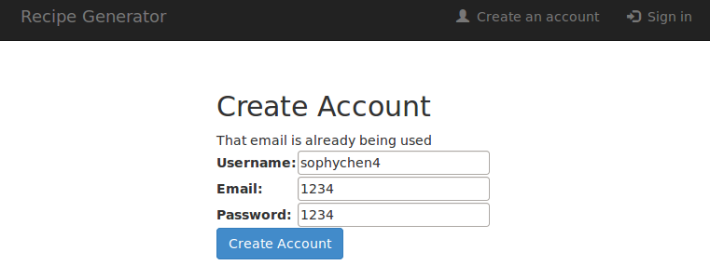

2-3-1

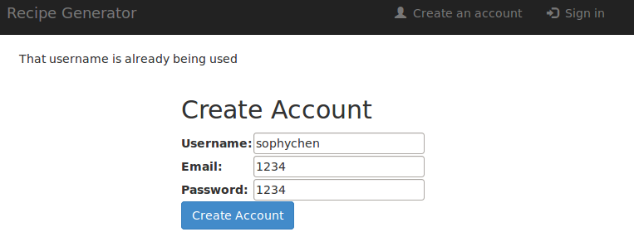

2-3-2

4. Sign in with nonexistent username or wrong password

If you are signing in with a nonsexist username or wrong password, it will not log in and creates an error message saying “Invalid Login”

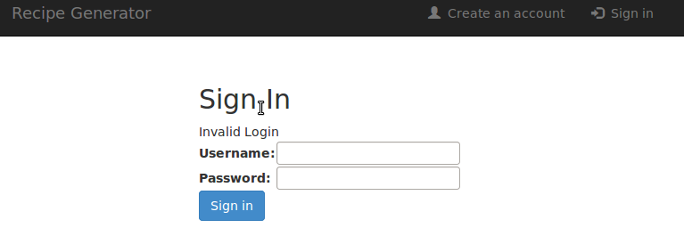

2-3-3

3. Create / View / Edit your Profile

1. Create your profile for the first time

When you first created your account, you will see need to create your profile page as 2-1-3, click in and you are on your profile view page.

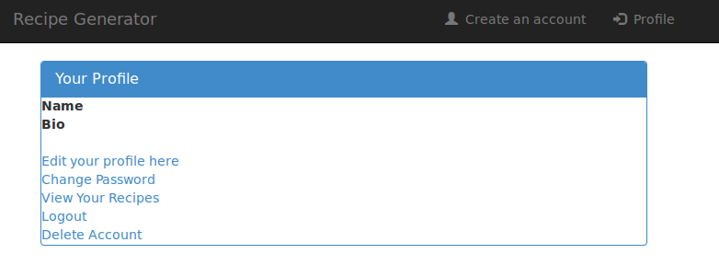

3-1-1

You can see the name and bio is empty, so click on “Edit your profile” and change the information.

In the Edit page, change your first name, last name, and bio, and click on “update profile”.

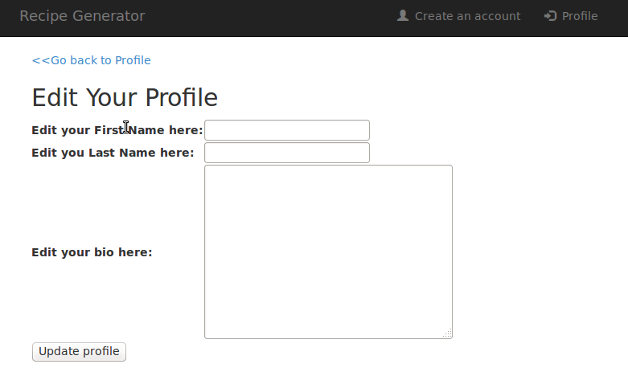

3-1-2

You will be sent back to the profile view page and a confirmation message shows your “user updated successfully” at top.

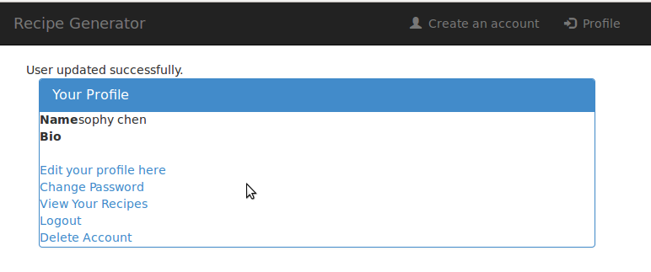

3-1-3

2. To View your profile

When you finish editing your profile or you log in, you will always land on the profile view page. To go back to profile from Edit page or recipe index page, click on “Back to Profile.”

4. Change your password for the account

1. Change your password

On your profile view page, Click on the “Change password” and input old password, new passwords, (2nd password is for confirmation). and click on “Update Account”.

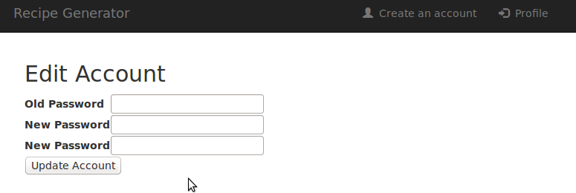

4-1-1

You will be sent back to the profile view page and a confirmation message shows your “password successfully updated”.

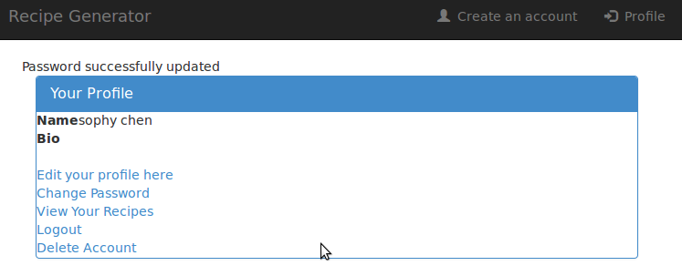

4-1-2

2. Wrong passwords

If you give the wrong old password for the account, an error message will be generated saying, “You password do not match”

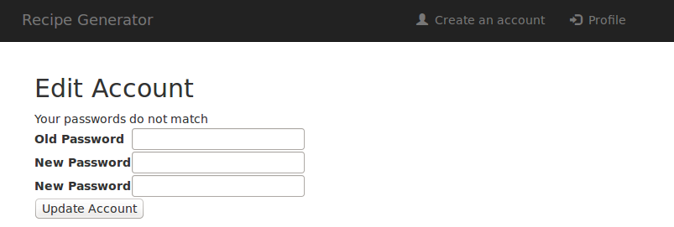

4-2-1

If your first new password does not match the 2nd new password, it will generate the same error as above

5. Log-out

1. To log out from your account, Click on “Logout” on your profile view page and you will be sent back to the Recipe Generator home page

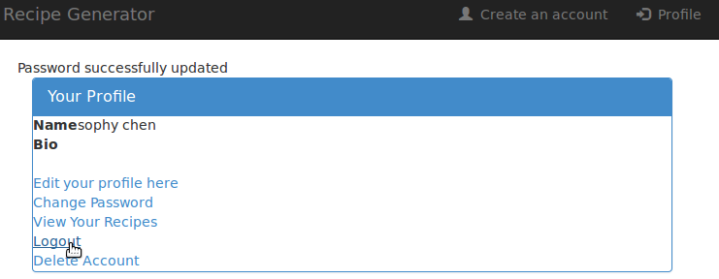

5-1-1

6. View / Add / Edit / Delete recipes

1. Check your recipe list

From the profile page, Click on “View your Recipes”, and you are on the recipe index page.

6-1-1

You can always click on “Back to List” when you are updating or add a new recipe to go back to recipe index page.

6-1-2

2. Show a recipe

Click on the “Show” next to the recipe name to see the recipe description.

6-1-2

3. Add a new recipe

Click on “Add New Recipes” on the recipe index page, you will go to add recipe page. Type in the recipe name and description, and click on “Create Recipe” to save it.

6-3-1

You will be sent back to the recipe index page and a confirmation will show on top.

6-3-2

4. Delete a recipe

Click on the “Delete” button in the index page, recipe will be deleted and a confirmation showing on top of the page.

6-4-1

7. Home page and Searches for Recipes

1. To search for recipes through the API of yummly.com

You could always go back to the home page to search for recipes by clicking on “Recipe Generator” on the top left.

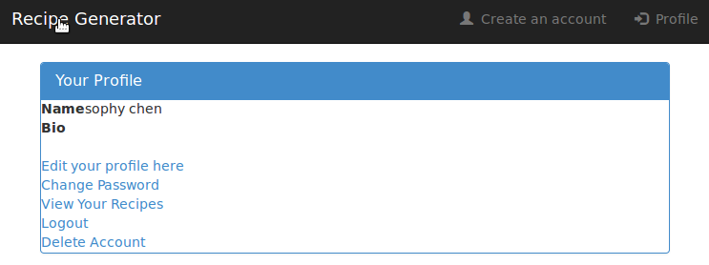

7-1-1

You will be sent back to the home page. Type in the search form, and you will see the search results from yummly.com

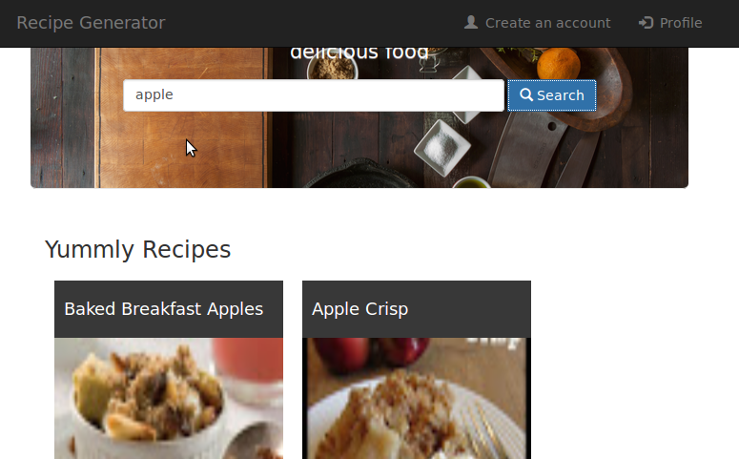

7-1-2

Too see detailed recipe results on yummly, click on “View on Yummly” on the recipe image.

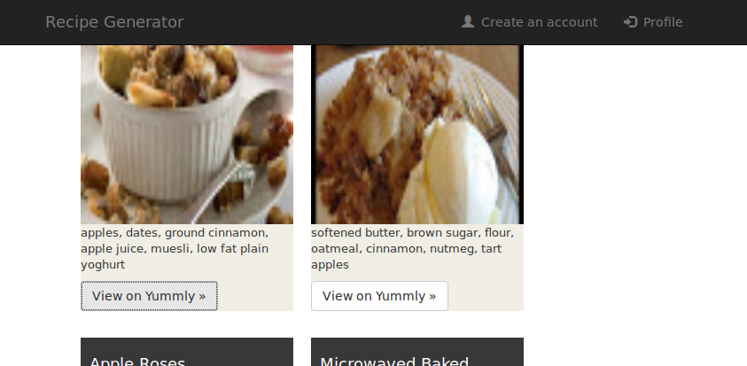

7-1-3

2. Go back to profile page when logged-in

You can always go back to your main profile page when you’re logged in by clicking the “Profile” on the top right corner on home page.