Astrology App — Design Specification
Web Portals · Landing Site · Mobile Apps
Version 1.0 · 2026-04-26
Table of Contents

Table of Contents
# | Section | Page
1 | Overview | 1
2 | Persona Map | 2
3 | Design System | 3
3.1 | Brand Theme | 3
3.2 | Color Tokens | 4
3.3 | Typography | 5
3.4 | Spacing, Radius, Elevation | 5
3.5 | Iconography & Glyphs | 6
4 | Component Library Strategy | 7
4.1 | shadcn/ui Inventory | 7
4.2 | reactbits.dev Inventory | 8
4.3 | Mobile Component Mapping | 9
4.4 | Custom Components | 10
5 | Landing Page | 11
6 | User Web Portal | 14
7 | Astrologer Web Portal | 19
8 | Admin Web Portal | 22
9 | Mobile App — User | 25
10 | Mobile App — Astrologer | 29
11 | Key User Flows | 31
12 | Accessibility & Internationalisation | 32
13 | Motion & Animation Guidelines | 33
14 | Empty, Loading & Error States | 34
15 | Hand-off & Implementation Notes | 35

1. Overview
This document defines the visual design, component composition, screen inventory and interaction patterns for the Astrology App across:
- Public landing site (Next.js 16, server-rendered, marketing).
- Web portals for User, Astrologer, Admin (Next.js 16 App Router, signed-in shells).
- Mobile apps for User and Astrologer (React Native + Expo, single codebase per app).
The component strategy combines two libraries:
- shadcn/ui — accessible, headless-by-default React primitives (forms, tables, sheets, dialogs, charts via Recharts). Drives structure and accessibility.
- reactbits.dev — a curated set of animated, copy-paste React components (Aurora, StarField, MagicBento, ShinyText, TextType, DecryptedText, TiltedCard, ClickSpark, CountUp, etc.). Drives delight, motion, and the celestial brand.
Custom components fill the gap where domain logic is unique — most importantly the Chart Wheel renderer (Western and Vedic North/South Indian), the Aspect Grid heatmap, Synastry Overlay, and the TransitTimeline.
Note on mobile: shadcn/ui ships React-DOM components; on React Native we use the parallel ports referenced as shadcn-rn:* throughout this document — concretely shadcn/react-native (community port) plus NativeWind for Tailwind-class parity, Tamagui as the underlying design-system primitives, and Reanimated 3 for motion. reactbits-style effects on mobile are re-implemented with react-native-skia + Reanimated.

2. Persona Map
Persona | Surface | Primary jobs
Visitor | Landing site | Understand value, sign up, install app
User (free / Plus / Pro) | User web + mobile | Read horoscopes, generate charts, chat with chart, book astrologers
Astrologer | Astrologer web + mobile | Take queue, run live consultations, manage earnings, schedule
Admin / Ops | Admin web | Monitor health, moderate content, manage subscriptions, watch LLM cost, run experiments
Each persona has its own shell (sidebar items, top bar, branding tone). Visitors and users share the brand “celestial night”; admins use a light operations variant of the same tokens for clarity at high information density.

3. Design System

3.1 Brand Theme — Celestial Night
Two skins of one system:
- Astro (default for end-users) — deep indigo background, gold accents, subtle starfield, soft violet glow. Conveys mystery + warmth.
- Light Operations (admin) — same hue family but inverted to a near-white background with violet accents. Optimised for tables, charts, and dense data.
Both skins share radii, spacing, motion timing, and typographic scale.

3.2 Color Tokens
Tokens are defined as CSS variables and consumed via Tailwind’s theme extension. Names match those used in the wireframe code (docs/design/wireframes/_wf.py).
Token | Astro (dark) | Light Ops | Use
--bg | #0e0a1f | #f7f5fb | Page background
--surface | #1a1530 | #ffffff | Top-level cards / shell
--surface-2 | #231a3d | #f0ecfa | Inset cards
--border | #3a2f6b | #d8d2eb | Hairlines
--ink | #e9e3ff | #1a1530 | Primary text
--ink-muted | #998fc7 | #5a4d8c | Secondary text
--brand-gold | #f4c95d | #f4c95d | Highlight / Astro accent
--brand-violet | #7c5cff | #7c5cff | Primary action
--brand-aqua | #3ad6c2 | #3ad6c2 | Success / positive
--brand-rose | #ff6b8a | #ff6b8a | Danger / destructive
Semantic aliases: success = aqua, warning = gold, destructive = rose, info = violet.
Contrast: Every text-on-surface combination meets WCAG 2.2 AA (verified at design time; lint runs in CI via axe-core for the web app).

3.3 Typography
Role | Web | Mobile | Notes
Display | Fraunces (var) | Fraunces SemiBold | Headlines, hero
Body | Inter (var) | Inter | UI copy
Numerals | Inter Tabular | Inter Tabular | Tables, chart degrees
Sanskrit / Hindi | Noto Serif Devanagari | Noto Sans Devanagari | i18n
Glyphs | Noto Sans Symbols 2 | system fallback | Planet/zodiac glyphs
Type scale (rem on web, sp on mobile): 12 / 14 / 16 / 18 / 20 / 24 / 30 / 36 / 48 / 60. Body default 16/24. Headlines use −2% letter-spacing.

3.4 Spacing, Radius, Elevation
- Spacing scale (px): 4 · 8 · 12 · 16 · 20 · 24 · 32 · 40 · 48 · 64. Tailwind space-* aligns 1:1.
- Radius: xs 4, sm 8, md 12, lg 16, xl 24, pill 999. Cards default lg, modal/sheet xl, buttons pill on landing/CTA, md everywhere else.
- Elevation (dark uses gold-tinted glow, light uses violet-tinted shadow):
  - e1 — soft hairline (cards): 0 1px 0 rgba(...)
  - e2 — standard card lift: 0 4px 16px rgba(124,92,255,0.08)
  - e3 — modal / sheet: 0 24px 48px rgba(0,0,0,0.45) (dark) / (124,92,255,0.18) (light)

3.5 Iconography & Glyphs
- UI icons: lucide-react (web) / lucide-react-native (mobile). Stroke 1.5, size 16 / 20 / 24.
- Astrology glyphs: Unicode block Symbols 2 (U+263F – U+26FF) for planets and zodiac, fallback to a tiny custom SVG sprite for crisp rendering at small sizes.
- Empty-state illustrations: 6 hand-illustrated SVG scenes (constellation, telescope, scroll, etc.) — produced by design lead at handoff.

4. Component Library Strategy

4.1 shadcn/ui Inventory (Web)
Generated into src/frontend/components/ui/ on first install; we do not install all of them — only the curated list below. Each is themed with our tokens.
Group | Components
Inputs | Button, Input, Textarea, Form, Label, Checkbox, RadioGroup, Switch, Select, Combobox, DatePicker, DateRangePicker, Slider, Toggle, ToggleGroup, InputOTP
Layout / Containers | Card, Sheet, Dialog, AlertDialog, Drawer, Tabs, Accordion, Collapsible, Separator, ScrollArea, ResizablePanels, Sidebar
Data | Table, DataTable (TanStack), Pagination, Command (cmdk), Calendar, Chart (Recharts wrapper), Progress, Skeleton, Avatar, Badge
Feedback | Toast (Sonner), Tooltip, HoverCard, Popover, ContextMenu, DropdownMenu, AlertDialog, Banner
Theming | ThemeProvider, theme switcher (using next-themes)
Anything outside this list goes through design review before adding — keeps the bundle small and the system coherent.

4.2 reactbits.dev Inventory
Used for delight and the celestial brand. Components are copied (not npm-installed) into src/frontend/components/effects/ so we can adapt them. Below is the curated list and where each is used.
Component | Where it appears | Purpose
Aurora (background) | Landing hero · User Today hero | Mystical animated gradient
StarField / Particles | Landing hero · Mobile splash · onboarding | Celestial atmosphere
Squares / Beams | Admin dashboard background (subtle) | Texture without distraction
VariableProximity (text) | Landing headline · Predictions title | Hover-reactive headline
ShinyText | Hero CTA labels · Muhurta tag | Premium shimmer
DecryptedText | “Reveal” interactions in Predictions / Reports / AI hints | Reinforces “decode the stars” metaphor
TextType | AI Chat assistant streaming bubble | Typewriter feel for live AI output
MagicBento | Landing feature grid · User dashboard tiles · Admin KPI grid | Animated grid with hover spotlight
SpotlightCard | Today’s hero card · Premium upsell cards | Hover spotlight follow
TiltedCard | Pricing cards · Profile avatar card · Compatibility result | 3D tilt on hover
CountUp | KPIs (DAU, earnings, scores) | Animated number entry
ClickSpark | Primary CTA on landing · Onboarding “Reveal” button | Tactile feedback
StarBorder | “Get started” pill · subscribed-tier card | Twinkling border on key surfaces
GradientText | Logo wordmark · Section headings | On-brand gradient text
Performance contract: any reactbits component that animates continuously is paused via IntersectionObserver / Reanimated useAnimatedReaction when off-screen. On low-power mode (battery < 20% on mobile, prefers-reduced-motion on web) we degrade to a static fallback.

4.3 Mobile Component Mapping (React Native)
Web (shadcn/ui) | Mobile (RN) | Library
Button | Pressable + Tamagui Button | tamagui
Card | View + Tamagui Card | tamagui
Sheet | BottomSheet | @gorhom/bottom-sheet
Dialog / AlertDialog | RN Modal + custom | RN core
Tabs | react-native-tab-view | community
DataTable | FlashList + custom rows | shopify
Form / Input | react-hook-form + Tamagui inputs | rhf + tamagui
Calendar | react-native-calendars | community
Chart | victory-native (Recharts equivalent) | community
Toast | sonner-native | community
Skeleton | react-native-skeleton-placeholder | community
Tooltip | custom popover (RN) | in-house
Avatar | expo-image + circular mask | expo
Switch | RN core Switch (themed) | RN core
Combobox | react-native-bottom-sheet + custom | composite
reactbits-style motion → re-built with Reanimated 3 + Skia:
- Aurora / StarField → @shopify/react-native-skia shaders.
- TextType / DecryptedText → Reanimated derived value drives character index.
- TiltedCard → Reanimated useAnimatedSensor(gyroscope) for tilt.
- CountUp → Reanimated withTiming over numeric shared value.
- MagicBento → Reanimated layout grids with shared element transitions.

4.4 Custom Components (Built In-house)
Component | Description | Uses
<ChartWheel /> | SVG-based chart wheel with planets, houses, signs, aspects. Variants: Western circular, North-Indian diamond, South-Indian square. | All chart screens
<AspectGrid /> | Heatmap grid of planet-vs-planet aspects with tooltip drill-down. | Chart Workspace, AI Chat context
<SynastryOverlay /> | Two ChartWheels overlaid with composite midpoints highlighted. | Compatibility
<TransitTimeline /> | D3 horizontal timeline of transits/dashas with bands. | Predictions, Calendar
<DashaProgress /> | Stacked Vimshottari progress bar with sub-periods. | Chart Workspace, Reports
<MuhurtaDayCard /> | Tithi, nakshatra, suitability score, do/don’t list. | Calendar
<ChartChat /> | AI chat shell that injects chart-JSON context invisibly. | AI Chat
<ShareCard /> | OG/social card generator for daily horoscope. | Today screen

5. Landing Page (Public)
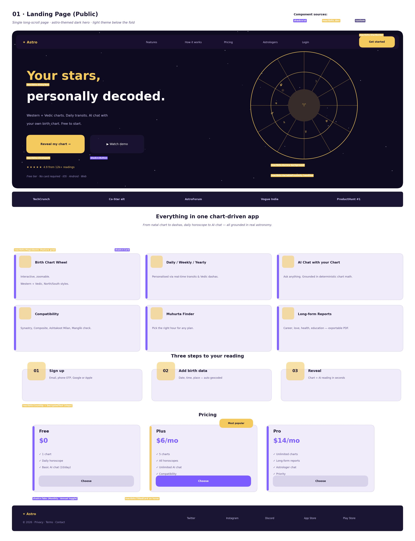
Landing wireframe
Goal: convert a cold visitor into a signed-up user in under 60 seconds.
Sections (top → bottom):
- Hero — Aurora background with subtle StarField; left column has the headline (VariableProximity), sub-copy, primary CTA Reveal my chart → (ClickSpark on press) and a secondary ▶ Watch demo. Right column shows a slowly rotating <ChartWheel />.
- Trust bar — press logos / ratings / install counts.
- Features grid — 6 features in a MagicBento 3×2 grid; each tile is a shadcn Card with a glyph and 2-line summary.
- How it works — 3 numbered steps with animated entry (CountUp on the step numbers, DecryptedText on the step titles).
- Pricing — 3 plans as TiltedCards; “Plus” gets StarBorder + a “Most popular” badge. Toggle Monthly/Annual via shadcn Tabs.
- Testimonials — Carousel of SpotlightCards (shadcn Carousel for structure).
- App download — App Store / Play Store badges, mobile mockup screenshot.
- Footer — sitemap, legal links, social, language toggle.
Components used: reactbits:Aurora, reactbits:StarField, reactbits:VariableProximity, reactbits:ShinyText, reactbits:MagicBento, reactbits:TiltedCard, reactbits:StarBorder, reactbits:ClickSpark, reactbits:CountUp, reactbits:DecryptedText; shadcn:Button, shadcn:Card, shadcn:Tabs, shadcn:Carousel, shadcn:Sheet (mobile nav).
Performance: Hero loads under 2.0s LCP on mid-tier 4G mobile. Heavy reactbits effects are deferred to post-LCP via requestIdleCallback.

6. User Web Portal
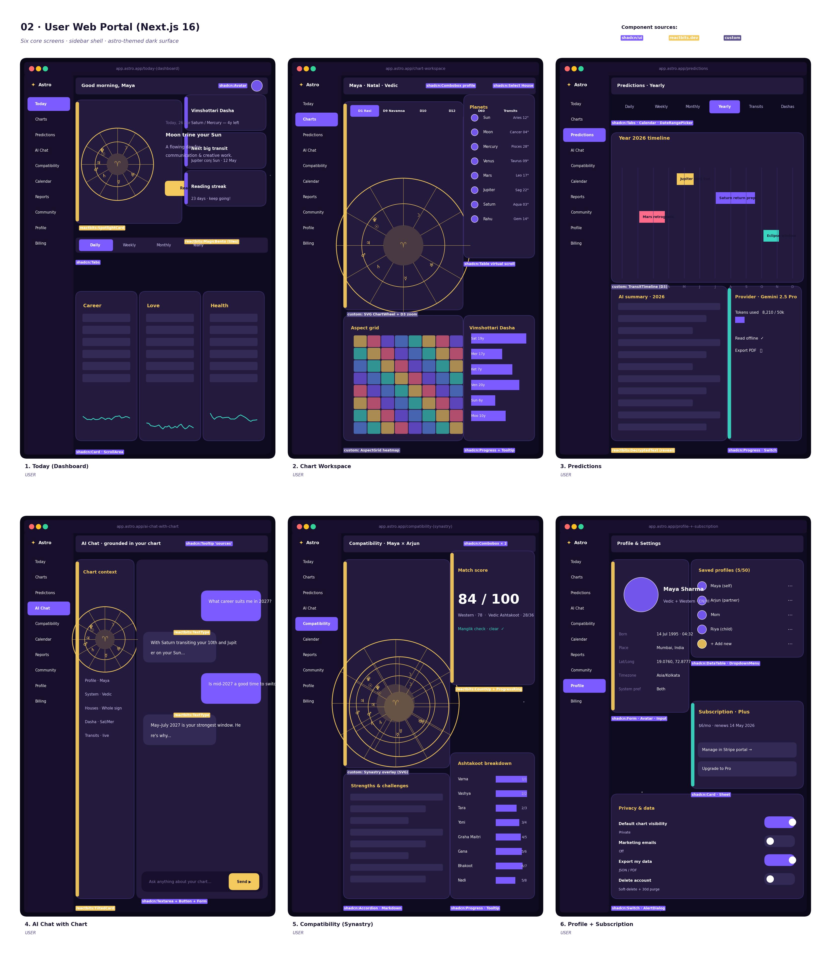
User web wireframe
The user portal uses a collapsible sidebar shell (shadcn Sidebar primitive, new in late 2025) with 10 nav items: Today, Charts, Predictions, AI Chat, Compatibility, Calendar, Reports, Community, Profile, Billing.

6.1 Today (Dashboard)
Purpose: the daily landing surface — what’s happening for me right now.
- Header card: chart wheel preview + the day’s headline aspect (reactbits:SpotlightCard).
- Right column tiles: dasha summary, next big transit, reading streak (reactbits:MagicBento).
- Tabs: Daily / Weekly / Monthly / Yearly (shadcn:Tabs).
- Mini cards under tabs: Career, Love, Health (shadcn:Card + sparklines).
- CTA tile inviting AI chat or report generation.

6.2 Chart Workspace
Purpose: the pro tool — explore the chart in depth.
- Top bar: profile combobox, system + house selectors (shadcn:Combobox, shadcn:Select).
- Tab strip for divisional charts: D1, D9, D10, D12, D60, Transits.
- Center: large <ChartWheel /> with zoom and orb sliders.
- Right rail: <PlanetTable /> (shadcn Table with virtualized rows).
- Bottom: <AspectGrid /> and <DashaProgress />.

6.3 Predictions
Purpose: zoom out to the year.
- Tabs: Daily / Weekly / Monthly / Yearly / Transits / Dashas (shadcn:Tabs).
- Yearly: <TransitTimeline /> with coloured bands per transit.
- Long-form AI summary card with reactbits:DecryptedText reveal.
- Right card: provider / token / cost meter (transparency).

6.4 AI Chat with Chart
Purpose: unbounded Q&A grounded in the user’s chart math.
- Left rail: chart context card (reactbits:TiltedCard) — wheel + key facts.
- Right pane: chat thread; assistant bubbles use reactbits:TextType for streaming feel.
- Input: shadcn Textarea + Button. Quick-prompt chips above the input.
- “Sources” tooltip on each AI answer (shadcn Tooltip).

6.5 Compatibility (Synastry)
Purpose: check the relationship.
- Picker: two profiles (shadcn Combobox × 2).
- Left: <SynastryOverlay /> of two wheels.
- Right: animated score (reactbits:CountUp 0→84) inside a progress ring, plus Manglik / Ashtakoot breakdown bars.
- Bottom: long-form “strengths & challenges” (shadcn Accordion).

6.6 Profile + Subscription
Purpose: identity, profiles, plan, privacy.
- Identity card (avatar, birth data, system pref).
- Multi-profile list (shadcn DataTable with row menu).
- Subscription card with portal link (Stripe).
- Privacy controls — shadcn Switch rows for visibility, marketing, delete account (shadcn:AlertDialog).
Other user screens (not pictured but in scope) follow the same shell: Calendar (Muhurta + transits, see mobile mock), Reports (long-form AI export), Community feed, Billing/invoices.

7. Astrologer Web Portal
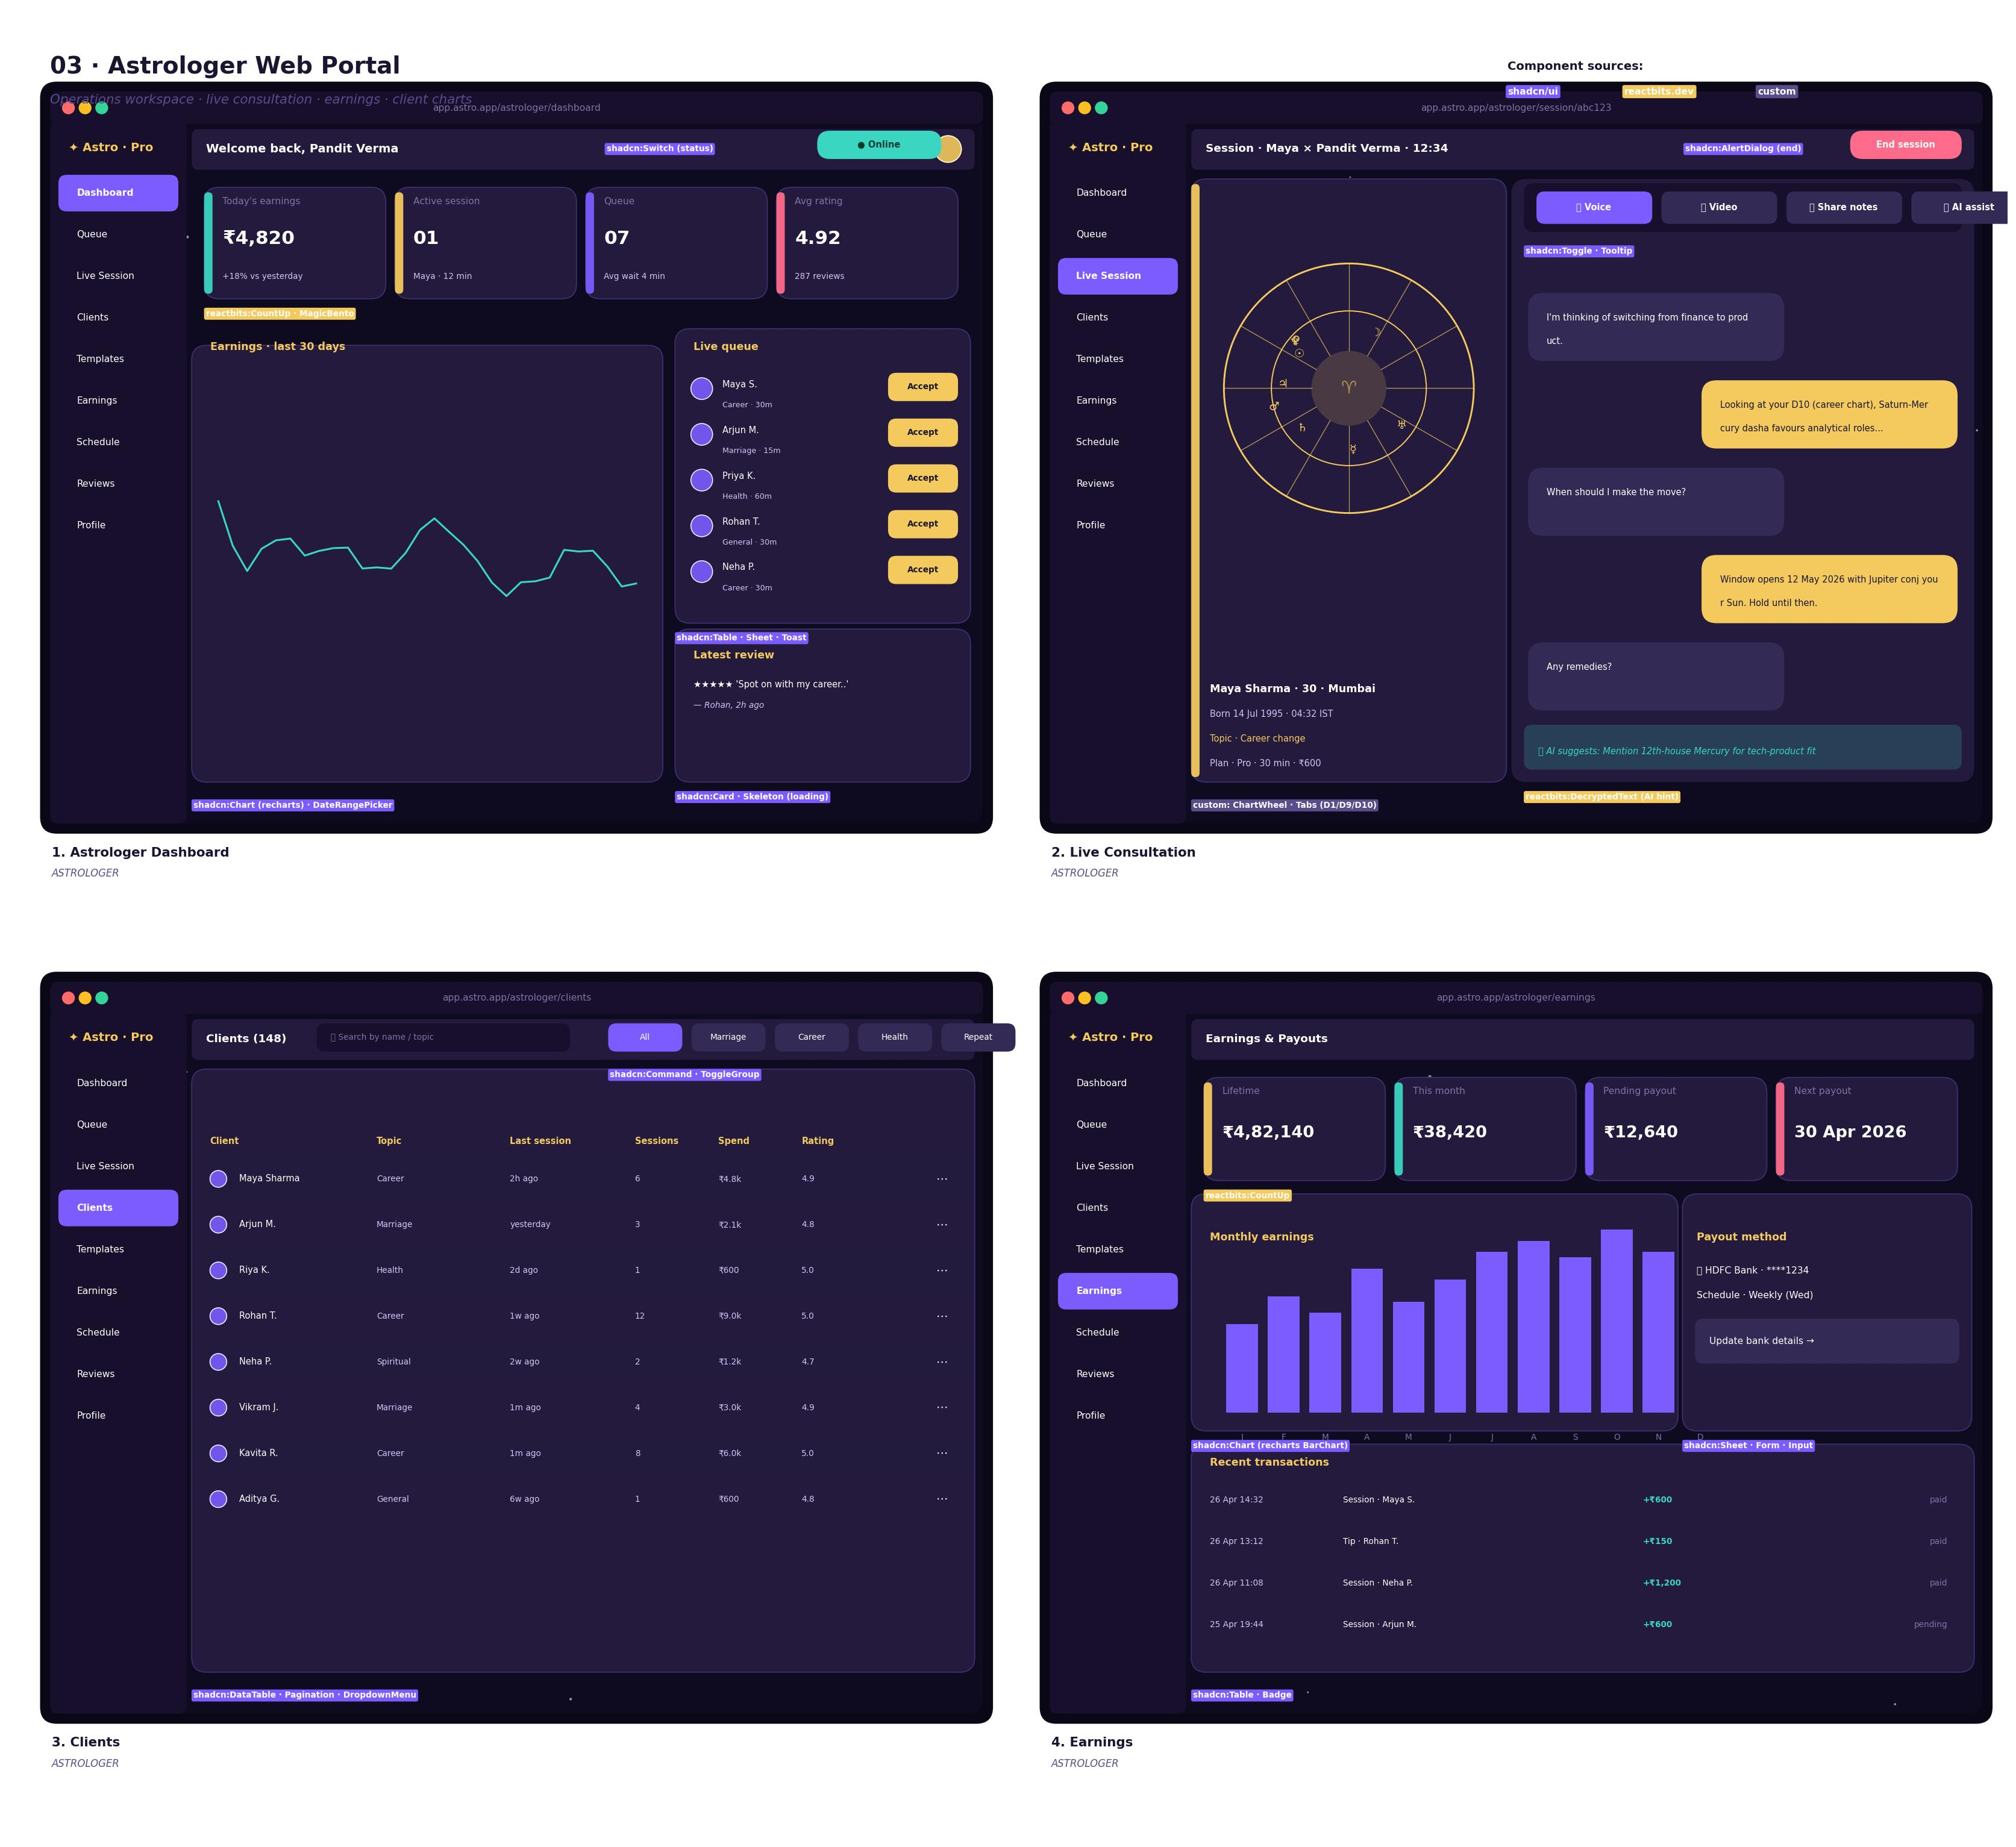
Astrologer web wireframe
Astrologer shell uses the Astro skin with a Pro badge in the logo. 9 nav items: Dashboard, Queue, Live Session, Clients, Templates, Earnings, Schedule, Reviews, Profile.

7.1 Dashboard
KPIs (today’s earnings, active session, queue, rating) in reactbits:MagicBento. Earnings sparkline (Recharts) and live queue with “Accept” buttons. Online/offline status toggle in top bar (shadcn Switch).

7.2 Live Consultation
Split layout: client mini-chart context on the left, chat thread + voice/video toggles on the right. AI-assist hint bar surfaces relevant chart facts in real time (reactbits:DecryptedText). End-session button gated by shadcn AlertDialog to avoid accidental termination.

7.3 Clients
Searchable, filterable shadcn:DataTable with rows for client, topic, last session, total spend, average rating. Row menu opens a sheet with the client’s chart and notes (shadcn Sheet).

7.4 Earnings
KPI strip + monthly bar chart + payout method form + recent transactions list. Payout settings live in a shadcn Sheet to keep the page calm.
Templates (saved prompt blocks for common readings), Schedule (slot calendar), Reviews (paginated list), and Profile (verification, photo, languages) follow the same patterns and are not pictured separately.

8. Admin Web Portal
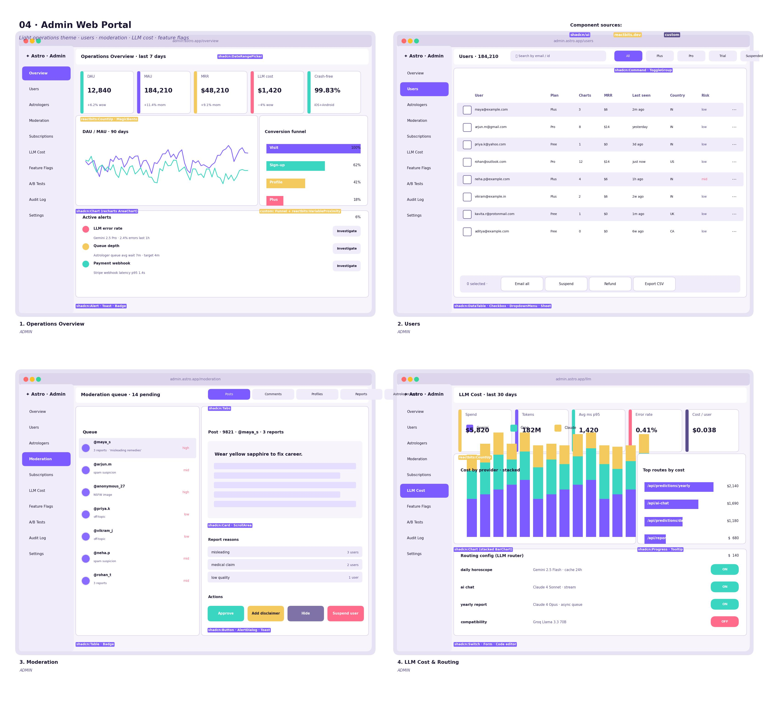
Admin web wireframe
Admin uses the Light Operations skin for clarity at high information density. 10 nav items: Overview, Users, Astrologers, Moderation, Subscriptions, LLM Cost, Feature Flags, A/B Tests, Audit Log, Settings.

8.1 Overview
- 5 KPI cards (DAU, MAU, MRR, LLM cost, crash-free).
- DAU/MAU 90-day chart (shadcn:Chart AreaChart).
- Conversion funnel (custom built from shadcn Progress + labels).
- Active alerts panel — clickable to drill into incidents.

8.2 Users
A shadcn:DataTable with row checkboxes, search (shadcn:Command), filter chips (Plan, Risk, Country). Bulk action bar at the bottom: Email all, Suspend, Refund, Export CSV. Row click opens a Sheet with user detail, sessions, charts, billing, audit timeline.

8.3 Moderation
Two-pane layout: queue list on the left, detail viewer on the right. Detail shows the offending content, report reasons, and a row of action buttons (Approve, Add disclaimer, Hide, Suspend user) — destructive actions go through an AlertDialog.

8.4 LLM Cost & Routing
- KPIs: spend, tokens, p95 latency, error rate, cost per user.
- Stacked bar chart showing cost split by provider (Gemini / Groq / Claude) per day.
- Top routes by cost, ranked.
- Routing config table — toggle providers per route via shadcn:Switch. Editing the routing rule opens a code editor in a Sheet.
Astrologers (verification queue, payout limits, KYC), Subscriptions (Stripe sync, churn cohorts), Feature Flags (variant control), A/B Tests (per-template lift), Audit Log (immutable timeline), and Settings all follow the same DataTable + Sheet pattern.

9. Mobile App — User
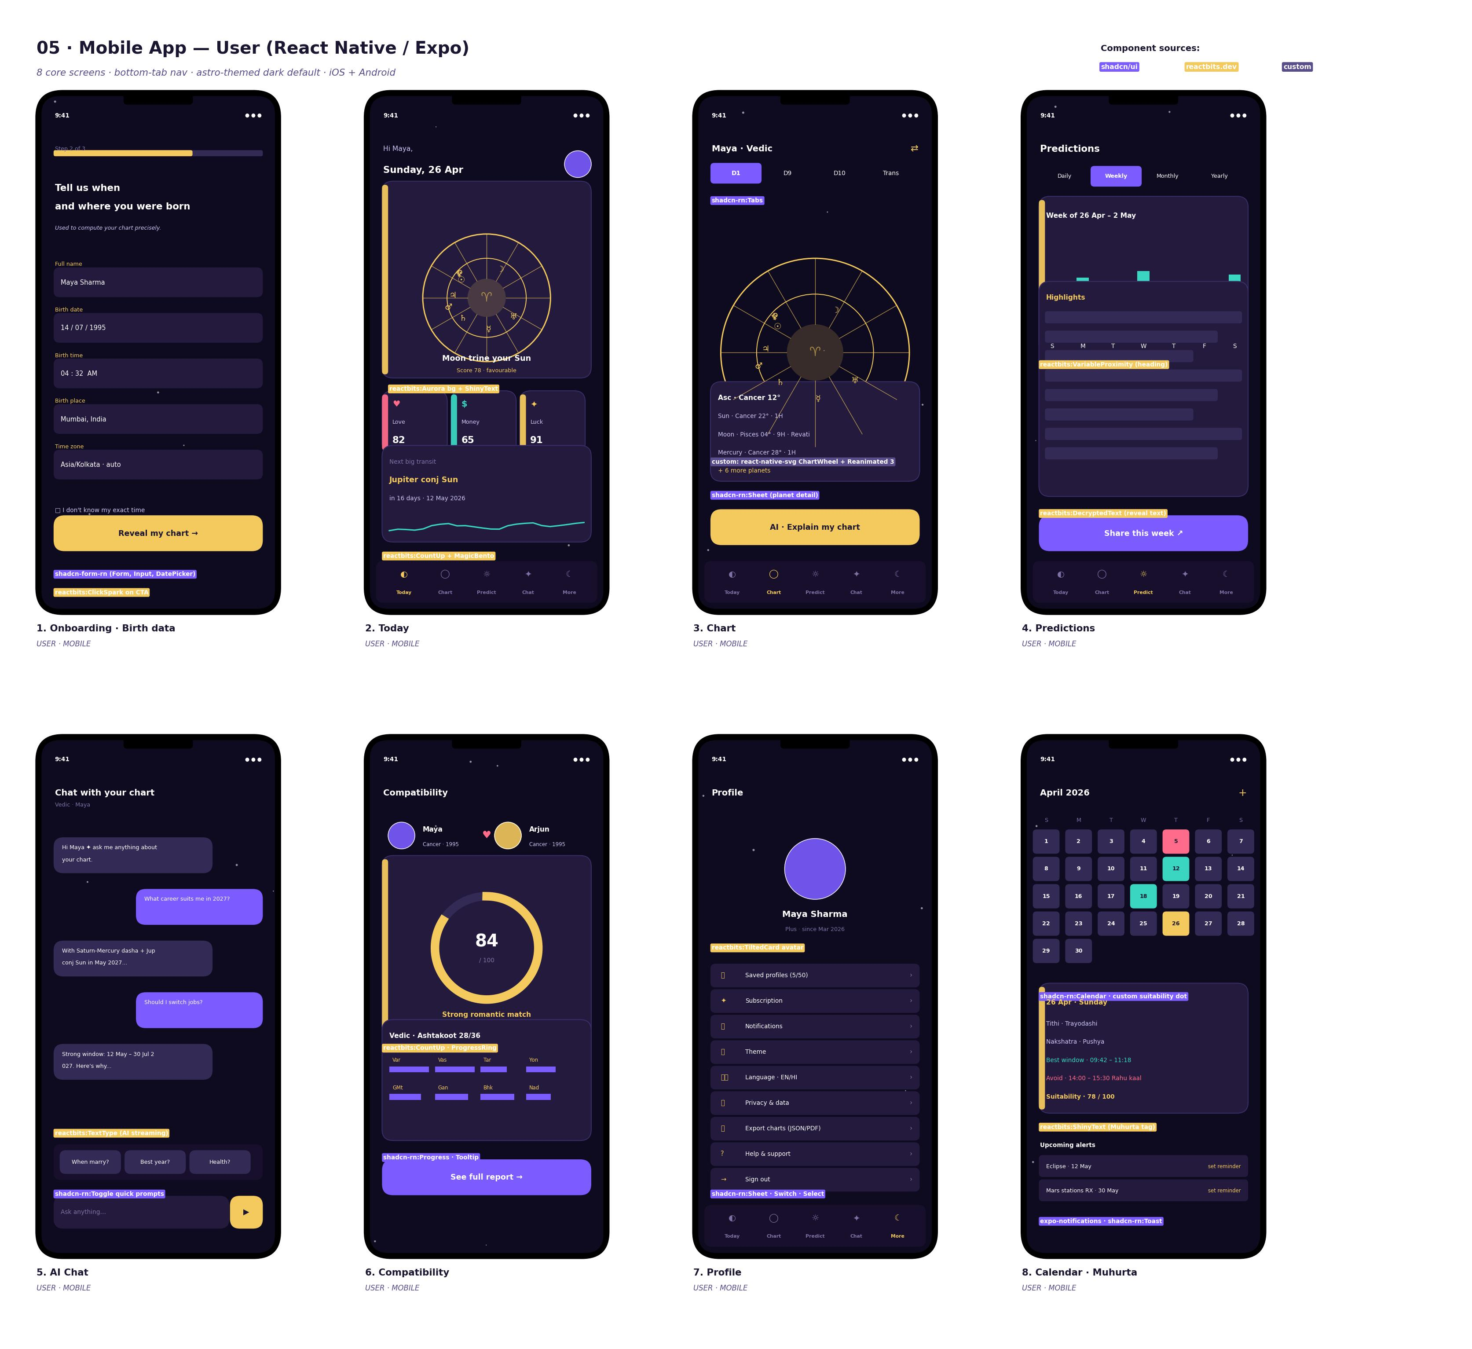
Mobile user wireframes
Navigation: bottom-tab bar with 5 tabs — Today, Chart, Predictions, AI Chat, More. Onboarding is a full-screen flow before first tab.

9.1 Onboarding · Birth Data (3 steps)
- Step 1: account (email/phone OTP/Google/Apple — handled by expo-auth-session).
- Step 2 (pictured): birth data — name, date, time, place (auto-geocoded via shadcn-rn Combobox calling our Nominatim/OpenCage proxy), timezone (auto). “Don’t know my time” checkbox sets the rectified-chart flag.
- Step 3: system preference (Western / Vedic / Both) and notification permission ask. Reanimated step progress bar at top.

9.2 Today
The mobile equivalent of the web Today screen. Hero card (Aurora bg, chart wheel preview, headline aspect). Three mini-cards Love / Money / Luck (reactbits:MagicBento mobile port). Next-big-transit card with sparkline.

9.3 Chart
Tabs for D1 / D9 / D10 / Transits. Centerpiece: <ChartWheel /> rendered with react-native-svg and animated by Reanimated (rotate to current degree, pinch-to-zoom). Tap a planet → bottom sheet with details (shadcn-rn Sheet). CTA: “AI · Explain my chart”.

9.4 Predictions
Tabs Daily / Weekly / Monthly / Yearly. Weekly view: 7-day suitability bars. Below: AI-narrated highlights with reactbits:DecryptedText reveal. Share button generates a <ShareCard /> and opens the OS share sheet.

9.5 AI Chat
Streaming bubbles (reactbits:TextType ported via Reanimated). Quick-prompt chips above the input. Input has a gold send button — long-press to record voice (Phase 2).

9.6 Compatibility
Two avatars at the top (current user + selected partner). Big animated score ring (reactbits:CountUp). Ashtakoot mini-grid below. CTA opens the full report.

9.7 Profile
Profile card + grouped settings list (Saved profiles, Subscription, Notifications, Theme, Language, Privacy, Export, Help, Sign out).

9.8 Calendar · Muhurta
Month grid with suitability dots (gold / aqua / rose). Selected day card shows tithi, nakshatra, best window, avoid window, suitability score. Upcoming alerts list with set-reminder action (uses expo-notifications).

10. Mobile App — Astrologer
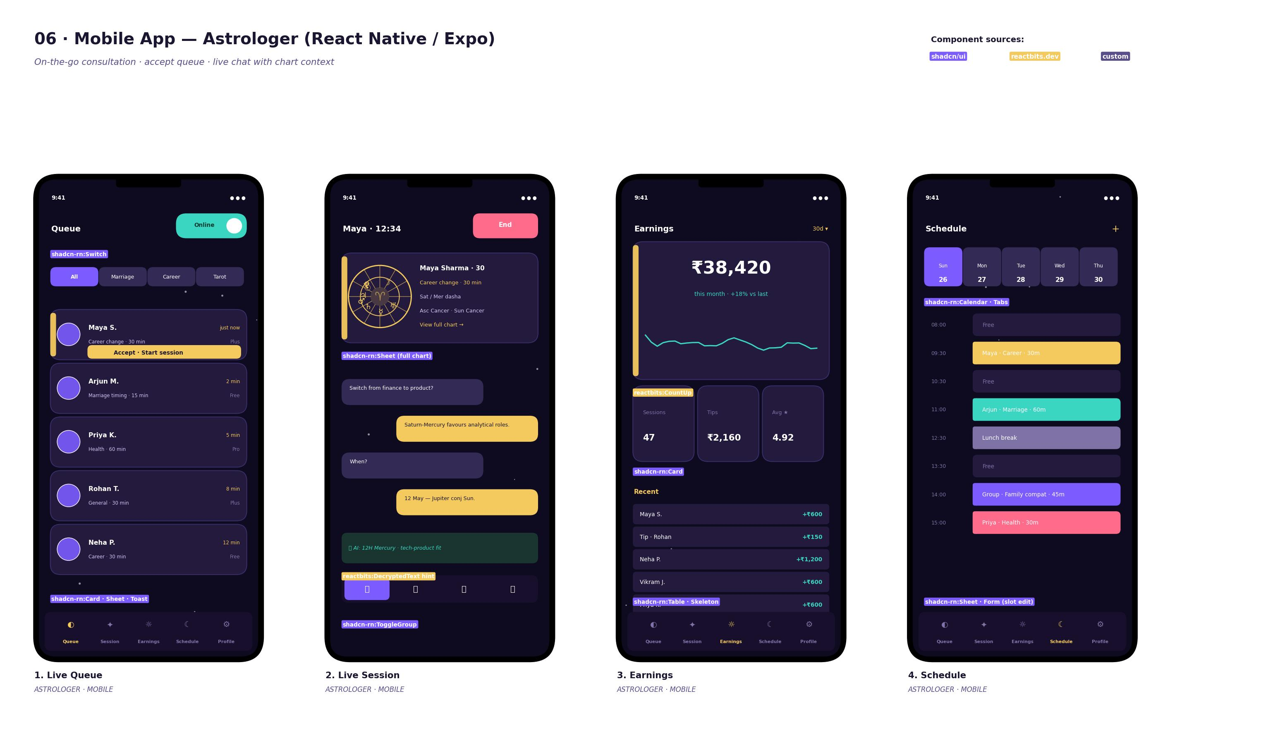
Mobile astrologer wireframes
Navigation: 5-tab bottom bar — Queue, Session, Earnings, Schedule, Profile.

10.1 Live Queue
Online/offline Switch in the top right. Filter chips for topic (Marriage, Career, Tarot). Cards for each waiting client with name, topic, wait time and plan. Top card highlighted with gold border + “Accept · Start session” button.

10.2 Live Session
Top: session timer + End button (gated by AlertDialog). Client mini-chart context card with key facts. Chat thread below. AI-assist hint pill surfaces relevant chart points. Mode toggles at the bottom: text / voice / video / attachments.

10.3 Earnings
Hero: ₹38,420 with reactbits:CountUp and trend. Mini-KPIs: Sessions, Tips, Avg rating. Recent transactions list with status.

10.4 Schedule
Week strip + time-slot list. Each slot is colour-coded by booking status. Tap a slot → edit sheet (shadcn-rn Sheet with Form).
Profile (verification status, photo, languages, payout bank details) is the fifth tab and reuses the User Profile pattern.

11. Key User Flows
Below are the four highest-traffic flows, written as goal → step → component → outcome so they can be implemented and tested directly. Other flows (compatibility, report generation, astrologer booking) follow the same structure and are documented in docs/design/flows/ (per-flow markdown).

11.1 First-time User → Personalised Reading
# | Step | Surface | Components | Success signal
1 | Land on hero | Landing | Aurora, VariableProximity, ClickSpark CTA | Click Reveal my chart
2 | Sign up | Auth modal | shadcn:Form, Input, Button, NextAuth | Account created
3 | Birth data | Onboarding step 2 | shadcn:DatePicker, Combobox (geocoding) | Lat/long resolved
4 | Compute chart | Loader | shadcn:Skeleton + reactbits:StarField | Chart JSON ready
5 | First reveal | Today | reactbits:DecryptedText + SpotlightCard | User reads first reading
6 | Save streak | Today (next day) | reactbits:CountUp | Streak +1

11.2 User Asks AI Chat a Career Question
# | Step | Surface | Components | Success signal
1 | Open AI Chat | Sidebar nav / mobile tab | shadcn:Sidebar / TabBar | Chat screen mounts
2 | Type prompt | Input | shadcn:Textarea | Submit
3 | Stream answer | Bubble | reactbits:TextType | Tokens visible <600ms first token
4 | Show sources tooltip | Bubble | shadcn:Tooltip | Cites chart facts
5 | Save to “My readings” | Action | shadcn:DropdownMenu | Persisted to DB

11.3 Astrologer Takes a Live Session
# | Step | Surface | Components | Success signal
1 | Toggle Online | Dashboard top bar | shadcn:Switch | Status pushed to server
2 | Accept queue card | Queue | shadcn:Card + Button | Session created
3 | See client chart | Live Session | custom:ChartWheel | Chart loads <500ms
4 | Use AI hint | Hint bar | reactbits:DecryptedText | Suggestion appears
5 | End session | Top bar | shadcn:AlertDialog | Receipt + payout queued

11.4 Admin Investigates an LLM Cost Spike
# | Step | Surface | Components | Success signal
1 | See alert | Overview | shadcn:Alert + Toast | Click “Investigate”
2 | Open LLM Cost | Sidebar | Light skin sidebar | Cost dashboard mounts
3 | Drill route | Top routes panel | shadcn:Progress + Tooltip | Route identified
4 | Edit routing | Routing config | shadcn:Switch + Sheet (code editor) | Switch provider, save
5 | Verify | Real-time chart | shadcn:Chart | Cost curve flattens

12. Accessibility & Internationalisation
- WCAG 2.2 AA target across all surfaces. CI fails the build if axe-core finds a serious violation on a key route.
- All interactive elements ≥ 44 × 44 pt touch target on mobile.
- Focus rings: 2px violet outline on dark, 2px gold on light. Never removed.
- VoiceOver / TalkBack: every chart-wheel planet renders an accessible label like “Sun in Cancer at 22 degrees, first house”. Decorative effects (StarField, Aurora) are aria-hidden.
- Reduced motion: when prefers-reduced-motion: reduce is true (web) or Reduce Motion is on (iOS) / Remove animations on Android — Aurora becomes a still gradient, TextType becomes instant text, CountUp becomes the final value.
- i18n: EN, HI, plus 2 regional Indian languages chosen at kickoff. RTL not in scope for v1. Number formatting via Intl.NumberFormat. Astrology terms keep the Sanskrit/IAST original alongside the translation in glossary entries.

13. Motion & Animation Guidelines
Property | Token | Use
Easing | cubic-bezier(0.22, 1, 0.36, 1) | Default for entrances
Easing | cubic-bezier(0.65, 0, 0.35, 1) | Default for exits
Duration | 150ms | Hover / micro-interactions
Duration | 220ms | Tab swap, card reveal
Duration | 420ms | Sheet / dialog enter
Duration | 1200ms | DecryptedText reveal
Duration | 2000ms | CountUp KPI roll
Rules:
- Animate purpose, not decoration. Every animation either signals state (loading, success) or communicates spatial relationship (sheet slides up from bottom).
- Don’t double-animate. If reactbits already animates the entrance, don’t add a Tailwind animate-fade-in.
- Cap continuous loops to 3. Aurora, StarField, gradient text — anything more is noise.
- Always cancel on unmount. Reanimated cancelAnimation, web requestAnimationFrame cancellation.

14. Empty, Loading & Error States
Each major surface has explicit states:
- Empty — illustration + 1-line headline + 1 CTA. e.g. Compatibility before any partner profile is added.
- Loading — shadcn:Skeleton rows that match the eventual layout, not a global spinner.
- Error — friendly message + retry CTA + (in dev) a “Copy error” button. Errors are reported to Sentry with the route + user id.
- Offline (mobile) — banner: “You’re offline · showing cached chart”. Disabled actions become non-interactive but stay visible.
- Rate-limited (AI chat) — soft block with countdown using reactbits:CountUp inverted.

15. Hand-off & Implementation Notes
- Source files for these wireframes live in docs/design/wireframes/gen_*.py. They are matplotlib generators; rerun python3 docs/design/wireframes/gen_*.py to refresh.
- Tokens are exported as JSON at src/frontend/styles/tokens.json and consumed by Tailwind (web) + NativeWind (mobile) via a shared build step.
- Storybook (web) at apps/web/.storybook — every shadcn and reactbits component has a story with all states (default, hover, focus, disabled, loading, error). PRs that add a UI component must add a story.
- Figma library — generated at handoff from this spec; tokens stay synced via the Figma Tokens plugin pointing at tokens.json.
- Definition of Done (UI): implemented, themed (both skins where applicable), responsive (mobile-first breakpoints sm 640 / md 768 / lg 1024 / xl 1280 / 2xl 1536), accessible (axe pass), i18n-ready (no hard-coded copy), tested (Storybook + at least one unit test), reviewed.

End of Design Specification — version 1.0 — 2026-04-26.

