MicroDataCenter Platform
Technical Implementation Roadmap
PDM Observability · MeshCentral · NetFlow
Audience: Backend & frontend engineers on the MDC platform
Status: Draft v1

1. Purpose & Scope
This document is an implementation-oriented roadmap for three new capabilities on the MDC platform: PDM-sourced observability, MeshCentral remote connectivity, and tiered distributed NetFlow. It is written for engineers who will write the code. It is not a commercial proposal.
Each integration is described with:
- a concrete target folder layout inside the three existing repositories,
- the C# types, interfaces and background services to add to MicroDataCenter-WebAPI,
- the EF Core entities and migrations required,
- the HTTP / OData endpoint contracts exposed to the two Next.js frontends,
- the frontend route and component additions,
- the testing strategy needed before the slice can be considered done.

2. Existing Codebase Baseline
The three repositories the work lands in:
Repo | Stack | Relevant existing surfaces
MDC-web-dashboard | Next.js 14 / React 18, MSAL, Zustand, React Query, Tailwind | src/app/ (routes), src/lib/mdc, src/lib/bridge, src/lib/api, src/stores, src/types
MDC-admin-frontend | Next.js 14 / React 18, MSAL, Zustand, React Query, Tailwind | src/app/admin, src/lib/mdc, src/lib/api, src/stores, src/types
MicroDataCenter-WebAPI | .NET 10, C#, Controllers + OData, EF Core 10, JWT Bearer + API Key | MDC.Api/Controllers, MDC.Core/Services/Providers/{PVEClient,ZeroTier,MDCDatabase,MDCEndpoint,DatacenterFactory}, MDC.Core/Models, MDC.Shared
All three integrations add new provider modules under MDC.Core/Services/Providers/ without modifying the existing OData contracts, the WebSocket VNC relay, or the Entra ID authentication path.

3. System Overview
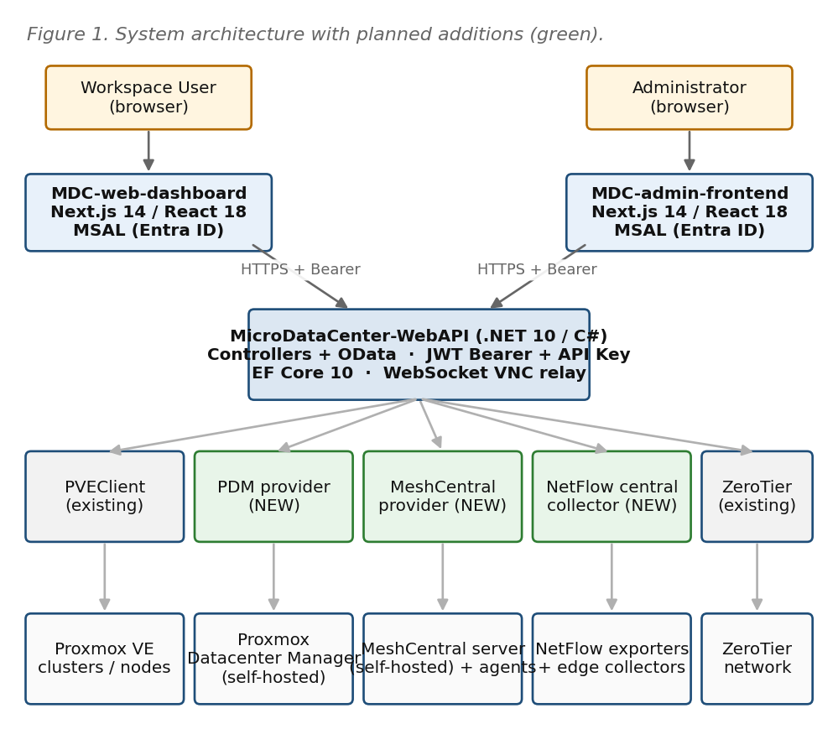
Figure 1 — Current platform with planned additions (green boxes).
Three external dependencies are introduced: a self-hosted Proxmox Datacenter Manager, a self-hosted MeshCentral server, and the NetFlow ingest path. All three are reached only by the backend; browsers never talk to them directly.

4. Repository Impact Map
Repository | New directories / files (abridged)
MicroDataCenter-WebAPI | MDC.Core/Services/Providers/ProxmoxDatacenterManager/*  MDC.Core/Services/Providers/MeshCentral/*  MDC.Core/Services/Providers/NetFlow/* (central)  MDC.EdgeCollector/* (new project for edge deployment)  MDC.Core/Models/Observability/*  MDC.Core/Models/Mesh/*  MDC.Core/Models/NetFlow/*  MDC.Core/Migrations/* (3 new migrations)  MDC.Api/Controllers/ObservabilityController.cs  MDC.Api/Controllers/MeshController.cs  MDC.Api/Controllers/FlowsController.cs  MDC.Api/Controllers/FlowExportersController.cs
MDC-web-dashboard | src/app/workspaces/[id]/network/* (NetFlow per-interface view)  src/app/workspaces/[id]/vms/[vmid]/observability/*  src/app/workspaces/[id]/vms/[vmid]/remote/* (MeshCentral launcher)  src/lib/api/observability.ts, flows.ts, mesh.ts  src/components/observability/*, network/*, mesh/*  src/hooks/useObservability.ts, useFlows.ts, useRemoteSession.ts
MDC-admin-frontend | src/app/admin/observability/* (fleet/clusters/nodes/storage/events)  src/app/admin/netflow/* (exporters, explorer, physical, per-VM)  src/app/admin/mesh/* (device health, groups, audit)  src/lib/api/{observability,flows,mesh}.ts  src/components/{observability,netflow,mesh}/*

5. Integration A — Proxmox Observability via PDM

5.1 Architecture
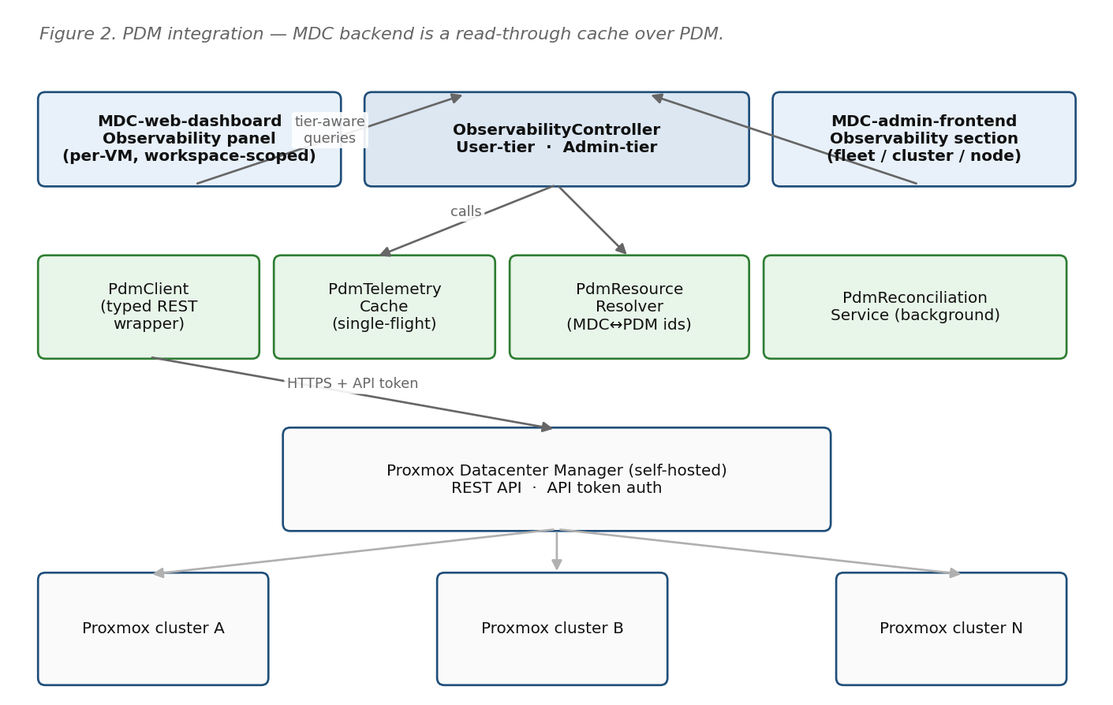
Figure 2 — PDM integration. MDC backend is a thin, tier-aware, cached adapter over PDM.

5.2 Backend Folder Layout
[tree]
MDC.Core/Services/Providers/ProxmoxDatacenterManager/
├── PdmClient.cs // typed REST wrapper
├── PdmClientOptions.cs // base URL, token, timeouts
├── PdmResourceResolver.cs // MDC ↔ PDM id mapping
├── PdmTelemetryCache.cs // short-TTL single-flight cache
├── PdmReconciliationService.cs // BackgroundService
├── PdmHealthCheck.cs
├── Dto/
│ ├── PdmCluster.cs / PdmNode.cs / PdmVm.cs
│ └── PdmMetricsSample.cs
└── Extensions/
└── ServiceCollectionExtensions.cs

5.3 Key Types (skeleton)
[csharp]
public interface IPdmClient
{
Task<IReadOnlyList<PdmCluster>> ListClustersAsync(CancellationToken ct);
Task<IReadOnlyList<PdmNode>> ListNodesAsync(string clusterId, CancellationToken ct);
Task<IReadOnlyList<PdmVm>> ListVmsAsync(string clusterId, CancellationToken ct);
Task<PdmMetricsSample> GetVmMetricsAsync(PdmVmRef vm, CancellationToken ct);
Task<PdmMetricsSample> GetNodeMetricsAsync(PdmNodeRef node, CancellationToken ct);
Task<IReadOnlyList<PdmEvent>> GetRecentEventsAsync(int take, CancellationToken ct);
}
public sealed class PdmTelemetryCache
{
// TTL: metrics 5s, inventory 60s, events 10s (all configurable).
// Collapses concurrent identical requests into one upstream call (single-flight).
public Task<T> GetOrFetchAsync<T>(string key, TimeSpan ttl, Func<Task<T>> loader);
}
public sealed class PdmResourceResolver
{
public Task<PdmVmRef?> ResolveVmAsync(Guid virtualMachineEntryId);
public Task<Guid?> ResolveWorkspaceAsync(PdmVmRef vm);
public Task ReconcileAsync(CancellationToken ct);
}

5.4 EF Entity & Migration
[csharp]
public sealed class PdmResourceLink // MDC.Core/Models/Observability
{
public Guid Id { get; set; }
public Guid VirtualMachineEntryId { get; set; }
public string PdmClusterId { get; set; } = default!;
public string PdmNodeId { get; set; } = default!;
public int PdmVmid { get; set; }
public DateTime LastReconciledUtc{ get; set; }
public bool IsStale { get; set; }
}
// Unique index on (PdmClusterId, PdmVmid). FK to VirtualMachineEntry.
// Migration: AddPdmResourceLink_20260420.cs

5.5 Configuration (appsettings)
[json]
"Pdm": {
"BaseUrl": "https://pdm.internal.example.com",
"ApiTokenSecretName": "pdm-api-token",
"MetricsCacheSeconds": 5,
"InventoryCacheSeconds": 60,
"ReconcileIntervalMinutes": 10,
"RequestTimeoutSeconds": 10
}

5.6 HTTP API Surface
Method & route | Tier | Purpose
GET /api/observability/vms/{vmId}/metrics | User / Admin | Live CPU, memory, disk I/O, network throughput for a single VM. User-tier: 403 if VM not in caller's workspaces.
GET /api/observability/workspaces/{wsId}/summary | User | One-row-per-VM health summary, workspace-scoped.
GET /api/observability/fleet | Admin | All clusters with aggregate health and quorum state.
GET /api/observability/clusters/{id}/nodes | Admin | Node list with per-node health.
GET /api/observability/nodes/{id}/metrics | Admin | Host-level CPU/memory/IO/network.
GET /api/observability/storage | Admin | Pool usage and health across the fleet.
GET /api/observability/events?take=100 | Admin | Recent PDM task and event log.
GET /api/observability/status | Public (auth'd) | Reports PDM reachability and cache freshness — drives the degraded-mode banner.

5.7 Frontend Changes
MDC-web-dashboard
- New: src/app/workspaces/[id]/vms/[vmid]/observability/page.tsx — single VM live panel.
- New: src/components/observability/VmMetricsPanel.tsx, WorkspaceHealthGrid.tsx.
- New: src/hooks/useObservability.ts (React Query + WebSocket upgrade for live values).
- New: src/lib/api/observability.ts (createObservabilityClient(getAccessToken)).
- Existing VM detail page gains an Observability tab alongside Console and Network.
MDC-admin-frontend
- New: src/app/admin/observability/{page,fleet,clusters/[id],nodes/[id],storage,events}.tsx.
- New: src/components/observability/FleetOverview.tsx, ClusterPanel.tsx, NodePanel.tsx, StoragePanel.tsx, EventTable.tsx, DegradedBanner.tsx.

5.8 Testing Strategy
- Unit: PdmTelemetryCache single-flight behaviour; PdmResourceResolver mapping edge cases.
- Integration: PdmClient against a recorded PDM API (WireMock.Net replay) — happy path, 401, 5xx, timeout.
- Contract: ObservabilityController tier-rewrite tests — user claim without workspace → 403; user claim with workspace → filtered response.
- Chaos: PDM unreachable for > cache TTL — verify degraded-mode banner and last-known values are returned.
- Frontend: Playwright — VM observability tab renders, shows staleness timestamp, survives a simulated backend 503.

6. Integration B — MeshCentral Remote Connectivity

6.1 Topology & Session Flow
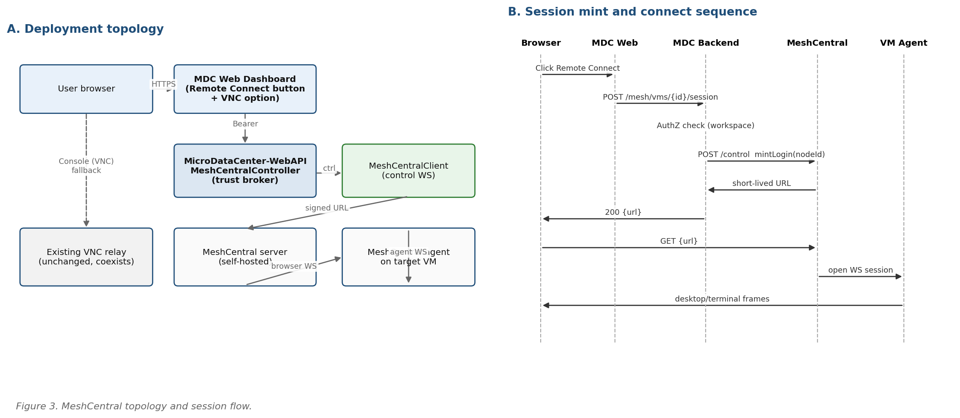
Figure 3 — MeshCentral deployment (left) and session mint/connect sequence (right).

6.2 Backend Folder Layout
[tree]
MDC.Core/Services/Providers/MeshCentral/
├── MeshCentralClient.cs // control WS wrapper (/control.ashx)
├── MeshCentralClientOptions.cs
├── MeshSessionBroker.cs // authZ + login-URL mint
├── MeshDeviceDirectory.cs // MDC VM ↔ Mesh NodeId
├── MeshEnrollmentHostedService.cs // BackgroundService
└── Dto/
├── MeshDevice.cs / MeshGroup.cs
└── MeshSessionTicket.cs

6.3 Key Types (skeleton)
[csharp]
public interface IMeshCentralClient : IAsyncDisposable
{
Task ConnectAsync(CancellationToken ct);
Task<IReadOnlyList<MeshDevice>> ListDevicesAsync(CancellationToken ct);
Task<MeshSessionTicket> MintLoginTicketAsync(string nodeId, TimeSpan ttl, CancellationToken ct);
Task<MeshAgentStatus> GetAgentStatusAsync(string nodeId, CancellationToken ct);
}
public sealed class MeshSessionBroker
{
// Verifies the caller has permission to VM, then asks Mesh for a login ticket
// and returns a signed URL. Never returns the raw control credential.
public Task<Uri> CreateSessionUrlAsync(ClaimsPrincipal user, Guid virtualMachineEntryId, CancellationToken ct);
}

6.4 EF Entity & Migration
[csharp]
public sealed class MeshDeviceLink // MDC.Core/Models/Mesh
{
public Guid Id { get; set; }
public Guid VirtualMachineEntryId { get; set; }
public string MeshNodeId { get; set; } = default!;
public string MeshGroupId { get; set; } = default!;
public DateTime FirstSeenUtc { get; set; }
public DateTime? LastOnlineUtc { get; set; }
public string AgentVersion { get; set; } = "";
}
// Unique index on MeshNodeId. FK to VirtualMachineEntry (nullable for orphaned devices).
// Migration: AddMeshDeviceLink_20260420.cs

6.5 Configuration
[json]
"MeshCentral": {
"BaseUrl": "https://mesh.internal.example.com",
"ControlWsPath": "/control.ashx",
"ServiceUser": "mdc-service",
"ServiceKeySecretName": "meshcentral-service-key",
"LoginTicketTtlSeconds": 60,
"EnrollmentGroupPrefix": "mdc-ws-"
}

6.6 HTTP API Surface
Method & route | Tier | Purpose
POST /api/mesh/vms/{vmId}/session | User / Admin | Returns { url, expiresAt }. Backend has already verified VM access and minted a short-lived MeshCentral login URL.
GET /api/mesh/vms/{vmId}/status | User / Admin | { online, agentVersion, lastSeenUtc } — drives button enable/disable on the VM detail page.
POST /api/mesh/vms/{vmId}/enroll | Admin | Force an enrollment attempt; used for break-glass and for legacy VMs.
GET /api/mesh/devices | Admin | List of all Mesh-known devices with enrolment drift vs MDC inventory.
GET /api/mesh/sessions/audit?take=100 | Admin | Recent session audit records surfaced from MeshCentral.

6.7 Agent Enrollment Strategy
- New VMs: cloud-init user-data injects a one-shot installer that registers into the workspace's Mesh group. User-data template lives in MDC.Core/Services/Providers/MeshCentral/Templates/.
- Templated VMs: optional preinstalled agent; first-boot re-registration to the correct group once MDC knows the workspace.
- Legacy VMs: admin-triggered install via the existing VNC path — documented runbook, no automation initially.

6.8 Frontend Changes
MDC-web-dashboard
- VM detail page now shows two equal buttons: Remote Connect (MeshCentral) and Console (VNC). Existing VNC path untouched.
- New: src/components/mesh/RemoteConnectButton.tsx, RemoteSessionLauncher.tsx.
- New: src/hooks/useRemoteSession.ts — calls POST /mesh/vms/{id}/session, handles the window.open or iframe launch.
MDC-admin-frontend
- New: src/app/admin/mesh/{page,devices,groups,audit}.tsx.
- New: src/components/mesh/DeviceHealthTable.tsx, EnrollmentDriftPanel.tsx, SessionAuditTable.tsx.

6.9 Testing Strategy
- Unit: MeshSessionBroker — deny when VM not in user's workspaces, allow for admin, ticket TTL respected.
- Integration: MeshCentralClient against a dev MeshCentral instance (docker-compose target under scripts/dev/meshcentral/).
- End-to-end: Playwright test that clicks Remote Connect on a test VM, follows the redirect, asserts the Mesh web UI loads and the session cookie is present.
- Negative: expired ticket replay — second redemption must 401.

7. Integration C — NetFlow (Tiered, Distributed)

7.1 Architecture
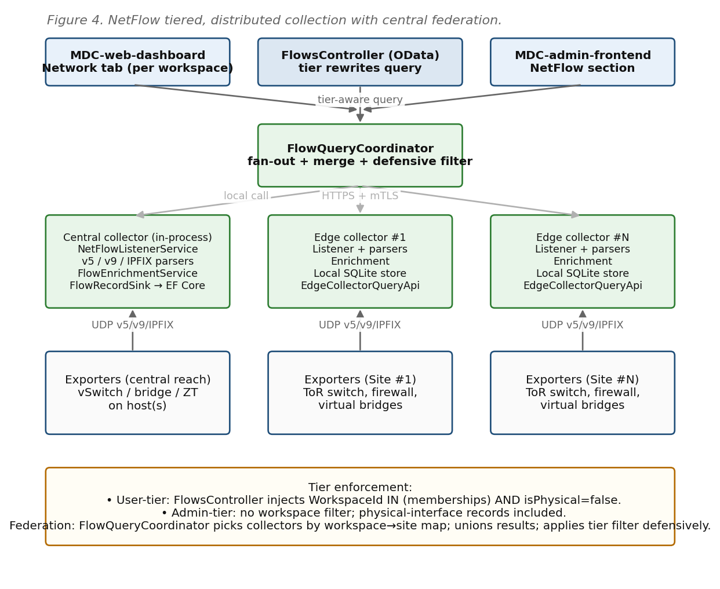
Figure 4 — NetFlow: central collector, per-site edge collectors, central federation.

7.2 Central Collector Folder Layout
[tree]
MDC.Core/Services/Providers/NetFlow/
├── NetFlowListenerService.cs // BackgroundService, UDP 2055 / 4739
├── Parsers/
│ ├── NetFlowV5Parser.cs
│ ├── NetFlowV9Parser.cs // + TemplateCache
│ └── IpfixParser.cs
├── FlowEnrichmentService.cs // IP → VM / Workspace / isPhysical
├── FlowRecordSink.cs // batched EF Core writer
├── FlowAggregationService.cs // rollups
├── FlowQueryCoordinator.cs // federation fan-out
├── EdgeCollectorRegistry.cs // known edges + health
├── Options/
│ └── NetFlowOptions.cs
└── Dto/
└── FlowRecord.cs / FlowQuery.cs / FlowPage.cs

7.3 Edge Collector Project Layout
[tree]
MDC.EdgeCollector/ // new .NET project, deployable as a single-file publish
├── Program.cs // minimal host: listener + local store + query API
├── LocalFlowStore.cs // SQLite-backed ring store
├── EdgeQueryApi.cs // HTTPS endpoint the central coordinator calls
├── Authentication/
│ └── SharedSecretHandler.cs // rotated via MDCEndpoint channel
└── appsettings.json // listen port, retention, parent URL, shared secret

7.4 Key Types (skeleton)
[csharp]
public sealed record FlowRecord(
DateTime TsUtc,
string ExporterId,
int ObservationPoint, // interface index on exporter
IPAddress SrcIp, int SrcPort,
IPAddress DstIp, int DstPort,
byte Protocol,
long Bytes, long Packets,
Guid? VmId, // enriched
Guid? WorkspaceId, // enriched
bool IsPhysicalInterface);
public interface IFlowQueryCoordinator
{
// Fans out to central store + relevant edges, merges, applies tier filter.
Task<FlowPage> QueryAsync(FlowQuery q, ClaimsPrincipal caller, CancellationToken ct);
}
public interface IEdgeClient
{
Task<FlowPage> QueryAsync(FlowQuery q, CancellationToken ct);
Task<EdgeHealth> PingAsync(CancellationToken ct);
}

7.5 EF Entities (central)
[csharp]
public sealed class FlowExporter // registry
{
public Guid Id { get; set; }
public string DisplayName { get; set; } = default!;
public string SourceIp { get; set; } = default!;
public string HomeCollector { get; set; } = "central"; // or edge id
public bool IsEnabled { get; set; }
}
public sealed class FlowRecordEntity // only for records landing centrally
{
public long Id { get; set; }
public DateTime TsUtc { get; set; }
public Guid ExporterId { get; set; }
public int ObservationPoint { get; set; }
public string SrcIp { get; set; } = default!;
public int SrcPort { get; set; }
public string DstIp { get; set; } = default!;
public int DstPort { get; set; }
public byte Protocol { get; set; }
public long Bytes { get; set; }
public long Packets { get; set; }
public Guid? VmId { get; set; }
public Guid? WorkspaceId { get; set; }
public bool IsPhysicalInterface { get; set; }
}
// Indexes: (TsUtc DESC), (WorkspaceId, TsUtc DESC), (VmId, TsUtc DESC).

7.6 Tier Enforcement (central contract)
[csharp]
// FlowsController.Query(...)
var tier = _tierResolver.Resolve(User); // Admin | WorkspaceMember
var effective = query with {
WorkspaceIds = tier.Kind == TierKind.Admin
? query.WorkspaceIds // unrestricted
: tier.WorkspaceIds, // constrained
IncludePhysical = tier.Kind == TierKind.Admin && query.IncludePhysical
};
var page = await _coordinator.QueryAsync(effective, User, ct);
// Defensive second filter inside QueryAsync before returning,
// in case an edge returns out-of-scope records.

7.7 HTTP API Surface
Method & route | Tier | Purpose
GET /api/flows | User / Admin | Paginated flow records. Server rewrites WorkspaceIds to caller's memberships for user tier.
GET /api/flows/top-talkers?scope=workspace|vm|interface&window=5m | User / Admin | Top-N aggregate.
GET /api/flows/by-vm/{vmId} | User / Admin | Convenience filter; 403 if VM not in caller workspaces.
GET /api/flows/physical | Admin | Physical-interface records only.
GET /api/flow-exporters | Admin | Registry list with home collector + health.
POST /api/flow-exporters | Admin | Register a new exporter.
Edge (internal) POST /internal/edge/query | Service auth | Called by FlowQueryCoordinator against each edge collector. mTLS or rotated shared secret.

7.8 Frontend Changes
MDC-web-dashboard (Workspace User)
- New: src/app/workspaces/[id]/network/page.tsx (interface list for this workspace).
- New: src/app/workspaces/[id]/network/[ifaceId]/page.tsx (per-interface drilldown).
- New: src/components/network/InterfaceList.tsx, TopTalkersCard.tsx, FlowTable.tsx, ProtocolBreakdown.tsx.
- New: src/lib/api/flows.ts and src/hooks/useFlows.ts.
MDC-admin-frontend (Administrator)
- New: src/app/admin/netflow/{page,exporters,explorer,physical,vms/[id]}.tsx.
- New: src/components/netflow/ExporterTable.tsx, FlowExplorer.tsx, PhysicalInterfacePanel.tsx, PerVmDrilldown.tsx.

7.9 Testing Strategy
- Unit: each parser against a corpus of recorded datagrams (fixtures under tests/fixtures/netflow/).
- Unit: FlowEnrichmentService — IP → VM mapping, IP in two workspaces, unmatched IP returns null ids.
- Contract: tier rewriter — user tier cannot pass WorkspaceIds they do not belong to; IncludePhysical silently forced false.
- Integration: central + one edge in docker-compose; assert federated query returns merged results with correct tier filtering.
- Load: 1 k records/sec for 10 minutes into central store; verify query latency bounds.

8. Cross-Cutting Concerns

8.1 Auth & Claim Model
- Admin tier: presence of the existing Administrator role claim (confirm exact claim name with Identity team before coding).
- Workspace-member tier: workspaces claim (array of workspace IDs) derived from existing IAM. If absent, a backend call to IWorkspaceService resolves memberships and caches for the request lifetime.
- A single TierResolver lives at MDC.Core/Services/Security/TierResolver.cs and is consumed by ObservabilityController, FlowsController, and MeshSessionBroker — one place, three call sites.

8.2 Configuration & Secrets
- All three integrations add top-level sections to appsettings.json (Pdm, MeshCentral, NetFlow).
- Every secret (PDM token, MeshCentral service key, edge shared secret) is resolved through the existing secret-store abstraction, never committed.
- Edge collectors receive their shared secret through the existing MDCEndpoint registration channel; rotation is a background job.

8.3 Logging & Audit
- Every session mint (MeshCentral) and every admin-tier query (NetFlow physical, ObservabilityController admin endpoints) writes an audit record via the existing IAuditLog sink.
- PDM request/response sizes are logged at Debug; failures at Warning; circuit-breaker state transitions at Info.

8.4 Error Handling & Degraded Modes
- PDM unreachable → ObservabilityController returns 200 with X-MDC-Degraded: pdm-unreachable header and last-known cached values; UI renders the degraded banner.
- MeshCentral unreachable → POST /session returns 503 with a body pointing the UI to the VNC fallback.
- Edge collector unreachable → FlowQueryCoordinator returns partial results with a collectorsMissing field enumerating which edges timed out; UI shows a warning badge.

9. Delivery Roadmap
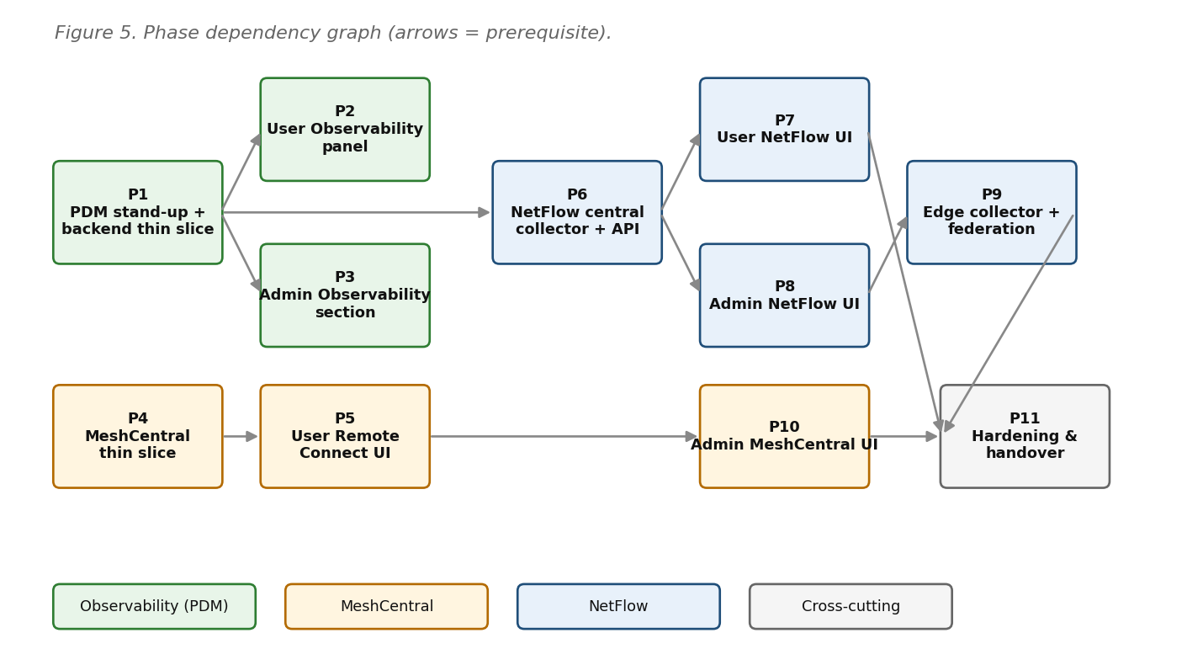
Figure 5 — Phase dependency graph. Arrows indicate prerequisites.
Phase | Work | Depends on | Exit criterion
P1 | PDM stand-up, PdmClient, resource resolver, observability thin slice for one cluster | — | `GET /api/observability/fleet` returns a real cluster from PDM
P2 | User observability panel in MDC-web-dashboard | P1 | Workspace user sees live metrics for their own VMs only
P3 | Admin observability section in MDC-admin-frontend | P1 | Admin can operate Proxmox estate from MDC without visiting PDM UI
P4 | MeshCentral server + trust broker thin slice | — | One enrolled VM reachable via Remote Connect button
P5 | User Remote Connect UI + cloud-init enrollment | P4 | Newly created VM auto-enrolls and is reachable from browser
P6 | NetFlow central collector + tier-aware API | P1 | One exporter's flows visible via /api/flows, correctly tagged
P7 | User NetFlow UI | P6 | Workspace user sees per-vNIC flow analysis, no cross-workspace leakage
P8 | Admin NetFlow UI | P6 | Admin can answer 'what is VM X talking to' and see physical uplinks
P9 | Edge collector + federation | P8 | At least one edge in production, queryable transparently
P10 | Admin MeshCentral UI | P5 | Admin lifecycle operations for Mesh inside MDC admin
P11 | Hardening and handover | P7, P9, P10 | Runbooks + training session delivered

10. Local Development Setup
- docker-compose profile `dev` brings up: PDM (where available) or a mock PDM container, a MeshCentral server, a NetFlow exporter simulator (e.g. nfgen), and a single edge collector. Files under scripts/dev/.
- `dotnet run --project MDC.Api` picks up appsettings.Development.json with dev URLs and test secrets from user-secrets.
- Frontends: pnpm dev as today. New env vars: NEXT_PUBLIC_OBSERVABILITY_ENABLED, NEXT_PUBLIC_MESH_ENABLED, NEXT_PUBLIC_NETFLOW_ENABLED (feature gates for progressive rollout).
- Smoke script: scripts/dev/smoke.sh — hits each new endpoint with a dev Bearer token and asserts shape.

11. Definition of Done (per integration)
Checkpoint | PDM Observability | MeshCentral | NetFlow
Backend provider + config | ✓ | ✓ | ✓
EF migration committed and applied in CI | ✓ | ✓ | ✓ (central)
HTTP contracts covered by unit + contract tests | ✓ | ✓ | ✓
Tier enforcement tests (user-scoped + admin-scoped) | ✓ | ✓ (authZ on session mint) | ✓
Frontend routes behind feature flag | ✓ | ✓ | ✓
End-to-end Playwright smoke | ✓ (VM panel loads) | ✓ (Remote Connect redirect lands on Mesh UI) | ✓ (user flow list filtered to own workspace)
Degraded-mode path documented and tested | ✓ (PDM down) | ✓ (Mesh down → VNC fallback) | ✓ (edge down → partial-result banner)
Operator runbook updated | ✓ | ✓ | ✓

