STATEMENT OF WORK
SPARKING
AI-Powered Smart Parking Management System

Version 2.0
February 2026

Table of Contents

1. | Executive Summary | 3
2. | Feature List | 4
3. | Technology Stack | 9
4. | Data Flow Diagram | 13
5. | Software Architecture | 14
6. | Plan of Action (Phase-wise Development) | 16
7. | Required Team Setup | 19
8. | Project Timeline | 21
9. | API Documentation (89+ Endpoints) | 23
10. | Database Schema | 29

1. Executive Summary
SPARKING is a comprehensive, enterprise-grade Smart Parking Management System designed to revolutionize parking facility operations through artificial intelligence and real-time monitoring. The system combines cutting-edge computer vision technology with a robust payment infrastructure to deliver a seamless parking experience for both operators and end-users.
The platform addresses critical challenges faced by modern parking facilities including:
• Real-time occupancy tracking and management
• Automated vehicle detection and license plate recognition
• Intelligent slot allocation and guidance
• Secure, multi-method payment processing
• Comprehensive analytics and revenue management
Target Markets:
• Airports and Transportation Hubs
• Shopping Malls and Retail Centers
• Hospitals and Medical Facilities
• Commercial Office Buildings
• Hotels and Hospitality Venues
• Sports Stadiums and Event Venues
• Residential Complexes
Key Differentiators:
1. AI-Powered Detection: Utilizes Intel OpenVINO and YOLOv8/v10 for real-time vehicle and license plate detection with 95%+ accuracy
2. Intel Hardware Acceleration: Native support for Intel GPU and Intel NPU with optimized inference pipelines achieving <100ms latency
3. Scalable Architecture: Microservices-based design supporting multiple venues with thousands of parking slots
4. Integrated Wallet System: PayPal-like digital wallet with P2P transfers, KYC verification, and multi-gateway support
5. Real-time Operations: Socket.IO and MQTT-based real-time updates for instant occupancy changes
6. Hardware Agnostic: Compatible with existing CCTV infrastructure through RTSP/ONVIF protocols
7. Mobile App: Native mobile application built with Expo/React Native for customer self-service parking, vehicle management, and mobile payments
8. Microsoft SSO: Enterprise-grade Single Sign-On via Microsoft Azure AD/MSAL for seamless corporate integration

2. Feature List

2.1 Core Parking Management
- Multi-Venue Support: Organize and manage multiple parking facilities (airports, malls, hospitals, stadiums, etc.) from a single dashboard with independent configurations
- Multi-Level Architecture: Support for multi-story parking structures with floor-wise and zone-wise organization
- Zone Management: Create specialized zones: General, VIP, EV Charging, Disabled, Staff, Visitor, Short-term, Long-term, Two-wheeler, Valet, Reserved
- Slot Configuration: Individual slot setup with type (Standard, Compact, Large, Handicapped, EV, Motorcycle, VIP, Reserved), vehicle restrictions, and visual positioning
- Real-time Status: Live tracking of slot status: Available, Occupied, Reserved, Maintenance, Blocked
- Visual Slot Mapping: Interactive floor plans with slot positions, rotations, and live occupancy indicators

2.2 AI-Powered Detection
- Vehicle Detection: Real-time detection using YOLOv8n model optimized for parking scenarios with 95%+ accuracy
- License Plate Recognition: Automatic Number Plate Recognition (ANPR) supporting multiple plate formats and regions
- Occupancy Detection: AI-based slot occupancy detection through bounding box matching with configurable confidence thresholds
- Multi-Camera Support: Parallel processing of multiple camera feeds with Intel OpenVINO acceleration
- Intel OpenVINO Integration: Deep integration with Intel OpenVINO 2024.0+ for optimized inference on Intel CPUs, GPUs, and NPUs
- Intel GPU/NPU Acceleration: Hardware-accelerated inference with FP16 precision on Intel GPU and INT8 on Intel NPU for maximum throughput
- Edge Processing: On-premise AI inference for reduced latency (<100ms target) and enhanced privacy
- Detection Events: Comprehensive logging of all detection events with timestamps, confidence scores, and associated metadata
- Adaptive Frame Processing: Intelligent frame skipping and batch processing optimized for Intel hardware to maintain target FPS

2.3 Entry/Exit Management
- Token Generation: Multiple token types: QR Code (auto-generated), RFID, Barcode, ANPR-based, Manual entry
- Smart Slot Allocation: Intelligent algorithm considering vehicle type, zone preference, accessibility needs, and EV charging requirements
- Gate Control Integration: Support for Entry, Exit, and Bidirectional gates with RS485, Relay, and API-based hardware
- Automatic Gate Opening: Token validation triggers automatic gate operation with manual override capability
- Visit History: Complete vehicle visit tracking with entry/exit timestamps and duration calculations

2.4 Payment & Wallet System
- Digital Wallet: Built-in wallet system with Personal, Business, and Merchant account types
- Multiple Pricing Models: Flat Rate, Hourly (with peak multipliers), Slab-based, Dynamic pricing, Free parking options
- Payment Methods: Cash, Card (Stripe), UPI (Razorpay), Wallet balance, Postpaid accounts
- P2P Transfers: Peer-to-peer wallet transfers between users with transaction limits
- Bank Integration: Link bank accounts for deposits/withdrawals with penny-drop verification
- KYC Verification: Tiered KYC levels (None, Basic, Intermediate, Full) with corresponding transaction limits
- Transaction Management: Complete transaction history with statuses: Pending, Processing, Completed, Failed, Cancelled, Reversed
- Refund Processing: Automated and manual refund capabilities with audit trail

2.5 Analytics & Reporting
- Real-time Dashboard: Live metrics: current occupancy, available slots, active tokens, today's revenue, camera status
- Historical Analytics: Occupancy trends, revenue analysis, traffic patterns by hour/day/month
- Zone Performance: Comparative analysis across zones with utilization metrics
- Peak Hour Analysis: Identification of busiest periods for staffing and pricing optimization
- Vehicle Distribution: Statistics by vehicle type and parking duration
- Predictive Analytics: Occupancy forecasting based on historical patterns
- Custom Reports: Export to CSV and PDF with custom date ranges and filters

2.6 Mobile Application
- Customer Self-Service: Native mobile app (Expo/React Native) for customers to manage parking sessions, vehicles, and payments
- Vehicle Management: Add, edit, and delete vehicles with license plate, make, model, color, and type
- Session Management: View active and past parking sessions, create new sessions, and mark exits
- Mobile Wallet: View wallet balance, deposit funds, and track transaction history from the mobile app
- Mobile Payments: Process parking payments directly from the mobile app with wallet or gateway integration
- QR Code Validation: Scan and validate parking QR codes for entry/exit
- Push Notifications: Receive real-time notifications for parking events, payment confirmations, and session alerts
- Parking Lot Discovery: Browse available parking lots with real-time availability, zones, and slot details
- User Profile: Manage profile information, phone number, and notification preferences

2.7 Authentication & Single Sign-On
- Email/Password Login: Traditional email and password authentication with bcrypt hashing
- Microsoft SSO: Enterprise Single Sign-On via Microsoft Azure AD using MSAL (Microsoft Authentication Library)
- JWT Sessions: Stateless JWT tokens with database-backed session validation for immediate revocation
- Token Refresh: Mobile app token refresh mechanism for seamless session continuity
- Rate-Limited Auth: Login and registration endpoints protected with rate limiting (5/min login, 3/min register)

2.8 User Management & Access Control
- Role-Based Access: Six user roles: Super Admin, Admin, Operator, Auditor, Viewer, Customer
- Multi-Session Support: Configurable concurrent session limits per user
- Parking Lot Assignments: Operators can be assigned to specific facilities
- Audit Logging: Comprehensive tracking of all user actions with before/after values
- Session Security: IP and user agent tracking, automatic session cleanup

2.9 Notifications & Alerts
- Multi-Channel Delivery: In-app notifications, Email (SMTP/Resend/SendGrid), SMS (Twilio/MSG91)
- Alert Rules: Configurable metric-based alerts with operators (GT, LT, EQ, GTE, LTE)
- Alert Actions: Email, SMS, Push notifications, Webhook triggers
- Cooldown Periods: Prevent alert fatigue with configurable cooldown intervals
- Notification Types: Payment confirmations, session alerts, overstay warnings, system notifications

2.10 Hardware Integration
- Camera Support: RTSP and ONVIF protocol support with PTZ and IR capabilities
- Display Integration: LED counters, LCD signage, kiosks, directional displays
- Gate Systems: Entry/exit gates with multiple control protocols
- Health Monitoring: Real-time camera status tracking (Online, Offline, Error, Maintenance)
- Encrypted Credentials: Secure storage of camera and hardware credentials

3. Technology Stack

3.1 Frontend Technologies
Category | Technology | Version/Details
Framework | Next.js | 16.1.1 (App Router, Server Components)
UI Library | React | 19.2.3
Styling | Tailwind CSS | 4.0
Component Library | Radix UI | Full suite (15+ components)
Forms | React Hook Form + Zod | 7.69.0 / 4.2.1
State Management | Zustand | 5.0.9
Data Fetching | TanStack React Query | 5.90.12
Charts | Recharts | 2.15.4
Maps | Leaflet + React-Leaflet | 1.9.4 / 5.0.0
Icons | Lucide React | 0.562.0
PDF Generation | jsPDF + Autotable | 3.0.4
Real-time | Socket.IO Client | 4.8.3
Language | TypeScript | 5.x

3.2 Backend Technologies
Category | Technology | Version/Details
Runtime | Node.js | LTS (18.x+)
Framework | Next.js API Routes | 16.1.1
ORM | Prisma | 7.2.0
Database | PostgreSQL | 16+
Cache | Redis | 7.x
Auth | jose (JWT) + bcryptjs | 6.1.3 / 3.0.3
Real-time | Socket.IO Server | 4.8.3
Email | Nodemailer | 7.0.12
Validation | Zod | 4.2.1

3.3 AI/ML Pipeline
Category | Technology | Version/Details
Language | Python | 3.9+
Inference Engine | Intel OpenVINO | 2024.0.0+ (Core runtime)
OpenVINO Dev Tools | openvino-dev | Model optimization & conversion
Hardware Support | Intel GPU/NPU | FP16/INT8 acceleration
Object Detection | Ultralytics YOLOv8 | 8.0.0+ (OpenVINO export)
Computer Vision | OpenCV | 4.8.0+
Video Processing | PyAV | 10.0.0
Messaging | paho-mqtt | 1.6.1
HTTP Client | aiohttp + requests | 3.9.0 / 2.31.0
Geometry | Shapely | 2.0.0
Logging | structlog | 23.0.0

3.4 Mobile Application
Category | Technology | Version/Details
Framework | Expo | SDK 54
UI Library | React Native | 0.81
Navigation | Expo Router | v6 (file-based routing)
Styling | NativeWind | v4 (Tailwind CSS for RN)
State Management | Zustand | 5.x
HTTP Client | Axios / Fetch | Bearer token auth
QR Scanner | expo-camera | QR code scanning
Secure Storage | expo-secure-store | Token persistence
Language | TypeScript | 5.x

3.5 DevOps & Infrastructure
Category | Technology | Version/Details
Containerization | Docker | Latest
Orchestration | Docker Compose | Multi-service setup
Reverse Proxy | Nginx | Alpine
Message Broker | Eclipse Mosquitto | 2.x (MQTT)
Hosting | Vercel / Self-hosted | Serverless + Docker
CI/CD | Git-based deployment | Vercel auto-deploy

3.6 External Services & Integrations
Category | Technology | Version/Details
Payment - India | Razorpay | Cards, UPI, Wallets
Payment - Global | Stripe | Cards, Apple Pay, Google Pay
Email | SMTP / Resend / SendGrid | Transactional emails
SMS - India | MSG91 | OTP, Notifications
SMS - Global | Twilio | SMS worldwide
Storage | Local / AWS S3 | File storage
SSO | Microsoft Azure AD / MSAL | Enterprise Single Sign-On

4. Data Flow Diagram
The following diagram illustrates the flow of data through the SPARKING system, showing how information moves between external entities, processes, and data stores.
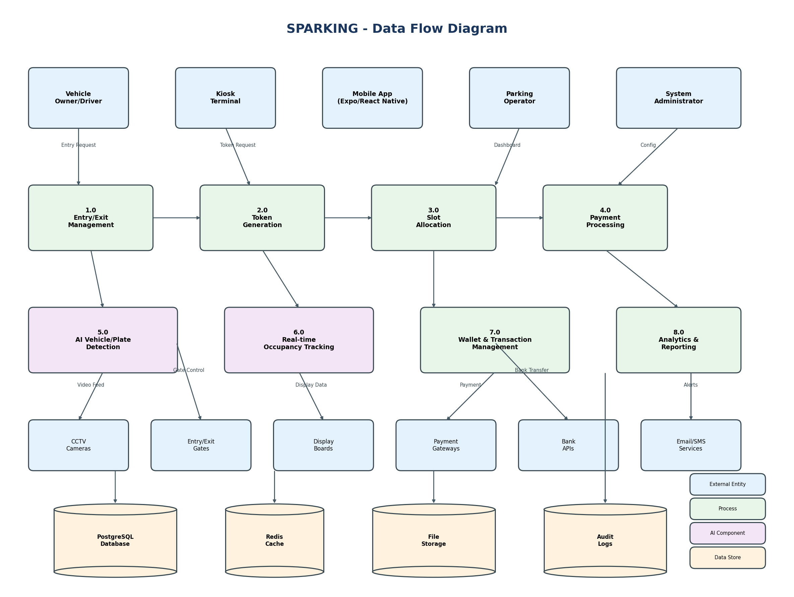

4.1 Data Flow Description
- Entry Flow: Vehicle arrives → Camera detects vehicle/plate → Token generated → Slot allocated → Gate opens → Occupancy updated
- Payment Flow: Token validated → Duration calculated → Price computed → Payment processed → Wallet debited → Receipt generated
- Exit Flow: Vehicle at exit → Token validated → Payment confirmed → Gate opens → Slot released → Analytics updated
- AI Detection Flow: Camera feed → OpenVINO inference → Detection events → MQTT/API → Database → Real-time broadcast
- Analytics Flow: Raw data → Aggregation jobs → Metrics calculation → Dashboard display → Report generation

5. Software Architecture
SPARKING follows a layered architecture pattern with clear separation of concerns. The diagram below shows the system's architectural components and their relationships.
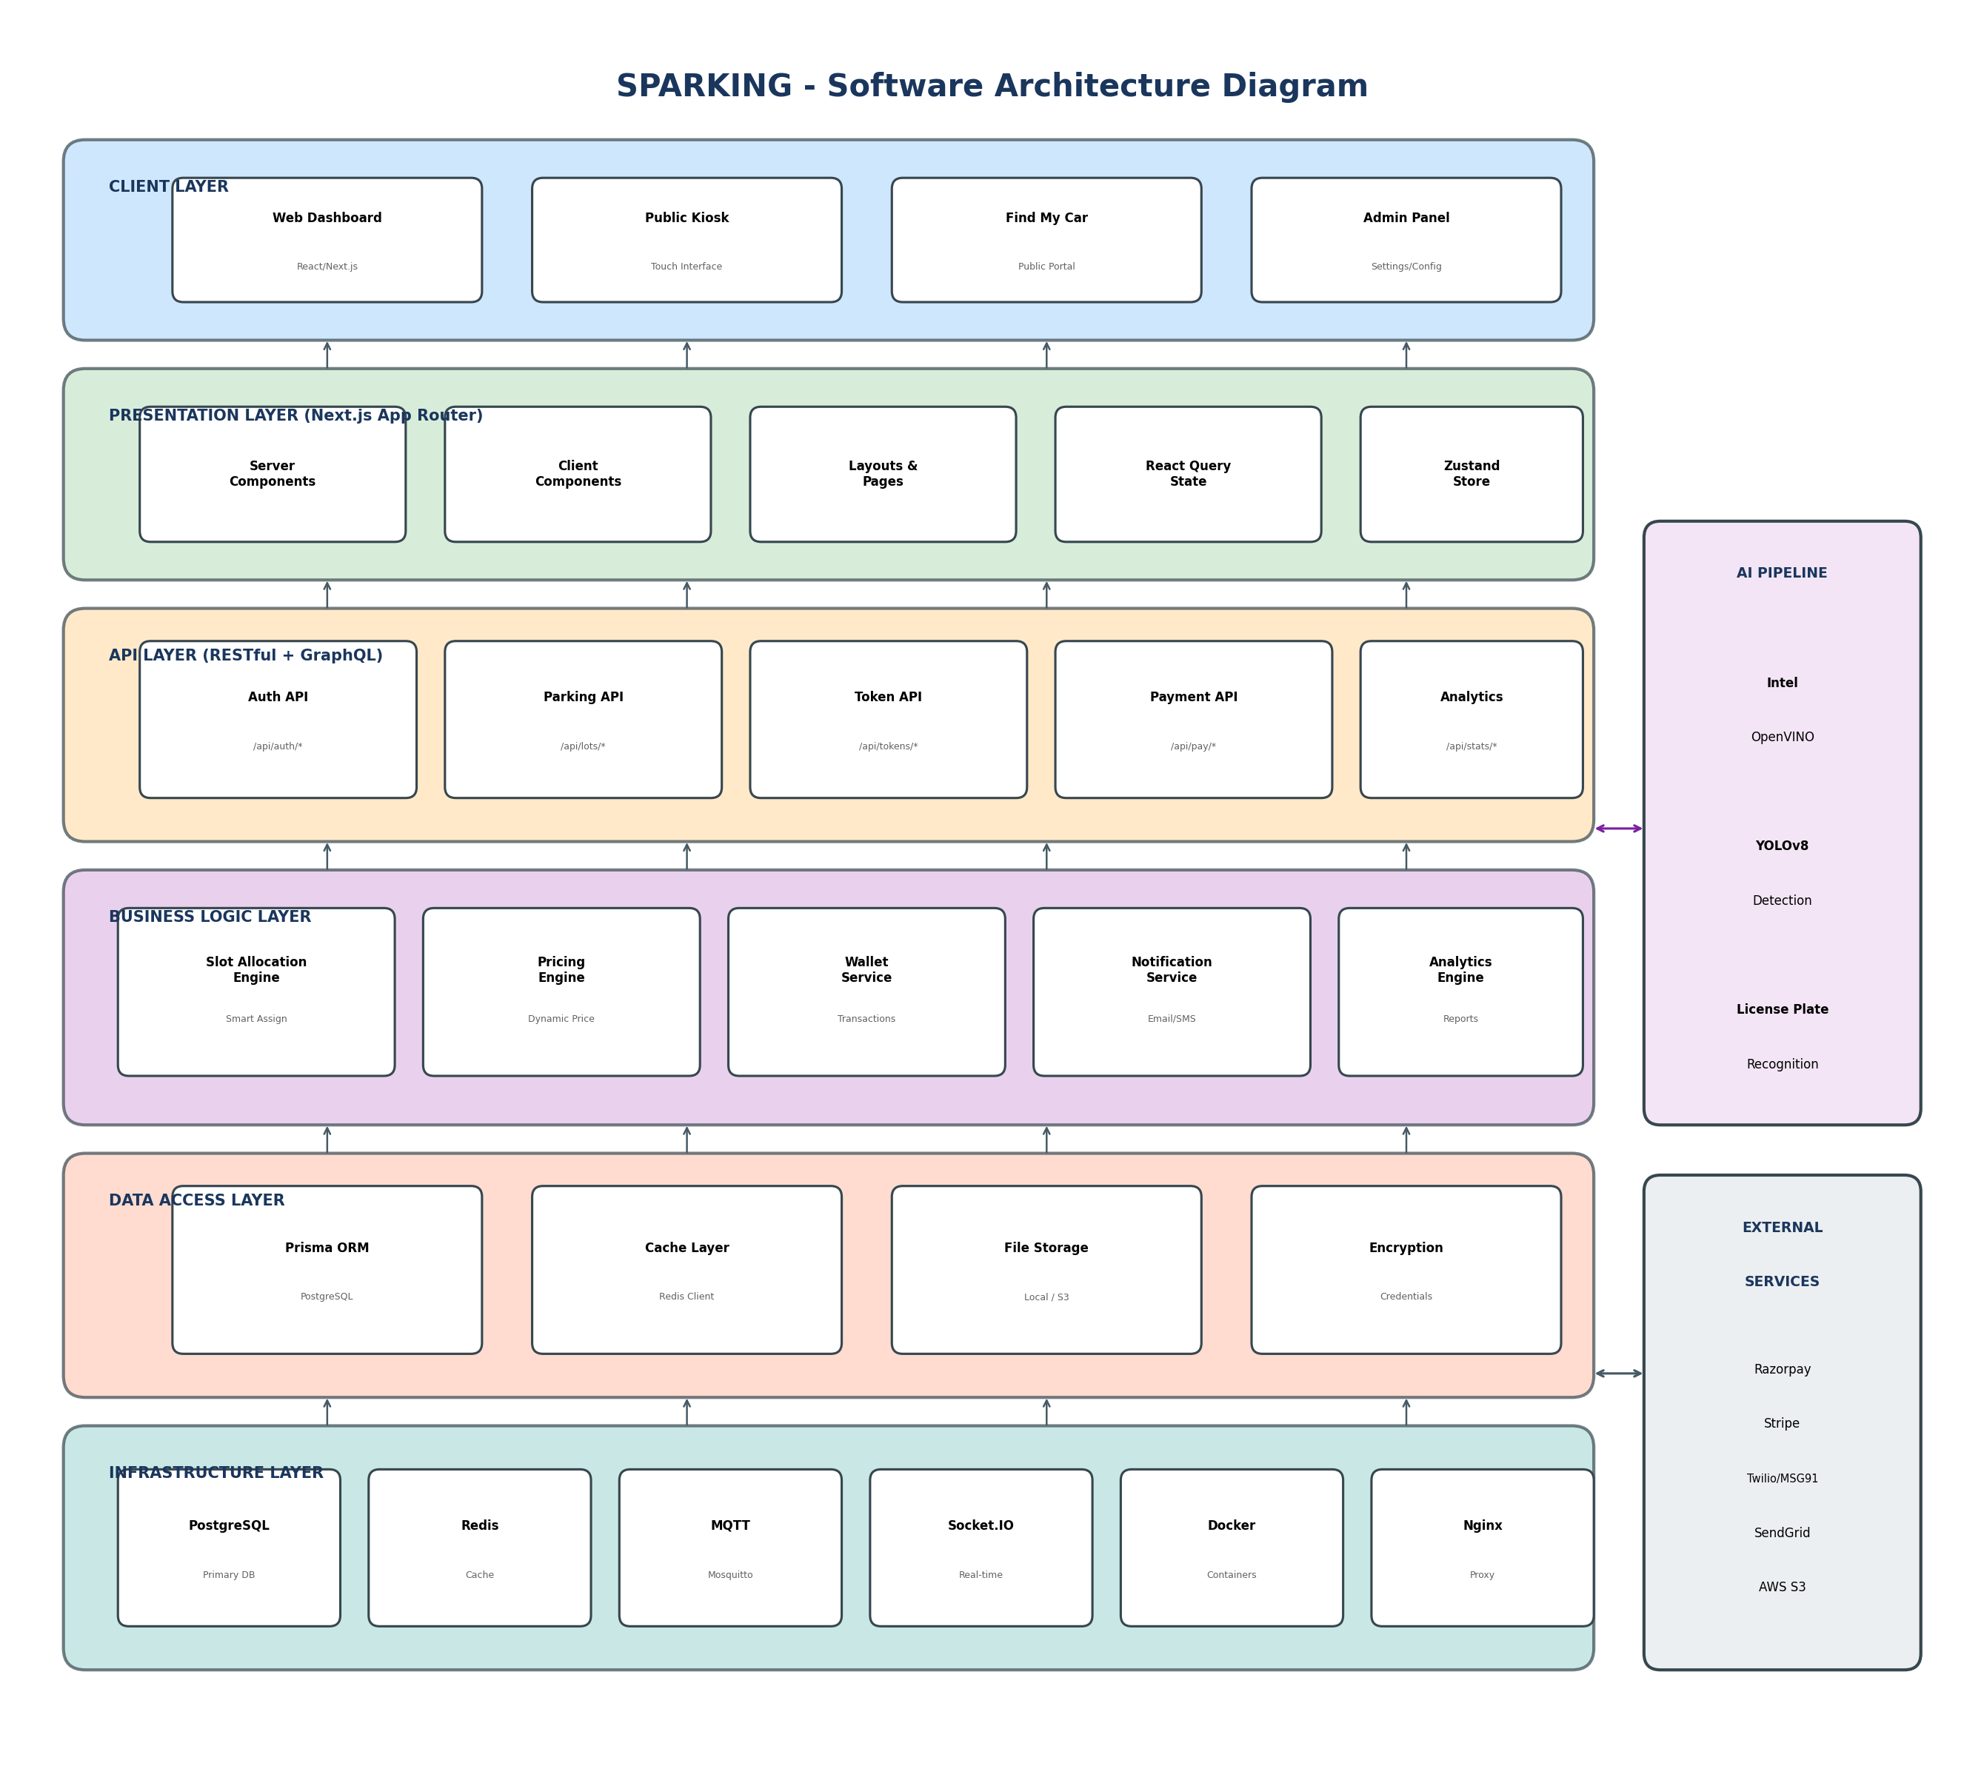

5.1 Architecture Layers
- Client Layer: Web dashboard, public kiosk interface, vehicle finder portal, and admin panel built with React/Next.js
- Presentation Layer: Next.js App Router with Server Components, Client Components, and state management via React Query and Zustand
- API Layer: RESTful endpoints organized by domain (auth, parking, tokens, payments, analytics) with optional GraphQL support
- Business Logic Layer: Core services including slot allocation engine, pricing engine, wallet service, notification service, and analytics engine
- Data Access Layer: Prisma ORM for PostgreSQL, Redis client for caching, file storage abstraction, and encryption services
- Infrastructure Layer: PostgreSQL database, Redis cache, MQTT broker, Socket.IO server, Docker containers, and Nginx reverse proxy

5.2 Intel OpenVINO Integration
The AI pipeline leverages Intel OpenVINO™ toolkit for optimized deep learning inference, providing significant performance benefits across Intel hardware platforms. This integration enables real-time vehicle detection and license plate recognition with sub-100ms latency.

Hardware Acceleration Configurations
- Intel GPU (Integrated/Discrete): FP16 precision, 2 inference streams, 4 threads, batch size 4 - optimal for desktop/server deployments
- Intel NPU (Neural Processing Unit): INT8 precision, single stream, batch size 1 - optimized for edge devices with dedicated AI accelerators
- Intel CPU (Optimized): FP32 precision, 4 inference threads, batch size 1 - fallback for systems without GPU/NPU
- NVIDIA GPU (CUDA): FP16 precision, 4 streams, batch size 8 - supported for mixed hardware environments

Intel OpenVINO Features Used
- Model Optimization: Automatic model conversion from YOLO/PyTorch to OpenVINO IR format with quantization support
- Async Inference: Non-blocking inference API for parallel frame processing and improved throughput
- Auto Device Selection: Automatic detection and selection of optimal hardware (GPU > NPU > CPU)
- Model Caching: Compiled model caching for faster startup and reduced initialization time
- Dynamic Batching: Adaptive batch processing based on system load and latency requirements

Pre-trained Intel Models
- vehicle-attributes-recognition-barrier-0039: Vehicle color and type classification (Intel Model Zoo)
- vehicle-license-plate-detection-barrier-0106: License plate detection optimized for barrier cameras
- license-plate-recognition-barrier-0007: OCR for license plate text recognition
- yolov10s-int8: INT8 quantized YOLOv10 for efficient vehicle detection

6. Plan of Action (Phase-wise Development)

Phase 1: Foundation & Core Infrastructure
Duration: 4 Weeks
Deliverables:
- Project setup with Next.js 16, TypeScript, and Tailwind CSS
- Database schema design and Prisma setup with PostgreSQL
- Authentication system with JWT and session management
- User management with RBAC (roles and permissions)
- Basic UI component library setup with Radix UI
- Docker configuration for development environment
- CI/CD pipeline setup with Vercel

Phase 2: Parking Management Core
Duration: 6 Weeks
Deliverables:
- Parking lot CRUD with multi-venue support
- Zone and floor management
- Slot management with bulk creation and visual mapping
- Token generation system (QR, RFID, ANPR)
- Smart slot allocation algorithm
- Entry/exit workflow implementation
- Gate control integration (API-based)
- Display board integration

Phase 3: AI Pipeline Integration
Duration: 5 Weeks
Deliverables:
- Intel OpenVINO 2024.0+ environment setup and configuration
- Intel GPU/NPU hardware detection and auto-configuration
- YOLOv8 model integration with OpenVINO export and optimization
- Intel Model Zoo integration (vehicle-attributes, license plate models)
- License plate detection and OCR recognition pipeline
- Camera management with RTSP/ONVIF support
- Real-time video stream processing with frame skipping optimization
- Async inference queue for parallel processing
- Detection event pipeline with MQTT
- Occupancy detection with confidence scoring
- Latency profiling and optimization (<100ms target)
- AI-to-backend communication via secure API

Phase 4: Payment & Wallet System
Duration: 5 Weeks
Deliverables:
- Wallet system architecture and database schema
- Wallet creation with KYC levels
- Deposit and withdrawal functionality
- P2P transfer implementation
- Razorpay integration (UPI, Cards)
- Stripe integration (Cards, Digital wallets)
- Parking payment workflow
- Bank account linking with verification
- Transaction history and statements
- Refund processing

Phase 5: Real-time & Notifications
Duration: 3 Weeks
Deliverables:
- Socket.IO server setup for real-time updates
- Live dashboard with occupancy updates
- Email notification service (SMTP/Resend/SendGrid)
- SMS integration (Twilio/MSG91)
- In-app notification system
- Alert rules engine with configurable thresholds
- Webhook support for external integrations

Phase 6: Analytics & Reporting
Duration: 3 Weeks
Deliverables:
- Analytics data aggregation jobs
- Dashboard metrics and KPIs
- Historical trend analysis
- Revenue reports with breakdowns
- Occupancy analytics with heatmaps
- CSV and PDF export functionality
- Predictive analytics foundation

Phase 7: Public Interfaces & Testing
Duration: 3 Weeks
Deliverables:
- Public kiosk interface for self-service
- Find My Car portal for vehicle location
- API documentation portal
- Comprehensive unit and integration testing
- Load testing and performance optimization
- Security audit and penetration testing
- Bug fixes and refinements

Phase 8: Deployment & Launch
Duration: 2 Weeks
Deliverables:
- Production environment setup
- Database migration and seeding
- SSL/TLS certificate configuration
- Monitoring and alerting setup
- Documentation finalization
- User training materials
- Go-live support and stabilization

Phase 9: Mobile Application
Duration: 4 Weeks
Deliverables:
- Expo/React Native project setup with SDK 54
- Mobile authentication (login, register, token refresh)
- Vehicle management (CRUD operations)
- Parking lot discovery with real-time availability
- Session management (create, view, exit)
- Mobile wallet integration (balance, deposits, transactions)
- QR code scanning for entry/exit validation
- Push notification integration
- Dark theme UI with NativeWind
- Mobile-specific API endpoints (/api/mobile/*)
- Cross-platform testing (iOS and Android)

7. Required Team Setup

7.1 Core Development Team
Role | Count | Experience | Key Responsibilities
Project Manager | 1 | 5+ years | Project planning, stakeholder management, delivery oversight
Tech Lead / Architect | 1 | 7+ years | Architecture design, technical decisions, code reviews
Senior Full-Stack Developer | 2 | 4+ years | Frontend/backend development, API design, database
Full-Stack Developer | 2 | 2+ years | Feature development, bug fixes, testing
Mobile Developer | 1 | 3+ years | React Native/Expo mobile app development, iOS/Android
AI/ML Engineer | 1 | 3+ years | Intel OpenVINO integration, GPU/NPU optimization, detection pipeline
DevOps Engineer | 1 | 3+ years | Infrastructure, CI/CD, Docker, monitoring
UI/UX Designer | 1 | 3+ years | Interface design, user experience, prototyping
QA Engineer | 1 | 3+ years | Test planning, automation, quality assurance

7.2 Required Skills Matrix
Area | Required Skills | Nice to Have
Frontend | React, Next.js, TypeScript, Tailwind CSS | React Query, Zustand, Radix UI
Backend | Node.js, Prisma, PostgreSQL, REST APIs | GraphQL, Redis, Socket.IO
Mobile | React Native, Expo, TypeScript | NativeWind, Expo Router, Zustand
AI/ML | Python, OpenCV, Deep Learning, Intel OpenVINO | YOLO, Model optimization, MQTT
Intel AI | OpenVINO Runtime, Model conversion | Intel GPU/NPU optimization, INT8 quantization
DevOps | Docker, Linux, CI/CD | Kubernetes, AWS, Nginx
Database | PostgreSQL, SQL optimization | Redis, Database design
Payment | Payment gateway integration | Razorpay, Stripe, PCI compliance

7.3 Team Structure
Total Team Size: 11 members
- Sprint-based Agile methodology with 2-week sprints
- Daily stand-ups and weekly sprint reviews
- Dedicated QA involvement from Phase 2 onwards
- AI/ML engineer engaged primarily in Phases 3-4
- DevOps support throughout with focus on Phases 1 and 8

8. Project Timeline

8.1 Overall Timeline Summary
Total Project Duration: 35 Weeks (~9 Months)
Phase | Description | Duration | Cumulative
Phase 1 | Foundation & Core Infrastructure | 4 weeks | Week 1-4
Phase 2 | Parking Management Core | 6 weeks | Week 5-10
Phase 3 | AI Pipeline Integration | 5 weeks | Week 11-15
Phase 4 | Payment & Wallet System | 5 weeks | Week 16-20
Phase 5 | Real-time & Notifications | 3 weeks | Week 21-23
Phase 6 | Analytics & Reporting | 3 weeks | Week 24-26
Phase 7 | Public Interfaces & Testing | 3 weeks | Week 27-29
Phase 8 | Deployment & Launch | 2 weeks | Week 30-31
Phase 9 | Mobile Application | 4 weeks | Week 32-35

8.2 Milestone Schedule
Milestone | Target | Deliverables
M1: Foundation Complete | Week 4 | Authentication, user management, basic UI
M2: Core Parking Ready | Week 10 | Full parking management workflow
M3: AI Integration Complete | Week 15 | Vehicle and plate detection operational
M4: Payment System Live | Week 20 | All payment methods functional
M5: Real-time Features | Week 23 | Live updates and notifications
M6: Analytics Dashboard | Week 26 | Full reporting capabilities
M7: Beta Release | Week 29 | Feature-complete for testing
M8: Production Launch | Week 31 | Go-live with support
M9: Mobile App Release | Week 35 | iOS and Android apps published

9. API Documentation

9.1 API Overview
SPARKING provides a comprehensive RESTful API with 89+ endpoints organized by domain, including dedicated mobile APIs. All endpoints follow consistent patterns and return JSON responses.
Base URL: https://api.sparking.com/api or /api (relative)
Authentication: JWT Bearer token in Authorization header or HttpOnly cookie
Content-Type: application/json
Error Format: { "error": "message", "code": "ERROR_CODE" }

9.2 Authentication APIs
Method | Endpoint | Description | Auth Required
POST | /api/auth/login | User login with email/password | No
POST | /api/auth/logout | Terminate current session | Yes
POST | /api/auth/microsoft | Microsoft SSO callback | No
GET | /api/auth/me | Get current user details | Yes

9.3 Parking Lot APIs
Method | Endpoint | Description | Auth Required
GET | /api/parking-lots | List all parking lots with stats | Yes
POST | /api/parking-lots | Create new parking lot | Admin
GET | /api/parking-lots/{id} | Get parking lot details | Yes
PATCH | /api/parking-lots/{id} | Update parking lot | Admin
GET | /api/parking-lots/{id}/stats | Real-time statistics | Yes

9.4 Token Management APIs
Method | Endpoint | Description | Auth Required
GET | /api/tokens | List tokens with filters | Yes
POST | /api/tokens | Create entry token | Yes
GET | /api/tokens/{id} | Get token details | Yes
PATCH | /api/tokens/{id} | Update token (mark exit) | Yes
DELETE | /api/tokens/{id} | Cancel token | Admin

9.5 Payment & Wallet APIs
Method | Endpoint | Description | Auth Required
GET | /api/wallet | Get user wallets | Yes
POST | /api/wallet | Create new wallet | Yes
GET | /api/wallet/{id}/balance | Get wallet balance | Yes
POST | /api/payments/parking | Pay for parking | Yes
POST | /api/payments/deposit | Deposit to wallet | Yes
POST | /api/payments/withdraw | Withdraw to bank | Yes
POST | /api/payments/transfer | P2P transfer | Yes
GET | /api/transactions | Transaction history | Yes

9.6 Analytics APIs
Method | Endpoint | Description | Auth Required
GET | /api/analytics | Overview metrics | Yes
GET | /api/analytics?type=occupancy | Occupancy trends | Yes
GET | /api/analytics?type=revenue | Revenue analysis | Yes
GET | /api/analytics?type=traffic | Entry/exit patterns | Yes
GET | /api/analytics/predictive | Forecasting | Yes
GET | /api/reports/export | Export CSV/PDF | Yes

9.7 Real-time & Detection APIs
Method | Endpoint | Description | Auth Required
POST | /api/realtime/detection | AI detection event (from pipeline) | API Key
GET | /api/cameras | List cameras | Yes
GET | /api/cameras/{id}/stream | RTSP stream proxy | Yes
GET | /api/metrics | System metrics | Yes
WS | /socket.io | Real-time updates | Yes

9.8 Mobile APIs
Method | Endpoint | Description | Auth Required
POST | /api/mobile/auth/login | Mobile login | No
POST | /api/mobile/auth/register | Mobile registration | No
POST | /api/mobile/auth/logout | Mobile logout | Bearer
POST | /api/mobile/auth/refresh | Token refresh | Bearer
GET | /api/mobile/vehicles | List user vehicles | Bearer
POST | /api/mobile/vehicles | Add vehicle | Bearer
GET | /api/mobile/vehicles/{id} | Get vehicle | Bearer
PATCH | /api/mobile/vehicles/{id} | Update vehicle | Bearer
DELETE | /api/mobile/vehicles/{id} | Delete vehicle | Bearer
GET | /api/mobile/parking-lots | Available lots | Bearer
GET | /api/mobile/parking-lots/{id} | Lot details | Bearer
GET | /api/mobile/sessions | Parking sessions | Bearer
POST | /api/mobile/sessions | Create session | Bearer
GET | /api/mobile/sessions/active | Active session | Bearer
GET | /api/mobile/wallet | Wallet balance | Bearer
POST | /api/mobile/wallet/deposit | Add funds | Bearer
GET | /api/mobile/wallet/transactions | Wallet history | Bearer
POST | /api/mobile/payments/process | Process payment | Bearer
POST | /api/mobile/qr/validate | Validate QR code | Bearer
GET | /api/mobile/profile | User profile | Bearer
PATCH | /api/mobile/profile | Update profile | Bearer
GET | /api/mobile/notifications | Get notifications | Bearer

10. Database Schema

10.1 Schema Overview
The SPARKING database consists of 27 interconnected models managed by Prisma ORM. The schema is designed for scalability, data integrity, and efficient querying.
Total Models: 27
Total Fields: 250+
Primary Database: PostgreSQL 16
ORM: Prisma 7.2.0
ID Strategy: CUID (collision-resistant unique identifiers)

10.2 Core Models

Organization
Field | Type | Description
id | String @id @default(cuid()) | Primary key
name | String | Organization name
slug | String @unique | URL-friendly identifier
email | String? | Contact email
phone | String? | Contact phone
address | String? | Physical address
logo | String? | Logo URL
isActive | Boolean @default(true) | Active status
createdAt | DateTime @default(now()) | Creation timestamp
updatedAt | DateTime @updatedAt | Last update

User
Field | Type | Description
id | String @id @default(cuid()) | Primary key
email | String @unique | Login email
password | String | Hashed password (bcrypt)
name | String | Display name
role | UserRole @default(VIEWER) | SUPER_ADMIN, ADMIN, OPERATOR, AUDITOR, VIEWER
status | UserStatus @default(ACTIVE) | ACTIVE, INACTIVE, SUSPENDED
organizationId | String? | Foreign key to Organization
maxSessions | Int @default(5) | Concurrent session limit
createdAt | DateTime @default(now()) | Creation timestamp

ParkingLot
Field | Type | Description
id | String @id @default(cuid()) | Primary key
name | String | Parking lot name
type | VenueType | AIRPORT, MALL, HOSPITAL, STADIUM, etc.
address | String | Physical address
city | String | City
latitude | Float? | GPS latitude
longitude | Float? | GPS longitude
totalCapacity | Int | Total slot count
operatingHours | Json? | Operating schedule
contactPhone | String? | Contact number
isActive | Boolean @default(true) | Active status
organizationId | String | Foreign key to Organization

Slot
Field | Type | Description
id | String @id @default(cuid()) | Primary key
slotNumber | String | Display number (e.g., A-001)
type | SlotType | STANDARD, COMPACT, LARGE, EV_CHARGING, etc.
status | SlotStatus @default(AVAILABLE) | AVAILABLE, OCCUPIED, RESERVED, MAINTENANCE
isOccupied | Boolean @default(false) | Quick occupancy check
vehicleType | VehicleType? | CAR, SUV, MOTORCYCLE, etc.
positionX | Float? | Visual map X coordinate
positionY | Float? | Visual map Y coordinate
rotation | Float? @default(0) | Visual rotation angle
hasEvCharger | Boolean @default(false) | EV charging availability
hasRoof | Boolean @default(false) | Covered parking
isAccessible | Boolean @default(false) | Handicap accessible
zoneId | String | Foreign key to Zone
parkingLotId | String | Foreign key to ParkingLot

Token
Field | Type | Description
id | String @id @default(cuid()) | Primary key
tokenNumber | String @unique | Unique token identifier
type | TokenType | QR_CODE, RFID, BARCODE, ANPR, MANUAL
status | TokenStatus @default(ACTIVE) | ACTIVE, COMPLETED, CANCELLED, EXPIRED
qrCode | String? | Generated QR code data
licensePlate | String? | Vehicle license plate
entryTime | DateTime @default(now()) | Entry timestamp
exitTime | DateTime? | Exit timestamp
duration | Int? | Parking duration in minutes
amount | BigInt? | Charged amount in paise
isPaid | Boolean @default(false) | Payment status
slotId | String? | Foreign key to Slot
vehicleId | String? | Foreign key to Vehicle
parkingLotId | String | Foreign key to ParkingLot

Wallet
Field | Type | Description
id | String @id @default(cuid()) | Primary key
type | WalletType | PERSONAL, BUSINESS, MERCHANT
balance | BigInt @default(0) | Balance in paise (smallest unit)
currency | String @default("INR") | Currency code
isActive | Boolean @default(true) | Active status
kycLevel | KycLevel @default(NONE) | NONE, BASIC, INTERMEDIATE, FULL
dailyLimit | BigInt? | Daily transaction limit
monthlyLimit | BigInt? | Monthly transaction limit
perTransactionLimit | BigInt? | Single transaction limit
userId | String? | Foreign key to User
parkingLotId | String? | Foreign key (for merchant wallets)

10.3 Model Relationships
- Organization → Users, ParkingLots, Settings (one-to-many)
- ParkingLot → Zones, Slots, Tokens, Cameras, Gates, Displays (one-to-many)
- Zone → Slots, PricingRules (one-to-many)
- Slot → SlotOccupancy, Tokens (one-to-many)
- User → Sessions, Wallets, AuditLogs, ParkingLotAssignments (one-to-many)
- Token → Transaction, Vehicle, Slot (many-to-one)
- Wallet → WalletTransactions, BankAccounts, Payments (one-to-many)
- Camera → DetectionEvents (one-to-many)

10.4 Indexes & Optimizations
Slot: parkingLotId, zoneId, status, isOccupied
Token: parkingLotId, status, entryTime, licensePlate
WalletTransaction: walletId, type, status, createdAt
DetectionEvent: cameraId, type, timestamp
AuditLog: userId, entityType, createdAt

Document Information
Document Version: 2.0
Created Date: January 2026
Last Updated: February 2026
Prepared By: Development Team
Confidentiality: This document contains proprietary information.
For any questions or clarifications regarding this Statement of Work, please contact the project team.

