Statement of Work — Hospital ERP
Field | Value
Project | Hospital ERP (Hospital Management System)
Repository | git@github.com:Tatu1984/hospital.git
Branch | develop
Document version | 1.0
Date | 2026-05-01
Owner | Tatu1984
Audience | Client stakeholders, engineering, compliance, finance

1. Executive summary
The Hospital ERP is a multi-tenant, multi-branch, web-based hospital management system that digitises the entire patient journey — from front-office registration, through OPD/IPD/ER/ICU/OT clinical workflows, diagnostics (lab, radiology, phlebotomy, blood bank), pharmacy and inventory, to billing, TPA claims, double-entry accounting, HR, payroll, ambulance, housekeeping and analytics.
The system is delivered as a containerised stack (Postgres + Express + React + Redis + Nginx) with first-class RBAC across 19 roles and 100+ fine-grained permissions, structured audit logging, and a Swagger-documented REST API surface of 187 endpoints across 34 modules.

2. Objectives
- Single source of clinical and financial truth for the hospital — replace point solutions across OPD/IPD/lab/pharmacy/billing.
- Compliance posture for HIPAA-style audit, NABH-aligned record-keeping, and Indian statutory requirements (GST, Tally export).
- Operational efficiency — reduce front-office wait, eliminate paper notes for OPD/IPD, automate billing aggregation, real-time bed/ICU dashboards.
- Multi-branch consolidation — one tenant, many branches, branch-scoped data with cross-branch reporting for owners.
- Doctor revenue & commission transparency — contracts, accruals, payouts, referral commissions.
- Self-hostable with optional cloud deployment.

3. Scope

3.1 In-scope modules (34)
# | Module | Status
1 | Patient registration & MRD | ✅
2 | Appointments & front-office | ✅
3 | OPD (encounter, vitals, notes, prescription) | ✅
4 | IPD (admission, bed, nursing, discharge) | ✅
5 | Emergency Room (triage → admit/discharge) | ✅
6 | ICU (beds, vitals, ventilator) | ✅
7 | Operation Theatre & Surgery | ✅
8 | Laboratory (orders, results, masters) | ✅
9 | Radiology (orders, reports, masters) | ✅
10 | Phlebotomy (collection workflow) | ✅
11 | Pharmacy (drugs, stock, dispensing) | ✅
12 | Blood Bank (donors, inventory, cross-match, issuance) | ✅
13 | Inventory & Purchase Orders | ✅
14 | Billing & Invoicing (OPD + IPD) | ✅
15 | TPA / Insurance (pre-auth, claims) | ✅
16 | Doctor Accounting & Commissions | ✅
17 | Accounting (GL, ledger, trial balance, Tally) | ✅
18 | HR & Payroll | ✅
19 | Biometric Attendance | ✅
20 | Ambulance fleet | ✅
21 | Housekeeping & Laundry | ✅
22 | Diet / Kitchen | ✅
23 | CSSD (sterilisation cycles) | ✅
24 | Quality & Incidents | ✅
25 | Health Checkup Packages | ✅
26 | Mortuary / Physiotherapy / MRD | 🟡
27 | DICOM / PACS | 🟦
28 | MIS & Analytics | ✅
29 | Master Data | ✅
30 | Auth & RBAC (19 roles) | ✅
31 | Audit & Security | ✅
32 | System Administration | ✅
33 | Multi-tenant / Multi-branch | ✅
34 | Notifications (SMS/Email) | 🟡
For a deep dive per module see FEATURES.md.

3.2 Out of scope (this engagement)
- Native mobile apps (iOS/Android) — PWA only
- Custom report builder (drag-drop) — phase 2
- AI clinical decision support
- Voice transcription / dictation
- Wearable / IoT continuous-monitoring integration beyond ICU manual entry
- Patient-facing portal (phase 2)

4. Deliverables
# | Deliverable | Format | Status
1 | Source code on develop branch | Git repo | ✅
2 | This SoW | .md, .docx | ✅
3 | Feature list | .md, .docx | ✅
4 | Developer guide (DB schema + APIs + routers) | .md, .docx | ✅
5 | Software architecture diagram | .jpg | ✅
6 | Data flow diagram | .jpg | ✅
7 | Postman / Swagger collection | OpenAPI JSON at /api/docs.json | ✅
8 | Docker Compose + Nginx config | Repo | ✅
9 | CI/CD pipeline | .github/workflows/*.yml | ✅
10 | Seed data with sample tenant + roles | prisma/seed.ts | ✅
11 | Migration scripts | prisma/migrations/* | ✅
12 | Test suite (RBAC + validators) | backend/src/__tests__/ | ✅
13 | .env.example for backend | Repo root + backend | ✅ (post-fix)
14 | Operational runbook (startup, backup, secrets rotation) | .md | 🟡

5. Architecture
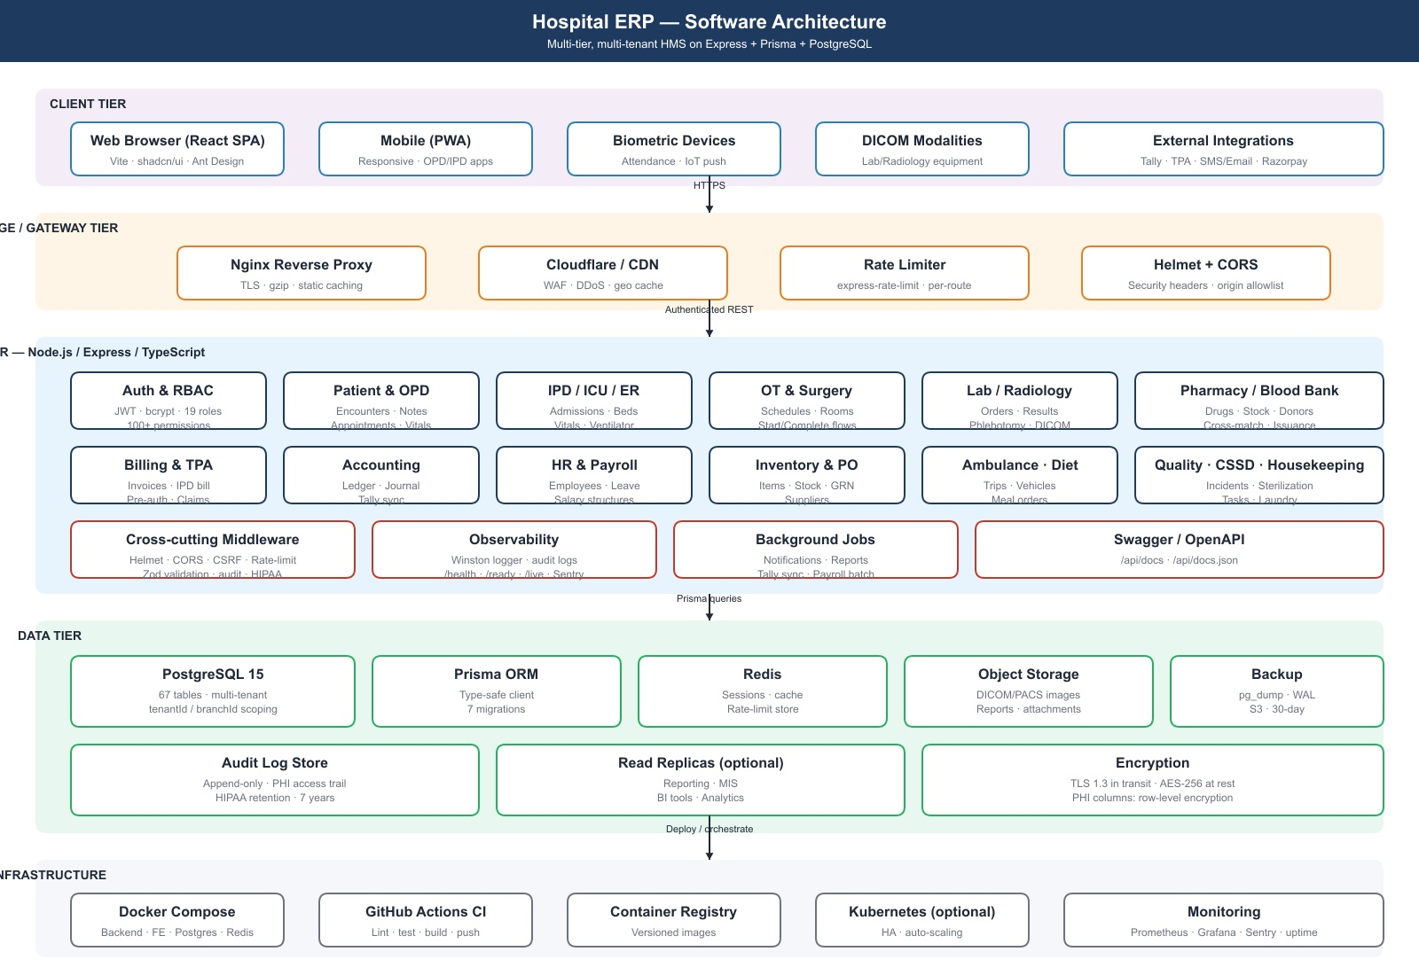
Software architecture

5.1 Tiers
Tier | Components
Client | React 18 SPA (Vite), Ant Design + shadcn/ui, jsPDF for printing, recharts for analytics
Edge | Nginx (TLS, gzip, static cache, security headers); optional Cloudflare WAF/CDN
Application | Node.js 20 + Express + TypeScript; modular controllers; cross-cutting middleware (helmet, CORS, CSRF, rate-limit, Zod, HIPAA, audit)
Data | PostgreSQL 15 (67 tables, Prisma ORM); Redis (sessions, cache, rate-limit store); object storage for DICOM/reports/attachments; pg backups (pg_dump + WAL)
Observability | Winston structured logs; Sentry; /health, /api/live, /api/ready, /api/health/detailed; Prometheus / Grafana optional
Infrastructure | Docker Compose for dev/single-node; Kubernetes optional; GitHub Actions CI/CD

5.2 Tech stack (precise versions)
Backend (backend/package.json) - Node.js 20 · TypeScript 5.3 · Express 4.18 - Prisma 5.7 + PostgreSQL 15 - bcryptjs, jsonwebtoken (JWT auth) - helmet, express-rate-limit, cors, compression, morgan - zod (validation) - winston (logging) · @sentry/node - swagger-jsdoc + swagger-ui-express - vitest + supertest (testing)
Frontend (frontend/package.json) - React 18 + Vite 5 + TypeScript 5.3 - Ant Design 5 + shadcn/ui (Radix primitives) + Tailwind CSS 4 - react-router-dom 6 - axios (API client) - recharts (charts), jspdf + jspdf-autotable (PDF export) - date-fns, dayjs - @react-google-maps/api (ambulance/geo)
Infra - Docker · Docker Compose · Nginx · Redis 7 - GitHub Actions (Postgres 15 service for tests)

5.3 Data flow
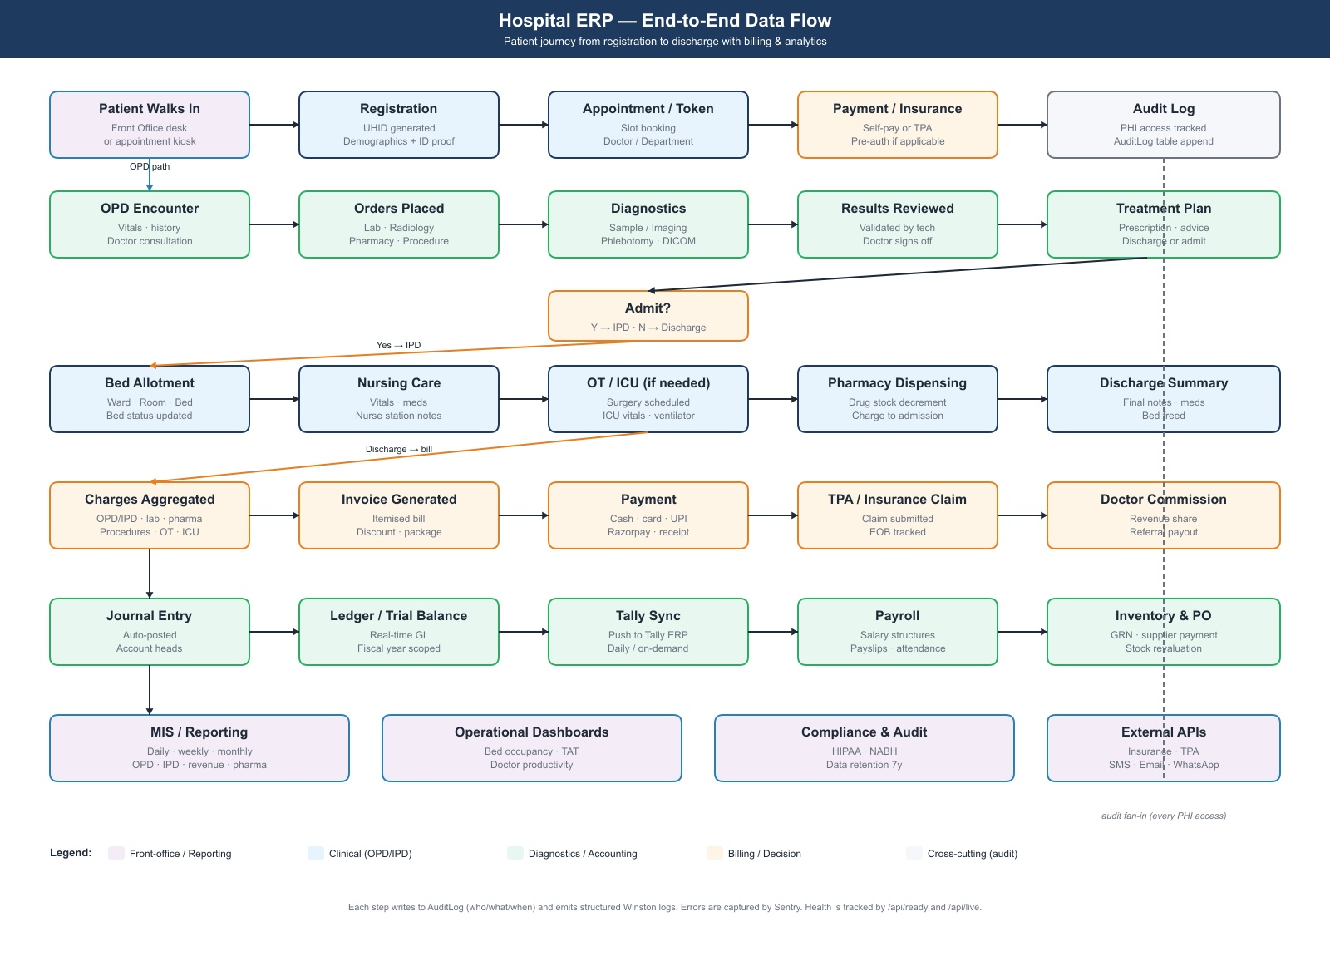
Data flow
Patient walks in → registration creates Patient → appointment & token → check-in opens Encounter → OPD/IPD/ER/ICU paths produce Order (lab/radiology/pharmacy/procedure) → results / dispensing aggregate as InvoiceItem against the encounter or admission → invoice + payment → journal entries posted to GL → optional Tally sync → reports & MIS read the same DB. Every PHI-touching read or mutation appends to AuditLog.

6. Non-functional requirements
Category | Target
Performance | p95 API < 500ms for read endpoints under 100 RPS; list endpoints paginated (default 20, max 200)
Availability | 99.5% (single-node) / 99.9% (HA optional); container healthchecks + auto-restart
Security | OWASP top-10 mitigations; JWT (15-min access, 7-day refresh — phase 2); bcrypt cost 10; TLS 1.3 only; CSP + HSTS via Nginx; rate limit 5 attempts/15min on /auth/login
Data protection | TLS in transit; at-rest encryption via Postgres + disk; PHI-column encryption (phase 2); 7-year audit retention
Compliance | HIPAA-style audit; NABH record-keeping alignment; GST-compliant invoices
Backups | Nightly pg_dump; WAL archiving; 30-day retention; quarterly restore drill
Browsers | Latest 2 versions of Chrome / Edge / Safari; Firefox best-effort
Accessibility | WCAG 2.1 AA target
Localisation | English baseline; Hindi / regional roadmap
Scale | 100 concurrent users / branch; 50k patients / 5M rows on baseline 4 vCPU / 16 GB / 200 GB SSD

7. Security & compliance
- Authentication: JWT with bcryptjs password hashing.
- Authorisation: Role + Permission RBAC (backend/src/rbac.ts) — 19 roles × 100+ permissions enforced via requireRole(...) and requirePermission(...) on every API route.
- Audit: Append-only AuditLog for PHI access, security events (LOGIN_SUCCESS, LOGIN_FAILED), and sensitive mutations.
- Validation: Zod schemas at the API boundary on all create/update endpoints.
- Headers: Helmet (CSP, X-Frame-Options, X-Content-Type-Options, Referrer-Policy) + Nginx hardening.
- Rate-limit: authRateLimiter on /auth/login (5/15min) and generalRateLimiter on /api/* (100/15min).
- Secrets: .env only; no defaults baked into docker-compose.yml. Production uses Docker secrets / Kubernetes secrets.
- Tenant isolation: tenantId + branchId on every table; runtime middleware attaches scope from JWT.

8. Milestones & timeline
Phase | Scope | Status
M0 — Foundation | Repo, schema, auth, RBAC, CI | ✅
M1 — Core clinical | Patient, Appointment, OPD, IPD, Lab, Pharmacy, Billing | ✅
M2 — Specialty modules | ER, ICU, OT, Blood Bank, Radiology, Phlebotomy | ✅
M3 — Operations | HR, Payroll, Inventory/PO, Ambulance, Housekeeping, Diet, CSSD | ✅
M4 — Finance | TPA, Doctor accounting, Commissions, GL/Tally | ✅
M5 — Production hardening | RBAC enforcement on every route, full Zod coverage, secrets cleanup, frontend state mgmt + token refresh, CI test gate | ✅ (this engagement)
M6 — Phase 2 | DICOM/PACS, patient portal, native mobile, custom reports, MFA/SSO | 🟦

9. Acceptance criteria (M5 — production hardening)
The engagement is complete when:
- ✅ All 187 API routes carry an explicit requireRole/requirePermission guard (no authenticated-only endpoint outside /auth/login and /health/*).
- ✅ All POST/PUT routes outside trivial endpoints carry a validateBody(...) Zod schema.
- ✅ No secret values (JWT, DB password, default user password) appear as defaults in docker-compose.yml, seed.ts, or any committed file. .env.example documents every required variable.
- ✅ npm test runs in CI on every push and PR; failing tests block merge.
- ✅ Frontend uses a typed API client with token refresh + global auth context; all 39 pages share a single auth store.
- ✅ Both .md and .docx documents (this SoW, FEATURES, DEVELOPER_GUIDE) are committed under docs/sow/.
- ✅ Architecture and data-flow .jpg diagrams render in .md and embed in .docx.

10. Risks & mitigations
Risk | Mitigation
RBAC drift as new endpoints land | Lint rule / route registry checked in CI; reviewer template
Schema migration on hot data | Use prisma migrate deploy only; pre-flight on staging; reversible migrations
PHI leakage via logs | Winston redaction filter; no patient identifiers in logs (only IDs)
Single-node failure | Healthcheck + restart; HA cutover via Kubernetes (phase 2)
Tally export drift | Idempotent sync with run-ids; reconciliation report
Performance under load | DB indexes audited per release; pagination enforced; Redis for hot reads

11. Assumptions
- Customer provides domain, TLS certs, SMTP and SMS gateway credentials.
- Customer’s IT can run Docker (or supplies a Linux VM with 4 vCPU / 16 GB / 200 GB).
- DICOM/PACS integration in phase 2 will use a shipped Orthanc or Dicoogle instance.
- Tally Prime is on the same LAN as the ERP host or accessible via VPN.
- All clinical staff have unique user accounts (no shared logins).

12. Roles & responsibilities
Role | Responsibility
Vendor (Engineering) | Build, test, deploy, operate; code reviews; weekly release
Customer (Hospital admin) | UAT sign-off, master data seeding, user provisioning, training rollout
Customer (Clinical) | OPD/IPD workflow validation, prescription templates, NABH alignment
Customer (Finance) | GST setup, fiscal year config, Tally credentials, invoice templates
Customer (IT/Infra) | Server provisioning, backups, network, biometric device install

13. Change control
Any change to scope, deliverables, or acceptance criteria is captured in a written change request, sized in story points, and approved by the customer sponsor before implementation. Hot fixes for live-site issues are exempt and tracked separately.

14. References
- FEATURES.md — full feature catalogue
- DEVELOPER_GUIDE.md — DB schema, API surface, frontend route map
- backend/prisma/schema.prisma — 67-model data model
- backend/src/server.ts — 187-endpoint API surface
- backend/src/rbac.ts — role/permission catalogue
- /api/docs — live Swagger UI
- /api/docs.json — OpenAPI spec

