STATEMENT OF WORK

Human Resource Management System
(HRMS)

Version 1.0
Date: January 27, 2026

Table of Contents

1. Executive Summary
2. Feature List
3. Technology Stack
4. Data Flow Diagram
5. Software Architecture
6. Plan of Action (Phase-wise Development)
7. Required Team Setup
8. Timeline
9. API Documentation
10. Database Schema
11. Appendix

1. Executive Summary
This Statement of Work (SoW) outlines the comprehensive development plan for a Human Resource Management System (HRMS). The system is designed to streamline HR operations, automate routine tasks, and provide actionable insights through advanced analytics and AI-powered features.

Key Objectives:
- Centralize all HR operations in a single platform
- Automate attendance tracking with advanced monitoring
- Streamline payroll processing with multiple salary structures
- Enable efficient leave and project management
- Integrate with popular development tools (Azure DevOps, Asana, Confluence)
- Provide AI-powered insights and automation

2. Feature List

2.1 Employee Management
- Complete employee profiles with personal and professional details
- KYC document management (Aadhar, PAN, Passport, etc.)
- Bank account details with verification workflow
- Emergency contact information
- Document storage (offer letters, appointment letters, certificates)
- Reporting hierarchy and organizational structure
- Department and designation management
- Employee activation/deactivation controls

2.2 Attendance & Monitoring
- Punch-in/punch-out system with timestamp and IP tracking
- Break management (start/end breaks)
- Idle time detection and calculation
- Suspicious activity detection:
  - Mouse jiggler pattern detection
  - Auto-typer detection
  - Keystroke pattern analysis
  - Macro detection
- Dual heartbeat system for accurate tracking
- Activity logs with browser and device information
- Attendance calendar view
- Manual attendance entry for admin/managers

2.3 Leave Management
- Multiple leave types: Sick, Casual, Earned, Unpaid
- Leave application workflow with approval process
- Leave status tracking: Pending, Approved, Rejected, Cancelled, Hold
- Admin comment system for leave decisions
- Leave balance tracking per employee per year
- Overlap detection for leave applications
- Leave-to-attendance synchronization

2.4 Payroll & Compensation
- Automated monthly payroll generation
- Support for fixed and variable salary structures
- Component-based salary calculation
- Sales target tracking for variable pay employees
- Professional tax and TDS calculation
- Penalty and advance payment deductions
- Configurable other deductions
- Payroll approval workflow
- Payslip generation and download

2.5 Project & Task Management
- Project creation with detailed information
- Project types: Milestone-based and Retainer
- Project status tracking: Active, Completed, On Hold, Cancelled
- Milestone-based project structure
- Budget and upfront payment tracking
- Project member assignment with role tracking
- Task management with priorities: Low, Medium, High, Urgent
- Task status workflow: Pending, In Progress, Hold, Completed
- Task updates and progress tracking

2.6 Sales & CRM
- Lead management with multiple statuses
- Lead progression: New → Cold Call → Warm → Prospect → Converted
- Lead to sale conversion tracking
- Sales record management
- Commission calculation
- Monthly sales target tracking
- Multi-currency support (USD, INR, etc.)
- Sale-to-project synchronization

2.7 Invoicing & Accounting
- Invoice generation and management
- Invoice statuses: Draft, Sent, Paid, Overdue, Cancelled
- Multiple currency support
- Invoice item line tracking
- Payment tracking
- Account/Ledger management
- Income and expense categorization

2.8 Messaging & Communication
- Internal messaging system
- Message tracking and read status
- Granular messaging permissions
- Conversation threads

2.9 AI & Automation Features
- AI-powered HR chatbot
- Natural language queries for leave, attendance, payroll
- Sentiment analysis
- Resume parsing and analysis
- Skill gap analysis
- Learning recommendations
- Predictive analytics (attrition, performance)
- Automation rules and triggers

2.10 Integrations
- Azure DevOps: Work items, commits, pull requests
- Asana: Task and project synchronization
- Confluence: Documentation sync
- User mapping between platforms

3. Technology Stack

3.1 Frontend
Technology | Version | Purpose
Next.js | 15.5.6 | React framework with App Router, SSR, API routes
React | 19.1.0 | UI component library
TypeScript | 5.x | Type-safe JavaScript
Tailwind CSS | 4.x | Utility-first CSS framework
Radix UI | Latest | Accessible component primitives
Recharts | 3.3.0 | Data visualization and charts
Lucide React | 0.546.0 | Icon library (546+ icons)

3.2 Backend
Technology | Version | Purpose
Next.js API Routes | 15.x | Serverless API endpoints
Prisma | 6.17.1 | Type-safe ORM
PostgreSQL | Latest | Primary database
JWT (jose) | 6.1.0 | Authentication tokens
bcryptjs | 3.0.2 | Password hashing
Zod | 4.1.12 | Schema validation

3.3 External Services
Service | Purpose
OpenAI GPT | AI chatbot and analytics
Azure DevOps API | Work item synchronization
Asana API | Task management integration
Confluence API | Documentation sync
Vercel | Deployment platform

4. Data Flow Diagram
The following diagram illustrates the data flow within the HRMS application, showing how information moves between different components and external services.

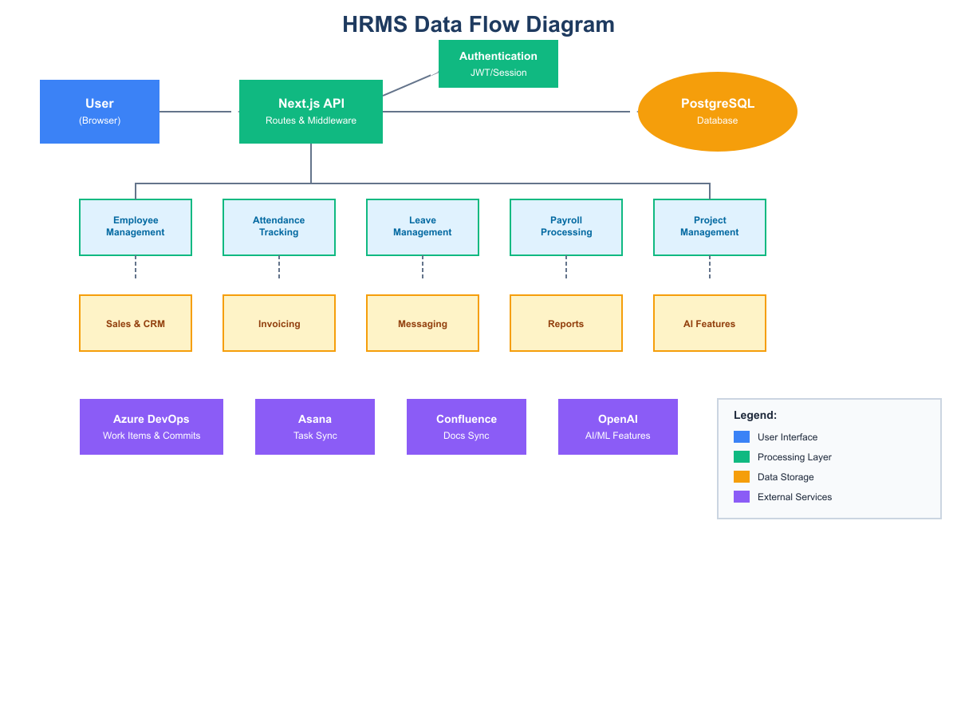

Key Data Flows:
- User interactions flow through the Next.js API layer
- All requests are authenticated via JWT middleware
- Business logic modules process data before database operations
- External integrations sync data bidirectionally
- AI features process data through OpenAI APIs

5. Software Architecture
The HRMS follows a layered architecture pattern with clear separation of concerns. This ensures maintainability, scalability, and testability.

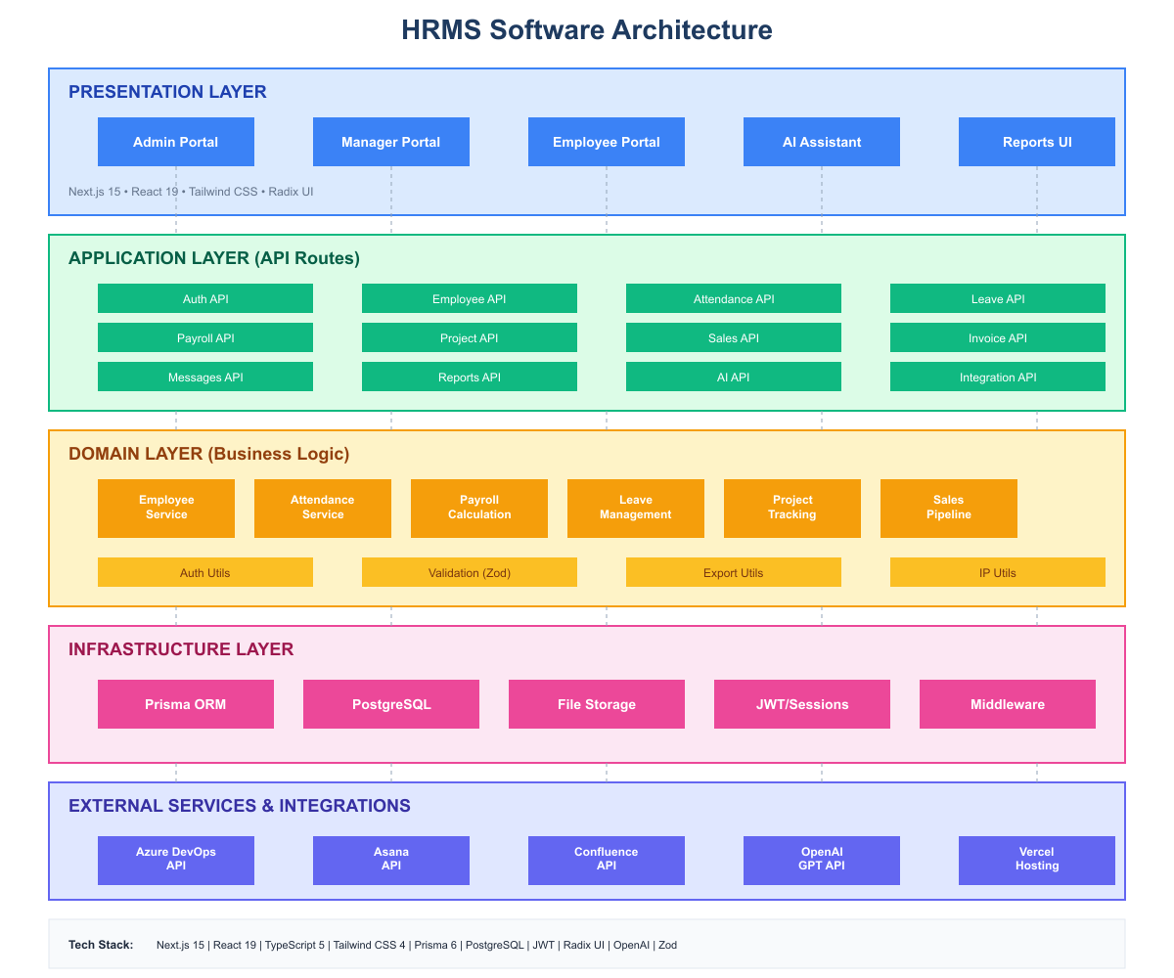

5.1 Architecture Layers
Presentation Layer:
- Three role-based portals: Admin, Manager, Employee
- Responsive UI built with Tailwind CSS and Radix UI
- Server-side rendering for optimal performance
Application Layer:
- RESTful API routes handling all business operations
- Middleware for authentication and authorization
- Request validation using Zod schemas
Domain Layer:
- Business logic encapsulated in service modules
- Complex calculations (payroll, attendance)
- Integration orchestration
Infrastructure Layer:
- Prisma ORM for database operations
- PostgreSQL for data persistence
- File storage for documents

6. Plan of Action (Phase-wise Development)

Phase 1: Foundation & Core Modules
Objective: Establish the foundational infrastructure and core HR modules.
- Project setup with Next.js 15 and TypeScript
- Database schema design and Prisma setup
- Authentication system (JWT-based)
- Role-based access control implementation
- Employee management module
- Basic UI components library
Deliverables: Working authentication, employee CRUD, role-based dashboards

Phase 2: Attendance & Leave Management
Objective: Implement comprehensive attendance tracking and leave management.
- Punch-in/punch-out functionality
- Activity tracking with heartbeat system
- Suspicious activity detection algorithms
- Leave application workflow
- Leave approval process
- Attendance calendar views
Deliverables: Complete attendance system with monitoring, leave management

Phase 3: Payroll System
Objective: Build a flexible payroll processing system.
- Salary structure configuration
- Fixed and variable pay calculation
- Tax calculations (PT, TDS)
- Deduction management
- Payroll generation automation
- Payslip generation
Deliverables: Automated payroll processing with multiple salary types

Phase 4: Project & Sales Management
Objective: Enable project tracking and sales pipeline management.
- Project creation and management
- Task management system
- Lead management (CRM)
- Sales tracking and conversion
- Commission calculations
Deliverables: Complete project management, CRM with sales tracking

Phase 5: Financial Modules
Objective: Implement invoicing and accounting features.
- Invoice generation
- Payment tracking
- Account/Ledger management
- Income/expense categorization
- Financial reports
Deliverables: Invoicing system, basic accounting

Phase 6: Integrations
Objective: Connect with external development tools.
- Azure DevOps integration
- Asana integration
- Confluence integration
- User mapping system
- Sync mechanisms
Deliverables: Working integrations with major platforms

Phase 7: AI Features & Analytics
Objective: Add AI-powered insights and automation.
- AI chatbot implementation
- Predictive analytics
- Sentiment analysis
- Resume parsing
- Skill gap analysis
- Automation rules
Deliverables: AI assistant, predictive insights, automation

Phase 8: Testing & Optimization
Objective: Ensure quality and performance.
- Unit and integration testing
- Performance optimization
- Security audit
- User acceptance testing
- Bug fixes and refinements
Deliverables: Production-ready, tested application

7. Required Team Setup

7.1 Core Development Team
Role | Count | Responsibilities
Project Manager | 1 | Overall project coordination, client communication, timeline management
Tech Lead | 1 | Architecture decisions, code reviews, technical guidance
Senior Full-Stack Developer | 2 | Core module development, API design, complex features
Full-Stack Developer | 2 | Feature development, UI implementation, testing
Frontend Developer | 1 | UI/UX implementation, responsive design, component library
QA Engineer | 1 | Test planning, automation, quality assurance

7.2 Specialized Roles
Role | Count | Responsibilities
DevOps Engineer | 1 | CI/CD setup, deployment, infrastructure management
UI/UX Designer | 1 | User interface design, user experience optimization
Database Administrator | 0.5 | Database optimization, backup strategies, performance tuning

7.3 Team Structure
Total Team Size: 9-10 members
- Project Manager reports to client stakeholders
- Tech Lead oversees all technical decisions
- Developers work in feature teams with rotating responsibilities
- QA Engineer works closely with development team
- Daily standups and weekly sprint reviews

8. Timeline
The following timeline provides an estimated schedule for each development phase. Actual durations may vary based on scope changes and resource availability.

Phase | Duration | Key Milestones
Phase 1: Foundation & Core | 4 weeks | Auth system, Employee module, Basic UI
Phase 2: Attendance & Leave | 3 weeks | Attendance tracking, Leave management
Phase 3: Payroll | 3 weeks | Salary calculation, Payslip generation
Phase 4: Project & Sales | 4 weeks | Project management, CRM, Sales tracking
Phase 5: Financial | 2 weeks | Invoicing, Accounting basics
Phase 6: Integrations | 3 weeks | Azure DevOps, Asana, Confluence
Phase 7: AI Features | 3 weeks | Chatbot, Analytics, Automation
Phase 8: Testing & Launch | 2 weeks | UAT, Bug fixes, Deployment

Total Estimated Duration: 24 weeks (6 months)

8.1 Milestone Schedule
- Week 4: MVP with authentication and employee management
- Week 7: Attendance and leave modules complete
- Week 10: Payroll system operational
- Week 14: Project and sales management live
- Week 16: Financial modules ready
- Week 19: External integrations functional
- Week 22: AI features deployed
- Week 24: Production release

9. API Documentation
The HRMS exposes a comprehensive RESTful API. All endpoints require authentication unless specified otherwise.

9.1 Authentication APIs
Method | Endpoint | Description
POST | /api/auth/login | Authenticate user and receive JWT token
POST | /api/auth/logout | Clear session and invalidate token
GET | /api/auth/me | Get current user session information

9.2 Employee APIs
Method | Endpoint | Description
GET | /api/employees | List all employees with filters
POST | /api/employees | Create new employee and user account
GET | /api/employees/[id] | Get employee details
PUT | /api/employees/[id] | Update employee information
DELETE | /api/employees/[id] | Delete employee
POST | /api/employees/[id]/documents | Upload employee documents
PUT | /api/employees/[id]/banking | Update banking details

9.3 Attendance APIs
Method | Endpoint | Description
GET | /api/attendance | Get attendance records
POST | /api/attendance | Punch in/out or create manual entry
PUT | /api/attendance | Edit attendance record
POST | /api/attendance/heartbeat | Send activity heartbeat
POST | /api/attendance/activity | Log detailed activity

9.4 Leave APIs
Method | Endpoint | Description
GET | /api/leaves | Get leave requests
POST | /api/leaves | Apply for leave
PUT | /api/leaves | Approve/reject leave

9.5 Payroll APIs
Method | Endpoint | Description
GET | /api/payroll | Get payroll records
POST | /api/payroll | Generate monthly payroll
PUT | /api/payroll | Update payroll status
GET | /api/payroll/[id] | Get payroll details

9.6 Project & Task APIs
Method | Endpoint | Description
GET | /api/projects | Get projects list
POST | /api/projects | Create new project
PUT | /api/projects | Update project
GET | /api/tasks | Get tasks
POST | /api/tasks | Create task
PUT | /api/tasks | Update task status

9.7 Sales & CRM APIs
Method | Endpoint | Description
GET | /api/leads | Get leads
POST | /api/leads | Create lead
PUT | /api/leads | Update lead
GET | /api/sales | Get sales records
POST | /api/sales | Create sale
PUT | /api/sales | Update sale

9.8 AI APIs
Method | Endpoint | Description
POST | /api/ai/chat | Send message to AI assistant
GET | /api/ai/chat | Get chat history
POST | /api/ai/predictions | Get predictive analytics
POST | /api/ai/sentiment | Analyze sentiment
POST | /api/ai/recruitment | Parse and analyze resume

10. Database Schema
The HRMS uses PostgreSQL with Prisma ORM. Below are the key database entities and their relationships.

10.1 Core Entities
User
Field | Type | Description
id | String (UUID) | Primary key
email | String | Unique email address
username | String | Unique username
password | String | Hashed password
role | Enum | ADMIN, MANAGER, EMPLOYEE
employeeId | String | Foreign key to Employee
permissions | JSON | Granular permissions

Employee
Field | Type | Description
id | String (UUID) | Primary key
employeeId | String | Employee code (EMP001)
name | String | Full name
email, phone | String | Contact information
designation | String | Job title
department | String | Department name
salary | Float | Monthly salary
salaryType | Enum | FIXED, VARIABLE
dateOfJoining | DateTime | Join date
reportingHeadId | String | Manager reference

Attendance
Field | Type | Description
id | String (UUID) | Primary key
employeeId | String | Foreign key to Employee
date | DateTime | Attendance date
punchIn, punchOut | DateTime | Timestamps
totalHours | Float | Hours worked
idleTime | Float | Idle hours detected
status | Enum | PRESENT, ABSENT, HALF_DAY, LEAVE, HOLIDAY

10.2 Financial Entities
Payroll
Field | Type | Description
id | String (UUID) | Primary key
employeeId | String | Foreign key to Employee
month, year | Int | Payroll period
basicSalary | Float | Base salary amount
variablePay | Float | Variable component
grossSalary | Float | Total before deductions
totalDeductions | Float | All deductions
netSalary | Float | Take-home amount
status | Enum | PENDING, APPROVED, PAID

Invoice
Field | Type | Description
id | String (UUID) | Primary key
invoiceNumber | String | Unique invoice number
clientName | String | Client name
amount | Float | Invoice amount
currency | String | Currency code
status | Enum | DRAFT, SENT, PAID, OVERDUE
items | JSON | Line items

10.3 Project Entities
Project
Field | Type | Description
id | String (UUID) | Primary key
projectId | String | Project code (PRJ00001)
name | String | Project name
projectType | Enum | MILESTONE, RETAINER
totalBudget | Float | Project budget
status | Enum | ACTIVE, COMPLETED, ON_HOLD, CANCELLED
milestones | JSON | Milestone definitions

Task
Field | Type | Description
id | String (UUID) | Primary key
projectId | String | Foreign key to Project
title | String | Task title
assignedTo | String | Foreign key to Employee
status | Enum | PENDING, IN_PROGRESS, HOLD, COMPLETED
priority | Enum | LOW, MEDIUM, HIGH, URGENT
dueDate | DateTime | Due date

10.4 CRM Entities
Lead
Field | Type | Description
id | String (UUID) | Primary key
leadNumber | String | Lead code (LD00001)
companyName | String | Company name
contactName | String | Contact person
status | Enum | NEW, WARM, PROSPECT, CONVERTED, LOST
estimatedValue | Float | Estimated deal value

Sale
Field | Type | Description
id | String (UUID) | Primary key
saleNumber | String | Sale code (SL00001)
leadId | String | Foreign key to Lead
netAmount | Float | Sale amount
status | Enum | PENDING, CONFIRMED, DELIVERED, PAID
commission | String | Commission details

10.5 Entity Relationships
- User ↔ Employee: One-to-One
- Employee ↔ Attendance: One-to-Many
- Employee ↔ Leave: One-to-Many
- Employee ↔ Payroll: One-to-Many
- Employee ↔ Task: One-to-Many (assigned tasks)
- Project ↔ Task: One-to-Many
- Project ↔ ProjectMember: One-to-Many
- Lead ↔ Sale: One-to-One
- Employee ↔ Employee: Self-referential (reporting hierarchy)
- Department ↔ Designation: One-to-Many

11. Appendix

11.1 Security Considerations
- All passwords hashed with bcryptjs (salt rounds: 10)
- JWT tokens stored in httpOnly, secure cookies
- CSRF protection via SameSite cookie attribute
- SQL injection prevention through Prisma ORM
- Role-based access control on all endpoints
- Audit logging for all sensitive operations
- IP address tracking for security monitoring

11.2 Deployment Requirements
- Node.js 18+ runtime
- PostgreSQL 14+ database
- Minimum 2GB RAM for application server
- SSL certificate for HTTPS
- Environment variables for configuration

11.3 Environment Variables
Variable | Purpose
DATABASE_URL | PostgreSQL connection string
JWT_SECRET | JWT signing secret
OPENAI_API_KEY | OpenAI API authentication
AZURE_DEVOPS_PAT | Azure DevOps Personal Access Token
ASANA_ACCESS_TOKEN | Asana API token
CONFLUENCE_API_TOKEN | Confluence API token

11.4 Support & Maintenance
Post-deployment support includes:
- Bug fixes for 90 days after launch
- Security patches as needed
- Performance monitoring setup
- Documentation and training materials
- Knowledge transfer sessions

--- End of Document ---

