STATEMENT OF WORK
IT Asset Management (ITAM) Platform

Prepared by: Infiniti Tech Partners
Date: March 2026
Version: 1.0

Table of Contents
1. Executive Summary
2. Feature List
3. Technology Stack
4. Data Flow Architecture
5. Software Architecture
6. API Structure
7. Project Timeline & Milestones
8. Assumptions & Dependencies
9. Acceptance Criteria

1. Executive Summary
This Statement of Work (SOW) defines the scope, deliverables, and technical specifications for the development of an IT Asset Management (ITAM) platform. The platform will provide automated network discovery, centralized asset inventory management, software license tracking, real-time monitoring, and comprehensive reporting capabilities. The system is designed to be deployed as a self-hosted solution with secure remote access via Cloudflare Tunnel.

2. Feature List

2.1 Network Discovery Engine
- IP range scanning (subnets, CIDR blocks)
- Protocol-based discovery: WMI, SNMP v1/v2/v3, SSH, ICMP, TCP port scanning
- Scheduled recurring scans (hourly, daily, weekly)
- Auto device classification (workstations, servers, routers, switches, printers, IoT, VMs)
- Network segmentation awareness (cross-VLAN discovery)
- Optional agent-based discovery for deep endpoint inventory

2.2 Asset Inventory Management
- Centralized asset repository with detailed hardware inventory (hostname, manufacturer, model, CPU, RAM, disk, NIC, BIOS, serial, asset tag, warranty)
- OS information tracking (type, version, kernel, build, install date, patch level)
- Software inventory (name, publisher, version, install date, license info)
- Virtualization awareness (VMware, Hyper-V, KVM — host-to-VM relationships)

2.3 Asset Lifecycle Management
- Procurement logging and assignment to employees/departments
- Warranty tracking and maintenance history
- Asset depreciation tracking
- Retirement/decommissioning records with historical audit logs

2.4 Real-Time Asset Monitoring
- Server uptime, CPU, memory, and disk utilization monitoring
- Network availability and service availability checks
- Configurable alert thresholds with email and web dashboard notifications

2.5 Software License Management
- License count tracking and compliance reporting
- Detection of unauthorized, over-licensed, or under-licensed software
- License expiration alerts

2.6 Patch & Update Visibility
- Missing OS update identification
- Patch compliance dashboards
- Vulnerable software detection
- Integration hooks for patch management systems

2.7 Reporting & Analytics
- Asset reports: total inventory, by department, by device type, end-of-life hardware
- Software reports: installed software, unauthorized detection, version distribution
- Security reports: unpatched systems, unsupported OS, missing antivirus
- Scheduled generation, export to PDF/Excel/CSV, custom report builder

2.8 Network Topology Visualization
- Auto-generated network topology diagrams
- Device relationship and switch port mapping
- Visual network segment representation

2.9 User & Access Management
- Role-based access control (Admin, Technician, Auditor, Department Manager)
- Granular permission control and audit logging
- Multi-user dashboard access

2.10 Helpdesk & Ticketing Integration
- Ticket creation, tracking, and assignment
- Email-based ticket submission and SLA tracking
- Asset-to-ticket linkage

2.11 API & Integration Framework
- RESTful API for asset retrieval, status queries, inventory updates
- Integration with ITSM, SIEM, configuration management, and cloud platforms
- Automation workflow support

2.12 Security & Compliance
- Detection of unsupported OS and vulnerable software
- Unauthorized device monitoring and access auditing
- Compliance reporting for ISO 27001, SOC 2, and IT asset frameworks

2.13 Multi-Site Support
- Multi-location inventory management with site-based filtering
- Distributed scanning nodes with centralized dashboard

2.14 Notification & Alerting Engine
- Configurable alerts: new/removed devices, hardware failures, storage thresholds, compliance violations
- Delivery via email, web notifications, and webhook integrations

2.15 Dashboard & Visualization
- Centralized admin dashboard: total assets, health overview, alerts, patch compliance, software inventory
- Role-based customizable dashboard views

3. Technology Stack
Layer | Technology | Purpose
Frontend Framework | Next.js 16 (App Router) | Server-side rendering, API routes, file-based routing
UI Library | React 19 | Component-based UI with Server Components & React Compiler
Styling | Tailwind CSS 4 | Utility-first CSS framework for responsive design
Language | TypeScript 5 | Type-safe development across frontend and backend
ORM | Prisma 7 | Type-safe database access with migration support
Database | PostgreSQL (NeonDB) | Serverless PostgreSQL for asset data persistence
Caching | Redis | Session management, real-time data caching, pub/sub
Authentication | NextAuth.js / JWT | Session management and role-based access control
Network Scanning | Node.js (net, dgram, snmp-native) | SNMP, WMI, SSH, ICMP discovery protocols
Reporting | PDFKit / ExcelJS | PDF, Excel, and CSV report generation
Visualization | D3.js / React Flow | Network topology diagrams and data charts
Background Jobs | BullMQ + Redis | Scheduled scans, report generation, alert processing
Deployment | Self-hosted (Node.js) | Local LAN deployment with direct network access
Remote Access | Cloudflare Tunnel | Secure external access without exposing ports
Linting | ESLint 9 | Code quality and consistency enforcement
Build Tool | Turbopack (Next.js) | Fast development builds with HMR

4. Data Flow Architecture
The following diagram illustrates the end-to-end data flow within the ITAM platform, from data collection sources through processing and storage to output delivery.
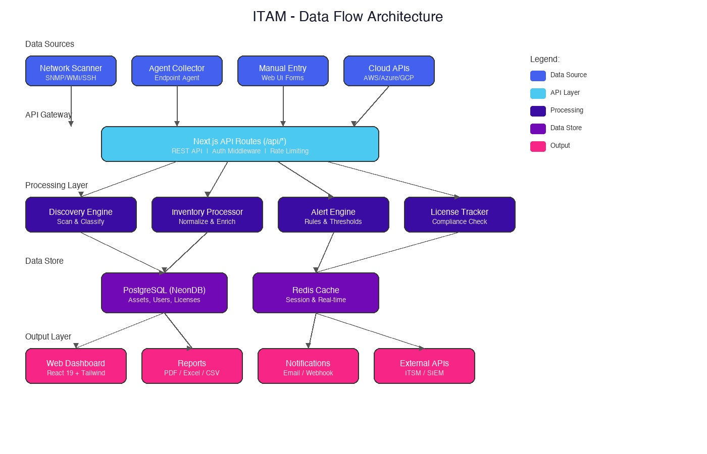

Data Flow Description
- Data Sources: Network scanners (SNMP/WMI/SSH), endpoint agents, manual web UI entry, and cloud provider APIs feed raw asset data into the system.
- API Gateway: All incoming data passes through Next.js API route handlers which enforce authentication, authorization, rate limiting, and input validation.
- Processing Layer: The Discovery Engine classifies devices, the Inventory Processor normalizes and enriches data, the Alert Engine evaluates rules, and the License Tracker checks compliance.
- Data Store: Processed data is persisted to PostgreSQL (NeonDB) for durable storage and Redis for real-time caching and session management.
- Output Layer: The Web Dashboard (React 19), Report Generator (PDF/Excel/CSV), Notification Engine (email/webhook), and External API integrations consume the processed data.

5. Software Architecture
The platform follows a layered architecture pattern ensuring separation of concerns, testability, and maintainability. The following diagram shows the complete software architecture.
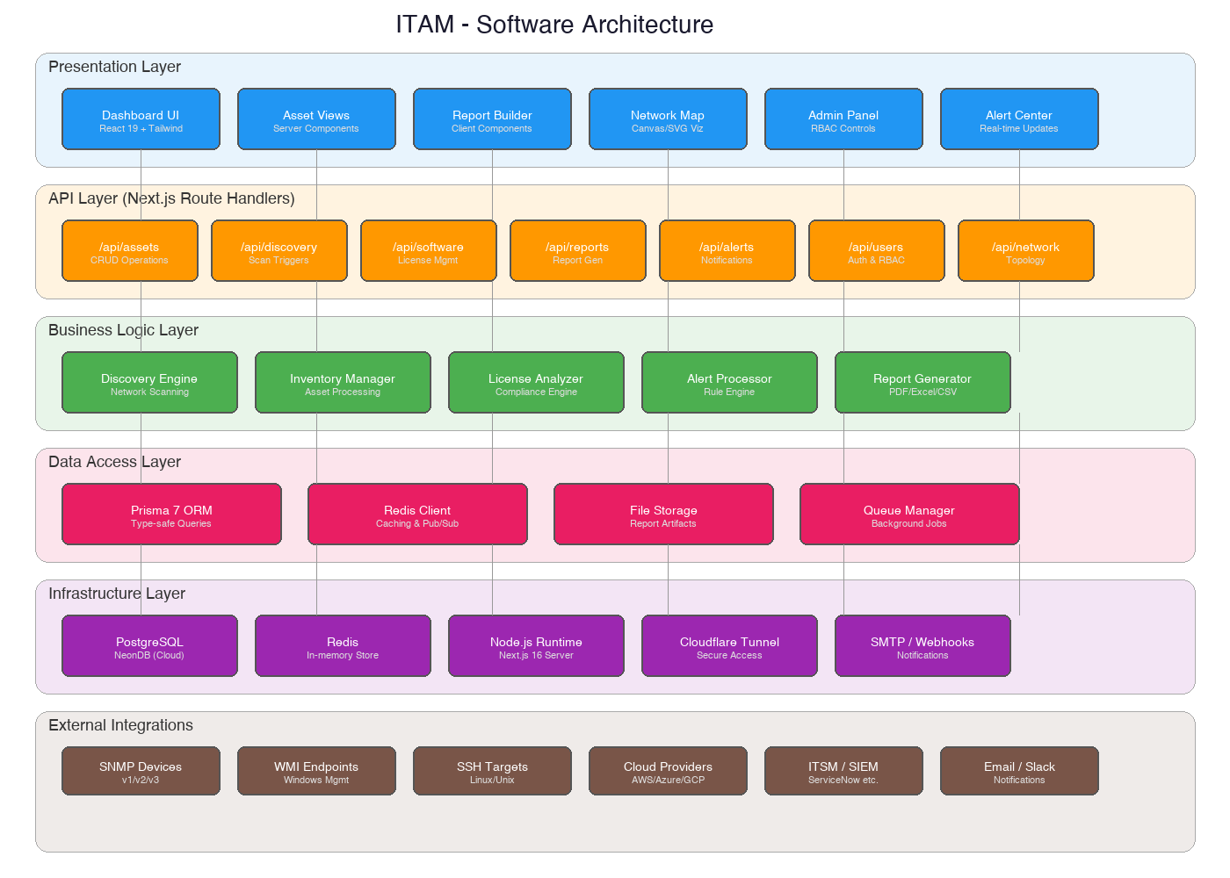

Architecture Layers

Presentation Layer
React 19 components with Tailwind CSS 4. Uses Next.js 16 Server Components for optimal performance. Includes Dashboard UI, Asset Views, Report Builder, Network Map, Admin Panel, and Alert Center.

API Layer
Next.js Route Handlers organized under /api/*. Provides RESTful endpoints for all platform operations with middleware for auth, rate limiting, and validation. All API routes are consolidated in a single folder structure.

Business Logic Layer
Core processing engines including Discovery Engine, Inventory Manager, License Analyzer, Alert Processor, and Report Generator. Contains all domain-specific business rules.

Data Access Layer
Prisma 7 ORM for type-safe PostgreSQL queries, Redis client for caching and pub/sub, file storage for report artifacts, and queue manager for background job processing.

Infrastructure Layer
PostgreSQL (NeonDB) for persistence, Redis for caching, Node.js runtime hosting Next.js 16, Cloudflare Tunnel for secure remote access, and SMTP/Webhook services for notifications.

External Integrations
SNMP devices (v1/v2/v3), WMI endpoints, SSH targets, cloud provider APIs, ITSM/SIEM platforms, and notification channels (email, Slack).

6. API Structure
All API routes are organized within a single folder: src/app/api/. The following table defines the complete API endpoint structure.
Endpoint | Method | Description | Auth Required
/api/auth/login | POST | User authentication | No
/api/auth/logout | POST | User logout | Yes
/api/auth/session | GET | Get current session | Yes
/api/users | GET, POST | List/create users | Admin
/api/users/[id] | GET, PUT, DELETE | User CRUD operations | Admin
/api/assets | GET, POST | List/create assets | Yes
/api/assets/[id] | GET, PUT, DELETE | Asset CRUD operations | Yes
/api/assets/[id]/history | GET | Asset lifecycle history | Yes
/api/assets/[id]/software | GET | Asset installed software | Yes
/api/assets/import | POST | Bulk asset import (CSV) | Admin
/api/assets/export | GET | Export assets (CSV/Excel) | Yes
/api/discovery/scan | POST | Trigger network scan | Admin
/api/discovery/schedules | GET, POST | Manage scan schedules | Admin
/api/discovery/results | GET | Get scan results | Yes
/api/software | GET | List all software | Yes
/api/software/licenses | GET, POST | License management | Admin
/api/software/compliance | GET | License compliance report | Yes
/api/software/unauthorized | GET | Unauthorized software list | Yes
/api/monitoring/status | GET | Device status overview | Yes
/api/monitoring/alerts | GET, POST | Alert management | Yes
/api/monitoring/thresholds | GET, PUT | Alert threshold config | Admin
/api/reports | GET, POST | List/generate reports | Yes
/api/reports/[id] | GET, DELETE | Report CRUD | Yes
/api/reports/scheduled | GET, POST | Scheduled report config | Admin
/api/network/topology | GET | Network topology data | Yes
/api/network/devices | GET | Discovered devices list | Yes
/api/tickets | GET, POST | Helpdesk ticket management | Yes
/api/tickets/[id] | GET, PUT | Ticket operations | Yes
/api/patches | GET | Patch status overview | Yes
/api/patches/compliance | GET | Patch compliance report | Yes
/api/sites | GET, POST | Multi-site management | Admin
/api/dashboard | GET | Dashboard summary data | Yes
/api/audit-log | GET | User action audit log | Admin

API Folder Structure
src/app/api/
├── auth/
│ ├── login/route.ts
│ ├── logout/route.ts
│ └── session/route.ts
├── users/
│ ├── route.ts
│ └── [id]/route.ts
├── assets/
│ ├── route.ts
│ ├── import/route.ts
│ ├── export/route.ts
│ └── [id]/
│ ├── route.ts
│ ├── history/route.ts
│ └── software/route.ts
├── discovery/
│ ├── scan/route.ts
│ ├── schedules/route.ts
│ └── results/route.ts
├── software/
│ ├── route.ts
│ ├── licenses/route.ts
│ ├── compliance/route.ts
│ └── unauthorized/route.ts
├── monitoring/
│ ├── status/route.ts
│ ├── alerts/route.ts
│ └── thresholds/route.ts
├── reports/
│ ├── route.ts
│ ├── scheduled/route.ts
│ └── [id]/route.ts
├── network/
│ ├── topology/route.ts
│ └── devices/route.ts
├── tickets/
│ ├── route.ts
│ └── [id]/route.ts
├── patches/
│ ├── route.ts
│ └── compliance/route.ts
├── sites/
│ └── route.ts
├── dashboard/
│ └── route.ts
└── audit-log/
└── route.ts

7. Project Timeline & Milestones
Phase | Deliverables | Duration | Milestone
Phase 1: Foundation | Project setup, DB schema, auth, base UI | 3 weeks | Core infrastructure ready
Phase 2: Discovery | Network scanner, device classification, scan scheduling | 4 weeks | Discovery engine operational
Phase 3: Inventory | Asset CRUD, lifecycle tracking, software inventory | 3 weeks | Asset management functional
Phase 4: Monitoring | Real-time monitoring, alerting engine, notifications | 3 weeks | Monitoring & alerts live
Phase 5: Compliance | License management, patch visibility, security auditing | 3 weeks | Compliance reporting ready
Phase 6: Reporting | Report builder, scheduled reports, export functionality | 2 weeks | Reporting engine complete
Phase 7: Integration | API framework, ITSM/SIEM integration, multi-site | 3 weeks | External integrations live
Phase 8: Polish | Network topology viz, helpdesk module, dashboard refinement | 3 weeks | Feature complete
Phase 9: Testing & QA | End-to-end testing, security audit, performance tuning | 2 weeks | Production ready
Phase 10: Deployment | Production deployment, documentation, training | 1 week | Go-live

8. Assumptions & Dependencies
- Network infrastructure allows scanning protocols (SNMP, WMI, SSH, ICMP) from the host machine.
- NeonDB PostgreSQL instance is provisioned and accessible.
- Target devices have appropriate credentials configured for discovery protocols.
- Cloudflare account is available for tunnel configuration (for remote access).
- SMTP service is available for email notifications.
- Client will provide access to any ITSM/SIEM systems for integration.
- The deployment server runs Node.js 20+ with sufficient resources.

9. Acceptance Criteria
- Network discovery successfully detects and classifies devices across defined IP ranges.
- Asset inventory stores and retrieves complete hardware, OS, and software information.
- RBAC system enforces role-based permissions across all features.
- Real-time monitoring reports device health with configurable alert thresholds.
- Reports generate correctly in PDF, Excel, and CSV formats.
- API endpoints return correct responses with proper authentication enforcement.
- Network topology visualization accurately represents discovered device relationships.
- System performs within acceptable response times under expected asset load.
- All security compliance checks function against ISO 27001 and SOC 2 criteria.
- Multi-site management correctly segments and filters assets by location.

