KMCP · PROPOSED SCREENS
A dashboard, a map,
and a way to pay
Kolkata Municipal Corporation Parking — vendor and citizen applications
5 September 2026
The vendor app gets the numbers an operator actually asks for, and a QR that carries the fare. The citizen app gets built — map, car park detail, wallet, history. Vendor screens reuse the existing theme.ts unchanged; citizen screens propose a light palette, because a map is unreadable on a dark ground and a citizen is not standing in the sun.
Decisions this document assumes
DECISION | CHOICE | CONSEQUENCE
Wallet | Full ledger | Balance, top-up, debit and refund. None of this exists today — the only genuinely new subsystem.
QR payments | Razorpay QR Codes API | Amount fixed server-side; reconciles itself through the webhook that already runs.
Citizen sign-in | OTP — already built | auth/otp/request and auth/otp/verify exist, are documented for citizens, and have never been called.
Starting a session | Still the attendant | The citizen app finds their car by registered plate. It does not start sessions.

Every screen in this document was drawn against the live schema. Field and endpoint names quoted here were verified against kmcp-backend at commit 7446f1d.

1. The operator's numbers
VENDOR APP · app/(tabs)/shift.tsx → today.tsx
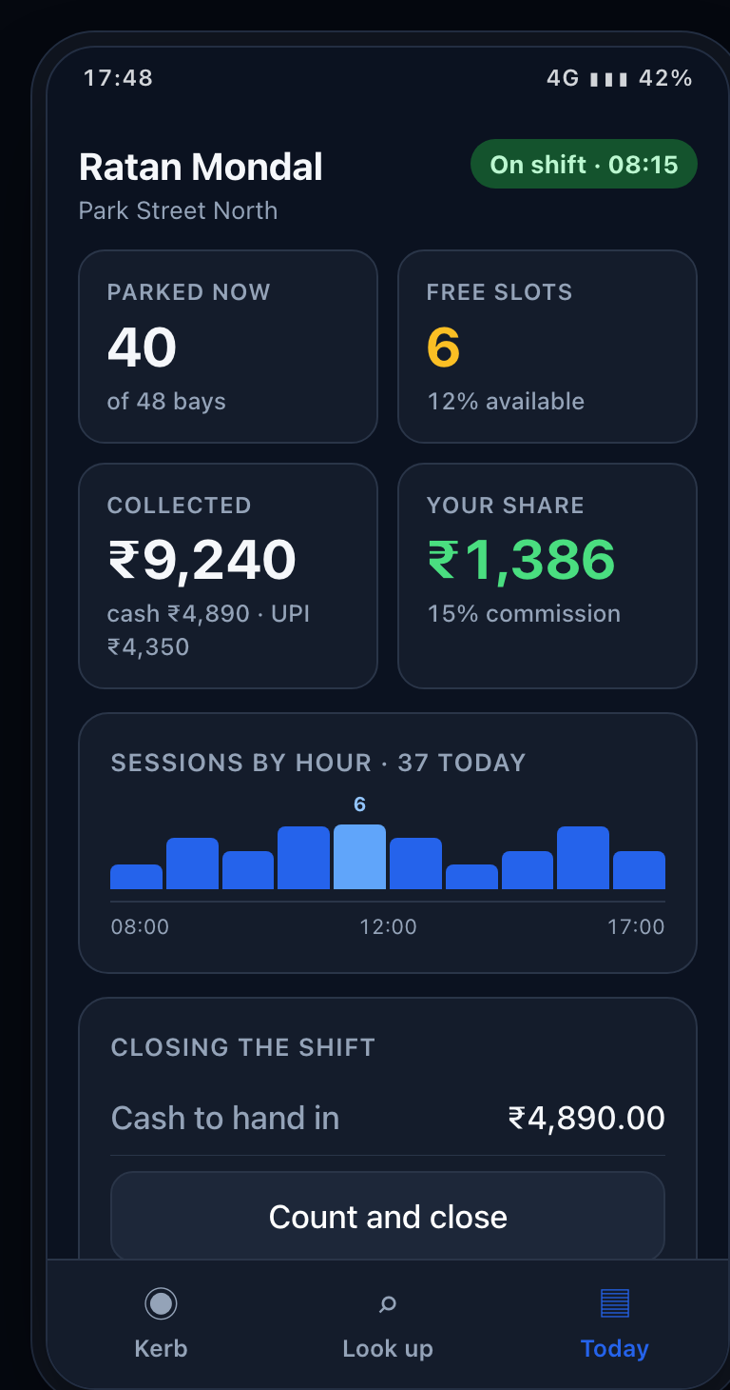
Today — the Shift tab, grown into a dashboard
Every figure on this screen already exists on the live API. Parked-now and free slots come from the slot summary, the collected split from the open shift, and the vendor's share from the commission percentage applied to what was collected — the same calculation the settlement engine already performs.

Why this is not a fourth tab
The app's own layout file states the rule: "three tabs and no more — a fourth would be a feature nobody asked for competing for a thumb that is holding a phone in the rain." That reasoning is sound, so the dashboard does not add a tab. The Shift tab already carried sessions, digital total and zone; it becomes Today and absorbs the rest. The Kerb remains the working screen.

Reading the screen
Free slots is the only tile that changes colour, because it is the only number an attendant has to act on; the others exist to be known, not chased. The hourly strip is a single series in a single hue with only the peak labelled — a number above every bar would be noise at this size.
- All four figures are available from the live API today.
- GET /revenue is guarded by payment.read — confirm a vendor's share is scoped to their own vendor and not the whole city.

2. A QR that carries the fare
VENDOR APP · app/session/[code].tsx
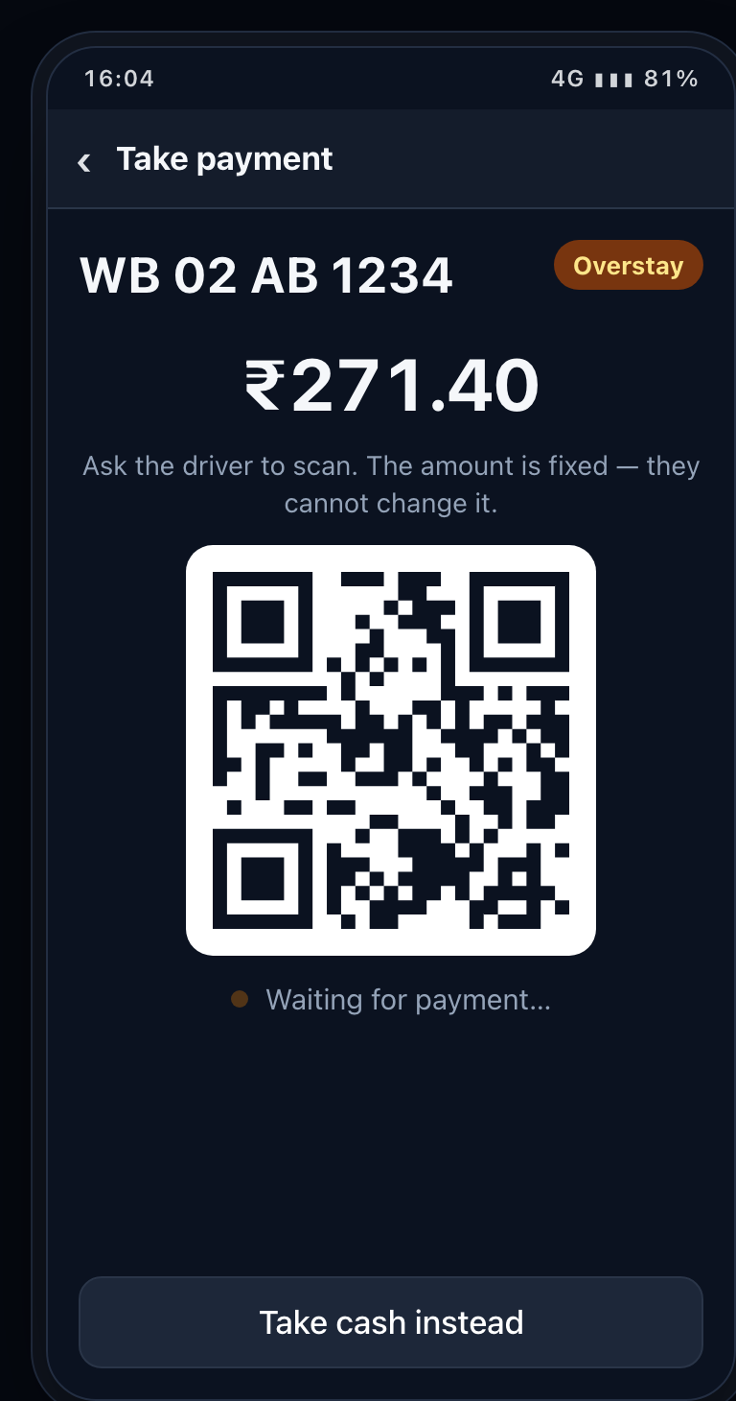 | 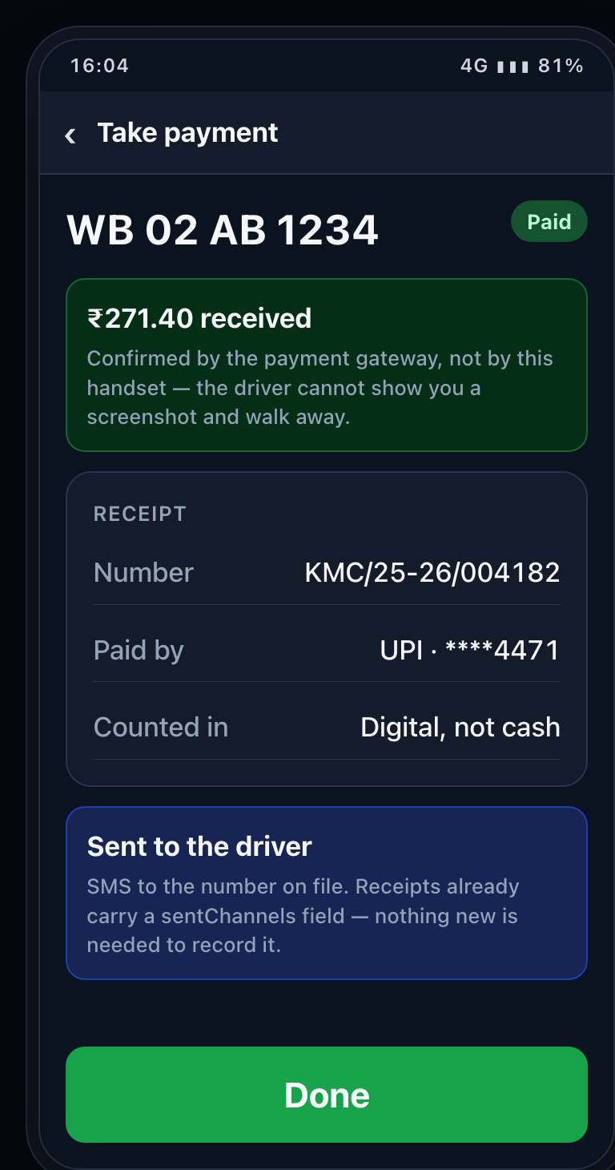
Awaiting — the amount is locked server-side | Settled — the gateway confirms, not the phone
The requirement is a QR carrying the payment value on every payment. Today the collect endpoint creates a Razorpay order and returns the gateway key and order — which is what a checkout sheet needs, not something a driver can scan.

What has to change
razorpay.service.ts has exactly one method, createOrder. It needs a second, createQrCode, calling Razorpay's QR Codes API with a fixed amount and single use, returning an image URL the handset renders. The webhook then handles the qr_code.credited event alongside the payment events it already verifies.

Why this matters more than it looks
A fixed-amount QR is the first payment path in this system where the attendant never touches the money. That removes at source the variance it currently takes an entire reconciliation screen to detect.
- New: createQrCode() in the Razorpay service.
- New: qr_code.credited handling in the webhook.
- New: the handset must poll or subscribe until the payment lands.
- Already exists: receipt model, SMS channel, and idempotency keys.

3. Where can I park
CITIZEN APP · apps/citizen — new workspace
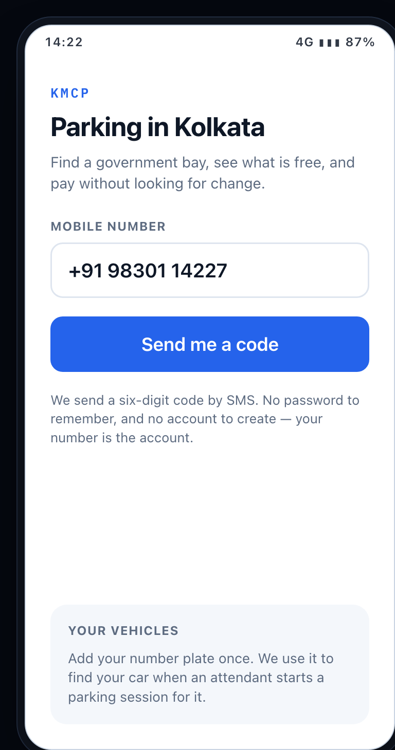 | 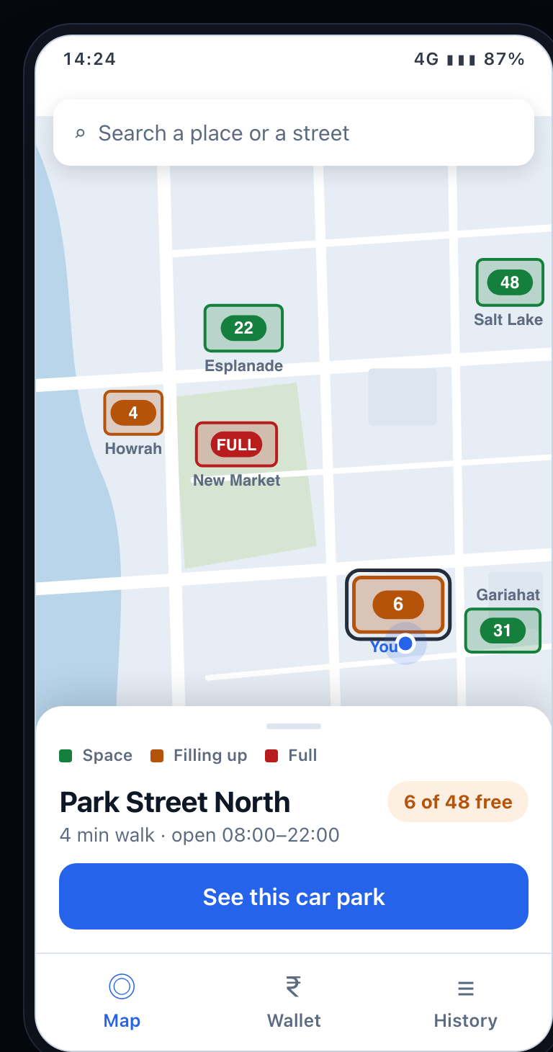
Sign in — the OTP endpoint already exists | Map — lot footprints, each carrying its free count
The map is the cheapest thing in this document. Zone.boundary is already a GeoJSON polygon with a capacity, which is why the lots are drawn as footprints rather than pins — the outline is real data. The nearby-zones endpoint is already callable anonymously; the vendor app's own client passes anonymous: true to it. A citizen can therefore see the map before signing in.

Colour is never the only signal
Every lot carries its free-bay count inside the footprint. Green, amber and red are status colours reserved for exactly this purpose, and a driver who cannot distinguish them still reads 22, FULL, 31.

Sign-in
auth/otp/request and auth/otp/verify exist and are documented as "send a login OTP to a citizen's mobile". They have never been called. Note that the vendor app's device binding must not apply here — it is the correct rule for a depot handset and the wrong one for the general public.
- Works today: OTP sign-in, and GET /zones/nearby — the only two routes a citizen token can reach.
- The CITIZEN role is seeded with zero permissions, commented "No portal access at all". Every route carrying @RequirePermissions answers 403 to a citizen.
- GET /zones/nearby does not select boundary, so lots render as circles until it does.
- Slot summary, plate lookup and applicable tariff sit behind administrator permissions.
- No citizen vehicle self-registration: POST /me/vehicles does not exist.

4. Inside a car park
CITIZEN APP · apps/citizen — new workspace
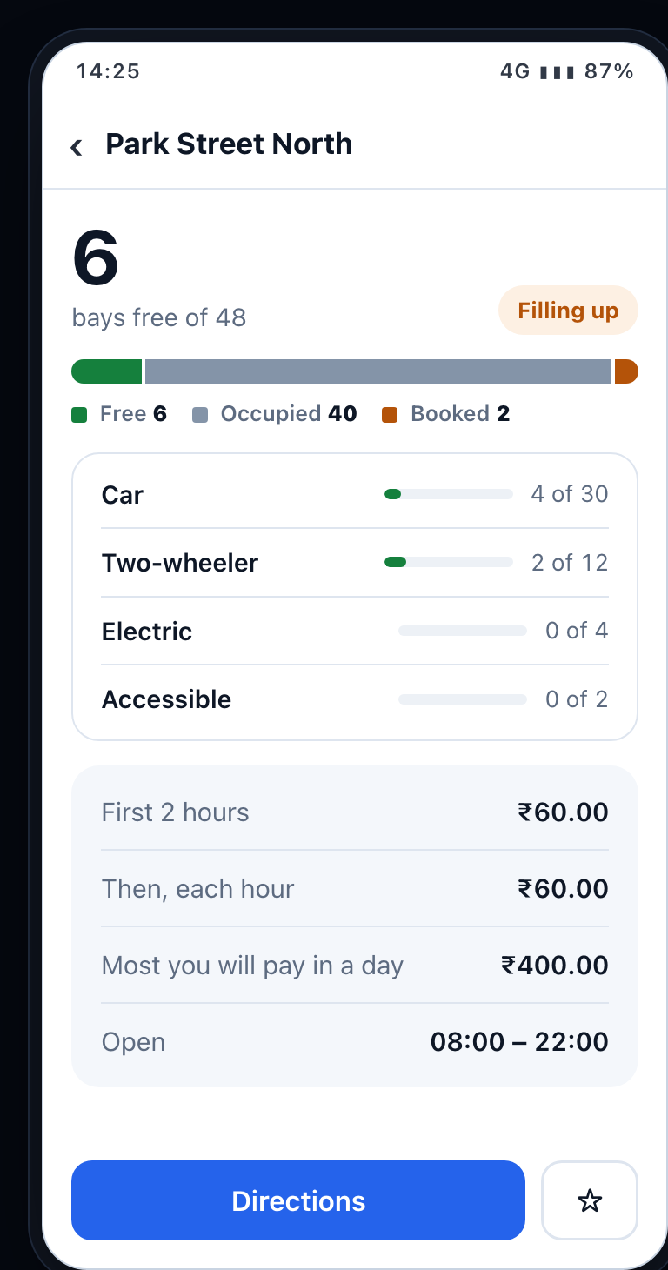 | 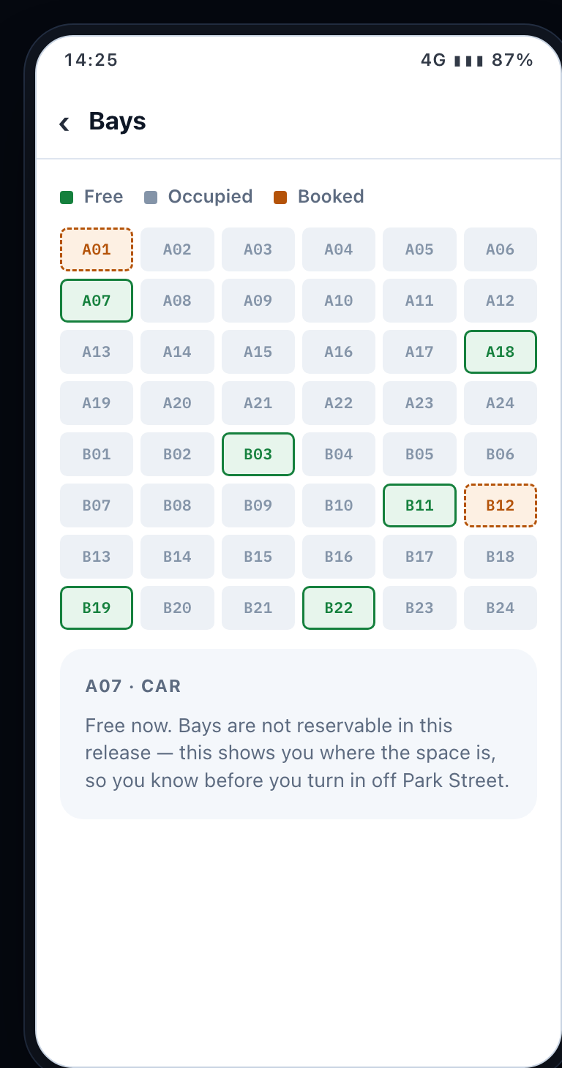
Car park — free, occupied and booked are three numbers | Bays — one cell per Slot.code, coloured by status
This is the screen the backend was most clearly expecting. slots.service.ts carries the comment "Bay counts by status and type — what the zone detail screen draws." The query was written for a screen nobody had yet drawn.

Free and booked are not one number
SlotStatus has four values — AVAILABLE, OCCUPIED, RESERVED and OUT_OF_SERVICE — so "6 free" and "2 booked" are genuinely different facts rather than one figure split for presentation. A bay out of service is subtracted from capacity rather than counted as full, which is why the figures on this screen total 48.

Everything on these screens is a real column
The type breakdown is Slot.type. The opening hours are Zone.openTime and Zone.closeTime. The bay codes are Slot.code, unique per zone. The star writes a Favourite row — a model that already exists in the schema and has never been used.
- Already exists: GET /slots/summary/:zoneId returns counts by status and by type.
- Already exists: Zone carries hours, capacity, allowed vehicle types and closure reason.
- Guarded by zone.read — a citizen needs a public view of the same counts.
- Bay-level status is live data. Decide whether it polls, or whether the map shows totals only.

5. Paying for the car that is parked
CITIZEN APP · apps/citizen — new workspace
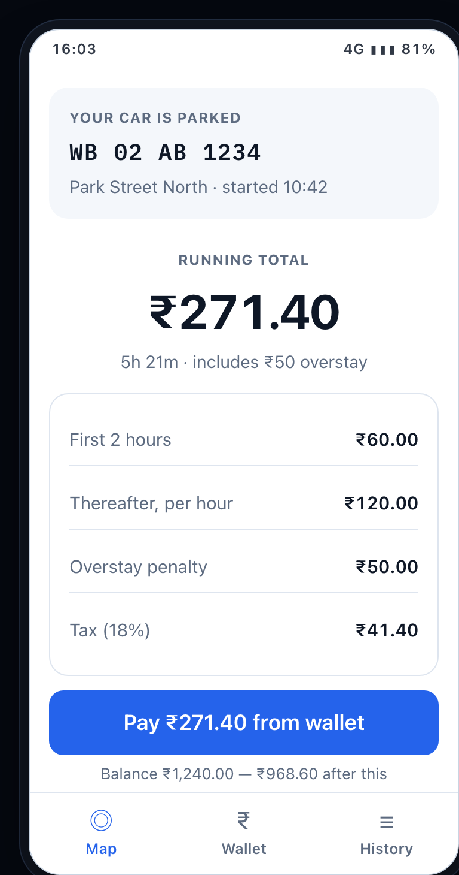 | 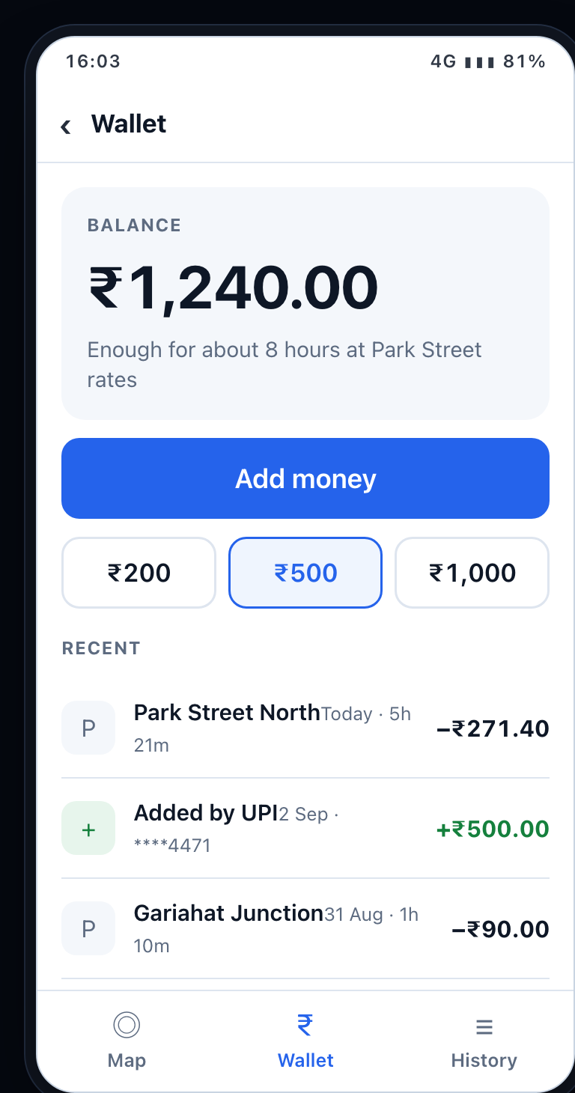 | 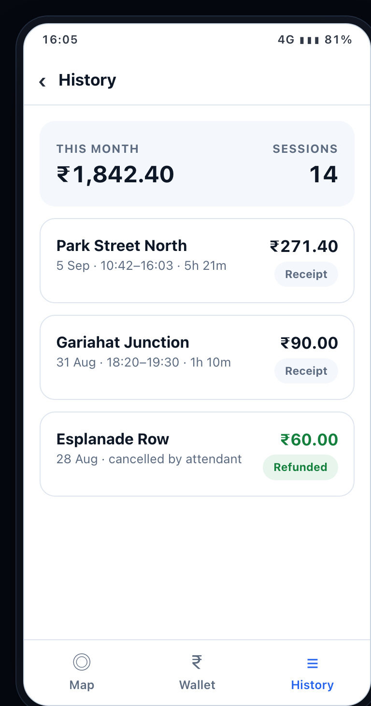
Pay — the same fare lines the attendant sees | Wallet — every row is a ledger entry | History — receipts that already exist server-side
These three screens are where the work actually is, and almost none of it is application work. The wallet does not exist in any form. WALLET is a value in the PaymentMode enum and nothing else — no balance field, no ledger table, no top-up, no refund path.

The model is already there
It is worth being precise about what is missing, because it is less than it appears. A citizen is a User holding the CITIZEN role. Vehicle.ownerUserId already links a plate to its owner, Favourite already stores home and office car parks, Notification and Pass already hang off the user, and Payment.paidByUserId already attributes a payment to a citizen. The data model is complete; it has no doors into it.

What a wallet costs
Two new models and one rule that never bends: the balance is derived from the ledger, never stored as a mutable number. A top-up creates a gateway order and credits on webhook; a session debit is a ledger row; a cancellation writes a compensating row rather than editing the original. That is what makes a disputed balance answerable months later — the same reasoning the shift reconciliation already relies on.

The plate is the join
A citizen never starts a session; an attendant does. The application therefore finds "your car" by matching a registered plate against active sessions. The plate lookup already performs exactly this query — it needs a citizen-scoped variant returning only the caller's own vehicles.
- New models: Wallet and WalletEntry — the only genuinely new subsystem.
- New: top-up order and credit-on-webhook, debit on session end, refund as a compensating entry.
- Settlements must learn that wallet-paid sessions are already collected.
- GET /me/sessions, /me/payments and /me/vehicles do not exist — but every table behind them does.
- Already modelled: citizen identity, vehicle ownership, favourites, passes, receipts, idempotency.

6. What each screen needs from the server
Verified against kmcp-backend at commit 7446f1d.
FEATURE | STATE | THE ENDPOINTS BEHIND IT
Active parkings | Ready | GET /sessions?status=ACTIVE — already called by the Kerb screen.
Free / booked bays | Expose it | GET /slots/summary/:zoneId returns counts by status and type; its own comment calls it "what the zone detail screen draws". SlotStatus separates AVAILABLE, OCCUPIED, RESERVED and OUT_OF_SERVICE. Needs a public variant for the citizen map.
Total collected | Ready | GET /payments/summary, plus cashExpected and digitalTotal on the open shift.
Vendor share | Scope it | GET /revenue and /settlements/summary. The schema holds commissionPct, vendorShare and commissionAmount — confirm a vendor sees only their own.
QR per payment | Build | razorpay.service.ts needs createQrCode(); the webhook needs qr_code.credited. Only createOrder exists today.
Citizen sign-in | Ready | POST /auth/otp/request and /auth/otp/verify — built, documented for citizens, never used.
Map of car parks | Expose it | GET /zones/nearby is public and works — the only public data route on the API. But it selects centerLat/Lng and capacity, not boundary, so lots cannot be drawn as footprints until it does. /zones/:id and /zones/heatmap sit behind zone.read.
Citizen permissions | Build | The CITIZEN role is seeded with no permissions at all. Do not resolve this by granting it zone.read or session.read — those cover the authority's own zone and session listings. It needs a small set of narrow public or citizen-scoped routes instead.
My vehicles | Expose it | Vehicle.ownerUserId and User.vehicles already exist and are indexed. Missing only the citizen-scoped endpoints — citizens.controller.ts is an administrator's view.
My parking & history | Expose it | No citizen-scoped reads, but the data is present: Payment.paidByUserId, sessions by vehicle, and Pass indexed on userId and status.
Saved car parks | Ready | Favourite { userId, zoneId, label } — HOME, OFFICE or custom. Modelled and unused.
Passes | Expose it | Pass already carries qrCode, validity dates and PENDING_PAYMENT. pass-plans is administrator CRUD — there is no purchase endpoint.
Wallet | Build | Nothing exists. Wallet and WalletEntry models, top-up order, credit on webhook, debit on session end, refund as a compensating entry, and a settlement rule for wallet-paid sessions.

Suggested build order
STEP | EFFORT | SCOPE
1 · Vendor dashboard | ~1 week | Pure application work against a backend that already answers. Ships without touching the server.
2 · QR payments | ~1 week | Small, high value, and the first path where cash never reaches an attendant's pocket.
3 · Citizen doors | ~1 week | Half of this is opening doors rather than building rooms — public views over queries that already run. The rest is the /me/* reads. Unblocks the whole application except the wallet.
4 · Citizen app | ~3 weeks | Map, car park detail, parking and history, on an API that now returns what they need.
Separate · The wallet | ~2 weeks | The only genuinely new subsystem and the only one carrying a compliance question. Sequence it independently — everything else ships without it.

Two things worth deciding before any of this is written
The wallet is a prepaid instrument. Holding citizens' money — even small amounts, even without cash-out — places KMC in a regulated position under the Reserve Bank of India's prepaid payment instrument rules. That is a decision for whoever owns the contract, not something to discover after the ledger has been built. The alternative that avoids it entirely is pay-per-session by UPI, which the QR work in step two delivers in any case. Because the wallet is the only part of the citizen backend that is genuinely new, deferring it moves the citizen application forward by roughly two weeks.
The citizen app changes what the vendor app is for. Once a driver can pay from their own phone, the attendant stops being a cashier and becomes someone who verifies and photographs. That is a better job and a smaller cash-handling risk — but the shift reconciliation screen, currently the most carefully constructed part of the vendor application, becomes considerably less central. That is worth knowing before it receives further investment.

