STATEMENT OF WORK

School ERP System

Comprehensive School Management Platform

Version 1.0
Date: January 27, 2026

CONFIDENTIAL

Table of Contents

1. Executive Summary
2. Feature List
3. Technology Stack
4. Data Flow Diagram
5. Software Architecture
6. Plan of Action (Phase-wise Development)
7. Required Team Setup
8. Timeline
9. API Documentation
10. Database Schema
11. Appendix

1. Executive Summary
The School ERP System is a comprehensive, enterprise-grade school management platform designed to digitize and streamline all aspects of educational institution operations. This full-stack web application provides a unified solution for managing students, staff, academics, finance, transport, hostel, library, canteen, and more.

1.1 Project Overview
This system is built to serve educational institutions ranging from small private schools to large multi-branch school networks. It supports multi-tenancy, allowing different schools to operate independently while sharing the same infrastructure.

1.2 Key Highlights
- Multi-school, multi-branch architecture with centralized management
- Role-based access control with 13 predefined roles and custom role support
- 60+ database models covering all school operations
- 210+ API endpoints with comprehensive CRUD operations
- 72 dashboard pages for complete administrative control
- Real-time GPS tracking for transport management
- Smart wallet system for cashless canteen transactions
- Complete audit logging for security and compliance
- Learning Management System (LMS) with assignments and examinations

2. Feature List
The School ERP System comprises 20+ integrated modules covering every aspect of school management:
2.1 Core Administration
- Multi-school management with independent configurations
- Multi-branch support within schools
- Academic year management with current year tracking
- Class and section management with capacity limits
- Subject management with class-wise assignment
- Custom role and permission management
2.2 Student Management
- Complete student profiles with demographics, contact, and medical info
- Guardian management (primary and secondary)
- Sibling relationship tracking
- Photo upload and document management
- Bulk student upload via CSV
- Class promotion with bulk operations
- Custom fields support for school-specific data
2.3 Admissions Module
- Full admission funnel: Inquiry → Prospect → Test → Interview → Approval
- Online application form management
- Entrance test scheduling and scoring
- Interview management with notes and feedback
- Document verification and management
- Follow-up tracking and notifications
- Waitlist management
2.4 Staff & HRMS
- Complete employee records with qualifications
- Department and designation management
- Daily attendance with check-in/check-out
- Leave management with approval workflow
- Payroll processing with allowances and deductions
- Salary payment tracking
- Bank details and document storage
2.5 Transport Management
- Route management with multiple stops and timings
- Vehicle fleet management with driver assignment
- Real-time GPS tracking
- Transport alerts and safety notifications
- Student assignment to routes/stops
- Fare management per route/stop
2.6 Hostel Management
- Multi-building, multi-floor structure
- Room and bed allocation
- Occupancy tracking and reporting
- Mess plan management
- Student hostel assignment with dates
2.7 Library Management
- Book cataloging with ISBN and barcode
- Issue and return tracking
- Overdue monitoring with automatic fine calculation
- Library reports and statistics
- Reserved books management
2.8 Finance Module
- Flexible fee structure (11 fee types)
- Fee frequency: one-time, monthly, quarterly, half-yearly, yearly
- Multiple payment modes: Cash, Cheque, Card, UPI, Net Banking
- Fee payment tracking with receipt generation
- Fee due reports and reminders
- Expense tracking and categorization
- Financial reports and analytics
2.9 Learning Management System (LMS)
- Course management with teacher assignment
- Assignment creation with due dates and scoring
- Student submission tracking
- Online examination system
- Exam results management
- Report card generation per term
- Performance analytics
2.10 Canteen & Smart Wallet
- Digital menu management with pricing
- Student order placement and tracking
- Smart wallet with balance management
- Transaction history (credit, debit, refund)
- Canteen reports and analytics
2.11 Marketplace
- Product catalog (uniforms, books, stationery, sports)
- Online ordering system
- Order tracking and delivery management
- Inventory management
2.12 Communication
- School announcements with priority levels
- Event calendar management
- Direct messaging between users
- In-app notifications
- Push notification support
2.13 Security & Compliance
- Comprehensive audit logging of all actions
- Data backup and restore functionality
- Compliance record tracking
- User activity monitoring
- IP address and user-agent logging
2.14 Inventory & Assets
- Vendor management with GST details
- Purchase order workflow with approvals
- Stock tracking and management
- Asset tracking by category (Furniture, Equipment, Electronics, etc.)
2.15 Analytics & Reporting
- Dashboard with key metrics
- Student analytics and performance tracking
- Attendance reports
- Financial analytics
- Custom report generation

3. Technology Stack
The School ERP System is built on modern, industry-standard technologies ensuring scalability, security, and maintainability.
3.1 Frontend Technologies
Technology | Version | Purpose
Next.js | 14.1.0 | React framework for server-side rendering and routing
React | 18.3.1 | UI component library
TypeScript | 5.3.3 | Type-safe JavaScript development
TailwindCSS | 3.4.15 | Utility-first CSS framework
Lucide React | 0.400.0 | Icon library
React Hook Form | 7.53.2 | Form state management and validation
Recharts | 2.12.7 | Data visualization and charts
React Hot Toast | 2.6.0 | Toast notifications
3.2 Backend Technologies
Technology | Version | Purpose
Node.js | 18+ | JavaScript runtime
Next.js API Routes | 14.1.0 | RESTful API endpoints
Prisma ORM | 5.20.0 | Database ORM and migrations
NextAuth.js | 4.24.10 | Authentication and session management
Bcryptjs | 2.4.3 | Password hashing
Zod | 3.23.8 | Schema validation
date-fns | 3.0.6 | Date manipulation utilities
3.3 Database
Technology | Purpose
PostgreSQL | Primary relational database
Prisma Migrations | Database schema versioning
Database Indexes | Performance optimization on frequently queried fields
3.4 Development & DevOps
Technology | Purpose
pnpm | Package manager
ESLint | Code linting
Git | Version control
Vercel | Deployment platform
Docker | Containerization (optional)
3.5 Security
Technology | Purpose
JWT Tokens | Secure session management
bcryptjs | Password hashing with salt
CSRF Protection | NextAuth.js built-in protection
SQL Injection Prevention | Prisma ORM parameterized queries
XSS Protection | Next.js built-in sanitization

4. Data Flow Diagram
The following diagrams illustrate the data flow within the School ERP System:
4.1 High-Level System Data Flow

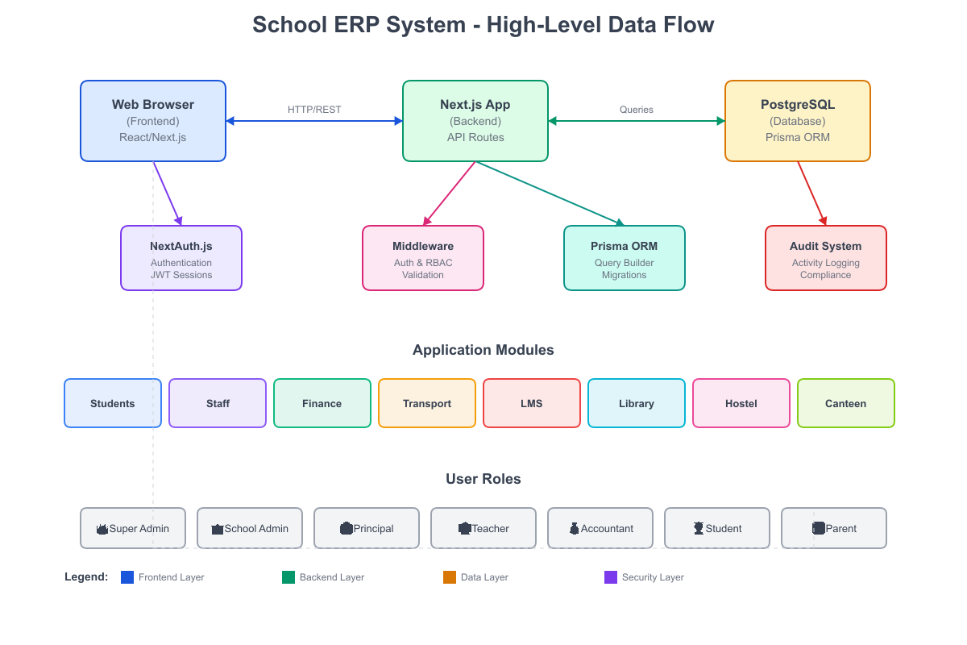

4.2 Authentication Flow
- 1. User enters credentials on login page
- 2. Credentials sent to /api/auth/callback/credentials
- 3. NextAuth validates credentials against database
- 4. Password verified using bcryptjs
- 5. JWT token generated with user role and school ID
- 6. Session cookie set with 8-hour expiration
- 7. User redirected to role-appropriate dashboard
4.3 API Request Flow
- 1. Client sends request with session token
- 2. Middleware validates token and extracts user info
- 3. Request headers enriched with x-user-id, x-user-role, x-school-id
- 4. API route handler receives request
- 5. Authorization checked against role permissions
- 6. Zod schema validates request body
- 7. Prisma executes database operations
- 8. Response returned with standardized format
- 9. Audit log entry created for tracking
4.4 Module Data Flow Example: Admission Process
- 1. Inquiry received and stored in Admission table (status: INQUIRY)
- 2. Prospect converted after initial screening (status: PROSPECT)
- 3. Entrance test scheduled (status: TEST_SCHEDULED)
- 4. Test completed and scores recorded (status: TEST_COMPLETED)
- 5. Interview scheduled for qualified candidates
- 6. Interview completed with notes and feedback
- 7. Admission decision made (APPROVED/REJECTED/WAITLISTED)
- 8. Approved admission creates Student record
- 9. Fee structure assigned and payment initiated

5. Software Architecture
The School ERP System follows a modern, scalable architecture designed for enterprise-grade deployments.
5.1 Architecture Overview
The system implements a monolithic architecture using Next.js, combining frontend and backend in a single deployable unit. This approach simplifies deployment while maintaining clear separation of concerns.
5.2 Layer Architecture
Layer | Components | Responsibility
Presentation | React Components, Pages | User interface rendering
Application | API Routes, Middleware | Business logic execution
Data Access | Prisma ORM | Database operations
Database | PostgreSQL | Data persistence
Security | NextAuth, Middleware | Authentication & Authorization
5.3 Directory Structure

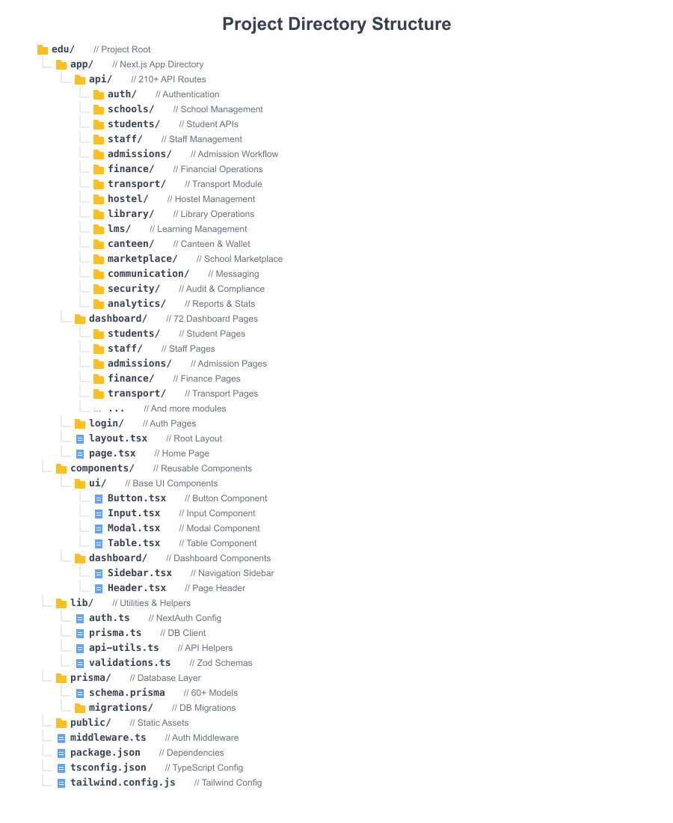

5.4 Design Patterns
- Repository Pattern: Prisma ORM abstracts database operations
- Middleware Pattern: Request processing pipeline for auth/validation
- Factory Pattern: Standardized API response generation
- Strategy Pattern: Role-based permission checking
- Observer Pattern: Audit logging for all operations
5.5 Multi-Tenancy Architecture
The system implements row-level multi-tenancy where all data is scoped by schoolId. This ensures:
- Data isolation between schools
- Shared infrastructure for cost efficiency
- Centralized super-admin management
- School-specific configurations
5.6 Security Architecture
Component | Implementation | Purpose
Authentication | NextAuth.js + JWT | User identity verification
Authorization | Role-based middleware | Access control
Data Isolation | School-scoped queries | Multi-tenant security
Password Security | bcrypt (salt: 10) | Credential protection
Session Management | 8-hour JWT tokens | Secure sessions
Audit Trail | AuditLog model | Activity tracking

6. Plan of Action (Phase-wise Development)
The School ERP System development is organized into distinct phases for structured delivery:
Phase 1: Foundation & Core Infrastructure
Objective: Establish the technical foundation and core modules
- Project setup with Next.js, TypeScript, and Prisma
- Database schema design and initial migrations
- Authentication system with NextAuth.js
- Role-based authorization middleware
- UI component library development
- School and branch management
- Academic year and class structure
- Basic dashboard layout
Phase 2: Student & Staff Management
Objective: Implement core user management modules
- Student profile management with all fields
- Guardian and sibling management
- Bulk student upload functionality
- Staff management with complete profiles
- Department and designation setup
- Staff attendance tracking
- Leave management workflow
Phase 3: Admissions & Finance
Objective: Implement admission workflow and financial modules
- Complete admission funnel implementation
- Entrance test and interview management
- Fee structure configuration
- Fee payment processing
- Expense tracking
- Financial reports
- Payroll processing
Phase 4: Academic & LMS
Objective: Build learning management capabilities
- Course management
- Assignment creation and submission
- Examination system
- Result management
- Report card generation
- Performance analytics
Phase 5: Facilities Management
Objective: Implement facility management modules
- Transport route and vehicle management
- GPS tracking integration
- Hostel room and bed allocation
- Library book management
- Issue/return tracking
- Inventory and asset management
Phase 6: Canteen, Marketplace & Communication
Objective: Build engagement and commerce modules
- Canteen menu management
- Smart wallet implementation
- Order processing
- Marketplace product catalog
- Announcement system
- Messaging and notifications
Phase 7: Security, Analytics & Optimization
Objective: Enhance security and reporting
- Comprehensive audit logging
- Compliance tracking
- Backup and restore
- Dashboard analytics
- Performance optimization
- Security hardening
Phase 8: Testing, Documentation & Deployment
Objective: Prepare for production deployment
- Unit and integration testing
- User acceptance testing
- Performance testing
- Security audit
- Documentation completion
- Production deployment
- Training and handover

7. Required Team Setup
The following team structure is recommended for successful project execution:
7.1 Core Development Team
Role | Count | Key Responsibilities
Project Manager | 1 | Project planning, client communication, milestone tracking
Technical Lead | 1 | Architecture decisions, code reviews, technical guidance
Senior Full-Stack Developer | 2 | Core feature development, complex integrations
Full-Stack Developer | 3 | Module development, API implementation
Frontend Developer | 2 | UI/UX implementation, responsive design
Database Developer | 1 | Schema design, query optimization, migrations
QA Engineer | 2 | Testing, bug tracking, quality assurance
DevOps Engineer | 1 | CI/CD, deployment, infrastructure
7.2 Extended Team (As Needed)
Role | Count | Key Responsibilities
UI/UX Designer | 1 | Interface design, user experience
Technical Writer | 1 | Documentation, user guides
Security Specialist | 1 | Security audits, penetration testing
Business Analyst | 1 | Requirements gathering, process mapping
7.3 Team Skill Requirements

Technical Lead:
- 5+ years experience with React/Next.js
- Strong PostgreSQL and Prisma knowledge
- Experience with enterprise applications
Full-Stack Developers:
- 3+ years React and Node.js experience
- TypeScript proficiency
- REST API design experience
- Database design knowledge
Frontend Developers:
- 3+ years React experience
- TailwindCSS proficiency
- Responsive design expertise

8. Timeline
The following timeline outlines the estimated duration for each development phase:
8.1 Phase-wise Timeline
Phase | Duration | Start Week | End Week
Phase 1: Foundation & Core | 4 weeks | Week 1 | Week 4
Phase 2: Student & Staff | 4 weeks | Week 5 | Week 8
Phase 3: Admissions & Finance | 4 weeks | Week 9 | Week 12
Phase 4: Academic & LMS | 3 weeks | Week 13 | Week 15
Phase 5: Facilities | 4 weeks | Week 16 | Week 19
Phase 6: Canteen & Communication | 3 weeks | Week 20 | Week 22
Phase 7: Security & Analytics | 2 weeks | Week 23 | Week 24
Phase 8: Testing & Deployment | 4 weeks | Week 25 | Week 28
8.2 Total Project Duration
Estimated Total Duration: 28 weeks (7 months)
8.3 Milestone Deliverables
Milestone | Week | Deliverables
M1 | Week 4 | Core infrastructure, authentication, basic admin
M2 | Week 8 | Student management, staff management complete
M3 | Week 12 | Admissions workflow, finance module complete
M4 | Week 15 | LMS with examinations and report cards
M5 | Week 19 | Transport, hostel, library modules complete
M6 | Week 22 | Canteen, marketplace, communication ready
M7 | Week 24 | Security, analytics, optimization complete
M8 | Week 28 | Production-ready deployment with documentation
8.4 Post-Launch Support
- 30 days of post-launch bug fixes included
- Knowledge transfer and documentation handover
- Optional: Ongoing maintenance and support contract

9. API Documentation
The School ERP System exposes 210+ RESTful API endpoints. Below is the comprehensive API structure:
9.1 API Design Principles
- RESTful architecture with resource-based URLs
- JSON request and response format
- JWT-based authentication via NextAuth
- Zod schema validation for all inputs
- Standardized pagination (page, limit, sortBy, sortOrder)
- Consistent error response format
9.2 Authentication Endpoints
Method | Endpoint | Description
POST | /api/auth/signin | User login with credentials
POST | /api/auth/signout | User logout
GET | /api/auth/session | Get current session
POST | /api/mobile/auth/login | Mobile app authentication
9.3 School Administration APIs
Method | Endpoint | Description
GET/POST | /api/schools | List/Create schools
GET/PUT/DELETE | /api/schools/[id] | School CRUD operations
GET/POST | /api/branches | Branch management
GET/POST | /api/academic-years | Academic year management
GET/POST | /api/classes | Class management
GET/POST | /api/sections | Section management
GET/POST | /api/subjects | Subject management
GET/POST | /api/roles | Role and permission management
9.4 Student Management APIs
Method | Endpoint | Description
GET/POST | /api/students | List/Create students
GET/PUT/DELETE | /api/students/[id] | Student CRUD operations
POST | /api/students/bulk-upload | Bulk CSV import
POST | /api/students/bulk-promote | Class promotion
GET/POST | /api/guardians | Guardian management
9.5 Admissions APIs
Method | Endpoint | Description
GET/POST | /api/admissions | Admission records
GET/POST | /api/admissions/applications | Applications
GET/POST | /api/admissions/prospects | Prospect management
GET/POST | /api/admissions/tests | Test scheduling
GET/POST | /api/admissions/interviews | Interview management
GET | /api/admissions/approved | Approved admissions
9.6 Staff Management APIs
Method | Endpoint | Description
GET/POST | /api/staff | Staff records
GET/POST | /api/staff/attendance | Attendance tracking
GET/POST | /api/staff/leaves | Leave management
GET/POST | /api/staff/payroll | Payroll processing
9.7 Transport APIs
Method | Endpoint | Description
GET/POST | /api/routes | Route management
GET/POST | /api/vehicles | Vehicle management
GET | /api/transport/tracking | GPS tracking data
GET/POST | /api/transport/stops | Stop information
GET/POST | /api/transport/alerts | Transport alerts
9.8 Finance APIs
Method | Endpoint | Description
GET/POST | /api/fees | Fee structure
GET/POST | /api/fees/payments | Fee payments
GET | /api/finance/fee-due | Due fee reports
GET/POST | /api/finance/expenses | Expense tracking
GET | /api/finance/reports | Financial analytics
9.9 LMS APIs
Method | Endpoint | Description
GET/POST | /api/lms/courses | Course management
GET/POST | /api/lms/assignments | Assignment management
GET/POST | /api/lms/submissions | Submission tracking
GET/POST | /api/lms/examinations | Exam management
GET/POST | /api/lms/results | Results management
GET/POST | /api/lms/report-cards | Report card generation
9.10 Other Module APIs
Module | Base Endpoint | Operations
Hostel | /api/hostels, /api/hostel/* | Room, bed, allocation management
Library | /api/books, /api/library/* | Books, issues, overdue
Canteen | /api/canteen/* | Menu, orders, wallet, transactions
Marketplace | /api/marketplace/* | Products, orders, inventory
Communication | /api/communication/* | Announcements, messages, notifications
Security | /api/security/* | Audit logs, compliance, backups
Analytics | /api/analytics/* | Dashboard, reports, statistics
Inventory | /api/inventory/* | Vendors, stock, purchase orders
9.11 API Response Format
// Success Response { "success": true, "data": { ... }, "pagination": { "page": 1, "limit": 10, "total": 100, "totalPages": 10 } } // Error Response { "success": false, "error": "Error message description" }

10. Database Schema
The School ERP System uses PostgreSQL with Prisma ORM. The database contains 60+ models organized into logical domains:
10.1 Core Administration Models
Model | Key Fields | Purpose
School | id, name, code, address, email, phone | Main school entity
Branch | id, schoolId, name, address, isMainBranch | School branches
AcademicYear | id, schoolId, name, startDate, endDate, isCurrent | Academic sessions
Class | id, schoolId, name, grade, order | Class hierarchy
Section | id, classId, name, capacity, teacherId | Class sections
Subject | id, schoolId, name, code, description | Subject management
10.2 User & Authorization Models
Model | Key Fields | Purpose
User | id, email, password, role, schoolId, isActive | User accounts
Role | id, schoolId, name, permissions (JSON) | Custom roles
UserCustomRole | id, userId, roleId | User-role mapping
User Roles Enum:
- SUPER_ADMIN, SCHOOL_ADMIN, PRINCIPAL, VICE_PRINCIPAL, HEAD_TEACHER, TEACHER
- ACCOUNTANT, LIBRARIAN, TRANSPORT_MANAGER, HOSTEL_WARDEN, RECEPTIONIST, STUDENT, PARENT
10.3 Student Management Models
Model | Key Fields | Purpose
Student | id, schoolId, admissionNo, firstName, lastName, classId, sectionId, ... | Student profiles (30+ fields)
Guardian | id, studentId, name, relation, email, phone, isPrimary | Parent/guardian info
StudentSibling | id, studentId, siblingId | Sibling relationships
Admission | id, schoolId, status, studentName, testScore, interviewDate, ... | Admission workflow
10.4 Staff Management Models
Model | Key Fields | Purpose
Staff | id, schoolId, employeeId, userId, department, designation, salary, ... | Employee records
StaffAttendance | id, staffId, date, status, checkIn, checkOut | Attendance tracking
LeaveRequest | id, staffId, leaveType, startDate, endDate, status | Leave management
Payroll | id, staffId, month, year, basic, allowances, deductions | Payroll processing
10.5 Transport Models
Model | Key Fields | Purpose
Route | id, schoolId, name, description, stops[] | Transport routes
Stop | id, routeId, name, arrivalTime, departureTime, fare | Route stops
Vehicle | id, schoolId, number, type, capacity, driverId | Vehicle fleet
StudentTransport | id, studentId, routeId, stopId | Student assignments
GPSTracking | id, vehicleId, latitude, longitude, speed, timestamp | Real-time tracking
10.6 Hostel Models
Model | Key Fields | Purpose
Hostel | id, schoolId, name, type, wardenId | Hostel buildings
HostelFloor | id, hostelId, name, floorNumber | Floor management
HostelRoom | id, floorId, roomNumber, type, capacity | Room information
HostelBed | id, roomId, bedNumber, isOccupied | Bed allocation
StudentHostel | id, studentId, bedId, messPlan, startDate | Student assignment
10.7 Finance Models
Model | Key Fields | Purpose
Fee | id, schoolId, name, type, amount, frequency | Fee structure
FeePayment | id, feeId, studentId, amount, paymentMode, status | Payment records
Expense | id, schoolId, category, amount, description, date | Expense tracking
Vendor | id, schoolId, name, contact, gstNumber | Vendor management
PurchaseOrder | id, vendorId, totalAmount, status | Procurement
10.8 LMS Models
Model | Key Fields | Purpose
Course | id, schoolId, name, subjectId, teacherId, classId | Course management
Assignment | id, courseId, title, description, dueDate, totalMarks | Assignments
AssignmentSubmission | id, assignmentId, studentId, marks, feedback | Submissions
Exam | id, schoolId, name, type, date, classId, subjectId | Examinations
ExamResult | id, examId, studentId, marksObtained, grade | Results
ReportCard | id, studentId, term, overallGrade, remarks | Report cards
10.9 Library Models
Model | Key Fields | Purpose
Library | id, schoolId, name, location | Library entity
Book | id, libraryId, title, author, isbn, barcode, copies | Book catalog
LibraryIssue | id, bookId, userId, issueDate, dueDate, returnDate, fine | Issue tracking
10.10 Canteen & Marketplace Models
Model | Key Fields | Purpose
MenuItem | id, schoolId, name, price, category, isAvailable | Menu items
CanteenOrder | id, studentId, totalAmount, status | Orders
SmartWallet | id, studentId, balance | Wallet balance
WalletTransaction | id, walletId, type, amount, description | Transactions
Product | id, schoolId, name, price, category, stock | Marketplace products
MarketplaceOrder | id, studentId, totalAmount, status | Product orders
10.11 Communication & Security Models
Model | Key Fields | Purpose
Announcement | id, schoolId, title, content, priority, targetRole | Announcements
Message | id, senderId, receiverId, subject, content | Direct messages
Notification | id, userId, title, content, isRead | Notifications
Event | id, schoolId, title, date, location, description | School events
AuditLog | id, userId, action, entity, entityId, ipAddress | Audit trail
DataBackup | id, schoolId, filename, size, status | Backup records
ComplianceRecord | id, schoolId, type, status, dueDate | Compliance tracking
10.12 Database Indexes
Strategic indexes are applied on frequently queried fields:
- schoolId - on all school-scoped tables for multi-tenant queries
- createdAt - for time-based sorting and filtering
- status - for filtering by record status
- email - unique index for user lookup
- admissionNo - unique per school for student lookup
- Composite indexes on foreign key combinations
10.13 Key Enums
Enum Name | Values
UserRole | SUPER_ADMIN, SCHOOL_ADMIN, PRINCIPAL, VICE_PRINCIPAL, HEAD_TEACHER, TEACHER, ACCOUNTANT, LIBRARIAN, TRANSPORT_MANAGER, HOSTEL_WARDEN, RECEPTIONIST, STUDENT, PARENT
AdmissionStatus | INQUIRY, PROSPECT, TEST_SCHEDULED, TEST_COMPLETED, INTERVIEW_SCHEDULED, APPROVED, REJECTED, WAITLISTED, ADMITTED, CANCELLED
FeeType | TUITION, ADMISSION, EXAM, TRANSPORT, HOSTEL, LIBRARY, LABORATORY, SPORTS, ACTIVITY, UNIFORM, OTHER
PaymentMode | CASH, CHEQUE, CARD, UPI, NET_BANKING
PaymentStatus | PENDING, COMPLETED, FAILED, REFUNDED
StaffType | TEACHING, NON_TEACHING, ADMINISTRATIVE, SUPPORT
LeaveStatus | PENDING, APPROVED, REJECTED, CANCELLED
AssetType | FURNITURE, EQUIPMENT, ELECTRONICS, VEHICLE, BUILDING, OTHER

11. Appendix
11.1 Glossary
Term | Definition
ERP | Enterprise Resource Planning - integrated management system
LMS | Learning Management System - academic content delivery
RBAC | Role-Based Access Control - permission management
JWT | JSON Web Token - authentication token format
ORM | Object-Relational Mapping - database abstraction layer
API | Application Programming Interface - service endpoints
Multi-tenancy | Single instance serving multiple organizations
11.2 Assumptions & Dependencies
- PostgreSQL database server available and configured
- Node.js 18+ runtime environment
- Client devices have modern web browser support
- Stable internet connectivity for deployment
- SSL certificate for production deployment
11.3 Acceptance Criteria
- All modules functional as per specifications
- Role-based access working correctly
- Data integrity maintained across operations
- Response time under 2 seconds for typical operations
- Mobile-responsive design across all pages
- Complete audit trail for all operations
11.4 Out of Scope
- Native mobile applications (iOS/Android)
- Third-party payment gateway integration
- SMS gateway integration
- Video conferencing integration
- Custom report builder
11.5 Change Management
Any changes to the scope, timeline, or requirements outlined in this SoW will be handled through a formal change request process. Changes may impact the project timeline and cost.

--- End of Document ---

