STATEMENT OF WORK
Billing, Inventory & E-Commerce System

The Biker Genome

Prepared by: Infiniti Tech Partners
Date: March 5, 2026
Version: 1.0

Table of Contents
1. Executive Summary
2. Feature List
3. Tech Stack
4. Data Flow Diagram
5. Software Architecture
6. Role-Based Access Control (RBAC)
7. E-Commerce Integration
8. Project Timeline & Milestones
9. Cost Estimate (INR)
10. Terms & Conditions

1. Executive Summary
This Statement of Work outlines the development of a comprehensive Billing, Inventory Management, and E-Commerce system for The Biker Genome, a retail store specializing in bike accessories. The system will replace the existing Excel-based billing and manual inventory tracking workflow with a modern, web-based POS system that includes automated inventory management, structured reporting, role-based access control, and an integrated e-commerce storefront.
The solution will serve two primary channels: (1) In-store POS billing for walk-in customers with direct printer integration, and (2) An online e-commerce website for customers to browse and purchase products remotely. Both channels will share a unified inventory and product database.

2. Feature List

2.1 Product & Inventory Management
Product Master Database: Centralized product catalog with SKU, barcode, category, brand, size, color, cost price, selling price, GST %, supplier, stock quantity, and reorder threshold.
Category Management: Product grouping into categories (Helmets, Riding Jackets, Gloves, Boots, Accessories, Parts, Luggage, Protection Gear) for faster search and reporting.
Inventory Tracking: Automatic stock movement tracking on sales, purchases, returns, manual adjustments, and damaged/lost stock. Each movement generates a transaction record.
Low Stock Alerts: Dashboard alerts when product stock falls below the predefined reorder threshold.

2.2 Billing System (POS)
POS Billing Interface: Quick product entry via search or barcode scanner, multi-item bills, quantity editing, discount entry, automatic GST calculation, and bill preview.
Invoice Generation: Automated formatted invoices with invoice number, date/time, store name, itemized list, GST breakdown, total amount, and payment method.
Printer Integration: Direct printing to store printer with one-click print, print preview, reprint previous invoice, and printer configuration.
Payment Methods: Support for Cash, UPI, Credit Card, Debit Card, and Split Payment across multiple methods.

2.3 Non-Billed Cash Sales
Quick Cash Sale: Stock deduction without formal invoice generation, with inventory update and internal transaction logging.
Internal Tracking: All non-billed sales recorded with product, quantity, date, staff user, and notes for audit compliance.
Restricted Visibility: Non-billed sales visible only to authorized roles (Owner: full, Manager: limited, Cashier: none).

2.4 Supplier & Purchase Management
Supplier Database: Supplier records with name, contact, address, GST number, and payment terms.
Stock Purchase Entry: Purchase record creation with supplier selection, product addition, quantity entry, and automatic inventory update.

2.5 Returns & Exchanges
Product Return: Invoice-based return processing with inventory restoration and refund recording.
Product Exchange: Return and replace flow with automatic price difference adjustment.

2.6 Reports & Business Insights
Sales Reports: Daily, monthly, product-wise, and category-wise sales reports.
Inventory Reports: Current stock levels, low stock items, fast-moving products, and dead stock analysis.
Profit Reports: Margin analysis per product based on cost price, selling price, and discounts.

2.7 User Management & Dashboard
Multi-User Support: Role-based user management with Owner, Manager, Cashier, and Inventory Staff roles.
Dashboard: Real-time business overview showing today's sales, cash vs digital breakdown, low stock alerts, and top-selling products.

2.8 E-Commerce Storefront
Product Catalog: Public-facing product listing with categories, search, filters, and product detail pages.
Shopping Cart: Add to cart, quantity management, and cart persistence.
Online Checkout: Customer registration/login, address management, payment gateway integration (UPI/Card), and order placement.
Order Management: Order tracking, status updates, and order history for customers.
Unified Inventory: Shared stock between POS and e-commerce - real-time inventory sync across both channels.

3. Tech Stack
Layer | Technology | Purpose
Frontend Framework | Next.js 15 (App Router) | Server-side rendering, routing, API routes
UI Library | React 19 | Component-based UI development
Language | TypeScript | Type-safe development across frontend & backend
Styling | Tailwind CSS + shadcn/ui | Utility-first CSS with pre-built accessible components
State Management | Zustand | Lightweight client-side state management
API Client | Axios | HTTP client with interceptors for auth
Backend (API) | Next.js Route Handlers | RESTful API endpoints within the same project
ORM | Prisma | Type-safe database access and migrations
Local Database | SQLite | Development and local testing
Production Database | Neon PostgreSQL | Serverless PostgreSQL for production
Authentication | JWT (jose library) | Stateless token-based authentication
Validation | Zod | Runtime schema validation for API inputs
Hosting | Vercel | Serverless deployment with edge functions
Printer Integration | Browser Print API / node-printer | Direct invoice printing from POS
Payment Gateway | Razorpay / PhonePe | UPI and card payment processing
Testing | Vitest + Playwright | Unit, integration, and E2E testing
Version Control | Git + GitHub | Source code management

4. Data Flow Diagram
The following diagram illustrates the data flow through the system, from user interactions through the frontend, API layer, services, repositories, and into the database and external services.
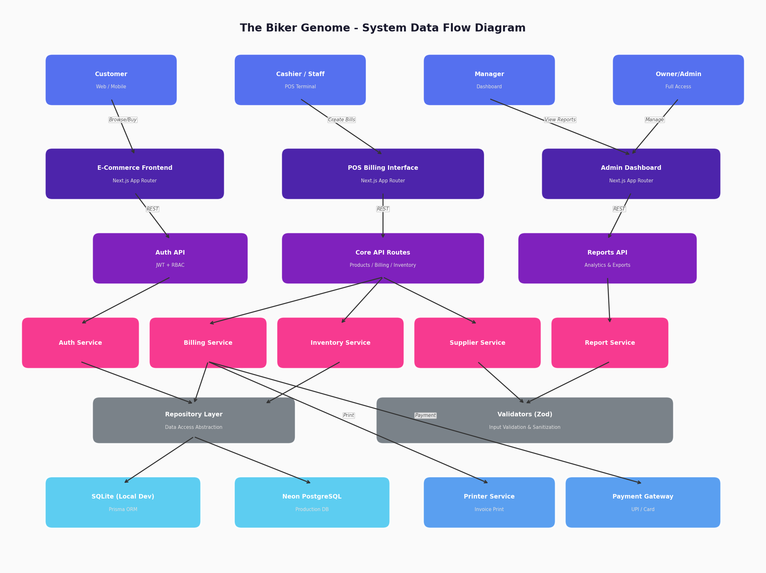

Key data flows include: Customer browsing and purchasing through e-commerce, cashier creating bills through POS, managers viewing reports, and the owner managing all system settings. All flows pass through the API layer with JWT authentication and RBAC middleware before reaching business logic services.

5. Software Architecture
The system follows a layered architecture pattern with clear separation of concerns. The frontend and backend coexist within a single Next.js project but are organized into separate directories for maintainability.
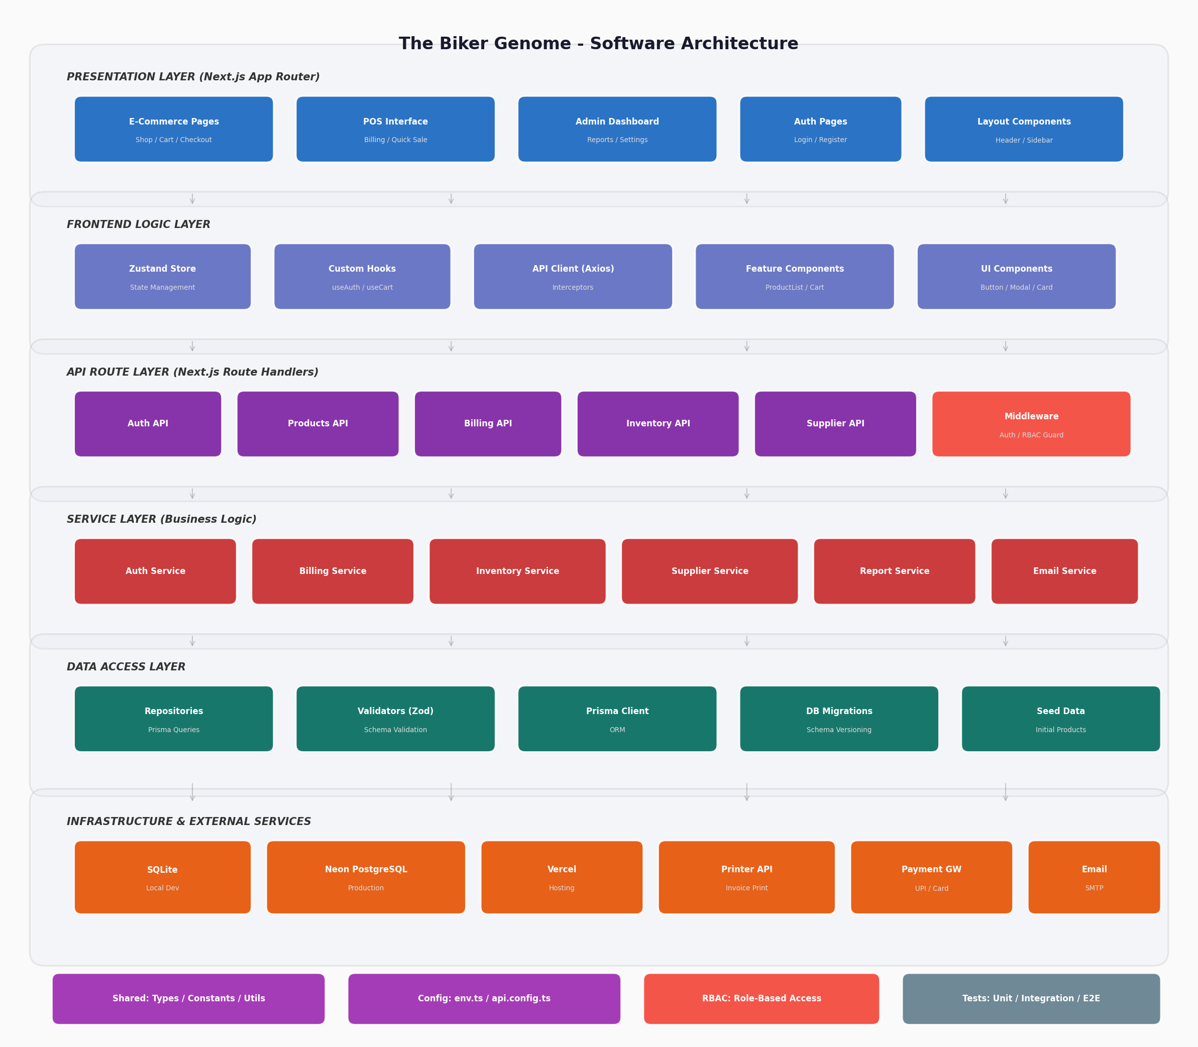

Architecture Layers:
Presentation Layer: Next.js App Router pages for e-commerce, POS, admin dashboard, and auth flows.
Frontend Logic Layer: Zustand stores, custom hooks, Axios API client, and reusable React components.
API Route Layer: Next.js Route Handlers serving as RESTful endpoints with auth/RBAC middleware.
Service Layer: Business logic for auth, billing, inventory, suppliers, reports, and email.
Data Access Layer: Prisma-based repositories with Zod validation, database migrations, and seed data.
Infrastructure Layer: SQLite (dev) / Neon PostgreSQL (prod), Vercel hosting, printer API, payment gateway.

6. Role-Based Access Control (RBAC)
The system implements role-based access control to ensure appropriate permissions for each user type. The following matrix defines access levels:
Feature / Module | Owner | Manager | Cashier | Inventory Staff
POS Billing | Full | Full | Full | No Access
Invoice Reprint | Full | Full | Own Only | No Access
Product Management | Full | Full | View Only | Full
Category Management | Full | Full | No Access | View Only
Inventory Tracking | Full | Full | View Only | Full
Low Stock Alerts | Full | Full | View Only | Full
Non-Billed Cash Sales | Full | Limited View | No Access | No Access
Supplier Management | Full | Full | No Access | View Only
Purchase Entry | Full | Full | No Access | Full
Returns & Exchanges | Full | Full | Initiate Only | No Access
Sales Reports | Full | Full | Own Sales Only | No Access
Inventory Reports | Full | Full | No Access | Full
Profit Reports | Full | No Access | No Access | No Access
User Management | Full | No Access | No Access | No Access
Dashboard | Full | Full | Limited | Limited
System Settings | Full | No Access | No Access | No Access
E-Commerce Orders | Full | Full | Process Only | No Access
E-Commerce Settings | Full | No Access | No Access | No Access

7. E-Commerce Integration
The e-commerce module extends the core billing and inventory system to serve online customers. It shares the same product database and inventory, ensuring real-time stock synchronization between in-store POS sales and online orders.

7.1 Customer-Facing Features
- Product browsing with category filters, search, and sorting
- Product detail pages with images, specifications, and pricing
- Shopping cart with quantity management and persistence
- Customer registration and login (separate from staff accounts)
- Address management for shipping
- Checkout with Razorpay/PhonePe payment integration
- Order confirmation and tracking
- Order history and reorder functionality

7.2 Admin E-Commerce Management
- Toggle products as "available online" vs "in-store only"
- Manage product images and descriptions for the storefront
- View and process online orders
- Update order status (Confirmed, Shipped, Delivered, Cancelled)
- Configure shipping charges and policies
- View e-commerce specific analytics and reports

8. Project Timeline & Milestones
Phase | Deliverables | Duration | Milestone
Phase 1: Foundation | Project setup, DB schema, Auth, RBAC, User management | 2 weeks | Authentication & RBAC working
Phase 2: Core POS | Product management, POS billing, Invoice generation, Printer integration | 3 weeks | POS billing functional
Phase 3: Inventory | Inventory tracking, Stock alerts, Supplier management, Purchase entry | 2 weeks | Inventory auto-tracking live
Phase 4: Advanced Billing | Non-billed sales, Returns & Exchanges, Split payments, Cash sale tracking | 2 weeks | Full billing features complete
Phase 5: Reports | Sales reports, Inventory reports, Profit analysis, Dashboard | 2 weeks | Reporting dashboard live
Phase 6: E-Commerce | Storefront, Cart, Checkout, Payment gateway, Order management | 3 weeks | E-commerce storefront live
Phase 7: Testing & Polish | Unit/E2E tests, Bug fixes, Performance optimization, UAT | 2 weeks | Production-ready
Phase 8: Deployment | Vercel + Neon setup, Data migration, Training, Go-live | 1 week | System live

Total Estimated Duration: 17 weeks (~4 months)

9. Cost Estimate (INR)
Component | Description | Type | Cost (INR)
Project Setup & Architecture | Boilerplate, folder structure, DB schema, env config | One-time | 15,000
Authentication & RBAC | JWT auth, role management, middleware guards | One-time | 25,000
Product & Category Management | CRUD operations, search, filters, barcode support | One-time | 30,000
POS Billing System | Billing interface, invoice generation, GST calculation | One-time | 45,000
Printer Integration | Browser/native print, invoice templates, config panel | One-time | 15,000
Payment Integration | Cash, UPI, Card, Split payment support | One-time | 20,000
Inventory Management | Auto-tracking, stock transactions, alerts, adjustments | One-time | 35,000
Supplier & Purchase Module | Supplier DB, purchase entry, stock update | One-time | 20,000
Non-Billed Cash Sales | Quick sale, internal tracking, restricted visibility | One-time | 15,000
Returns & Exchanges | Return processing, exchange flow, refund recording | One-time | 15,000
Reports & Dashboard | Sales, inventory, profit reports, dashboard widgets | One-time | 30,000
E-Commerce Storefront | Product pages, cart, checkout, order management | One-time | 50,000
Payment Gateway (E-Com) | Razorpay/PhonePe integration for online payments | One-time | 15,000
Testing & QA | Unit tests, integration tests, E2E tests, bug fixes | One-time | 25,000
Deployment & Go-Live | Vercel + Neon setup, data migration, training | One-time | 15,000
TOTAL DEVELOPMENT COST |  |  | 3,70,000
Vercel Hosting (Pro) | Production hosting with custom domain | Monthly | 1,700/mo
Neon Database (Launch) | Serverless PostgreSQL with autoscaling | Monthly | 1,600/mo
Domain & SSL | Custom domain with SSL certificate | Annual | 1,200/yr
Payment Gateway Fees | Per-transaction charges (Razorpay ~2%) | Per txn | 2% per txn
TOTAL RECURRING COST |  | Monthly | ~3,300/mo + txn fees
AMC (Annual Maintenance) | Bug fixes, minor updates, server monitoring | Annual | 45,000/yr

Note: All prices are exclusive of GST (18%). Payment gateway transaction fees are charged by the gateway provider directly.

10. Terms & Conditions
Payment Terms: 40% advance on project start, 30% on Phase 4 completion, 30% on final delivery and go-live.
Scope Changes: Any feature additions or scope changes beyond this SoW will be estimated separately and require written approval.
Timeline: Timeline estimates assume timely feedback and approvals from the client. Delays in feedback may extend the timeline proportionally.
Intellectual Property: Upon full payment, all source code and assets developed under this SoW will be transferred to The Biker Genome.
Warranty: 30-day bug-fix warranty post go-live for issues related to developed features.
Support & Maintenance: AMC covers bug fixes, minor updates, and server monitoring. Major feature additions are billed separately.
Confidentiality: Both parties agree to maintain confidentiality of business information shared during the project.
Data Ownership: All business data entered into the system remains the property of The Biker Genome.

For Infiniti Tech Partners | For The Biker Genome
_________________________ | _________________________
Authorized Signatory | Authorized Signatory

