STATEMENT OF WORK

FleetTrack Pro
Enterprise Fleet Management & Telematics Platform

Project Type: | SaaS Web Application
Industry: | Fleet Management & Telematics
Platform: | Web-Based (Desktop & Mobile Responsive)
Document Version: | 1.0
Date: | January 2026

Table of Contents
1. Executive Summary 3
2. Feature List 3
2.1 Core Fleet Management 4
2.2 ELD Compliance 4
2.3 Safety & Analytics 4
2.4 Administration 4
3. Technology Stack 5
4. Data Flow Diagram 6
5. Software Architecture 7
6. Plan of Action (Phase-wise Development) 8
7. Required Team Setup 10
8. Project Timeline 11
9. API Documentation 12
10. Database Schema 15
11. Appendix 18

1. Executive Summary
FleetTrack Pro is a comprehensive, enterprise-grade fleet management and telematics SaaS platform designed to help transportation companies optimize their operations, ensure regulatory compliance, and improve safety across their entire fleet.
The platform provides real-time vehicle tracking, Electronic Logging Device (ELD) compliance management, driver performance monitoring, incident reporting, and advanced analytics - all within a secure, multi-tenant architecture that scales from small fleets to enterprise operations.
Key Business Objectives:
• Reduce operational costs through optimized routing and fuel management
• Ensure DOT/FMCSA compliance with automated ELD logging and reporting
• Improve fleet safety through real-time monitoring and incident management
• Provide actionable insights through comprehensive analytics and reporting
• Enable multi-organization support with role-based access control
Target Users:
• Fleet Managers - Oversee vehicle and driver operations
• Drivers - Log hours, view assignments, and report incidents
• Administrators - Manage organizations, users, and system settings
• Safety Officers - Monitor safety events and manage incidents

2. Feature List

2.1 Core Fleet Management
Feature | Description | Capabilities
Dashboard | Central command center for fleet operations | • Real-time fleet statistics  • Vehicle status overview  • Alert notifications  • Quick action cards
Live Tracking | Real-time GPS tracking of all vehicles | • Interactive map view  • Vehicle location markers  • Telemetry data display  • Geofence visualization
Vehicle Management | Complete vehicle lifecycle management | • Add/Edit/Delete vehicles  • VIN and registration tracking  • Maintenance scheduling  • Status management
Driver Management | Driver profiles and assignment management | • Driver profiles with licenses  • DOT medical certification  • Vehicle assignments  • Performance tracking
Trip Tracking | Comprehensive trip recording and analysis | • Start/End locations  • Distance and duration  • Fuel consumption  • Speed metrics
Geofencing | Virtual boundary management | • Circle and polygon zones  • Entry/Exit alerts  • Custom alert rules  • Zone visualization

2.2 ELD Compliance (Electronic Logging Device)
Feature | Description | Capabilities
Hours of Service | DOT-compliant HOS tracking | • Off-duty logging  • Sleeper berth tracking  • Driving time  • On-duty not driving
Log Certification | Daily log certification workflow | • Driver self-certification  • Compliance verification  • Historical log access  • Audit trail
Violation Detection | Automatic HOS violation alerts | • Real-time monitoring  • Violation notifications  • Compliance reports  • Remediation tracking

2.3 Safety & Analytics
Feature | Description | Capabilities
Incident Management | Complete incident lifecycle handling | • Incident reporting  • Status tracking  • Resolution workflow  • Video attachment
Safety Events | Behavioral event monitoring | • Harsh braking detection  • Rapid acceleration  • Speeding alerts  • Distraction/Fatigue
Alert System | Comprehensive notification system | • Geofence alerts  • Maintenance reminders  • ELD violations  • Safety notifications
Analytics Dashboard | Data-driven fleet insights | • Performance metrics  • Fuel analysis  • Driver rankings  • Cost tracking
Video Management | Dashcam and incident footage | • Video uploads  • Incident association  • Evidence management  • Playback

2.4 Administration & Security
Feature | Description | Capabilities
Multi-Tenancy | Organization-based data isolation | • Separate organizations  • Subscription tiers  • Custom branding  • Data isolation
User Management | Role-based access control | • 8 user roles  • Granular permissions  • User provisioning  • Activity tracking
Authentication | Secure login system | • Email/password auth  • JWT sessions  • 2FA support  • Session management
Audit Logging | Comprehensive activity tracking | • User action logs  • System changes  • Compliance reports  • Data export
Settings | User preference management | • Profile settings  • Notification prefs  • Password management  • Theme options

3. Technology Stack

3.1 Frontend Technologies
Technology | Version | Purpose
Next.js | 16.0.10 | React framework with server-side rendering and API routes
React | 19.2.1 | Component-based UI library
Tailwind CSS | 4.0 | Utility-first CSS framework
Leaflet | 1.9.4 | Interactive mapping library
Recharts | 3.6.0 | Data visualization and charting
Zustand | 5.0.9 | Lightweight state management
TanStack Query | 5.90.12 | Data fetching and caching
Lucide React | 0.561.0 | Icon library

3.2 Backend Technologies
Technology | Version | Purpose
Node.js | Latest LTS | JavaScript runtime environment
NextAuth.js | 5.0.0-beta | Authentication framework
Prisma | 5.22.0 | Type-safe ORM for database access
PostgreSQL | Latest | Primary relational database
Zod | 4.2.0 | Schema validation library
bcryptjs | 3.0.3 | Password hashing
jsonwebtoken | 9.0.3 | JWT token handling
Pino | 10.1.0 | High-performance logging

3.3 DevOps & Infrastructure
Technology | Version | Purpose
Vercel | Latest | Serverless deployment platform
Sentry | 10.32.1 | Error tracking and monitoring
TypeScript | 5.x | Type-safe JavaScript
ESLint | 9.x | Code linting and standards
Vitest | 4.0.16 | Unit and integration testing
Git | Latest | Version control

4. Data Flow Diagram
The following diagram illustrates how data flows through the FleetTrack Pro platform, from user interactions and IoT devices through the application layers to the database.

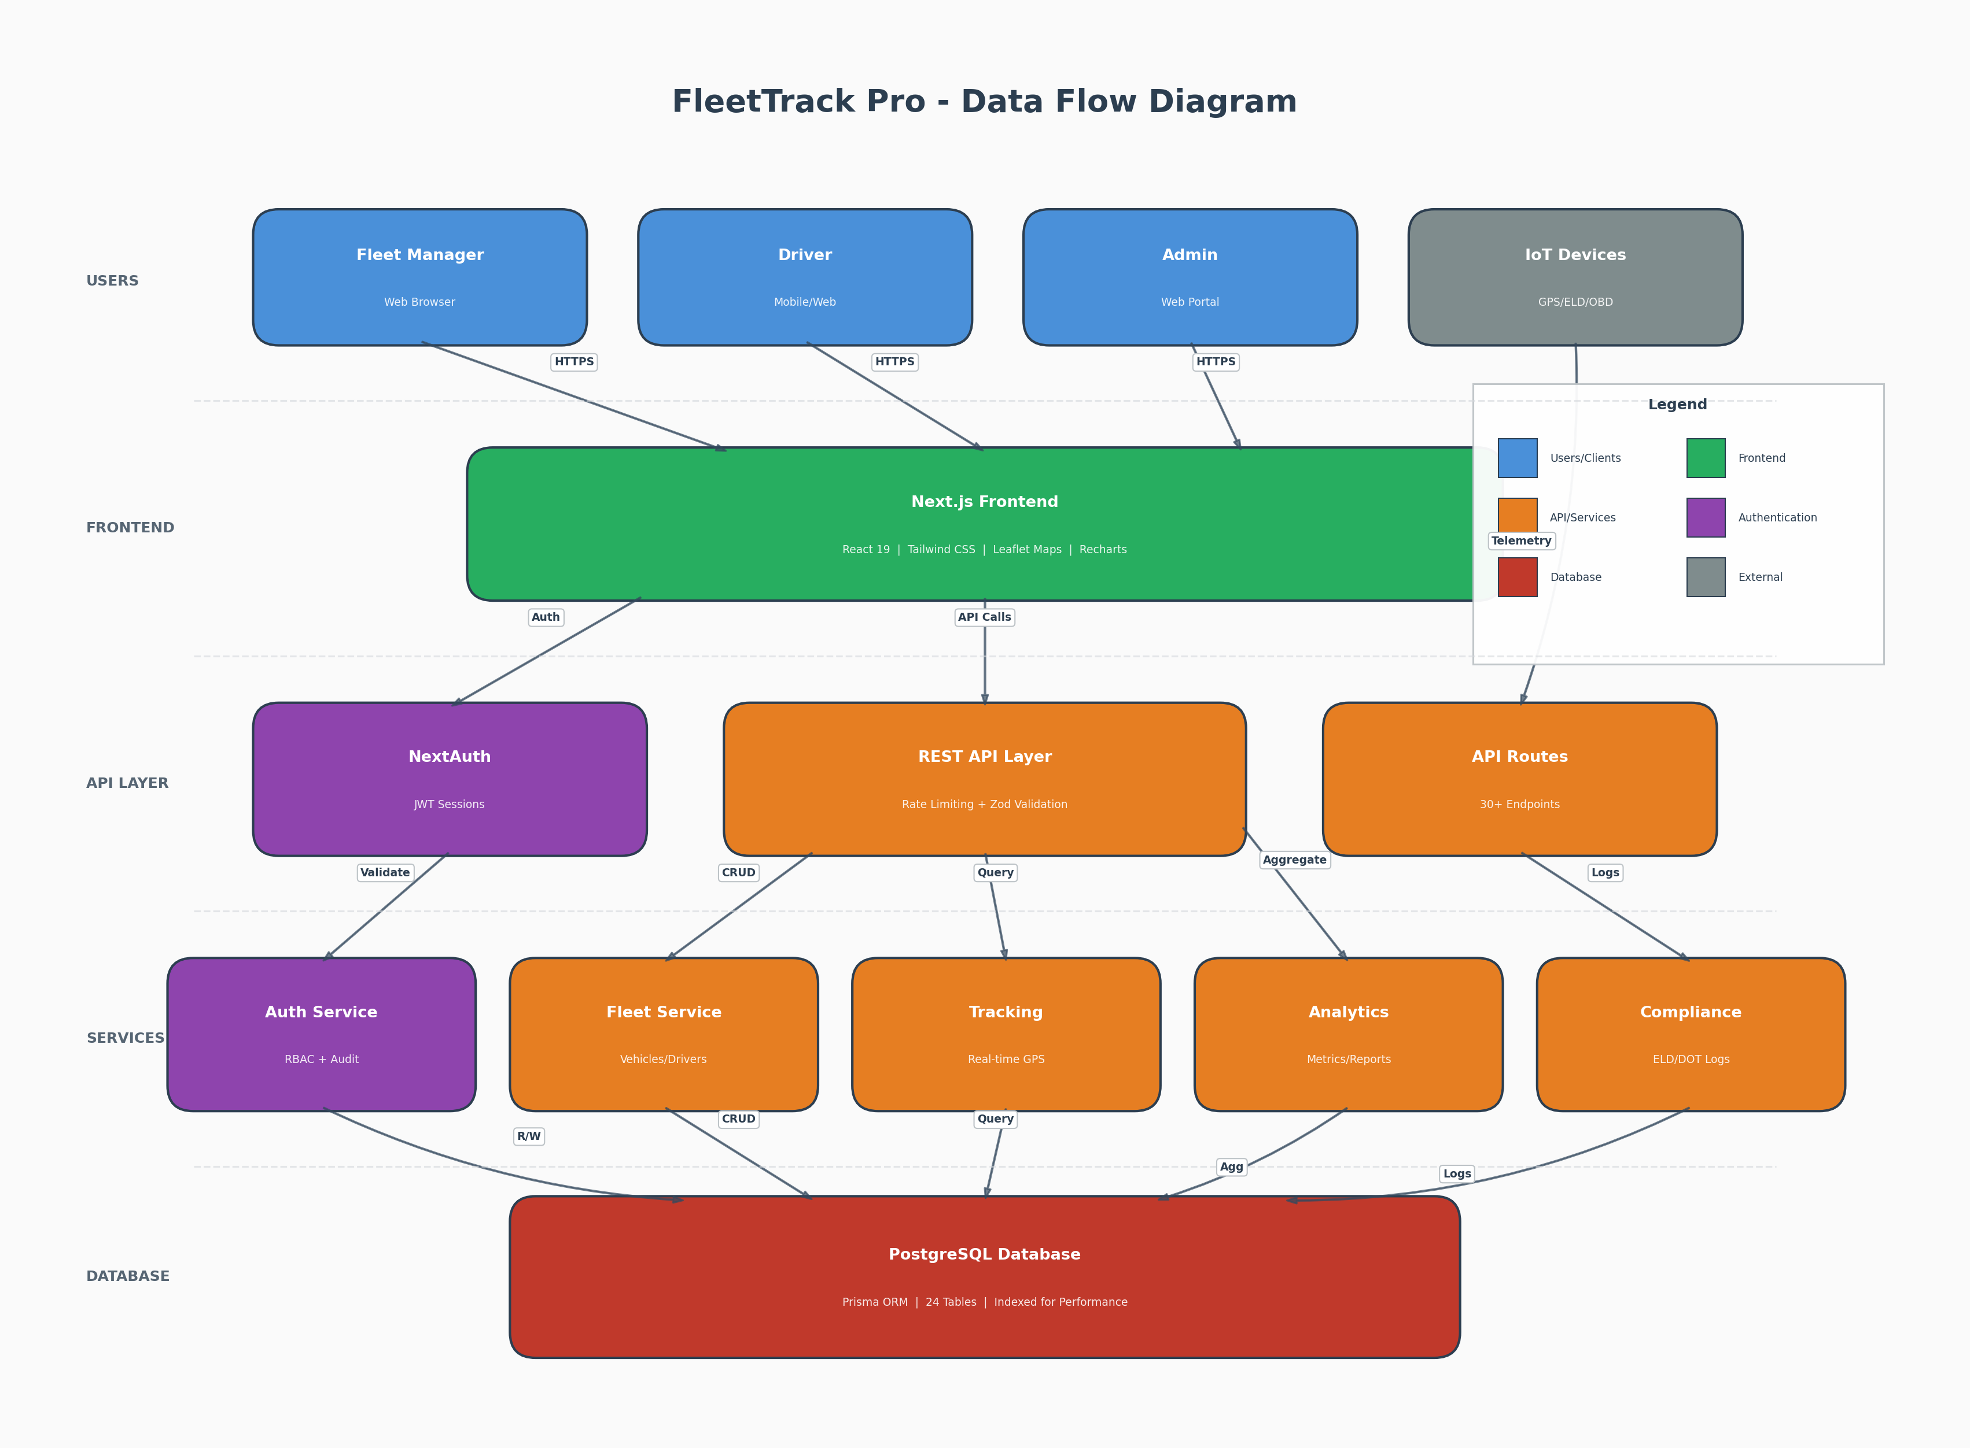

4.1 Data Flow Description
User Authentication Flow: Users submit credentials → NextAuth validates against database → Password verified with bcryptjs → JWT token created → Session established with 24-hour expiration → User redirected to dashboard
Real-Time Tracking Flow: Active vehicles queried → Location/telemetry data retrieved → Geofences fetched and parsed → Data transformed for map display → Frontend renders interactive map with markers
Incident Reporting Flow: User submits incident form → Incident record created → Alert automatically generated → Dashboard updated → Notifications dispatched
Analytics Flow: Time period specified → Multiple aggregations run in parallel → Trip stats, safety events, fuel data compiled → Driver performance calculated → Comprehensive analytics returned

5. Software Architecture
FleetTrack Pro follows a layered architecture pattern with clear separation of concerns. The platform is built as a Multi-Tenant SaaS application with Role-Based Access Control (RBAC).

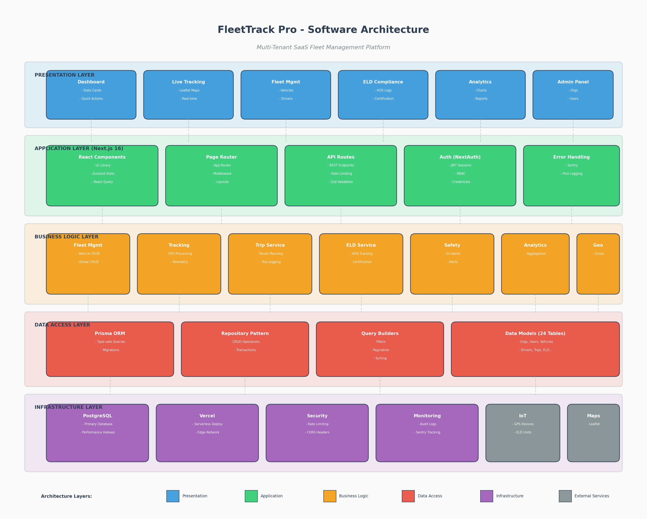

5.1 Architecture Layers
Presentation Layer: React-based UI components including Dashboard, Live Tracking, Fleet Management, ELD Compliance, Analytics, and Admin Panel. Built with Next.js pages and custom UI components.
Application Layer: Next.js framework handling routing, middleware, API routes, authentication (NextAuth), and error handling with Sentry integration.
Business Logic Layer: Core services including Fleet Management, Tracking, Trip Management, ELD Service, Safety Management, Analytics, and Geofencing.
Data Access Layer: Prisma ORM providing type-safe database queries, migrations, and repository patterns for all 24 data models.
Infrastructure Layer: PostgreSQL database, Vercel serverless hosting, security middleware (rate limiting, CORS), and external integrations (IoT devices, Maps).

5.2 Key Architectural Patterns
• Multi-Tenancy: Organizations own all their data with complete isolation
• RBAC: 8 distinct user roles with granular permissions
• API-First: All data accessed through RESTful API endpoints
• Rate Limiting: Per-user and per-IP request throttling
• Request Correlation: UUID-based request tracing for debugging
• Structured Error Handling: Consistent error responses with logging
• Input Validation: Zod schemas validate all incoming data
• Session-Based Security: JWT tokens with configurable expiration

6. Plan of Action (Phase-wise Development)
The development of FleetTrack Pro is organized into six strategic phases, each building upon the previous to deliver a complete, production-ready platform.

Phase 1: Foundation & Infrastructure
Deliverable | Details
Project Setup | Next.js 16 initialization, TypeScript configuration, ESLint/Prettier setup
Database Design | PostgreSQL schema design, Prisma ORM setup, migrations framework
Authentication System | NextAuth integration, JWT sessions, password hashing, RBAC foundation
Core UI Framework | Tailwind CSS setup, base components (Button, Input, Card, Table)
API Infrastructure | API route structure, error handling, logging (Pino), rate limiting
Development Environment | Local development setup, environment variables, Git workflow

Phase 2: Core Fleet Management
Deliverable | Details
Vehicle Management | CRUD operations, vehicle profiles, status management, maintenance tracking
Driver Management | Driver profiles, license tracking, DOT medical dates, assignments
Dashboard | Statistics cards, fleet overview, quick actions, alert summary
Organization Management | Multi-tenant support, organization CRUD, subscription tiers
User Management | User CRUD, role assignment, permission enforcement

Phase 3: Real-Time Tracking & Telematics
Deliverable | Details
Live Map Tracking | Leaflet map integration, vehicle markers, real-time updates
Telemetry Processing | Engine data capture, sensor readings, diagnostic codes
Geofencing System | Zone creation (circle/polygon), entry/exit detection, alert triggers
Trip Recording | Start/end tracking, route logging, distance/duration calculation
IoT Integration | Device management, data ingestion API, telemetry storage

Phase 4: Compliance & Safety
Deliverable | Details
ELD Logging | Hours of Service tracking, duty status changes, log storage
Log Certification | Driver certification workflow, compliance verification
Incident Management | Incident reporting, status tracking, resolution workflow
Safety Events | Behavioral detection, event logging, driver scoring
Alert System | Multi-type alerts, notification delivery, acknowledgment tracking

Phase 5: Analytics & Reporting
Deliverable | Details
Analytics Dashboard | Recharts integration, interactive visualizations, KPI displays
Fleet Performance | Trip analysis, fuel efficiency, utilization metrics
Driver Scoring | Performance ranking, safety scores, productivity metrics
Cost Analysis | Maintenance costs, fuel expenses, operational budgeting
Custom Reports | Configurable date ranges, data export, scheduled reports

Phase 6: Polish & Deployment
Deliverable | Details
Testing & QA | Unit tests (Vitest), integration tests, E2E testing, security audit
Performance Optimization | Database indexing, query optimization, caching strategies
Security Hardening | Penetration testing, vulnerability fixes, security headers
Documentation | API documentation, user guides, admin manuals
Production Deployment | Vercel configuration, environment setup, monitoring (Sentry)
Launch Support | Bug fixes, performance tuning, user feedback incorporation

7. Required Team Setup
The following team structure is recommended for successful delivery of the FleetTrack Pro platform:

Role | Count | Expertise Required | Responsibilities
Project Manager | 1 | Agile/Scrum, Fleet/Logistics domain | Sprint planning, stakeholder communication, timeline management
Tech Lead / Architect | 1 | Next.js, PostgreSQL, System Design | Architecture decisions, code reviews, technical guidance
Senior Full-Stack Developer | 2 | Next.js, React, Node.js, Prisma | Core feature development, API design, complex integrations
Full-Stack Developer | 2 | React, TypeScript, REST APIs | Feature implementation, bug fixes, unit testing
Frontend Developer | 1 | React, Tailwind CSS, Leaflet | UI components, map integration, responsive design
Backend Developer | 1 | Node.js, PostgreSQL, Authentication | API development, database optimization, security
QA Engineer | 1 | Vitest, E2E testing, API testing | Test planning, automation, bug tracking
DevOps Engineer | 1 | Vercel, CI/CD, Monitoring | Deployment pipelines, infrastructure, monitoring
UI/UX Designer | 1 | Figma, Design Systems, Prototyping | User research, wireframes, visual design

Total Team Size: 11 members (can be scaled based on timeline requirements)

7.1 Optional/Specialized Roles
• IoT/Hardware Specialist - For ELD device integration and telemetry optimization
• Security Specialist - For compliance requirements (SOC 2, FMCSA)
• Database Administrator - For large-scale deployments with complex data requirements
• Technical Writer - For comprehensive documentation and API guides

8. Project Timeline
The following timeline represents a comprehensive development schedule for the FleetTrack Pro platform:

Phase | Duration | Key Milestones | Dependencies
Phase 1: Foundation | Weeks 1-4 | • Dev environment ready  • Database schema complete  • Auth system functional  • Base UI components | Team onboarding, requirements sign-off
Phase 2: Core Fleet | Weeks 5-10 | • Vehicle CRUD complete  • Driver management done  • Dashboard functional  • Multi-tenancy working | Phase 1 completion
Phase 3: Tracking | Weeks 11-16 | • Live map operational  • Geofencing active  • Trip logging working  • Telemetry flowing | Phase 2 completion, IoT setup
Phase 4: Compliance | Weeks 17-22 | • ELD logging active  • Certification workflow  • Incident management  • Alert system live | Phase 3 completion
Phase 5: Analytics | Weeks 23-26 | • Dashboards complete  • Reports generating  • Driver scores active  • Cost tracking live | Phase 4 completion
Phase 6: Launch | Weeks 27-30 | • All tests passing  • Security audit passed  • Documentation complete  • Production deployed | All phases complete

Total Estimated Duration: 30 weeks (approximately 7.5 months)

8.1 Timeline Considerations
• Timeline can be compressed with additional resources or parallel workstreams
• Buffer time is included for testing, bug fixes, and unexpected challenges
• Client feedback cycles may extend certain phases
• IoT device integration timeline depends on hardware availability
• Regulatory compliance requirements may require additional review cycles

9. API Documentation
FleetTrack Pro exposes a comprehensive REST API with 30+ endpoints organized by functional domain. All endpoints require authentication except the health check endpoint.

9.1 Authentication
Method | Endpoint | Description | Auth Required
POST | /api/auth/[...nextauth] | NextAuth handler (sign in/out) | No
GET | /api/health | Health check endpoint | No

9.2 Vehicles API
Method | Endpoint | Description | Auth Required
GET | /api/vehicles | List all vehicles (org-scoped) | Yes
POST | /api/vehicles | Create new vehicle | Yes
GET | /api/vehicles/[id] | Get vehicle with locations, telemetry | Yes
PATCH | /api/vehicles/[id] | Update vehicle status, odometer | Yes
DELETE | /api/vehicles/[id] | Delete vehicle (cascade) | Yes

9.3 Drivers API
Method | Endpoint | Description | Auth Required
GET | /api/drivers | List all drivers with stats | Yes
POST | /api/drivers | Create driver (creates user + driver) | Yes
GET | /api/drivers/[id] | Get driver with trips and ELD logs | Yes
PATCH | /api/drivers/[id] | Update driver status, license info | Yes
DELETE | /api/drivers/[id] | Delete driver and related records | Yes

9.4 ELD Compliance API
Method | Endpoint | Description | Auth Required
GET | /api/eld | List ELD logs (date-filtered) | Yes
POST | /api/eld | Create ELD log entry | Yes
POST | /api/eld/certify | Certify daily ELD logs | Yes
GET | /api/eld/status | Get ELD status for driver | Yes

9.5 Additional API Endpoints
Method | Endpoint | Description | Auth Required
GET | /api/tracking | Get active vehicles with geofences | Yes
GET/POST | /api/trips | List/Create trips | Yes
GET/POST/PATCH/DELETE | /api/incidents | Incident management | Yes
GET/POST/PATCH/DELETE | /api/geofences | Geofence management | Yes
GET/PATCH | /api/alerts | Alert management | Yes
GET | /api/analytics | Fleet analytics | Yes
POST/PATCH/DELETE | /api/admin/organizations | Organization management | Admin
POST/PATCH/DELETE | /api/admin/users | User management | Admin
PATCH | /api/settings/* | User settings (profile, password, 2FA) | Yes

9.6 Response Formats
Success Response:
{
"id": "string",
"licensePlate": "string",
"make": "string",
"status": "active" | "inactive" | "maintenance" | "out_of_service",
// ... additional fields
}
Error Response:
{
"error": "string",
"details": [...], // optional validation errors
"message": "string" // optional
}

10. Database Schema
FleetTrack Pro uses PostgreSQL with Prisma ORM, featuring 24 interconnected data models organized into logical domains.

10.1 Organization & Users
Table | Key Fields | Relationships | Purpose
Organization | id, name, slug, subscriptionTier, status | Has many: Users, Vehicles, Drivers, Geofences | Multi-tenant container
User | id, email, password, role, preferences, twoFactorEnabled | Belongs to: Organization; Has one: Driver | User accounts and auth
Session | id, token, userId, expiresAt | Belongs to: User | JWT session tracking

10.2 Fleet Management
Table | Key Fields | Relationships | Purpose
Vehicle | id, vin, licensePlate, make, model, year, status, odometer | Belongs to: Organization; Has many: Locations, Telemetry, Trips | Vehicle profiles
Driver | id, licenseNumber, licenseState, licenseExpiry, dotMedicalExpiry, status | Belongs to: User, Organization; Has many: Trips, ELDLogs | Driver profiles
VehicleAssignment | id, vehicleId, driverId, startDate, endDate | Belongs to: Vehicle, Driver | Assignment history
IOTDevice | id, serialNumber, type, status, firmwareVersion | Belongs to: Vehicle | GPS/ELD devices

10.3 Tracking & Telemetry
Table | Key Fields | Relationships | Purpose
VehicleLocation | id, vehicleId, latitude, longitude, speed, heading, timestamp | Belongs to: Vehicle; Index: (vehicleId, timestamp) | GPS coordinates
VehicleTelemetry | id, vehicleId, engineRpm, fuelLevel, coolantTemp, oilPressure | Belongs to: Vehicle; Index: (vehicleId, timestamp) | Engine metrics
VehicleDiagnostic | id, vehicleId, code, description, severity, status | Belongs to: Vehicle | OBD-II codes
Trip | id, vehicleId, driverId, startLat, startLng, endLat, endLng, distance, duration | Belongs to: Vehicle, Driver | Trip records
Route | id, name, waypoints, estimatedDuration, estimatedDistance | Belongs to: Organization | Pre-defined routes

10.4 Compliance & Safety
Table | Key Fields | Relationships | Purpose
ELDLog | id, driverId, date, status, startTime, endTime, duration, certified | Belongs to: Driver; Index: (driverId, date) | Hours of Service
SafetyEvent | id, driverId, vehicleId, type, severity, location, timestamp | Belongs to: Driver, Vehicle; Index: (driverId, timestamp) | Behavioral events
Incident | id, driverId, vehicleId, type, severity, status, location, description | Belongs to: Driver, Vehicle, Organization | Incident reports
Video | id, incidentId, vehicleId, url, duration, type | Belongs to: Incident, Vehicle | Dashcam footage
Alert | id, type, severity, message, isRead, acknowledgedAt | Belongs to: Organization | System notifications

10.5 Operations & Maintenance
Table | Key Fields | Relationships | Purpose
MaintenanceRecord | id, vehicleId, type, description, cost, laborHours, status | Belongs to: Vehicle | Service records
FuelRecord | id, vehicleId, driverId, gallons, pricePerGallon, totalCost, odometer | Belongs to: Vehicle, Driver | Fuel purchases
Geofence | id, name, type, coordinates, alertOnEntry, alertOnExit | Belongs to: Organization | Virtual boundaries
AuditLog | id, userId, action, resource, resourceId, changes, timestamp | Belongs to: User | Activity tracking

10.6 Performance Indexes
• VehicleLocation: (vehicleId, timestamp) - Optimized for latest location queries
• VehicleTelemetry: (vehicleId, timestamp) - Optimized for latest telemetry
• ELDLog: (driverId, date) - Optimized for daily compliance reports
• SafetyEvent: (driverId, timestamp) - Optimized for driver safety scoring
• Trip: (vehicleId, startTime) - Optimized for trip history queries

11. Appendix

11.1 User Roles & Permissions
Role | Level | Permissions
saas_admin | Platform | Full system access, manage all organizations
saas_subscriber_manager | Platform | Manage subscriptions and billing
saas_support | Platform | Customer support, read-only access
saas_developer | Platform | API access, debugging tools
company_admin | Organization | Full org access, manage users and settings
fleet_manager | Organization | Manage vehicles, drivers, and operations
driver | Organization | View own trips, ELD logs, report incidents
company_support | Organization | Support staff, limited read access

11.2 Environment Configuration
Variable | Required | Description
DATABASE_URL | Yes | PostgreSQL connection string
NEXTAUTH_URL | Yes | Application base URL
NEXTAUTH_SECRET | Yes | JWT signing secret (32+ chars)
AUTH_URL | Yes | Authentication callback URL
LOG_LEVEL | No | Logging level (info, debug, error)
RATE_LIMIT_MAX | No | Max requests per window (default: 100)
RATE_LIMIT_WINDOW_MS | No | Rate limit window in ms (default: 60000)

11.3 Security Features
• Password hashing with bcryptjs (12 salt rounds)
• JWT-based sessions with 24-hour expiration
• Rate limiting: 100 requests/60s (API), 5 requests/60s (auth)
• CORS validation on all API routes
• Security headers (X-Content-Type-Options, X-Frame-Options, X-XSS-Protection)
• Request ID correlation for audit trails
• Sensitive field redaction in logs
• Input validation with Zod schemas
• Two-factor authentication support

11.4 Document Information
This Statement of Work provides a comprehensive overview of the FleetTrack Pro platform. For additional information, technical discussions, or project inquiries, please contact the project team.

— End of Document —

