# **C# Cheat Sheet – By Tatum & Patricia**

**Content:**

1. **The basics**

# The Basics

**using System;** The “Using” keyword is used to include **namespaces** into an app. A program generally has multiple “Using” statements.

**namespace Oefeningen** – The namespace contains all of the classes in the program. It is also the name of the folder where everything is stored.

**Static void Main(string[] args)** – The Main is a function, and it’s the entry point for all C# programs.

**{**

**}** – Important Note: You cannot make functions within a function, therefore you write all new functions below the Main; not in it. The Main is a “lifeline”, and everything you make outside of the Main are tools to use within it.

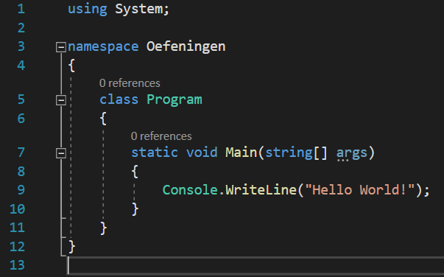

1. **Functions**

A function allows you to encapsulate (oftewel vasthouden) a piece of code from the other code in your application. You can then re-use this code over and over again, without having to rewrite it.

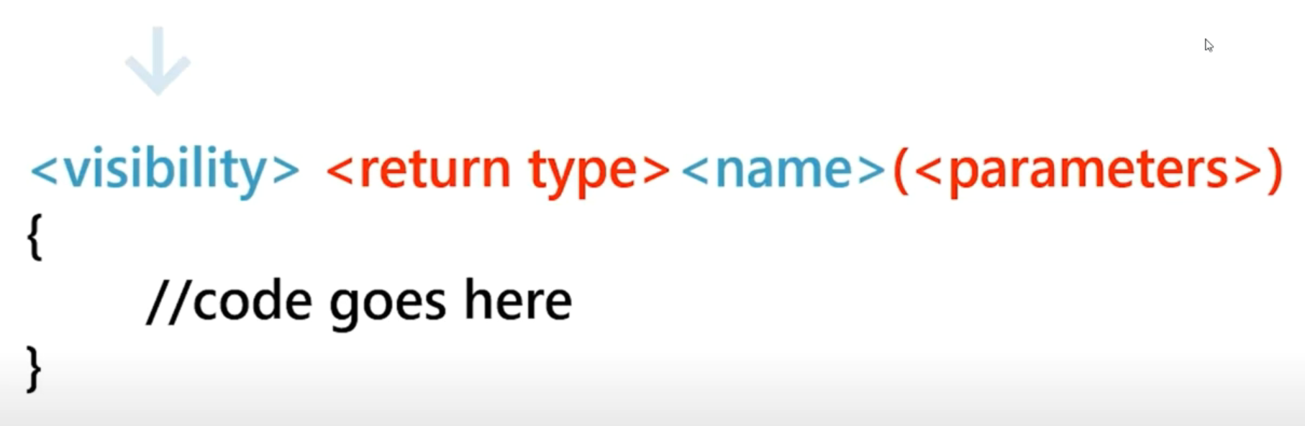

* 1. **Access Modifiers**

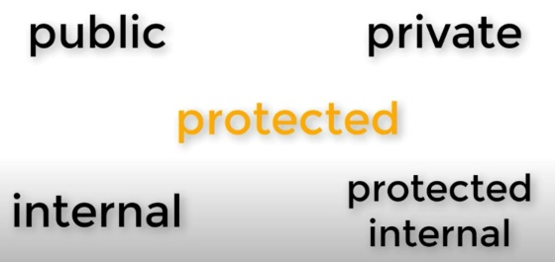There are 5 different access modifiers. These determine from which points in the code you can call other code.

**Public**

When something’s specified to be public, this means that it can be accessed from anywhere within your application.

**Private**

On the other hand, members defined private can only be accessed from within the class in which they are defined.