DHYAN INDUSTRIES

STOCKIST & SUPPLIERS OF : FERROUS & NON FERROUS METALS & STEINLESS STEEL PLATES, PIPES, RODS, CIRCLE, WIRE, S.S. 202, 304, 316, 310
39/41 KAMAL BUILDING, 1 ST KHUMBHARWADA, BHANDARI STREET, NEAR ROUND TEMPLE , MUMBAI 400004. TEL: 022- 66581631, MOB 09869607960
--------------------------------------------------------------------------
INTRODUCTION
Dear Sir,
We feel very proud to be introducing ourselves as Exporter, Suppliers and leading Stockist of materials like: -
STAINLESS STEEL – TYPE 202, 304, 304L, 316, 316L, 316TI, 317L, 321, 310, 310s, 410, 420, 430 in FORM OF SHEET, PLATES, PIPES & TUBES, BESIDES THESE WE CAN SUPPLY YOU MATERIALS LIKE BARS, RODS, WIRES, STRIPES & FOILS, FLANGES, FITTINGS, CIRCLES.
PIPES RANGE:
 | 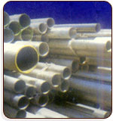
   | Metal Grade | 202, 304, 304L, 316, 316L, 310, 321
   | Outside Diameter | 1/2” to 6”
   | Thickness | 20 swg to 6 mm
   | Normal Bore | 3/8” to 12”
   | Schedule | 5 to XXS
  As per customer requirement... (Japan, Brazil, European)
  With Test Certificate
COILS / FOILS / SHEETS / PLATES RANGE:
 |  | 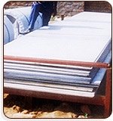
   | Metal Grade | 304, 304L, 316, 316L, 319, 409 M 410, 421
   | Thickness | 0.02 (FOIL) mm to 140 mm (PLATES)
   | Width | 1000/1250/1500/1800/2000 MM
   | Length | As per your requirement
   |  | JINDAL, IMPORTED OR CHINESE MATERIAL.
We have experience & are in this business past 22 years, Industry We Serve
 Power Houses |  |  Refineries/Petrochemicals
 Steel Plants |  | Cement Plants
 Offshore Platform |  |  Fertilizer Industries
 Chemical Industries |  |  Port Trusts
 Coal Mines |  |  Glass Industries
 Plastic Industries |  |  Synthetic Yarn Industries

Product Showcase :
Pipes & Tubes
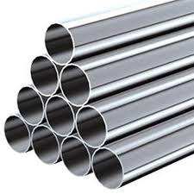 | 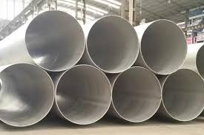 | 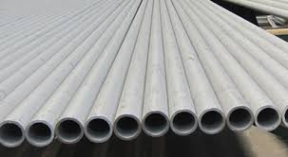
SheetS , Plates & Coils
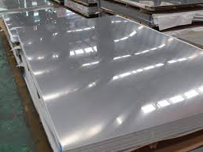 | 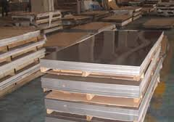 | 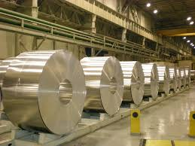
Buttweld Fittings
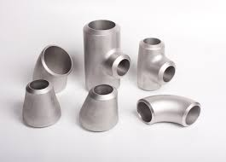 | 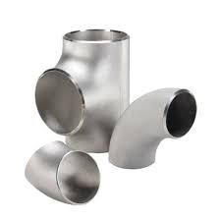 | 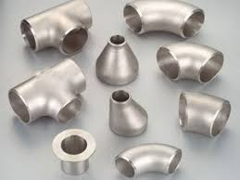
Forged Fittings
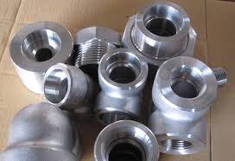 | 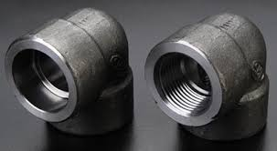 | 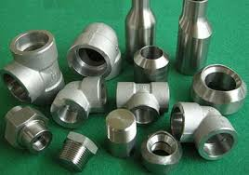
Ferrule Fittings  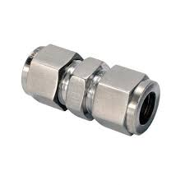 | 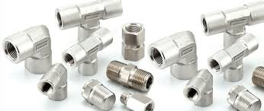 | 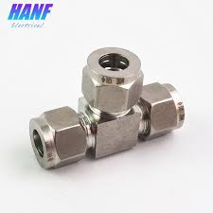
Nut Bolts, Screw  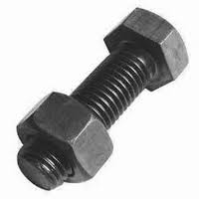 | 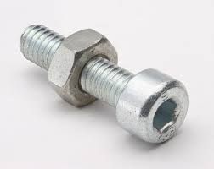 | 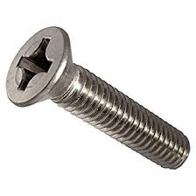
Flanges
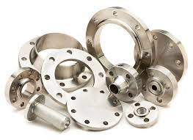 | 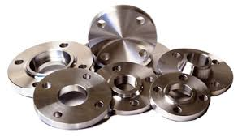 | 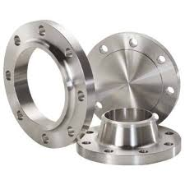
Rod, Bar & Wire
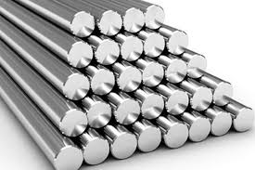 | 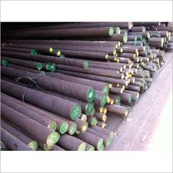 | 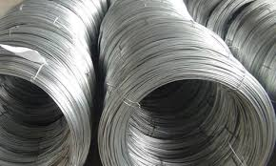
Copper Products
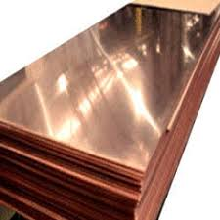 | 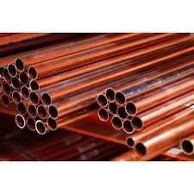 | 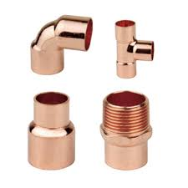
Brass products
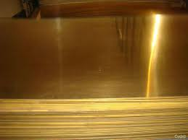 | 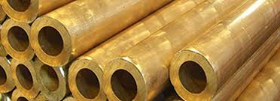 | 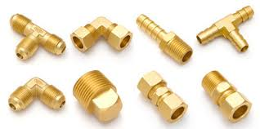

And several others INDUSTRIES like Cold storages, Fabricators, Engineering & Heat Exchangers.
We learn that you are the regulars purchasers of the above mention items and request you to KINDLY REGISTER OUR COMPANY’S NAME AS ONE OF YOUR APPROVED SUPPLIERS and also enclosed or illustrated catalogue which contains detail of all items and will enable you to make a suitable selection.ke the liberty of having your items (specification) and feel sure you will realize that our quoted price is very reasonable, but we are anxious to do what we can help you to establish your new business. therefore quite confident of rendering you the best service in this line and assure you that a trial order will certainly convince you.
We shall always serve you to the best of our ability and forward to receiving an early inquiry.
Thanks & Best Regards,
For DHYAN INDUSTRIES
KAPIL C JAIN
+91 9869607960
PROPRIETOR

