DevOps SLA Assignment — Task 4: Docker
Practical Implementation: Containerizing MKES CARE+ Flutter Web with Nginx
Aim | Create a Docker image of MKES CARE+ web application, run it on port 8081, open it in browser, and verify Supabase database connectivity.
Project Location | D:\mkes-lovable (Flutter Web Platform)
Docker Artifacts | Image: mkes-care-plus:latest (153 MB) | Container: mkes-care-web
Port Mapping | http://localhost:8081 (Host Port 8081 -> Container Port 80)
Backend / Database | Supabase PostgreSQL (External Cloud BaaS over client-side HTTPS/REST)

1. Dockerfile Creation and Explanation
A Dockerfile was created in the root directory (D:\mkes-lovable\Dockerfile) to package the static web application with a lightweight Nginx web server:
FROM nginx:alpine
COPY build/web /usr/share/nginx/html
EXPOSE 80

• FROM nginx:alpine: Uses the official Nginx web server based on Alpine Linux (~5 MB base). The resulting image is lightweight (153 MB total), secure, and quick to build.
• COPY build/web /usr/share/nginx/html: Copies the compiled static Flutter web files into Nginx's public web root.
• EXPOSE 80: Documents that the Nginx web server inside the container listens on port 80.

2. Generating the Flutter Web Build
Before building the Docker image, the Flutter application was compiled into production web artifacts using PowerShell in D:\mkes-lovable:
PS D:\mkes-lovable> flutter build web

This command compiles Dart code into JavaScript (main.dart.js), bundles CanvasKit WebAssembly modules, and generates the static files in build/web, which Nginx serves.
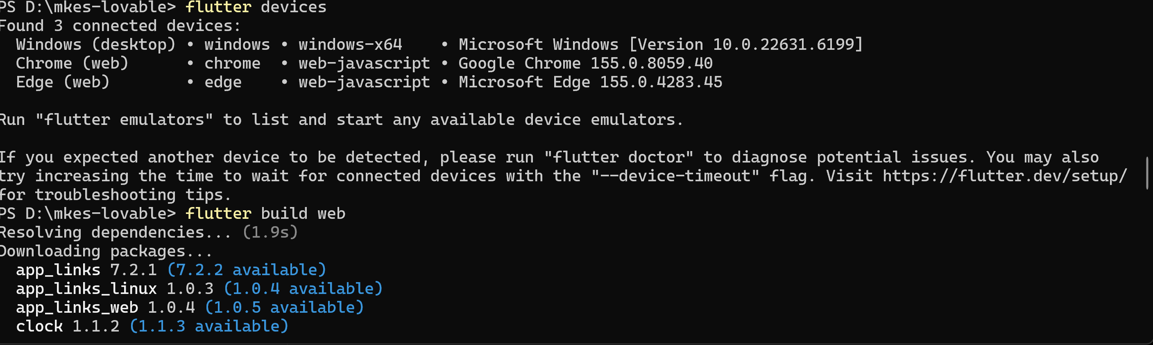
Figure 1 — Compiling MKES CARE+ to Web Assembly and Static JavaScript Assets using 'flutter build web'
[Verification] Verifies 'flutter devices' detecting web targets followed by successful execution of 'flutter build web' in D:\mkes-lovable.

3. Building the Docker Image
The Docker image was built from the project root using the following command:
PS D:\mkes-lovable> docker build -t mkes-care-plus .

• -t mkes-care-plus: Assigns the image name mkes-care-plus (tagged :latest by default).
• . (dot): Specifies the build context as the current directory (D:\mkes-lovable).
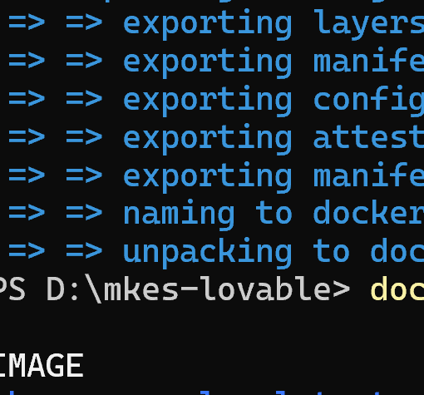
Figure 2a — Docker BuildKit Engine Exporting Layers and Committing Manifest
[Verification] Shows layer export and naming of docker.io/library/mkes-care-plus:latest.

4. Running the Docker Container
The container was launched in background detached mode mapped to host port 8081:
PS D:\mkes-lovable> docker run -d --name mkes-care-web -p 8081:80 mkes-care-plus

• -d: Detached mode (runs the container in the background).
• --name mkes-care-web: Assigns the custom container name mkes-care-web.
• -p 8081:80: Maps host port 8081 to container port 80 (<HostPort>:<ContainerPort>). Port 8081 was chosen to prevent conflicts with common development services running on port 8080.
Result: Returned container identifier d7342578d852d1ec1f84e83dd6522ac24bc4278ca21314a5bb529fcf9332cc9b.

5. Verifying the Image and Running Container
The created image and running container status were verified using CLI commands:
PS D:\mkes-lovable> docker images mkes-care-plus
IMAGE ID DISK USAGE CONTENT SIZE EXTRA
mkes-care-plus:latest bd5becd1da2b 153MB 41.2MB
PS D:\mkes-lovable> docker ps -a
CONTAINER ID IMAGE STATUS PORTS NAMES
d7342578d852 mkes-care-plus Up About a min 0.0.0.0:8081->80/tcp, [::]:8081->80/tcp mkes-care-web

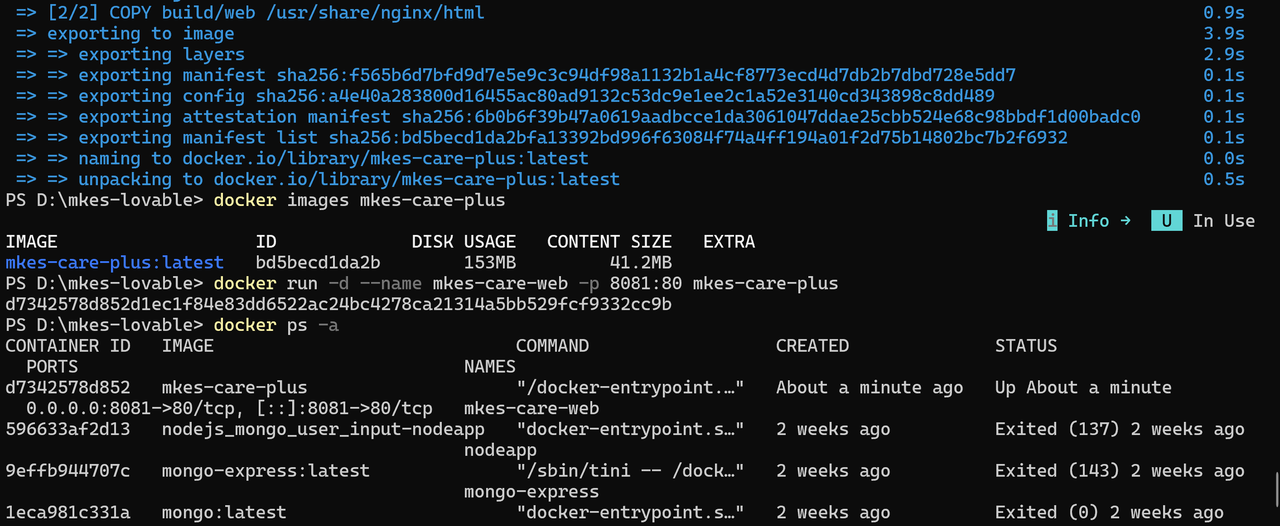
Figure 2 — Terminal Output: Docker Image Verification, Detached Container Launch ('mkes-care-web'), and Process Status ('docker ps -a')
[Verification] Proves: (1) Image verification (ID bd5becd1da2b, 153 MB), (2) Container execution with assigned ID d7342578..., and (3) docker ps -a verifying status Up on 0.0.0.0:8081->80/tcp.

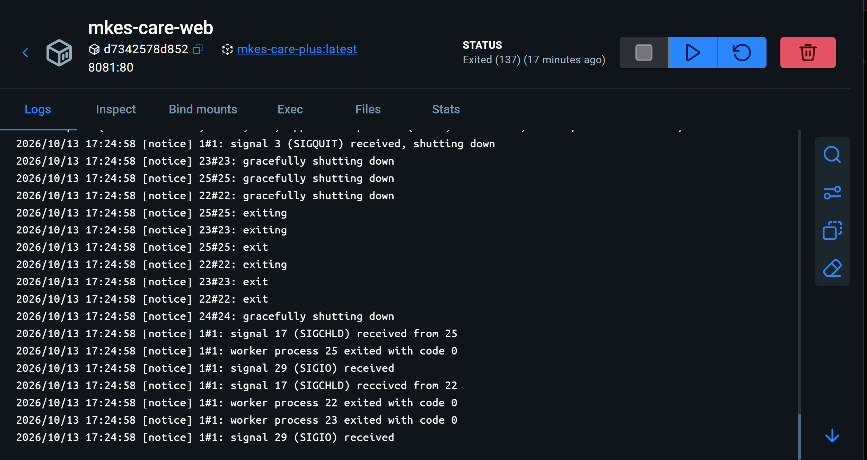
Figure 3 — Docker Desktop Dashboard: GUI Verification of 'mkes-care-web' Container, Port Mapping 8081:80, and Nginx Server Logs
[Verification] GUI verification in Docker Desktop confirming container mkes-care-web, port mapping 8081:80, and Nginx server process management logs.

6. Accessing the Application in the Browser
Open any browser and navigate to: http://localhost:8081
• Flow: Nginx serves the compiled Flutter web files. The Flutter engine boots and initializes Supabase from api.env.
• Authentication Portal: Since no session is stored, AuthWrapper automatically displays the Role Selection / Login screen, offering Admin Portal (admin & doctors) and Staff Portal (receptionists & assistants).

7. Supabase Database Connectivity & Security
• External Backend Architecture: The Docker container hosts ONLY the Nginx static web server. It does NOT contain PostgreSQL. The database is hosted externally on Supabase (*.supabase.co). The Flutter client in the browser makes direct outbound HTTPS/REST and WebSocket requests to Supabase.
• Live Demonstration Evidence: When navigating to staff management, the application queries the PostgreSQL profiles table, retrieving active staff accounts and real-time shift records.
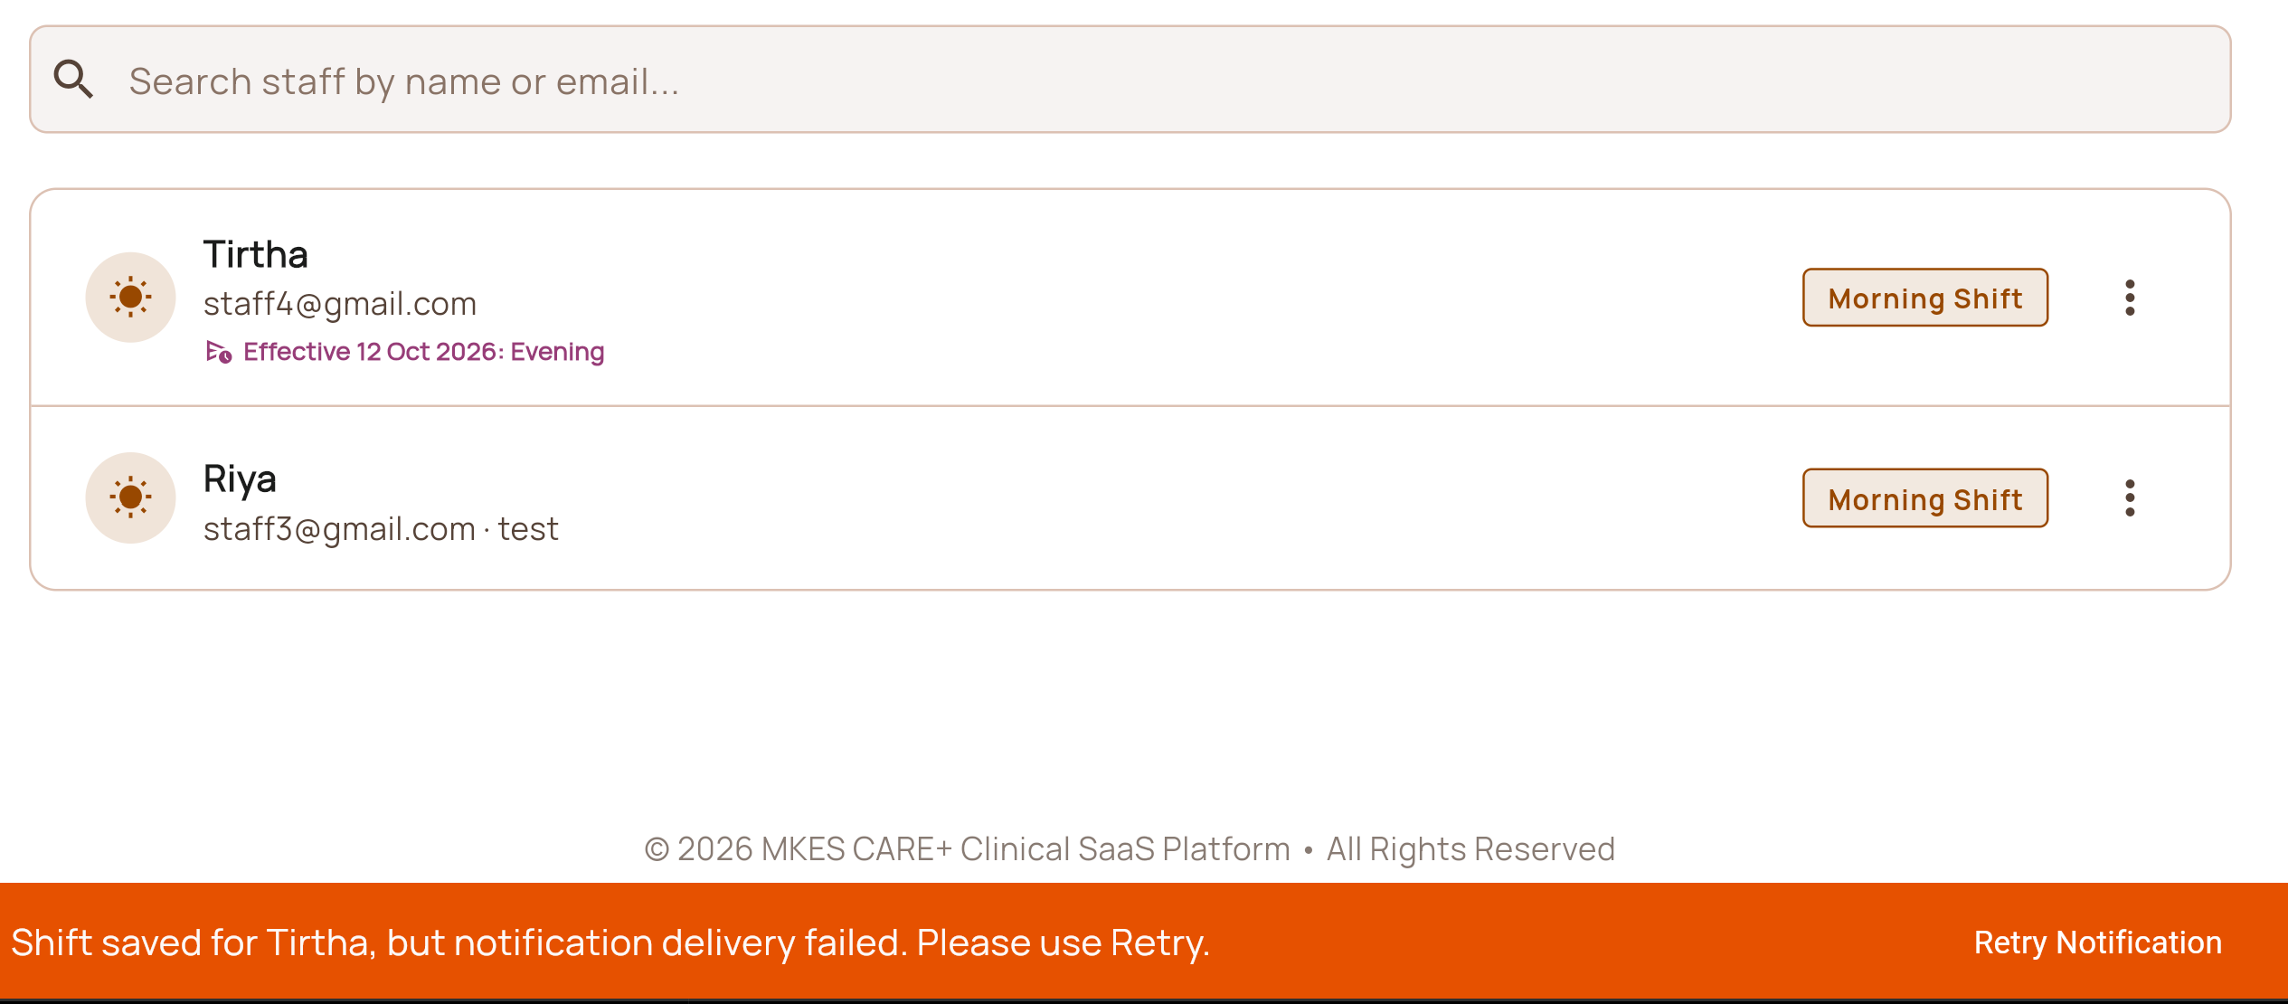
Figure 4 — MKES CARE+ Application Interface: Real-time Supabase Database Operations and Clinical Records Display
[Verification] Validates live database queries retrieving staff profiles (Tirtha, Riya) and mutation toast: 'Shift saved for Tirtha, but notification delivery failed. Please use Retry.', proving end-to-end database connectivity.

[CRITICAL SECURITY NOTE] Public Inspectability of Web Assets: In Flutter Web, api.env is bundled under assets/ and can be viewed by anyone at http://localhost:8081/assets/api.env. Therefore, api.env must ONLY contain public client keys (SUPABASE_URL and SUPABASE_ANON_KEY). Never include service_role keys, database passwords, or secret tokens. Database security relies strictly on PostgreSQL Row Level Security (RLS) policies.

8. Essential Docker Commands Reference
Purpose | Command
Build image | docker build -t mkes-care-plus .
Run container | docker run -d --name mkes-care-web -p 8081:80 mkes-care-plus
List running containers | docker ps
List all containers | docker ps -a
View container logs | docker logs mkes-care-web
Stop container | docker stop mkes-care-web

9. Result and Conclusion
Result: A compact Docker image mkes-care-plus:latest (153 MB) was built using nginx:alpine. The container mkes-care-web was deployed in detached mode with host port 8081 mapped to container port 80. The application was successfully verified via CLI (docker ps -a) and Docker Desktop GUI, and accessed in the browser at http://localhost:8081.
Conclusion:
1. Lightweight Deployment: Nginx Alpine provides an ultra-compact, high-performance static host for Flutter web apps.
2. Clean Architectural Separation: The Docker container isolates the frontend web server, while data persistence remains securely managed in the cloud by Supabase PostgreSQL.
3. Security Awareness: Public web distributions must never bundle privileged backend secrets; authorization is enforced via database Row Level Security (RLS).

10. Practical Viva Questions & Answers
Q1: Why did we choose 'nginx:alpine' as the base image?
Answer: Alpine Linux is an ultra-minimal distribution (~5 MB base). Nginx is ideal for serving Flutter's static HTML/JS assets. The final image is only 153 MB, compared to 500+ MB for Ubuntu-based images.
Q2: What does '-p 8081:80' mean in the docker run command?
Answer: It forwards host port 8081 to container internal port 80 (<HostPort>:<ContainerPort>). Port 8081 was chosen to prevent conflicts with common development tools running on port 8080.
Q3: Does this Docker container run PostgreSQL or the Supabase database?
Answer: No. The container contains only Nginx and static frontend files. Supabase PostgreSQL is an external cloud BaaS; the browser communicates directly with it over HTTPS/REST.
Q4: What is the security risk of including a service_role key in api.env for Flutter Web?
Answer: In Flutter Web, api.env is compiled into public assets reachable via HTTP. A service_role key would grant anyone full admin access to PostgreSQL. Only public anon keys should be in api.env, backed by Row Level Security (RLS).

