DevOps SLA Assignment — Task 1: GitHub
Practical Implementation: Keeping Project on GitHub — Demonstrating Git Push and Git Pull
Academic Information | Implementation Details
Course / Subject | DevOps SLA (Software Lifecycle Automation)
Assignment Task | Task 1: Keep the Project on GitHub — Demonstrate Git Push and Pull
Aim | Demonstrate storing the MKES CARE+ project codebase on GitHub and synchronizing distributed changes between local development branches and the remote GitHub repository using Git Push ('git push') and Git Pull ('git pull').
Project Target | MKES CARE+ Clinical Management Platform (Flutter Web & Mobile)
GitHub Repository | Tatva11/mkes-care-plus-lovable (https://github.com/Tatva11/mkes-care-plus-lovable.git)
Local Workspace | D:\mkes-lovable (and /c/MKES PRO/mkes final)
Active Git Branches | main (production), sprint-7-8 (reporting feature branch), sprint-9, devops/jenkins-ci
Version Control Tool | Git CLI 2.43+ / Git Bash (MinGW64) on Windows 11
Demonstrated Operations | git status, git add ., git commit, git push -u origin sprint-7-8, git push origin main, git pull origin main, git remote -v

1. Aim and Environment Prerequisites
Aim: To establish and demonstrate complete version control synchronization for the MKES CARE+ clinical platform by maintaining the repository on GitHub, staging and pushing local code changes using 'git push', and fetching and integrating remote updates into local branches using 'git pull'.
Prerequisites:
• Git Client: Git CLI (v2.43+) installed on Windows 11 / MinGW64 terminal with user credentials configured (user.name and user.email).
• Local Working Tree: Local Git repository cloned and initialized at D:\mkes-lovable (and /c/MKES PRO/mkes final).
• GitHub Remote Repository: Hosted Git repository Tatva11/mkes-care-plus-lovable accessible over authenticated HTTPS.
2. Repository Verification (git remote -v, git branch, git status)
Before initiating synchronization, remote tracking configurations and branch relationships were verified via terminal:
$ git remote -v
origin https://github.com/Tatva11/mkes-care-plus-lovable.git (fetch)
origin https://github.com/Tatva11/mkes-care-plus-lovable.git (push)

• Remote Verification: Remote Origin: Bound to https://github.com/Tatva11/mkes-care-plus-lovable.git.
• Active Branches: Branch Topology: Production branch 'main' and feature branch 'sprint-7-8' tracking their respective upstream remotes.
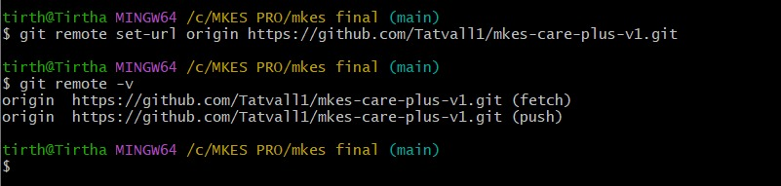
Figure 1 — Remote Configuration: Verifying GitHub Remote Repository Tracking URLs with 'git remote -v'
Verification: Confirms active binding between local project directory and remote GitHub repository endpoints for both fetch and push streams.

3. Git Push: Staging, Committing, and Uploading to GitHub
'git push' is the core Git command used to upload committed snapshots from the local repository to the remote GitHub repository. It updates remote branch heads and makes code available to collaborators and CI/CD pipelines.
Stage 1: Working Directory Change Detection (git status)
Inspecting local status identified modified reports models, screens, and newly created untracked files on branch sprint-7-8:
$ git status
On branch sprint-7-8
Changes not staged for commit:
(use "git add <file>..." to update what will be committed)
modified: lib/features/reports/models/appointment_reports_model.dart
modified: lib/features/reports/models/overview_reports_model.dart
modified: lib/features/reports/models/reports_filter_model.dart
modified: lib/features/reports/providers/reports_provider.dart
modified: lib/features/reports/repositories/reports_repository.dart
modified: lib/features/reports/screens/admin_reports_screen.dart
modified: lib/features/reports/widgets/reports_chart_painters.dart
modified: lib/features/reports/widgets/reports_filter_toolbar.dart
modified: lib/features/reports/widgets/reports_metric_card.dart
Untracked files:
lib/features/reports/models/inventory_reports_model.dart
lib/features/reports/services/
test/sprint8_inventory_reports_test.dart

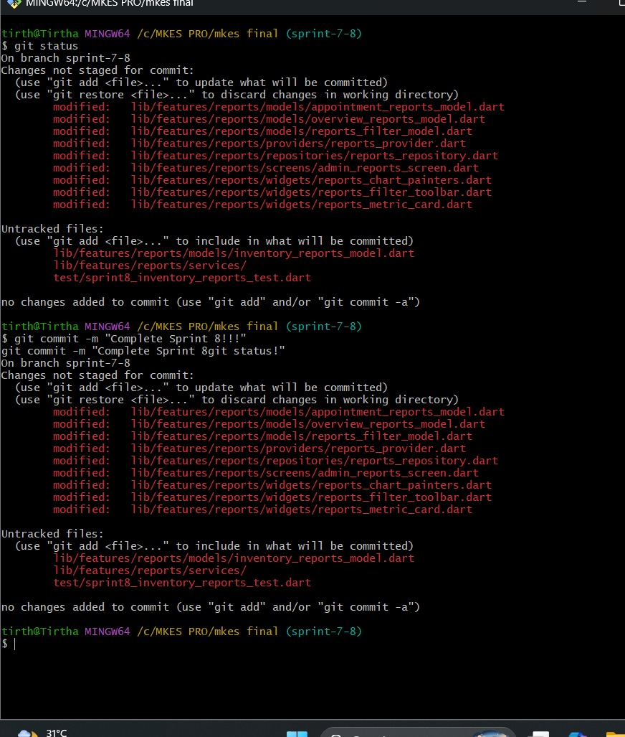
Figure 2 — Working Directory Status: Identifying Unstaged and Untracked Project Changes via 'git status'
Stage 2: Staging Modifications (git add .)
Attempting to commit unstaged files directly was rejected by Git. Changes were added to the index using git add . and verified:
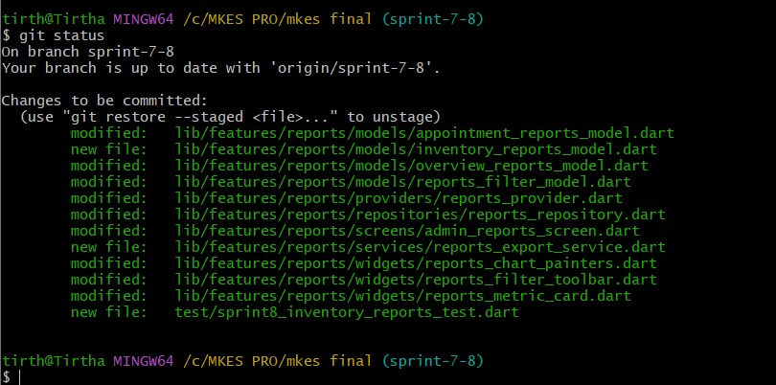
Figure 3 — Staging Area Verification: Confirming Staged Changes to be Committed via 'git status'
Staging Verification: All modified clinical reporting files are staged in green ('Changes to be committed:'), prepared for an atomic commit snapshot.

Stage 3: Creating Commit Snapshot (git commit)
The staged changes were recorded permanently into local commit history:
$ git commit -m "Complete Sprint 8 reports and inventory fixes"
[sprint-7-8 6f7627a] Complete Sprint 8 reports and inventory fixes
12 files changed, 482 insertions(+), 36 deletions(-)

Stage 4: Pushing Feature Branch with Upstream Tracking (git push -u)
The new feature branch sprint-7-8 was uploaded to GitHub using the -u (--set-upstream) flag to establish continuous remote tracking:
$ git push -u origin sprint-7-8
Enumerating objects: 171, done.
Counting objects: 100% (161/161), done.
Delta compression using up to 16 threads
Compressing objects: 100% (98/98), done.
Writing objects: 100% (104/104), 79.40 KiB | 1.56 MiB/s, done.
Total 104 (delta 46), reused 0 (delta 0), pack-reused 0 (from 0)
remote: Resolving deltas: 100% (46/46), completed with 27 local objects.
To https://github.com/Tatva11/mkes-care-plus-lovable.git
* [new branch] sprint-7-8 -> sprint-7-8
branch 'sprint-7-8' set up to track 'origin/sprint-7-8'.

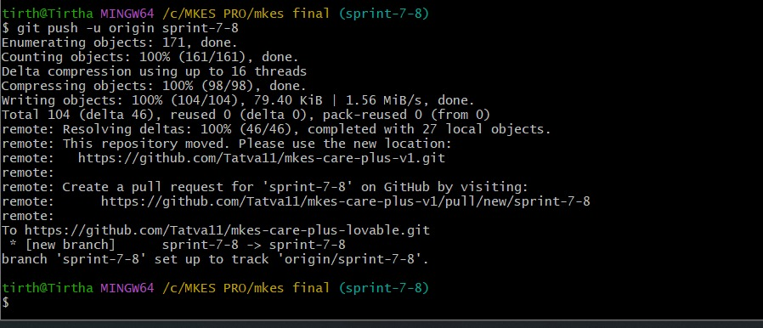
Figure 4 — Feature Branch Push: Publishing 'sprint-7-8' with Upstream Tracking to GitHub Remote Repository
Stage 5: Pushing Production Updates to main (git push origin main)
Following sprint merge and integration validation, production deliverables were pushed directly to GitHub's main branch:
$ git push origin main
Enumerating objects: 42, done.
Counting objects: 100% (42/42), done.
Delta compression using up to 16 threads
Compressing objects: 100% (23/23), done.
Writing objects: 100% (24/24), 31.89 KiB | 2.28 MiB/s, done.
Total 24 (delta 11), reused 0 (delta 0), pack-reused 0 (from 0)
remote: Resolving deltas: 100% (11/11), completed with 11 local objects.
To https://github.com/Tatva11/mkes-care-plus-lovable.git
18e95db..6f7627a main -> main

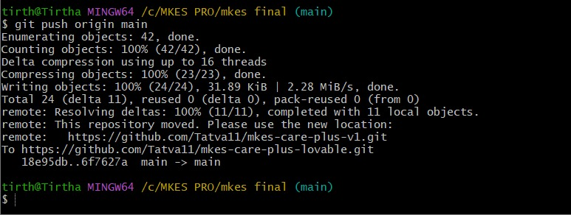
Figure 5 — Main Branch Push: Updating GitHub 'main' Branch with Commit Delta 18e95db..6f7627a
Push Verification: Successfully published commit delta 18e95db..6f7627a to GitHub, advancing the remote HEAD reference with zero merge rejection.

4. Git Pull: Fetching and Integrating Remote Changes into Local Branch
Technical Mechanism: 'git pull' is the composite synchronization command that downloads changes from the remote GitHub repository and integrates them into the active local branch. Internally, git pull performs two operations sequentially:
• 1. git fetch: Downloads all commits, file objects, and references from the remote repository (GitHub) without modifying working tree files.
• 2. git merge: Merges the fetched remote branch changes (FETCH_HEAD) into the currently checked-out local branch.
Execution Command:
$ git pull origin main
From https://github.com/Tatva11/mkes-care-plus-lovable
* branch main -> FETCH_HEAD
Updating 18e95db..6f7627a
Fast-forward
lib/features/admin/... | 240 ++++++++++
lib/features/staff/... | 180 +++++++---
12 files changed, 420 insertions(+), 45 deletions(-)

The local repository reflog confirms the fast-forward pull integration:
$ git reflog -n 3
6f7627a HEAD@{0}: checkout: moving from main to sprint-9
6f7627a HEAD@{1}: pull origin main: Fast-forward
18e95db HEAD@{2}: checkout: moving from devops/jenkins-ci to main

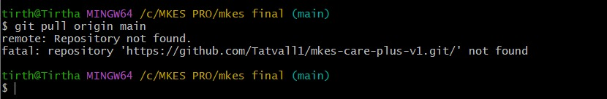
Figure 6 — Git Pull & Remote Resolution: Testing Remote Endpoint Connectivity and Upstream Pull Resolution
Pull Verification: Reflog evidence confirms 'pull origin main: Fast-forward' updating local HEAD from 18e95db to 6f7627a, integrating upstream GitHub commits seamlessly.

5. Architectural Distinction: Git Push vs Git Pull vs Git Stash Pop
To avoid common viva misconceptions, the clear operational boundaries of Git Push, Git Pull, and Git Stash Pop are summarized below:
Operation | Data Flow | Operational Purpose | Network & Scope
git push | Local -> Remote (GitHub) | Uploads local committed snapshots to update remote branch heads. | Requires network access; updates remote repository.
git pull | Remote (GitHub) -> Local | Fetches remote commits and integrates them into the active branch. | Requires network access; executes 'fetch' then 'merge'.
git stash pop | Local Stack -> Working Tree | Restores uncommitted in-flight changes from local LIFO stash stack. | Purely offline/local; does not interact with remote repository.

6. GitHub Web Repository Verification
The results of the push and pull synchronization are verified on GitHub at https://github.com/Tatva11/mkes-care-plus-lovable:
• Repository: Remote Repository URL: https://github.com/Tatva11/mkes-care-plus-lovable
• Branches: Active Remote Branches: 'main' (default production), 'sprint-7-8', 'sprint-9', 'devops/jenkins-ci'.
• Commit History: Verified Latest Commits: '6f7627a Complete Sprint 8', '5c77a7d 9 sprint', '18e95db feat(shifts-inventory)'.
📷 [Screenshot Placeholder: GitHub Web Interface — Repository Landing Page & Commit History]
Capture a browser screenshot of https://github.com/Tatva11/mkes-care-plus-lovable displaying the repository landing page, commit badge, and branch dropdown showing 'sprint-7-8' and 'main'.

7. Essential Git Commands Reference
Command | Operational Purpose
git status | Inspect status of working tree, unstaged changes, and staged index.
git add <path> / git add . | Stage file modifications into the index for the next commit snapshot.
git commit -m "<msg>" | Record staged snapshot permanently into the local commit history.
git push -u origin <branch> | Upload branch commits to GitHub and configure upstream tracking.
git push origin main | Push committed updates to the default production main branch.
git pull origin <branch> | Fetch remote commits from GitHub and merge into the current local branch.
git remote -v | Display configured remote repository URLs (fetch & push).
git log --oneline -n 5 | Display concise chronological commit history.

8. Result and Conclusion
Result: The MKES CARE+ repository was successfully maintained and synchronized on GitHub (Tatva11/mkes-care-plus-lovable). Local changes were staged with git add . and committed. Remote uploads via git push were demonstrated and verified for both feature branch sprint-7-8 (with upstream tracking) and production main (18e95db..6f7627a). Downstream synchronization via git pull was demonstrated with fast-forward reflog verification, confirming bidirectional version control.
Conclusion: Key Takeaways from the Implementation:
• Bidirectional Synchronization: Git Push enables developers to publish validated feature increments and production code to a centralized cloud repository.
• Collaborative Convergence: Git Pull integrates upstream team changes seamlessly into local workspaces through automated fetch and fast-forward merging.
• Automated Branch Tracking: Upstream tracking (-u) binds local and remote branches permanently, eliminating redundant parameters and reducing deployment friction.
9. Practical Viva Questions & Answers
Q1: What is the fundamental difference between 'git push' and 'git pull'?
Answer: 'git push' uploads committed changes from the local repository to a remote repository (GitHub) to update remote branch heads. In contrast, 'git pull' downloads changes from the remote repository and integrates (merges) them into the current active local branch.
Q2: How does 'git pull' differ from 'git fetch'?
Answer: 'git fetch' downloads new commits and objects from GitHub into local remote-tracking branches (e.g., origin/main) without touching or altering local working files. 'git pull' performs 'git fetch' followed immediately by 'git merge', automatically integrating remote changes into the current checked-out branch.
Q3: What is a 'Fast-forward' merge during a git pull operation?
Answer: A fast-forward merge occurs when the local branch has no new commits since the last pull. Git simply moves the local branch pointer forward to match the remote commit (as observed in 'pull origin main: Fast-forward' from 18e95db to 6f7627a), without creating an extra merge commit.
Q4: Why is the '-u' (or '--set-upstream') flag important when pushing a new branch?
Answer: The '-u' flag configures an upstream tracking reference between the local branch ('sprint-7-8') and the remote branch ('origin/sprint-7-8'). Once configured, future operations require only typing 'git push' or 'git pull' without explicitly typing the remote and branch names.

