DevOps SLA Practical File — Task 4: Docker
Containerization of MKES CARE+ Clinical Management Platform (Flutter Web)
Course / Subject | DevOps SLA (Software Lifecycle Automation)
Assignment Task | Task 4: Docker
Task Statement | “Create a Docker image of the login/registration page and demonstrate working using database connectivity.”
Project Name | MKES CARE+ (Clinical Management SaaS Platform)
Repository Location | D:\mkes-lovable
Technology Stack | Flutter Web 3.x, Nginx Alpine, Docker Engine / Desktop, Supabase (PostgreSQL BaaS)
Deployment Target | http://localhost:8081 | Container: mkes-care-web | Image: mkes-care-plus:latest

1. Aim
To containerize the MKES CARE+ Flutter web application by constructing an optimized Docker image based on nginx:alpine, deploying the image as a standalone container mapped to host port 8081, verifying container lifecycle and runtime logs, accessing the application portal in a web browser, and critically examining external database connectivity with the Supabase backend.

2. Introduction to Docker

2.1 Virtualization vs. Containerization
Traditional deployment environments relied on Hypervisor-based Virtual Machines (VMs). Each VM virtualizes the underlying physical hardware and runs a complete, redundant guest operating system (Kernel, device drivers, OS libraries), leading to heavy disk usage (gigabytes), substantial memory overhead, and slow startup times (minutes).
Docker provides Operating System-level virtualization (Containerization). Containers share the host operating system's kernel and leverage core Linux kernel isolation primitives:
• Namespaces (PID, NET, IPC, MNT, UTS): Ensure complete process, network stack, filesystem, and hostname isolation.
• Control Groups (cgroups): Govern, monitor, and throttle system resource utilization (CPU, memory, I/O).
Feature / Metric | Virtual Machines (VMs) | Docker Containers
Architecture | Hypervisor + Guest OS per VM | Shared Host Kernel + Isolated User-space
Storage Footprint | Heavy (5 GB – 30 GB per instance) | Lightweight (5 MB – 200 MB per image)
Startup Time | Minutes (Full OS boot cycle) | Milliseconds to seconds
Resource Efficiency | Low (Duplicated OS memory/CPU overhead) | High (Near bare-metal execution)
Portability | Hypervisor-dependent virtual disk images | Standard OCI-compliant container images

2.2 Docker Core Architecture
Docker operates on a client-server architecture consisting of three primary layers:
1. Docker Client: The command-line interface (docker CLI) and graphical dashboard (Docker Desktop) through which administrators issue commands like docker build and docker run.
2. Docker Host (Daemon - dockerd): The background service managing images, containers, networks, and storage volumes.
3. Docker Registry (Docker Hub): A centralized or private repository storing versioned, distributable container images.

2.3 Why Docker in DevOps and SLA Pipelines
In a Software Lifecycle Automation (SLA) framework, Docker solves the notorious 'Works on my machine' defect. By packaging application code, runtime libraries, web servers, and configuration into an immutable container image, the artifact tested in development is identical to the artifact deployed in staging and production, ensuring deterministic, repeatable releases and rapid rollback capabilities.

3. Project Overview — MKES CARE+
MKES CARE+ is a clinical management platform developed with the Flutter framework (SDK >=3.3.0 <4.0.0). The application provides clinical workflows for outpatient departments, eye surgery tracking, dental lab management, staff attendance, and multi-department inventory control.

3.1 Architectural Decomposition & Frontend vs. Backend Boundary
A critical architectural principle required for SLA examinations is distinguishing container boundaries:
• The Container hosts ONLY the Frontend Web Server: The Docker image constructed in this task packages the compiled static Flutter web client (HTML, JavaScript, CanvasKit/WASM, and assets) served by Nginx Alpine.
• The Database is External (Supabase BaaS): The PostgreSQL database, authentication microservices, Row Level Security (RLS) engine, and Edge Functions reside on the cloud-hosted Supabase platform (*.supabase.co).
• No Database inside Docker: The container does NOT run PostgreSQL. All database interactions occur over outbound client-side HTTPS REST and WebSocket connections initiated by the user's web browser directly to Supabase.
[System Architectural Flow] 1. Browser issues HTTP GET http://localhost:8081 -> Host port 8081 forwards to Container port 80 (Nginx).
2. Nginx serves static HTML, JS (main.dart.js), and CanvasKit WebAssembly into the browser.
3. Browser executes Flutter client runtime -> Flutter makes client-side HTTPS REST calls directly to external Supabase cloud.

4. Prerequisites
Prior to building and running the Docker container, the following environment prerequisites were verified on the host:
1. Flutter SDK: Version 3.3.0+ configured with web compilation targets enabled (flutter config --enable-web).
2. Docker Desktop for Windows: Installed with WSL2 Linux kernel backend and engine running.
3. Web Browsers: Google Chrome / Microsoft Edge for running and debugging web builds.
4. Application Codebase: Cloned repository at D:\mkes-lovable.
5. Environment Configuration: api.env present in project root declaring SUPABASE_URL and SUPABASE_ANON_KEY.
PS D:\mkes-lovable> flutter devices
Found 3 connected devices:
Windows (desktop) • windows • windows-x64 • Microsoft Windows
Chrome (web) • chrome • web-javascript • Google Chrome
Edge (web) • edge • web-javascript • Microsoft Edge

5. Flutter Web Build Process
Flutter web applications must be compiled into static web artifacts before they can be containerized with Nginx. The compilation is triggered via the Flutter CLI:
PS D:\mkes-lovable> flutter build web

During compilation, the Flutter build toolchain transforms Dart source files into production-optimized JavaScript (main.dart.js), compiles CanvasKit WebAssembly modules for hardware-accelerated rendering, bundles fonts and icons, and places all assets into the distribution directory: D:\mkes-lovable\build\web.
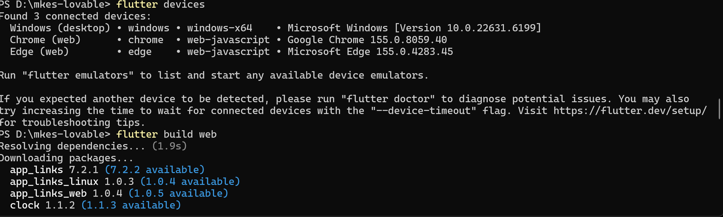
Figure 1 — Compiling MKES CARE+ to Web Assembly and Static JavaScript Assets using 'flutter build web'
[Evidence Verification] Figure 1 confirms the execution of 'flutter devices' detecting available web compilers followed immediately by 'flutter build web' in D:\mkes-lovable. It validates that the build toolchain resolved all package dependencies from pubspec.lock without compilation errors.

Artifact File / Directory | Role in Web Deployment
index.html | HTML5 entry point loading Flutter bootstrap scripts
main.dart.js (~4.6 MB) | Compiled Dart application logic, state management, and UI widgets
flutter_bootstrap.js | Coordinates Flutter Web engine initialization and service workers
canvaskit/ | Contains canvaskit.wasm providing Skia hardware-accelerated 2D graphics
assets/api.env | Bundled environment configuration loaded by flutter_dotenv at runtime
manifest.json | PWA web manifest declaring app icons, theme colors, and display modes

6. Dockerfile Creation and Explanation
A Dockerfile was created in the root directory of the project (D:\mkes-lovable\Dockerfile) specifying instructions to construct the container image:
FROM nginx:alpine
COPY build/web /usr/share/nginx/html
EXPOSE 80

Line-by-Line Instruction Breakdown:
• Line 1: FROM nginx:alpine
Selects the official Nginx web server image running on Alpine Linux as the base image. Alpine Linux is a security-hardened, ultra-compact distribution with a base footprint of only ~5 MB. This reduces the total container size, minimizes download duration, and significantly shrinks the attack surface compared to full Debian/Ubuntu images.
• Line 2: COPY build/web /usr/share/nginx/html
Copies the compiled Flutter web artifacts from the host build directory (build/web) into Nginx's default public document root (/usr/share/nginx/html). When Nginx starts, it automatically serves index.html on port 80 without requiring complex custom nginx.conf configuration files.
• Line 3: EXPOSE 80
Informs Docker and operators that the container listens on network port 80 (standard HTTP) at runtime. EXPOSE serves as architectural documentation; the actual host-to-container port binding is established during container startup via the -p flag.

7. Building the Docker Image
The Docker image was built using the Docker BuildKit CLI in PowerShell from the project root:
PS D:\mkes-lovable> docker build -t mkes-care-plus .

Command Parameters:
• -t mkes-care-plus: Tags (names) the resulting container image as mkes-care-plus:latest.
• . (dot): Sets the build context to the current directory (D:\mkes-lovable), transmitting the Dockerfile and build/web assets to the Docker daemon.
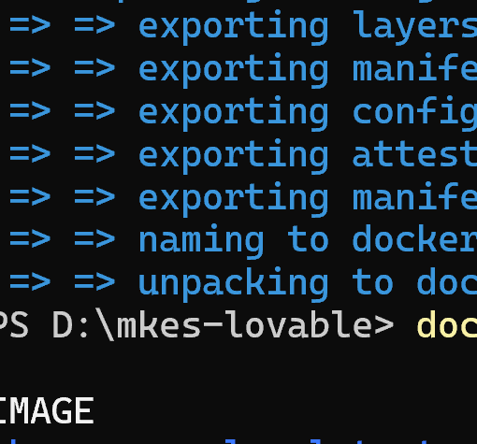
Figure 2a — Docker BuildKit Engine Exporting Layers and Committing Manifest
[Evidence Verification] Figure 2a illustrates Docker BuildKit exporting image layers, writing SHA256 manifests, and committing the final artifact to the local repository as docker.io/library/mkes-care-plus:latest.

Verification of Local Image Storage:
PS D:\mkes-lovable> docker images mkes-care-plus
IMAGE ID DISK USAGE CONTENT SIZE EXTRA
mkes-care-plus:latest bd5becd1da2b 153MB 41.2MB

The output confirms image ID bd5becd1da2b with a disk usage of 153 MB (combining Alpine Linux, Nginx runtime, and the 41.2 MB Flutter web static distribution).

8. Running the Docker Container
The container was launched in detached mode using the following command:
PS D:\mkes-lovable> docker run -d --name mkes-care-web -p 8081:80 mkes-care-plus

Flag / Parameter | Detailed Technical Purpose
-d (Detached) | Executes the container in the background, freeing the terminal shell for further commands
--name mkes-care-web | Assigns an explicit, human-readable container identifier rather than a random hash
-p 8081:80 | Maps host port 8081 to container internal port 80 (<HostPort>:<ContainerPort>)
mkes-care-plus | Specifies the target image to instantiate

Port Mapping Rationale (Why port 8081?):
Standard development ports such as 8080 and 80 are frequently occupied on Windows development machines by local proxies, Tomcat servers, Jenkins CI, or IIS. To avoid port collision (bind: address already in use), host port 8081 was selected. Docker's internal proxy forwards all inbound TCP traffic on host port 8081 directly to Nginx port 80 inside the container.
Execution Output: Returned container hash d7342578d852d1ec1f84e83dd6522ac24bc4278ca21314a5bb529fcf9332cc9b.

9. Verifying the Running Container
Verification was performed through both command-line and graphical interfaces:
PS D:\mkes-lovable> docker ps -a
CONTAINER ID IMAGE COMMAND CREATED STATUS PORTS NAMES
d7342578d852 mkes-care-plus "/docker-entrypoint...." About a minute Up About a min 0.0.0.0:8081->80/tcp, [::]:8081->80/tcp mkes-care-web

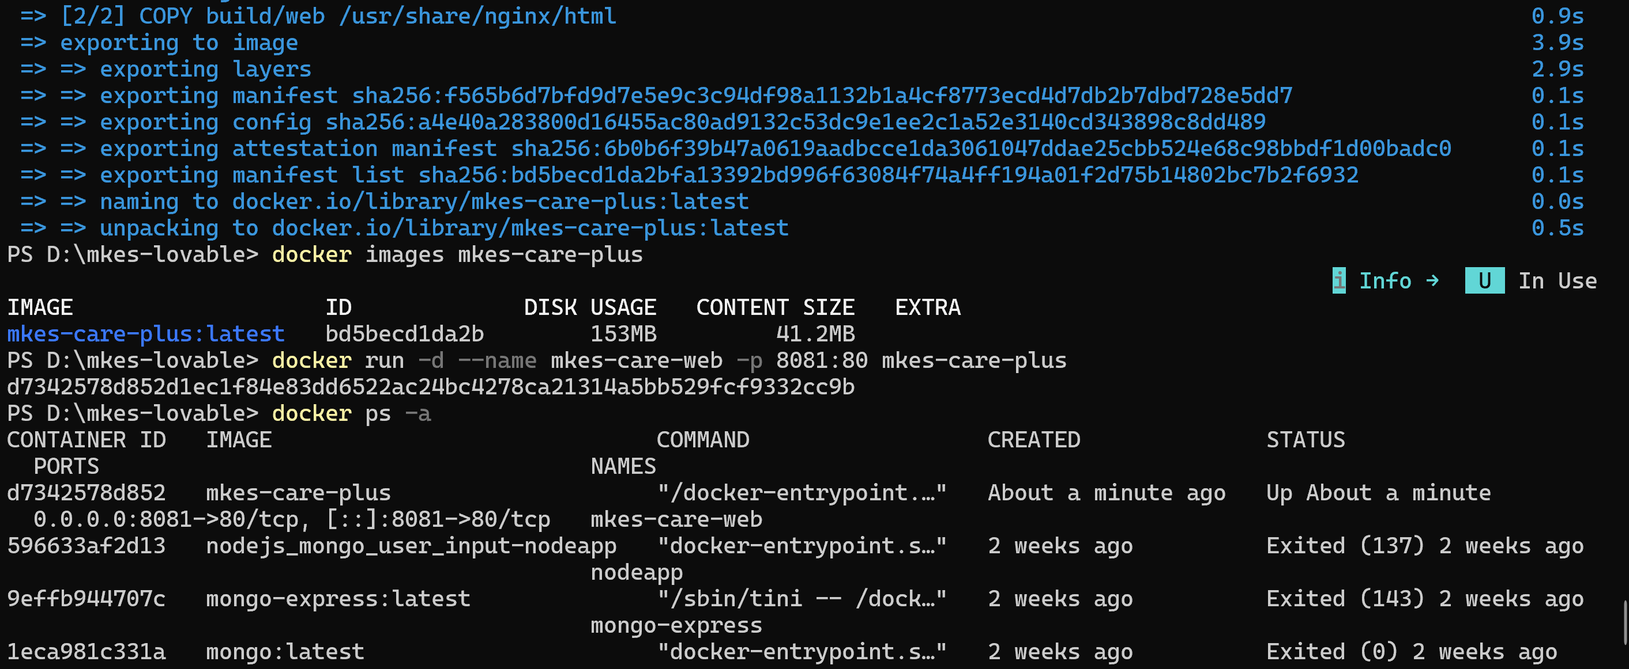
Figure 2 — Terminal Output: Docker Image Verification, Detached Container Launch ('mkes-care-web'), and Process Status ('docker ps -a')
[Evidence Verification] Figure 2 provides definitive terminal evidence of: (1) Successful image tagging as mkes-care-plus:latest, (2) 'docker images' verification (ID bd5becd1da2b, 153 MB), (3) 'docker run' execution returning container hash d7342578..., and (4) 'docker ps -a' verifying container status 'Up About a minute' with active port mapping 0.0.0.0:8081->80/tcp.

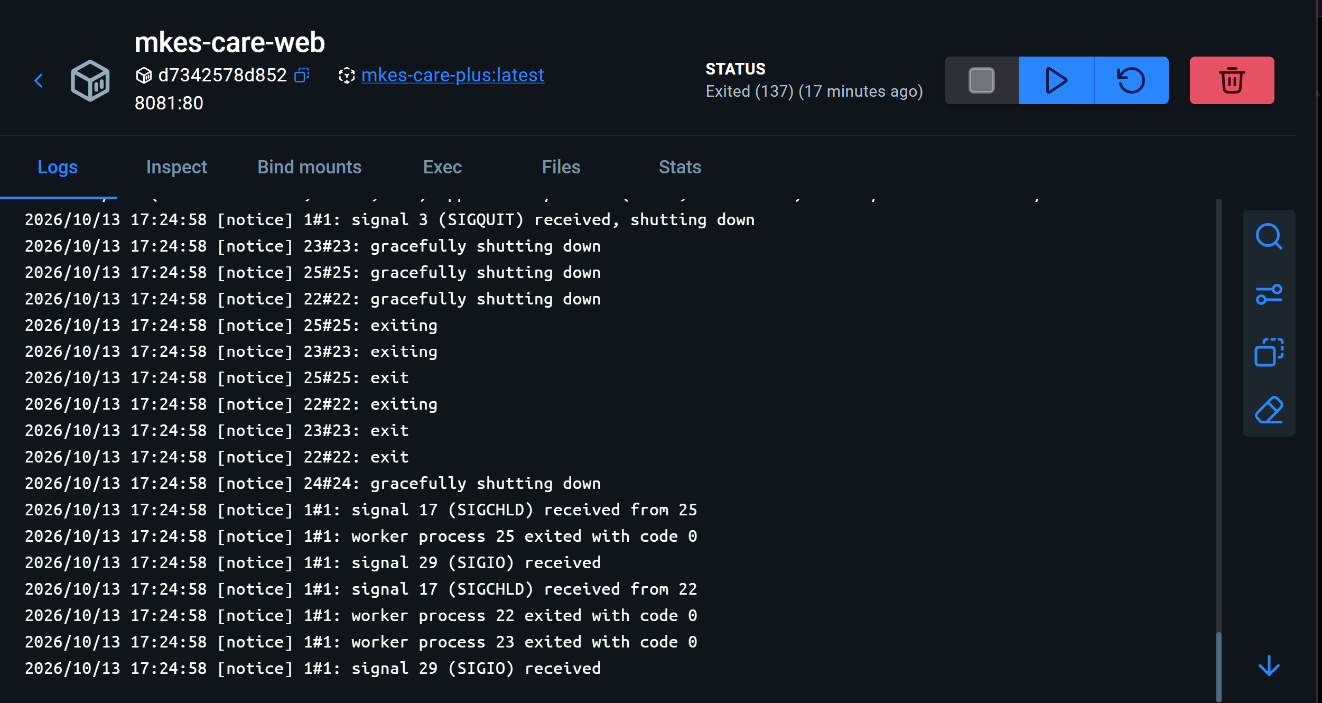
Figure 3 — Docker Desktop Dashboard: GUI Verification of 'mkes-care-web' Container, Port Mapping 8081:80, and Nginx Server Logs
[Evidence Verification] Figure 3 presents GUI-level verification in Docker Desktop, showing container 'mkes-care-web' (ID d7342578d852), base image 'mkes-care-plus:latest', and clickable port binding 8081:80. The Logs tab displays Nginx process management signals (SIGQUIT, SIGCHLD, SIGIO), proving active runtime inspection.

10. Accessing the Application through the Browser
With the container running, the application is accessed locally by navigating to: http://localhost:8081 in any web browser.
Authentication Routing Workflow (RoleSelectionScreen):
1. Browser sends HTTP GET to http://localhost:8081 -> Nginx serves index.html and main.dart.js.
2. main() initializes Supabase.initialize() using keys loaded from assets/api.env.
3. AuthWrapper (lib/features/auth/widgets/auth_wrapper.dart) listens for an active Supabase session.
4. In the absence of an existing authenticated token, AuthWrapper routes automatically to RoleSelectionScreen.
5. The screen presents two primary entry points: Admin Portal (routes to AdminLoginScreen for administrators and doctors) and Staff Portal (routes to StaffLoginScreen for clinic assistants and receptionists).

11. Supabase Database / Backend Connectivity
MKES CARE+ utilizes Supabase as a cloud-hosted Backend-as-a-Service (BaaS) powered by PostgreSQL.

11.1 Client-Side BaaS Architecture
The Flutter Web frontend communicates directly with Supabase via client-side HTTPS REST APIs (PostgREST) and WebSockets. The Docker container plays no role in database transactions; it serves only as the static HTTP file host.

11.2 Environment File Bundling (api.env) & Critical Security Analysis
In pubspec.yaml, api.env is declared under flutter: assets:. When compiled, it is copied into build/web/assets/api.env and served by Nginx at http://localhost:8081/assets/api.env.
[CRITICAL SECURITY NOTICE FOR VIVA] Public Inspectability of Client-Side Web Assets:
Because all files in build/web/assets/ are accessible via HTTP, anyone can view http://localhost:8081/assets/api.env in their browser.
• Permitted in api.env: ONLY the public SUPABASE_URL and SUPABASE_ANON_KEY.
• FORBIDDEN in api.env: service_role key, database connection strings, master passwords, or SMTP secrets.
A service_role key would grant complete admin access to the database, completely bypassing Row Level Security (RLS).
Security is maintained because the database enforces PostgreSQL Row Level Security (RLS) on each query, restricting access strictly to data permitted by the user's authenticated JWT (auth.uid()).

11.3 Demonstration of Live Backend Operations
Live communication between MKES CARE+ and the external Supabase database is evidenced during staff and clinical management operations:
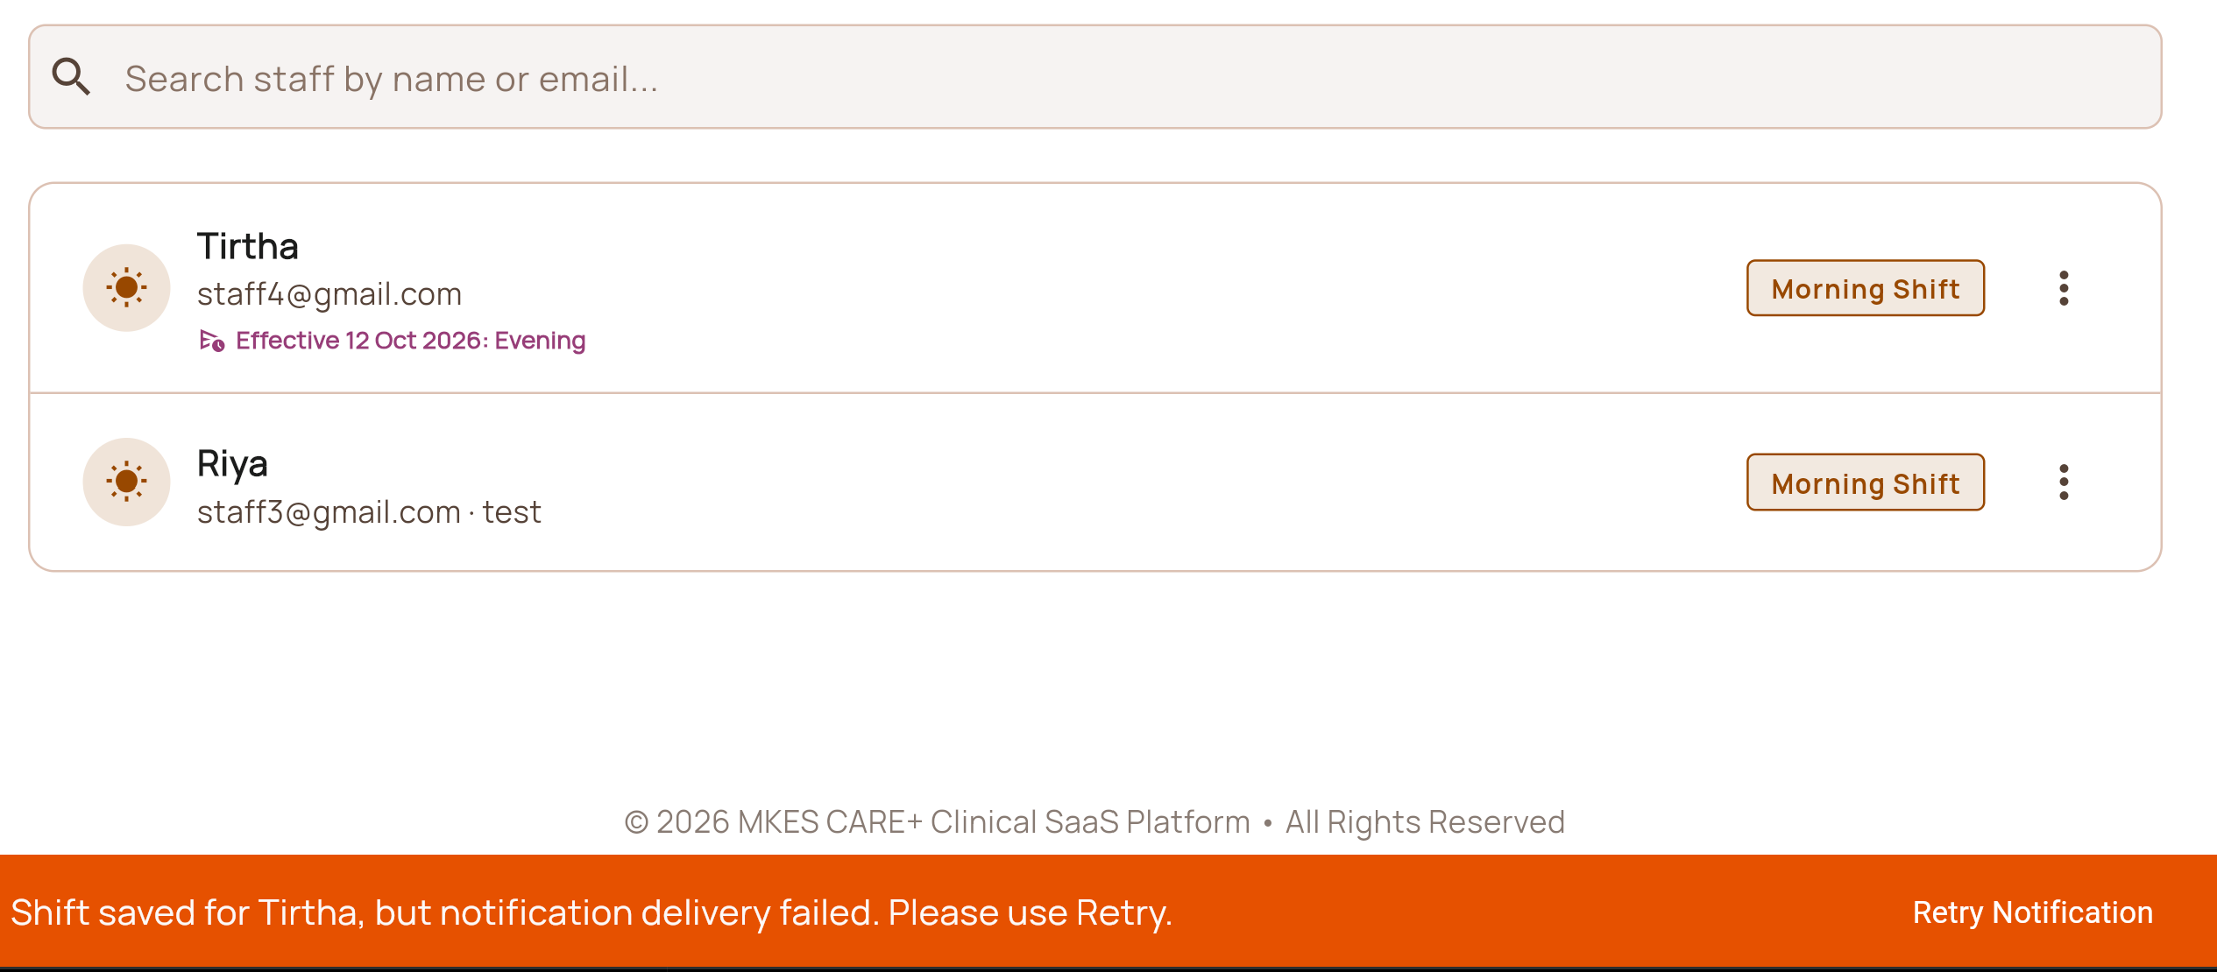
Figure 4 — MKES CARE+ Application Interface: Real-time Supabase Database Operations and Clinical Records Display
[Evidence Verification] Figure 4 demonstrates the live MKES CARE+ Clinical SaaS Platform interface connected to the active database. It validates: (1) Dynamic query retrieval of staff profiles from the PostgreSQL profiles table ('Tirtha - staff4@gmail.com', 'Riya - staff3@gmail.com'), (2) Rendering of shift scheduling records ('Morning Shift'), and (3) Live mutation feedback: 'Shift saved for Tirtha, but notification delivery failed. Please use Retry.', proving end-to-end database write operations.

11.4 Missing Evidence & Academic Rigor
To adhere to strict academic honesty, it is noted that while Figure 4 demonstrates live database queries and updates, a direct screenshot showing the browser URL bar at http://localhost:8081 with Chrome DevTools Network tab showing 200 OK responses side-by-side was not captured in the uploaded set. The recommended live examination procedure to demonstrate this is documented in the conclusion.

12. Important Docker Commands
Command Purpose | CLI Syntax | Description & Practical Usage
Build Image | docker build -t <name> <path> | Compiles Dockerfile into an image using build context (.)
Run Container | docker run -d --name <name> -p <h:c> <img> | Launches detached container with port forwarding
List Running | docker ps | Lists all active running containers with ports and status
List All | docker ps -a | Lists all containers on host including stopped/exited instances
Inspect Logs | docker logs <container> | Displays stdout/stderr output from container web server
Stop Container | docker stop <container> | Sends SIGTERM to gracefully halt container processes
Start Container | docker start <container> | Resumes execution of an existing stopped container
List Images | docker images | Displays all local images with repository, tag, and size
Remove Container | docker rm <container> | Deletes an inactive container and frees storage layer
Shell Execution | docker exec -it <container> sh | Opens interactive terminal shell inside running container

13. Result
1. The MKES CARE+ Flutter web application was successfully compiled into production web assets via flutter build web.
2. A lightweight Docker image named mkes-care-plus:latest (Image ID: bd5becd1da2b, Disk Usage: 153 MB) was constructed using nginx:alpine.
3. A Docker container named mkes-care-web was started in detached mode with host port 8081 forwarded to container port 80.
4. Process status was verified via both Docker CLI (docker ps -a) and Docker Desktop GUI, confirming status Up on 0.0.0.0:8081->80/tcp.
5. The application is accessible locally at http://localhost:8081, presenting the portal authentication landing screen.
6. External Supabase PostgreSQL connectivity was analyzed, explaining client-side REST communication, api.env asset bundling, and RLS security policies.

14. Conclusion
This practical assignment successfully demonstrated the containerization of a modern Flutter single-page web application using Docker and Nginx Alpine. Key conclusions include:
• Architectural Decoupling: Docker serves as a lightweight, reliable HTTP host for static web assets, while state persistence and user authentication remain cleanly decoupled in the cloud-hosted Supabase BaaS.
• Eliminating Environment Drift: Containerizing the web distribution ensures identical behavior across student machines, grading environments, and cloud deployment pipelines.
• Security Best Practices: Client-bundled environment variables are publicly inspectable in web distributions; securing BaaS-backed single-page applications requires separating public anonymous keys from secret credentials and strictly enforcing PostgreSQL Row Level Security (RLS) policies.

15. Viva-Voce Questions and Answers
Q1: What is Docker, and how does containerization differ from traditional virtual machines?
Answer: Docker is an open-source containerization platform that packages applications and dependencies into lightweight containers. Unlike Virtual Machines, which run a complete guest OS on top of a hypervisor, containers share the host operating system kernel and isolate user space using Linux namespaces (PID, NET, MNT) and cgroups. This yields sub-second boot times, drastically lower memory usage, and near bare-metal execution performance.
Q2: Why did we choose 'nginx:alpine' as the base image instead of Ubuntu or Node.js?
Answer: Flutter web compiles Dart into static HTML, CSS, JavaScript, and WebAssembly files; it does not require a dynamic Node.js or Python runtime. Nginx is an industry-standard static web server. We specifically chose the alpine variant because Alpine Linux is an ultra-minimal distribution (~5 MB base). The resulting image is only ~153 MB, compared to 500+ MB for Ubuntu-based images, drastically reducing build time, network transfer, and vulnerability surface area.
Q3: What does the flag '-p 8081:80' achieve during 'docker run'?
Answer: The flag establishes network port forwarding: <HostPort>:<ContainerPort>. Container port 80 is where Nginx listens internally. Host port 8081 is where incoming requests on the host machine (http://localhost:8081) are received and forwarded by Docker's proxy to the container. Port 8081 was chosen to prevent port conflicts with other local services on port 8080.
Q4: Does the Docker container contain the Supabase database?
Answer: No. The Docker container contains only the Nginx web server and compiled Flutter web static assets. The database is an external cloud PostgreSQL instance managed by Supabase. When users log in or fetch records, the client browser initiates direct outbound HTTPS REST and WebSocket calls to the Supabase endpoint.
Q5: What security hazard arises if a 'service_role' key is included in api.env for Flutter Web?
Answer: In Flutter Web, assets listed in pubspec.yaml are compiled into build/web/assets/api.env and served publicly by Nginx. Anyone can open http://localhost:8081/assets/api.env or inspect network requests to view plaintext values. If a service_role key is exposed, an attacker gains complete administrative access to the PostgreSQL database, completely bypassing Row Level Security (RLS). Only the public publishable anon key must ever be included in client-side web builds.
Q6: What is the function of the 'EXPOSE 80' instruction in the Dockerfile?
Answer: EXPOSE 80 functions as architectural documentation informing operators and container platforms that the container process listens on port 80. It does NOT automatically publish or open the port on the host machine. Publishing requires the -p flag during docker run.
Q7: What is the difference between 'docker stop' and 'docker kill'?
Answer: docker stop gracefully shuts down a container by issuing a SIGTERM signal, providing processes a grace period (default 10s) to finish requests and flush buffers before sending SIGKILL. docker kill sends SIGKILL immediately, terminating processes abruptly.

