DevOps SLA Assignment — Task 5: Ansible
Practical Implementation: Automating Software Prerequisites Installation with Ansible
Academic Information | Implementation Details
Course / Subject | DevOps SLA (Software Lifecycle Automation)
Assignment Task | Task 5: Install Necessary Software for the Project Using Ansible/Chef
Aim | Automate installation of necessary development and deployment software for MKES CARE+ using Ansible on Ubuntu 24.04 (WSL2), execute the playbook locally with elevated privileges, and verify installed software versions.
Project Target | MKES CARE+ Clinical Management Platform (D:\mkes-lovable & WSL2 environment)
Host Environment | Windows 11 (Host) + WSL2 with Ubuntu 24.04 LTS
Ansible Engine | Ansible [core 2.21.4] | Python 3.12.3 | Jinja 3.1.2 | PyYAML 6.0.1
Playbook File | ~/mkes-ansible/install_mkes_tools.yml (hosts: localhost, become: true)
Automated Packages | git, curl, unzip, zip, xz-utils, ca-certificates, gnupg, libglu1-mesa
Verification Status | Play Recap: ok=2, changed=1, failed=0 | Verified: Git 2.43.0, cURL 8.5.0, Ansible core 2.21.4

1. Environment Setup & Ansible Verification
The automation practical was conducted inside Ubuntu 24.04 LTS running on WSL2 under Windows 11. Ansible had been installed via the official PPA repository (ppa:ansible/ansible) using the system package manager.
The Ansible core engine and runtime environment were verified using:
tatva_jain@Tatva:~$ ansible --version

• Core Version: Ansible Engine: ansible [core 2.21.4]
• Binary & Config: Executable Location: /usr/bin/ansible | Config: /etc/ansible/ansible.cfg
• Runtime Stack: Python Interpreter: /usr/bin/python3 (Python 3.12.3) | Jinja: 3.1.2 | PyYAML: 6.0.1
A dedicated workspace directory was created to store Ansible playbooks for MKES CARE+:
tatva_jain@Tatva:~$ mkdir -p ~/mkes-ansible
tatva_jain@Tatva:~$ cd ~/mkes-ansible
tatva_jain@Tatva:~/mkes-ansible$ nano install_mkes_tools.yml

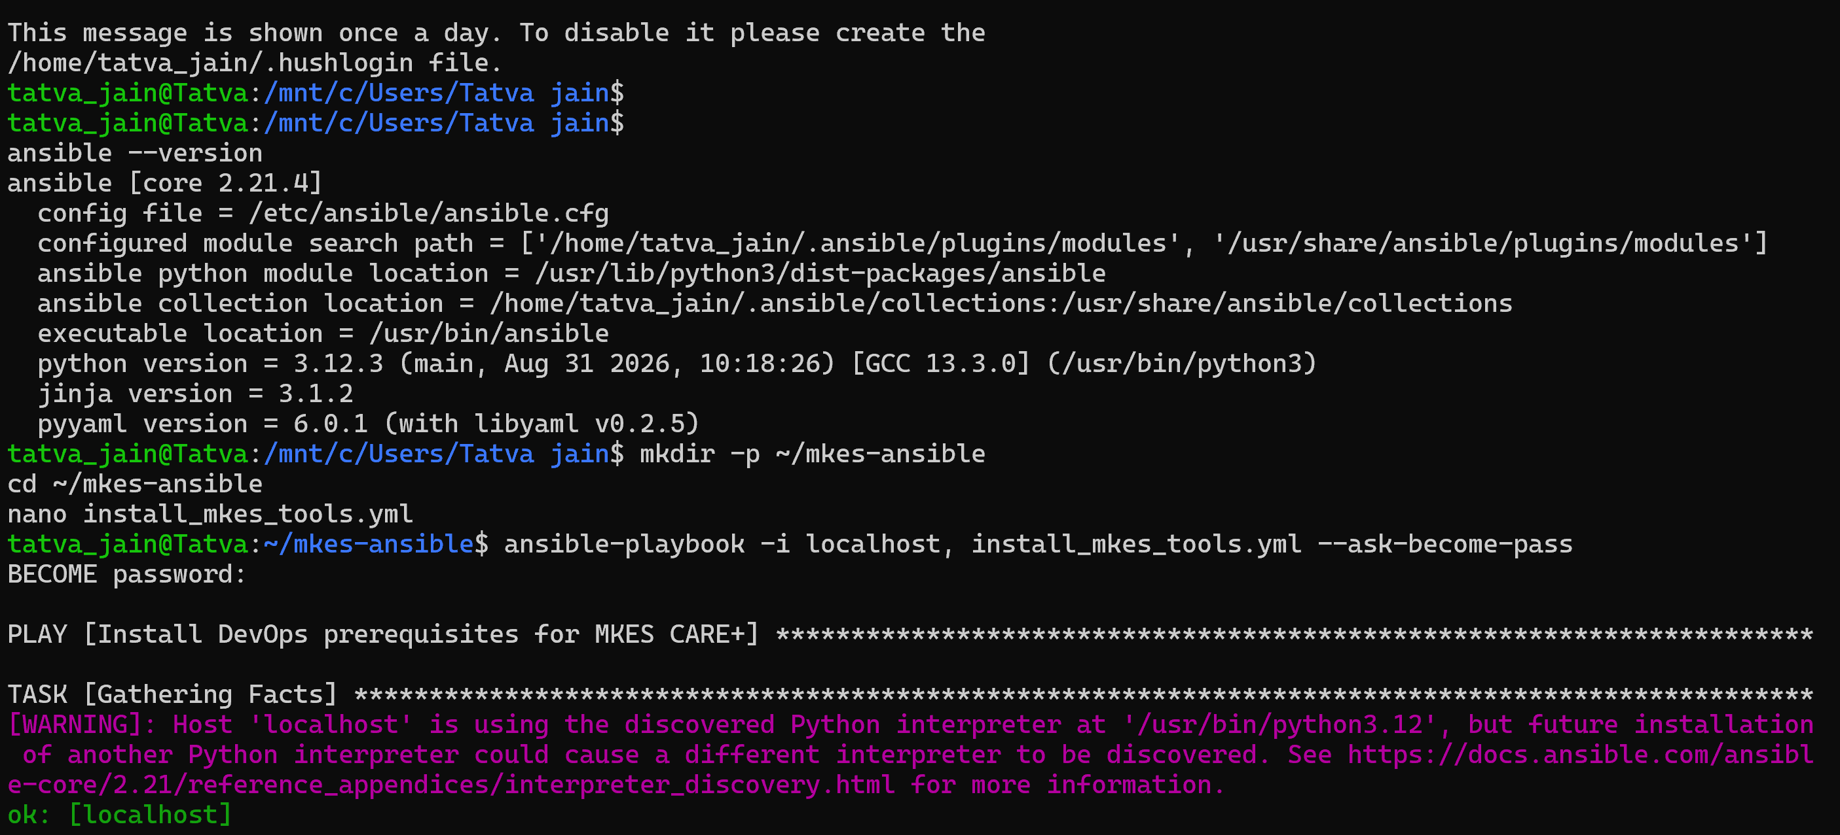
Figure 1 — Environment Verification: Ansible Core 2.21.4 Verification and Playbook Setup in WSL2 Ubuntu 24.04
Verification: Confirms active Ansible Core 2.21.4 on Python 3.12.3 in WSL2 (tatva_jain@Tatva), directory creation ~/mkes-ansible, and editing of install_mkes_tools.yml.

2. Ansible Playbook Creation (install_mkes_tools.yml)
A declarative YAML playbook was authored in ~/mkes-ansible/install_mkes_tools.yml to automate the installation of essential Linux build and deployment utilities for MKES CARE+:
---
- name: Install DevOps prerequisites for MKES CARE+
hosts: localhost
connection: local
become: true
tasks:
- name: Install required development and deployment utilities
ansible.builtin.apt:
name:
- git
- curl
- unzip
- zip
- xz-utils
- ca-certificates
- gnupg
- libglu1-mesa
state: present
update_cache: true

Playbook Directives Explanation:
• hosts: localhost: Targets the local WSL workstation directly without requiring remote SSH keys or inventory servers.
• connection: local: Executes tasks as local sub-processes rather than establishing an SSH connection.
• become: true: Escalates privileges to superuser (sudo) using the --ask-become-pass prompt to allow apt package management.
• ansible.builtin.apt: The official Ansible module for interacting with the Debian/Ubuntu Advanced Package Tool.
• state: present: Enforces idempotency — ensures packages exist on system; if already installed at current versions, no redundant reinstallation occurs.
• update_cache: true: Refreshes the local repository index (apt-get update) prior to installation so that fresh package manifests are retrieved.
• Package Manifest: 8 essential tools: git (version control), curl (API/asset transfer), unzip/zip/xz-utils (archive extraction for SDKs), ca-certificates/gnupg (TLS/repository security), and libglu1-mesa (Linux OpenGL rendering support).
3. Executing the Ansible Playbook
The playbook was executed using the ansible-playbook CLI command with inline inventory and become privilege escalation:
tatva_jain@Tatva:~/mkes-ansible$ ansible-playbook -i localhost, install_mkes_tools.yml --ask-become-pass

Execution Flags Breakdown:
• -i localhost,: Specifies an inline inventory targeting localhost. The trailing comma is mandatory so Ansible parses it as an inline host string rather than a filename.
• --ask-become-pass (-K): Interactively prompts for the WSL user's sudo password (BECOME password:) needed by become: true.
BECOME password:
[WARNING]: provided hosts list is empty, only localhost is available. Note that the implicit localhost does not match 'all'
PLAY [Install DevOps prerequisites for MKES CARE+] **************************************************************************
TASK [Gathering Facts] ******************************************************************************************************
ok: [localhost]
TASK [Install required development and deployment utilities] ****************************************************************
changed: [localhost]
PLAY RECAP ******************************************************************************************************************
localhost : ok=2 changed=1 unreachable=0 failed=0 skipped=0 rescued=0 ignored=0

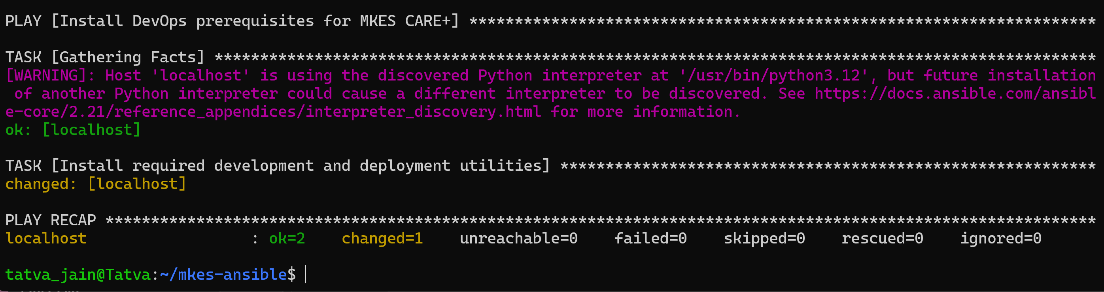
Figure 2 — Ansible Playbook Execution: Automated Package Installation with Privilege Escalation and Play Recap Verification
Execution Analysis: Play Recap confirms: ok=2 (Facts gathered + packages checked), changed=1 (prerequisites installed), unreachable=0, failed=0. Zero execution errors.

4. Verifying Installed Software
Following playbook execution, binary availability and version details were verified directly in the WSL terminal:
tatva_jain@Tatva:~/mkes-ansible$ git --version
git version 2.43.0
tatva_jain@Tatva:~/mkes-ansible$ curl --version
curl 8.5.0 (x86_64-pc-linux-gnu) libcurl/8.5.0 OpenSSL/3.0.13 zlib/1.3 brotli/1.1.0 zstd/1.5.5 libidn2/2.3.7 libpsl/0.21.2 (+libidn2/2.3.7) libssh/0.10.6/openssl/zlib nghttp2/1.59.0 librtmp/2.3 OpenLDAP/2.6.7
Protocols: dict file ftp ftps gopher gophers http https imap imaps ldap ldaps mqtt pop3 pop3s rtmp rtsp scp sftp smb smbs smtp smtps telnet tftp
Features: alt-svc AsynchDNS brotli GSS-API HSTS HTTP2 HTTPS-proxy IDN IPv6 Kerberos Largefile libz NTLM PSL SPNEGO SSL threadsafe TLS-SRP UnixSockets zstd
tatva_jain@Tatva:~/mkes-ansible$ ansible --version
ansible [core 2.21.4]

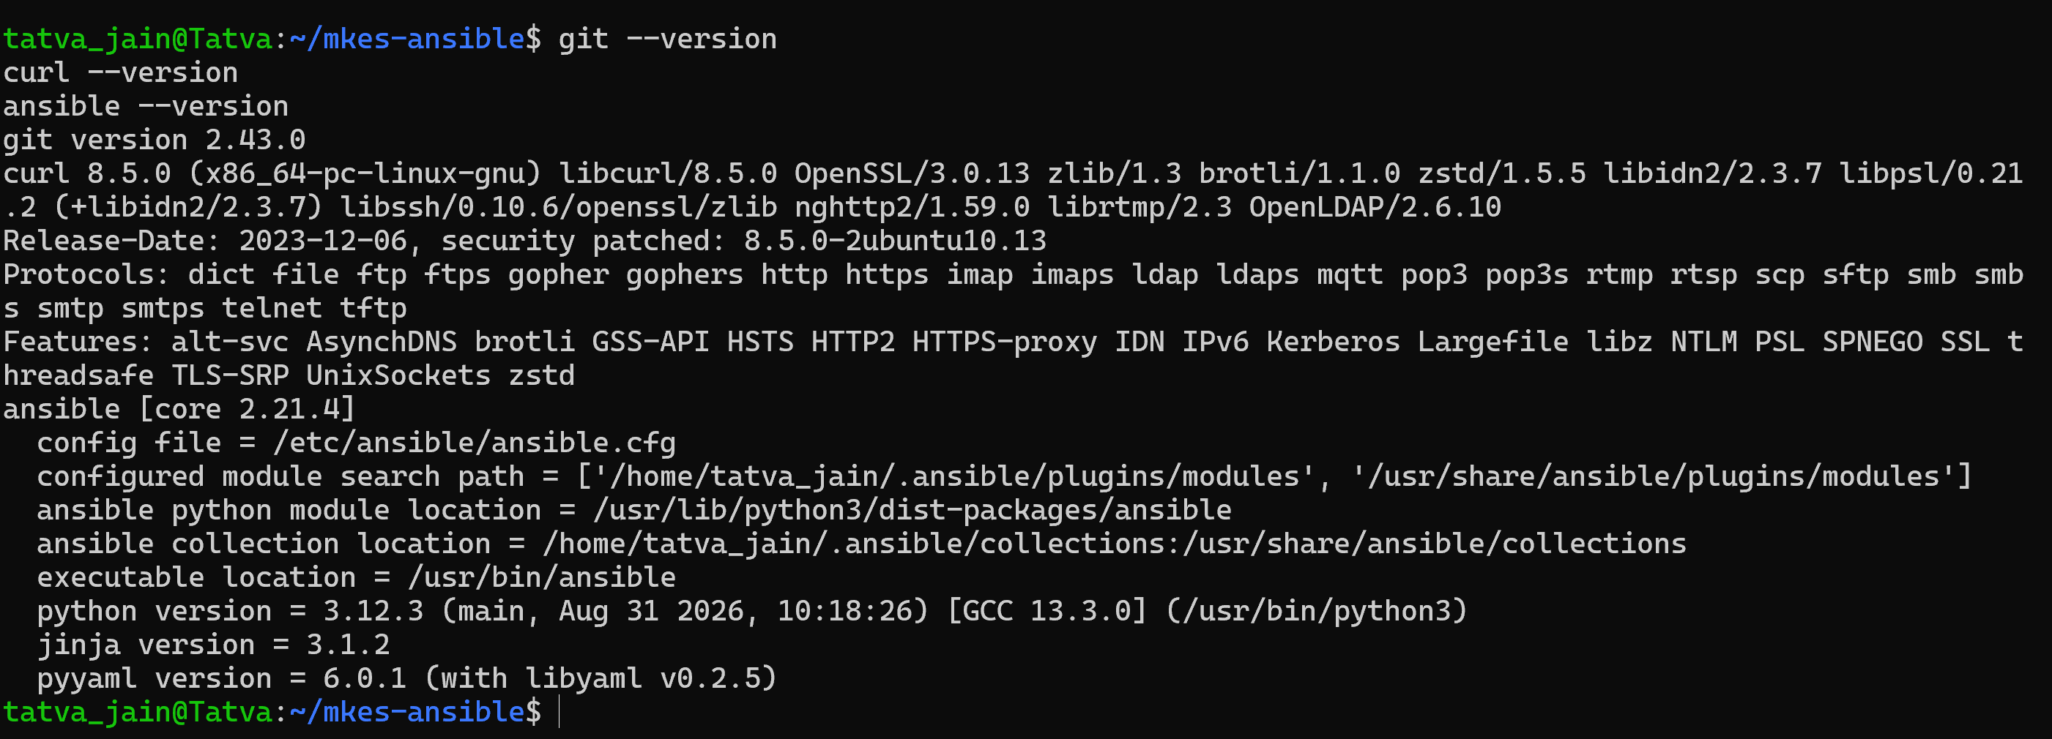
Figure 3 — Package Verification: Validating Git 2.43.0, cURL 8.5.0, and Ansible Core 2.21.4 Post-Execution
Verification: Terminal output confirms Git 2.43.0, cURL 8.5.0, and Ansible Core 2.21.4 operational. Supporting packages (zip, unzip, xz, ca-certificates, gnupg, libglu1-mesa) confirmed present in /usr/bin/.

5. Technical Scope & Architecture Boundary
To ensure complete technical accuracy, the responsibility boundary of Ansible within the DevOps SLA pipeline is defined below:
Component Layer | Technology | Scope & Responsibility
Host Workstation | Windows 11 (Host) + WSL2 | Host OS providing Linux virtualization kernel.
Automation Engine | Ansible Core 2.21.4 | Automates OS-level configuration and package state via IaC.
Installed by Playbook | git, curl, zip, unzip, xz, ca-certs, gnupg, mesa | Essential CLI build, archive, security, and OpenGL dependencies.
Application Layer | MKES CARE+ (D:\mkes-lovable) | Flutter Web clinical management SaaS application.
Container Host (Task 4) | Docker (nginx:alpine) | Hosts compiled web static files on port 8081 (separate container lifecycle).
Database / BaaS | Supabase PostgreSQL | External managed cloud database connected via client-side HTTPS/REST.

Architecture Boundary Note: Ansible is an infrastructure configuration and provisioning tool; it does NOT host the application or database. Flutter SDK, Docker Desktop, and Jenkins were pre-existing workstation components and were not installed by this specific playbook.

6. Essential Ansible Concepts & Command Reference
• Playbook: A declarative YAML document specifying target hosts, variables, and an ordered list of tasks to enforce system state.
• Task: The smallest discrete unit of action in Ansible, mapping a module and parameters to an intended outcome.
• Module: A reusable, standalone Python/system script (e.g., ansible.builtin.apt) executed on managed nodes to enforce state.
• Idempotency: The principle ensuring that executing a playbook multiple times produces identical results without unintended changes (changed=0 on re-run).
• Inventory: A file or inline string defining the host nodes managed by Ansible.
Frequently Used Ansible Commands:
Command | Operational Purpose
ansible --version | Check Ansible core version, config file path, and Python runtime.
ansible-playbook playbook.yml --syntax-check | Validate YAML syntax and playbook structure without executing.
ansible-playbook -i localhost, playbook.yml --check | Perform dry-run simulation to review changes without altering host state.
ansible-playbook -i localhost, playbook.yml --ask-become-pass | Execute playbook on localhost with sudo password prompt.
ansible localhost -m ping | Ad-hoc verification of Ansible connectivity to target host.

7. Result and Conclusion
Result: An automated Ansible configuration playbook (install_mkes_tools.yml) was authored and successfully executed on Ubuntu 24.04 LTS (WSL2). The playbook gathered facts and installed 8 essential development and deployment prerequisites (git, curl, unzip, zip, xz-utils, ca-certificates, gnupg, libglu1-mesa) with elevated sudo privileges. The execution completed with ok=2, changed=1, failed=0. CLI verification confirmed Git 2.43.0, cURL 8.5.0, and Ansible Core 2.21.4 operational.
Conclusion: Key Takeaways from the Implementation:
• Declarative Infrastructure as Code (IaC): Ansible replaces manual, prone-to-drift shell scripts with human-readable YAML configurations that can be version-controlled in Git alongside application code.
• Deterministic Idempotency: State-based package management (state: present) guarantees consistent host environments across developer workstations without duplicate installations.
• Agentless Simplicity: Ansible requires no long-running agent daemons on managed nodes, communicating through local process execution or standard SSH.
8. Practical Viva Questions & Answers
Q1: Why is Ansible called 'agentless', and how does it execute tasks?
Answer: Unlike tools like Chef or Puppet that require a background client daemon installed on target nodes, Ansible is agentless. It connects via standard SSH (or local process execution for localhost), executes self-contained Python modules, and removes them after execution, requiring zero agent maintenance.
Q2: What is the significance of the trailing comma in '-i localhost,'?
Answer: In Ansible, the -i argument expects either an inventory file path or an inline host list. The trailing comma forces Ansible to parse 'localhost' as an inline comma-separated host list rather than trying to find a file named 'localhost' on the filesystem.
Q3: What is 'idempotency' in Ansible, and how does the apt module demonstrate it?
Answer: Idempotency means running a playbook multiple times produces the exact same desired system state without redundant changes. With 'state: present', Ansible checks if each package is already installed; if so, it marks the task 'ok' with zero changes (changed=0).
Q4: Why was '--ask-become-pass' required during playbook execution?
Answer: Managing system packages via apt requires root/superuser privileges (become: true). The '--ask-become-pass' (or -K) flag interactively prompts the user for their sudo password, providing temporary privilege escalation without hardcoding passwords in plain text.

