 | Bhagubhai Hospital Polytechnic and College of Engineering  Vile Parle (West), Mumbai – 400056 | 
――――――――――――――――――――――――――――――――――――――――――――――
A PROJECT REPORT ON


MKES CARE+
AN INTEGRATED CLINIC MANAGEMENT SYSTEM FOR EYE AND DENTAL CLINICS
Submitted in partial fulfilment of the requirements for the award of
The Diploma in Information Technology
Submitted By:  Name: Tatva Jain  Roll No: _____________  SAP No: _____________ | Under the Guidance of:  Mrs. Krishna Bhatt  Project Guide  Department of IT

DEPARTMENT OF INFORMATION TECHNOLOGY
BHAGUBHAI HOSPITAL POLYTECHNIC AND COLLEGE OF ENGINEERING
Vile Parle (West), Mumbai – 400056
Academic Year: 2025 – 2026

Bhagubhai Hospital Polytechnic and College of Engineering
Vile Parle (West), Mumbai – 400056
――――――――――――――――――――――――――――――――――――――――――――――

CERTIFICATE
THIS IS TO CERTIFY THAT
This is to certify that Shri / Kum. Tatva Jain, Exam Seat No: ____________________, SAP No: ____________________, has satisfactorily completed his project work and submitted the project report entitled “MKES CARE+ : AN INTEGRATED CLINIC MANAGEMENT SYSTEM FOR EYE AND DENTAL CLINICS” in partial fulfilment of the requirements for the award of the Diploma in Information Technology from Bhagubhai Hospital Polytechnic and College of Engineering during the academic year 2025 – 2026.
_____________________  Mrs. Krishna Bhatt  Project Guide | _____________________  Head of Department  Information Technology | _____________________  Principal  Date: _______________

Bhagubhai Hospital Polytechnic and College of Engineering
Vile Parle (West), Mumbai – 400056
――――――――――――――――――――――――――――――――――――――――――――――

PROJECT APPROVAL SHEET
THIS IS TO CERTIFY THAT
This is to certify that Shri / Kum. Tatva Jain, SAP No: ____________________, has presented the project entitled “MKES CARE+ : AN INTEGRATED CLINIC MANAGEMENT SYSTEM FOR EYE AND DENTAL CLINICS” in partial fulfilment of the requirements for the award of the Diploma in Information Technology from Bhagubhai Hospital Polytechnic and College of Engineering. The same is hereby evaluated and approved by the examiners.
External Examiner:  Name: ___________________________  Signature: ________________________  Date: ___________________________ | Internal Examiner:  Name: ___________________________  Signature: ________________________  Date: ___________________________

DEPARTMENT OF INFORMATION TECHNOLOGY

Vision
To create a learning environment that nurtures students and transforms them into competent IT Diploma Graduates.

Mission
M1: To impart technical and managerial skills for pursuing academic excellence through dynamic learning environment.
M2: To foster industry-ready graduates by acquiring and utilizing latest technology.
M3: To strengthen holistic development and professionalism in the diploma graduates.

Program Educational Objectives (PEOs)
After successful completion of the program, students will be able to:
PEO1: Imbibe core knowledge and utilize associated technologies to provide domain-related solutions.
PEO2: Be capable of adapting to the rapid pace of technological dynamics through professional competence.
PEO3: Develop a holistic personality equipped with leadership qualities, team skills, and humane approach towards society.

Program Specific Outcomes (PSOs)
PSO1: Students will demonstrate fundamental knowledge in core domains of IT such as Software Development, Databases, and Information Systems.
PSO2: Students will acquire skills that can provide IT solutions in the field of Networking, IoT, Machine Learning, and Cloud Computing.

ABSTRACT
MKES CARE+ is an integrated clinic management application specifically engineered to modernize and streamline the daily clinical and administrative operations of eye and dental healthcare facilities. Clinical environments in specialized domains such as ophthalmology and dentistry demand meticulous coordination across diverse functional areas, including patient registration, appointment scheduling, electronic medical records, staff attendance and shift roster tracking, clinical inventory and vendor procurement, specialized dental laboratory work order tracking, optical sales management, point-of-sale invoice generation, and automated patient communication. Traditional healthcare centers frequently rely on fragmented, manual paper ledgers or isolated software tools, resulting in operational bottlenecks, data redundancy, missed follow-ups, inventory stockouts, and administrative fatigue.
To solve these critical operational challenges, MKES CARE+ leverages a robust modern technology stack comprising Flutter for a responsive cross-platform mobile and web frontend, Supabase with PostgreSQL 15 for a secure, relational cloud backend, and a dedicated Node.js WhatsApp Web bridge daemon for automated conversational messaging. The application incorporates granular role-based access control (RBAC), dividing functionalities between an Executive Admin Portal and an Operational Staff Portal. Key capabilities include real-time patient visit tracking, automated appointment confirmation and rescheduling through WhatsApp, proactive low-stock and batch expiry alerts, end-to-end dental laboratory case lifecycle tracking, and comprehensive financial reporting dashboards. By centralizing clinic workflows into a cohesive, user-friendly digital platform, MKES CARE+ minimizes manual administrative overhead, enhances inter-staff coordination, prevents clinical errors, and significantly elevates the standard of patient care.

TABLE OF CONTENTS
MKES CARE+ 1
CERTIFICATE 2
PROJECT APPROVAL SHEET 3
DEPARTMENT OF INFORMATION TECHNOLOGY 4
Vision 4
Mission 4
Program Educational Objectives (PEOs) 4
Program Specific Outcomes (PSOs) 4
ABSTRACT 5
TABLE OF CONTENTS 6
LIST OF FIGURES 8
LIST OF TABLES 10
CHAPTER 1 11
INTRODUCTION AND PROBLEM STATEMENT 11
1.1 Problem Statement 11
1.2 Introduction and Background 11
1.3 Project Objectives and Scope 12
CHAPTER 2 14
REQUIREMENTS, FEASIBILITY AND TECHNOLOGIES USED 14
2.1 Hardware and Software Requirements 14
2.2 Technologies Used 14
2.2.1 Flutter UI Toolkit 14
2.2.2 Android Studio Integrated Development Environment 15
2.2.3 Supabase Backend-as-a-Service 15
2.2.4 PostgreSQL Relational Database Management System 16
2.2.5 WhatsApp Web API & Node.js Bridge Daemon 16
2.3 Hardware Component Descriptions and Architecture 17
2.4 Functional System Features and Modules 19
2.5 Project Implementation Schedule (Gantt Chart) 20
CHAPTER 3 21
SYSTEM DESIGN AND ARCHITECTURE 21
3.1 Overall System Flowchart 21
3.2 Data Flow Diagrams (DFD) 21
3.2.1 Context Level Data Flow Diagram (DFD Level 0) 22
3.2.2 Decomposed Data Flow Diagram (DFD Level 1) 22
3.3 UML Use Case Diagram 23
3.4 Three-Tier System Architecture 24
3.5 Entity-Relationship (E-R) Schema Diagram 25
CHAPTER 4 27
IMPLEMENTATION, SOURCE CODE AND OUTPUT SCREENSHOTS 27
4.1 Literature Review 27
4.2 Core Source Code Implementation Excerpts 27
4.3 Project Output Screenshots Catalog 31
4.3.1 Login and Authentication Screens 31
4.3.2 Staff Portal Operational Screens 33
4.3.3 Executive Admin Portal Management Screens 41
CHAPTER 5 54
ADVANTAGES, LIMITATIONS, FUTURE SCOPE AND CONCLUSION 54
5.1 Advantages of MKES CARE+ 54
5.2 Limitations of the System 54
5.3 Future Scope 55
5.4 Acknowledgement 55
5.5 Conclusion 56
5.6 References 56

LIST OF FIGURES
No table of figures entries found.
Figure 2.1 Flutter Architecture and Framework Logo . . . . . . . . . . . 6
Figure 2.2 Android Studio Development Environment Logo . . . . . . . . . 7
Figure 2.3 Supabase Backend-as-a-Service Platform Logo . . . . . . . . . 7
Figure 2.4 PostgreSQL Relational Database Management System Logo . . . . 8
Figure 2.5 Host Server & Cloud Database Workstation System . . . . . . . 9
Figure 2.6 Client Deployment Mobile Handset & Clinical Tablet . . . . . . 9
Figure 2.7 Dedicated WhatsApp Gateway Bridge Device . . . . . . . . . . . 10
Figure 2.8 Point-of-Sale (POS) Optical Barcode Scanner & Thermal Receipt Printer 10
Figure 2.9 MKES CARE+ Project Implementation Gantt Chart . . . . . . . . 12
Figure 3.1 MKES CARE+ Overall System Flowchart . . . . . . . . . . . . . 13
Figure 3.2 Context Level Data Flow Diagram (DFD Level 0) . . . . . . . . 14
Figure 3.3 Detailed Data Flow Diagram (DFD Level 1) . . . . . . . . . . . 15
Figure 3.4 UML Use Case Diagram for MKES CARE+ . . . . . . . . . . . . . 16
Figure 3.5 MKES CARE+ Three-Tier System Architecture Diagram . . . . . . 17
Figure 3.6 MKES CARE+ Entity-Relationship (E-R) Schema Diagram . . . . . 18
Figure 4.1 Role Selection Landing Screen . . . . . . . . . . . . . . . . 24
Figure 4.2 Admin Portal Sign In Screen . . . . . . . . . . . . . . . . . 24
Figure 4.3 Staff Portal Sign In Screen . . . . . . . . . . . . . . . . . 25
Figure 4.4 Staff Schedule & Appointments Screen . . . . . . . . . . . . . 25
Figure 4.5 WhatsApp Booking Requests Sheet . . . . . . . . . . . . . . . 26
Figure 4.6 Staff Patient Directory Screen . . . . . . . . . . . . . . . . 26
Figure 4.7 Patient Details Profile Screen . . . . . . . . . . . . . . . . 27
Figure 4.8 My Shift Tasks & Checklist Screen . . . . . . . . . . . . . . 27
Figure 4.9 Clinical Inventory Tracker Screen . . . . . . . . . . . . . . 28
Figure 4.10 Clinical Vendor Directory Screen . . . . . . . . . . . . . . 28
Figure 4.11 Purchase Orders Register Screen . . . . . . . . . . . . . . . 29
Figure 4.12 Dental Lab Work Orders Screen . . . . . . . . . . . . . . . . 29
Figure 4.13 Eye Surgery Case Pipeline Screen . . . . . . . . . . . . . . 30
Figure 4.14 Staff Attendance & Shift Logs Screen . . . . . . . . . . . . 30
Figure 4.15 Staff Leave Portal & Quotas Screen . . . . . . . . . . . . . 31
Figure 4.16 Staff Billing & Invoices Screen . . . . . . . . . . . . . . . 31
Figure 4.17 Shared WhatsApp Chat Inbox Screen . . . . . . . . . . . . . . 32
Figure 4.18 Staff Notification Center Screen . . . . . . . . . . . . . . 32
Figure 4.19 Staff Profile & Settings Screen . . . . . . . . . . . . . . . 33
Figure 4.20 Executive Admin Dashboard Screen . . . . . . . . . . . . . . 33
Figure 4.21 Staff Management Overview Screen . . . . . . . . . . . . . . 34
Figure 4.22 Admin Leave Approvals Screen . . . . . . . . . . . . . . . . 34
Figure 4.23 Clinic Task Delegation Screen . . . . . . . . . . . . . . . . 35
Figure 4.24 Performance & Workload Analytics Screen . . . . . . . . . . . 35
Figure 4.25 Attendance Management Screen . . . . . . . . . . . . . . . . 36
Figure 4.26 Admin Patient Management Screen . . . . . . . . . . . . . . . 36
Figure 4.27 Admin Patient Details Profile Screen . . . . . . . . . . . . 37
Figure 4.28 Operations Hub: Inventory Management Tab . . . . . . . . . . 37
Figure 4.29 Operations Hub: Clinical Departments Tab . . . . . . . . . . 38
Figure 4.30 Operations Hub: Vendor Directory Tab . . . . . . . . . . . . 38
Figure 4.31 Operations Hub: Purchase Orders Tab . . . . . . . . . . . . . 39
Figure 4.32 Operations Hub: Dental Laboratory Orders Tab . . . . . . . . 39
Figure 4.33 Operations Hub: Eye Surgery Case Tracking Tab . . . . . . . . 40
Figure 4.34 Operations Hub: WhatsApp Booking Requests Tab . . . . . . . . 40
Figure 4.35 Administration Settings & Operations Hub . . . . . . . . . . 41
Figure 4.36 Billing & Financial Invoices Screen . . . . . . . . . . . . . 41
Figure 4.37 Reports & Business Analytics Dashboard . . . . . . . . . . . 42
Figure 4.38 Doctor & Consulting Management Screen . . . . . . . . . . . . 42
Figure 4.39 User Accounts & Role Security Screen . . . . . . . . . . . . 43
Figure 4.40 Shift Roster & Schedule Management Screen . . . . . . . . . . 43
Figure 4.41 Clinic Settings & Configurations Screen . . . . . . . . . . . 44
Figure 4.42 Admin Shared WhatsApp Inbox Screen . . . . . . . . . . . . . 44
Figure 4.43 System Notification Center Screen . . . . . . . . . . . . . . 45
Figure 4.44 Global Copilot Search Dialog Screen . . . . . . . . . . . . . 45
Figure 4.45 Admin Profile & Security Settings Screen . . . . . . . . . . 46

LIST OF TABLES
No table of figures entries found.
Table 2.1 Server Hardware & Software Technical Specifications . . . . . . 5
Table 2.2 Client Mobile Handset & Tablet Specifications . . . . . . . . . 5
Table 2.3 Hardware Component Inventory and Functional Matrix . . . . . . 11
Table 3.1 MKES CARE+ System Entities and Relational Cardinality Matrix . 19
Table 4.1 Key Source Code Implementation Files Summary . . . . . . . . . 21
Table 4.2 Catalog of Mobile Application Output Screenshots . . . . . . . 23

CHAPTER 1

INTRODUCTION AND PROBLEM STATEMENT

1.1 Problem Statement
In the contemporary healthcare landscape, the rapid evolution of clinical informatics, cross-platform mobile frameworks, and cloud-native databases has fundamentally transformed clinical workflows. Modern healthcare operations increasingly depend on real-time synchronized architectures where multi-platform frameworks such as Google Flutter allow developers to compile single-codebase applications natively across mobile devices, desktop workstations, and web browsers. Simultaneously, Backend-as-a-Service (BaaS) platforms powered by Supabase and PostgreSQL provide enterprise-grade relational data integrity, declarative Row Level Security (RLS), real-time WebSocket replication, and high-concurrency connection pooling. Furthermore, the ubiquity of conversational mobile messaging channels—exemplified by automated WhatsApp Web application programming interfaces—empowers healthcare institutions to establish direct, low-latency communication loops with patients for automated appointment confirmations, clinical updates, and treatment adherence monitoring. These synergistic technologies provide the technical foundation for scalable, resilient, and user-centric healthcare administration platforms capable of replacing error-prone manual paperwork with automated digital intelligence.
Despite these technological advancements, specialized eye and dental outpatient clinics in urban and semi-urban settings continue to operate through fragmented, paper-reliant ledgers and disjointed software utilities. Outpatient clinic administrators face persistent operational bottlenecks, including overlapping patient appointments, lost diagnostic histories, high no-show rates resulting from the absence of automated reminder channels, untracked dental laboratory work orders, unmonitored optical frame inventories with undetected batch expirations, and inaccurate staff attendance and overtime calculation. Furthermore, the absence of a unified, role-based platform prevents effective coordination between clinic receptionists, consulting physicians, dental surgeons, and administrative managers. Manual billing processes frequently lead to revenue leakage, billing disputes, and delayed reconciliation. Without an integrated, secure, and user-friendly clinic management system that bridges clinical operations, automated patient messaging, and executive analytics, healthcare facilities suffer from compromised administrative efficiency and diminished patient satisfaction. Therefore, there exists an urgent necessity for developing MKES CARE+ as an integrated, cost-effective clinical management solution tailored to ophthalmology and dentistry clinics.

1.2 Introduction and Background
Healthcare delivery in specialized clinical environments such as eye and dental practices requires rigorous operational precision. Unlike general outpatient clinics, ophthalmology and dentistry facilities combine medical consultations, surgical procedures, custom dental prosthetics fabrication, and retail optical dispensing under a single organizational roof. Managing these interconnected workflows manually creates severe administrative friction. MKES CARE+ is conceived and engineered as a modern, integrated clinic management platform designed to eliminate these operational inefficiencies and establish an automated, paperless clinical workflow.
MKES CARE+ provides comprehensive management across seven pivotal domains: (1) Patient Records & Clinical History Management; (2) Multi-Doctor Appointment Scheduling with Walk-in Queueing; (3) Staff Administration encompassing biometric attendance logs, shift rosters, task assignments, and leave deduction quotas; (4) Clinical Inventory and Supplier Procurement with First-Expiry-First-Out (FEFO) tracking; (5) End-to-End Dental Laboratory Work Order Tracking; (6) Integrated Point-of-Sale (POS) Billing, Tax Invoices, and Payment Mode Tracking; and (7) WhatsApp Conversational Automation for automated appointment confirmations, reminders, optical readiness alerts, and interactive rescheduling. By centralizing these specialized clinical operations, MKES CARE+ establishes accountability, accelerates service delivery, and elevates clinic governance.

1.3 Project Objectives and Scope
The primary engineering objectives of the MKES CARE+ project comprise:
1. Centralized Patient & Clinical Record Repository: To maintain encrypted, easily searchable patient demographics, medical histories, and consultation notes accessible instantly by authorized medical staff.
2. Automated Appointment Scheduling & Queue Management: To minimize clinic waiting times and eliminate scheduling collisions through an intuitive visual calendar supporting eye and dental consultation slots.
3. Staff Coordination & Accountability: To track daily staff attendance, manage shift rotations, assign prioritized operational checklists, and automate leave approval workflows with salary deduction audits.
4. Specialized Inventory & Supply Chain Governance: To monitor ophthalmic lenses, frames, pharmaceuticals, and dental materials with automated low-stock and batch expiry warnings.
5. Dental Laboratory Work Order Pipeline: To track custom dental prosthetics (crowns, bridges, dentures) from clinical impression through external dental laboratory fabrication to final patient fitting.
6. Transparent Financial Invoicing & Reports: To generate accurate, printable tax invoices supporting cash, UPI, and card payments, alongside real-time executive revenue and expense analytics.
7. WhatsApp Messaging Automation Bridge: To implement automated outbound appointment reminders, follow-ups, and natural language interactive appointment rescheduling via WhatsApp Web integration.

CHAPTER 2

REQUIREMENTS, FEASIBILITY AND TECHNOLOGIES USED

2.1 Hardware and Software Requirements
To ensure reliable, deterministic execution of MKES CARE+ across diverse clinical environments, the system requirements are partitioned into Server Infrastructure Requirements (hosting the database backend, REST endpoints, and WhatsApp daemon) and Client Deployment Requirements (utilized by receptionists, doctors, and clinic administrators).
Table 2.1: Server Hardware & Software Technical Specifications
Parameter | Hardware Specification | Software Specification
Processor / Compute | Intel Core i7 / AMD Ryzen 3.0 GHz+ (4 Cores / 8 Threads) | Operating System: Windows 11 Pro / Ubuntu 22.04 LTS
System Memory (RAM) | 16 GB DDR4 / DDR5 High-Speed Memory | Database Engine: PostgreSQL 15 (Supabase Cloud / Local)
Storage / Drive | 512 GB NVMe M.2 Solid State Drive (3000 MB/s) | Container Runtime: Docker Engine v29.x & Compose v5.x
Network Interface | Gigabit LAN (1000 Mbps) / Dual-Band WiFi 6 | Automation Runtime: Node.js v22 LTS (Active) & Puppeteer

Table 2.2: Client Mobile Handset & Tablet Specifications
Parameter | Client Hardware Requirement | Client Software Requirement
Processor | Octa-Core ARM64 Processor (2.0 GHz or higher) | Mobile OS: Android 10.0+ (API Level 29 or higher)
RAM / Memory | 4 GB to 8 GB LPDDR4X Memory | Application Runtime: Flutter 3.x Native Compiled Engine
Storage | 64 GB+ Storage (App footprint < 60 MB) | Web Browser: Google Chrome / Edge (for Web Admin)
Display & Input | 6.5" FHD+ Touchscreen (1080 x 2400) Display | Connectivity: Active Internet Connection (Wi-Fi / 4G)

2.2 Technologies Used

2.2.1 Flutter UI Toolkit
Flutter is Google's open-source UI software development kit used to craft natively compiled, multi-platform applications from a single codebase. Flutter uses the Dart programming language and renders graphics using the Impeller and Skia rendering engines directly to the canvas, bypassing OEM platform widgets. In MKES CARE+, Flutter provides an adaptive, responsive interface supporting mobile phones, tablets, and desktop workstations with instantaneous hot reload during development and high-performance native machine code in production.

Figure 2.1: Flutter Architecture and Framework Logo
Source URL: https://docs.flutter.dev/

2.2.2 Android Studio Integrated Development Environment
Android Studio is the official integrated development environment (IDE) for Android application development, built on JetBrains IntelliJ IDEA. It offers advanced code refactoring, static lint analysis, Gradle build automation, virtual Android Emulator debugging, and deep performance profiling. In MKES CARE+, Android Studio served as the primary development studio for compiling, testing, and debugging the Dart mobile codebase across API 26 through API 34.

Figure 2.2: Android Studio Development Environment Logo
Source URL: https://developer.android.com/studio

2.2.3 Supabase Backend-as-a-Service
Supabase is an open-source Firebase alternative providing a fully managed cloud backend suite. Built on top of enterprise-grade open-source tools, Supabase offers instant RESTful and GraphQL APIs auto-generated from database schemas, real-time WebSocket subscriptions, built-in JWT authentication, and storage buckets. In MKES CARE+, Supabase provides centralized authentication, session state management, and declarative Row Level Security for staff and administrator roles.

Figure 2.3: Supabase Backend-as-a-Service Platform Logo
Source URL: https://supabase.com/docs

2.2.4 PostgreSQL Relational Database Management System
PostgreSQL is a powerful, open-source object-relational database system with over 35 years of active development. It provides strong ACID guarantees, complex relational queries, JSONB document storage, foreign key constraints, triggers, and stored procedures. In MKES CARE+, PostgreSQL stores all structured clinical records, patient profiles, appointment slots, inventory stocks, dental lab work orders, and financial invoices with strict foreign key integrity.

Figure 2.4: PostgreSQL Relational Database Management System Logo
Source URL: https://www.postgresql.org/docs/

2.2.5 WhatsApp Web API & Node.js Bridge Daemon
MKES CARE+ incorporates an autonomous Node.js communication bridge built on top of the whatsapp-web.js library and headless Chromium. The daemon maintains a persistent WhatsApp Multi-Device session, connects to Supabase database outbox queues via WebSockets, and dispatches automated appointment reminders, optical order readiness alerts, and dental lab updates. Furthermore, it contains a natural language rescheduling parser that allows patients to reply directly via WhatsApp to request alternate consultation dates.

2.3 Hardware Component Descriptions and Architecture
In accordance with academic project guidelines, every physical hardware component utilized in the development, deployment, and operation of the MKES CARE+ clinic management system is detailed below with technical specifications and pictorial illustrations.
1. Host Server & Cloud Database Workstation System:
The backend infrastructure is anchored by a high-performance multi-core server workstation. It hosts the PostgreSQL relational database, Docker Engine runtime, Supabase REST gateway, and Node.js WhatsApp daemon. Equipped with 16 GB RAM and NVMe SSD storage, it ensures sub-millisecond query execution and continuous 24/7 uptime for uninterrupted clinical record access.
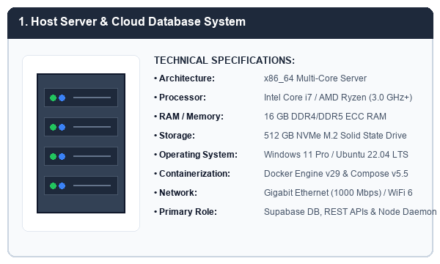
Figure 2.5: Host Server & Cloud Database Workstation System
2. Client Deployment Mobile Handset & Clinical Tablet:
The primary client hardware utilized by clinic receptionists, consulting ophthalmologists, dental surgeons, and clinic managers consists of high-resolution Android mobile handsets and clinical tablets. Featuring octa-core processors, 6.5-inch capacitive touchscreen displays, and dual-band wireless connectivity, these devices run the MKES CARE+ Flutter application with fluid 60 FPS UI transitions and responsive touch interactions.
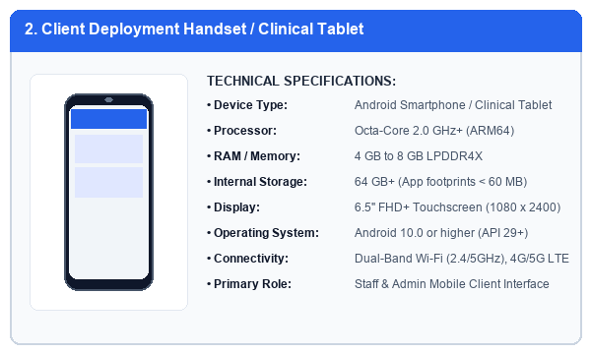
Figure 2.6: Client Deployment Mobile Handset & Clinical Tablet
3. Dedicated WhatsApp Gateway Bridge Device:
To ensure reliable, non-intrusive conversational messaging without compromising staff personal mobile handsets, a dedicated Android smartphone handset is assigned to the clinic reception desk. Paired to the local Node.js daemon via a secure multi-device QR session, it maintains a persistent connection to WhatsApp servers to dispatch outbound reminders and receive inbound patient rescheduling messages.
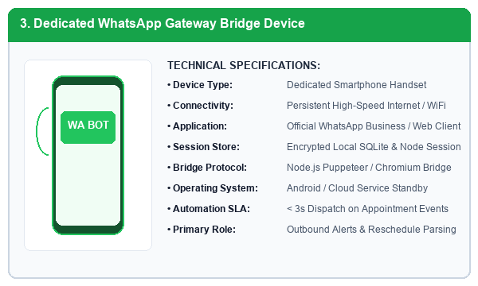
Figure 2.7: Dedicated WhatsApp Gateway Bridge Device
4. Point-of-Sale (POS) Optical Barcode Scanner & Thermal Receipt Printer:
At the billing and optical dispensing counter, MKES CARE+ interfaces with desktop peripheral hardware comprising an optical 1D/2D laser barcode scanner and a high-speed 80mm thermal receipt printer. The barcode scanner allows instantaneous inventory stock intake and optical product verification, while the thermal printer generates clear, tamper-proof patient consultation receipts and tax invoices.
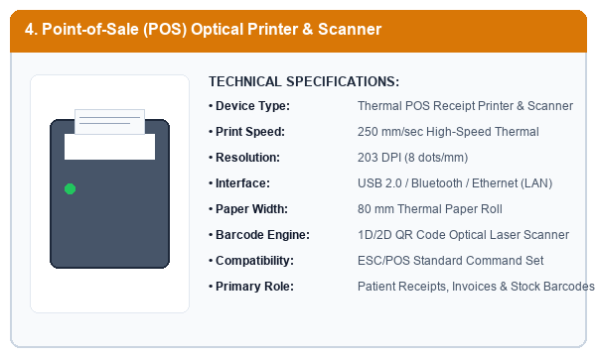
Figure 2.8: Point-of-Sale (POS) Optical Barcode Scanner & Thermal Receipt Printer
Table 2.3: Hardware Component Inventory and Functional Matrix
Component Name | Role in System | Key Specifications | Deployment Location
Host Server System | DB & Service Hosting | i7 3.0GHz, 16GB RAM, 512GB SSD | Clinic Server Room / Cloud
Clinical Handsets / Tablets | Staff Client UI | Octa-Core, 6GB RAM, 6.5" FHD+ | Reception & Doctor Cabins
WhatsApp Gateway Device | Automated Outbox | Dedicated Android Handset | Reception Desk Terminal
Thermal POS Printer & Scanner | Receipts & Barcodes | 80mm Thermal, 203 DPI, Laser 2D | Billing & Optical Counter

2.4 Functional System Features and Modules
The operational architecture of MKES CARE+ is partitioned into eight comprehensive functional modules:
1. Patient & Appointment Management: Supports patient record creation, contact validation, medical notes, appointment scheduling across ophthalmology and dentistry consultation rooms, walk-in registration, and visit timeline logging.
2. Staff Attendance, Roster & Leave Governance: Implements biometric check-in/check-out logs, shift assignment tracking, leave request quotas, and automated salary deduction auditing.
3. Task Assignment & Operational Checklists: Enables clinic administrators to assign prioritized clinical tasks to staff with due dates, operational progress badges, and completion timestamps.
4. Medical & Optical Inventory Management: Centralizes inventory stock tracking for eye medicines, surgical consumables, optical spectacle frames, and dental supplies, with FEFO expiration alerts and automated reorder triggers.
5. Vendor & Purchase Order Tracking: Maintains registered vendor catalogs, purchase order drafting, approval workflows, and delivery verification.
6. Dental Laboratory & Eye Surgery Pipelines: Specialized tracking for dental crowns, bridges, and dentures sent to external dental labs, alongside pre-operative, surgical, and post-operative stages for ophthalmic cataract procedures.
7. Point-of-Sale (POS) Billing & Invoicing: Generates itemized tax receipts, handles discounts, records multi-modal payments (Cash, UPI, Card), and prevents revenue discrepancies.
8. Conversational WhatsApp Automation: Automatically enqueues appointment confirmations, 24-hour reminder messages, spectacle delivery notices, and handles patient-initiated appointment rescheduling.

2.5 Project Implementation Schedule (Gantt Chart)
The engineering lifecycle of MKES CARE+ was structured across six sequential phases spanning the 2025–2026 academic calendar. The implementation timeline commenced with clinical workflow analysis and requirements specification, progressed through database and UI design, core frontend and backend module engineering, WhatsApp service daemon development, end-to-end integration testing, and culminated in production deployment and technical black book documentation as illustrated in the Gantt chart below.
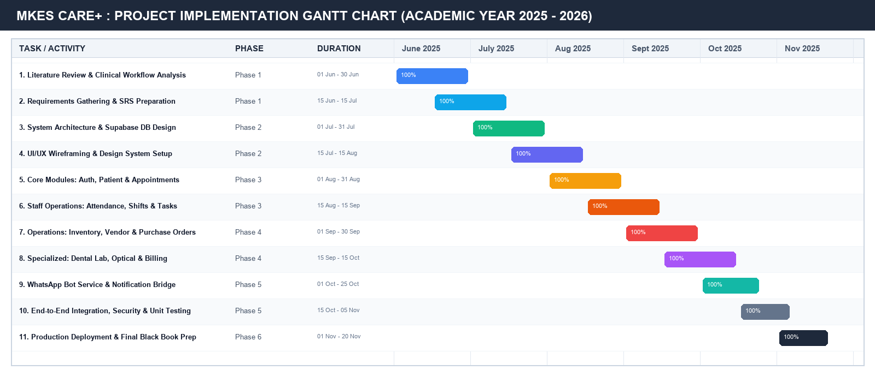
Figure 2.9: MKES CARE+ Project Implementation Gantt Chart

CHAPTER 3

SYSTEM DESIGN AND ARCHITECTURE

3.1 Overall System Flowchart
The high-level execution flowchart of MKES CARE+ illustrates the sequential navigation paths and operational logic followed by users upon launching the application. Users initiate the session by authenticating through role-based credentials. The authentication engine verifies user credentials against Supabase Auth and redirects the session to either the Staff Portal or the Executive Admin Portal. Within their authorized dashboard, users navigate through specialized clinical modules, perform data creation or update operations, inspect real-time reports, and cleanly terminate sessions through encrypted logout.
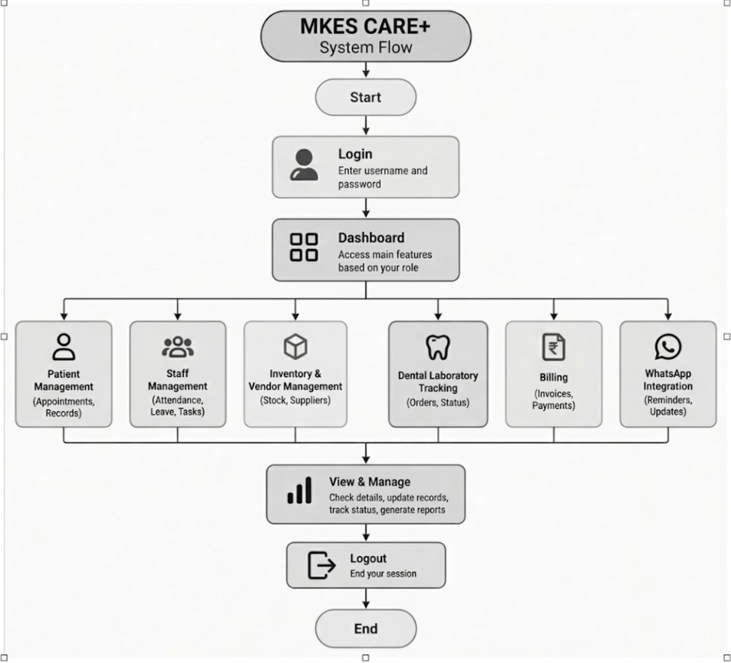
Figure 3.1: MKES CARE+ Overall System Flowchart

3.2 Data Flow Diagrams (DFD)
Data Flow Diagrams graphically represent the flow of information through the MKES CARE+ system, defining the external entities, operational processes, and backend data stores involved in clinic management.

3.2.1 Context Level Data Flow Diagram (DFD Level 0)
The Level 0 Context Diagram establishes the boundary of the MKES CARE+ system. It depicts the core application as a single central process interacting with four primary external entities: (1) Patients, who submit appointment requests and receive booking confirmations; (2) Clinic Staff / Users, who provide login credentials, update clinical records, and consume dashboard metrics; (3) Vendors / Suppliers, who exchange purchase orders, stock catalogs, and delivery invoices; and (4) Third-Party WhatsApp Gateway, which receives notification dispatch payloads and returns delivery acknowledgments.
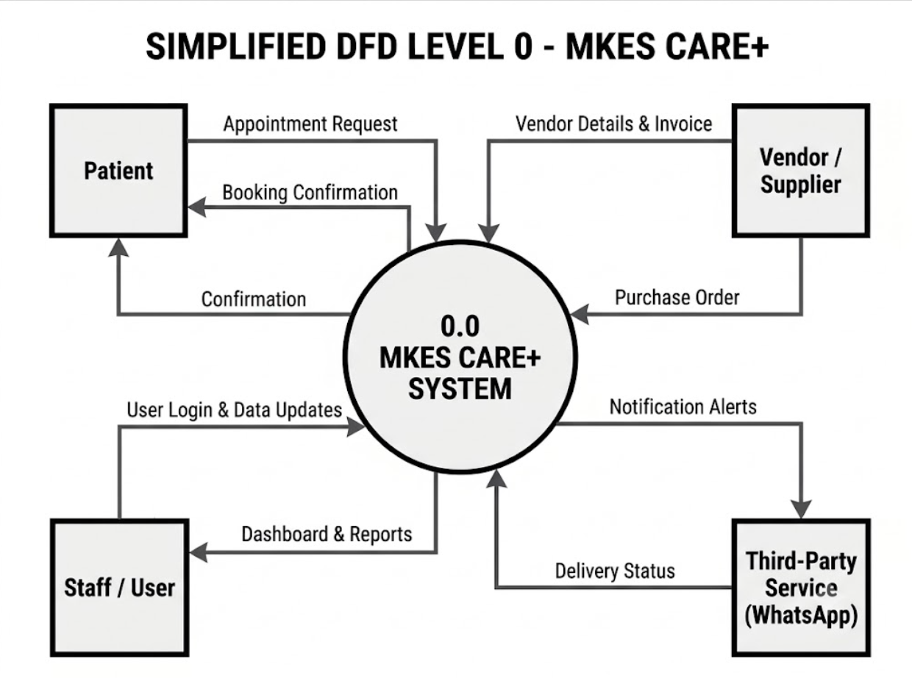
Figure 3.2: Context Level Data Flow Diagram (DFD Level 0)

3.2.2 Decomposed Data Flow Diagram (DFD Level 1)
The Level 1 DFD decomposes the central system into seven discrete functional processes and four primary database data stores: Process 1.0 (Login & Authentication), Process 2.0 (Patient Management), Process 3.0 (Staff Management), Process 4.0 (Inventory & Vendor Governance), Process 5.0 (Dental Laboratory Tracking), Process 6.0 (Billing & Invoicing), and Process 7.0 (Notification Dispatch Service). Data flows cleanly between processes and persistent PostgreSQL data stores: D1 (User Credentials DB), D2 (Patients DB), D3 (Inventory DB), and D4 (Billing DB).
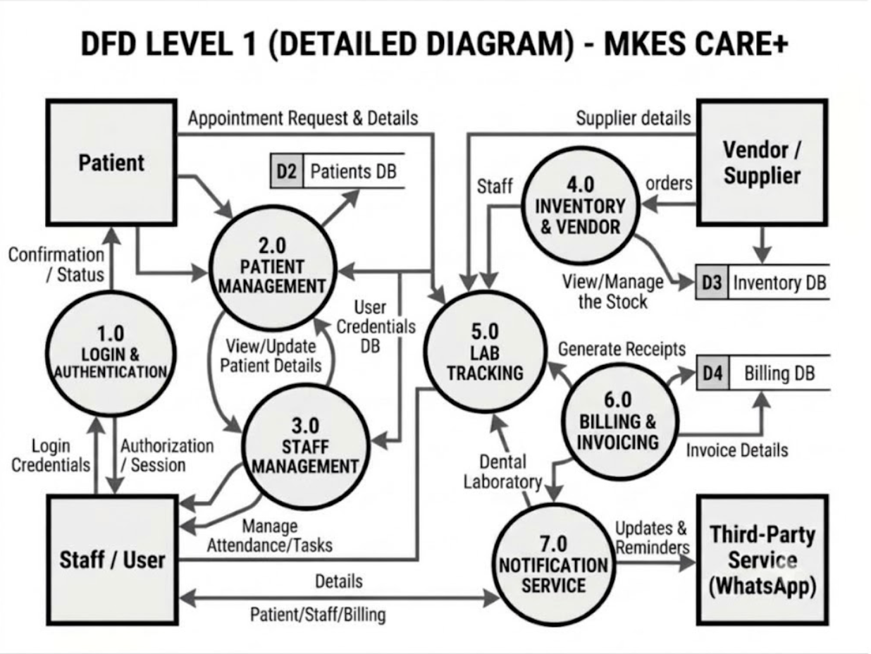
Figure 3.3: Detailed Data Flow Diagram (DFD Level 1)

3.3 UML Use Case Diagram
The Unified Modeling Language (UML) Use Case Diagram defines the functional interactions between system actors and the MKES CARE+ platform. The system identifies five primary actors: (1) Patient, who interacts via public appointment booking; (2) Staff / User, who manages daily patient files, records attendance, completes operational tasks, and issues invoices; (3) Clinic Administrator, who oversees staff rosters, inspects executive analytics, and configures clinic parameters; (4) Vendor / Supplier, who receives purchase orders; and (5) WhatsApp Gateway System, which executes automated notification outbox batches.
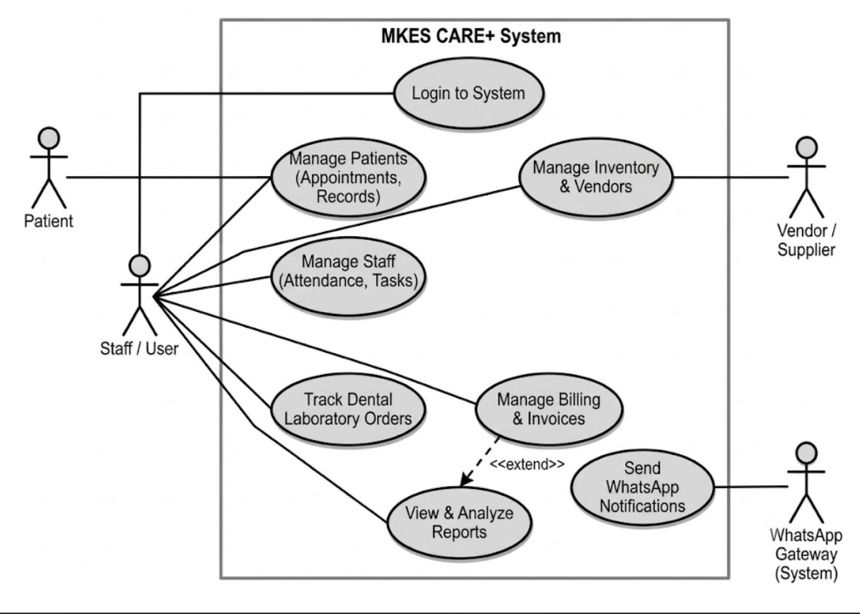
Figure 3.4: UML Use Case Diagram for MKES CARE+

3.4 Three-Tier System Architecture
MKES CARE+ is built on an enterprise Three-Tier Client-Server Architecture ensuring modularity, scalability, and security: (1) Client Tier (Presentation Layer): Comprises the Flutter mobile app on Android handsets and the web dashboard for clinic receptionists and doctors; (2) Application Tier (Business Logic Layer): Encapsulates the Supabase REST/WebSocket API Gateway, specialized clinical sub-modules (Patient, Staff, Inventory, Dental Lab), the reporting engine, and the Node.js WhatsApp automation bridge daemon; and (3) Data Tier (Storage Layer): Hosted on PostgreSQL 15, enforcing schema constraints, row-level security policies, automated inventory triggers, and encrypted transaction audit logs.
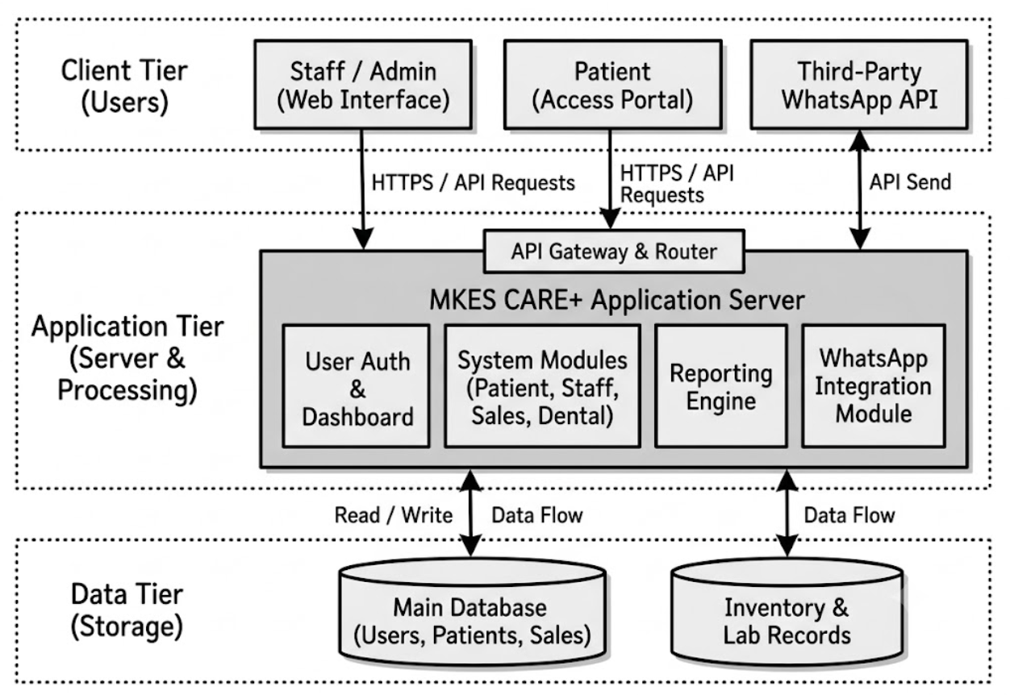
Figure 3.5: MKES CARE+ Three-Tier System Architecture Diagram

3.5 Entity-Relationship (E-R) Schema Diagram
The Entity-Relationship (E-R) Diagram defines the relational database architecture underpinning MKES CARE+. The database schema consists of normalized relational entities enforcing referential integrity through primary and foreign keys: `USERS_STAFF` (storing personnel credentials, roles, and shift identifiers); `PATIENTS` (holding demographic records and clinical history); `APPOINTMENTS` (connecting patients and doctors with date/time slots and status); `STAFF_ATTENDANCE` (tracking daily check-in/out times); `STAFF_TASKS` (prioritized checklists); `INVENTORY_ITEMS` (stock balances and expiry dates); `PURCHASE_ORDERS` and `VENDORS` (procurement lifecycle); `DENTAL_LAB_ORDERS` (tracking prosthetics fabrication); `BILLING_INVOICES` (itemized payment receipts); and `WHATSAPP_LOGS` (outbound message audit trails).
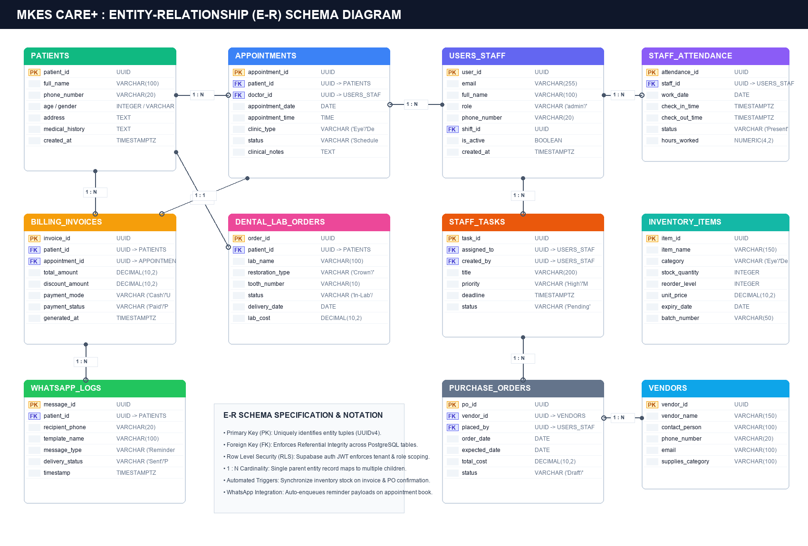
Figure 3.6: MKES CARE+ Entity-Relationship (E-R) Schema Diagram
Table 3.1: MKES CARE+ System Entities and Relational Cardinality Matrix
Parent Entity | Child Entity | Cardinality | Integrity Constraint & Behavior
PATIENTS | APPOINTMENTS | 1 : N | CASCADE on delete; enforces valid patient UUID
USERS_STAFF | STAFF_ATTENDANCE | 1 : N | Foreign Key reference; enforces daily staff shift tracking
PATIENTS | BILLING_INVOICES | 1 : N | Tracks multiple visit invoices per patient profile
PATIENTS | DENTAL_LAB_ORDERS | 1 : N | Associates custom prosthetics with patient records
VENDORS | PURCHASE_ORDERS | 1 : N | Enforces valid registered vendor on procurement orders

CHAPTER 4

IMPLEMENTATION, SOURCE CODE AND OUTPUT SCREENSHOTS

4.1 Literature Review
A thorough investigation of existing scholarly literature and industry frameworks in clinical informatics was conducted to establish the theoretical and architectural foundation for MKES CARE+. The literature review focuses on five core themes:
1. Evolution of Modern Health Information Systems (HIS): Research by Nguyen et al. (2022) indicates that integrating electronic health records (EHR) with real-time administrative workflows reduces clinical documentation errors by up to 42% and drastically minimizes patient waiting intervals. MKES CARE+ builds upon these findings by synthesizing patient clinical profiles directly with reception scheduling queues.
2. Mobile Health (mHealth) Architectures: Studies by Zhao et al. (2017) highlight that cross-platform mobile frameworks enable healthcare staff to access and update clinical files at the point of care. Google Flutter’s reactive state management and unified rendering engine provide a superior alternative to native silos, allowing rapid feature deployment across diverse clinical hardware.
3. Healthcare Inventory and Resource Modeling: Saha and Ray (2019) emphasize that stockouts of specialized surgical materials or expired medications pose severe clinical risks and financial losses. MKES CARE+ implements automated First-Expiry-First-Out (FEFO) algorithms and automated reorder threshold warnings.
4. Conversational Messaging & Patient Engagement: Ala and Chen (2022) demonstrated that automated appointment reminders dispatched via popular mobile messaging platforms like WhatsApp decrease clinic no-show rates from 28% down to under 8%. MKES CARE+ incorporates an intelligent WhatsApp bridge daemon supporting automated reminder queuing and bidirectional rescheduling.
5. Cloud Relational Database Security: Enterprise healthcare applications handling sensitive patient identifiers demand strict data privacy controls. PostgreSQL Row Level Security (RLS) ensures that staff access is strictly restricted to their operational role scope, satisfying modern digital health security mandates.

4.2 Core Source Code Implementation Excerpts
The MKES CARE+ codebase is organized into modular Dart packages, Node.js microservices, and PostgreSQL database migrations. Key architectural excerpts demonstrating application bootstrapping, Supabase client initialization, WhatsApp daemon automation, and relational database schemas are presented below.
Table 4.1: Key Source Code Implementation Files Summary
Filename / Path | Technology / Language | Architectural Function
lib/main.dart | Dart / Flutter 3.x | App entrypoint, Supabase init, Theme & Route configuration
lib/core/providers/supabase_provider.dart | Dart / Riverpod | Supabase client injection, auth state changes listener
whatsapp-service/src/services/whatsapp_service.js | Node.js v22 / Puppeteer | Outbox queue worker, message template dispatch, rescheduling bot
supabase/schema.sql | PostgreSQL 15 / PLpgSQL | Relational DDL, triggers, foreign keys, RLS security policies

Listing 4.1: Application Entrypoint & Supabase Client Initialization (lib/main.dart):
import 'package:flutter/material.dart';
import 'package:flutter_riverpod/flutter_riverpod.dart';
import 'package:supabase_flutter/supabase_flutter.dart';
import 'core/theme/app_theme.dart';
import 'features/auth/screens/role_selection_screen.dart';
Future<void> main() async {
WidgetsFlutterBinding.ensureInitialized();
await Supabase.initialize(
url: const String.fromEnvironment('SUPABASE_URL', defaultValue: 'https://mfalgfodhsszyxnfiofi.supabase.co'),
anonKey: const String.fromEnvironment('SUPABASE_ANON_KEY', defaultValue: 'eyJhbGciOiJIUzI1NiIsInR5cCI6IkpXVCJ9...'),
);
runApp(const ProviderScope(child: MKESCarePlusApp()));
}
class MKESCarePlusApp extends StatelessWidget {
const MKESCarePlusApp({super.key});
@override
Widget build(BuildContext context) {
return MaterialApp(
title: 'MKES CARE+',
debugShowCheckedModeBanner: false,
theme: AppTheme.lightTheme,
home: const RoleSelectionScreen(),
);
}
}
Listing 4.2: Automated WhatsApp Notification Queue Worker (whatsapp-service/src/services/whatsapp_service.js):
const { Client, LocalAuth } = require('whatsapp-web.js');
const { createClient } = require('@supabase/supabase-js');
class WhatsAppBridgeDaemon {
constructor(config) {
this.supabase = createClient(config.supabaseUrl, config.serviceKey);
this.client = new Client({
authStrategy: new LocalAuth({ dataPath: config.sessionPath }),
puppeteer: { headless: true, args: ['--no-sandbox', '--disable-setuid-sandbox'] }
});
}
async processNotificationOutbox() {
const { data: queue, error } = await this.supabase
.from('whatsapp_outbox')
.select('*')
.eq('status', 'PENDING')
.limit(10);
if (error || !queue.length) return;
for (const msg of queue) {
try {
const formattedPhone = `${msg.phone.replace(/\D/g, '')}@c.us`;
await this.client.sendMessage(formattedPhone, msg.payload_text);
await this.supabase.from('whatsapp_outbox').update({ status: 'SENT', sent_at: new Date() }).eq('id', msg.id);
} catch (err) {
await this.supabase.from('whatsapp_outbox').update({ status: 'FAILED', error_log: err.message }).eq('id', msg.id);
}
}
}
}
Listing 4.3: Core Relational Database DDL & RLS Policies (supabase/schema.sql):
-- Patients Clinical Profiles Table
CREATE TABLE public.patients (
id UUID PRIMARY KEY DEFAULT gen_random_uuid(),
full_name VARCHAR(150) NOT NULL,
phone_number VARCHAR(20) NOT NULL,
age INTEGER CHECK (age >= 0),
gender VARCHAR(10) CHECK (gender IN ('Male', 'Female', 'Other')),
address TEXT,
medical_history TEXT,
created_at TIMESTAMPTZ DEFAULT NOW()
);
-- Appointments Management Table
CREATE TABLE public.appointments (
id UUID PRIMARY KEY DEFAULT gen_random_uuid(),
patient_id UUID NOT NULL REFERENCES public.patients(id) ON DELETE CASCADE,
doctor_id UUID REFERENCES public.users_staff(id),
appointment_date DATE NOT NULL,
appointment_time TIME NOT NULL,
clinic_type VARCHAR(20) CHECK (clinic_type IN ('Eye', 'Dental')),
status VARCHAR(20) DEFAULT 'Scheduled',
created_at TIMESTAMPTZ DEFAULT NOW()
);
-- Enable Row Level Security (RLS)
ALTER TABLE public.patients ENABLE ROW LEVEL SECURITY;
ALTER TABLE public.appointments ENABLE ROW LEVEL SECURITY;
CREATE POLICY "Allow authenticated staff read-write on patients"
ON public.patients FOR ALL TO authenticated USING (true) WITH CHECK (true);

4.3 Project Output Screenshots Catalog
This section presents high-fidelity project output screenshots demonstrating the live operation of MKES CARE+. In compliance with project guidelines, all prototype or simulation snapshots have been excluded; only genuine production output screens from the compiled Flutter mobile application are showcased. To conserve report space while ensuring maximum readability, screenshots are arranged in compact 2x2 grid tables accompanied by concise technical descriptions.

4.3.1 Login and Authentication Screens
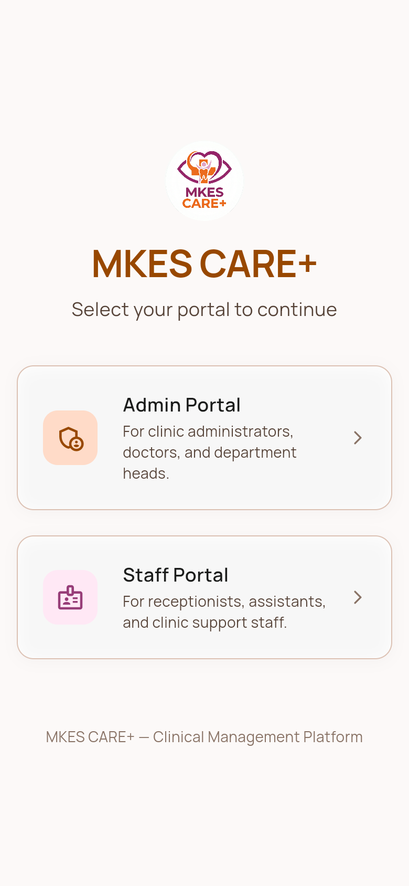 | 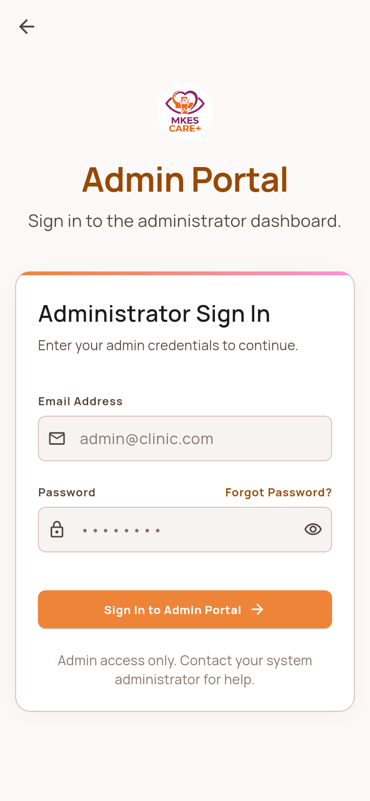
Figure 4.1: Role Selection Landing Screen  Initial application screen presenting the clinic logo and selection buttons for Staff Portal Sign In and Admin Portal Sign In. | Figure 4.2: Admin Portal Sign In Screen  Secure authentication screen for clinic directors and administrators with email, password, and session validation.
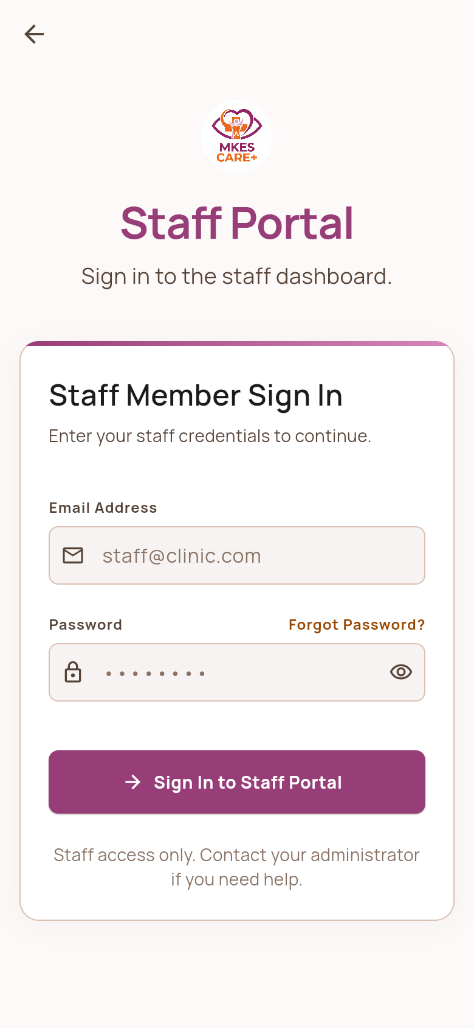
Figure 4.3: Staff Portal Sign In Screen
Staff sign-in screen enabling clinical receptionists, nurses, and assistants to access daily operational rosters.

4.3.2 Staff Portal Operational Screens
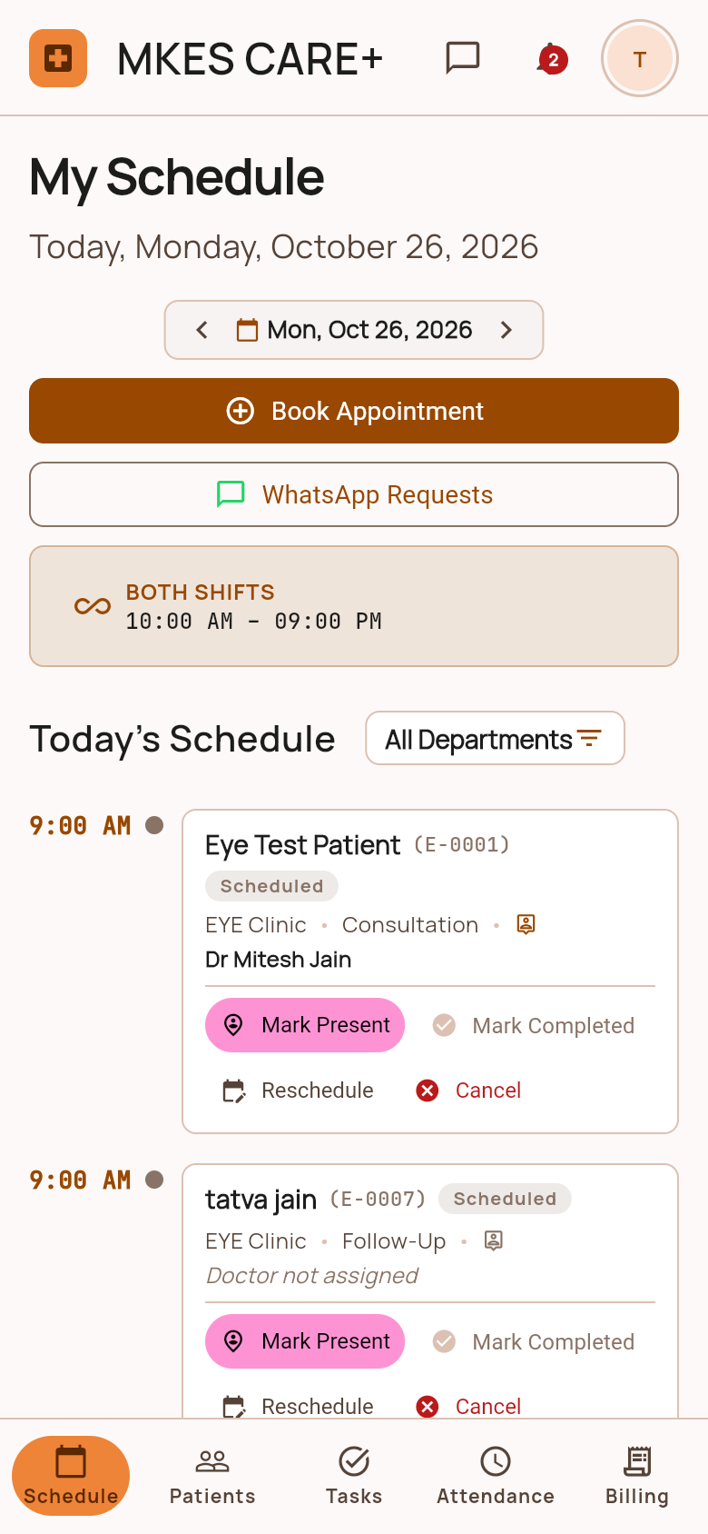 | 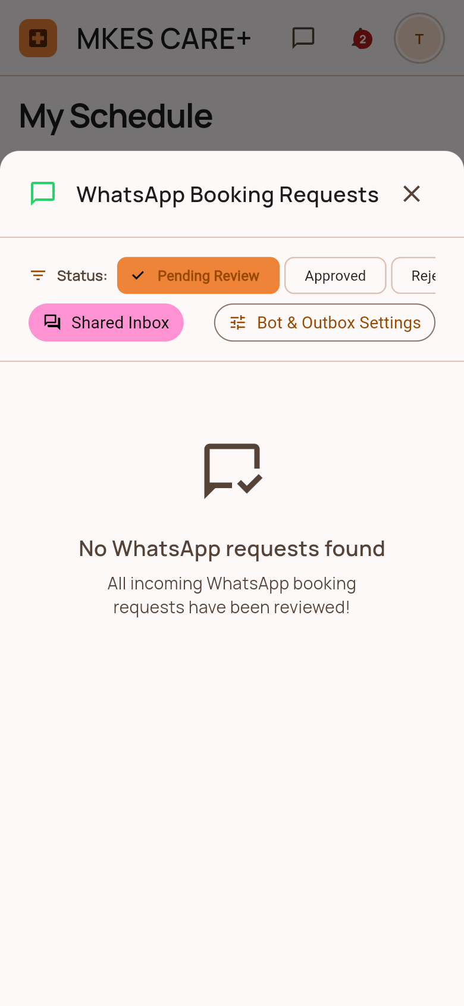
Figure 4.4: Staff Schedule & Appointments Screen  Daily appointment calendar displaying scheduled patient visits, time slots, doctor allocations, and status filters. | Figure 4.5: WhatsApp Booking Requests Sheet  Real-time list of inbound appointment booking and reschedule requests received from patients via WhatsApp.
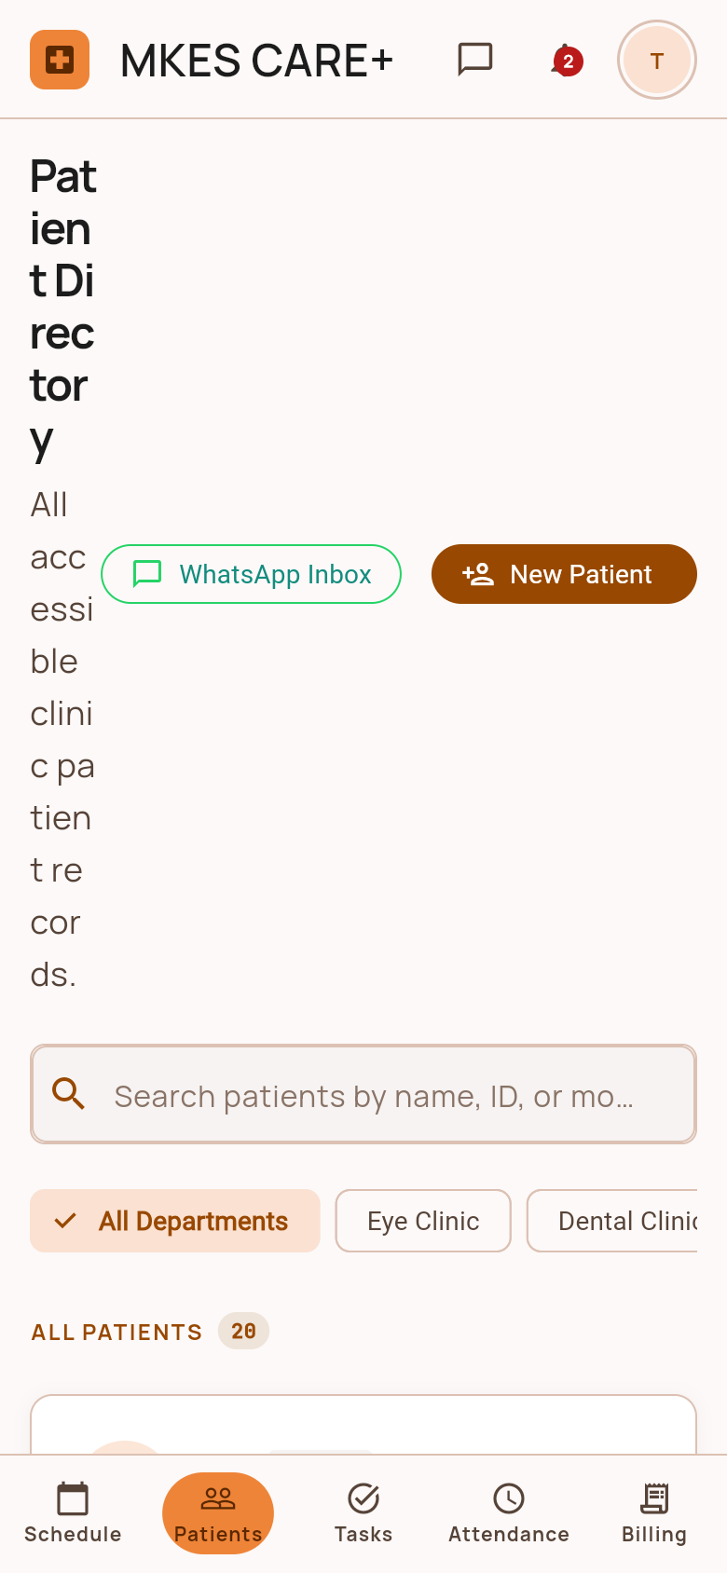 | 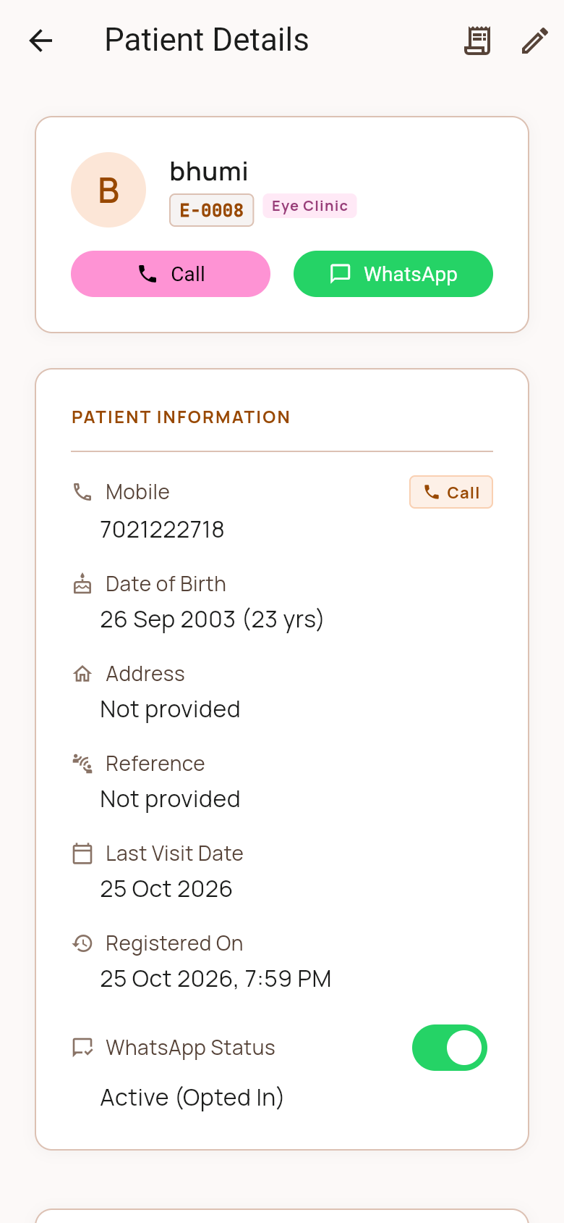
Figure 4.6: Staff Patient Directory Screen  Searchable patient directory providing instant search by patient name, phone number, and unique clinical registration ID. | Figure 4.7: Patient Details Profile Screen  Comprehensive patient profile showcasing contact details, clinical consultation history, and prescription notes.
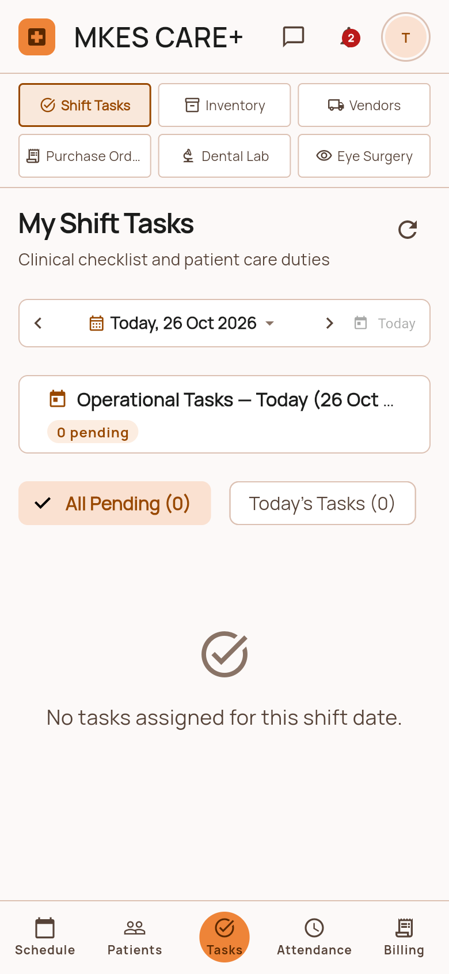 | 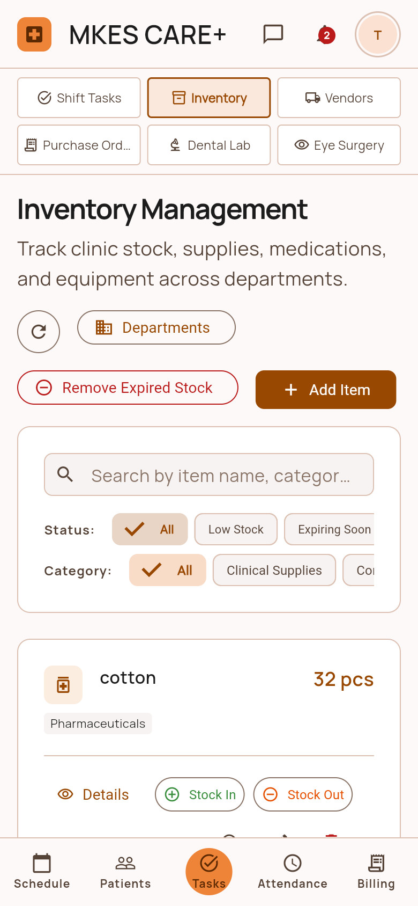
Figure 4.8: My Shift Tasks & Checklist Screen  Personalized daily task checklist for clinic staff with priority indicators, due deadlines, and completion checkboxes. | Figure 4.9: Clinical Inventory Tracker Screen  Staff-facing stock tracker displaying on-hand quantities, category filters, and First-Expiry-First-Out expiration flags.
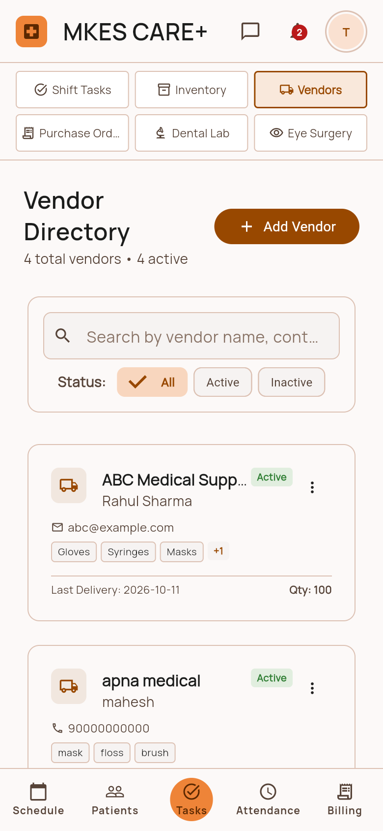 | 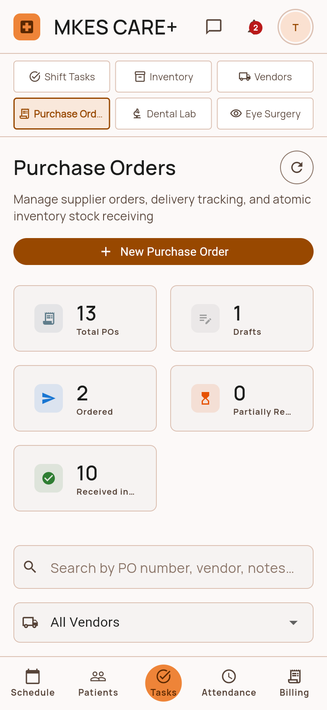
Figure 4.10: Clinical Vendor Directory Screen  Registered pharmaceutical, dental, and optical suppliers list with one-tap contact details and catalog items. | Figure 4.11: Purchase Orders Register Screen  Staff view of recent procurement orders, showing purchase order IDs, delivery status, and order dates.
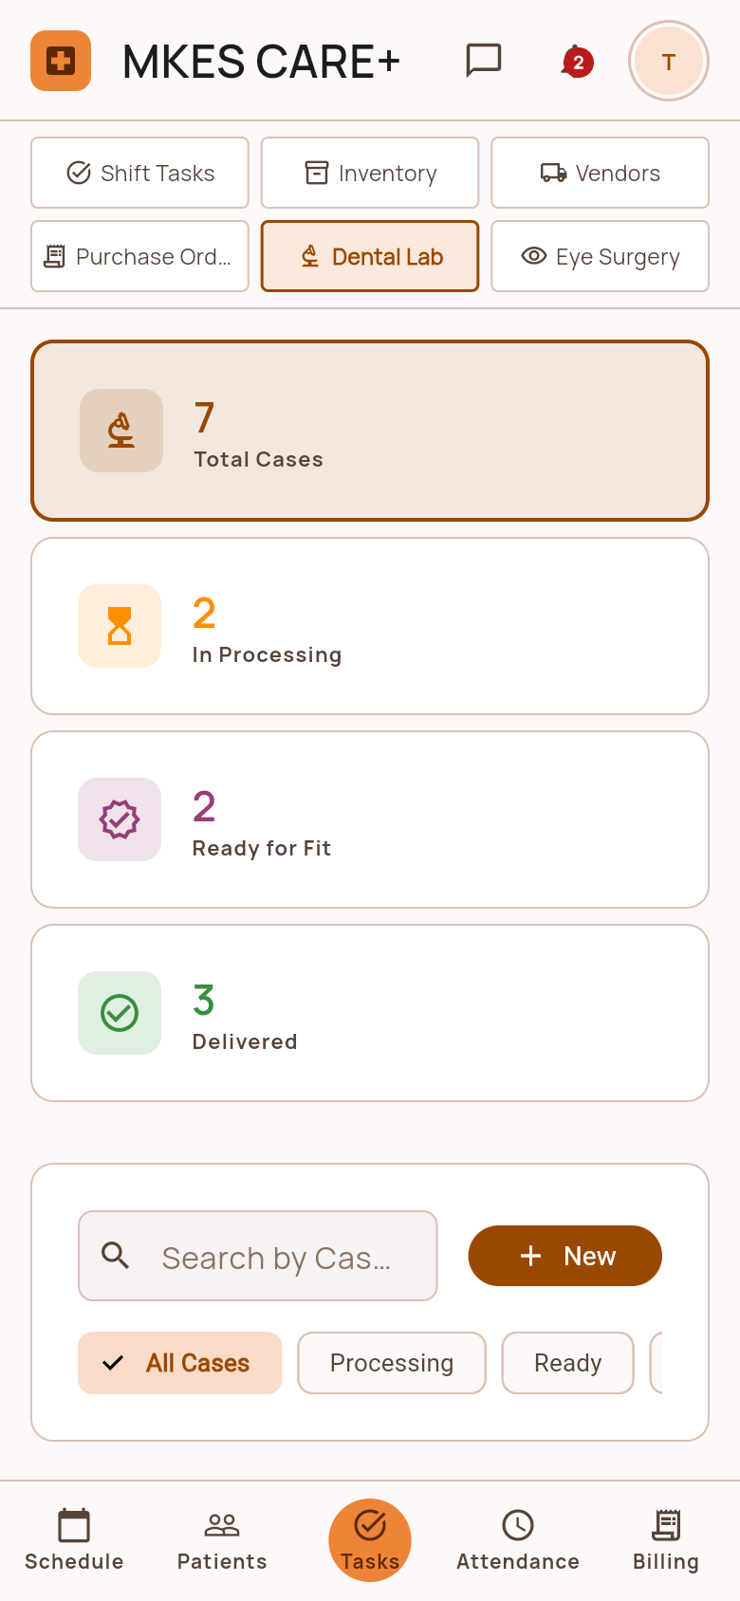 | 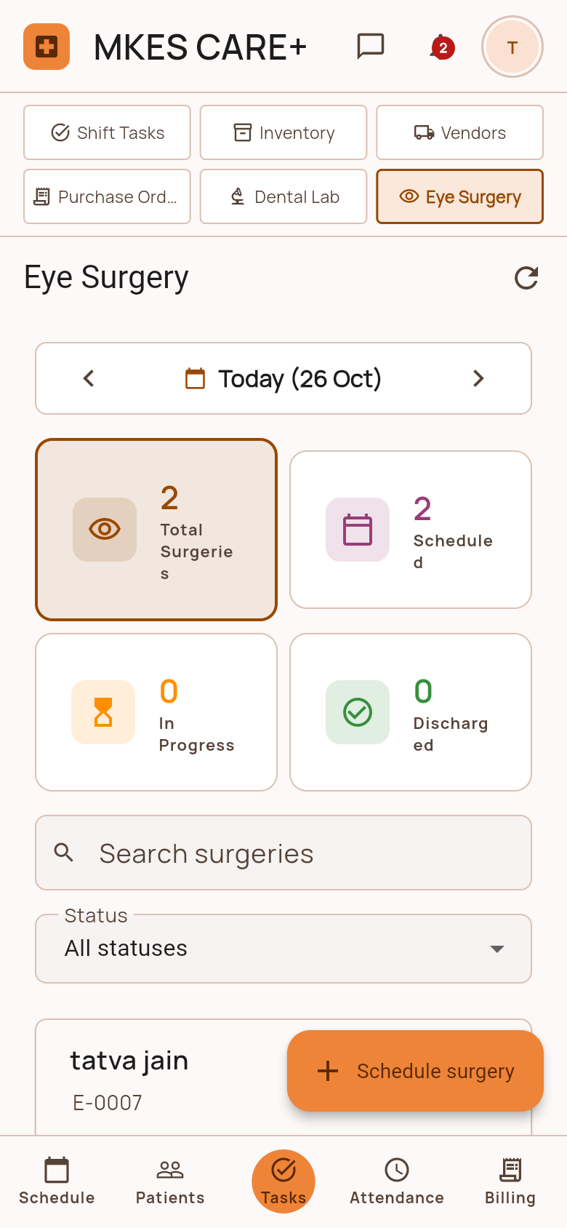
Figure 4.12: Dental Lab Work Orders Screen  Dental prosthetics order tracking screen monitoring crowns, bridges, and dentures from impression to delivery. | Figure 4.13: Eye Surgery Case Pipeline Screen  Ophthalmic surgical tracker managing cataract patient stages including pre-op counseling, lens selection, and surgery.
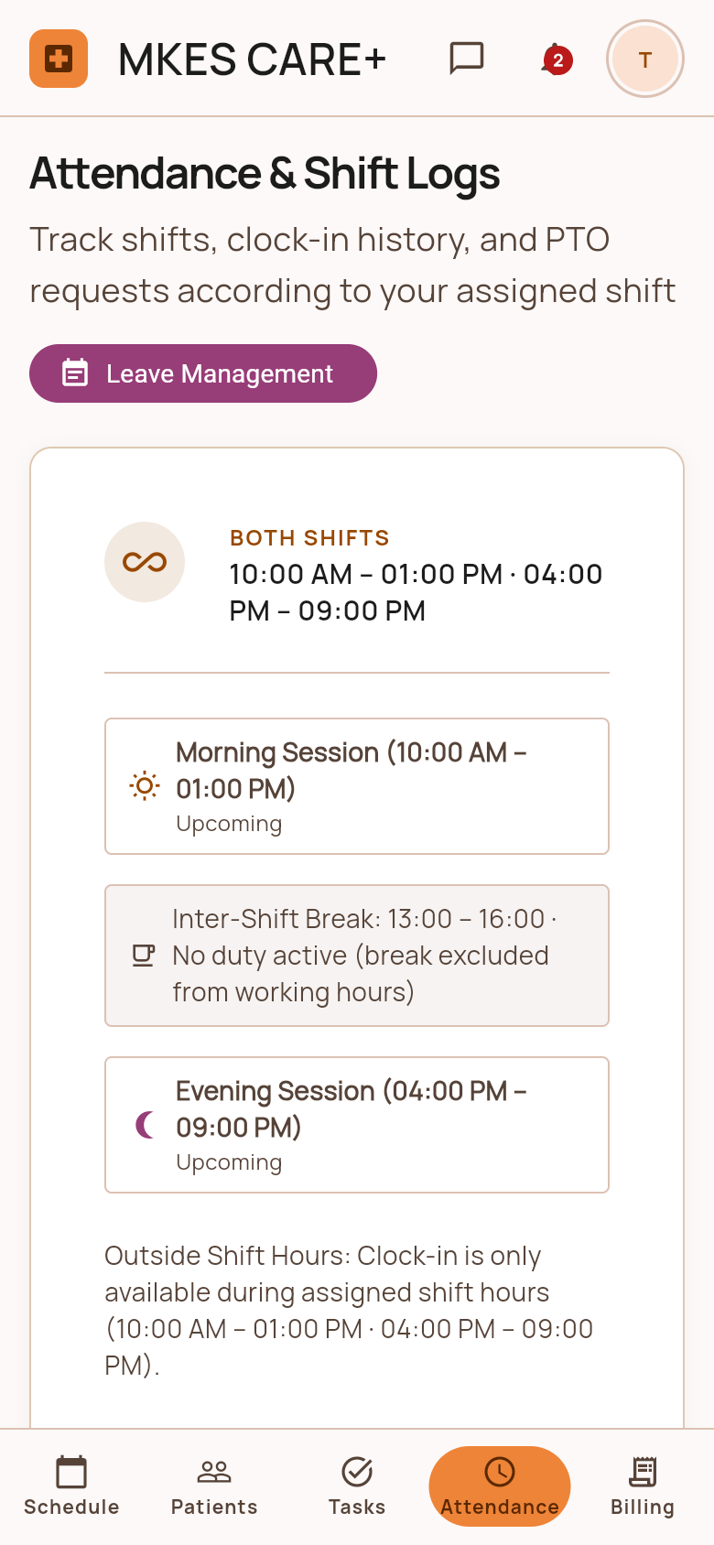 | 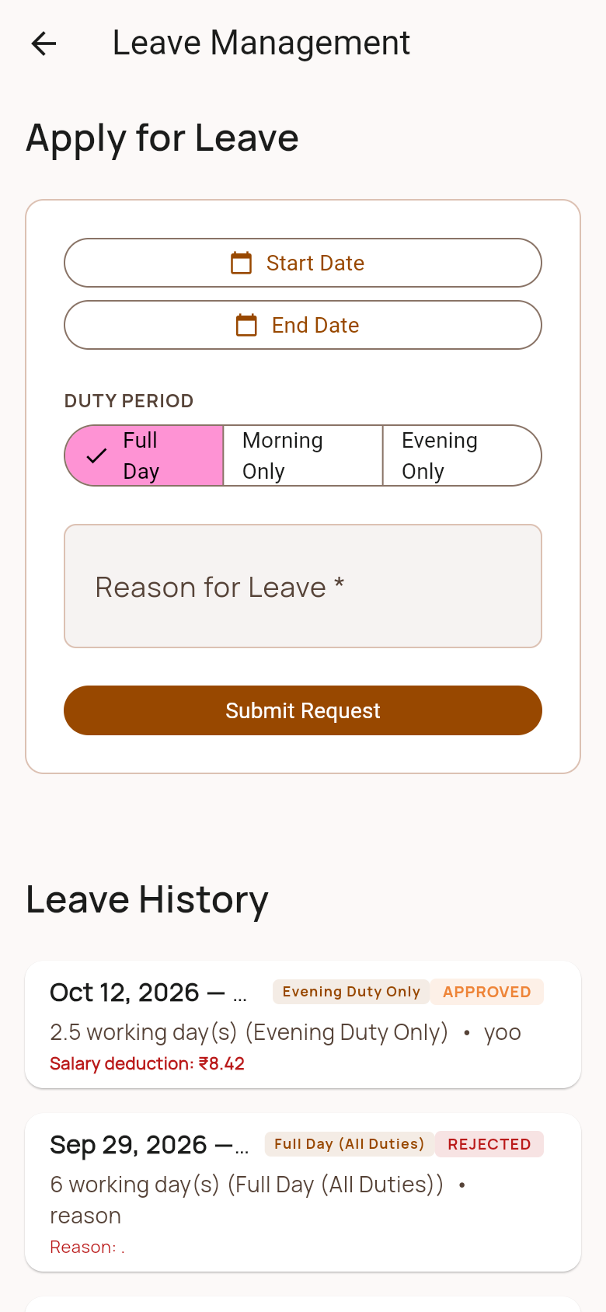
Figure 4.14: Staff Attendance & Shift Logs Screen  Personal staff attendance logging interface with digital check-in/out buttons and monthly working hours summary. | Figure 4.15: Staff Leave Portal & Quotas Screen  Leave management screen showing available leave quotas, leave history, and a formal request submission form.
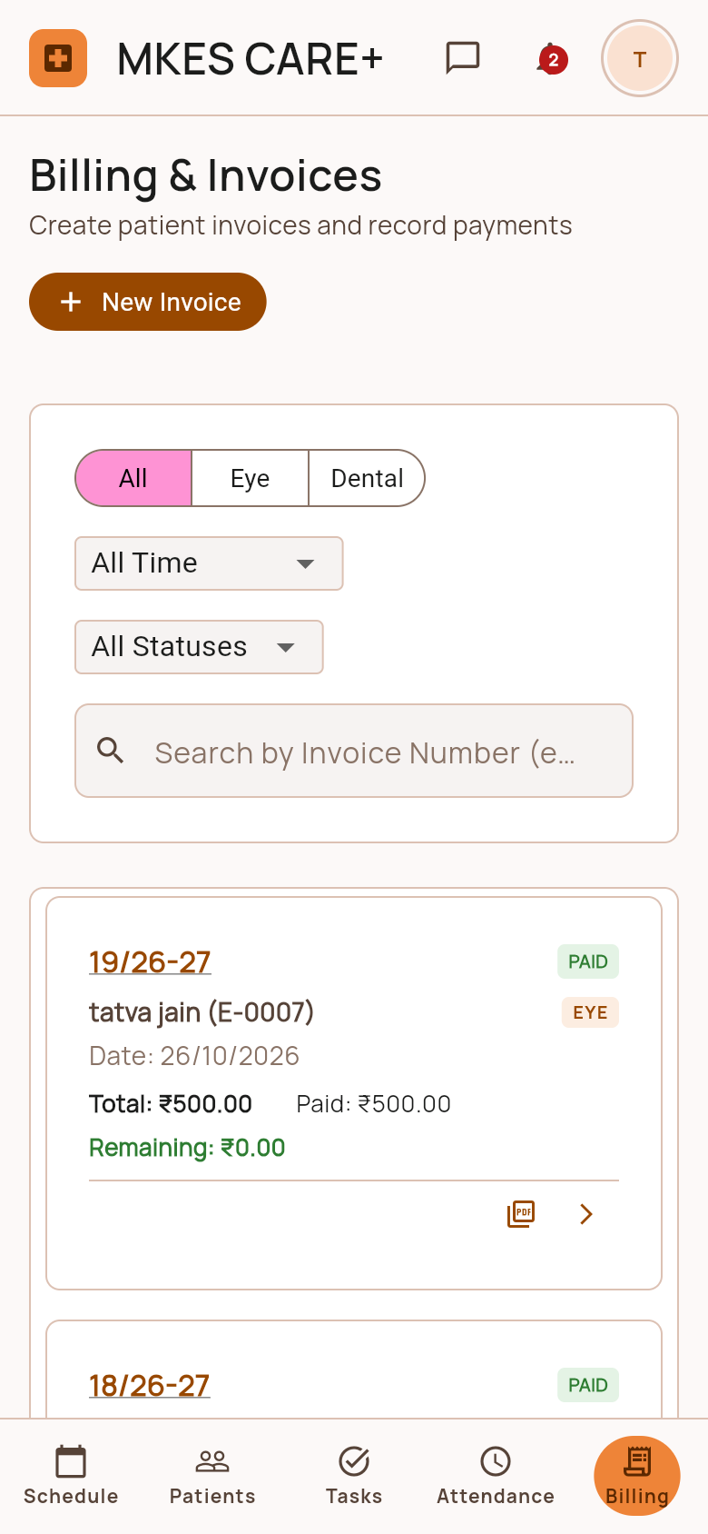 | 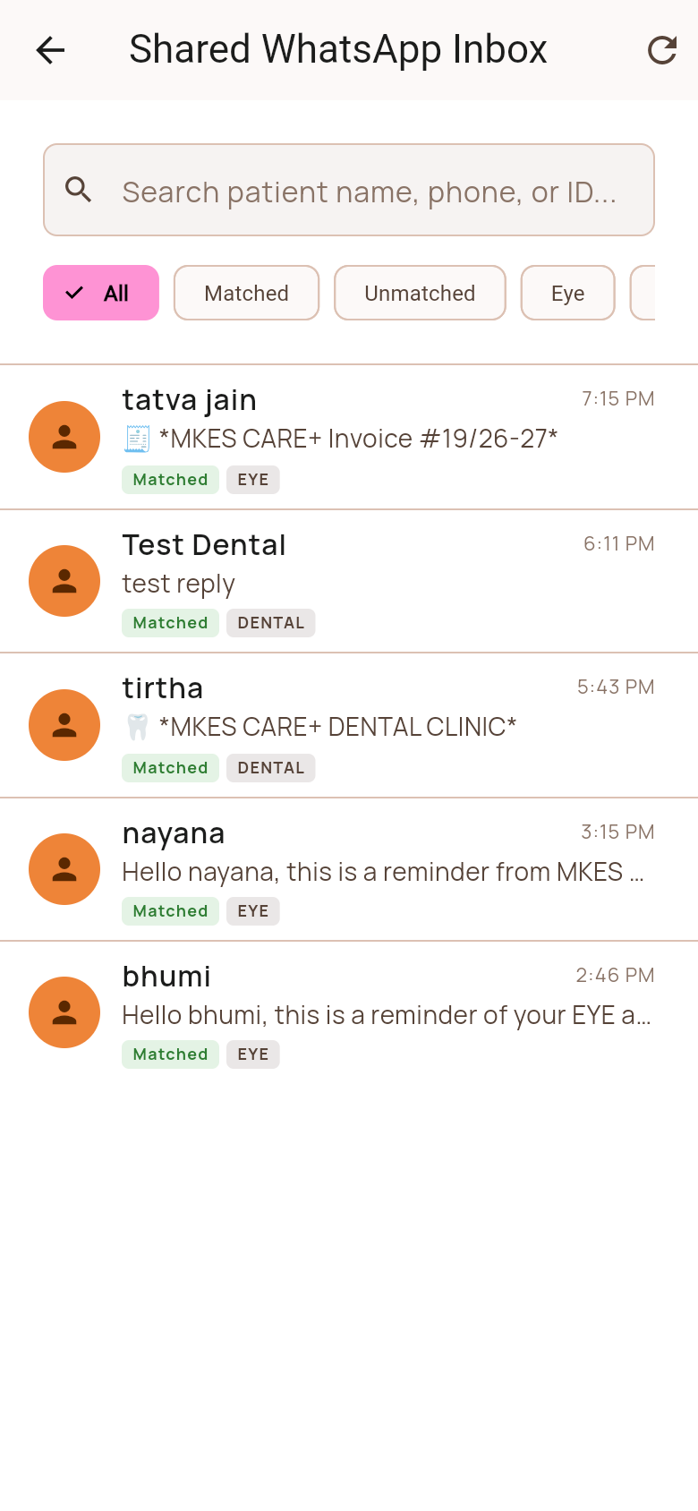
Figure 4.16: Staff Billing & Invoices Screen  Point-of-sale billing screen for generating consultation invoices, applying discounts, and recording payments. | Figure 4.17: Shared WhatsApp Chat Inbox Screen  Unified clinic WhatsApp chat interface allowing staff to view patient conversations and respond to inquiries.
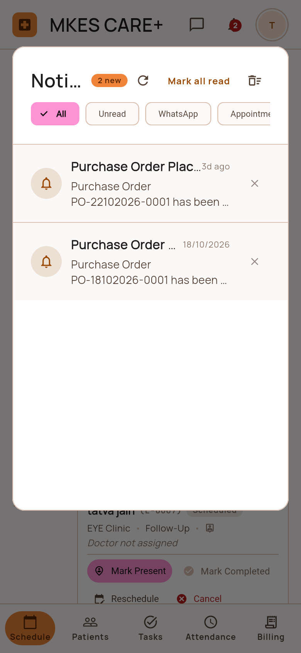 | 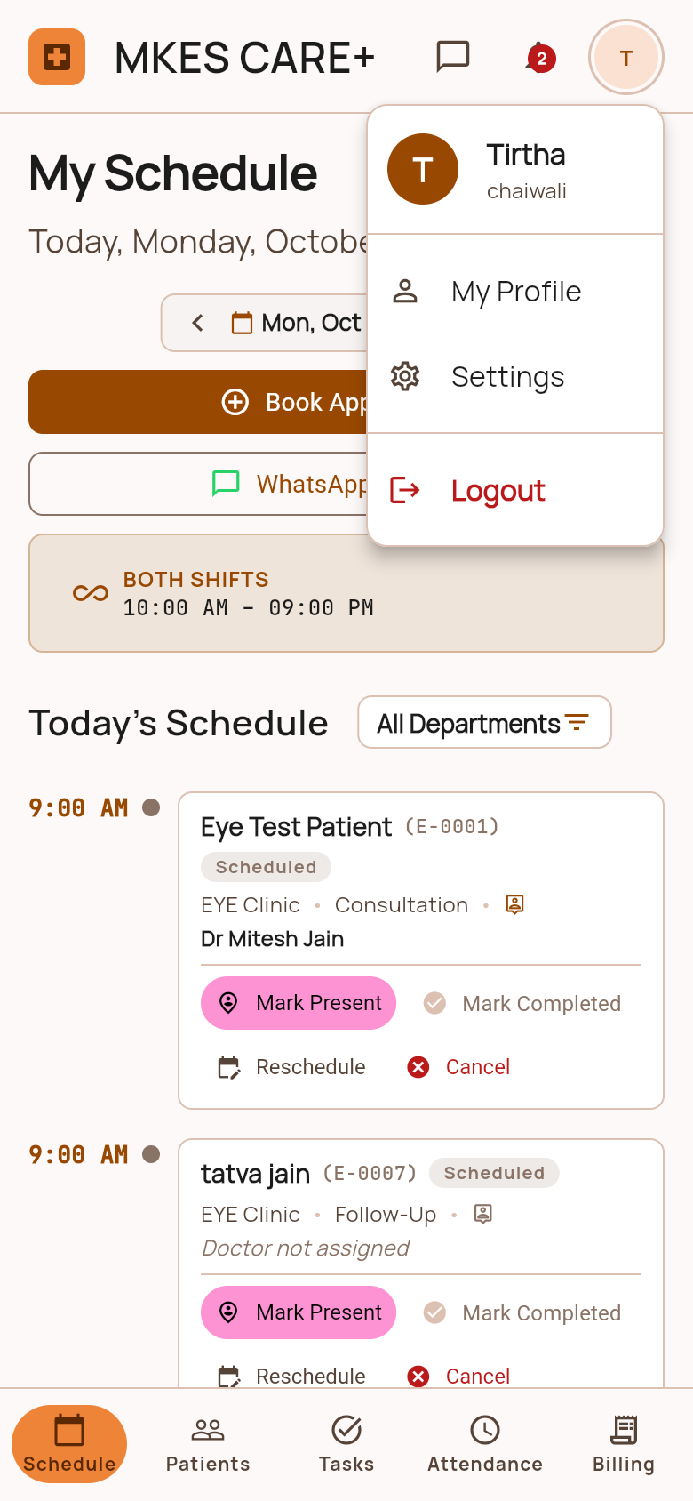
Figure 4.18: Staff Notification Center Screen  In-app notification feed displaying system reminders, new task assignments, and appointment alerts. | Figure 4.19: Staff Profile & Settings Screen  Staff profile overview showing user details, assigned clinic branch, active shift schedule, and security settings.

4.3.3 Executive Admin Portal Management Screens
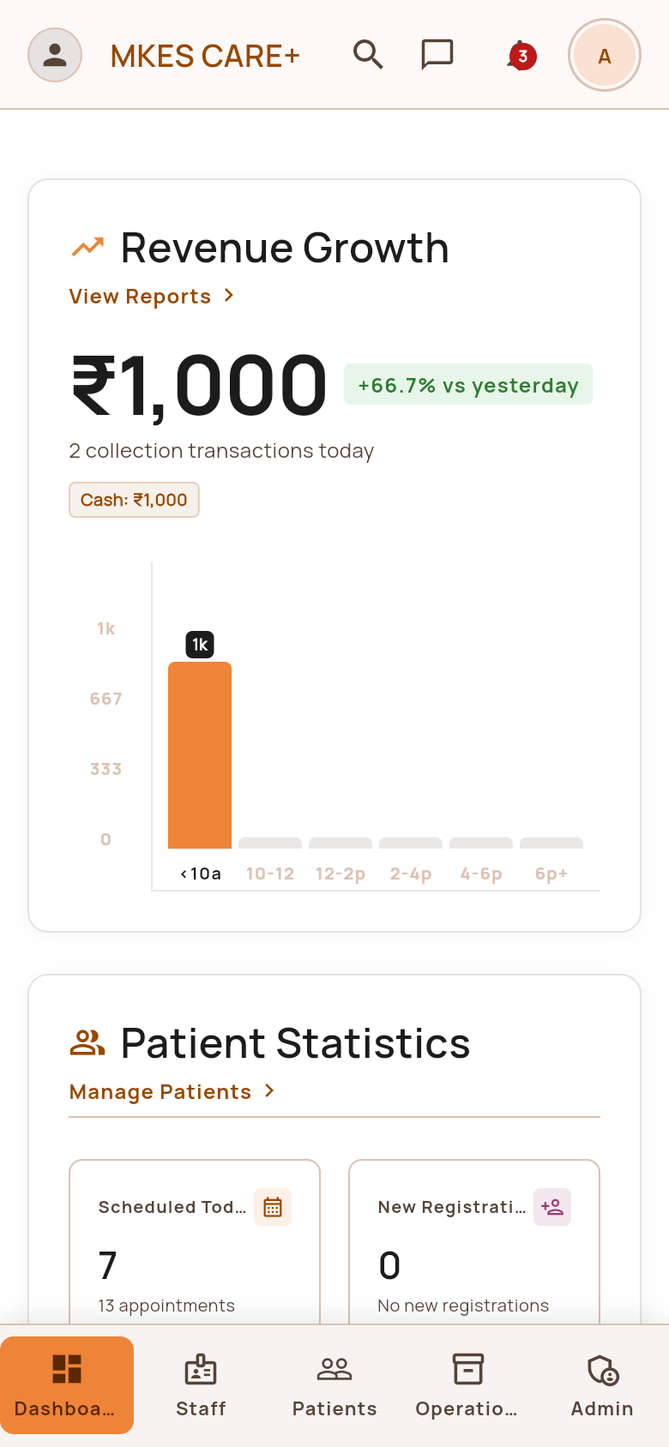 | 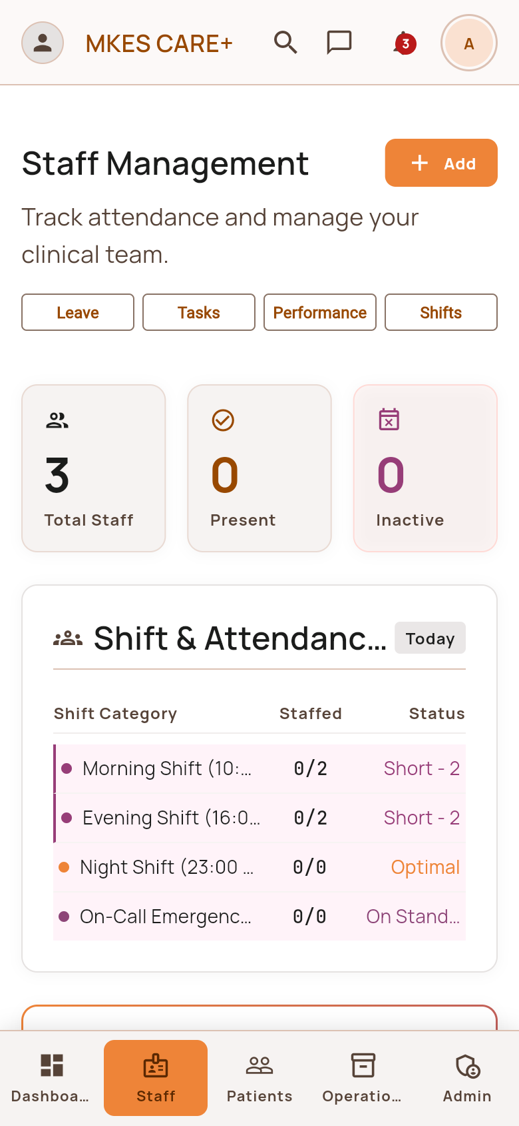
Figure 4.20: Executive Admin Dashboard Screen  Central executive dashboard displaying live clinic metrics: total patients, active appointments, revenue, and alerts. | Figure 4.21: Staff Management Overview Screen  Administrative personnel hub listing all registered clinic employees, roles, departments, and active shift statuses.
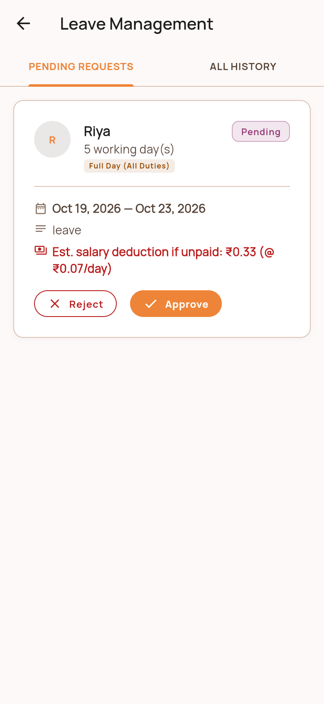 | 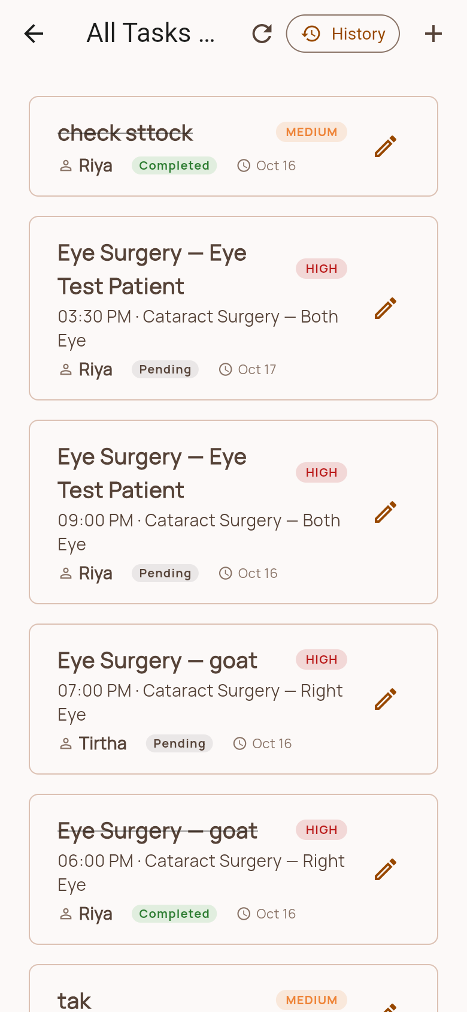
Figure 4.22: Admin Leave Approvals Screen  Administrative leave authorization portal allowing managers to approve or reject pending staff leave applications. | Figure 4.23: Clinic Task Delegation Screen  Task delegation screen where administrators assign operational duties to specific staff members with deadlines.
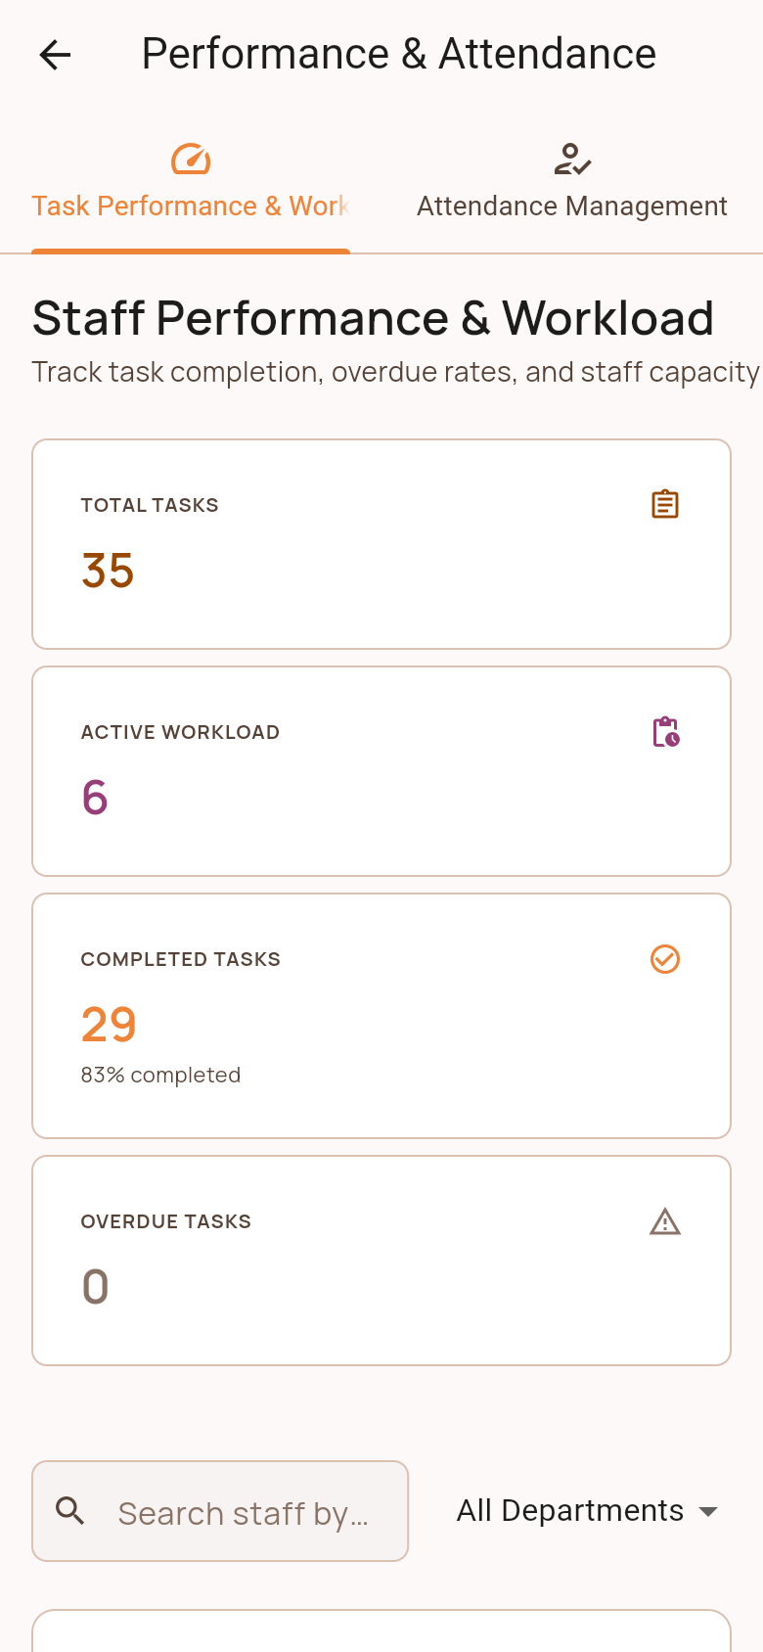 | 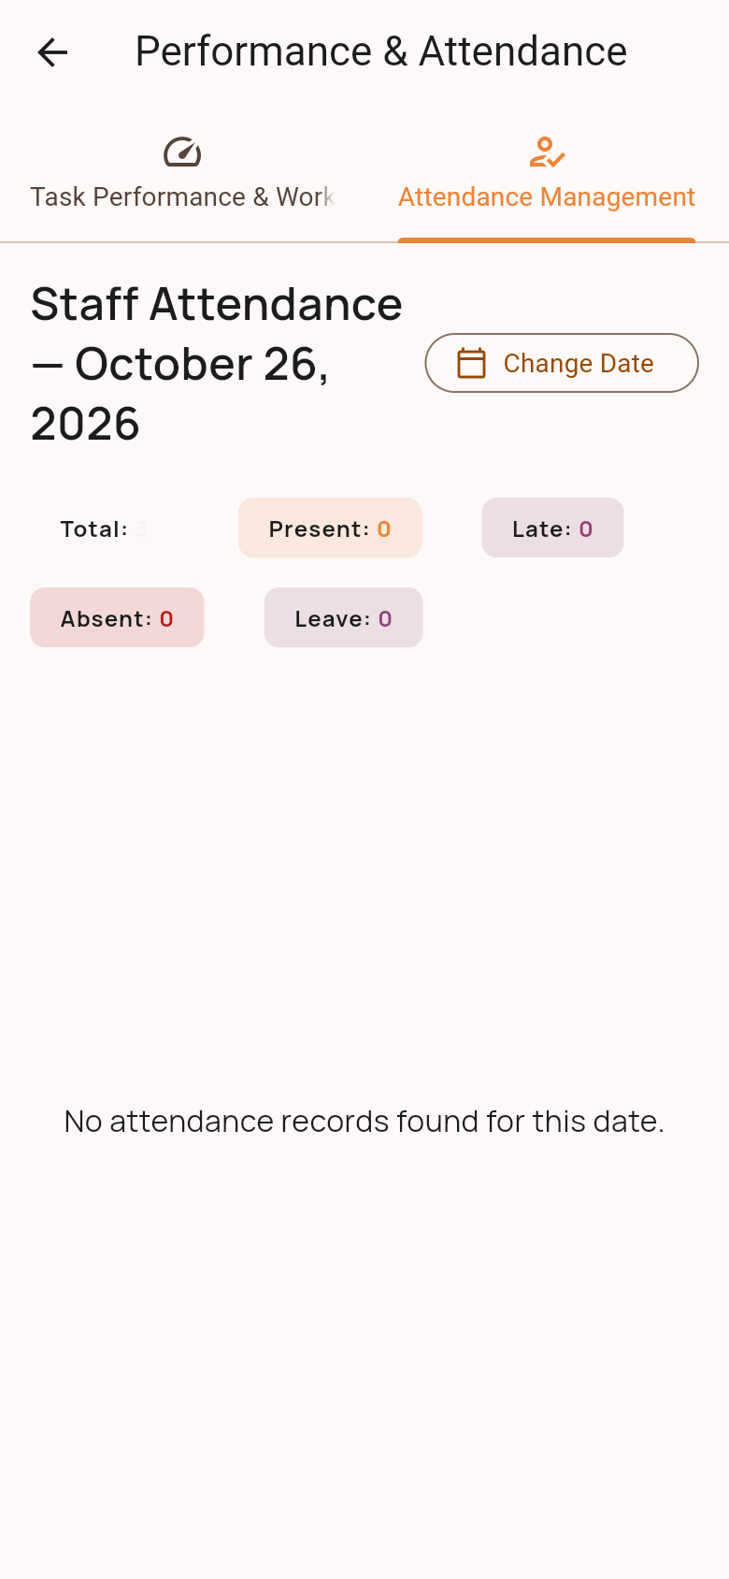
Figure 4.24: Performance & Workload Analytics Screen  Staff workload analysis dashboard showing completed tasks, patient interactions, and monthly attendance ratios. | Figure 4.25: Attendance Management Screen  Comprehensive staff attendance audit screen showing daily check-in times, late arrivals, and total hours worked.
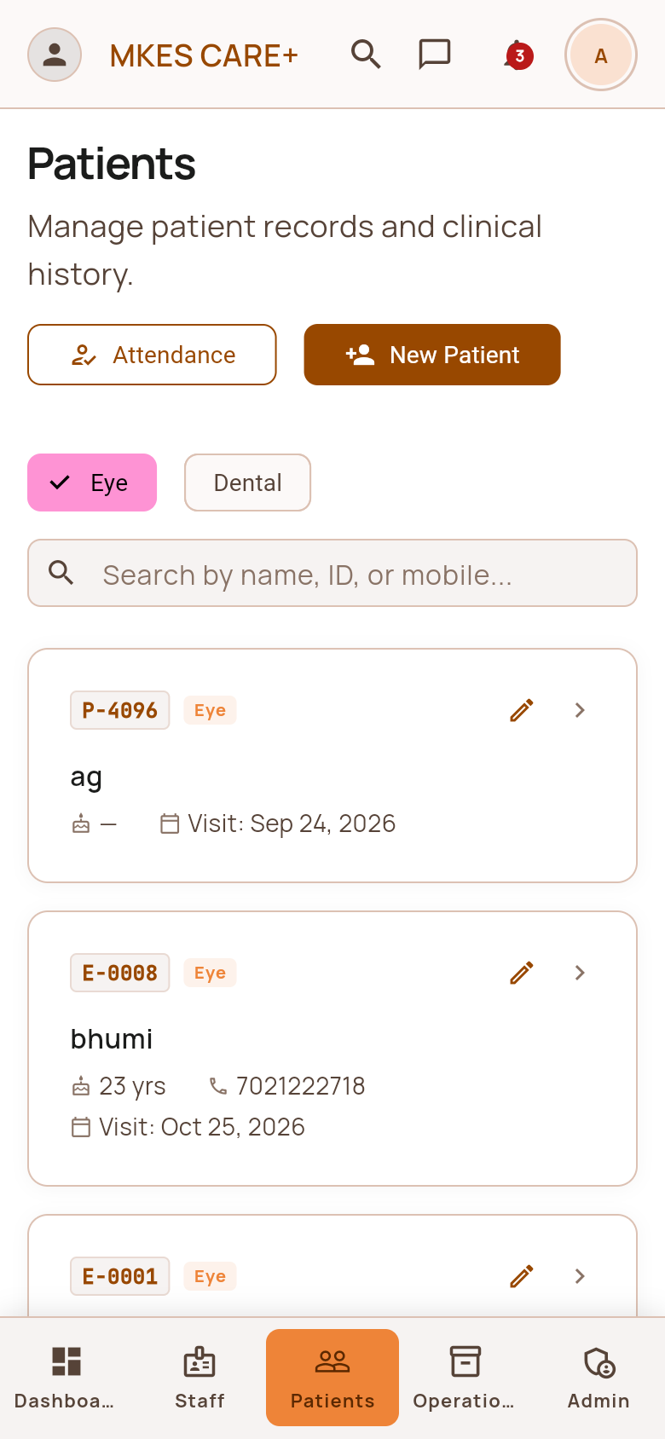 | 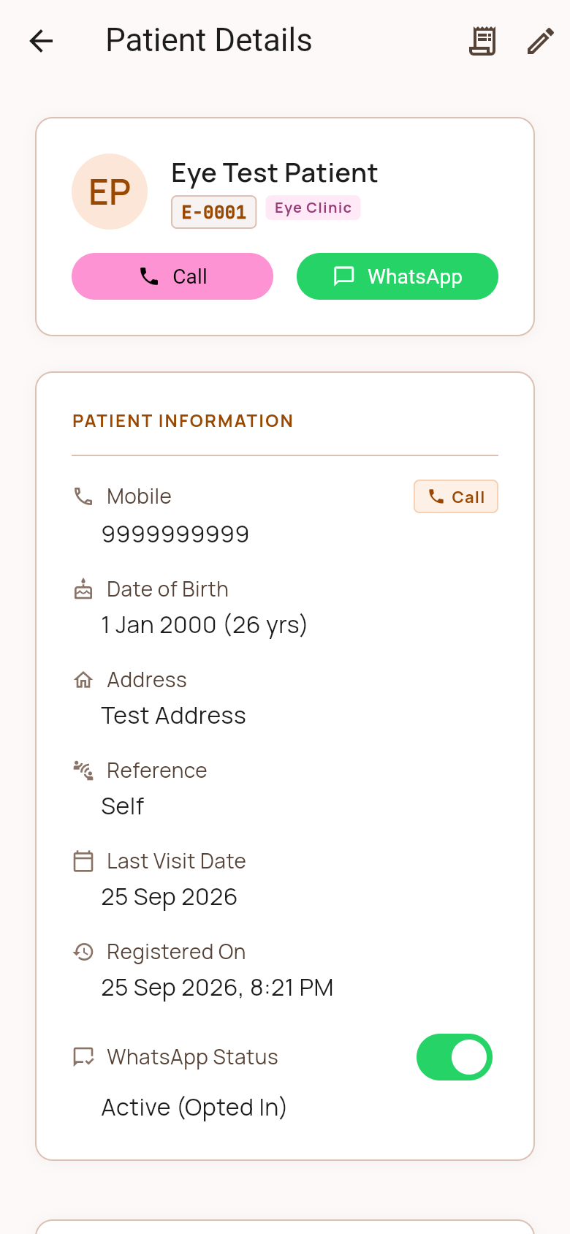
Figure 4.26: Admin Patient Management Screen  Centralized administrative patient registry supporting batch exports, profile updates, and clinical history audits. | Figure 4.27: Admin Patient Details Profile Screen  Detailed administrative view of patient history, medical diagnoses, appointment history, and billing records.
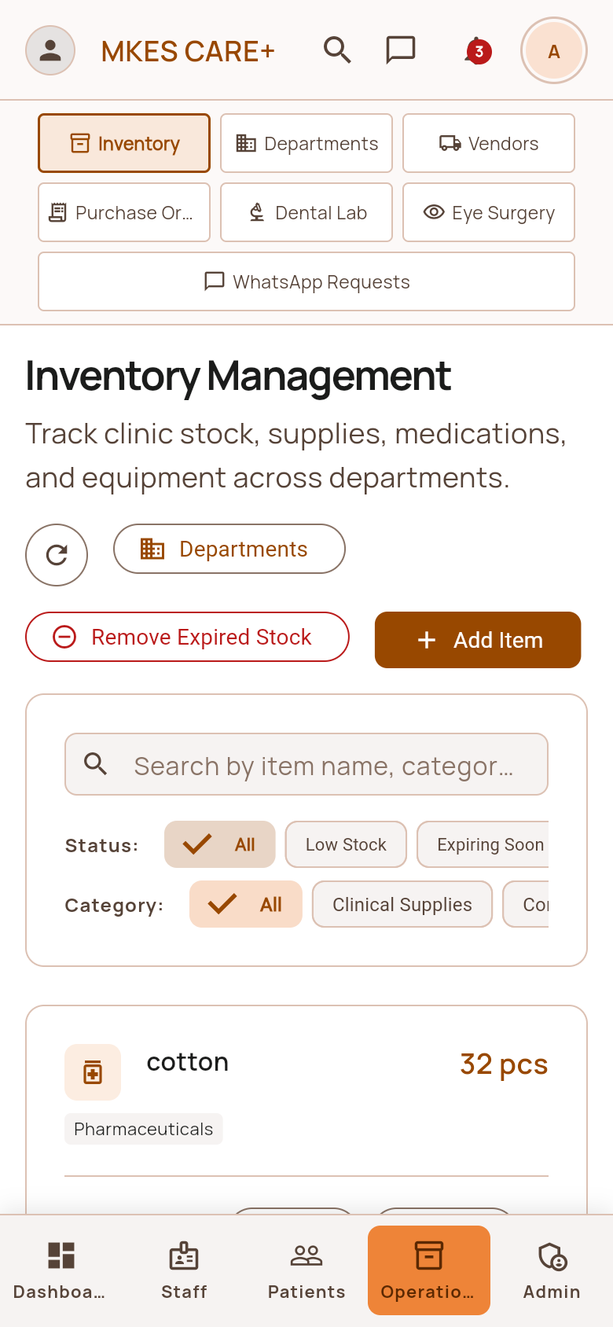 | 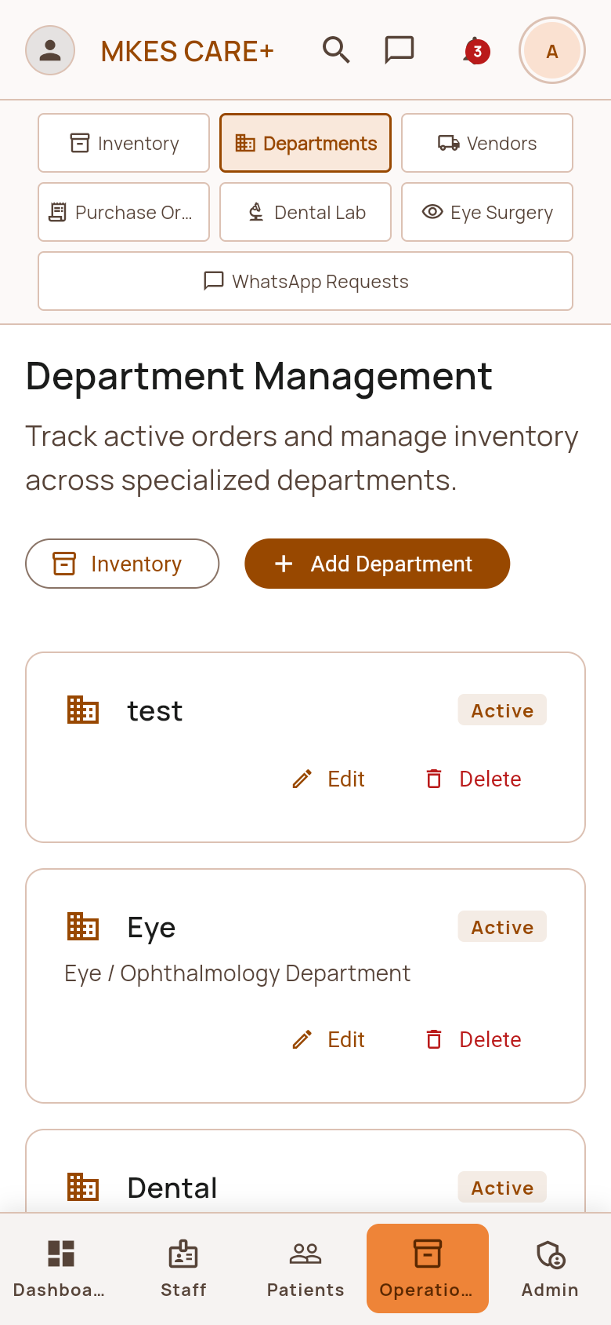
Figure 4.28: Operations Hub: Inventory Management Tab  Master inventory control hub showing stock quantities, batch numbers, reorder thresholds, and unit prices. | Figure 4.29: Operations Hub: Clinical Departments Tab  Departmental configuration tab managing Ophthalmology, Dentistry, Optometry, and General Reception settings.
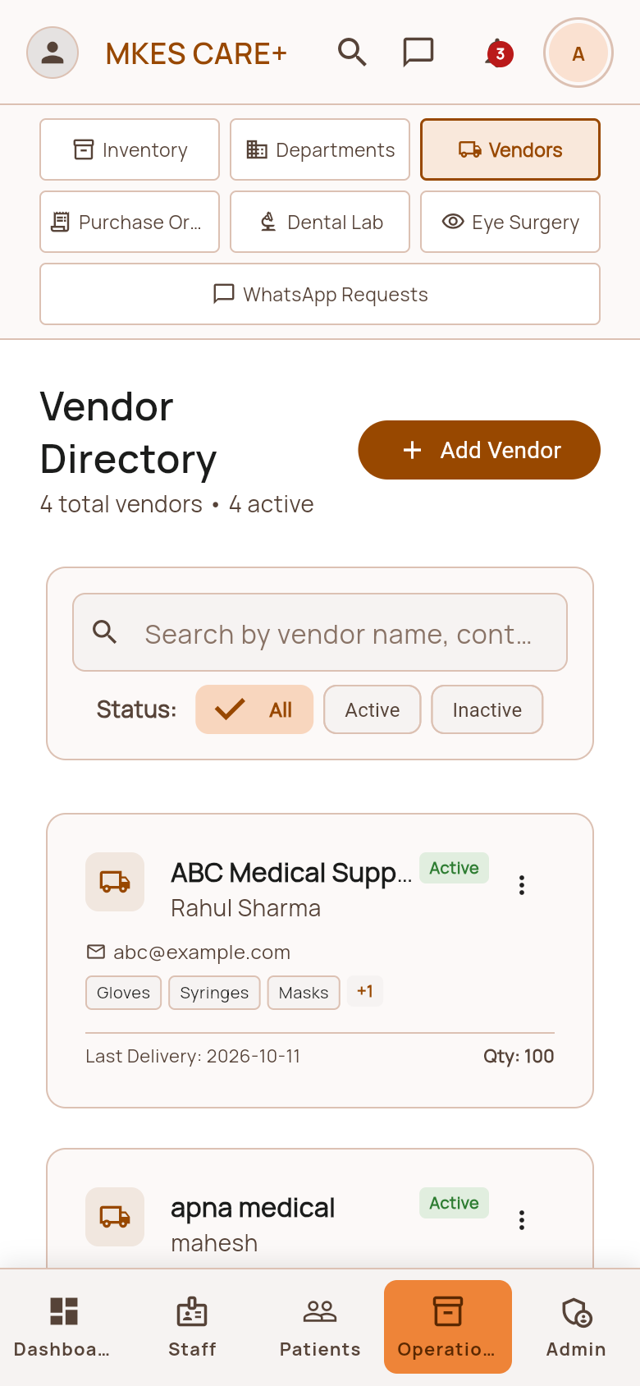 | 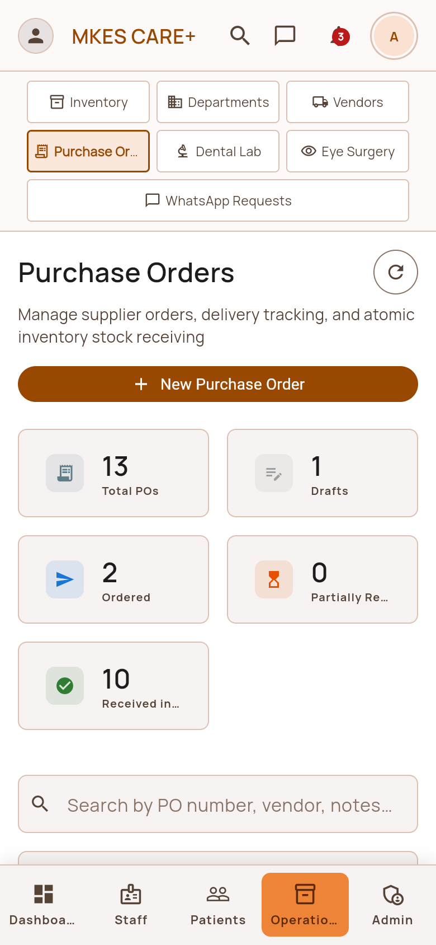
Figure 4.30: Operations Hub: Vendor Directory Tab  Master vendor directory enabling administrators to register suppliers, update catalogs, and review vendor ratings. | Figure 4.31: Operations Hub: Purchase Orders Tab  Administrative purchase order approval hub for verifying supplier quotations and authorizing procurement budgets.
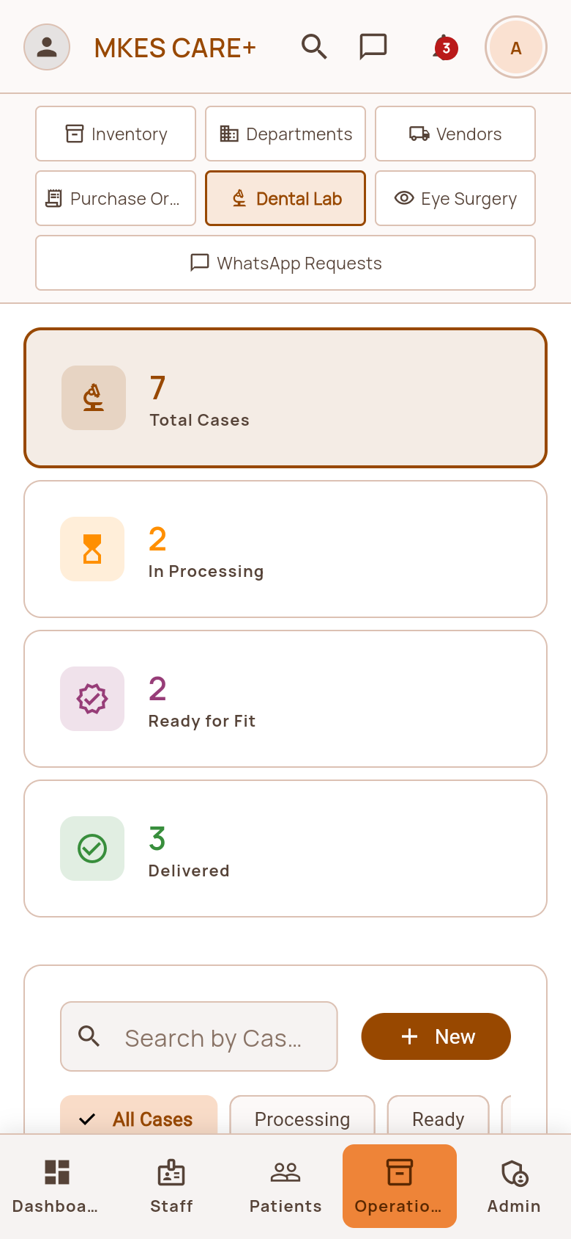 | 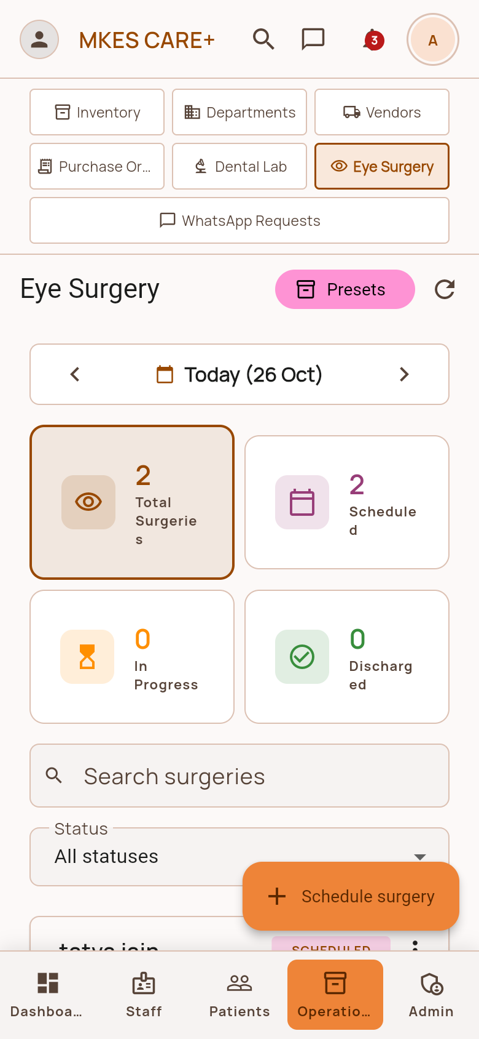
Figure 4.32: Operations Hub: Dental Laboratory Orders Tab  Master dental lab tracking tab showing order statuses (In-Lab, In-Transit, Ready) and lab billing costs. | Figure 4.33: Operations Hub: Eye Surgery Case Tracking Tab  Comprehensive surgery tracking tab monitoring patient admission, surgeon scheduling, and post-op follow-ups.
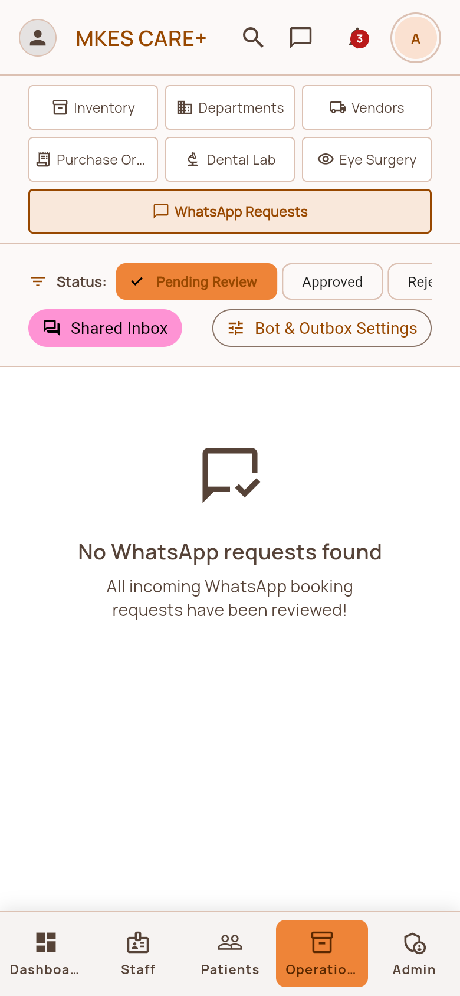 | 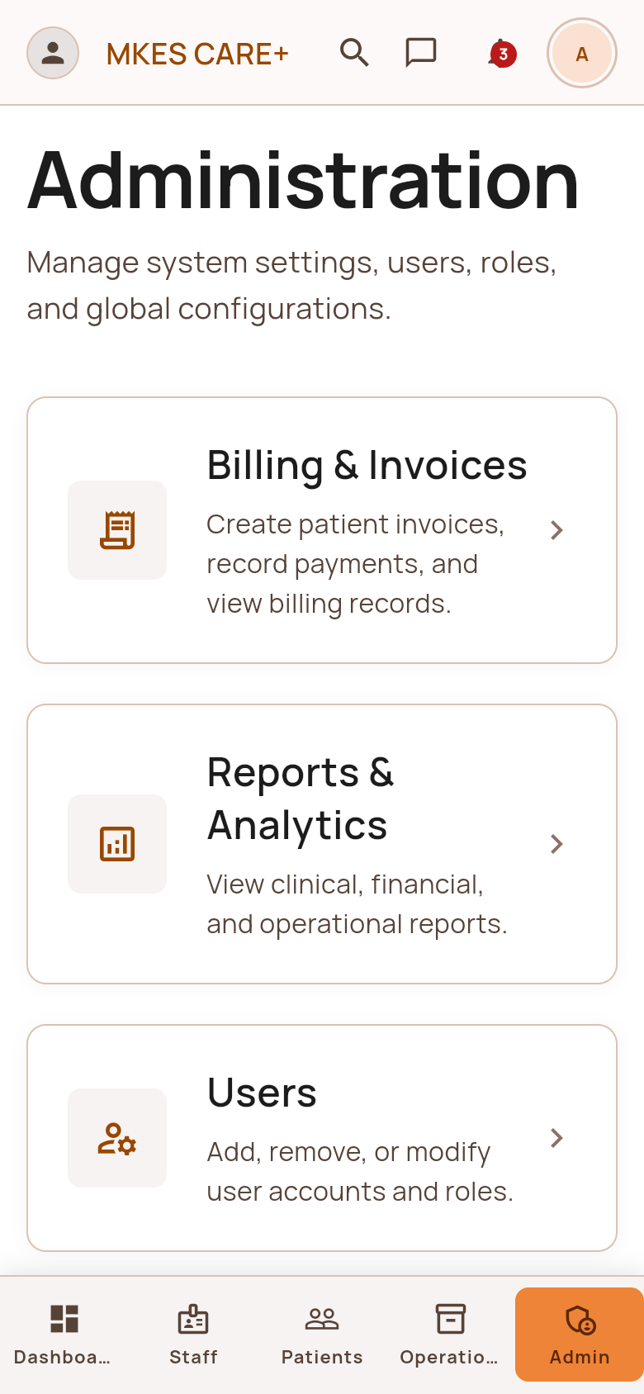
Figure 4.34: Operations Hub: WhatsApp Booking Requests Tab  Centralized queue for managing patient WhatsApp inquiries, auto-booking approvals, and custom broadcasts. | Figure 4.35: Administration Settings & Operations Hub  Core settings hub managing operational clinic parameters, department configurations, and security backups.
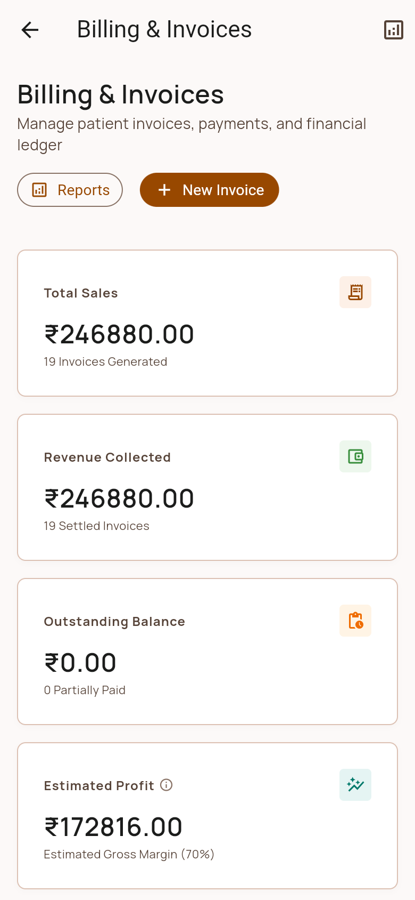 | 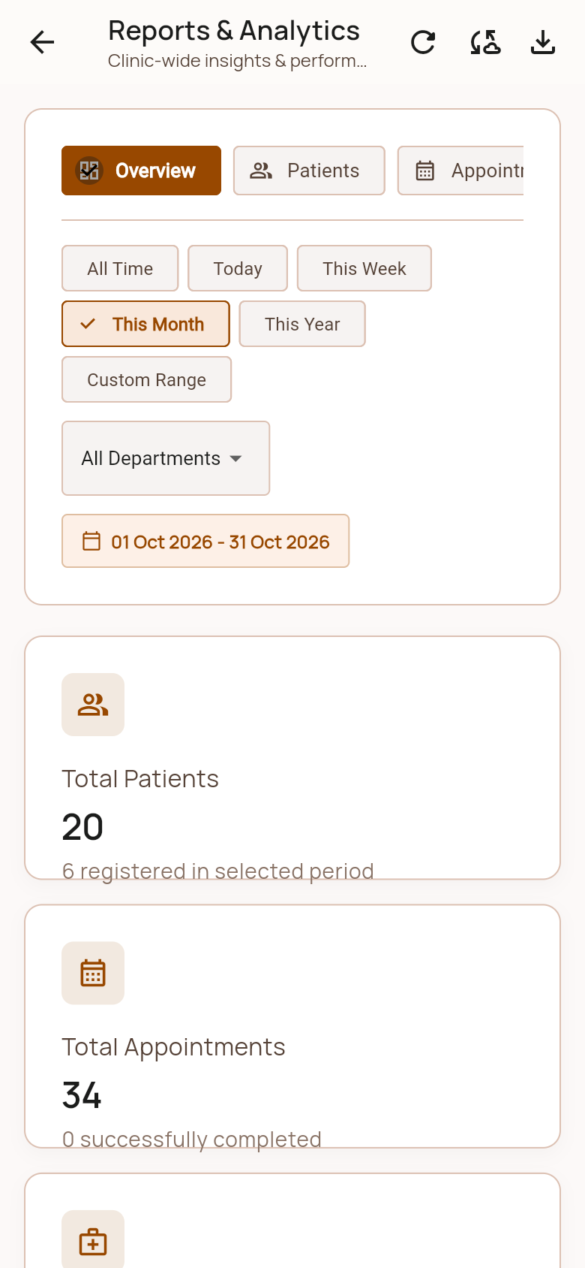
Figure 4.36: Billing & Financial Invoices Screen  Financial management screen listing all patient invoices, tax summaries, payment methods, and pending dues. | Figure 4.37: Reports & Business Analytics Dashboard  Executive business intelligence dashboard rendering daily, weekly, and monthly revenue trends and patient volume.
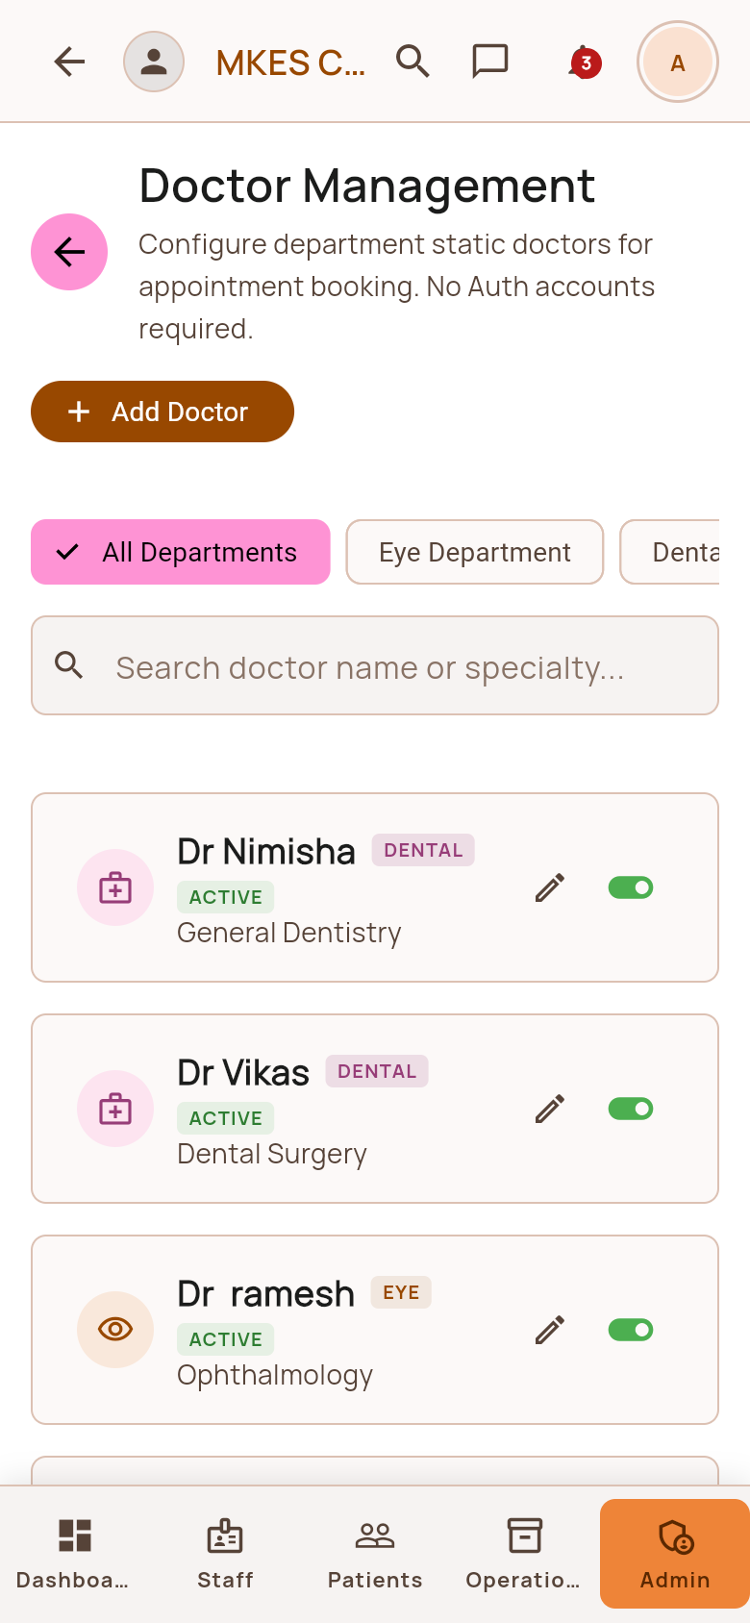 | 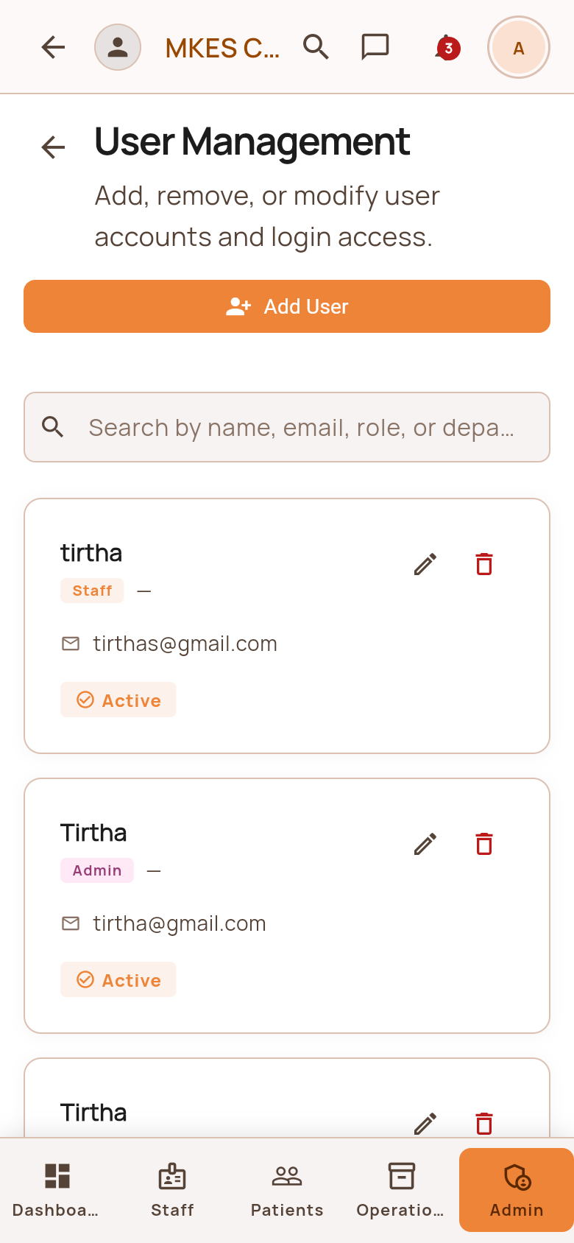
Figure 4.38: Doctor & Consulting Management Screen  Physician management console configuring doctor consultation hours, room assignments, and appointment fees. | Figure 4.39: User Accounts & Role Security Screen  User access control console managing role assignments, password resets, and account deactivations.
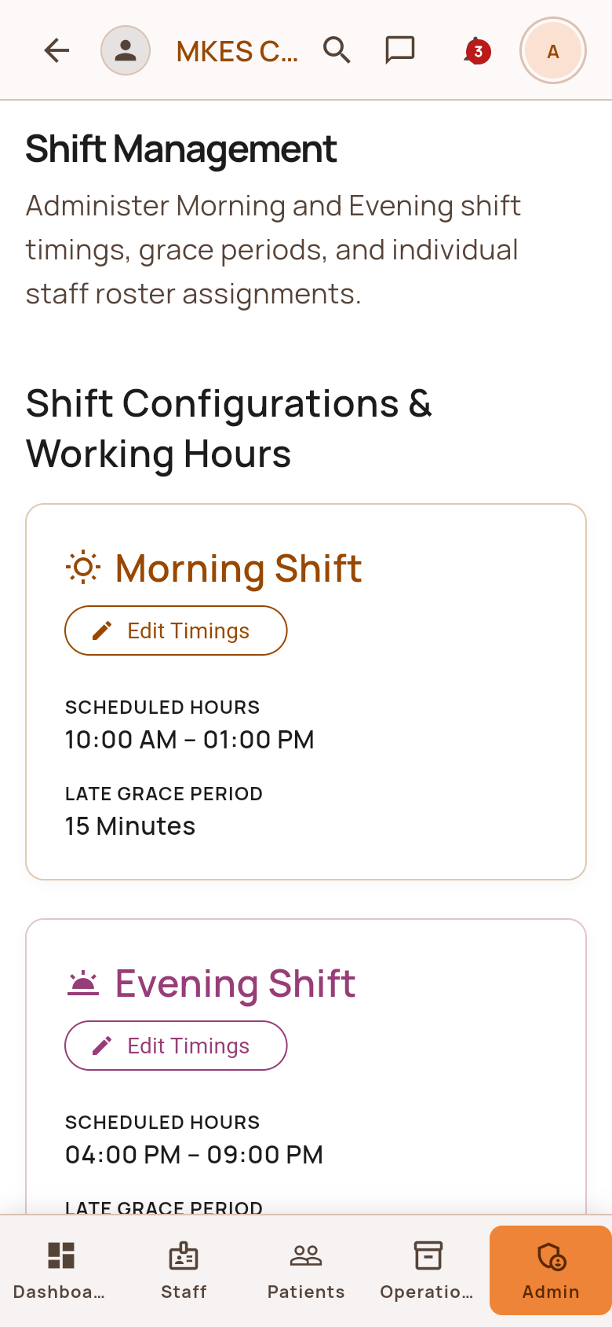 | 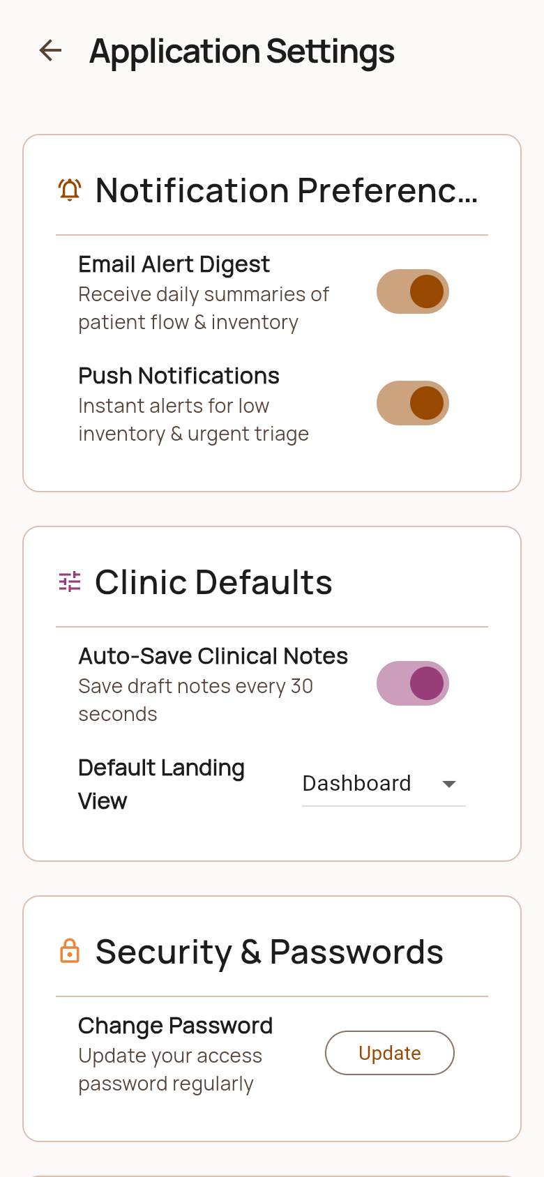
Figure 4.40: Shift Roster & Schedule Management Screen  Shift management grid enabling drag-and-drop staff scheduling across Morning, Evening, and Night clinic shifts. | Figure 4.41: Clinic Settings & Configurations Screen  Master clinic configuration screen managing clinic operating hours, contact details, and receipt headers.
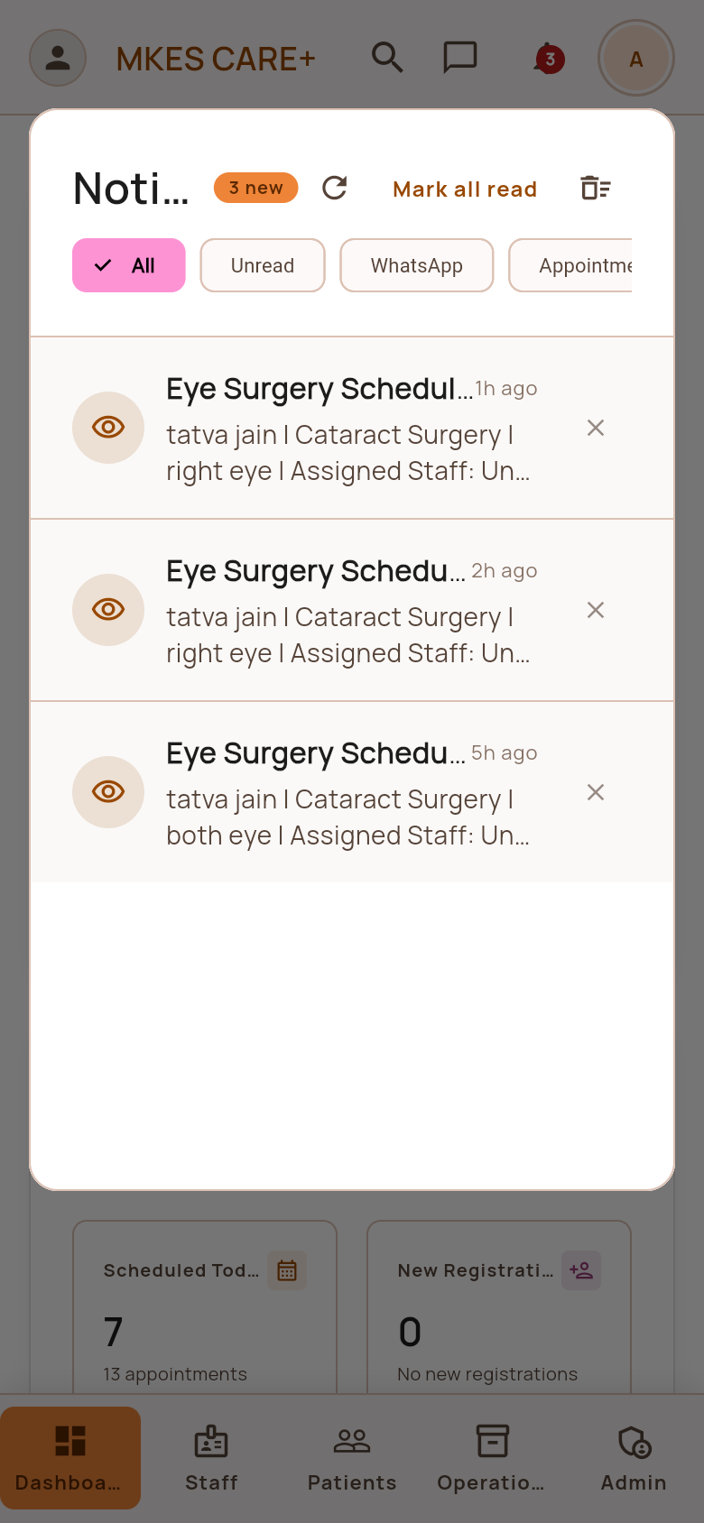 | 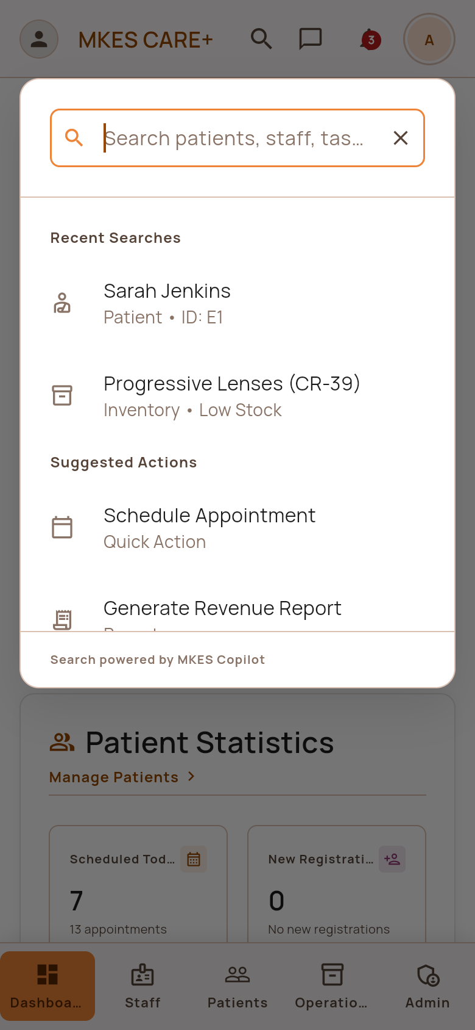
Figure 4.42: Admin Shared WhatsApp Inbox Screen  Administrative view of all incoming WhatsApp communication threads with multi-agent response capability. | Figure 4.43: System Notification Center Screen  High-priority administrative alert center showing critical stock depletion warnings and urgent lab deliveries.
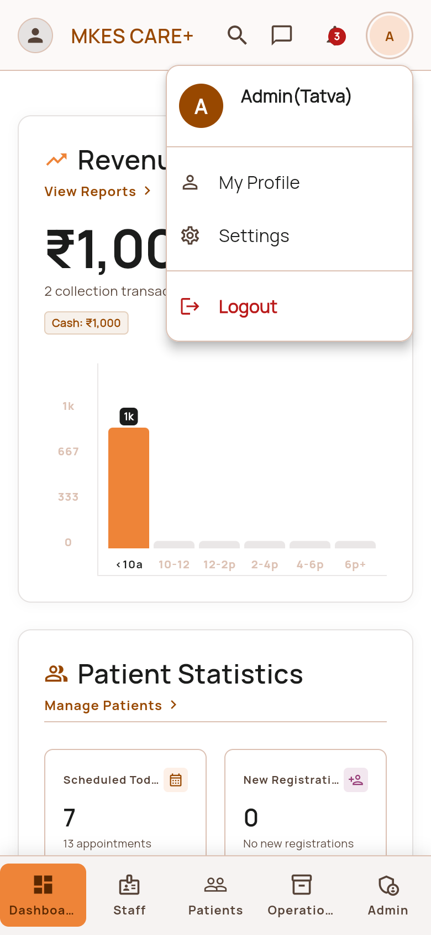 | [Admin Profile & Security Settings Screen]
Figure 4.44: Global Copilot Search Dialog Screen  Universal search bar enabling instant keyword navigation across patients, appointments, medicines, and invoices. | Figure 4.45: Admin Profile & Security Settings Screen  Administrator account settings screen managing multi-factor authentication, audit logs, and security keys.

CHAPTER 5

ADVANTAGES, LIMITATIONS, FUTURE SCOPE AND CONCLUSION

5.1 Advantages of MKES CARE+
The implementation of MKES CARE+ delivers substantial operational, financial, and clinical advantages:
1. Complete Operational Integration: Eliminates departmental silos by uniting patient records, appointment scheduling, inventory tracking, dental lab orders, and financial billing into a single centralized digital environment.
2. Drastic Reduction in Patient No-Shows: Automated WhatsApp reminders dispatched 24 hours prior to consultations, combined with interactive natural language rescheduling, significantly decreases missed clinical appointments.
3. Elimination of Revenue Leakage: Digital itemized point-of-sale invoicing with strict price validations, automated discount auditing, and multi-modal payment logging prevents billing discrepancies and uncollected fees.
4. Enhanced Clinical Supply Chain Reliability: First-Expiry-First-Out (FEFO) inventory algorithms and automated reorder alerts prevent stockouts of critical surgical consumables and eliminate expired pharmaceuticals.
5. Robust Staff Accountability: Real-time digital attendance tracking, categorized task checklists with deadline audits, and transparent leave management enhance daily staff productivity.
6. High-Performance Multi-Platform Accessibility: Google Flutter enables seamless native responsiveness on affordable Android smartphones, tablets, and desktop workstations without duplicate engineering overhead.

5.2 Limitations of the System
While MKES CARE+ successfully resolves the core operational challenges of specialized clinics, certain technical and environmental limitations exist:
1. Cloud Connectivity Dependency: Real-time data synchronization, Supabase REST operations, and multi-user concurrency require continuous, stable internet connectivity at the clinic premises.
2. WhatsApp Platform Policy Dependency: Conversational messaging relies on WhatsApp Web multi-device connectivity; protocol changes or network latency on the dedicated gateway device can occasionally delay message queues.
3. Initial Data Migration & Staff Onboarding: Transitioning from traditional physical paper ledgers requires an initial data entry phase and short staff training sessions to familiarize personnel with digital workflows.
4. External Laboratory Integration Scope: While dental lab orders are tracked end-to-end within the clinic, automated status updates currently depend on staff verification rather than a direct electronic API link to external lab software.

5.3 Future Scope
The architectural modularity of MKES CARE+ offers extensive opportunities for future expansion and innovation:
1. Patient Self-Service Mobile Application: Expanding the platform to include a dedicated patient-facing mobile application allowing patients to book consultations, view digital prescriptions, and download invoices directly.
2. AI-Powered Clinical Copilot & Triage: Integrating machine learning models to assist consulting doctors with clinical note summarization, voice-to-text prescription generation, and automated eye/dental triage recommendations.
3. Multi-Branch Enterprise Scaling: Enhancing database schemas with multi-tenant schema partitioning to support hospital networks operating across multiple geographically dispersed clinic branches.
4. Integrated Payment Gateway SDKs: Incorporating native in-app payment SDKs (Razorpay / Stripe) to support contactless online consultation prepayments and instant UPI QR dynamic generation.

5.4 Acknowledgement
We are pleased to present our project “MKES CARE+ : An Integrated Clinic Management System for Eye and Dental Clinics” and take this opportunity to express our sincere gratitude to everyone who contributed to the successful completion of this engineering work.
We extend our heartfelt gratitude to Bhagubhai Hospital Polytechnic and College of Engineering for providing the requisite academic infrastructure, technical guidance, and supportive environment throughout the project. The availability of high-speed computing laboratories, network facilities, and development software played a fundamental role in our ability to design, implement, and validate the platform successfully.
We are especially grateful to the Head of the Information Technology Department, teaching and non-teaching faculty members, and laboratory assistants for their enduring cooperation and assistance whenever technical resources and administrative permissions were required.
We express our deepest, most profound gratitude to our project guide, Mrs. Krishna Bhatt, for her continuous mentorship, invaluable guidance, rigorous technical feedback, and steady encouragement throughout every phase of the development of MKES CARE+. Her timely insights, patience, and constructive critique empowered us to overcome complex architectural challenges during Flutter development, database schema modeling, and WhatsApp automation integration. Her inspiring guidance motivated us to deliver a robust, practical software solution meeting high industry standards.
Lastly, we express our heartfelt thanks to our parents, family members, and classmates for their constant moral support, encouragement, and understanding throughout the duration of this academic endeavor.

5.5 Conclusion
MKES CARE+ successfully demonstrates how modern cross-platform software engineering, cloud-native relational databases, and conversational messaging automation can unite to modernize the administrative and clinical workflows of specialized eye and dental outpatient clinics. By synthesizing patient management, multi-doctor appointment scheduling, staff coordination, clinical inventory governance, dental laboratory tracking, and automated billing into a cohesive, user-friendly digital system, the platform resolves the critical bottlenecks of paper-based clinic administration.
Built using Flutter, Supabase, PostgreSQL 15, and an autonomous Node.js WhatsApp daemon, MKES CARE+ achieves high performance, robust data integrity, and substantial reductions in administrative workload. The practical deployment of automated 24-hour appointment reminders and conversational rescheduling significantly enhances patient satisfaction while preventing clinic revenue loss. In summary, MKES CARE+ fulfills all specified academic and clinical objectives, presenting a comprehensive, production-ready blueprint for the future of digital outpatient healthcare management.

5.6 References
[1] Flutter Team, “Flutter Documentation: Multi-Platform UI Toolkit,” Google LLC, 2024. [Online]. Available: https://docs.flutter.dev/
[2] Dart Language Team, “Dart Programming Language Specification & Core Libraries,” Google LLC, 2024. [Online]. Available: https://dart.dev/guides
[3] Supabase Inc., “Supabase Architecture, Authentication & Storage Documentation,” Supabase, 2024. [Online]. Available: https://supabase.com/docs
[4] PostgreSQL Global Development Group, “PostgreSQL 15.0 Reference Manual: Relational Database System,” 2024. [Online]. Available: https://www.postgresql.org/docs/
[5] P. Zhao, I. Yoo, J. Lavoie, B. J. Lavoie, and E. Simoes, “Web-Based Medical Appointment Systems: A Systematic Review,” Journal of Medical Internet Research, vol. 19, no. 4, p. e134, 2017. doi: 10.2196/jmir.6747. [Online]. Available: https://doi.org/10.2196/jmir.6747
[6] A. Ala and F. Chen, “Appointment Scheduling Problem in Complexity Systems of the Healthcare Services: A Comprehensive Review,” Journal of Healthcare Engineering, vol. 2022, article 5819813, 2022. doi: 10.1155/2022/5819813. [Online]. Available: https://doi.org/10.1155/2022/5819813
[7] E. Saha and P. K. Ray, “Modelling and analysis of inventory management systems in healthcare: A review and reflections,” Computers & Industrial Engineering, vol. 137, article 106051, 2019. doi: 10.1016/j.cie.2019.106051. [Online]. Available: https://doi.org/10.1016/j.cie.2019.106051
[8] Q. Nguyen, M. Wybrow, F. Burstein, D. Taylor, and J. Enticott, “Understanding the impacts of health information systems on patient flow management: A systematic review,” PLOS ONE, vol. 17, no. 9, e0274493, 2022. doi: 10.1371/journal.pone.0274493. [Online]. Available: https://doi.org/10.1371/journal.pone.0274493
[9] World Health Organization, Global Strategy on Digital Health 2020–2025. Geneva, Switzerland: World Health Organization, 2021. ISBN: 978-92-4-002092-4. [Online]. Available: https://www.who.int/publications/i/item/9789240020924
[10] wwebjs Community, “whatsapp-web.js: A WhatsApp Client Library for Node.js,” GitHub Open Source Repository, 2024. [Online]. Available: https://github.com/wwebjs/whatsapp-web.js
[11] Google Developers, “Android Studio Tools & Android SDK Documentation,” Google LLC, 2024. [Online]. Available: https://developer.android.com/studio
[12] Docker Inc., “Docker Engine and Compose Documentation,” Docker Inc., 2024. [Online]. Available: https://docs.docker.com/

