MKES CARE+ — Mobile Application Screen Catalog
High-fidelity 2 × 2 mobile portrait visual index for application presentation & documentation
Section 1: Login & Authentication | 3 Screens
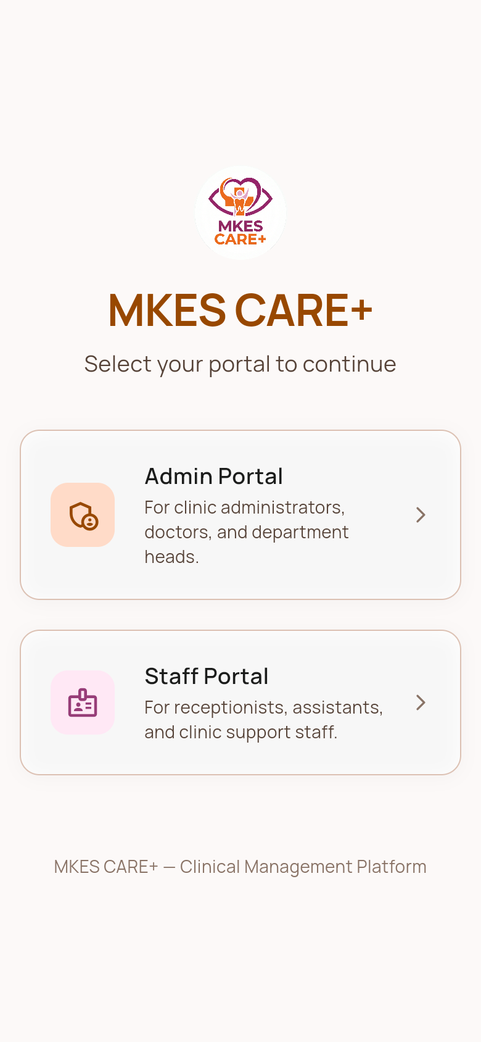  Role Selection Landing • Public / Auth | 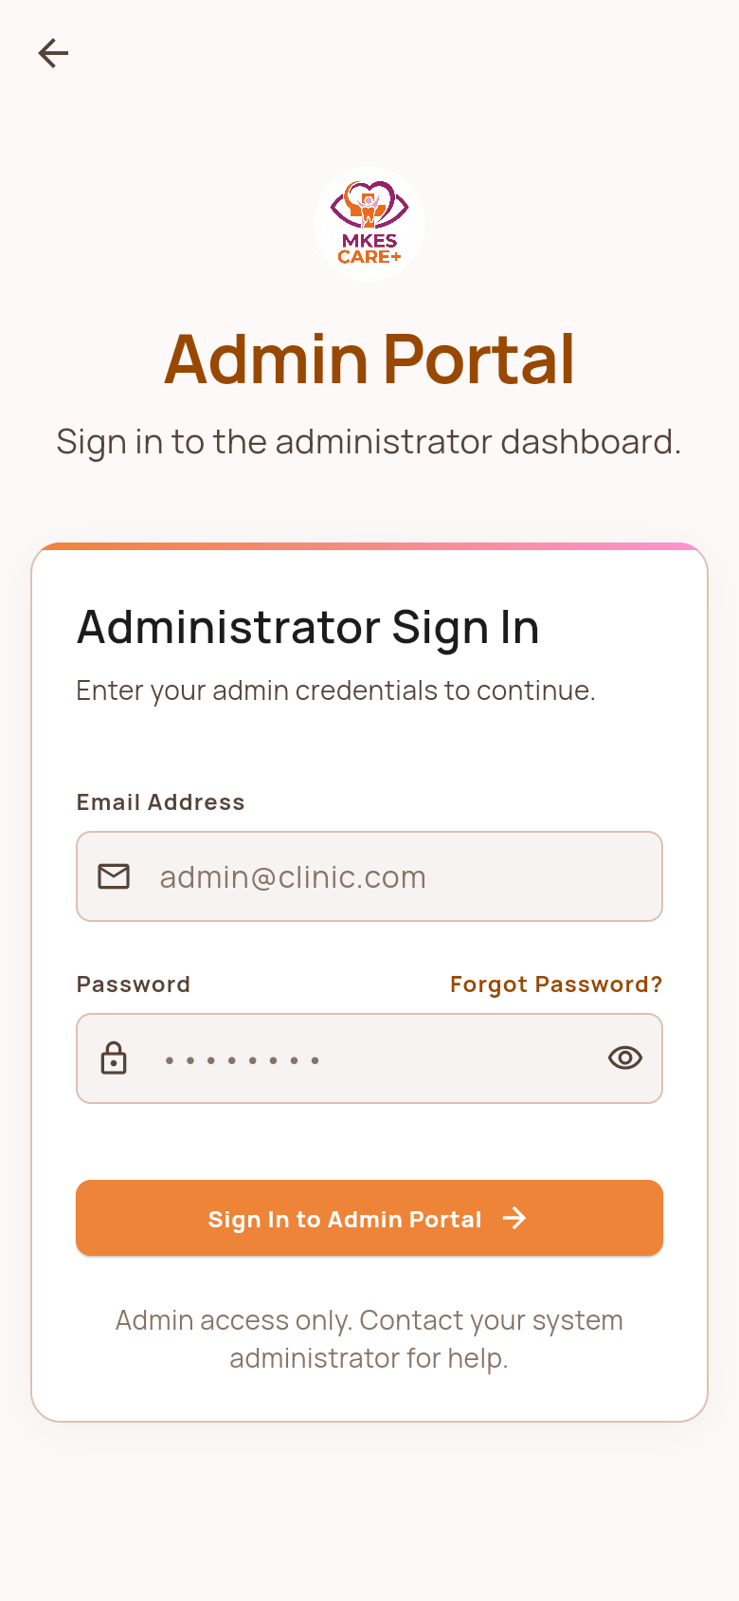  Admin Portal Sign In • Admin Portal
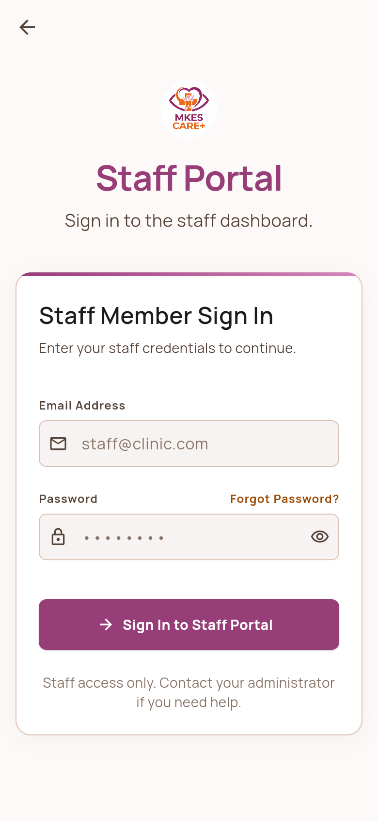
Staff Portal Sign In • Staff Portal

Section 2: Staff Portal | Page 1 of 4 • 4 Screens
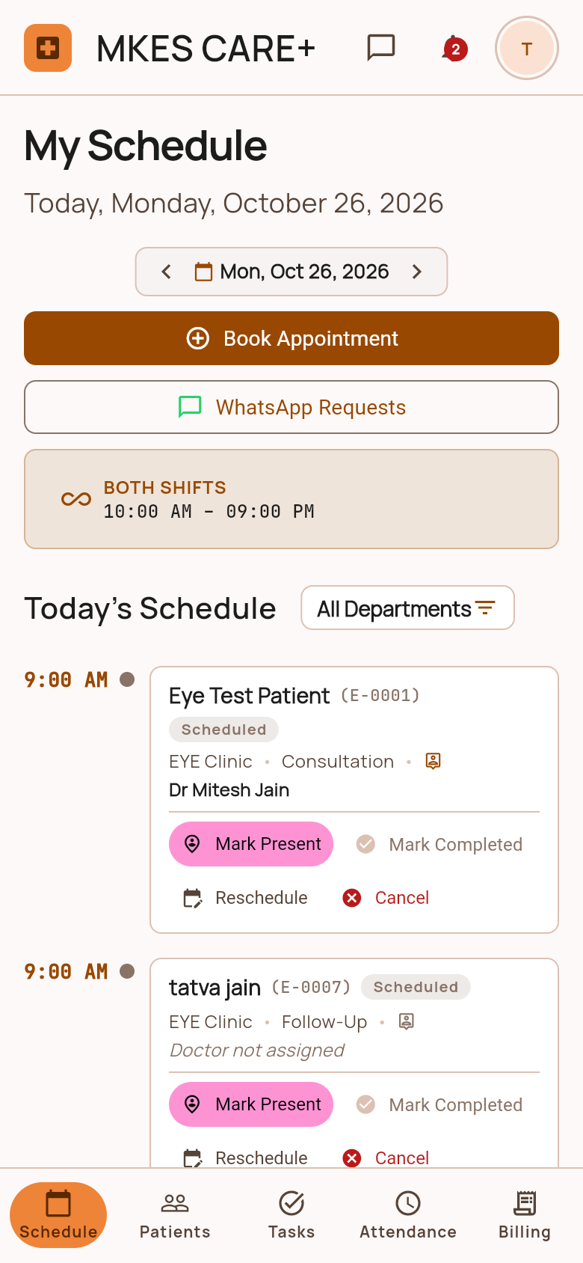  Staff Schedule & Appointments • Staff Portal | 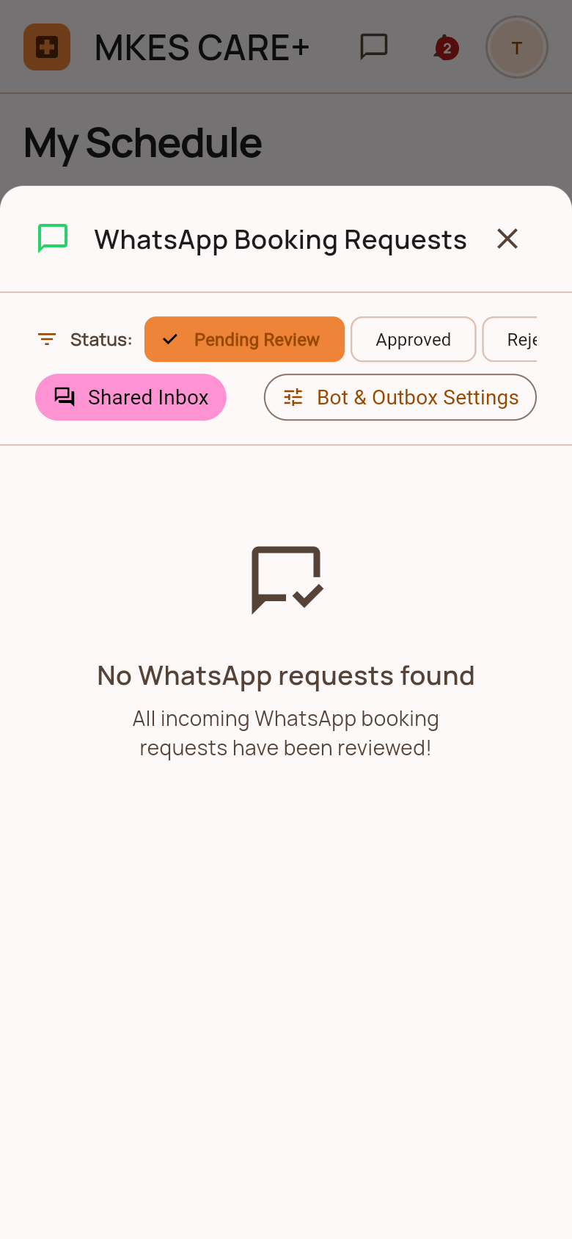  WhatsApp Booking Requests Sheet • Staff Portal
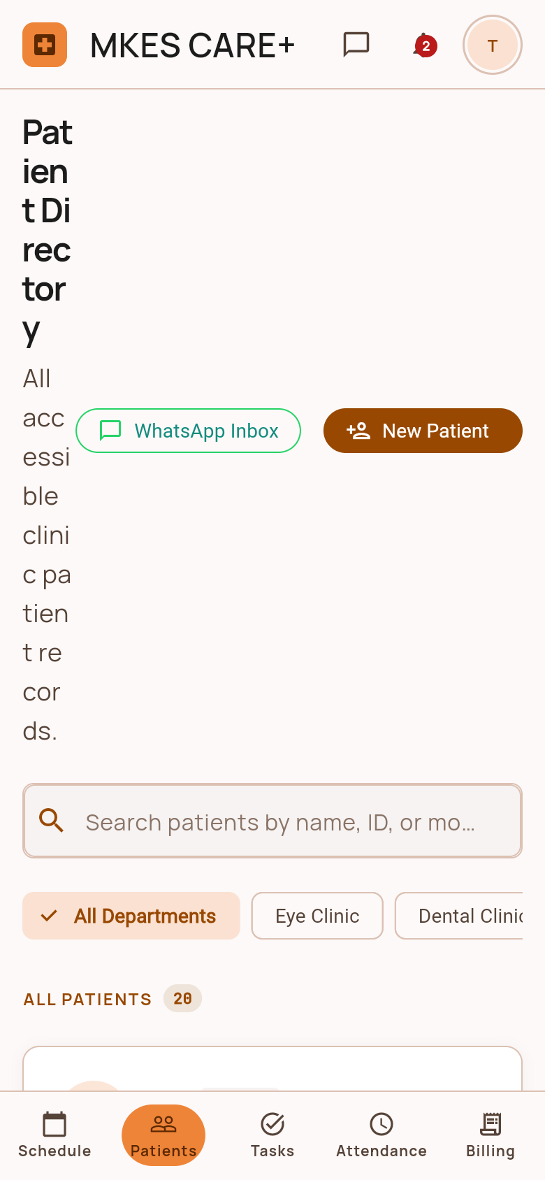  Staff Patient Directory • Staff Portal | 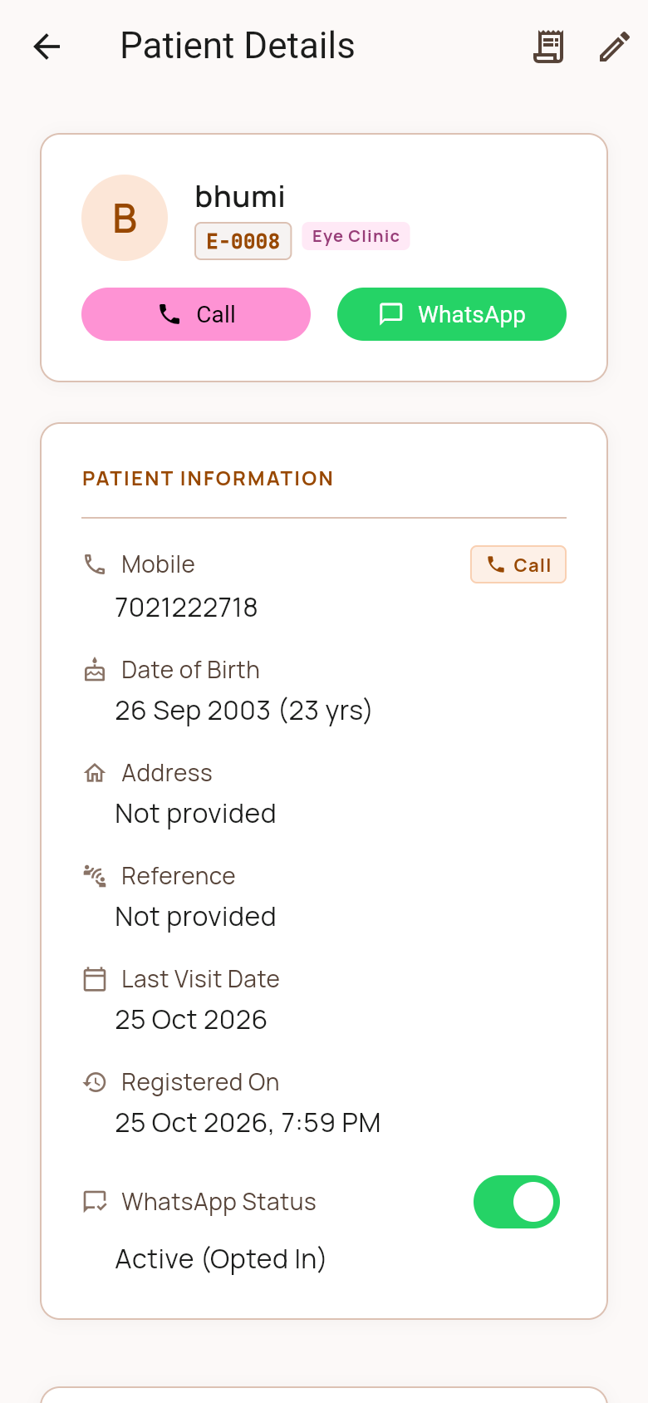  Patient Details Profile • Staff Portal

Section 2: Staff Portal | Page 2 of 4 • 4 Screens
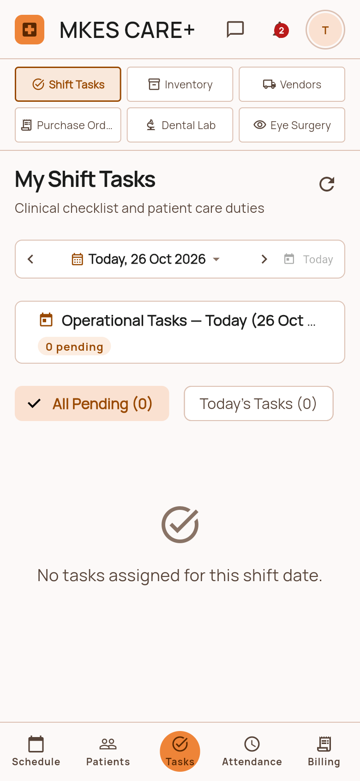  My Shift Tasks & Checklist • Staff Portal | 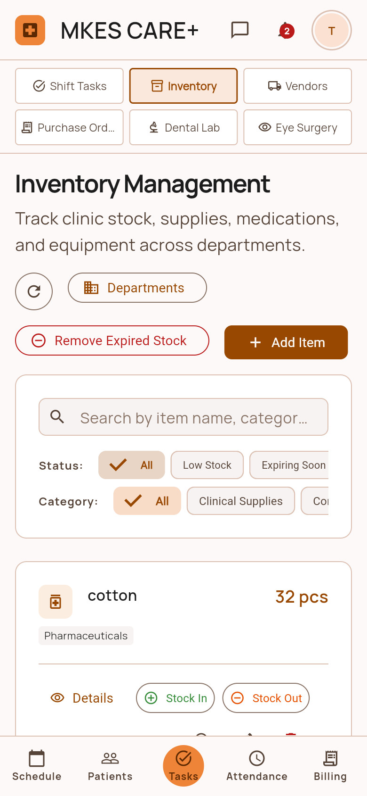  Clinical Inventory Tracker • Staff Portal
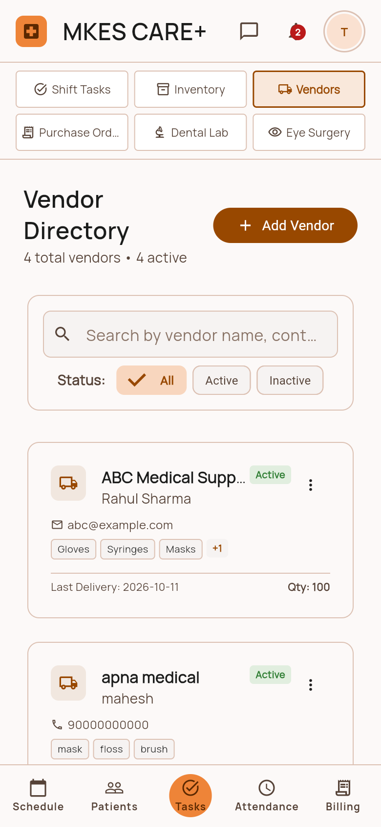  Clinical Vendor Directory • Staff Portal | 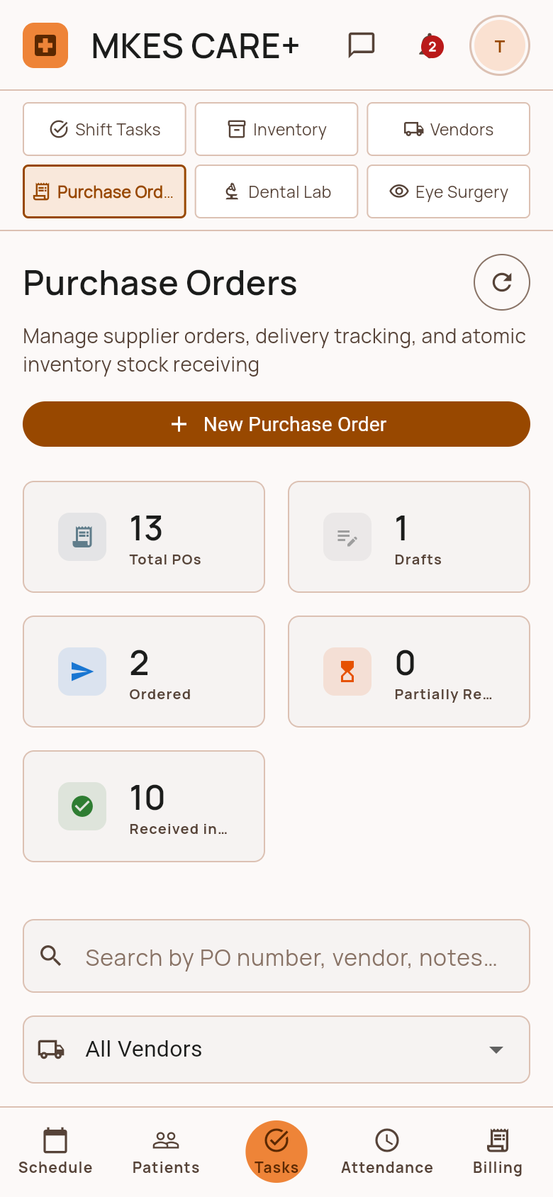  Purchase Orders Register • Staff Portal

Section 2: Staff Portal | Page 3 of 4 • 4 Screens
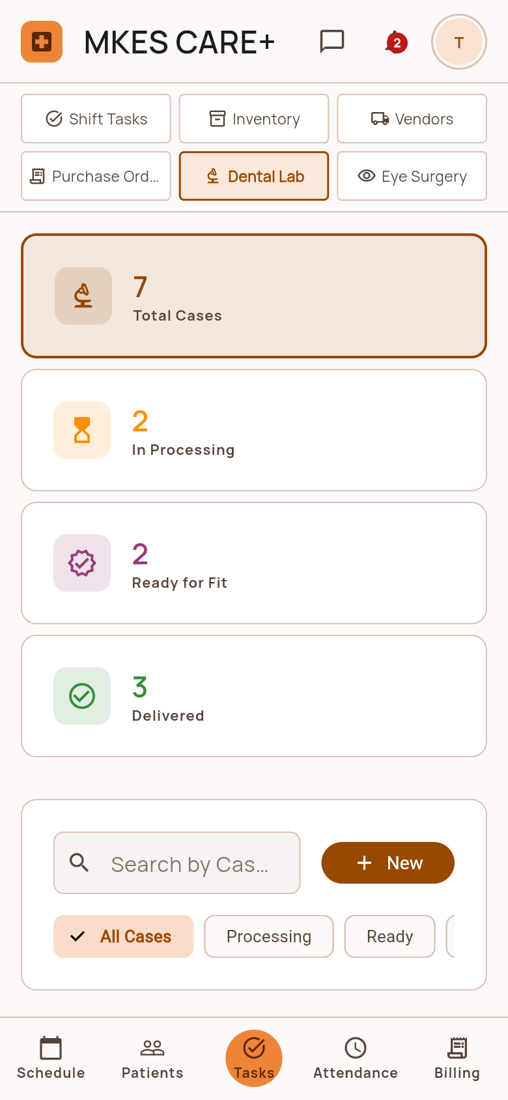  Dental Lab Work Orders • Staff Portal | 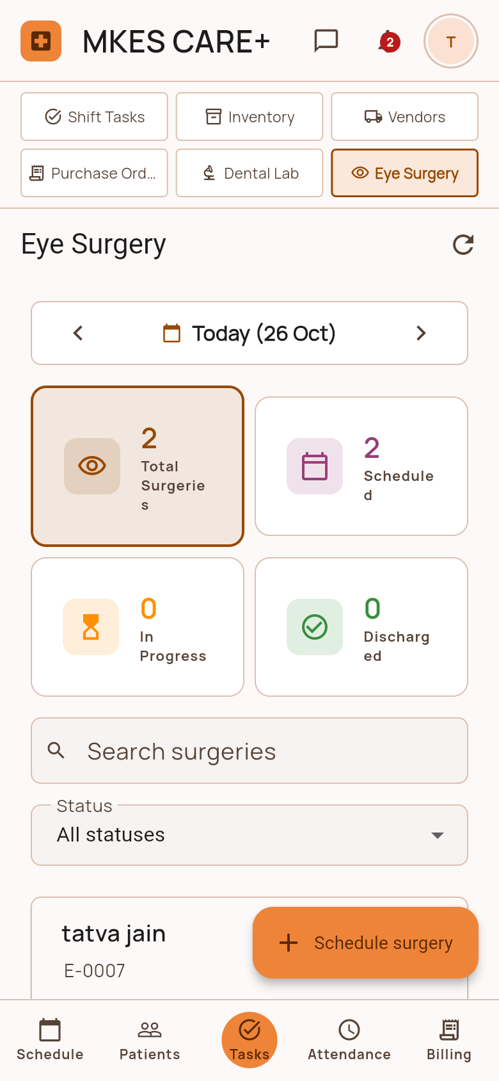  Eye Surgery Case Pipeline • Staff Portal
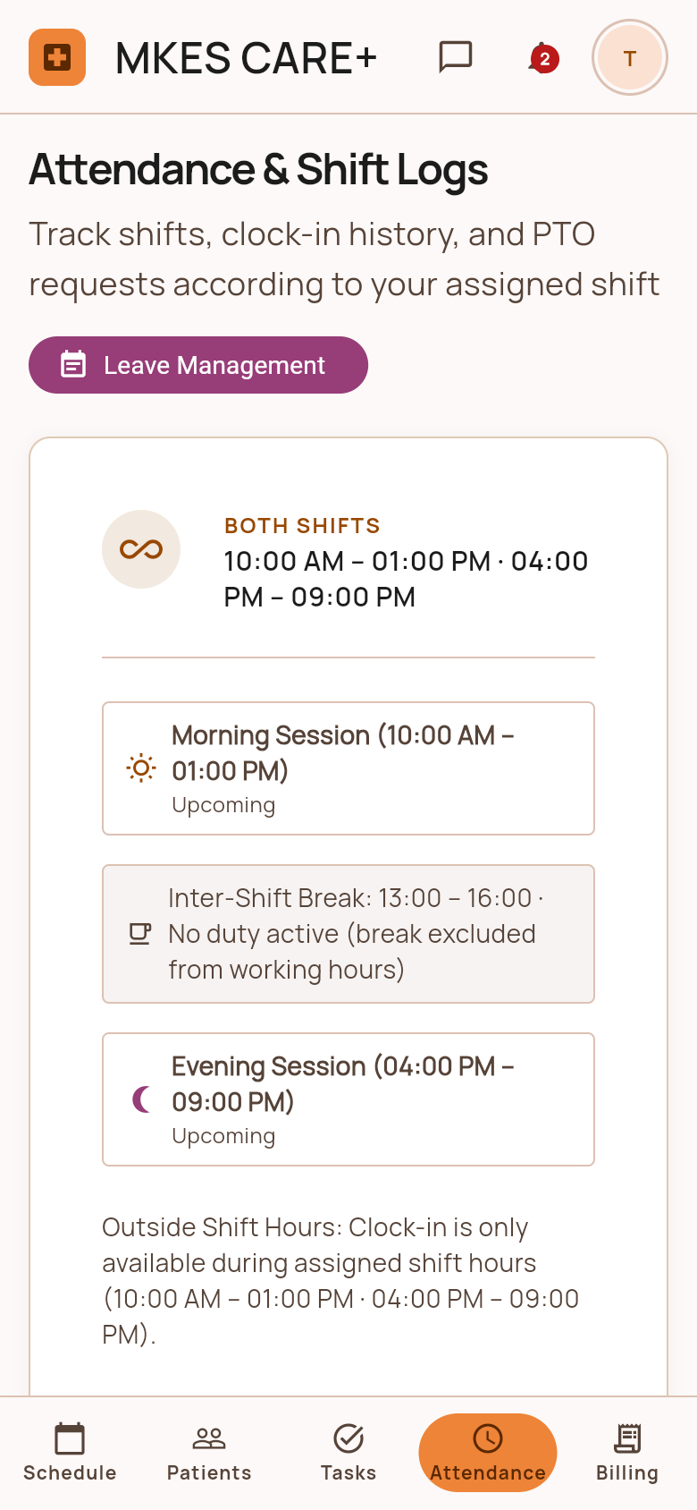  Staff Attendance & Shift Logs • Staff Portal | 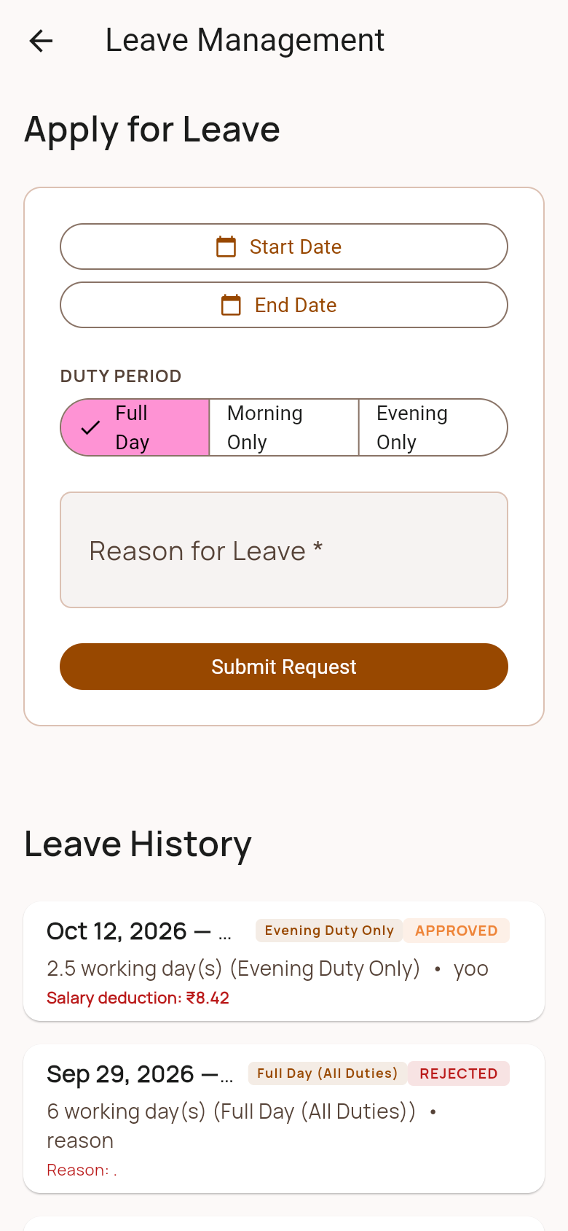  Staff Leave Portal & Quotas • Staff Portal

Section 2: Staff Portal | Page 4 of 4 • 4 Screens
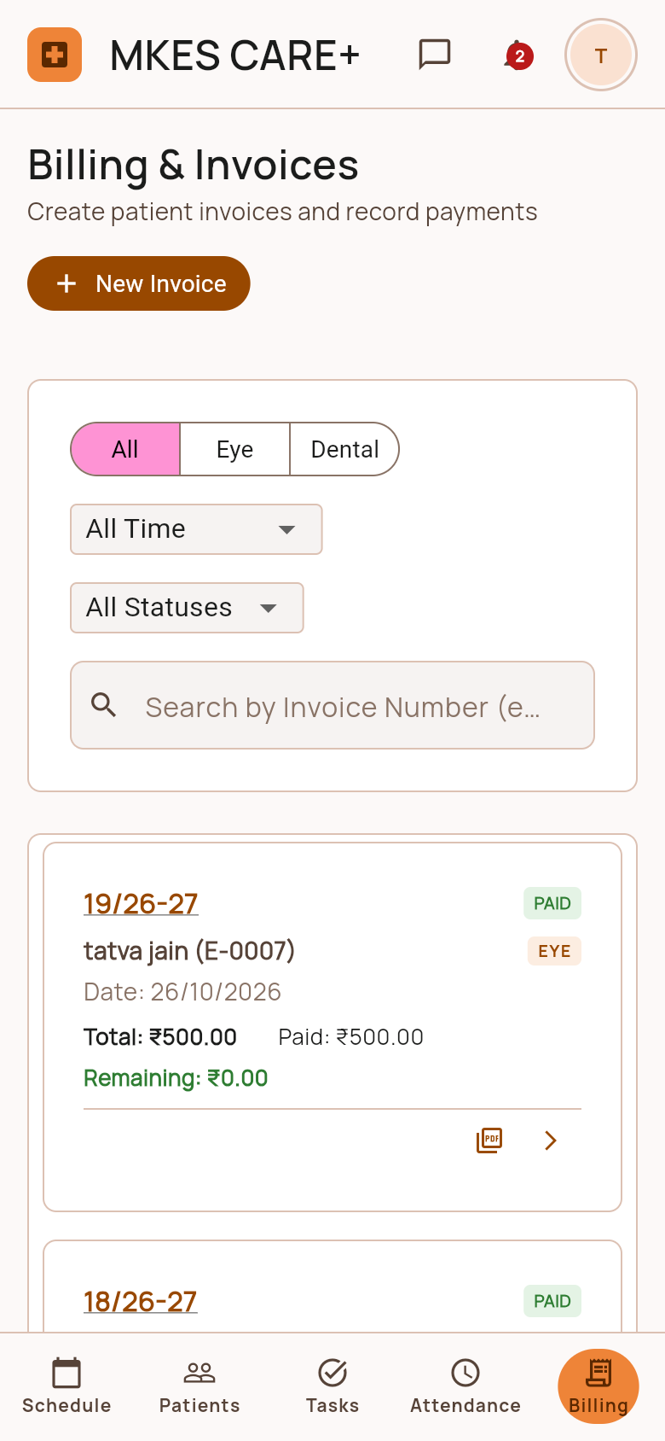  Staff Billing & Invoices • Staff Portal | 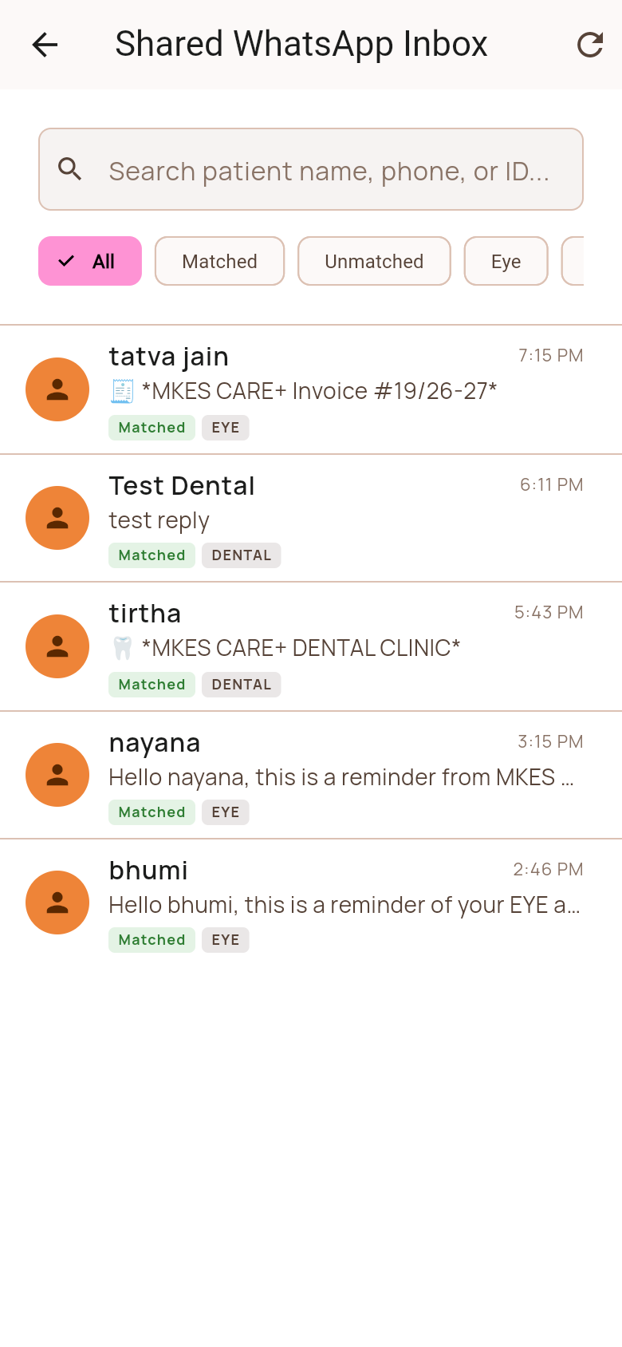  Shared WhatsApp Chat Inbox • Staff Portal
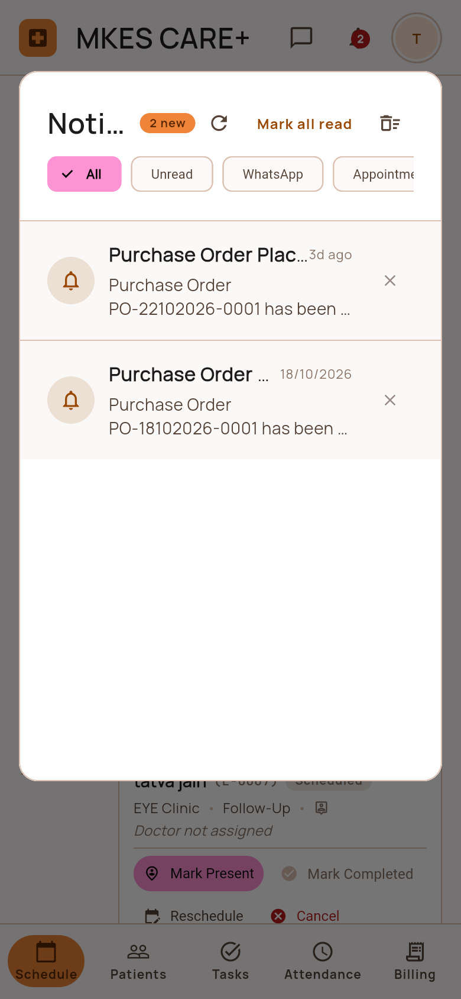  Staff Notification Center • Staff Portal | 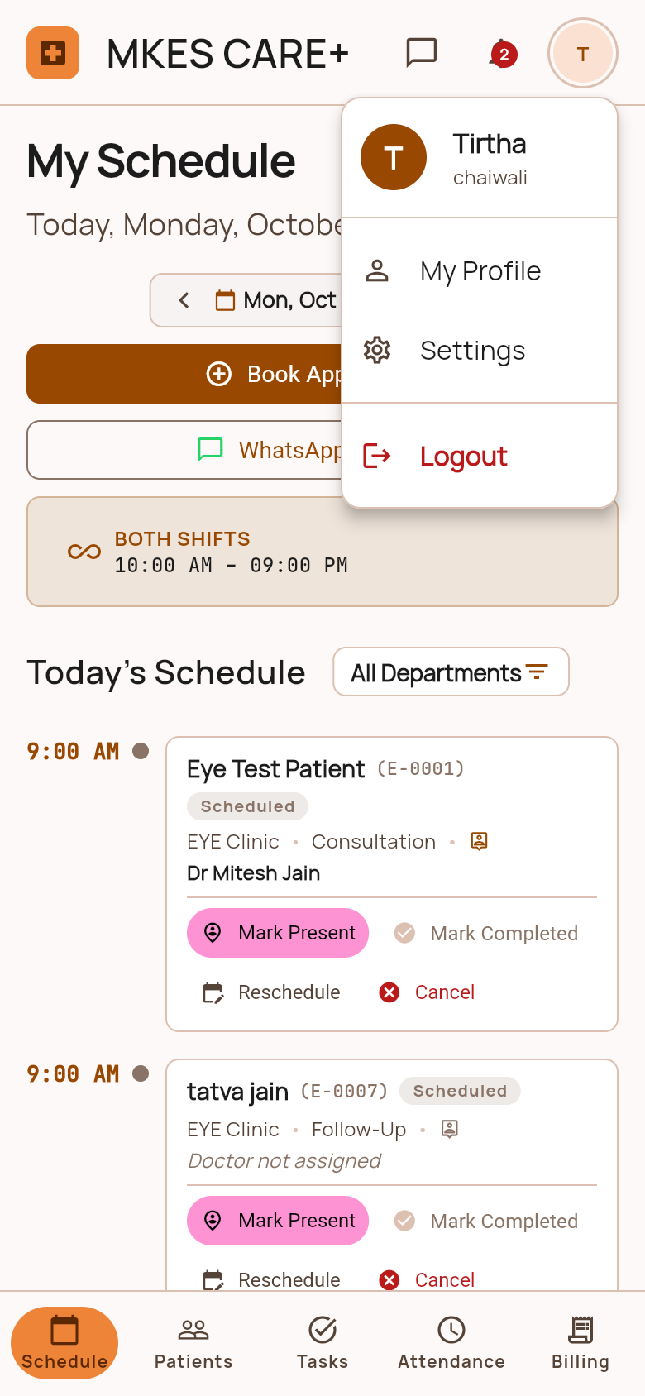  Staff Profile & Settings • Staff Portal

Section 3: Admin Portal | Page 1 of 7 • 4 Screens
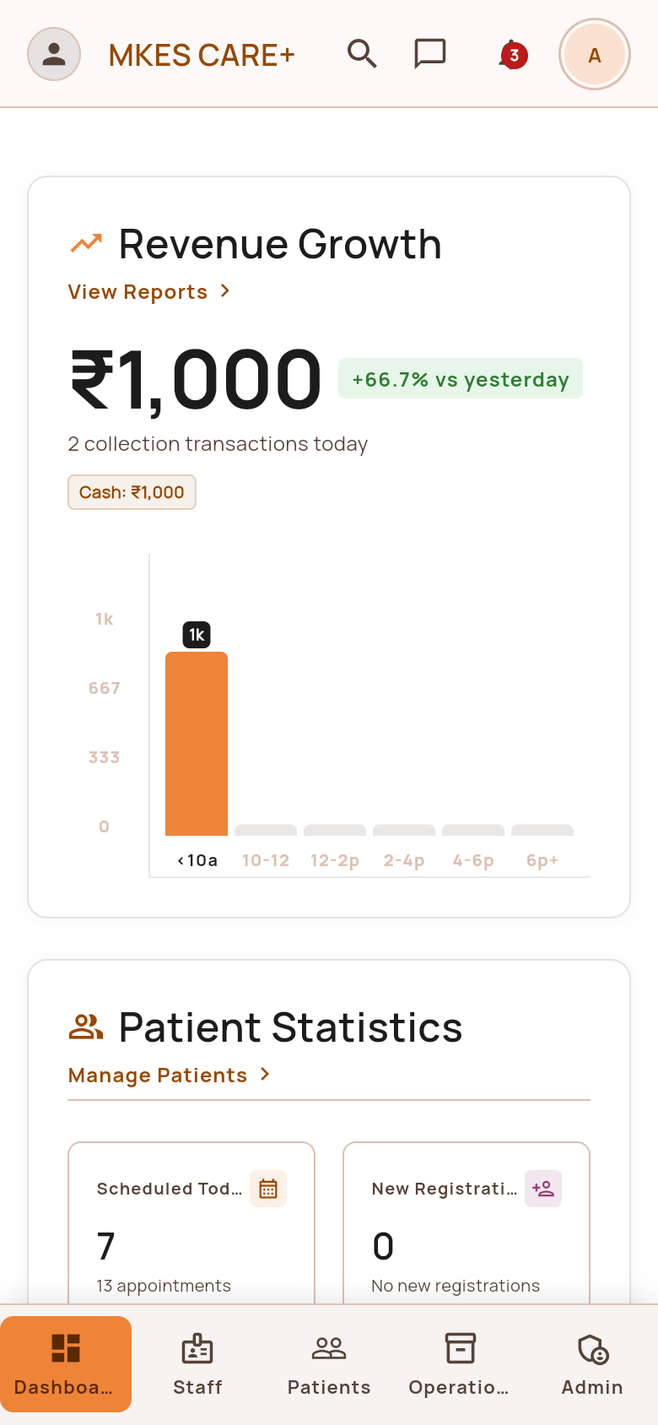  Executive Admin Dashboard • Admin Portal | 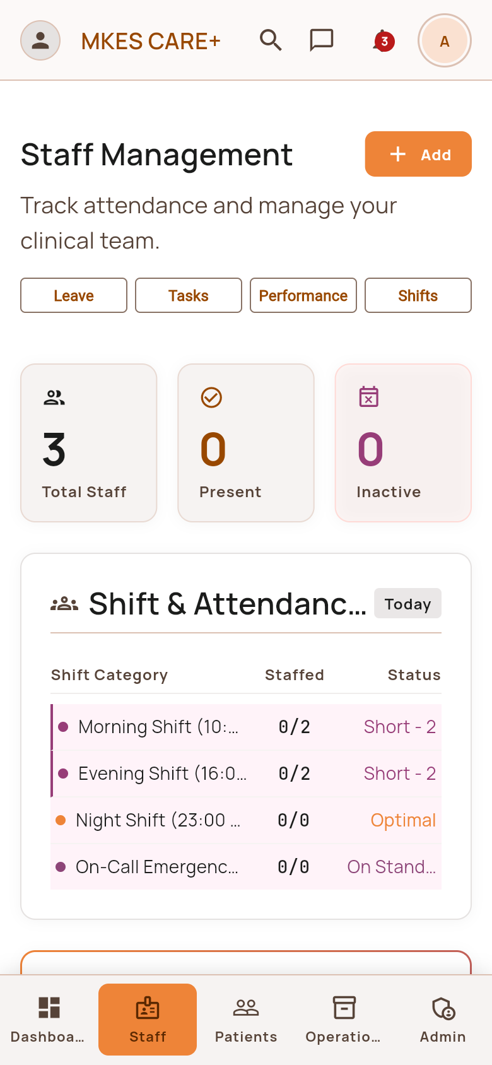  Staff Management Overview • Admin Portal
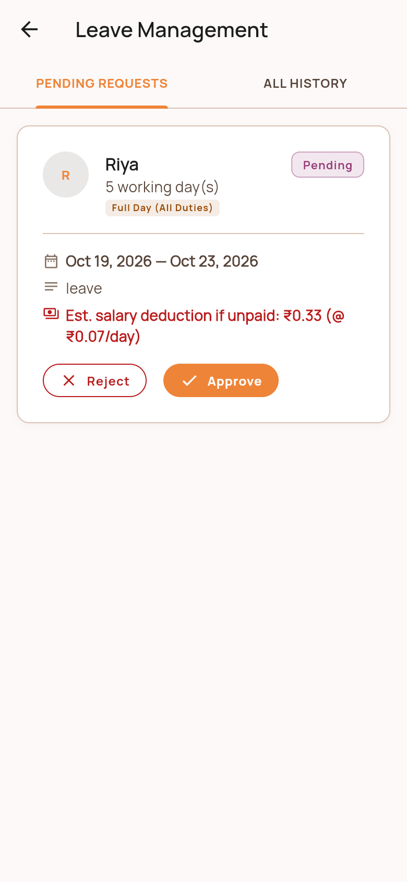  Admin Leave Approvals • Admin Portal | 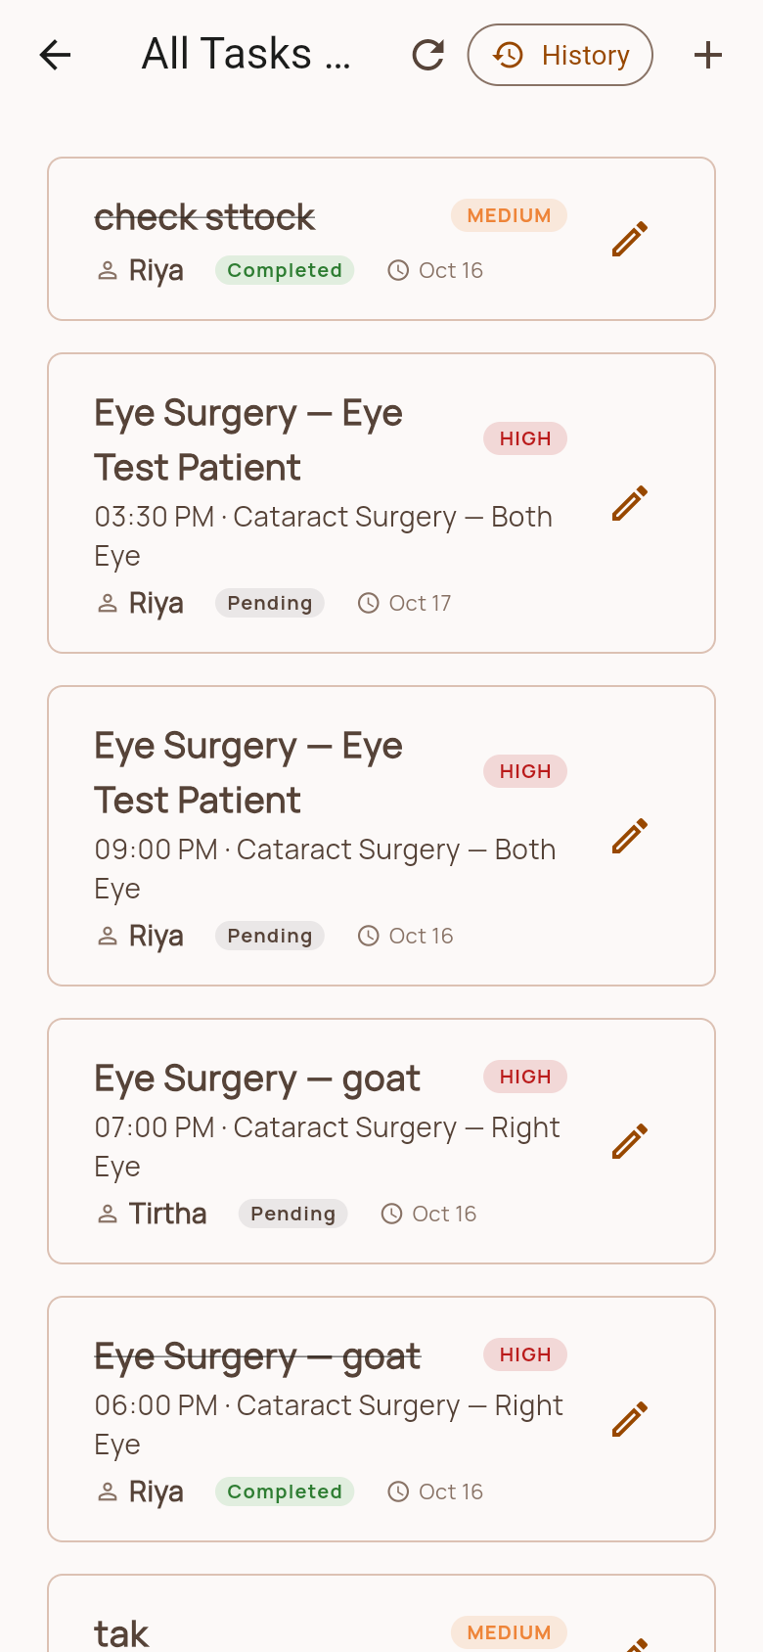  Clinic Task Delegation • Admin Portal

Section 3: Admin Portal | Page 2 of 7 • 4 Screens
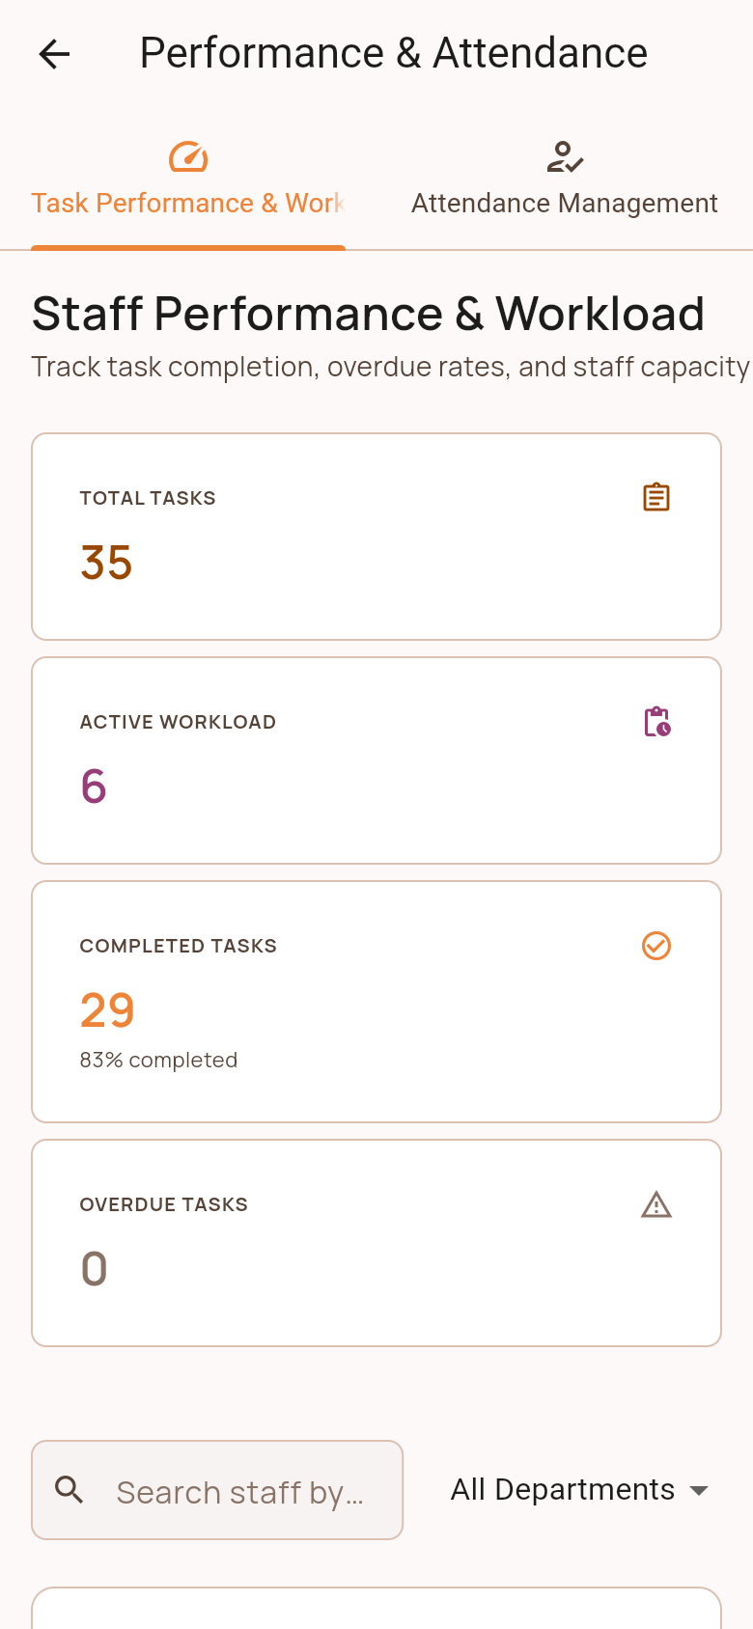  Performance & Workload (Tab 0) • Admin Portal | 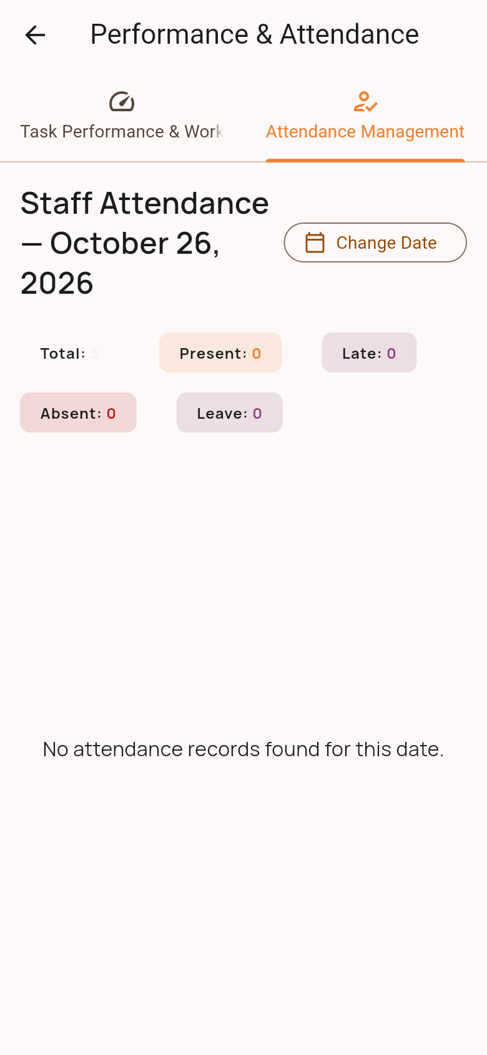  Attendance Management (Tab 1) • Admin Portal
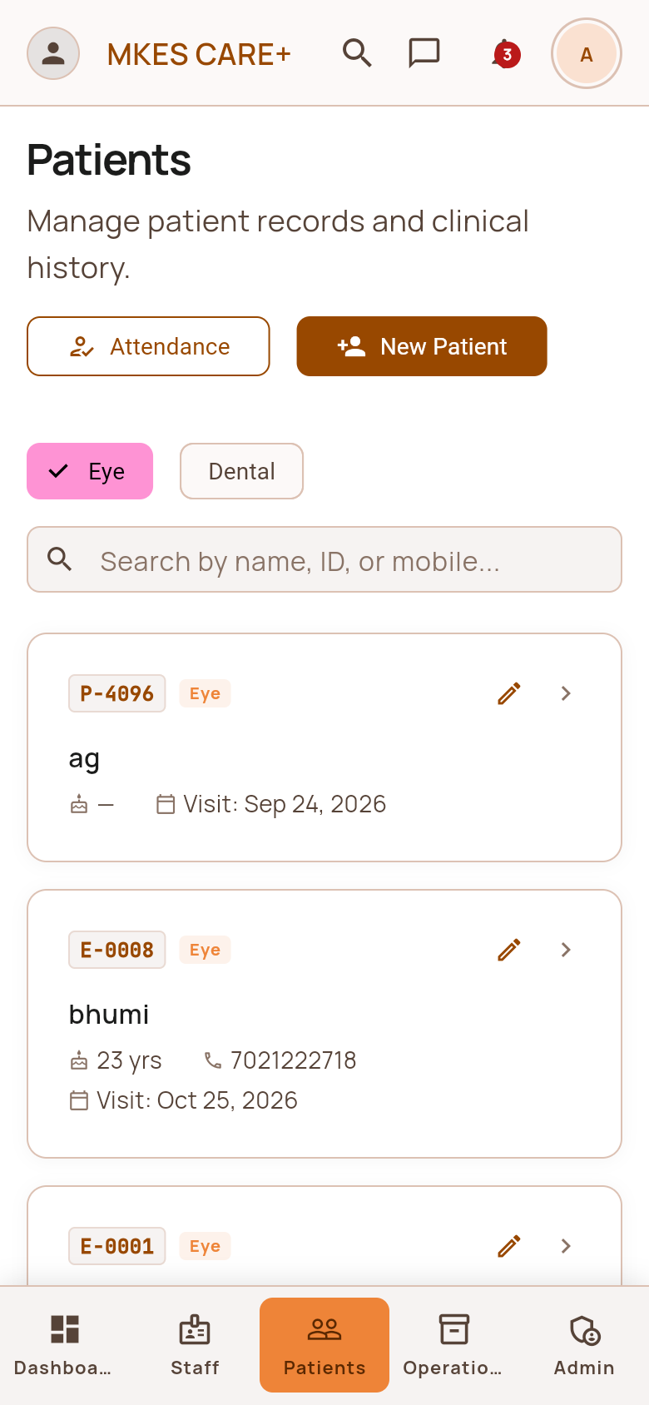  Admin Patient Management • Admin Portal | 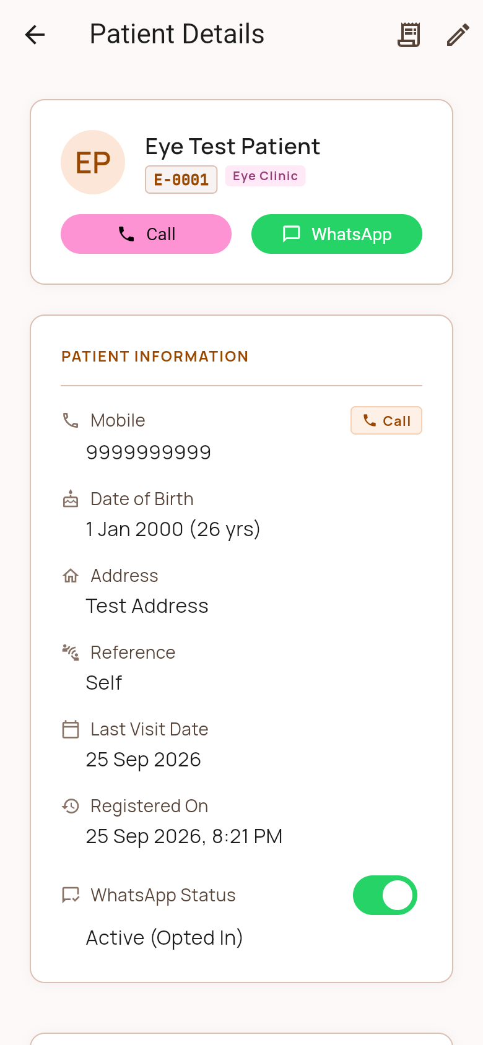  Admin Patient Details Profile • Admin Portal

Section 3: Admin Portal | Page 3 of 7 • 4 Screens
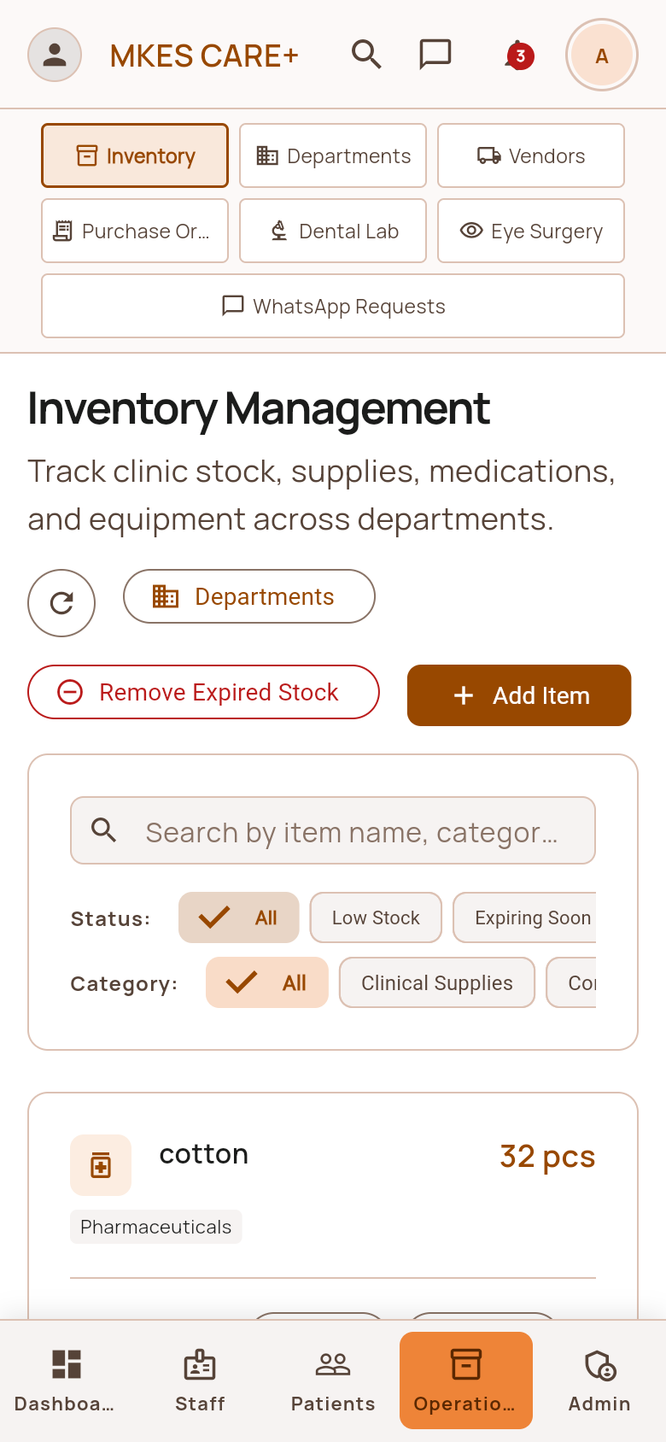  Operations: Inventory (Tab 0) • Admin Portal | 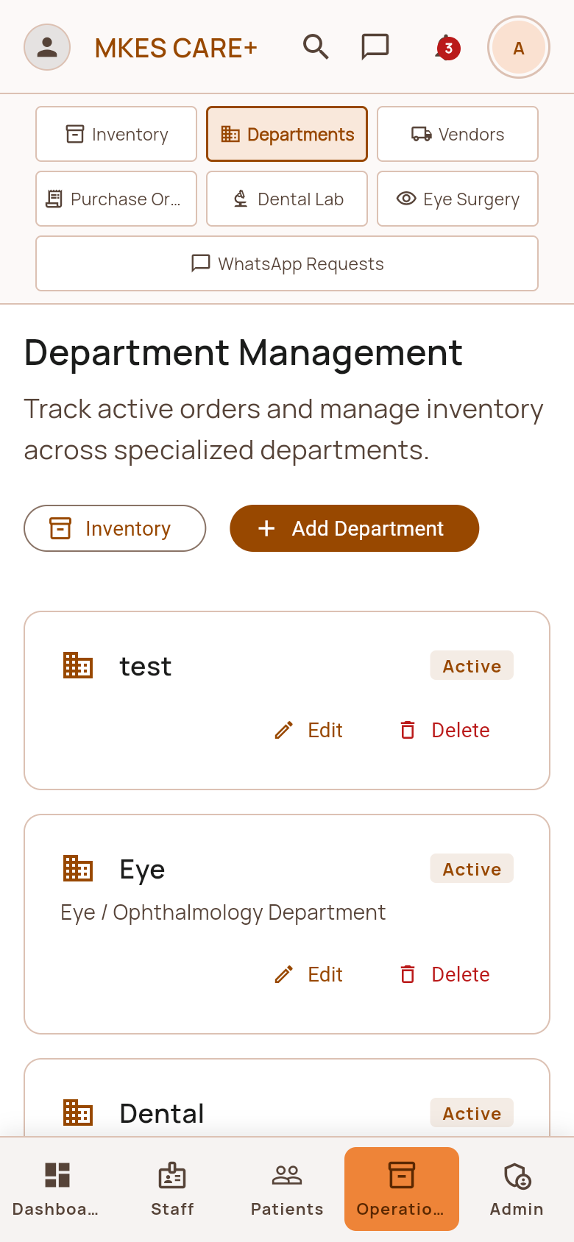  Operations: Departments (Tab 1) • Admin Portal
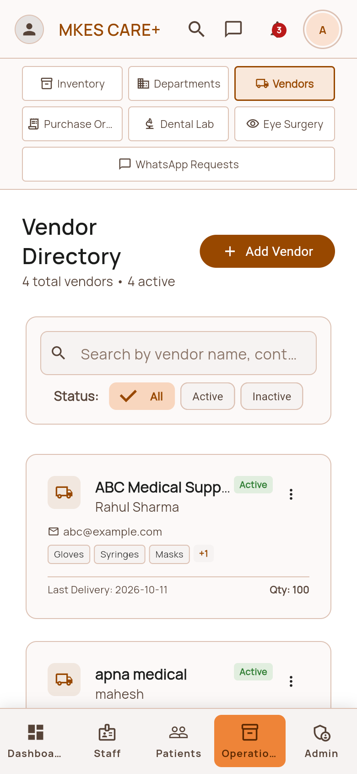  Operations: Vendors (Tab 2) • Admin Portal | 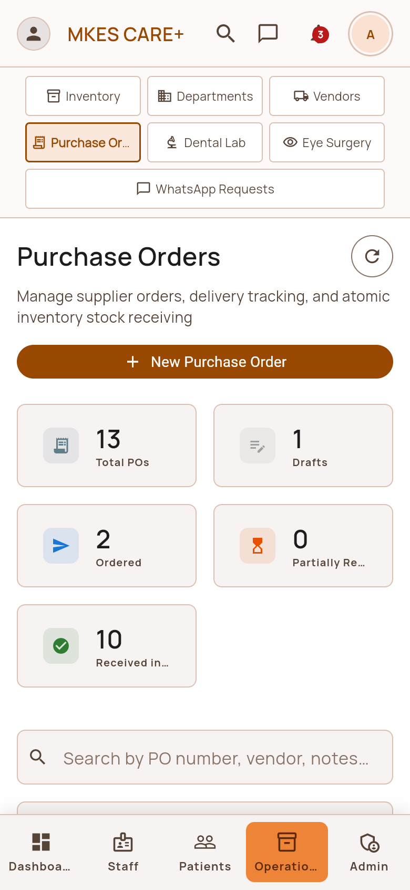  Operations: Purchase Orders (Tab 3) • Admin Portal

Section 3: Admin Portal | Page 4 of 7 • 4 Screens
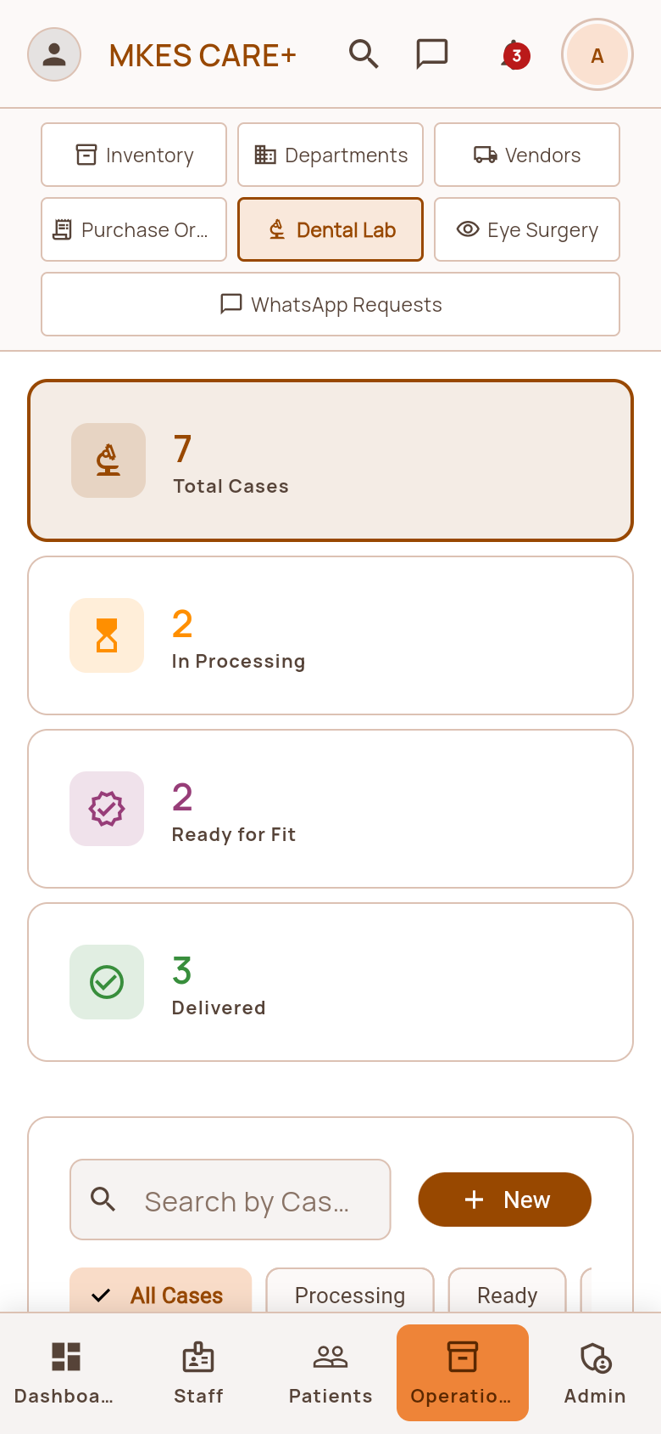  Operations: Dental Lab (Tab 4) • Admin Portal | 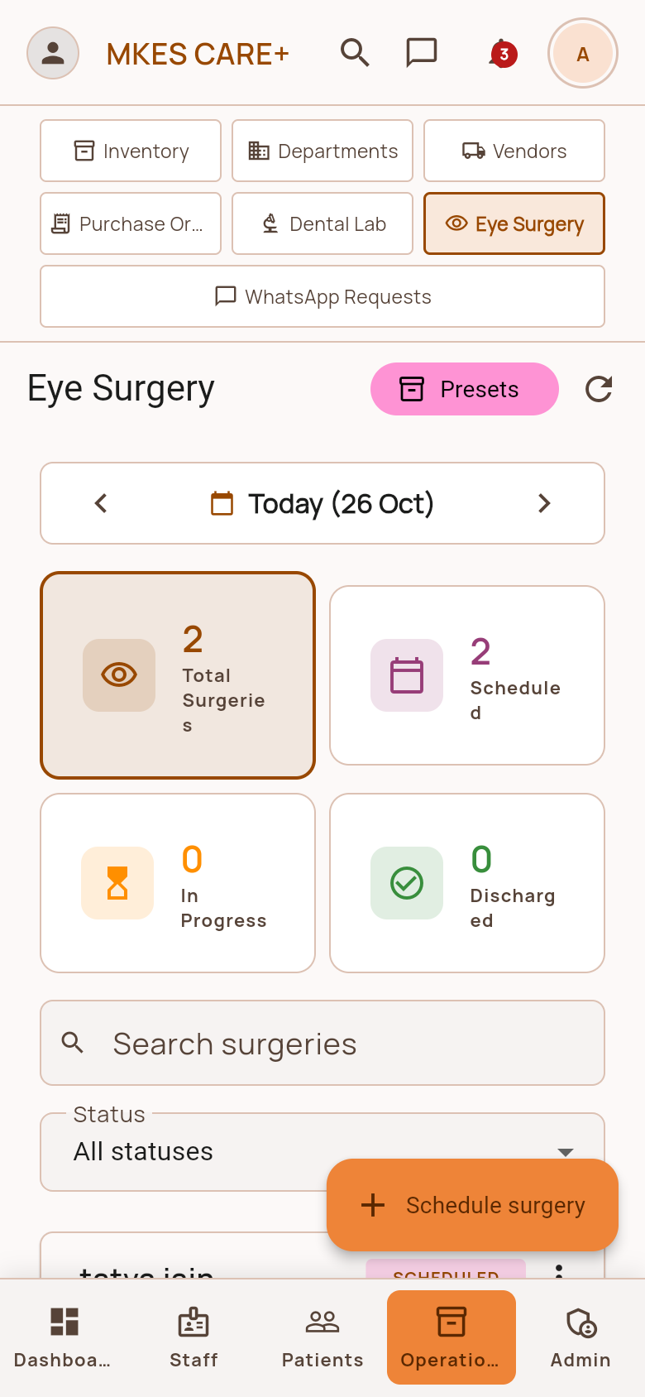  Operations: Eye Surgery (Tab 5) • Admin Portal
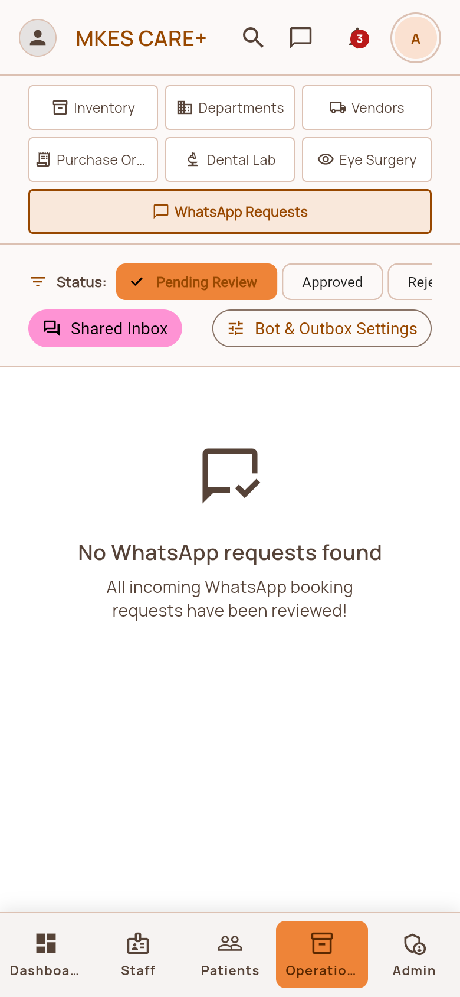  Operations: WhatsApp Requests (Tab 6) • Admin Portal | 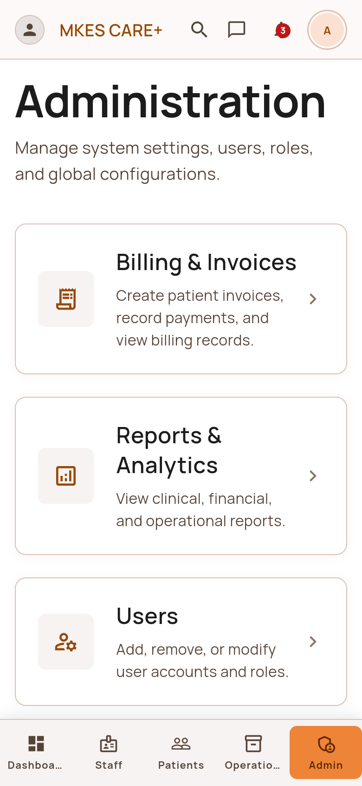  Administration Settings Hub • Admin Portal

Section 3: Admin Portal | Page 5 of 7 • 4 Screens
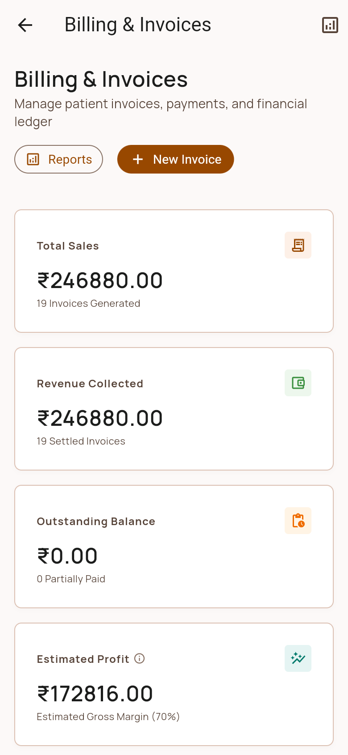  Billing & Financial Invoices • Admin Portal | 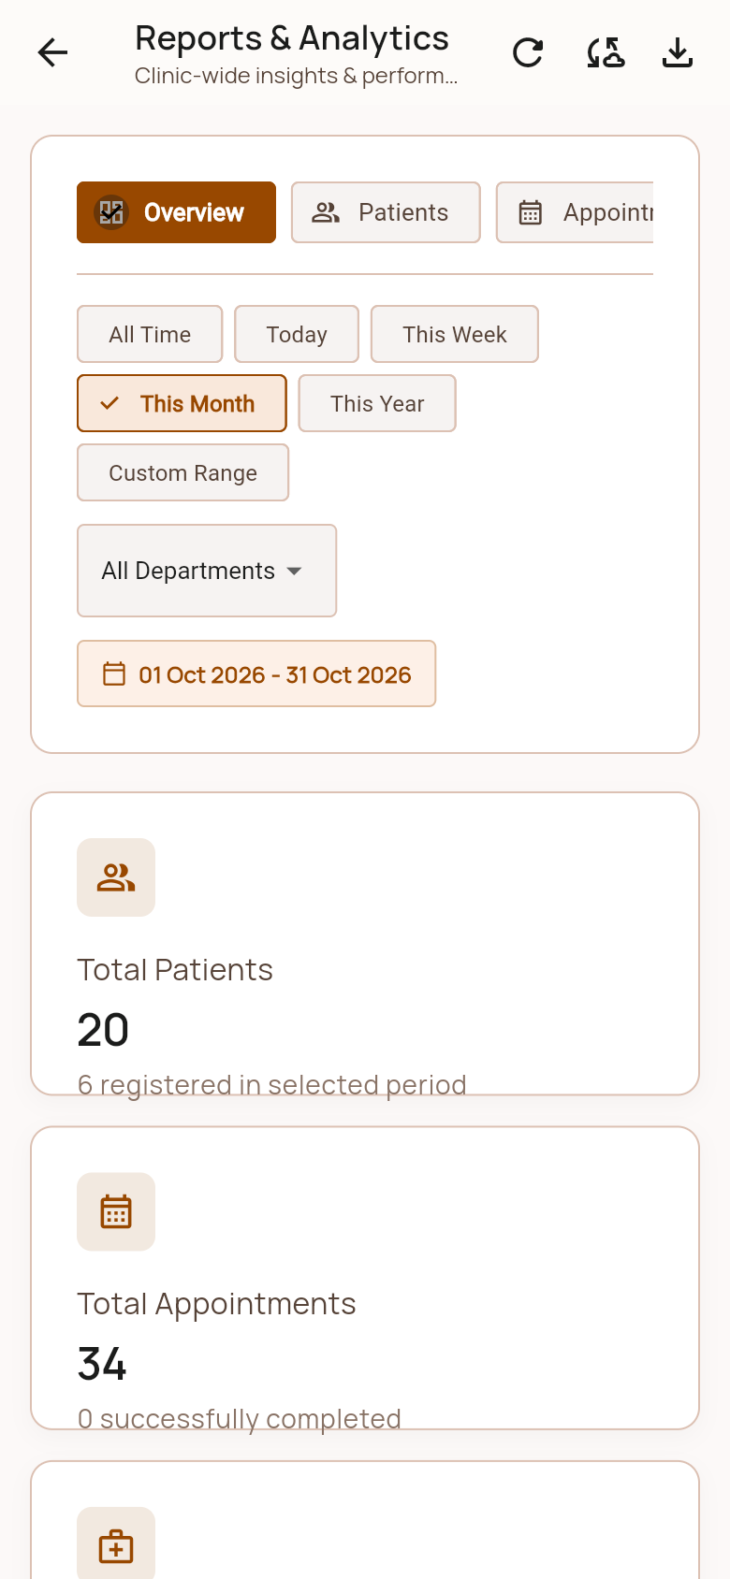  Reports & Business Analytics • Admin Portal
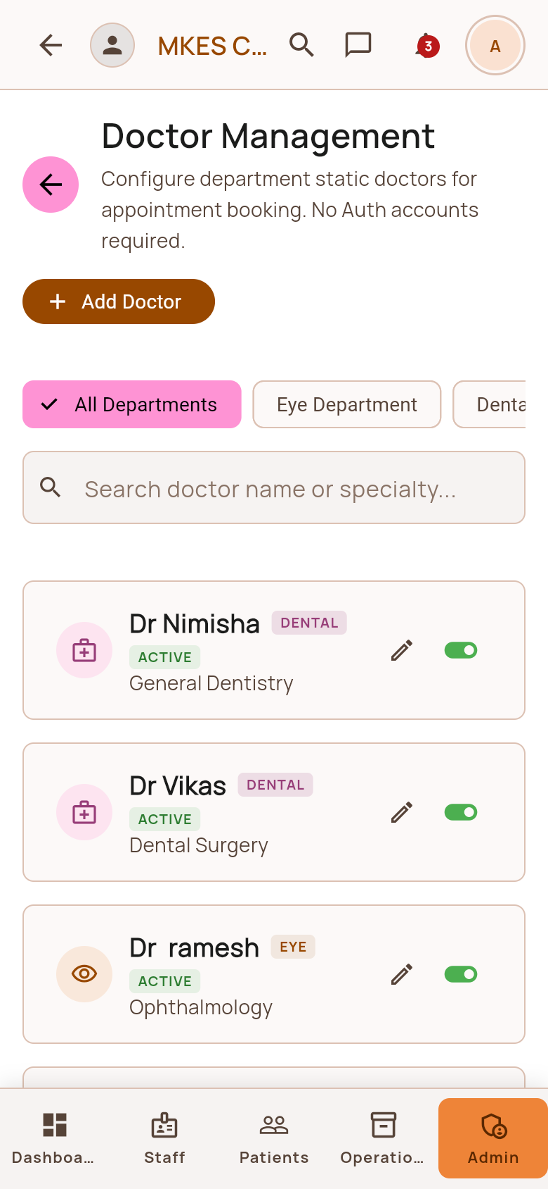  Doctor & Consulting Management • Admin Portal | 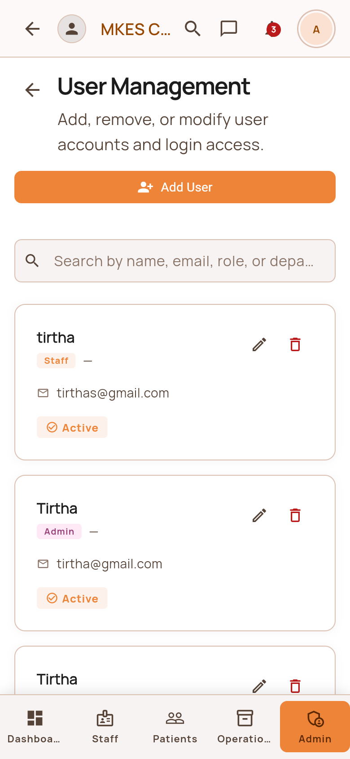  User Accounts & Role Security • Admin Portal

Section 3: Admin Portal | Page 6 of 7 • 4 Screens
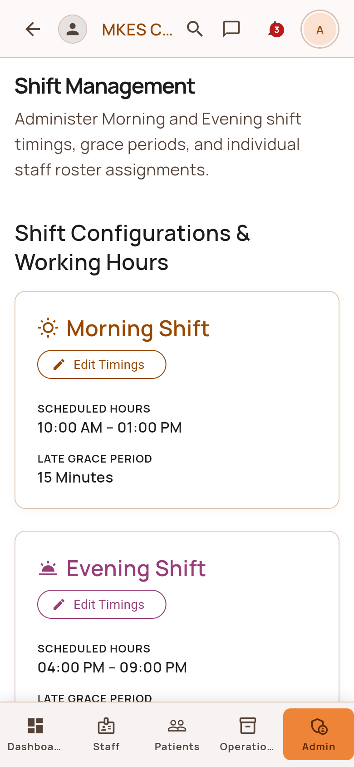  Shift Roster Management • Admin Portal | 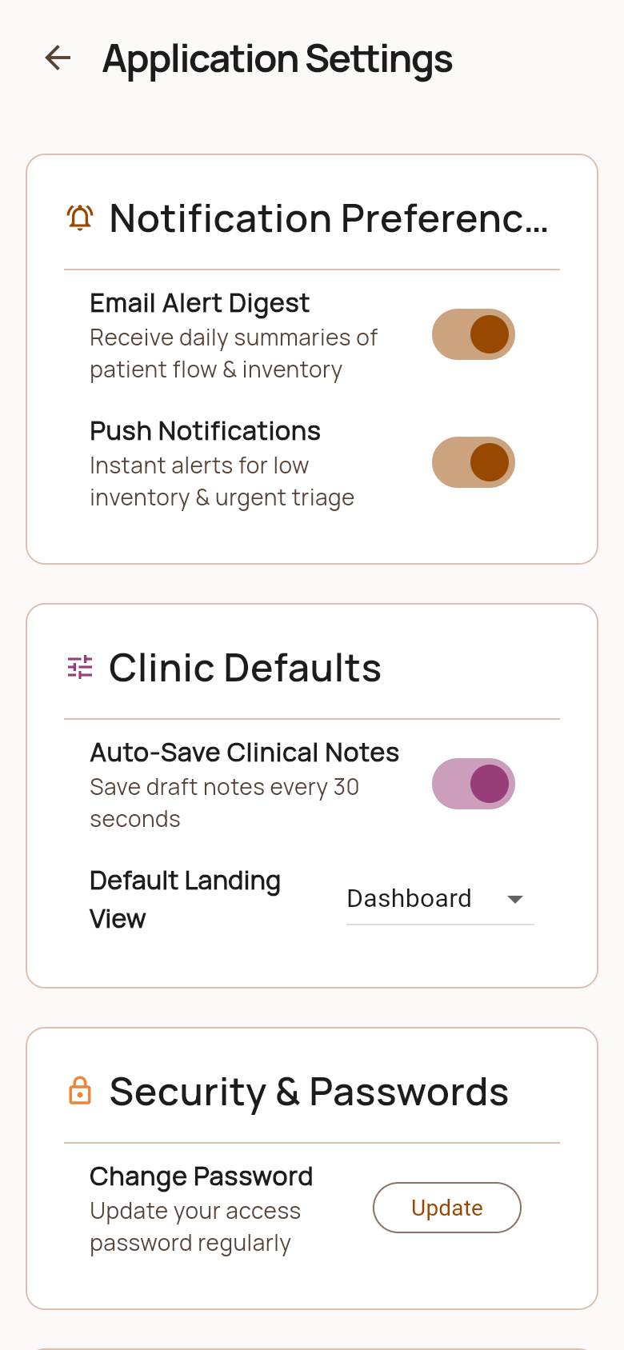  Clinic Settings & Configurations • Admin Portal
Admin Shared WhatsApp Inbox • Admin Portal | 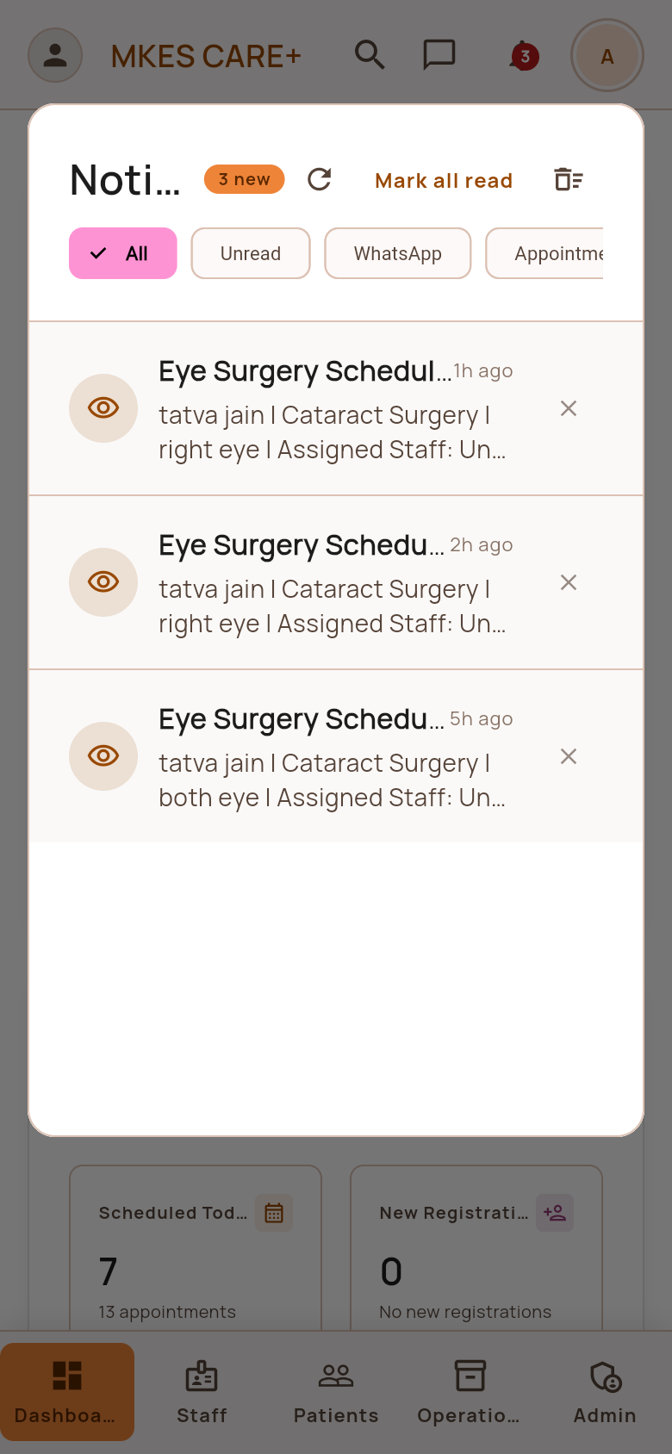  System Notification Center • Admin Portal

Section 3: Admin Portal | Page 7 of 7 • 2 Screens
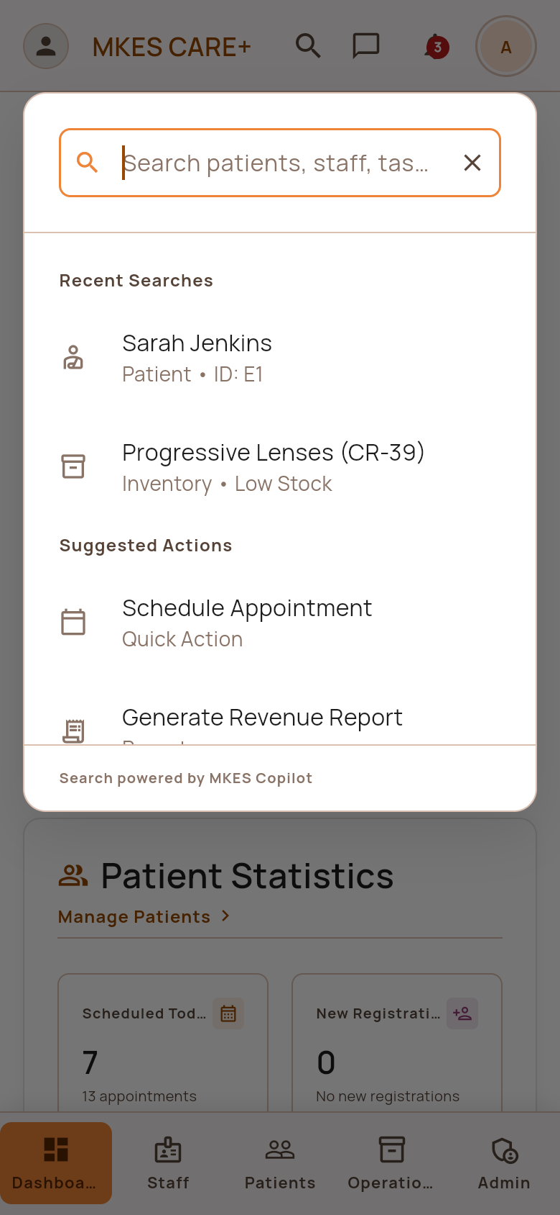  Global Copilot Search Dialog • Admin Portal | 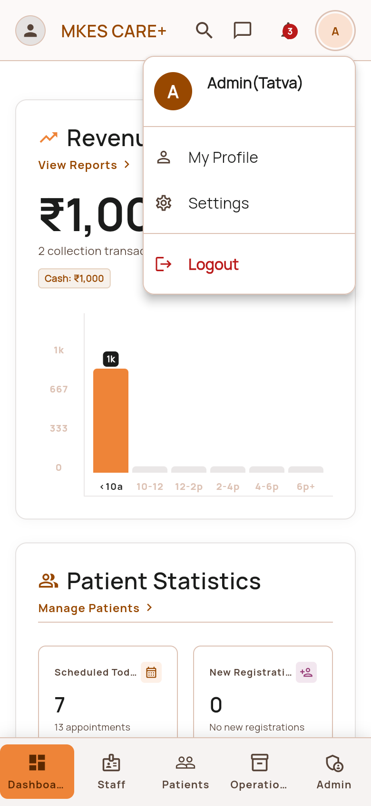  Admin Profile & Security Settings • Admin Portal

