**Name: H R Pratham**

**Usn:4MC22CS058**

**Qnu:1**

**Up/down :Down**

### Question with question number: 1.Design a mod-4 down counter using JK flip flop.

### J – K flip – flop excitation table:

|  |  |  |  |
| --- | --- | --- | --- |
| **Present state** | **Next state** | **J** | **K** |
| 0 | 0 | 0 | X |
| 0 | 1 | 1 | X |
| 1 | 0 | X | 1 |
| 1 | 1 | X | 0 |

### State Transition Diagram:

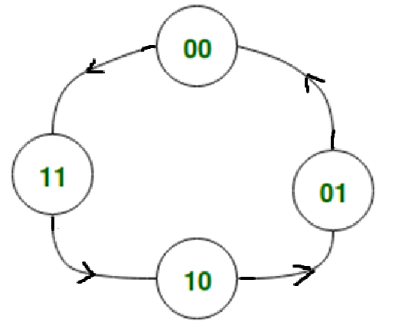

### Truth Table:

|  |  |  |  |  |  |  |  |
| --- | --- | --- | --- | --- | --- | --- | --- |
| **An** | **Bn** | **An+1** | **Bn+1** | **JA** | **KA** | **JB** | **KB** |
| 0 | 0 | 0 | 1 | 0 | X | 1 | X |
| 0 | 0 | 1 | 0 | 1 | X | 0 | X |
| 1 | 0 | 1 | 1 | X | 0 | 1 | X |
| 1 | 1 | 0 | 1 | X | 1 | X | 0 |

**Solving using K-map:**

|  |  |  |  |  |  |  |  |  |  |  |  |  |  |  |  |  |  |  |  |
| --- | --- | --- | --- | --- | --- | --- | --- | --- | --- | --- | --- | --- | --- | --- | --- | --- | --- | --- | --- |
| |  |  |  | | --- | --- | --- | | **A**  **B** | **A’** | **A** | | **B’** | 0 | 1 | | **B** | X | X |   **JA**= **A** | **KA= A**   |  |  |  | | --- | --- | --- | | **A**  **B** | **A’** | **A** | | **B’** | X | X | | **B** | 0 | 1 | |
| |  |  |  | | --- | --- | --- | | **A**  **B** | **A’** | **A** | | **B’** | 1 | 0 | | **B** | 1 | X |   **JB**= **A’** | **KA= 0**   |  |  |  | | --- | --- | --- | | **A**  **B** | **A’** | **A** | | **B’** | X | X | | **B** | X | 0 | |

**Circuit Diagram:**

