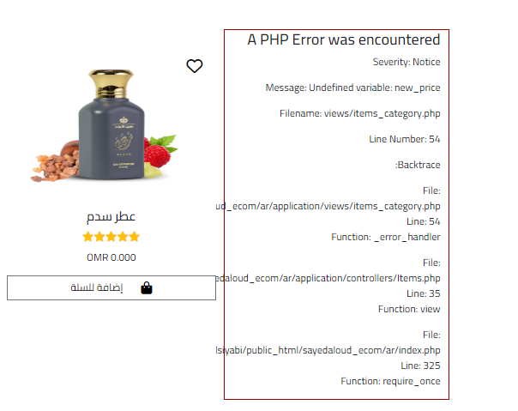1- Error found in menu same error found in system

done

2-how to calculate the weight?

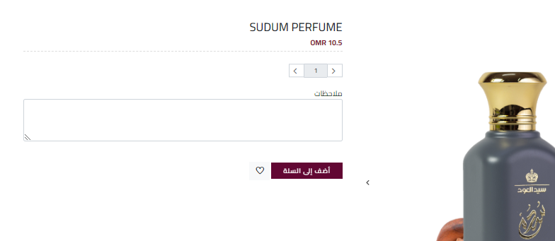3- quantity bottom not working

4- header need to arrange done



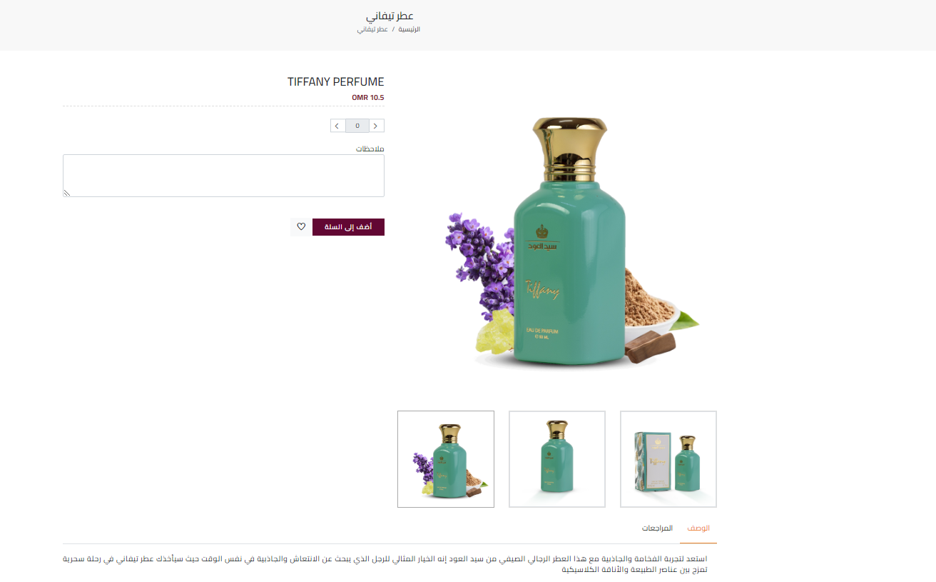

5- description not appear

6- redesign these (make written down of pic

done

7- change payment gate to paypal

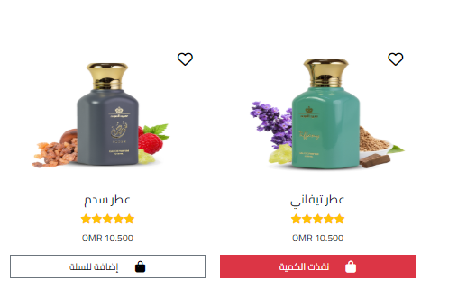8- items not clickable done

9- search with Arabic not activated

done

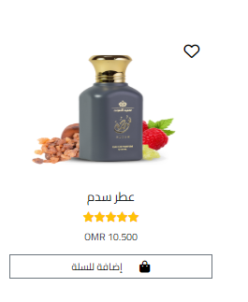

10- size of pic not properly

done

11-