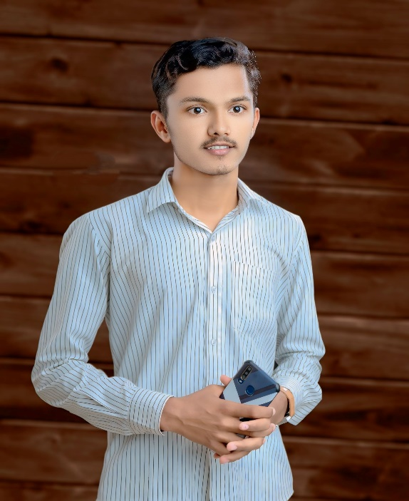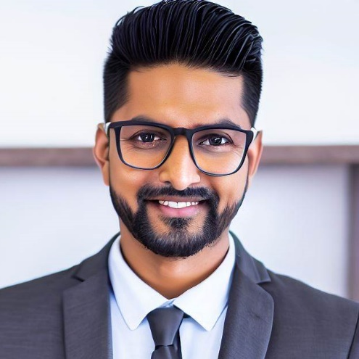

# PERSONAL DETAILS

**Date of Birth - 6 – Octomber – 2004**

**Marital Status - Unmarried**

**Gender - Male**

**Language - English,Hindi,Marathi**

# HOBBIES

* **Gaming**
* **Exploring Internet**
* **Adventuring**

# PROJECTS

* **Student Management System**

**Using Java Servlet Dynamic web and connected backend to MYSQL Database also Using JSP GUI.**

# Education

### BCS(Final Year) 2025

### Sangola College , Sangola

### 12th(HSC) 2022

**New English School , Sangola**

# about

**Passionate About Web Development Goal is To**

**Achieve A Good Position By Doing Statisfying Work**

**In The IT Field. Strongly Focused To Complete The**

**Task In Fast Faced Enviroment.**

# Contact



**Sangola , Maharashtra**



**+91 7447833156**



**tatyasokatkar2020@gmail.com**



**linkedin.com/in/tatyaso-katkar**

# Skills

* **COMMUNICATION**
* **WEB DEVELOPMENT**
* **PROBLEM SOLVING**
* **TEAM WORK**
* **CREATIVITY**

**TATYASO KATKAR**  
**BCS GRADUATE**

# languages

* **HTML & CSS,JAVASCRIPT**
* **C**
* **C++**
* **DBMS**
* **JAVA**
* **PYTHON**
* **C#**