STANDARD OPERATING PROCEDURE (SOP)
IT HELPDESK TICKET SUBMISSION (GLPI)
1. PURPOSE
This document provides step-by-step guidance for all users to submit issue reports (Incident) or service requests (Request) through the GLPI IT Helpdesk system, ensuring IT issues are handled faster, structurally, and accurately documented.
2. GLPI PORTAL ACCESS AND LOGIN
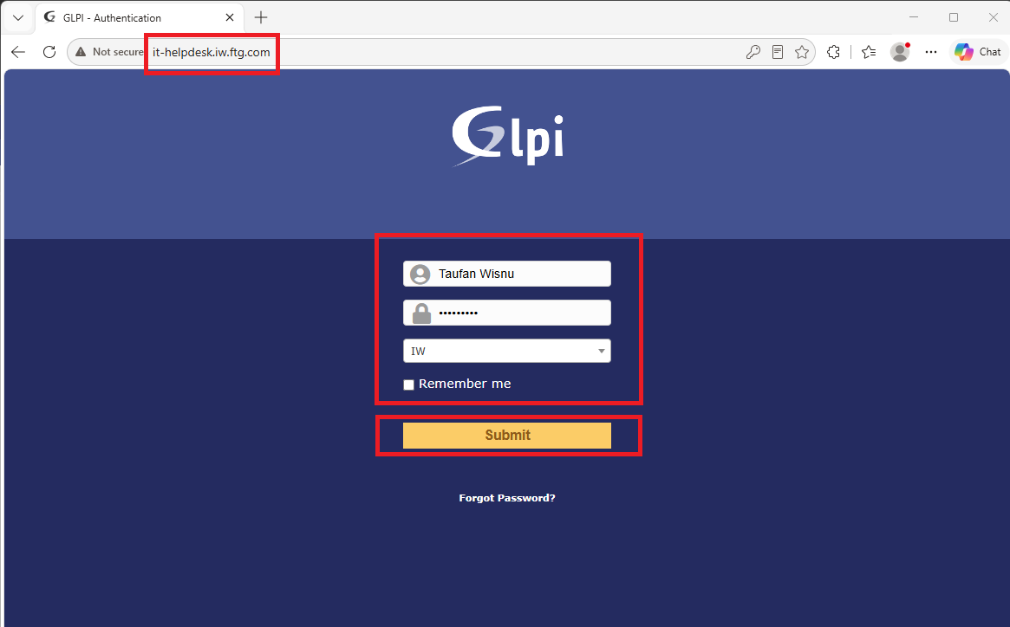
1. Ensure your computer/laptop is connected to the company's internal network.
2. Open a web browser (e.g., Google Chrome, Microsoft Edge, or Mozilla Firefox).
3. Enter the GLPI IT Service Desk URL: it-helpdesk.iw.ftg.com
4. Enter your Windows domain/LDAP Username (e.g., Taufan Wisnu).
5. Enter your active Windows domain/LDAP Password.
6. Click Submit to log into the GLPI IT Helpdesk portal.

3. TICKET FORM SUBMISSION STEPS
Step 1: GLPI Ticketing System Dashboard
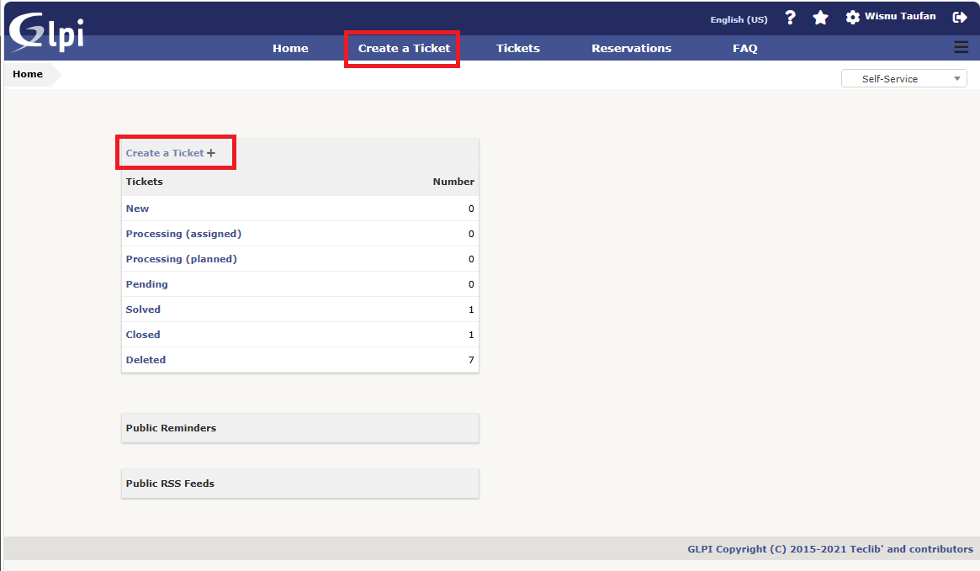
After logging in, you will arrive at the GLPI dashboard to view your ticket status and history. Click Create a Ticket to submit a new issue.

Main Menu Functions:
• Home: Main page displaying ticket status summaries and announcements.
• Create a Ticket: Form to submit a new report or request.
• Tickets: List and history of all tickets you have submitted.
• Reservations: Loan services for facilities or device assets.
• FAQ: Knowledge base and self-service solutions for common issues.

Ticket Status Definitions:
• New: Newly submitted ticket (not yet processed).
• Processing (assigned/planned): In progress or scheduled by a technician.
• Pending: On hold (awaiting information or spare parts).
• Solved: Issue resolved, awaiting your verification.
• Closed: Ticket officially closed.
• Deleted: Ticket deleted/cancelled.
Step 2: Select Ticket Type
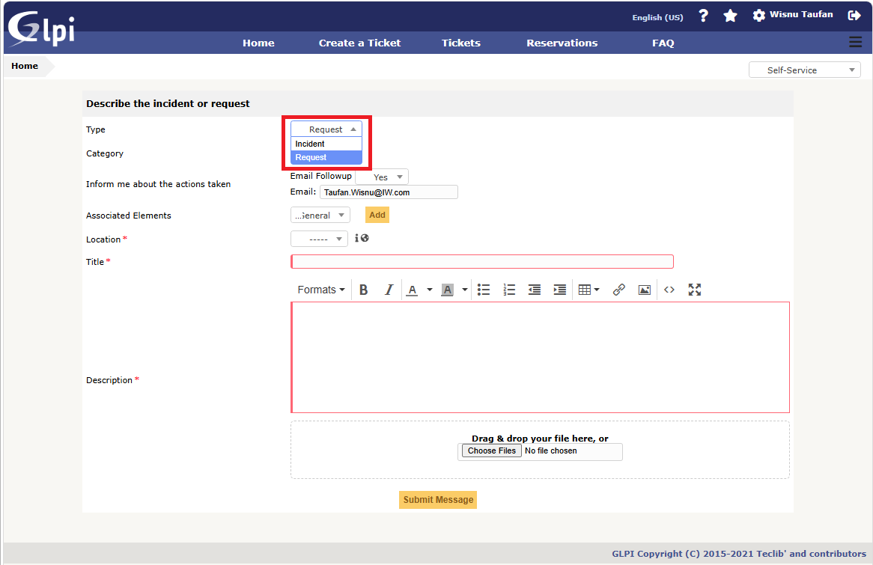
Select the ticket type from the Type dropdown menu:
• Incident: Choose if you experience a disruption, system failure, or technical issue on your device/system.
• Request: Choose if you require a new service, account access, application installation, or additional hardware.
Step 3: Select Problem Category
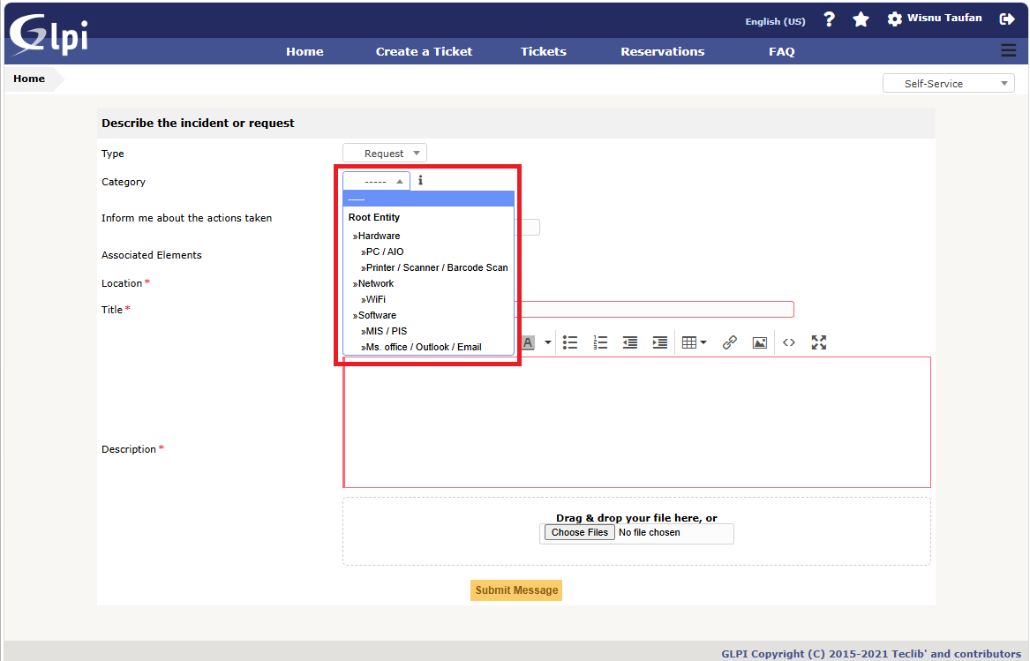
Select the most relevant category from the Category hierarchy:
• Hardware: Select related units such as PC / AIO, Printer / Scanner / Barcode Scanner.
• Network: Select options such as WiFi or wired LAN connection.
• Software: Select options such as MIS / PIS applications, Ms. Office / Outlook / Email.
Step 4: Configure Email Follow-up Notifications
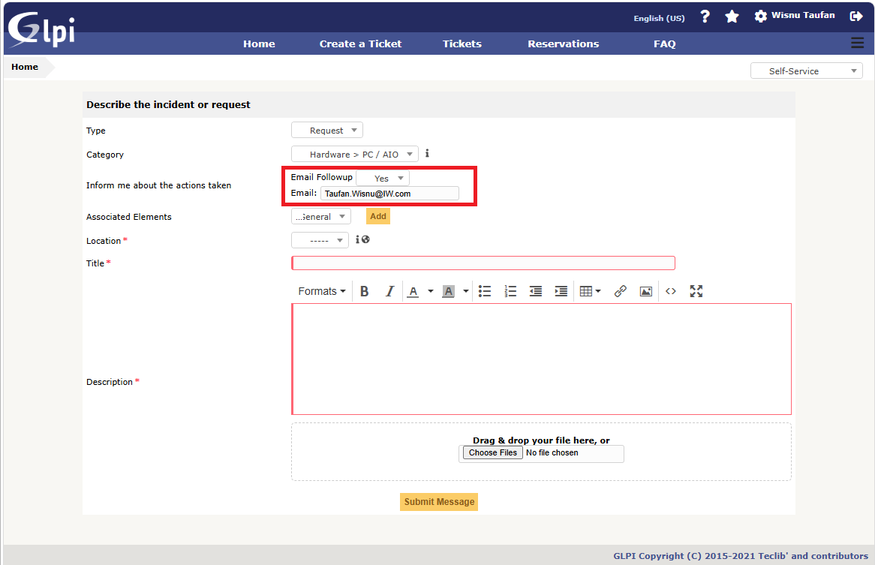
• Ensure the Email Followup option is set to Yes.
• Verify the Email address displayed on the form (e.g., Taufan.Wisnu@IW.com) to ensure automated updates and resolution notifications are delivered.
Step 5: Link Asset (Associated Elements – Step 1)
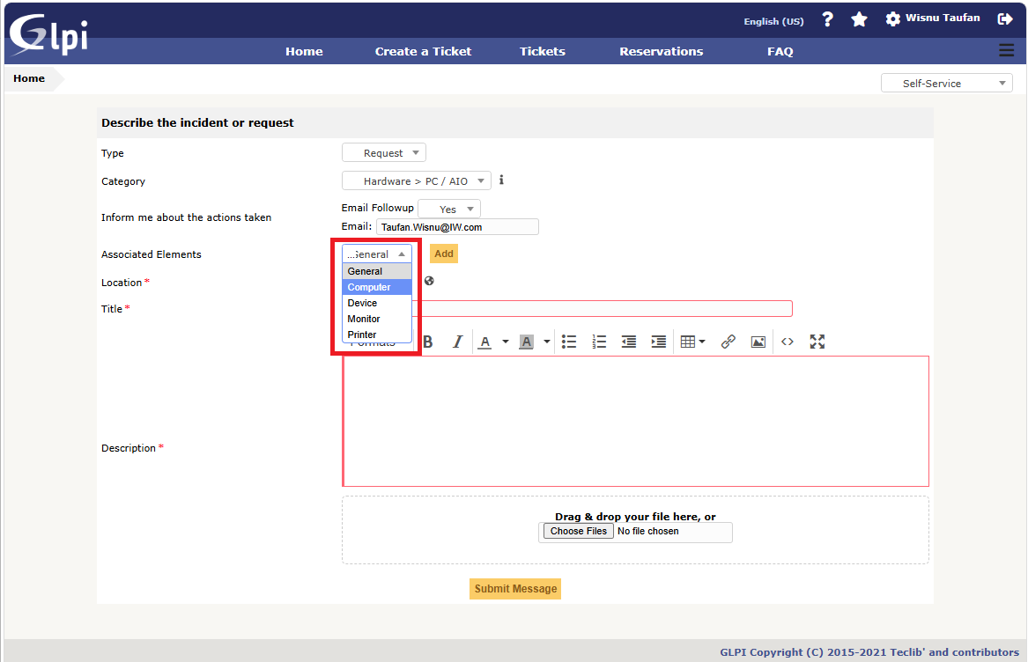
Under Associated Elements, select the device type from the first dropdown (e.g., Computer, Device, Monitor, Printer, General).
Step 5.2: Link Asset (Associated Elements – Step 2)
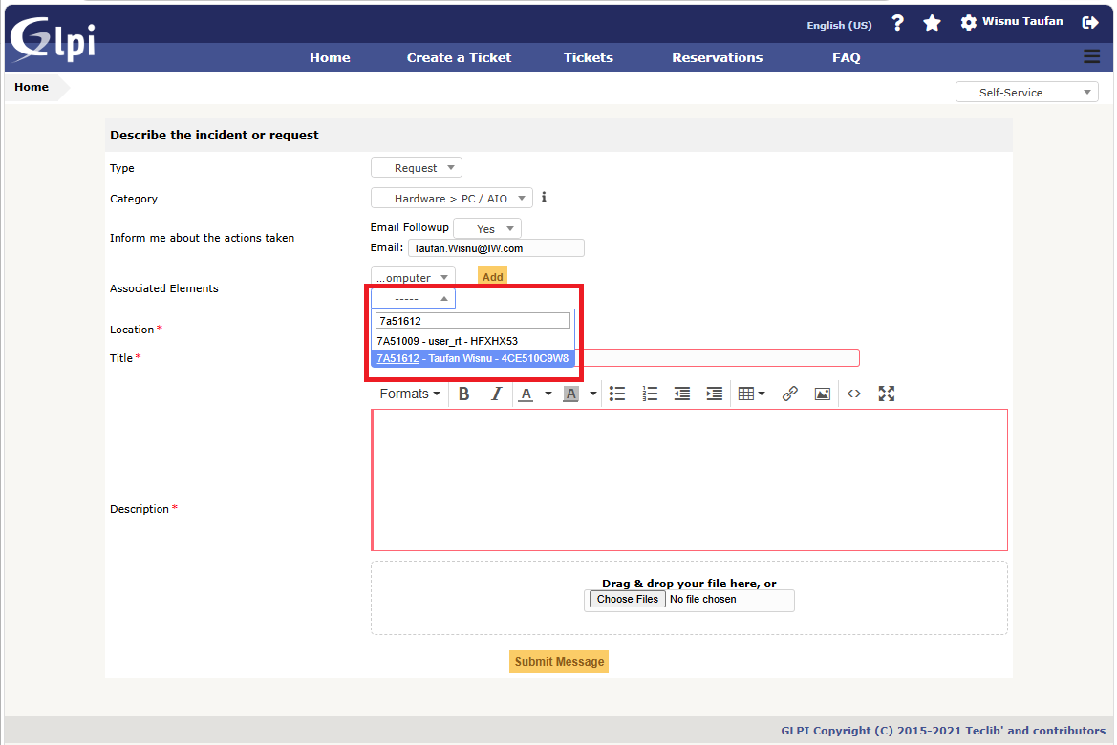
From the second dropdown, search and select your specific device asset name or serial number (e.g., 7A51612 - Taufan Wisnu - 4CE510C9W8).
Step 5.2: Link Asset (Associated Elements – Step 3)
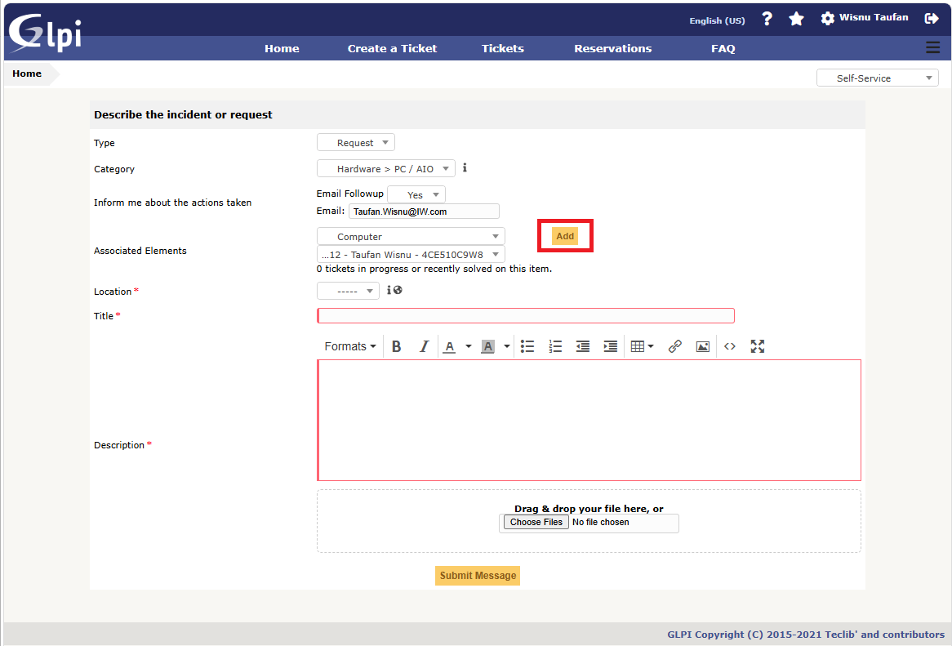
Click the yellow Add button to link the asset details to the ticket.
Step 6: Specify Location
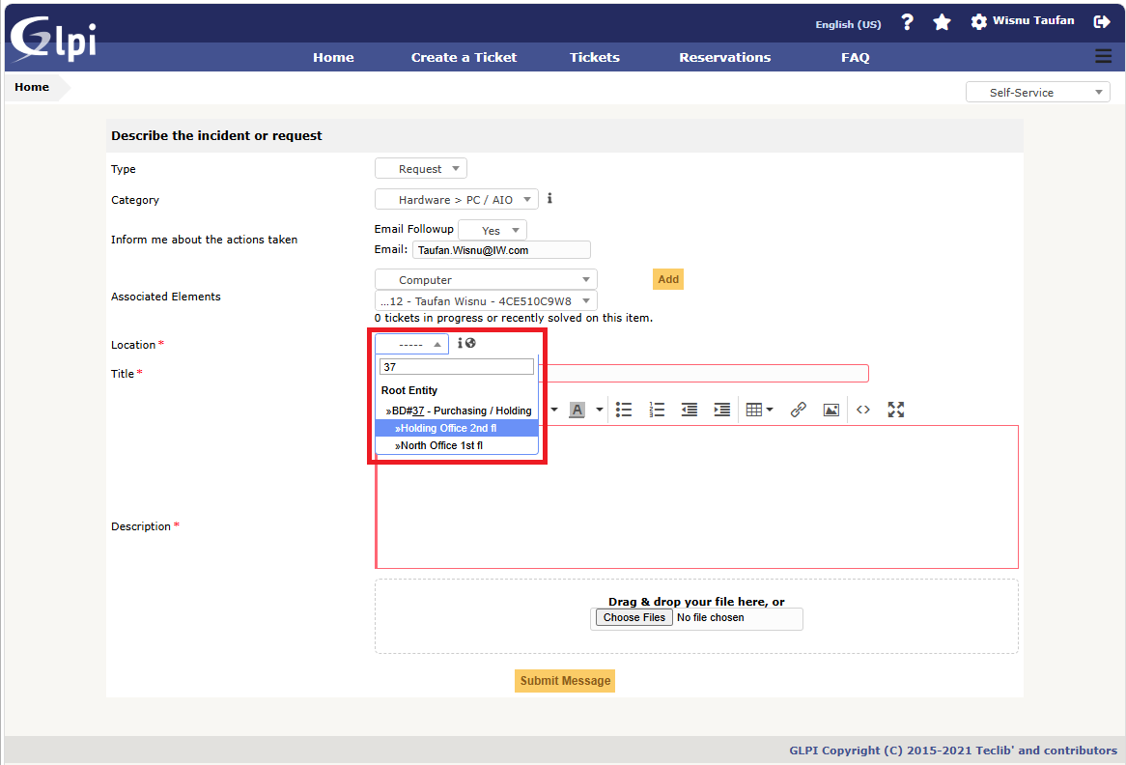
On the Location *** field (Required), select your detailed physical location or device placement (e.g., Holding Office 2nd fl or North Office 1st fl).
Step 7: Enter Ticket Title
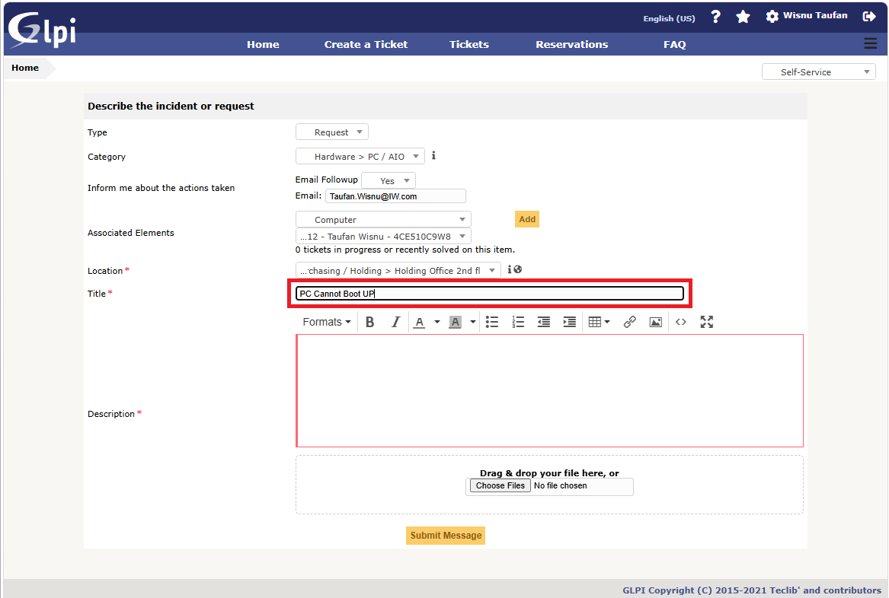
On the Title *** field (Required), enter a concise, clear summary of the issue or request (e.g., PC Cannot Boot UP).
Step 8: Fill Description, Attach Files, and Submit
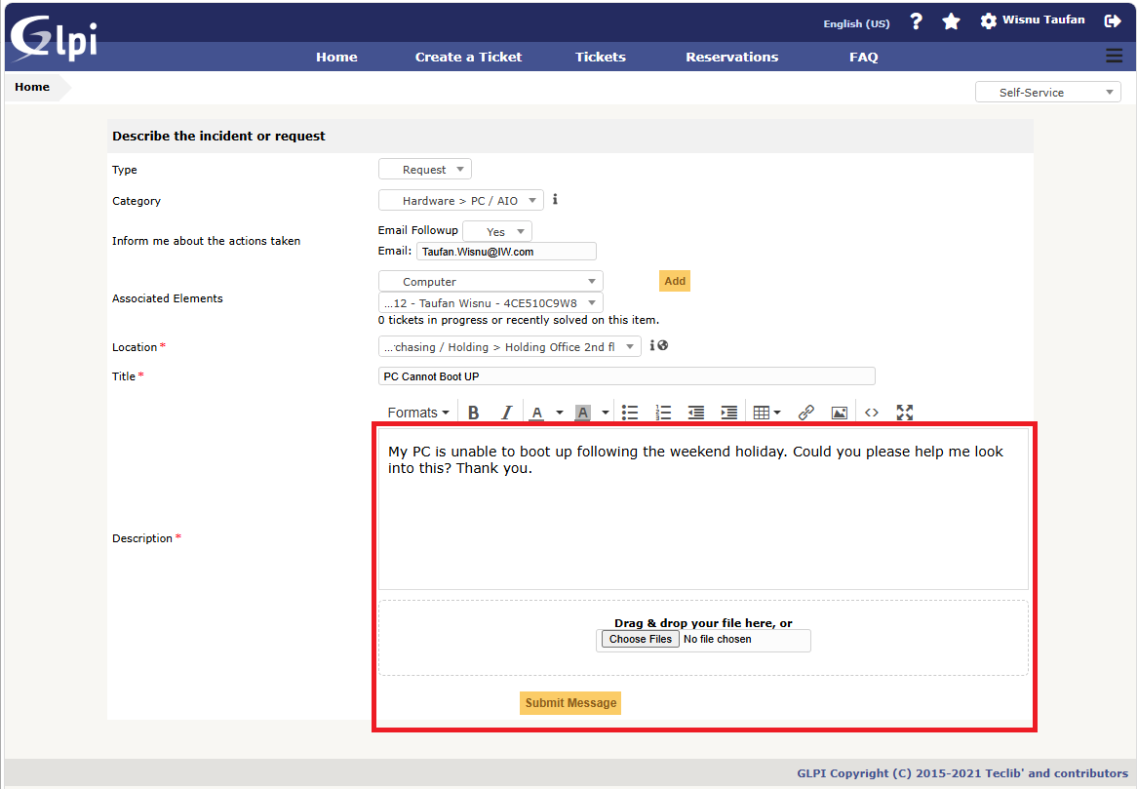
• Description *** (Required): Provide a detailed explanation of the issue (chronology, error messages, etc.). Example: "My PC is unable to boot up following the weekend holiday. Could you please help me look into this? Thank you."
• Attachment (Optional): Drag & drop or click Choose Files to attach error screenshots.
• Submit: Once all fields are correctly filled, click Submit Message at the bottom to send the ticket.
STEP 9: SOLVED TICKET VERIFICATION & SATISFACTION SURVEY
Once the IT team resolves your issue, the ticket status will change to Solved. You will receive an email notification to perform the final verification.
Verification (Approve / Refuse):
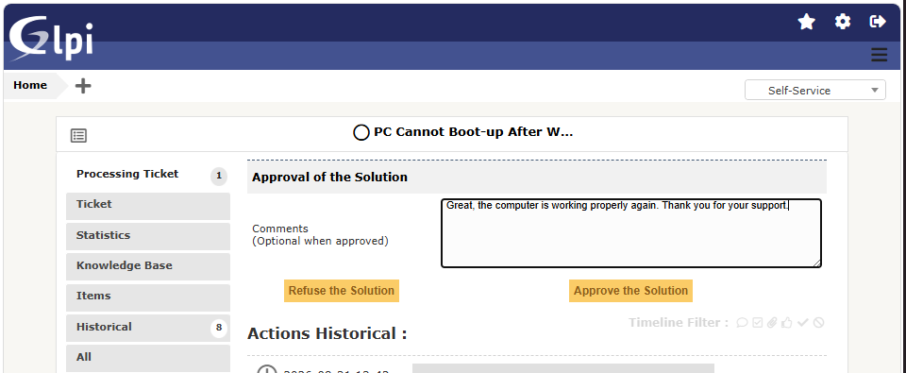
• Click Menu: Go to Tickets menu > Select Solved tab > Click your Ticket Title.
• Scroll to the bottom and select an action:
• Approve: Click Approve Solution if the issue is fixed. The ticket status updates to Closed.
• Refuse: Click Refuse Solution if the issue persists. Type your reason in the comment box and click Submit to reopen the ticket (Processing).

Satisfaction Survey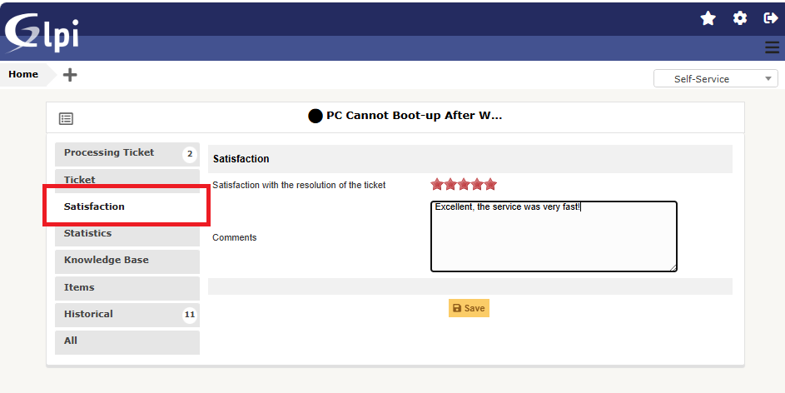
• Click Menu: After clicking Approve, click the Satisfaction Survey tab/pop-up window.
• Rating (1–5 Stars): Click the star rating based on your experience.
• Comment (Optional): Add feedback in the box, then click Save / Submit.
4. SUBMISSION COMPLETION
1. After clicking Submit Message, your ticket will be registered in the GLPI system.
2. You will receive an automated email confirmation containing a unique ticket number for tracking.
3. The IT Support team will review and process your ticket based on priority and request type.

