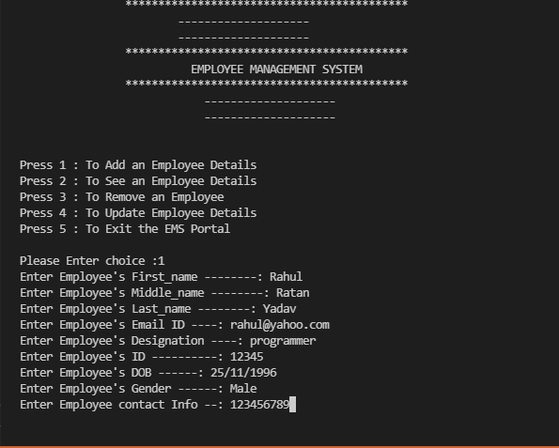

Fig 1 :- Enter Choices…

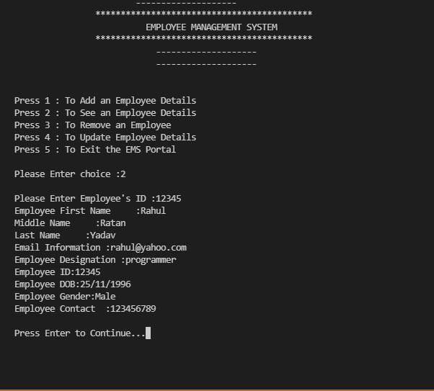

Fig 2 :- Add Employee Details..

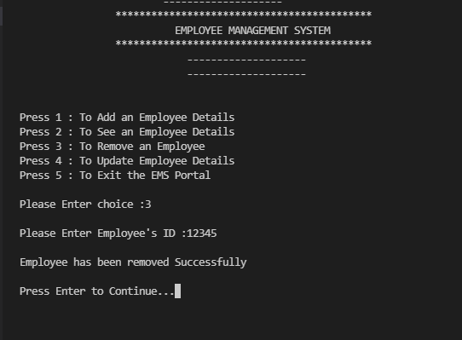

Fig 3:- Remove Employees Details..