**C# Web Api Consumption**

**HTTPGET:**

Api Url: <http://localhost:50664/Api/GetAllSuperAdmin?Action=>

Parameters:

* Action (string)=can be null

Below is the attached screenshot

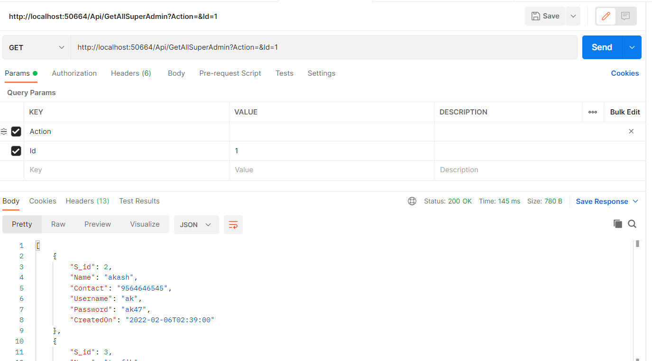

**HTTPPOST**

Api Url: <http://localhost:50664/Api/AddSuperAdmin?Action=>

Parameters:

* Action (string)=nullable
* Data with Model of Respective Table

**HTTPDELETE**

Api Url: <http://localhost:50664/Api/DeleteAdmin?Action=&Id=3>

Parameters:

* Action (string)=nullable
* Id (int)

Below is the Screenshot attached

