Feature Change Analysis

Using python, matplotlib, and sqlite, I have created a two graphs that can show the response from users to the new feature.

Both graphs can be produced by running the python file `dataprocessing.py` included in the project folder.

**Graph #1**

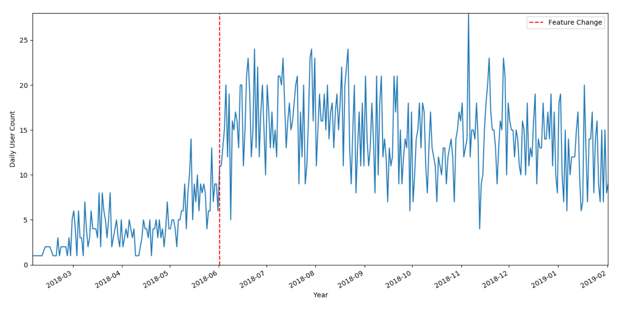

The graph makes it quite clear that the amount of daily active users greatly increased as a direct consequence of the feature change.

I derived the date for the feature change by finding the earliest timestamp in changing the status of a card.

When finding the daily user count, I converted the timestamp to Julian day and took the floor value, as to compound all the users who logged in on the same day.

I created a table in the database by running an sqlite query, and then took the data from the table into my python file by running a select statement and then plotting it on the graph.

**Graph #2**

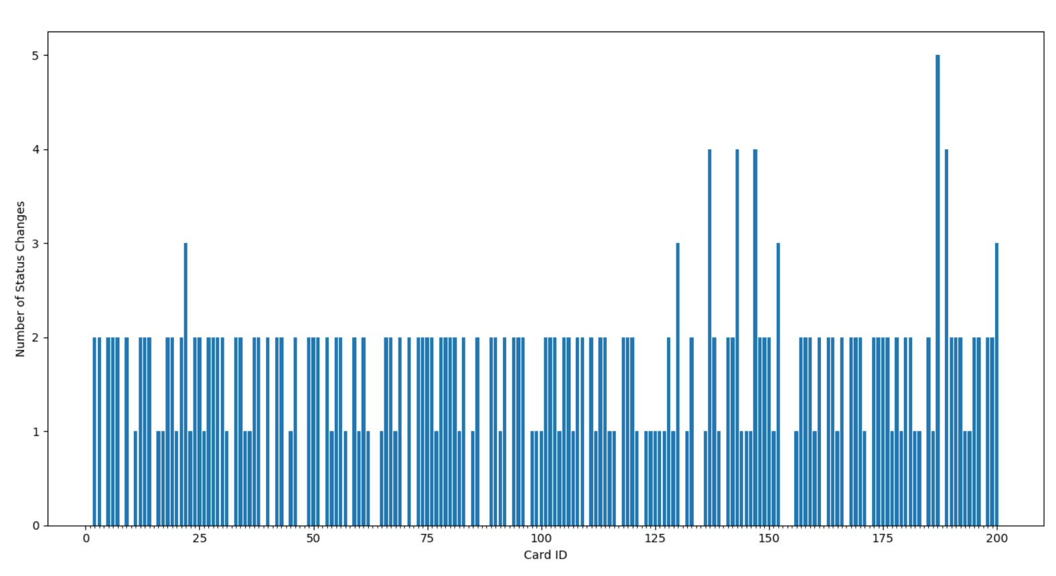

This graph shows the number of status changes by card. The average number of status changes was 1.77.

It seems like most users are using it in the correct fashion, with the logical max status changes being 2. Only a couple of outliers have been changed more than 2 times, which means that most users understand how to use this feature.

*Hypothesis:*

Users find that the feature is a productivity boost. It helps teams communicate with each other regarding the status of a specific client.

*Expected Impact:*

User retention will increase, and rate of new users will increase as well, through word of mouth marketing.

*What the feature is:*

It’s a Kanban board feature which allows users to move their shipping clients between three statuses of `backlog`, `in-progress`, and `complete`.

**Kanban Feature Flow Diagram**

