1. .

const catdata = require('./Database/catdetails')

The above line fetches the columns names and all from the catdetails.module.js file

👇

👇

const mongoose=require('mongoose');

const catdata=new mongoose.Schema({

    cat_name:String,

    breed_name:String,

    age:String,

    date:Date,

    problem:String,

    gender:String

})

const catdetails= mongoose.model('catdetails',catdata);

module.exports=catdetails;

1. To display the details we use (you already know)

app.get('/view', (req, res) => {

  catdata.find((err, catDet) => {

The above line which uses **find()** method of mongo node function to display values. Values coming from catdata [remember point 1 of this document]

var dateConverted = [];

I have declared a new array variable why because to get/store only single coulumn values [above is also the syntax to declare array in node i.e, typescript syntax]

1. Now I will be using for loop , first the syntax:

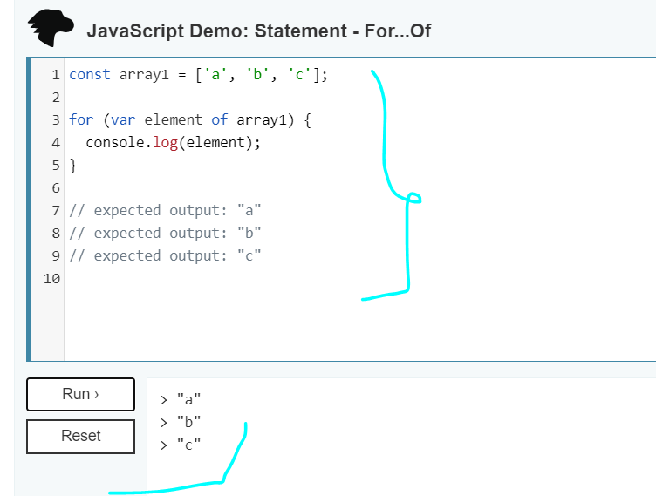

So I need to loop all the values coming from database for that I am using for loop, values coming from mongo will look like the below:

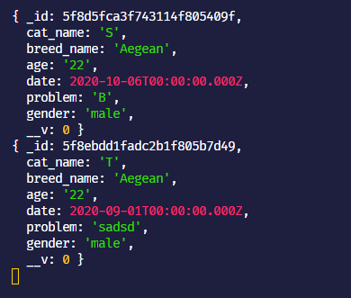

But now I need to fetch only date and then do the conversion(only date & time as you said)

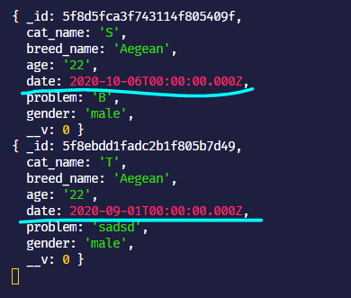

1. I declare new variable again but inside for loop [to fetch/catch/get only **date column values**]

for(let val of catDet) {

      var d =  val.date

var d = val.date => val is coming from the **alias** and its getting the value/details from catDet.

**catDet** is coming from :

 catdata.find((err, catDet) => {

**Now,** if I check what details/values I will get when I display/console as shown below

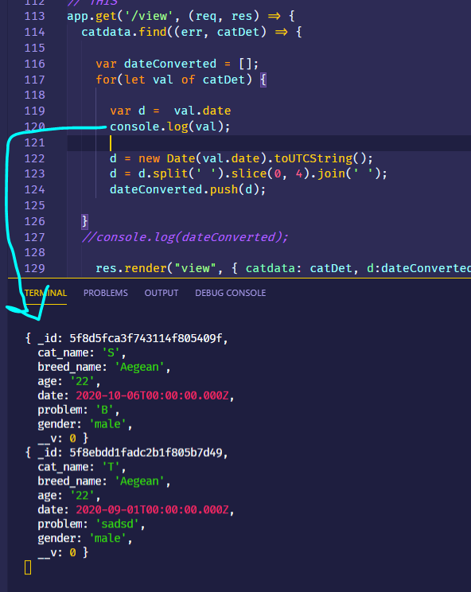

**Now ,** I have to fetch/get/use only date column for that I will use the following code:

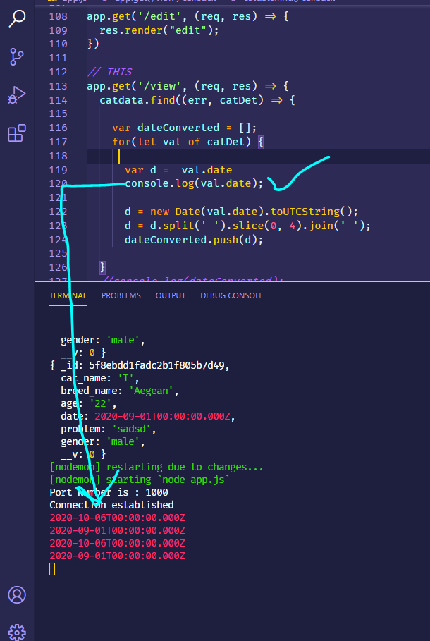

1. Since the code **var d = val.date** fetches only date column values then I can move on to **converting** them to **timestamp** [date time only] as shown below[Remember this is all occurring inside **for loop** only]:

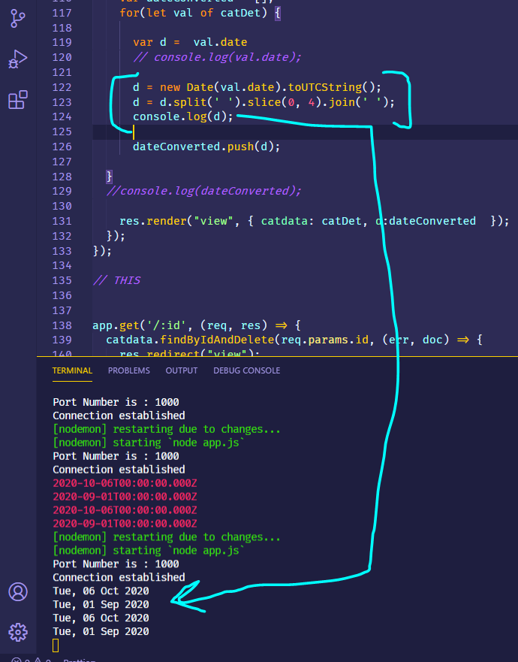

1. Now I have to insert to array variable i.e, **var dateConverted = [];** for that we use in node **push**

dateConverted.push(d);

d => value coming from

  var d =  val.date

      d = new Date(val.date).toUTCString();

      d = d.split(' ').slice(0, 4).join(' ');

      console.log(d);

1. So the complete code is below BUT its only node js part (backend)

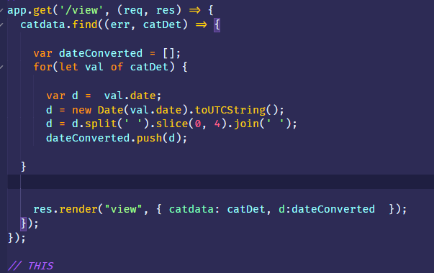

Now by using **d:dateConverted** => we will display those values in **frontend**

 res.render("view", { catdata: catDet, d:dateConverted  });

From the above catdata is coming from

const catdata = require('./Database/catdetails')

catDet is coming from

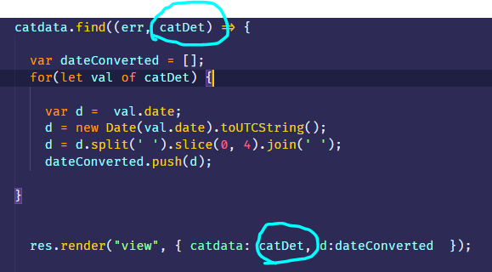

1. To display any values either coming from array or coming from database we use handlebars **{{#each}} {{/each}}** in-built helper

[Note: **pls study in-built helpers in node handlebars**]

Since we have to iterate two values i.e, **catdata** & **d**

**Again**, pls chck the above two values are coming from

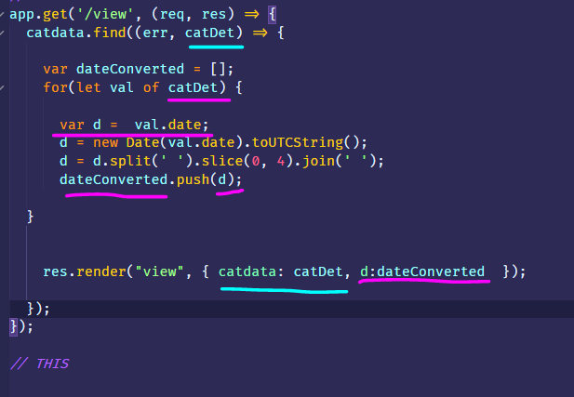

So , to loop we will be using the variable as marked below in pink => catdata

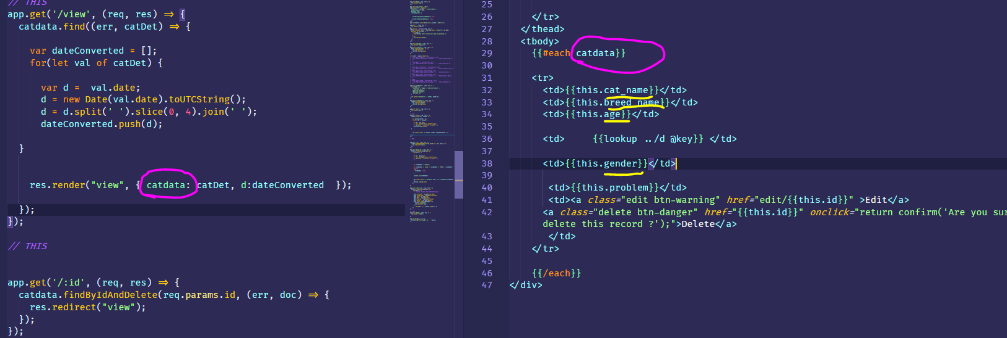

cat_name

breed_name

age

gender

The above values are coming from

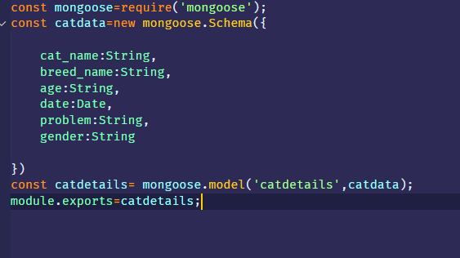

And the values are coming from mongo as:

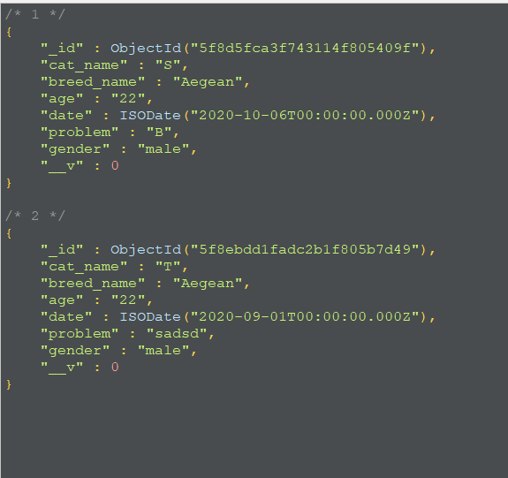

So to iterate we use **{{each}}** in built-helper node hbs, so for that we use

**{{this.cat_name}} {{this.cat_age}} …….** & so on.

1. Since we have to iterate the date [which we had used **for-loop** for converting each date value from each row] we use the following syntax

**{{lookup ../d @key}}**

For example suppose we have two arrays

**firstnames**: [ 'A', 'B', 'C','D','E' ],

**lastnames**: ['a','b','c','d','e']

we can iterate **firstnames**  as

**{{#each firstnames}}**

<h1>**{{this}}**</h1>

**{{/each}}**

**But** what about the **lastnames** array values , for that we use the following

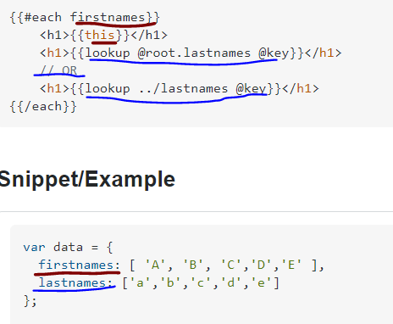

So lookup is basically two iterate more than one lists/arrays.

For much better understanding check the link below:

[**https://zordius.github.io/HandlebarsCookbook/0020-lookup.html**](https://zordius.github.io/HandlebarsCookbook/0020-lookup.html)

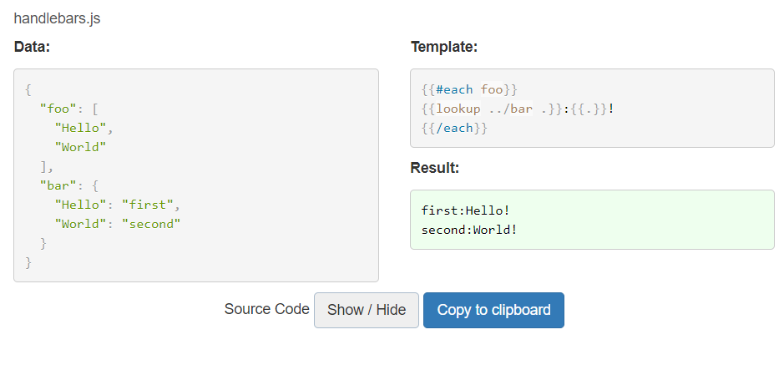

1. Still doubts ????

Pls go through the steps 1-11,

if still doubts contact the writer of this document.

Good Day !!