Data Driven Application Development Document

Application Title: Currency Converter
Module: Advanced Programming
Student Name: Tauheed Aqdas
Student ID: 03-24-047
API Used: Open Exchange Rate API (open.er-api.com)

Abstract
In this project, the Tkinter graphical user interface (GUI) framework and Python were used to create a data-driven Currency Converter application. Using real-time exchange rate data obtained from an external REST API, the application's goal is to enable users to convert monetary values between several international currencies. Functions, parameter passing, object-oriented programming concepts, and API integration are all demonstrated in the application. A straightforward and user-friendly graphical user interface (GUI) that accepts keyboard and mouse input allows users to engage with the system. The finished program accurately converts currencies and retrieves real-time exchange rate data. With an emphasis on usability and practicality, this application was created to be straightforward and useful.
The source code for this project is available on GitHub at:
[PASTE YOUR GITHUB REPOSITORY LINK HERE]

Project Plan
The project was completed in structured stages to ensure effective development and testing.
Phase | Description | Estimated Time
Planning | Research APIs, define features and requirements | 2 hours
Design | GUI layout planning, class design | 2 hours
Development | Tkinter GUI creation, API integration, logic | 5 hours
Testing | Functional testing and bug fixing | 2 hours
Documentation | Writing development document and appendix | 3 hours

Evidence of Design
Program Requirements
- Retrieve real-time exchange rate data from an external API
- Convert currency values accurately
- Provide a graphical user interface using Tkinter
- Validate user input and handle errors
- Use object-oriented programming principles
GUI Wireframe Description
The GUI consists of:
- A title label at the top
- Two dropdown menus for selecting the source and target currencies
- A text entry field for entering the amount
- Buttons for converting, swapping currencies, and clearing input
- A label to display the conversion result

Technical Description & Walkthrough
The CurrencyConverter class is used to implement the application in an object-oriented manner. This class is in charge of managing API connectivity, processing user interactions, and developing the GUI. The interface is built using Tkinter widgets including Label, Entry, Button, and Combobox.
In order to get the most recent exchange rates, the convert() function retrieves user input, verifies it, and then sends a request to an external REST API. The converted amount is determined by extracting the conversion rate for the chosen currency from the API response. Extra functions like swap() and clear() show modular function design and improve usability.
A video walkthrough demonstrating the application functionality and providing a technical explanation of the code is available here:
https://drive.google.com/file/d/1czWpEm5DYYzNNdk24_VI68qymAyJ9nYP/view?usp=drive_link

Testing
The application was tested to ensure reliability and correctness. The following test cases were conducted:
Test Case | Input | Expected Result | Outcome
Valid conversion | 100 USD → EUR | Correct converted value | Pass
Empty input | Blank amount | Error message | Pass
Invalid input | Alphabetic input | Error message | Pass
Swap currencies | Click swap button | Currencies swap | Pass
Additional currencies | AED → PKR | Correct conversion | Pass
Screenshots of the application during testing are included below this section as evidence.
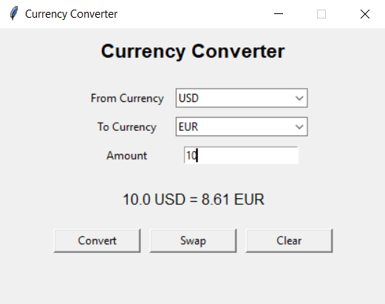

Critical Reflection
Working with external APIs and managing unforeseen errors when retrieving real-time data proved to be the most difficult part of developing this application. Before choosing a reliable solution that reliably produced accurate exchange rates, a number of APIs were tested. My knowledge of object-oriented programming, API integration, and Python error handling has all improved as a result of this project. If I had more time, I would add a conversion history feature and enhance the interface's visual design. All things considered, this project was a worthwhile educational opportunity that boosted my confidence in developing data-driven applications.

Appendix: Source Code
import tkinter as tk
from tkinter import ttk, messagebox
import requests

class CurrencyConverter:
def __init__(self, root):
self.root = root
self.root.title("Currency Converter")
self.root.geometry("420x300")
self.root.resizable(False, False)

self.currencies = ["USD", "EUR", "GBP", "JPY", "AUD", "CAD", "CHF", "INR", "AED", "PKR"]

self.create_gui()

def create_gui(self):
tk.Label(self.root, text="Currency Converter", font=("Arial", 16, "bold")).pack(pady=10)

frame = tk.Frame(self.root)
frame.pack(pady=10)

tk.Label(frame, text="From Currency").grid(row=0, column=0, padx=10, pady=5)
tk.Label(frame, text="To Currency").grid(row=1, column=0, padx=10, pady=5)
tk.Label(frame, text="Amount").grid(row=2, column=0, padx=10, pady=5)

self.from_currency = ttk.Combobox(frame, values=self.currencies, state="readonly")
self.from_currency.grid(row=0, column=1)
self.from_currency.set("USD")

self.to_currency = ttk.Combobox(frame, values=self.currencies, state="readonly")
self.to_currency.grid(row=1, column=1)
self.to_currency.set("EUR")

self.amount_entry = tk.Entry(frame)
self.amount_entry.grid(row=2, column=1)

self.result_label = tk.Label(self.root, text="", font=("Arial", 12))
self.result_label.pack(pady=10)

btns = tk.Frame(self.root)
btns.pack(pady=10)

tk.Button(btns, text="Convert", width=12, command=self.convert).grid(row=0, column=0, padx=5)
tk.Button(btns, text="Swap", width=12, command=self.swap).grid(row=0, column=1, padx=5)
tk.Button(btns, text="Clear", width=12, command=self.clear).grid(row=0, column=2, padx=5)

def convert(self):
try:
amount = float(self.amount_entry.get())
except ValueError:
messagebox.showerror("Error", "Please enter a valid number.")
return

base = self.from_currency.get()
target = self.to_currency.get()

url = f"https://open.er-api.com/v6/latest/{base}"
response = requests.get(url)
data = response.json()

if data["result"] != "success":
messagebox.showerror("Error", "Failed to fetch exchange rates.")
return

rate = data["rates"].get(target)
if rate is None:
messagebox.showerror("Error", "Currency not found.")
return

converted = amount * rate
self.result_label.config(text=f"{amount} {base} = {converted:.2f} {target}")

def swap(self):
a = self.from_currency.get()
b = self.to_currency.get()
self.from_currency.set(b)
self.to_currency.set(a)

def clear(self):
self.amount_entry.delete(0, tk.END)
self.result_label.config(text="")

if __name__ == "__main__":
root = tk.Tk()
app = CurrencyConverter(root)
root.mainloop()

