 | Patuakhali Science and Technology University
Project Report
Course Code: CIT-222
Course Title: Information System Analysis and Design Sessional
Level - II; Semester - II
Submitted By / Team members:
ID: | Name:
2202017 | Md. Gohora Mamun
2202075 | Tauhid Shahriar Shourove
2202076 | Md. Nafis Islam

Submitted To:
Prof. Golam Md. Muradul Bashir
Professor, Department of Computer and Communication Engineering
Faculty of Computer Science and Engineering
&
Muhtasim
Lecturer, Department of Computer Science and Information Technology
Faculty of Computer Science and Engineering

Submission Date: 10 September, 2025

Project Title
University Digital Payment System

Introduction
The Student Fee Payment System is a web-based platform designed to streamline and digitalize the fee payment process for educational institutions. This system enables students to pay their semester fees securely and conveniently through multiple payment channels, while providing administrators with an efficient tool to manage, verify, and track all financial transactions from a centralized dashboard.

The traditional, manual process of fee collection is often plagued by long queues, paperwork, delayed verification, and a lack of payment flexibility. This project directly addresses these challenges by introducing an automated, transparent, and user-friendly online ecosystem. It eliminates the need for physical presence, reduces administrative overhead, and minimizes errors, ensuring a smoother financial operation for both students and the institution's administration.

Objectives
The system allows students to:
- Register and log into a personalized dashboard
- View pending fees and semester-wise fee structure
- Pay fees using multiple methods such as Nagad, bKash, and DBBL
- Submit transaction IDs for verification
- Track payment status (Pending, Approved, or Rejected)
- Resubmit payments if rejected
For administrators, the system provides:
- A secure login and dashboard to monitor pending payments
- Tools to verify, approve, or reject transactions
- Ability to manage semester fees (add, update, view)
- Real-time status updates and record-keeping

How It Works
Student Registration & Login: Students create an account or log in using their credentials.
Fee Viewing & Payment Selection: Students view their pending fees and choose a preferred payment method.
External Payment Processing: Payments are made through integrated mobile financial services (MFS) or banking platforms.
Transaction Submission: Students submit the transaction ID to the system for verification.
Admin Verification: Administrators review and validate payments, updating the status accordingly.
Status Update: Students receive instant updates on their payment status via their dashboard.
The system is built using a structured database (MySQL), supports role-based access (Student/Admin), and follows a secure, scalable architecture suitable for future enhancements such as SMS notifications, automated reconciliation, and additional payment gateways.

Benchmarks
Features / Criteria | SUST Online Payment System | DU Sonali Bank e-Payment | Rupali Sure Cash System | My System
Online Payment Support | ✔ | ✔ | ✔ | ✔
Mobile Financial Services (MFS) | ✖ | ✖ | ✔ | ✔
Automatic Payment Verification | ✔ | ✔ | ✔ | ✖
Student Login System | ✔ | ✔ | ✔ | ✔
Shows Pending Fees | ✔ | ✔ | ✔ | ✔
Admin Dashboard | ✔ | ✔ | ✔ | ✔
Full Bank API Integration | ✖ | ✔ | ✖ | ✖
Works Without Standing in Line | ✔ | ✔ | ✔ | ✔
Scalable for Future Upgrades | ✔ | ✔ | ✔ | ✔
Instant Payment Confirmation | ✖ | ✔ | ✔ | ✖
Supports Multiple Payment Methods | ✖ | ✖ | ✔ | ✔

Sitemap

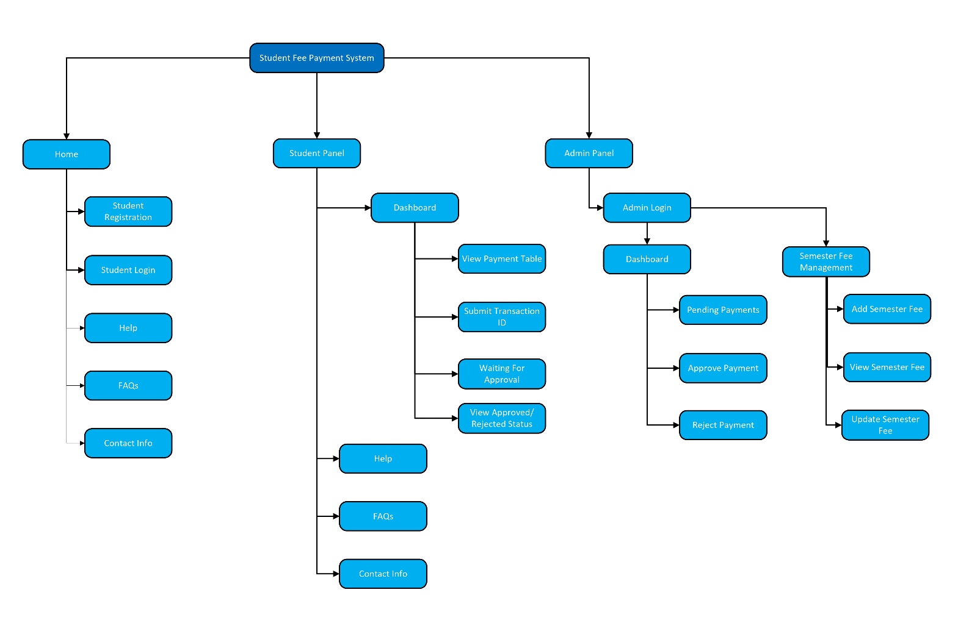

Context Diagram
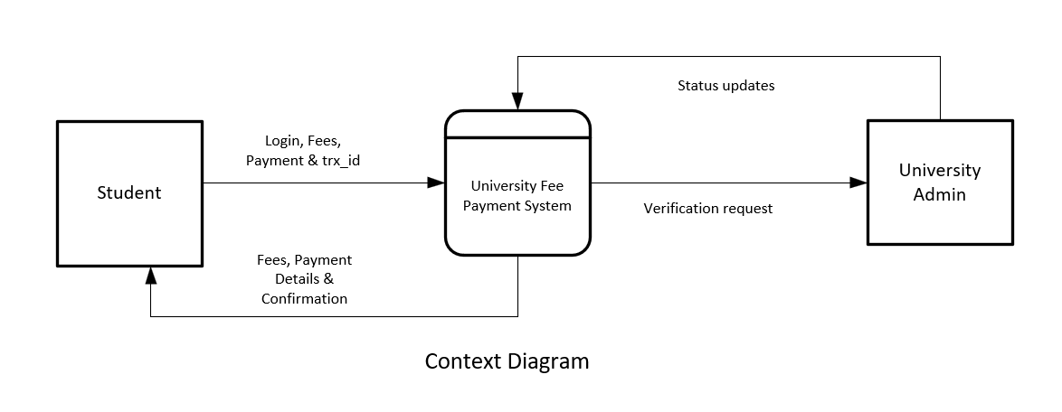

DFD
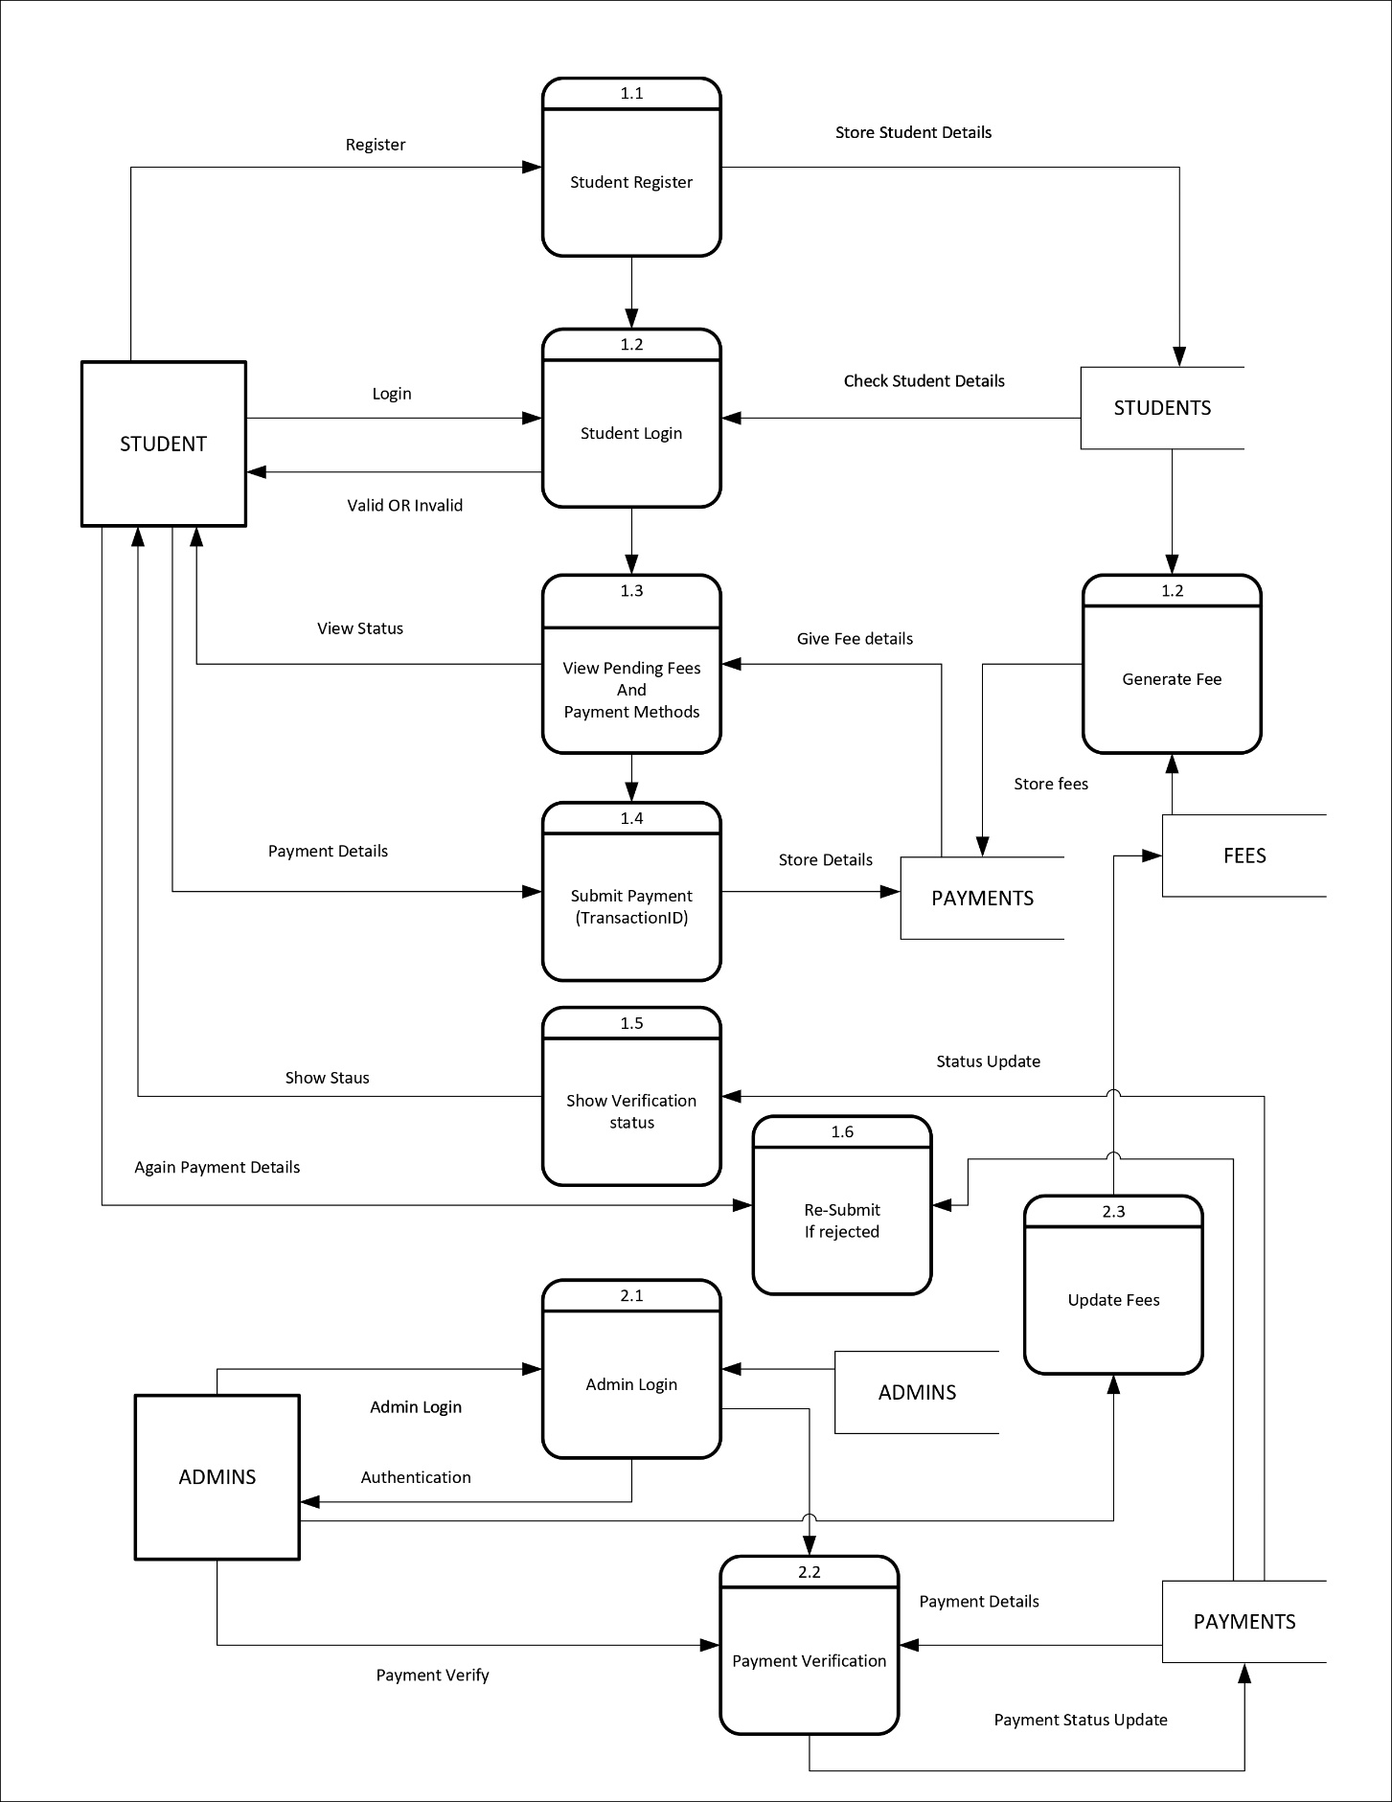

Activity Diagram
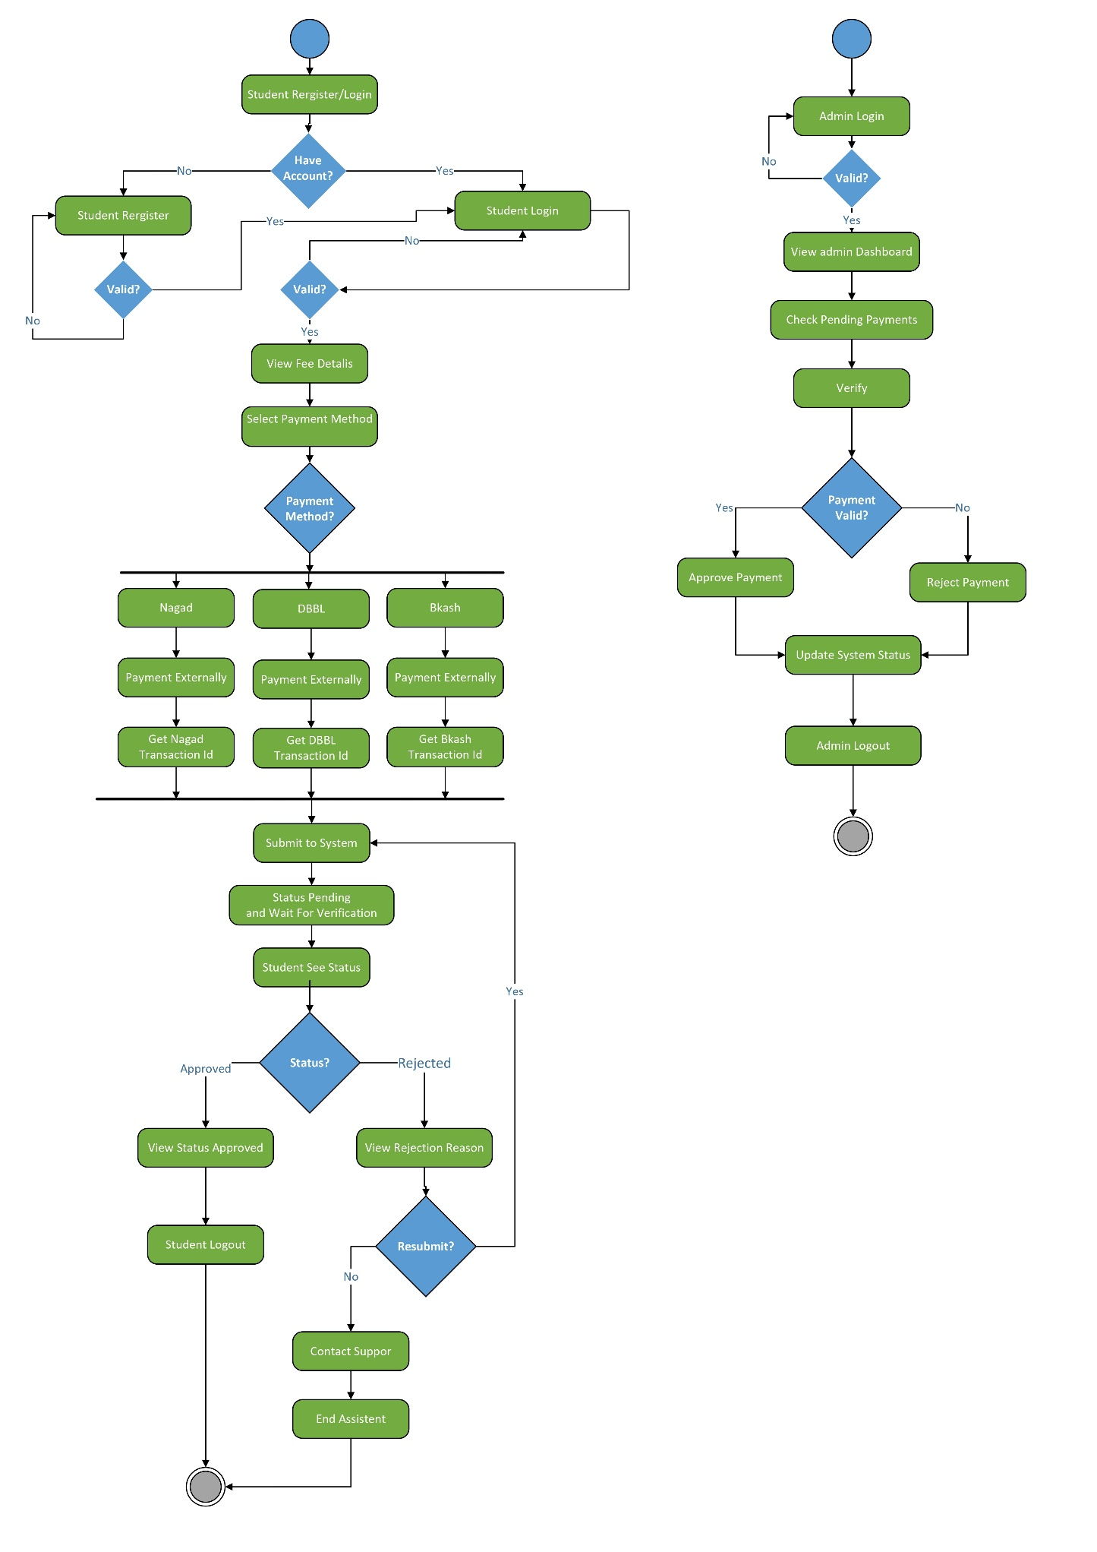

Use Case Diagram

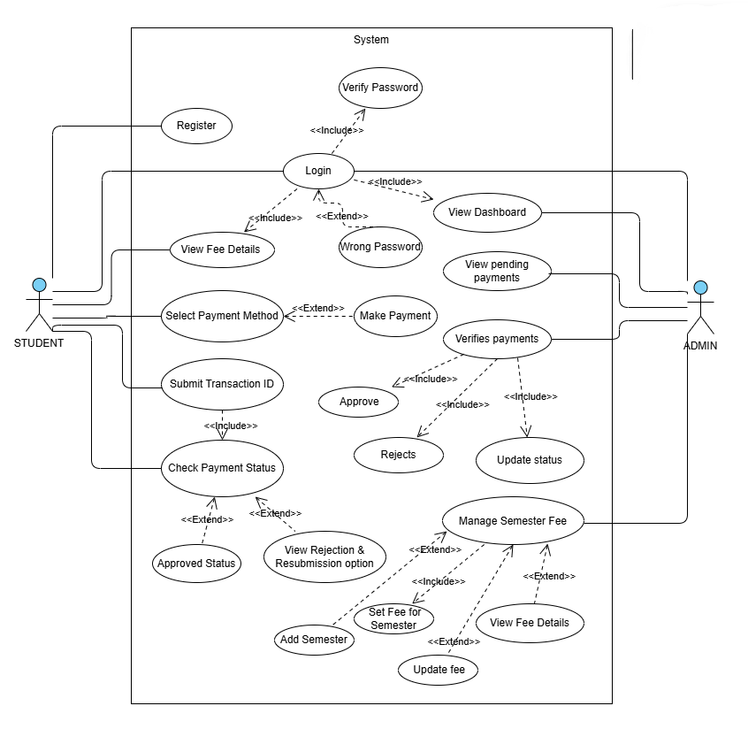

Class Diagram
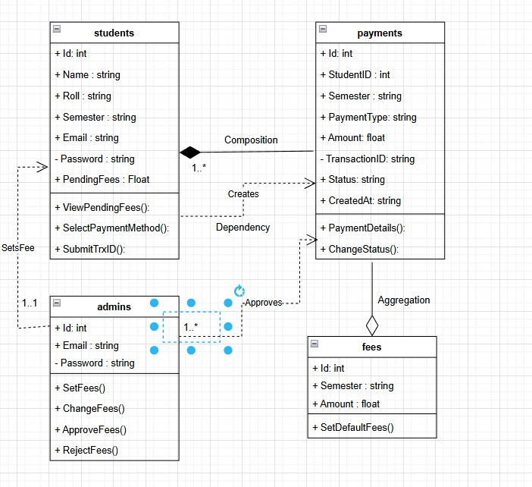

E-R Diagram
