

**CSE302 (Section 02)**

**[Summer 2022]**

**Lab Assignment Submission Report**

**Assignment Title: lab 00**

**Submitted by:**

**Md.Abu Zafor**

**2020-2-60-158**

**1.Screenshots**

**Problem 1:**

**Problem 2:**

**Problem 3:**

**Problem 4:**

**Problem 5:**

**Problem 6:**

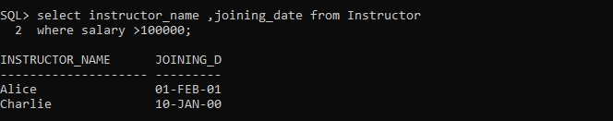

**Problem 7:**

**2. Learning Outcomes**

In lab class, I have learned about the data base system practically. In our practical life, we can see many kinds of database that can be varsity database, bank database, student database and so on.I have also known about SQL language which is case incentive language that means it doesn’t do any difference between upper-case and lower-case letters.

My learning outcomes of lab 00 are given below:

1.How to create a new user in command prompt. (Local database server).

2.Data types of SQL.

3.How to create a table through SQL commands.

4.How to update, delete and insert data of a table.

5.How to apply various conditions in a table while updating, inserting, and deleting.

6.How to show the table.

7.How to show specific row/column of a table.

6.How to save the table.

7.How to drop the table.