

**CSEAAA (Section 02)**

**[Fall 2022]**

**Lab Assignment Submission Report**

**Assignment Title: Lab05**

**Submitted by:**

**Md.Abu Zafor**

**Student ID:2020-2-60-158**

**1. Screenshots**

**Problem 1:**

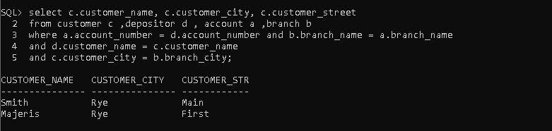

**Problem 2:**

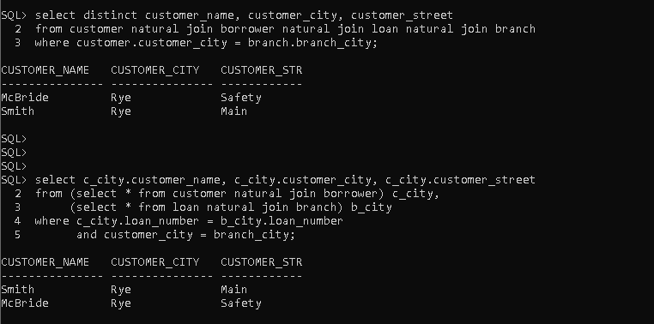

**Problem:03**

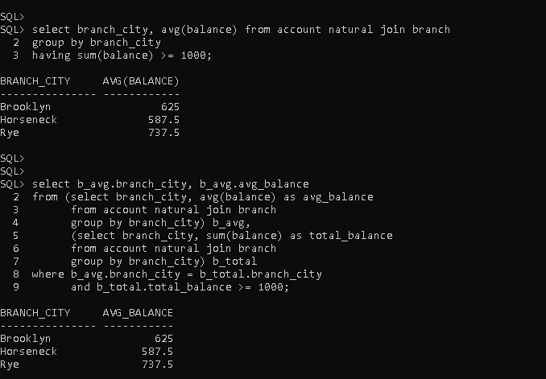

**Problem: 04**

**Problem: 05**

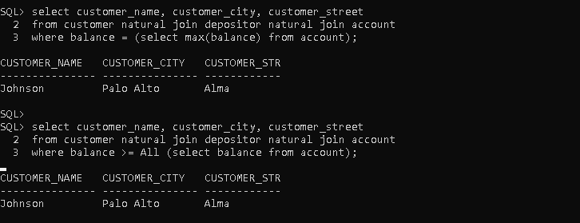

**Problem: 06**

**Problem: 07**

**Problem: 08**

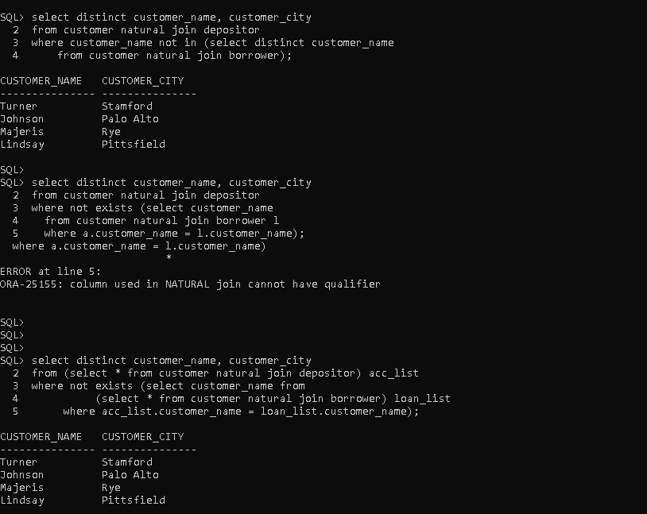

**Problem: 09**

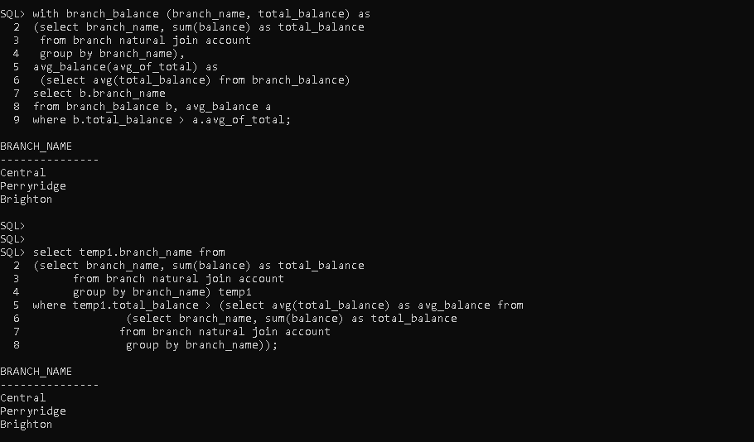

**Problem: 10**

**2. Learning Outcomes**

* **Subqueries in the WHERE clause**
* IN / NOT IN
* SOME / ALL
* EXISTS/NOT EXISTS
* **Subqueries in the FROM clause**
* **Complex Queries using WITH clause**
* **Subqueries in the SELECT clause**