

**CSE302 (Section 02)**

**[Summer 2022]**

**Lab Assignment Submission Report**

**Assignment Title: Lab01**

**Submitted by:**

**Md.Abu Zafor**

**2020-2-60-158**

**1. Screenshots**

**Problem 1:**

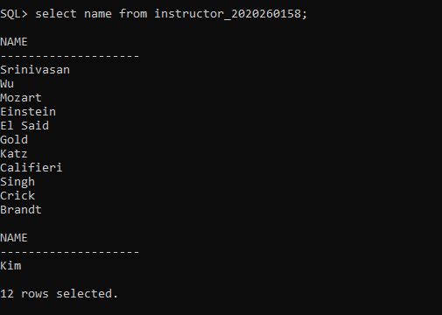

**Problem 2:**

**Problem 3:**

**Problem 4:**

**Problem 5:**

**Problem 6:**

**Problem 7:**

**Problem 8:**

**Problem 9:**

**Problem 10:**

**2. Learning Outcomes**

My learning outcomes of lab 01 are given below:

1.How to create a table through SQL commands.

2.How to update, delete and insert data of a table.

3.How to apply various conditions in a table while updating, inserting, and deleting.

4.How to show the table.

5.How to use not,and operator.

6.How to show all data or specific data in the table through select keyword.

7.How to save the table.

8.How to drop the table.